Table S1 IKP for several combinations of kinetic models for BHMPD
Kinetic model | E_{inv} / kJ mol⁻¹ | ln A_{inv} A/s⁻¹ | −r
AKM | 90.81 | 19.27 | 0.998
AKM−{F3; D1; D2; D3; D4} | 92.12 | 19.85 | 0.986
AKM−{F2; F3; D1; D2; D3; D4} | 91.02 | 19.41 | 0.988
AKM–{F1; F2; F3; D1; D2; D3; D4; A2; A3; A4; R2; R3} | 107.59 | 26.30 | 0.979
AKM–{F1; F2; F3; D1; D2; D3; D4; A2; R2; R3} | 105.13 | 26.09 | 0.981
AKM–{F1; F2; F3; D1; D2; D3; D4; R2; R3} | 103.49 | 24.84 | 0.979
AKM–{P2; P3; P4; F2; F3; D1; D2; D3; D4; A2; A3; A4} | 104.19 | 23.47 | 0.959
AKM–{P4; F1; F2; F3; D1; D2; D3; D4; A2; R2; R3} | 103.06 | 24.39 | 0.988

Table S2 IKP for several combinations of kinetic models for BHMBC
Kinetic model | E_{inv} / kJ mol⁻¹ | ln A_{inv} A/s⁻¹ | −r
AKM | 128.99 | 21.68 | 0.976
AKM–{F2; F3; D1; D2; D3; D4; R2; R3} | 128.75 | 22.05 | 0.999
AKM–{F2; F3; D1; D2; D3; D4; A2; R2; R3} | 127.20 | 21.68 | 0.988
AKM–{P2; P3; P4; F2; F3; D1; D2; D3; D4; R2; R3} | 128.40 | 21.93 | 0.988
AKM–{P4; F2; F3; D1; D2; D3; D4; A2; A3; A4; R2; R3} | 127.13 | 21.63 | 0.985
AKM–{P2; P3; P4; D1; D2; D3; D4; A2; A3; A4; R2; R3} | 125.62 | 21.28 | 0.996

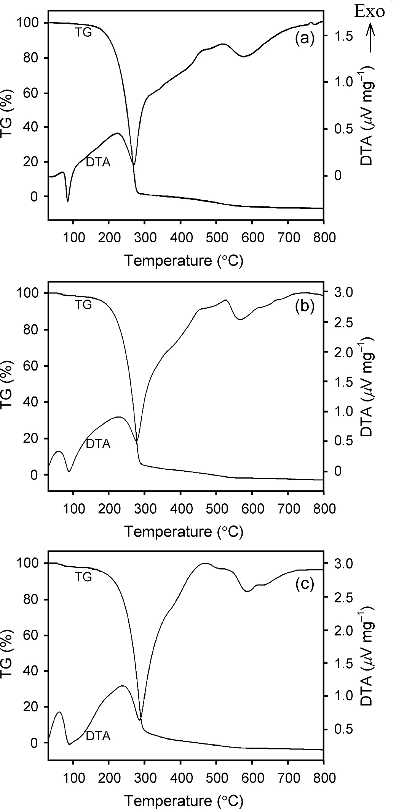

Figure S1 TG and DTA curves of BHMPD at (a) 10 K min^{–1}; (b) 15 K min^{–1}; (c) 20 K min^{–1} heating rates in nitrogen atmosphere

Figure S2 TG and DTA curves of BHMBC at (a) 10 K min^{–1}; (b) 15 K min^{–1}; (c) 20 K min^{–1} heating rates in nitrogen atmosphere

0.6

0.5

[1-(1-α)^{1/2}]
0.4

0.3
10 K/min⁻¹
15 K/min⁻¹
20 K/min⁻¹
0.2

0.1
0.00E+00
2.00E-10
4.00E-10
6.00E-10
8.00E-10
E_{a} p(x)/βR

Figure S3 Determination of A value by plotting [1-(1-α)^{1/2}] against E_{a} p(x)/βR for the decomposition process of BHMPD at the different heating rates (β).

