Supplimentary material
Design and synthesis of quinazolinone, benzothiazole derivatives bearing guanidinopropanoic acid moiety and their schiff bases as cytotoxic and antimicrobial agents
Palani Venkatesh* and Vijay Shankar Tiwariª
^{a*}Department of Pharmaceutical Chemistry, KMCH College of Pharmacy, Kovai Estate, Kalapatti Road, Coimbatore- 641048, India . phone: 0422-2628645
Email: venkateshom2001@gmail.com

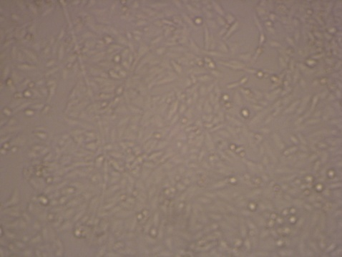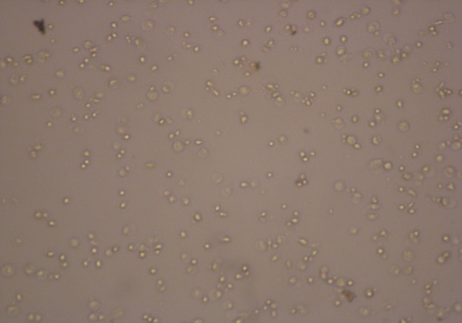
Photograph of HeLa cell line inhibition by Photograph of HeLa cell line inhibition
Negative control (without drug) by the compound 14

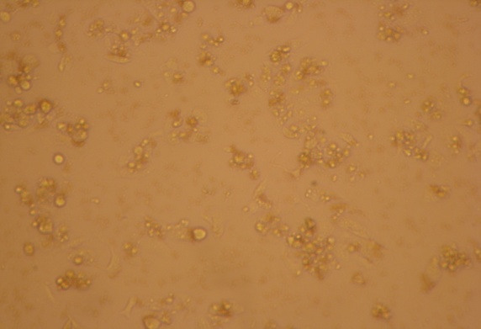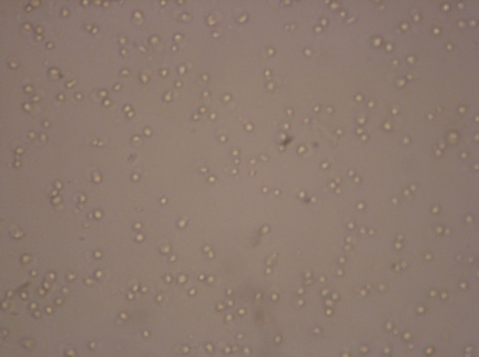
Photograph of HeLa cell line inhibition Photograph of HeLa cell line inhibition
by the compound 15 by the compound 16

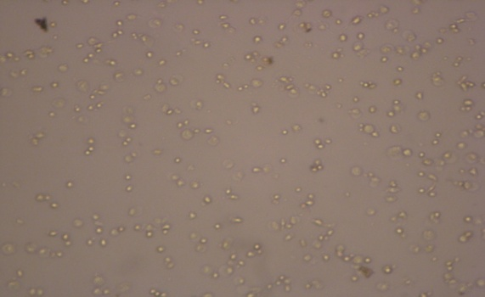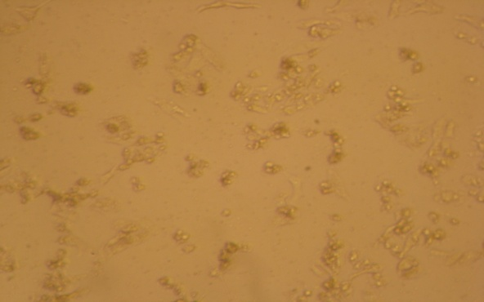
Photograph of HeLa cell line inhibition Photograph of HeLa cell line inhibition by the compound 17 by the compound 18

Photograph of HeLa cell line inhibition

