**Supplementary**

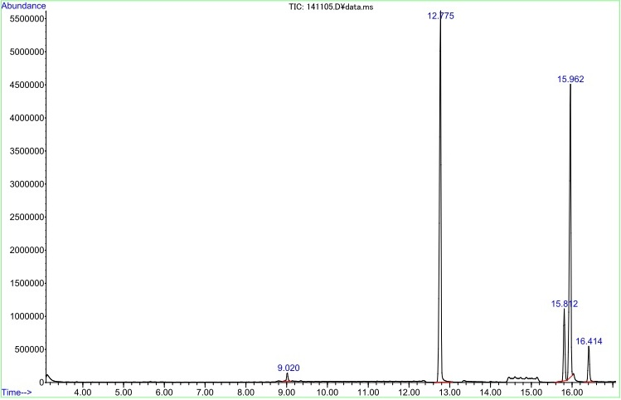

Methyl linoleate

Methyl palmitate

Methyl oleate

Methyl myristate

Methyl stearate

**Supp 1.** GC-MS spectrum of PFAD biodiesel.

**Supp 2.** FTIR spectrum of PFAD biodiesel.