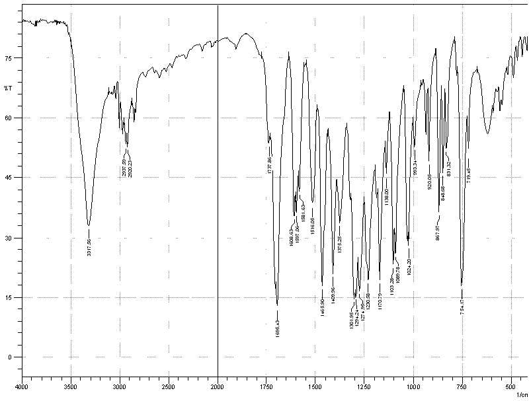

**IR spectrum of 2-(3-methoxy-4-methyl phenyl)-1,3-benzodiox-4-ol (4b)**

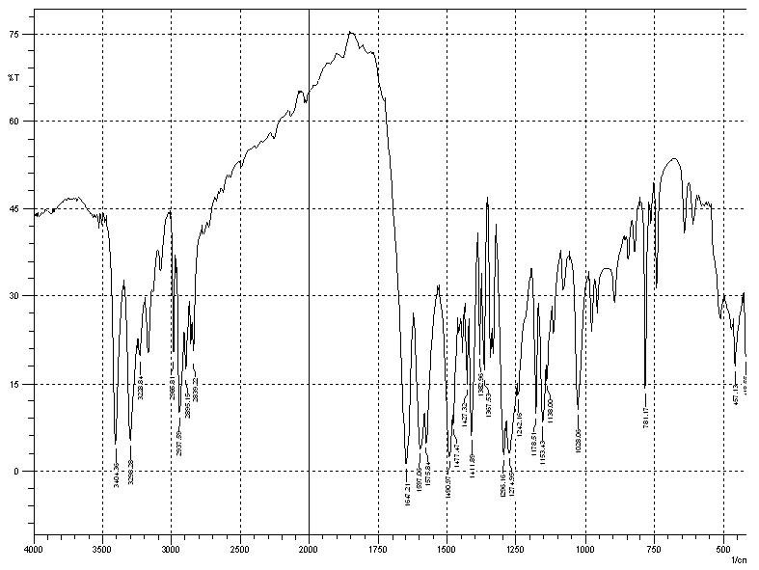

**IR spectrum of 2-(3-aminophenyl)-1,3-benzodioxole (7b)**

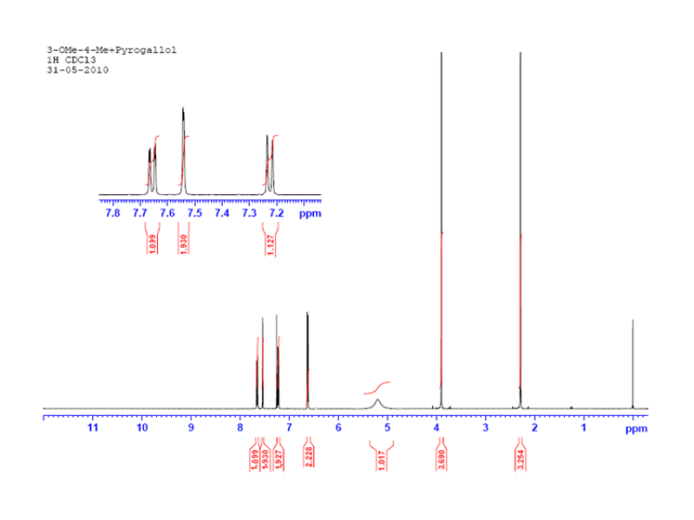 **NMR spectrum of 2-(3-methoxy-4-methyl phenyl)-1,3-benzodiox-4-ol (4b)**



**NMR spectrum of 2-(N-methyl-2-aminophenyl)-1,3-benzodiox-4-ol (9b)**

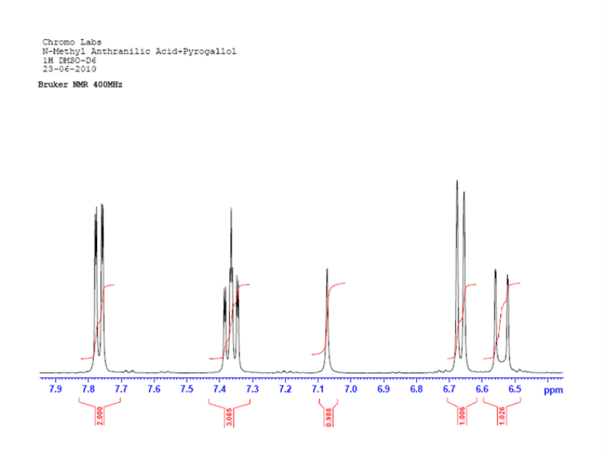

**NMR spectrum of 2-(N-methyl-2-aminophenyl)-1,3-benzodiox-4-ol**

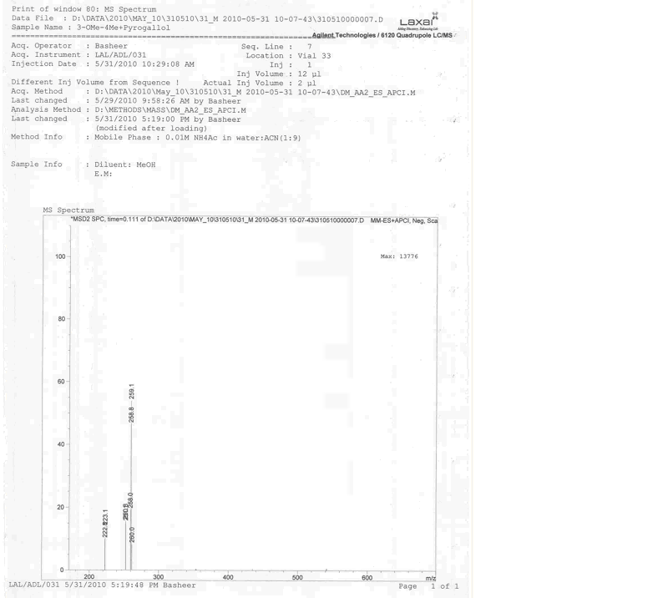

**Mass spectrum of 2-(3-methoxy-4-methyl phenyl)-1,3-benzodiox-4-ol (4b)**

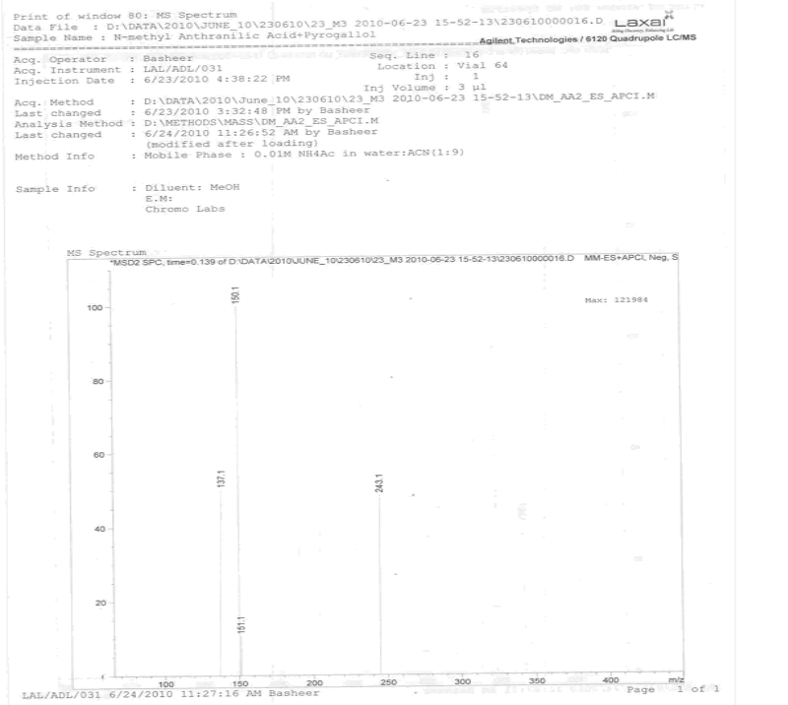

**Mass spectrum of 2-(N-methyl-2-aminophenyl)-1,3-benzodiox-4-ol (9b)**