**Supplementary Material (Figs. S1 to S9)**

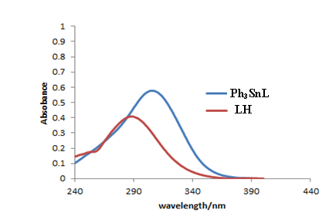

**Fig. S1.** UV-visible spectra of LH and Ph3SnL at concentration of 2.8×10-5 M.

|  |  |
| --- | --- |
| CPA-1 | CPA-2 |

**Fig. S2.** UV-visible spectra of (left) LH and (right) Ph3SnL at different concentrations.

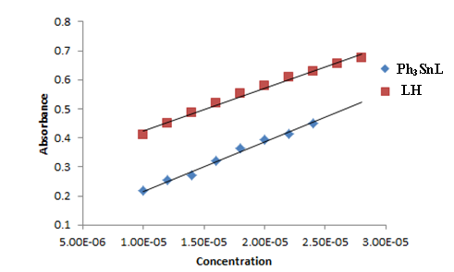

**Fig. S3.** Concentration profile of compounds LH and Ph3SnL.

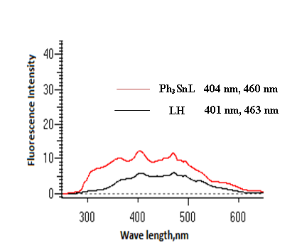

**Fig. S4.** Fluorescence emission spectra of LH and Ph3SnL at concentration of 2.8 × 10−5 M.

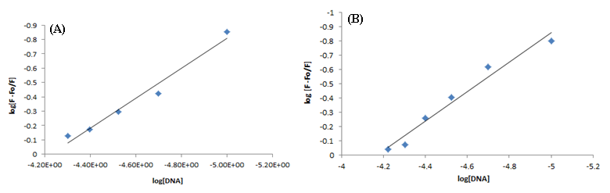

**Fig. S5.** Plots of log [(F-Fo) / F] *vs.* log [DNA] for the calculation of LH – DNA binding constant and binding site size at pH 4.7 (A) and 7.4 (B) and at 37 °C.

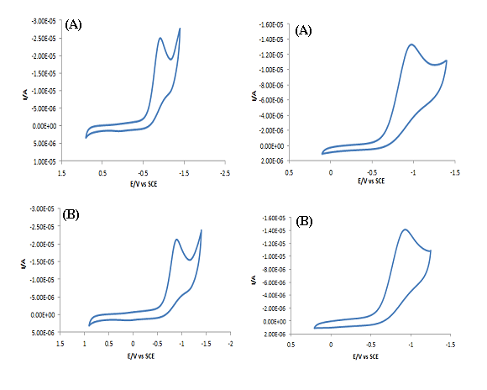

**Fig. S6.** Cyclic Voltammogram for LH and Ph3SnL (2.8×10-5 M) at scan rate (0.1Vs-1) in ethanol-water mixture (7:3) at (A) pH 4.7 and (B) pH 7.4, respectively.

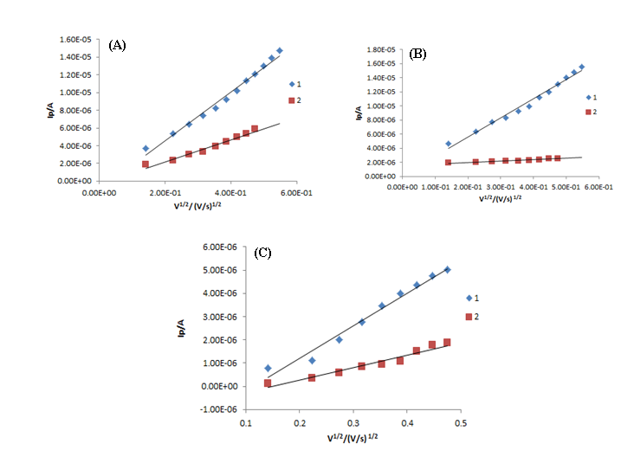

**Fig. S7.** Plots of Ip *vs.* υ1/2 for 2.8 × 10−5 M (A) LH at pH 4.7, (B) Ph3SnL at pH 7.4 and (C) Ph3SnL at pH 7.4 (acetate buffer) in the absence (1) and in the presence of 60 µM DNA (2) at various scan rates (Vs−1).

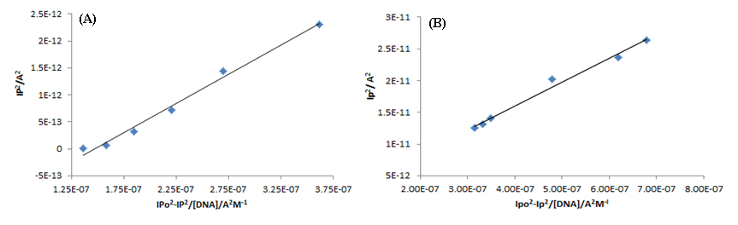

**Fig. S8.** Plots of Ip2 *vs.* Ipo2-Ip2/ [DNA] for calculation of binding constant of LH – DNA adducts at pH 4.7 (A) and 7.4 (B) and at 37 °C.

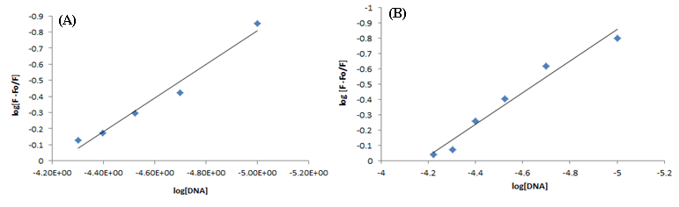

**Fig. S9.** Plots of I- IDNA / IDNA *vs.* [DNA] for determination of binding site size of LH – DNA adducts at pH 4.7 (A) and 7.4 (B) and at 37 °C.