SUPPLEMENTRY DATA

Stereoselective Synthesis of Spiro[5.5]undecane Derivatives via Base Promoted [5+1] Double Michael Addition of N,N-Dimethylbarbituric Acid to Dienones.

Mohammad Shahidul Islam*^{,†,1}, Assem Barakat*^{,†,1,2}, Abdullah Mohammed Al-Majid^{†,1}, Hazem A Ghabbour^{†,3} and Hoong-Kun Fun^{†,3,4}, M. Rafiq Siddiqui^{†,1}
¹Department of Chemistry, College of Science, King Saud University, P. O. Box 2455, Riyadh -11451, Saudi Arabia.
²Department of Chemistry, Faculty of Science, Alexandria University, P.O. Box 426, Ibrahimia- 21321 Alexandria, Egypt.
³Department of Pharmaceutical Chemistry, College of Pharmacy, King Saud University, P. O. Box 2457, Riyadh 11451, Saudi Arabia
⁴X-ray Crystallography Unit, School of Physics, Universiti Sains Malaysia, Penang, 11800 Malaysia.
Author to whom correspondence should be addressed; E–Mail: shahid.10amui@gmail.com; mislam@ksu.edu.sa (M.S); ambarakat@ksu.edu.sa (A.B); Tel.: +966114675884; Fax: +9661–4675992.

Contents:
Copies of spectra of some compounds | 03 – 29
X-Ray Crystal data 30 – 76
ORTEP diagram and Crystal data of 3a | 30 – 43
ORTEP diagram and Crystal data of 3h | 44 – 58
ORTEP diagram and Crystal data of 3i | 59 – 76

# | diarylidene 2b-n | R1/R₂ | 3b-m | yield (%)^{b}
1 | 2b | p-CH₃Ph | 3b | 96
2 | 2c | p-ClPh | 3c | 97
3 | 2d | 2,6-Cl₂Ph | 3d | 89
4 | 2e | 2,4-Cl₂Ph | 3e | 91
5 | 2f | p-BrPh | 3f | 93
6 | 2g | m-NO₂Ph | 3g | 95
7 | 2h | p-CH₃OPh | 3h | 97
8 | 2i | 2-Naphthayl | 3i | 96
9 | 2j | 2-Thiophene | 3j | 98
10 | 2k | 2-Furan | 3k | 98
11 | 2l | m-BrPh | 3l | 95
12 | 2m | Ph & p-CH₃Ph | 3m | 96

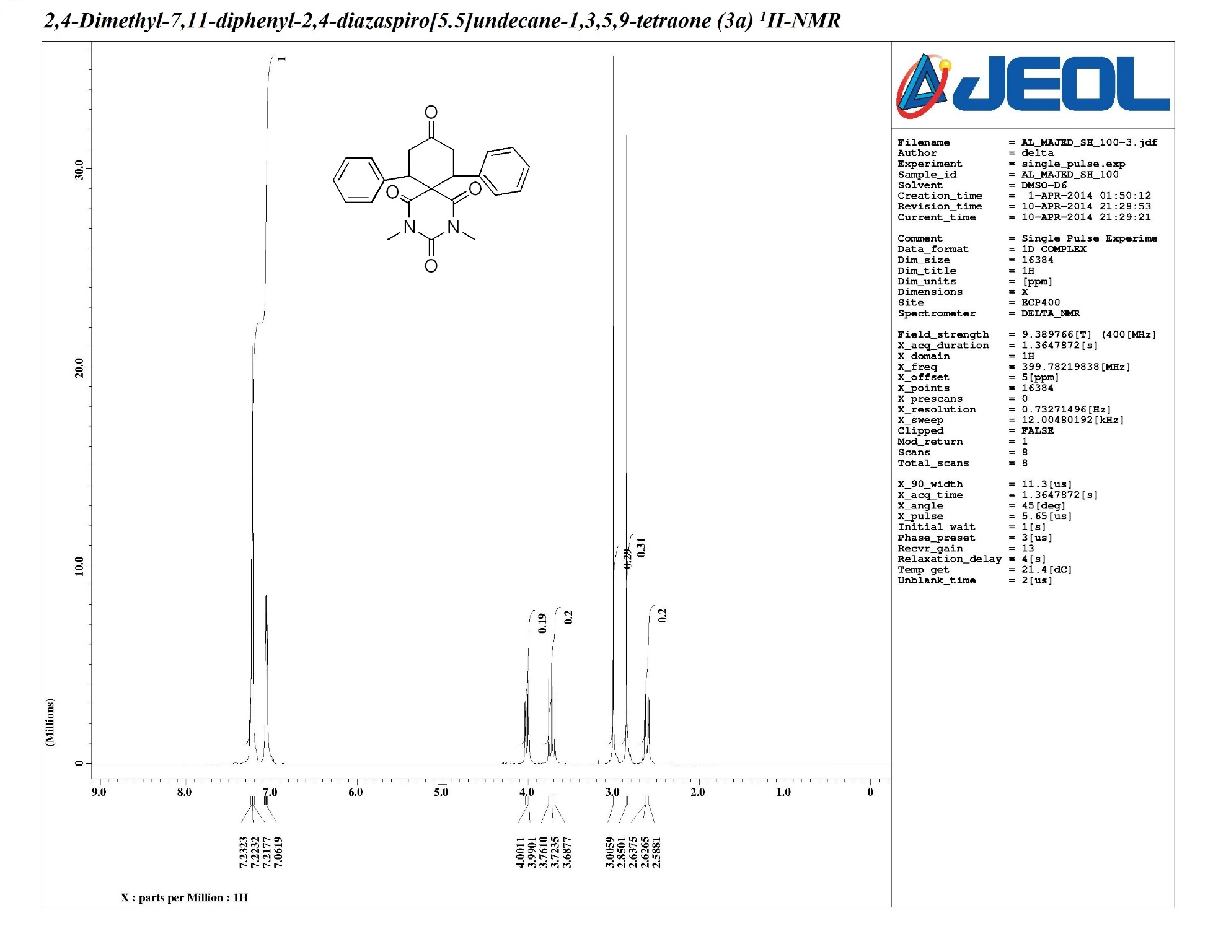
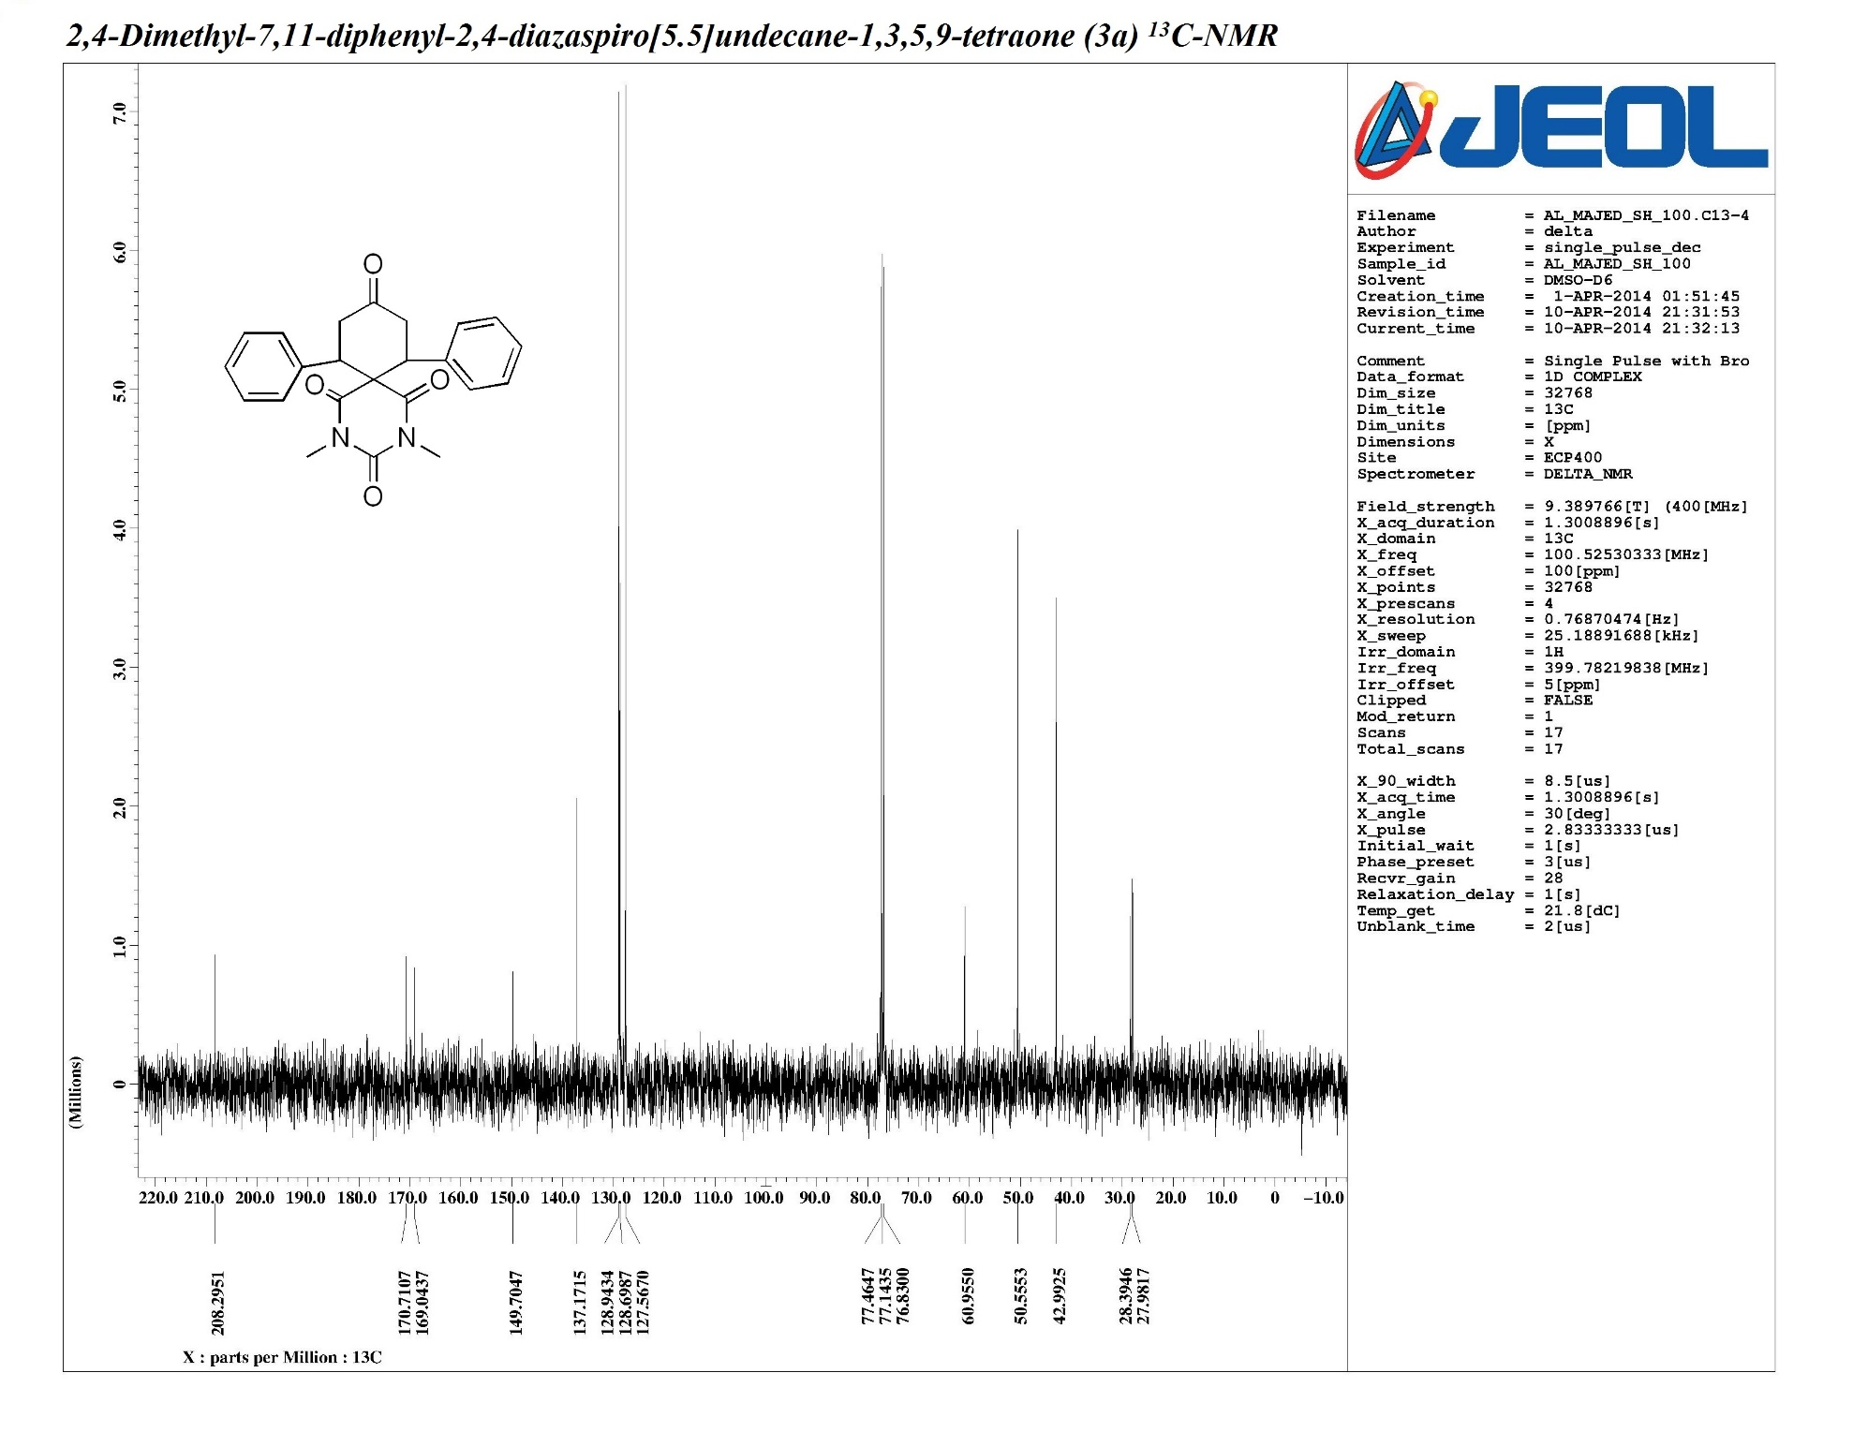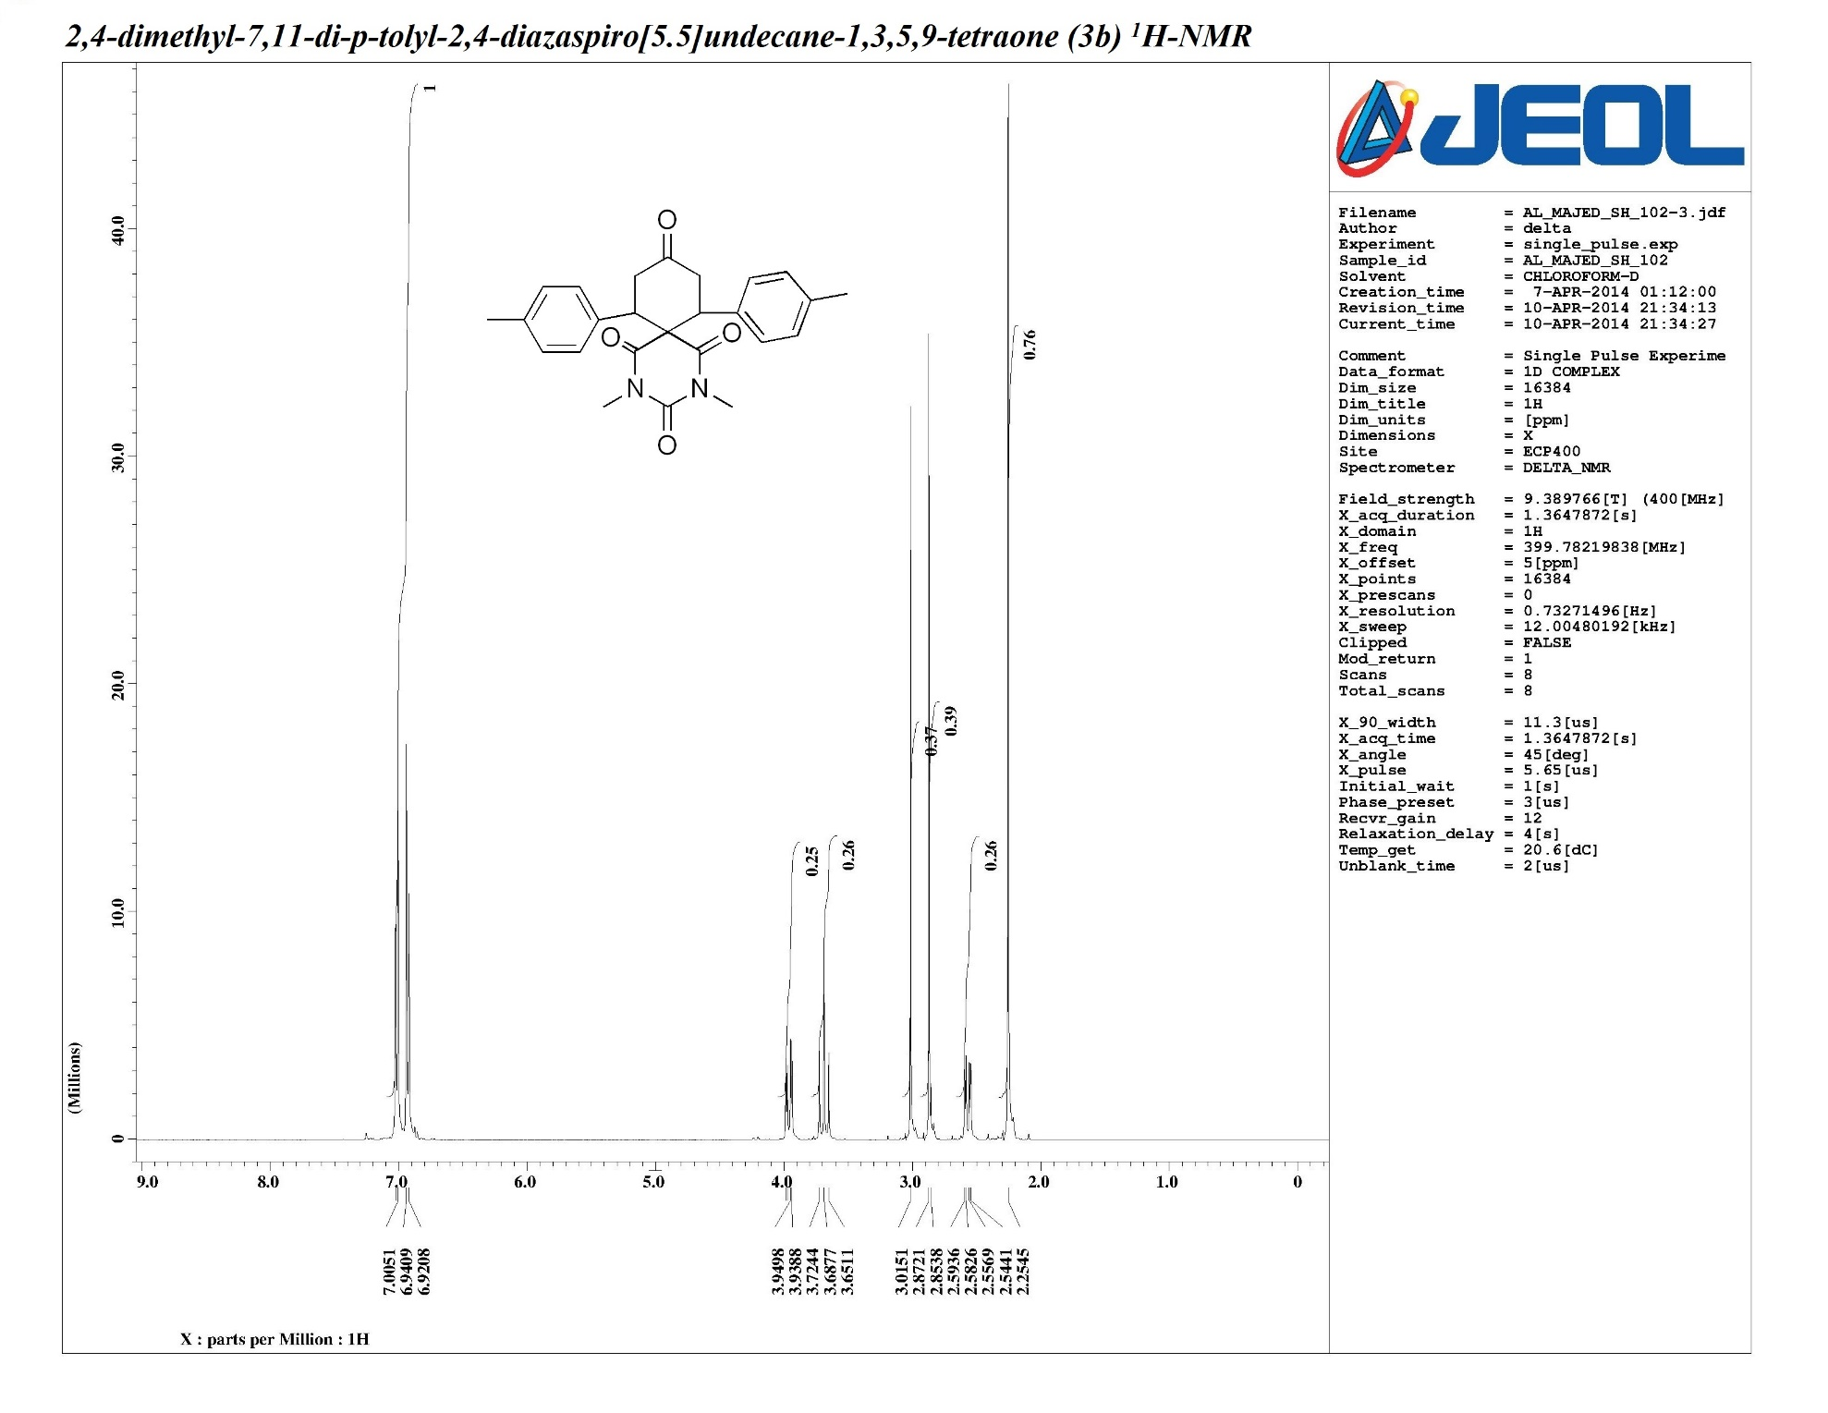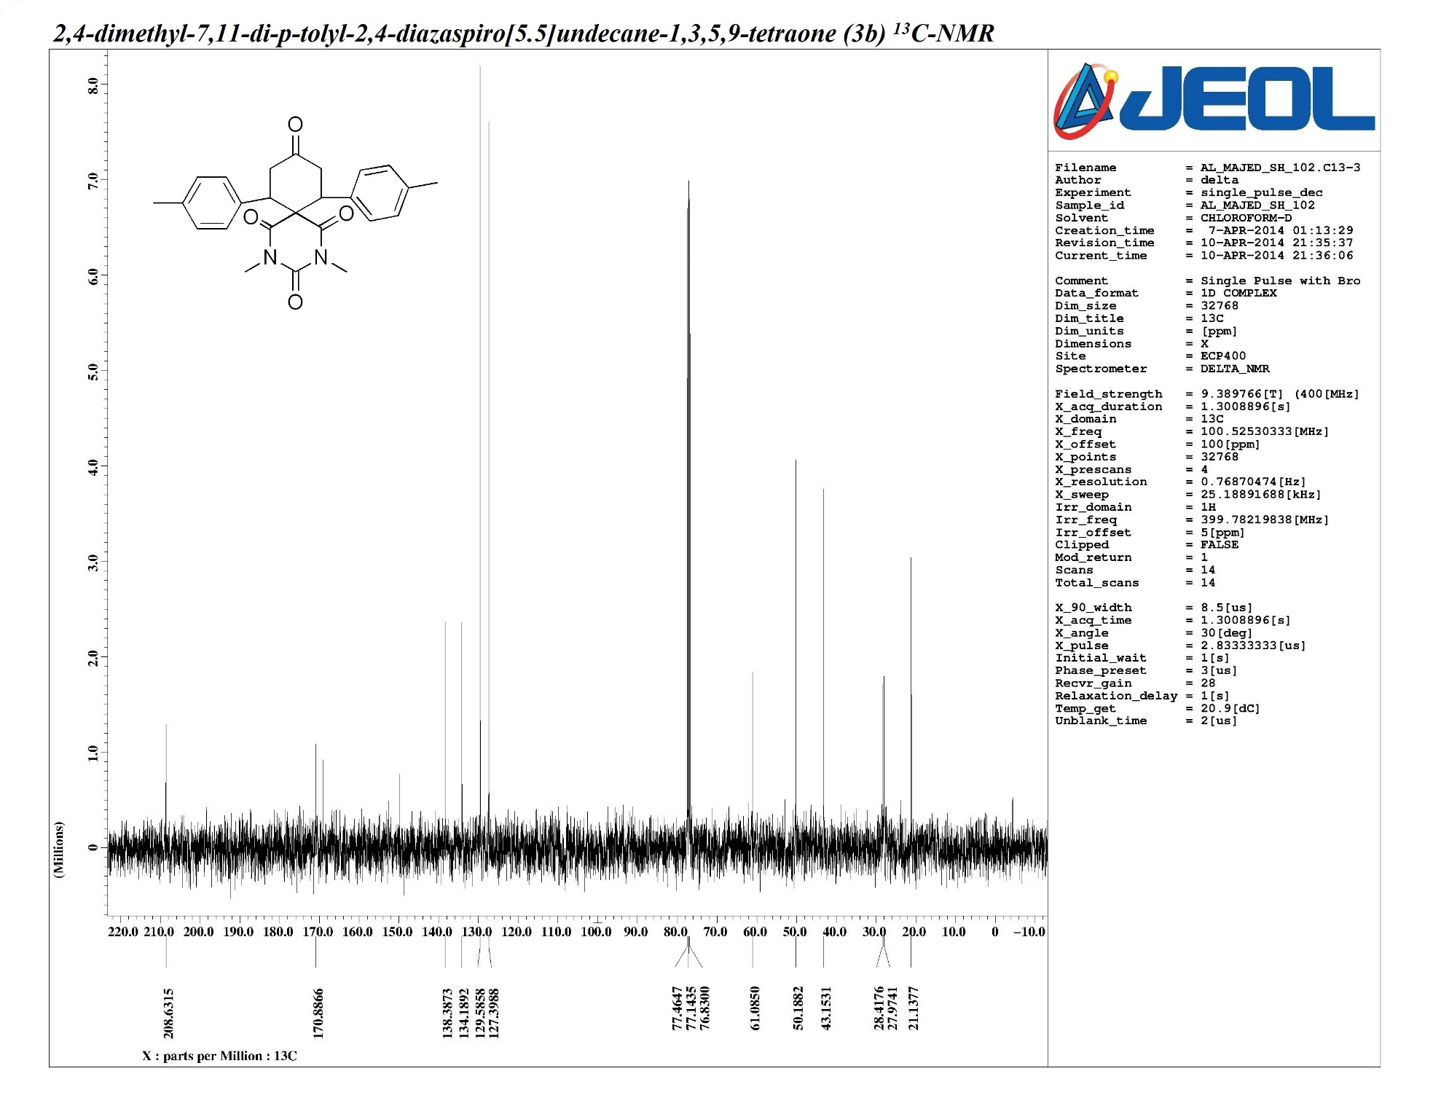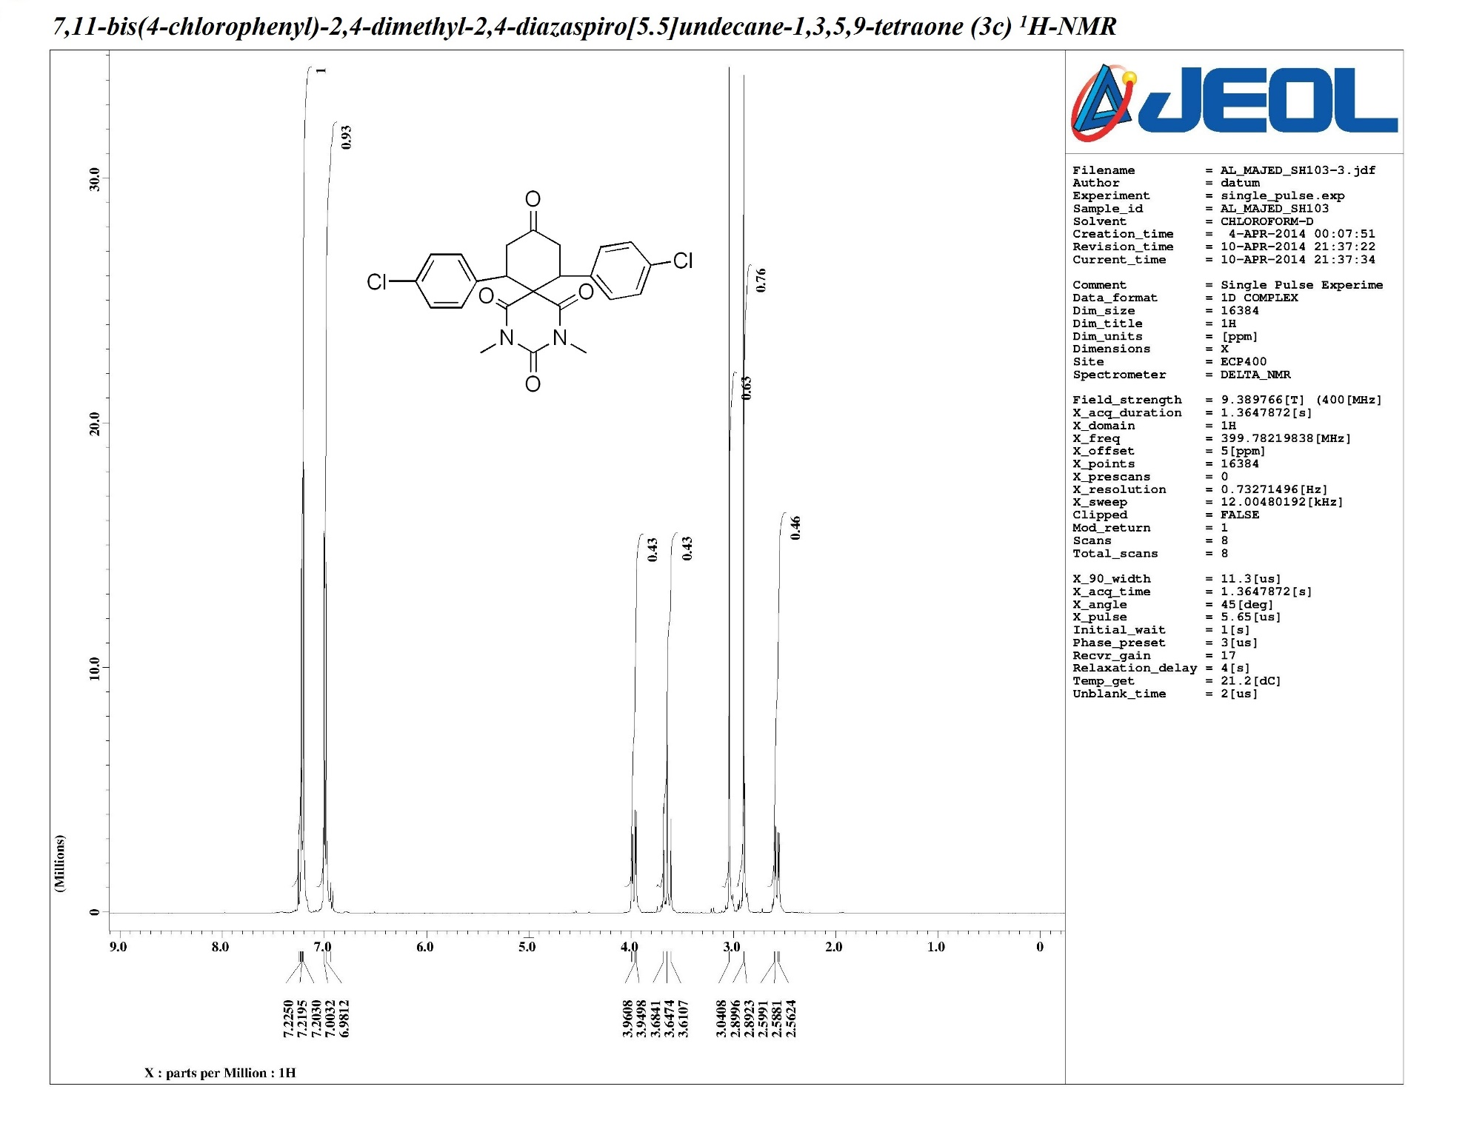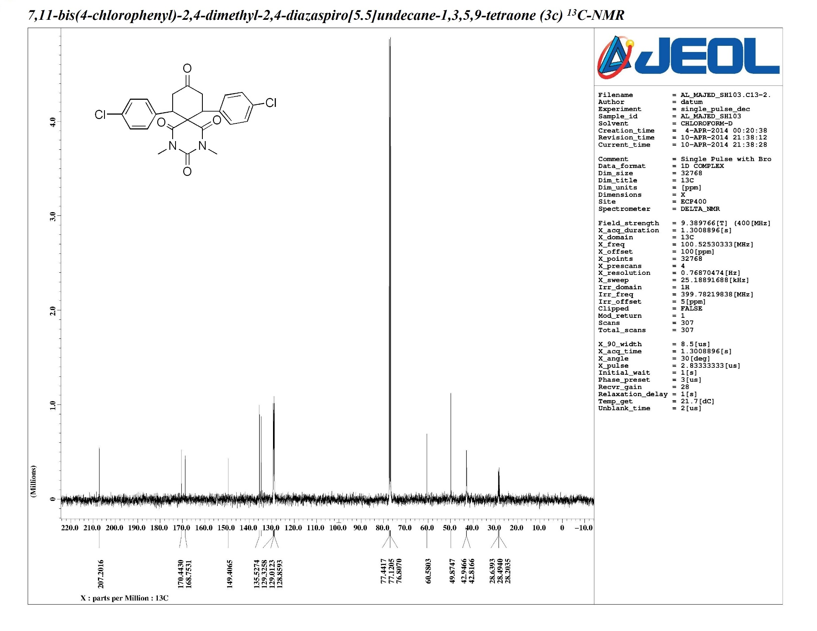
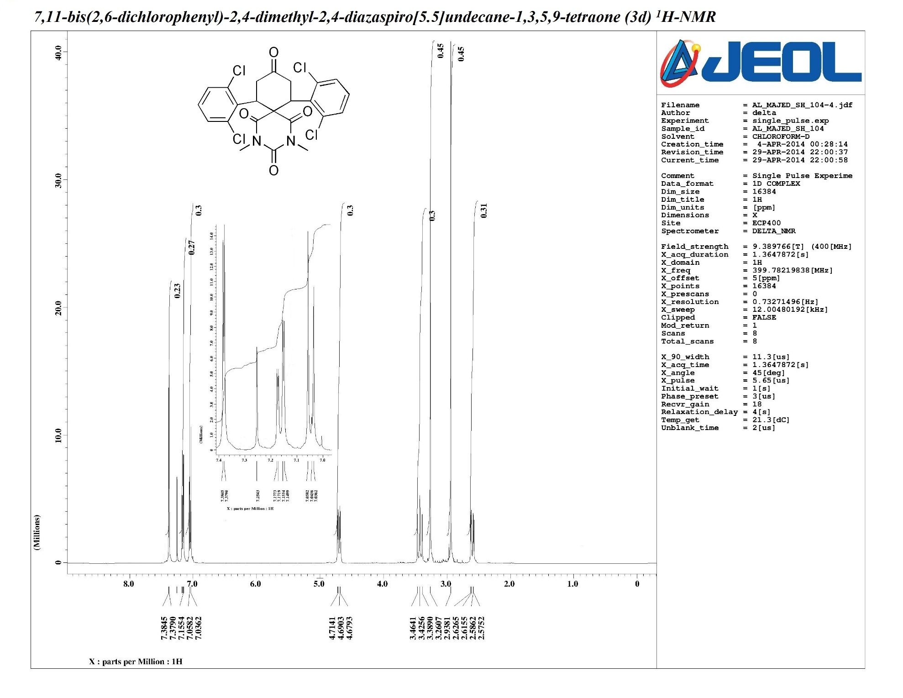
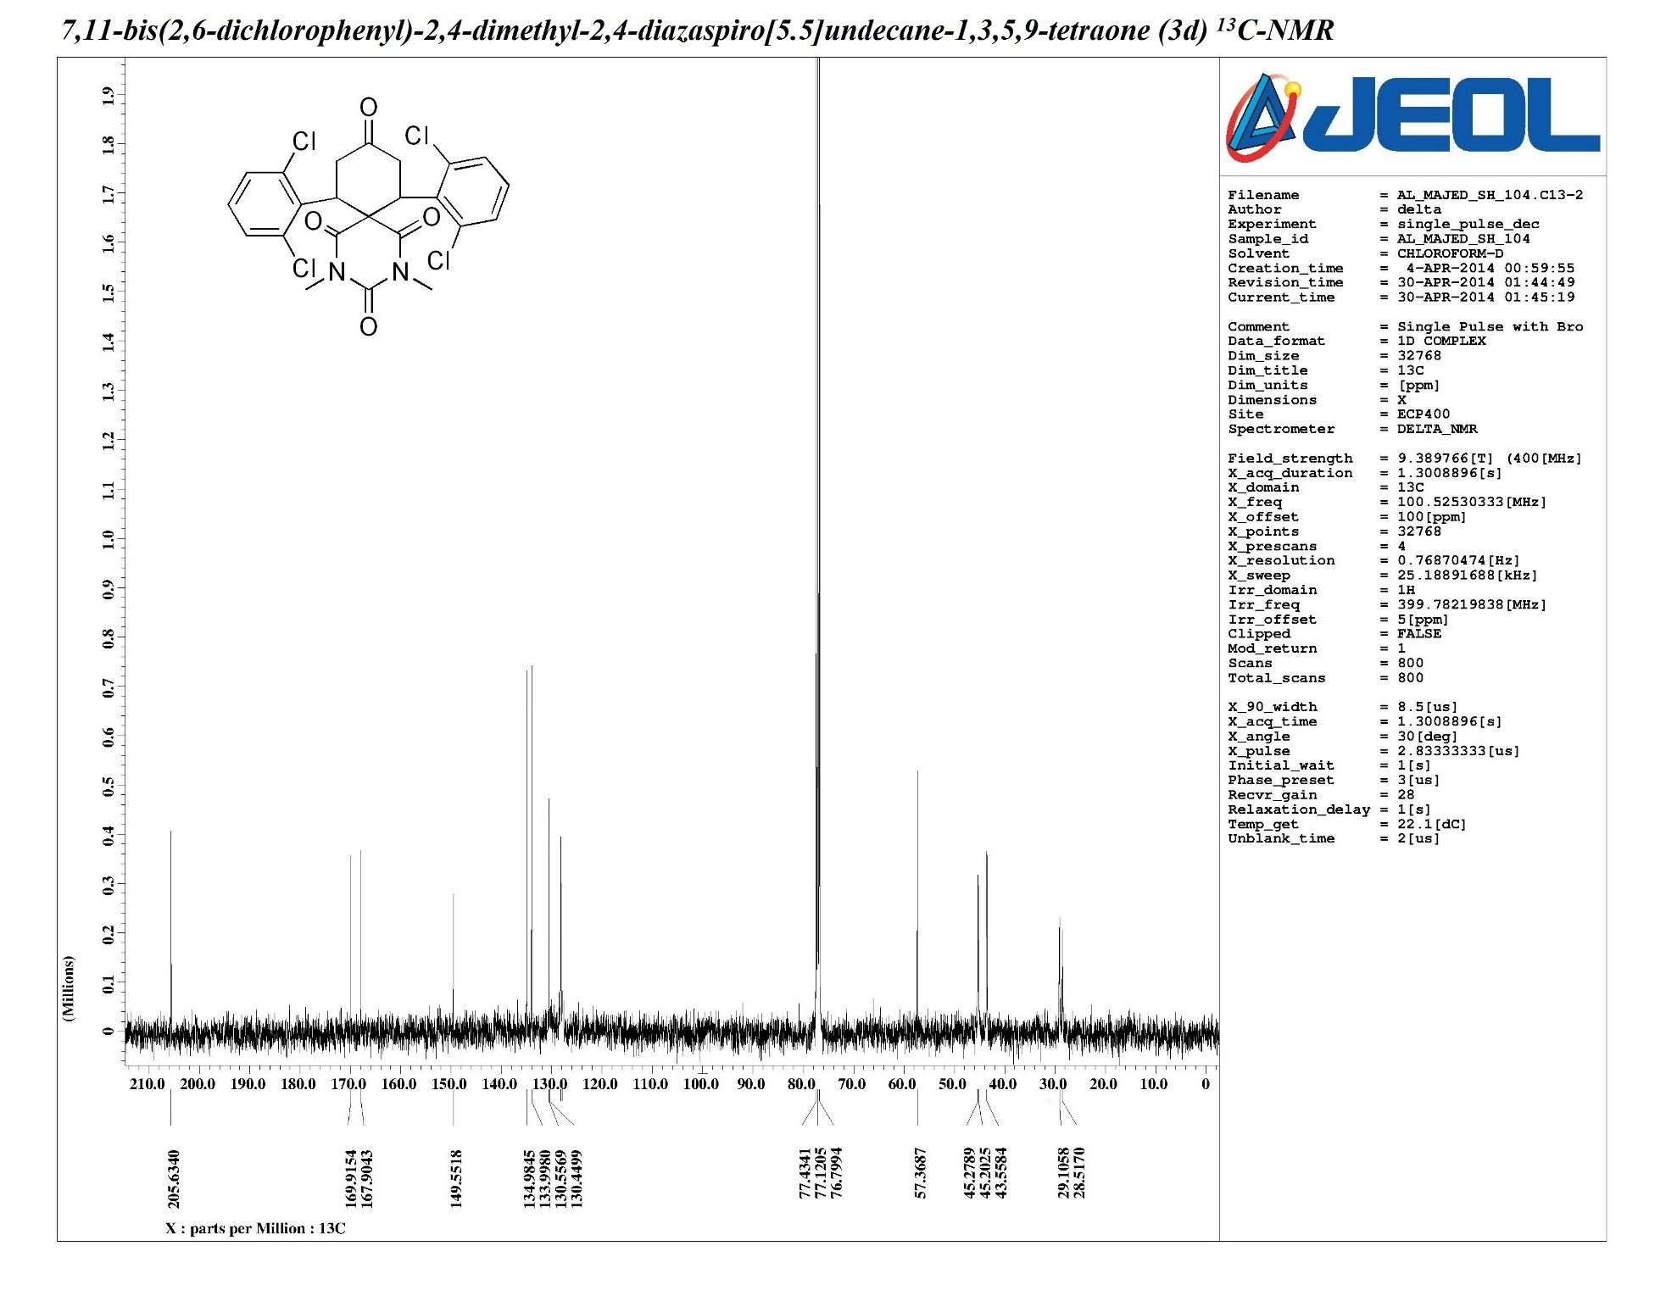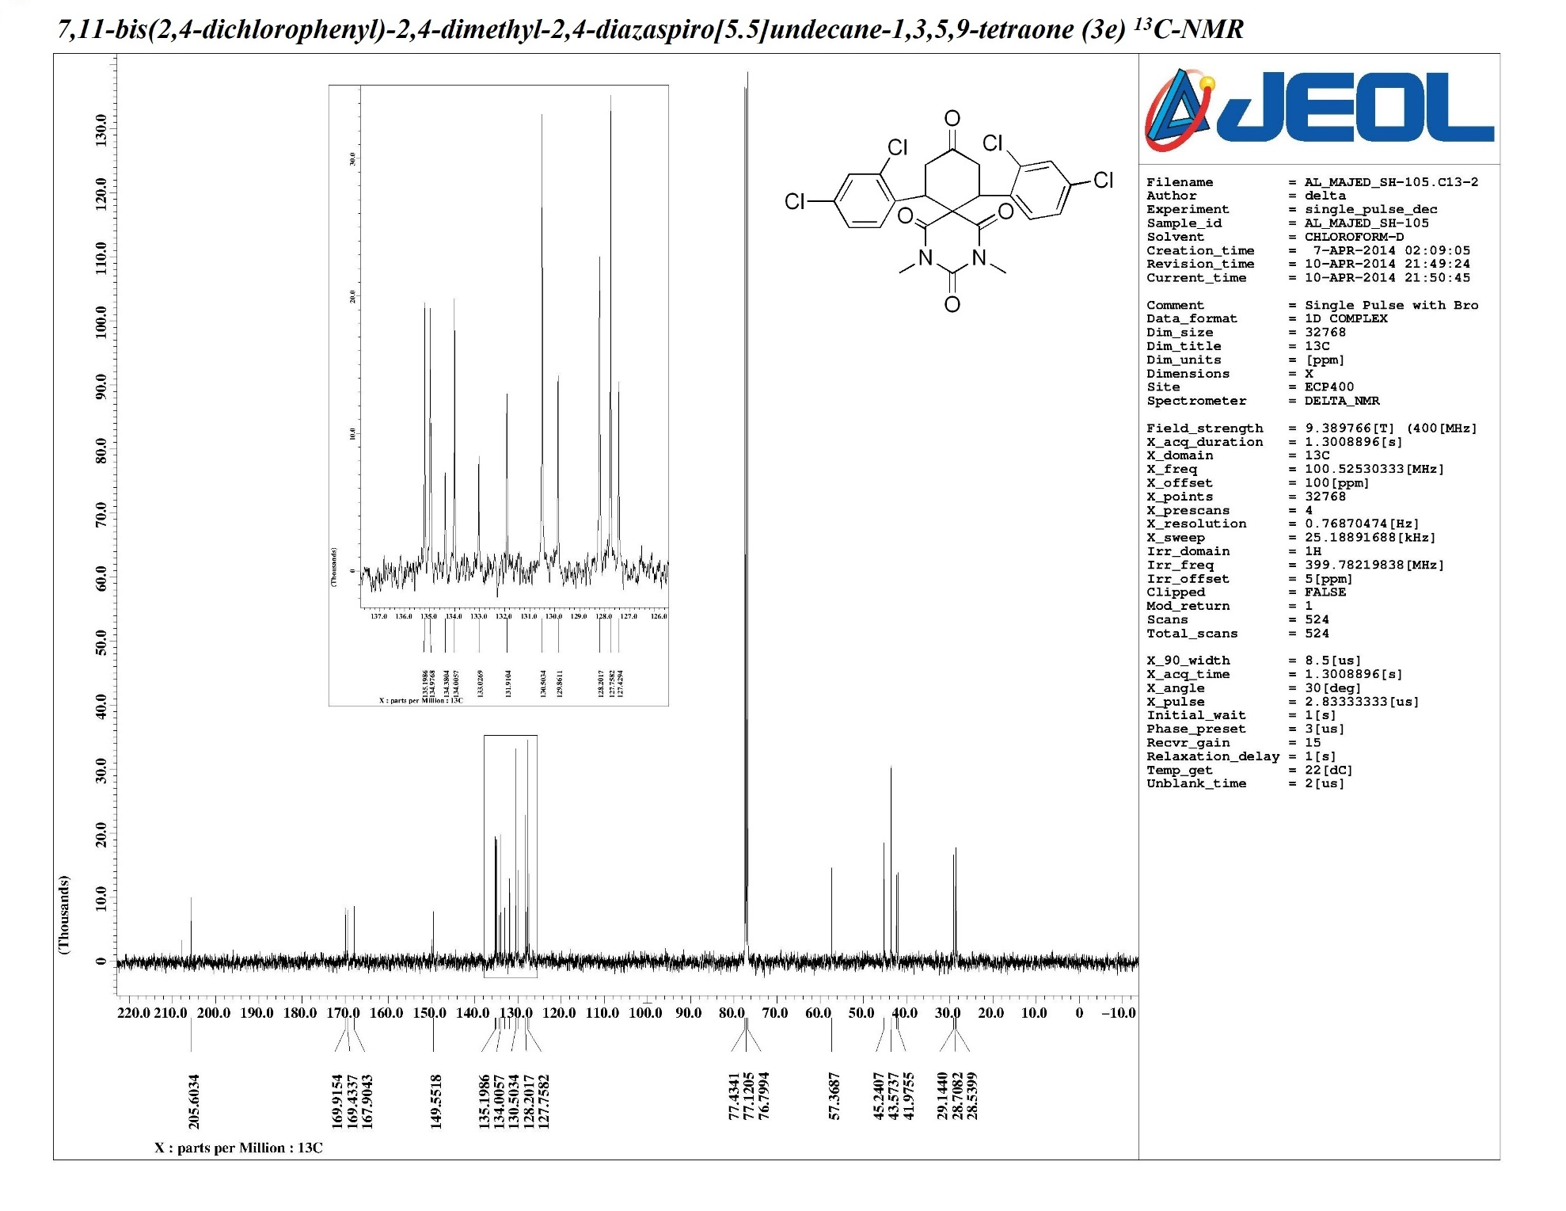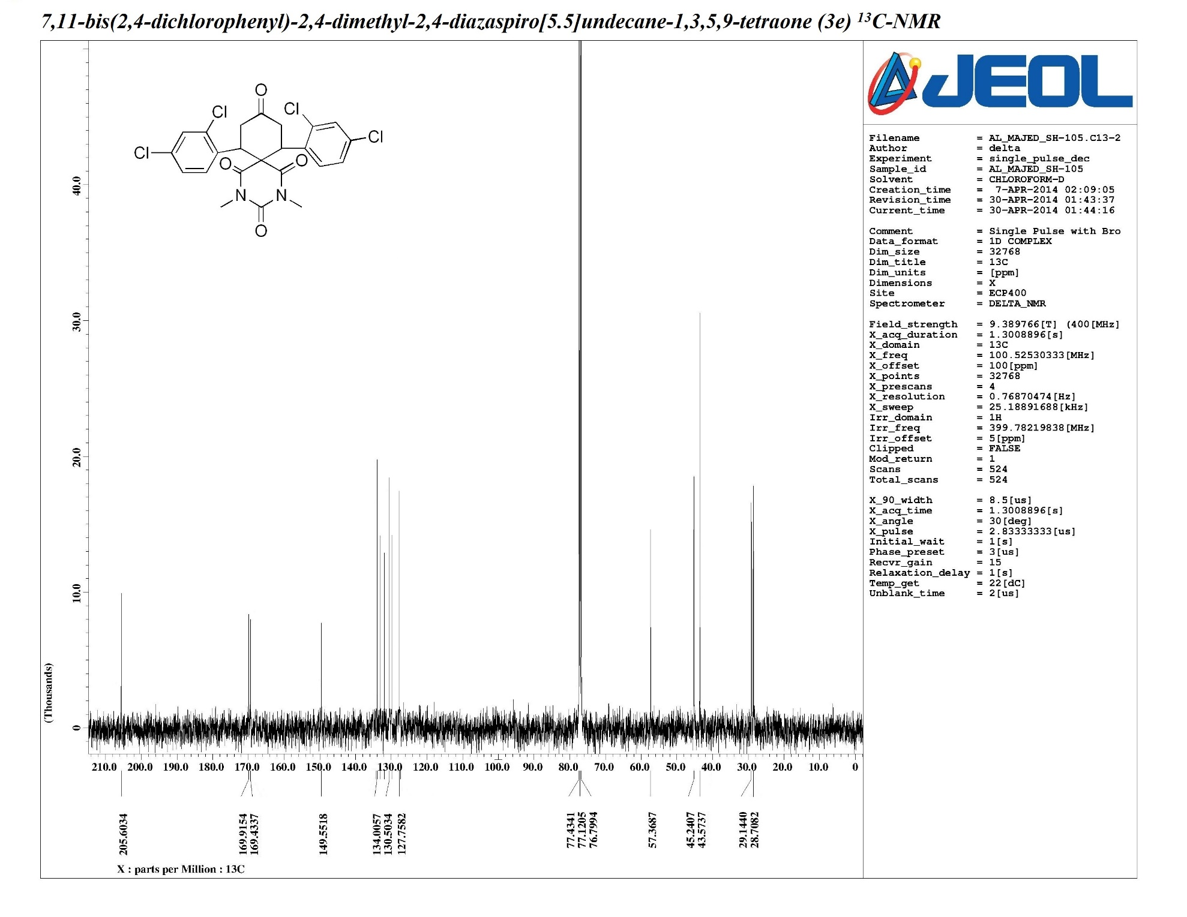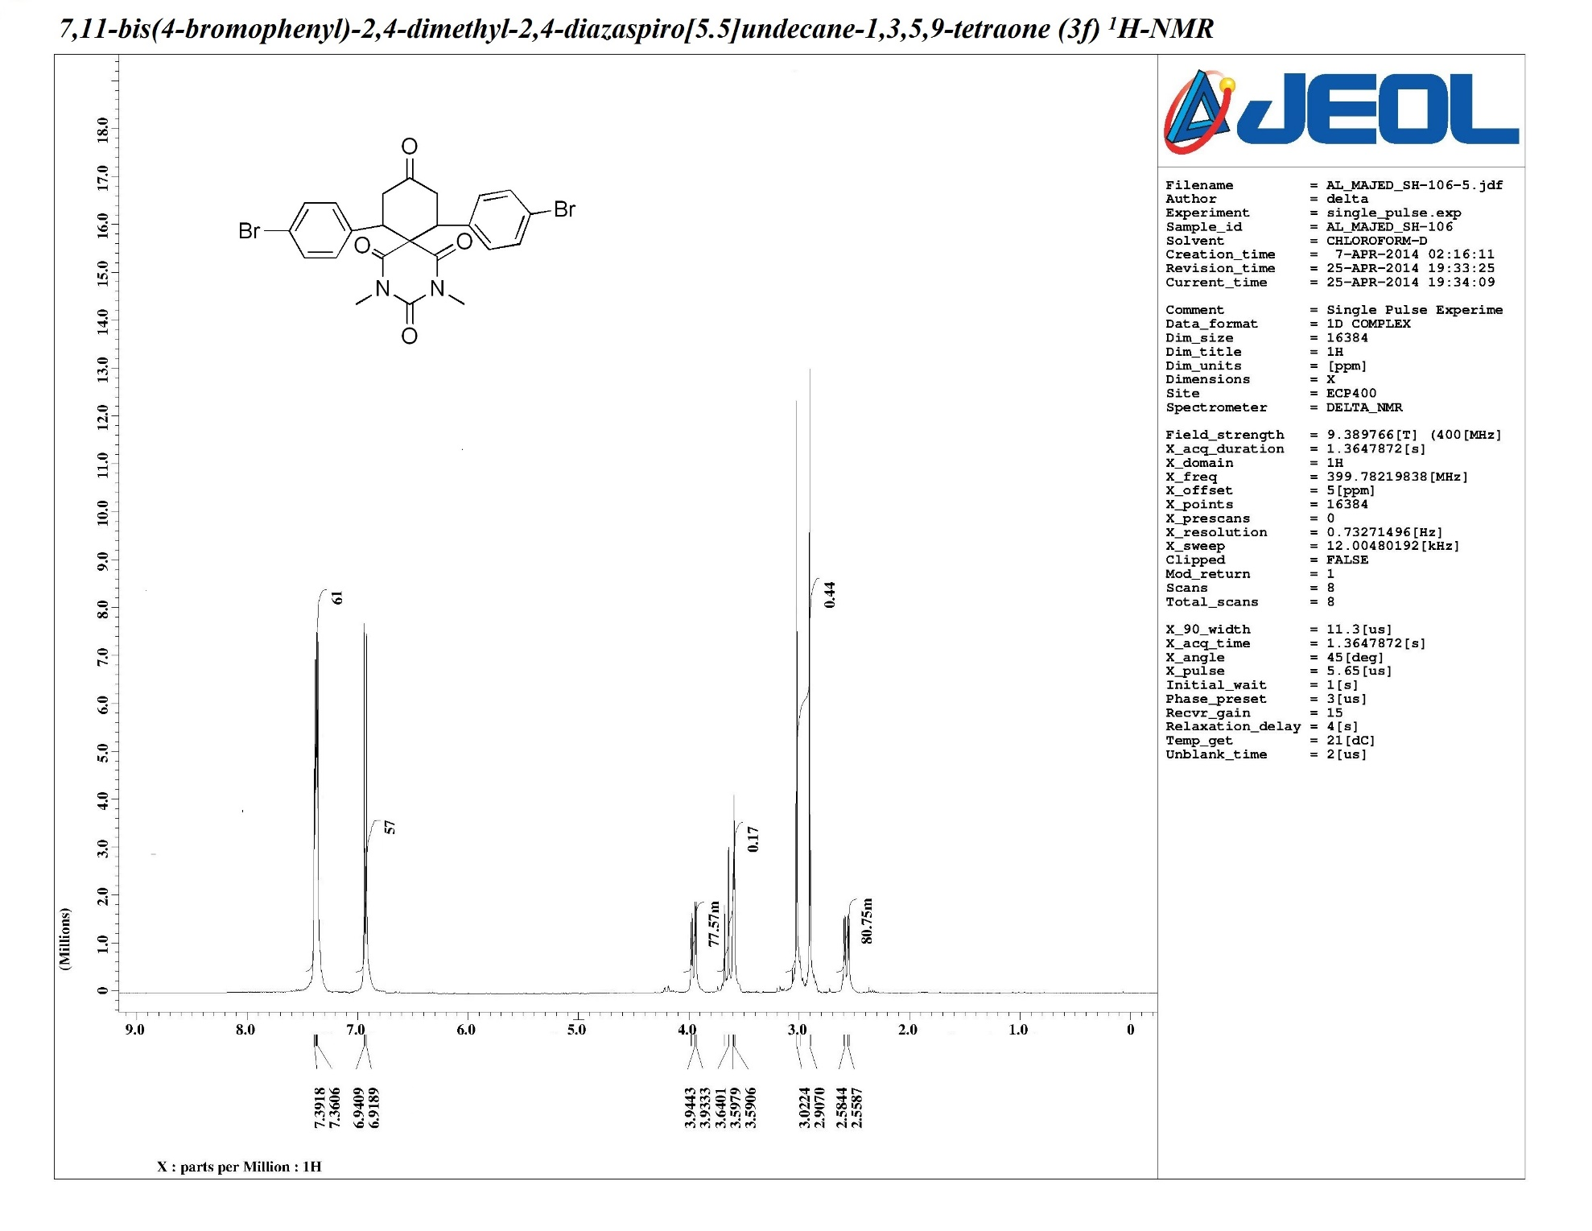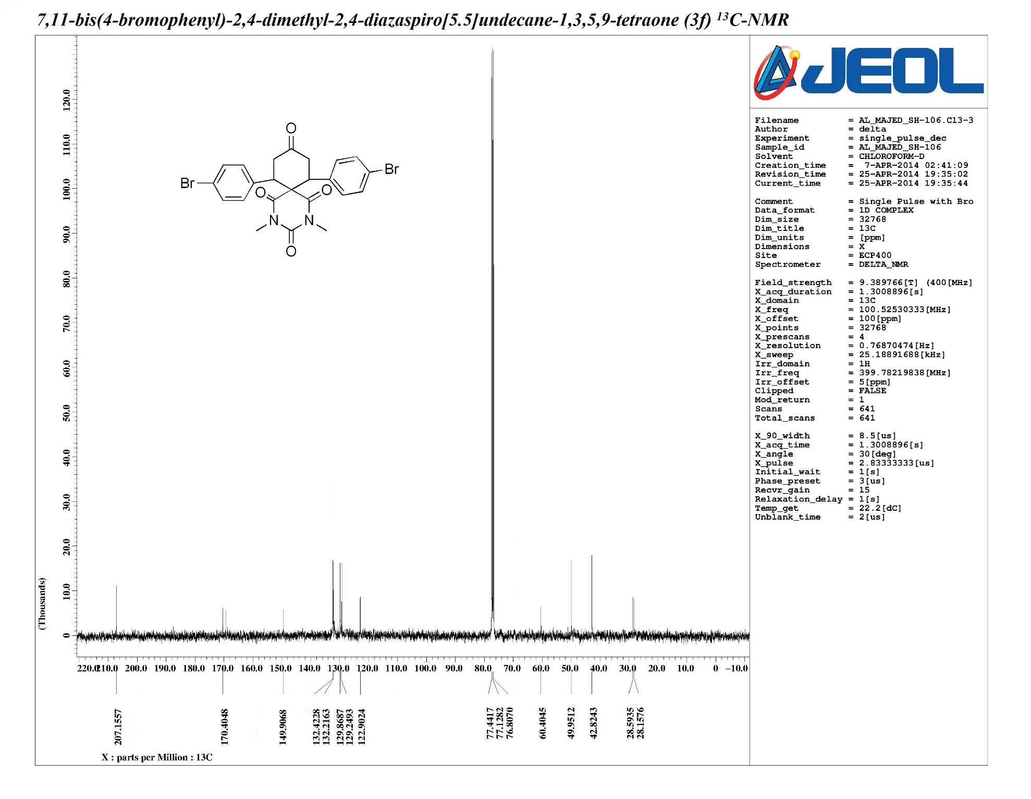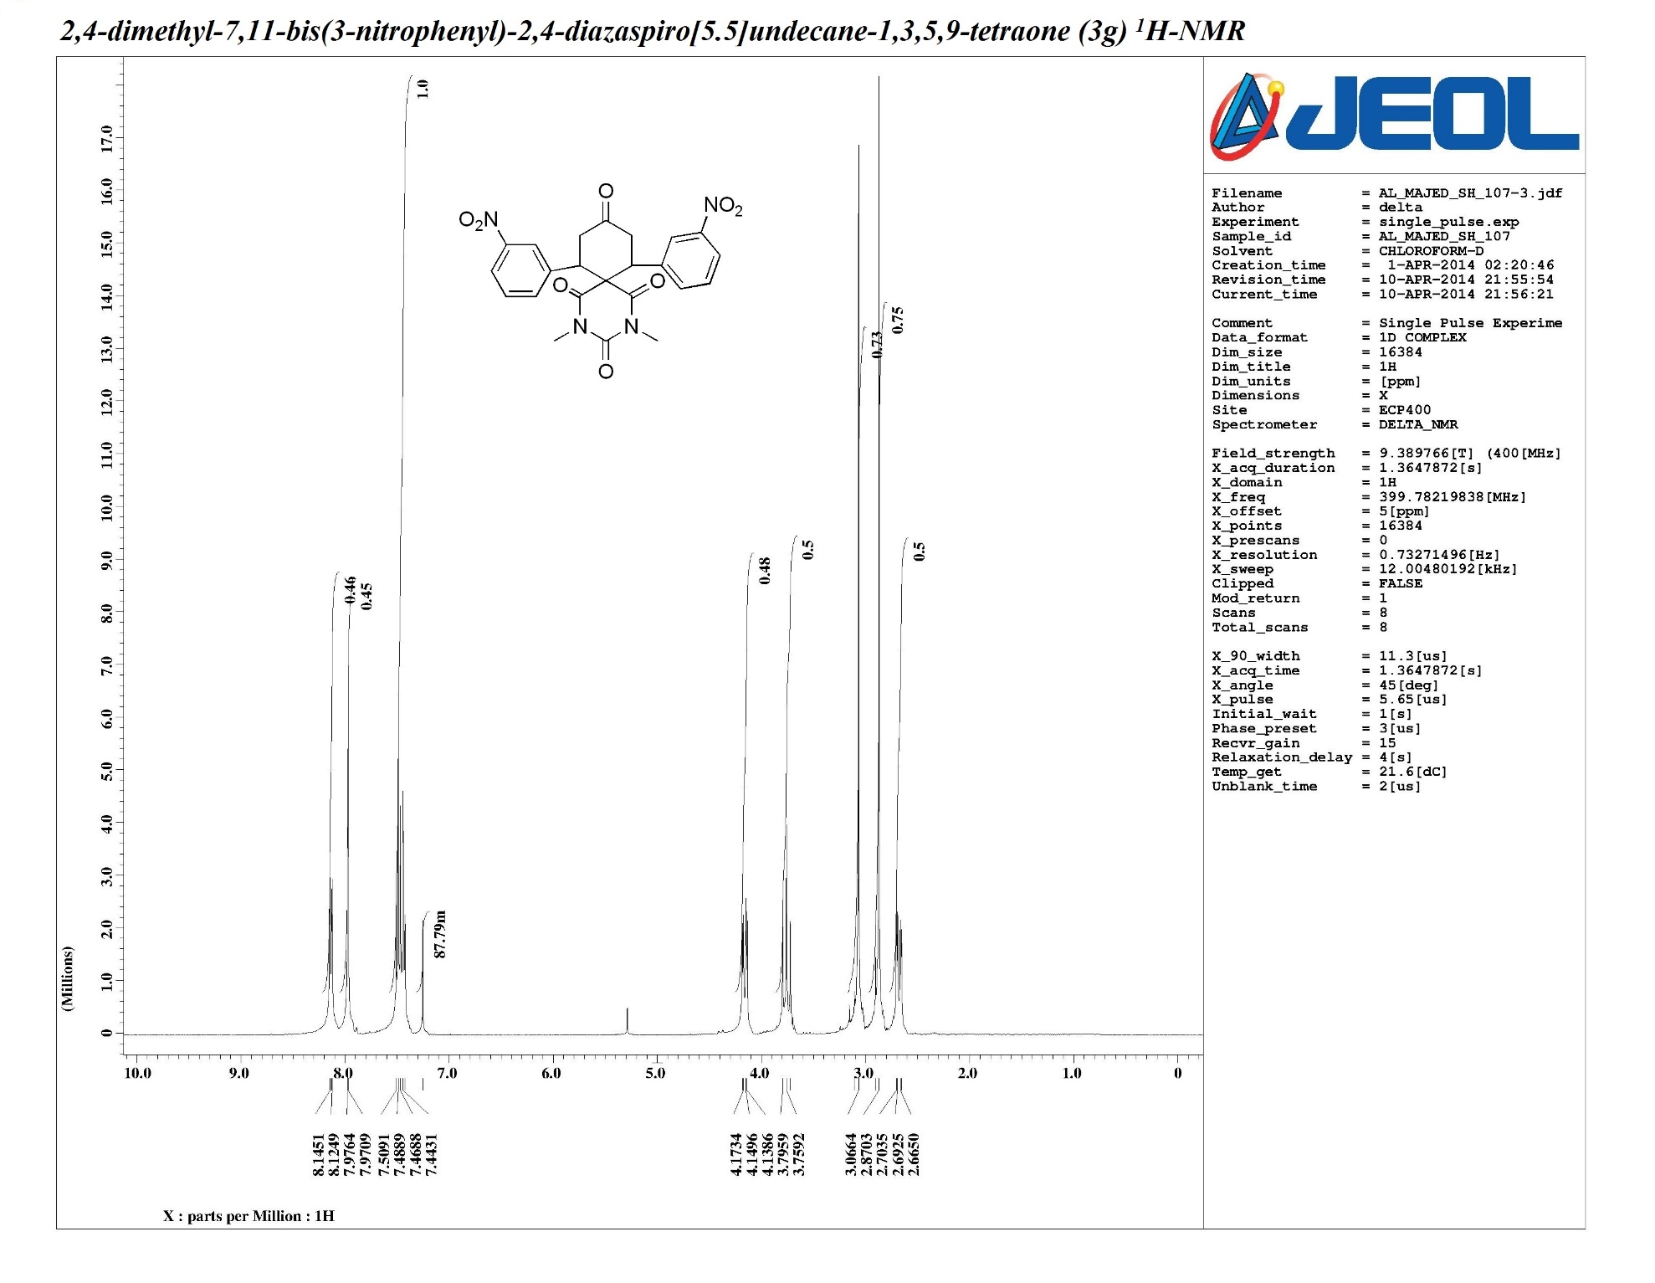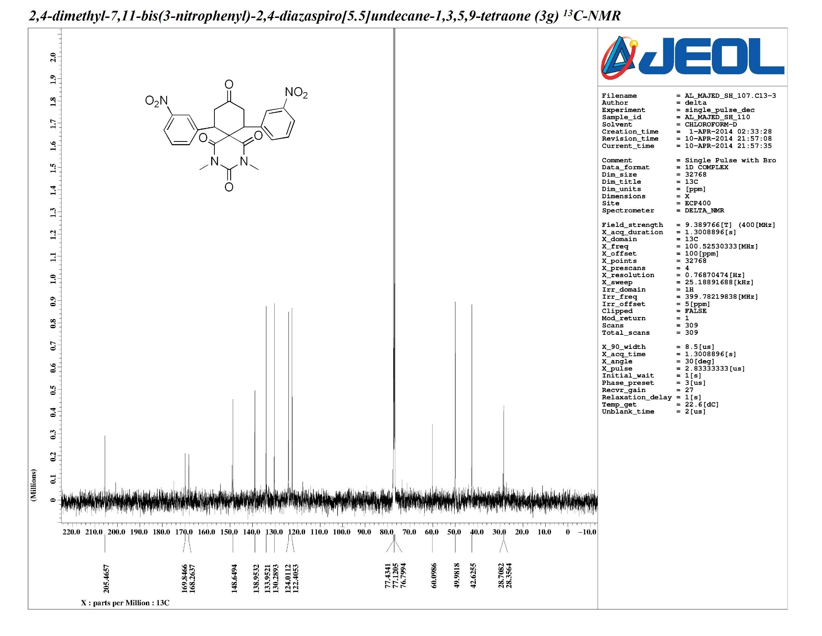
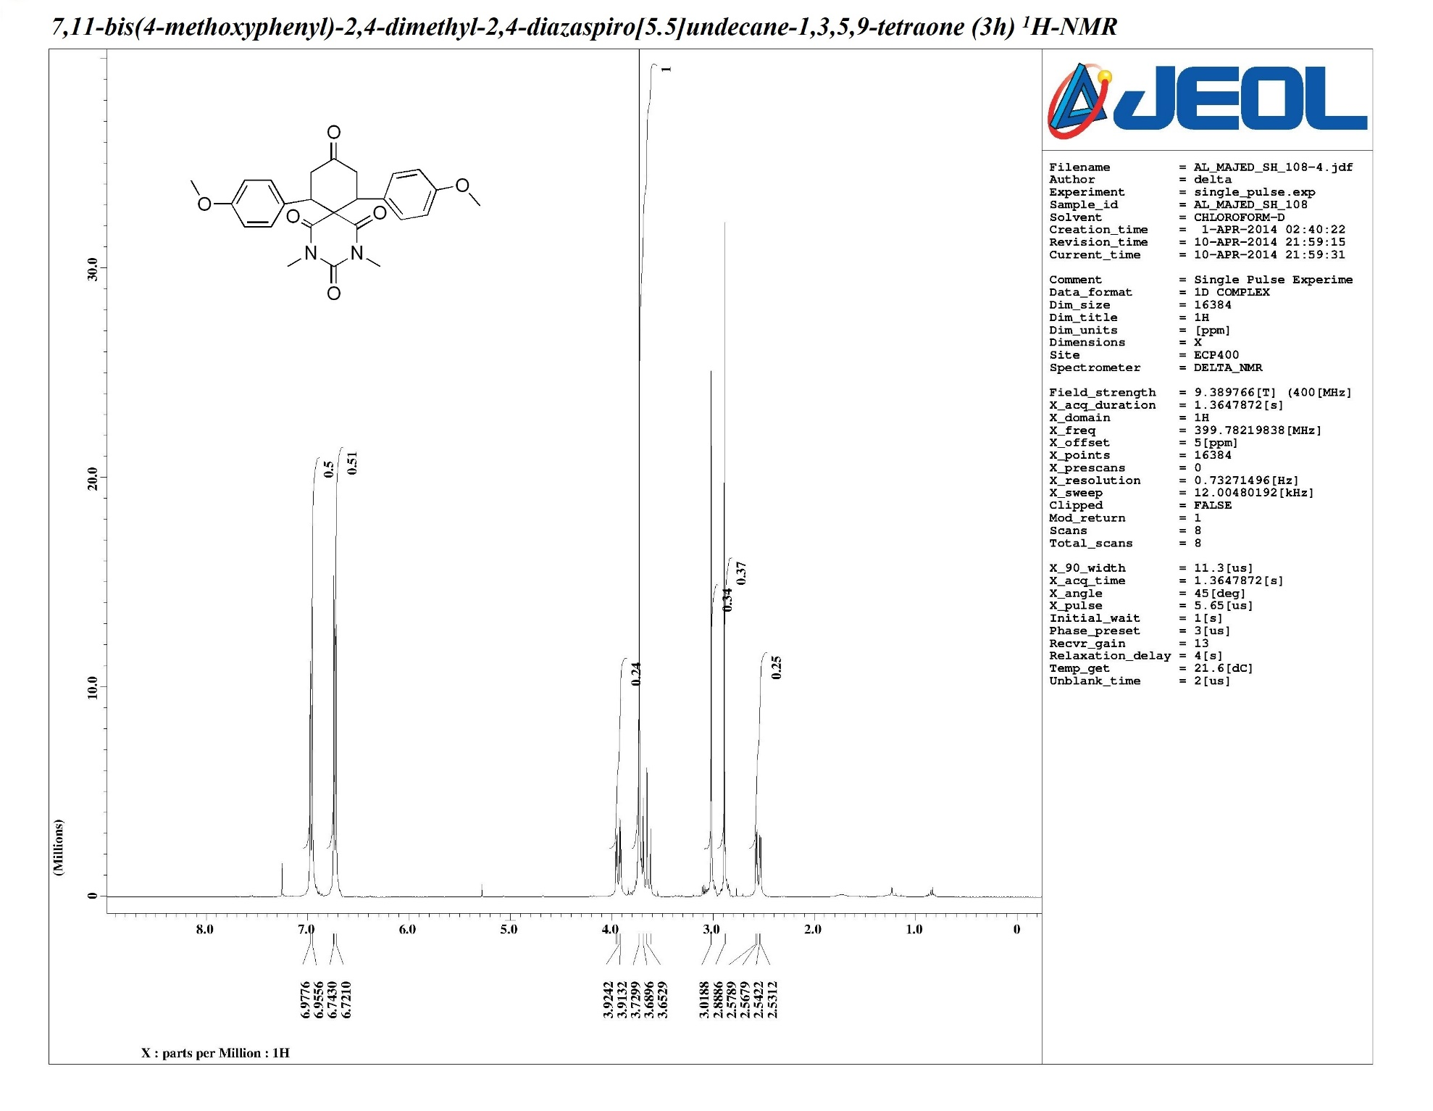
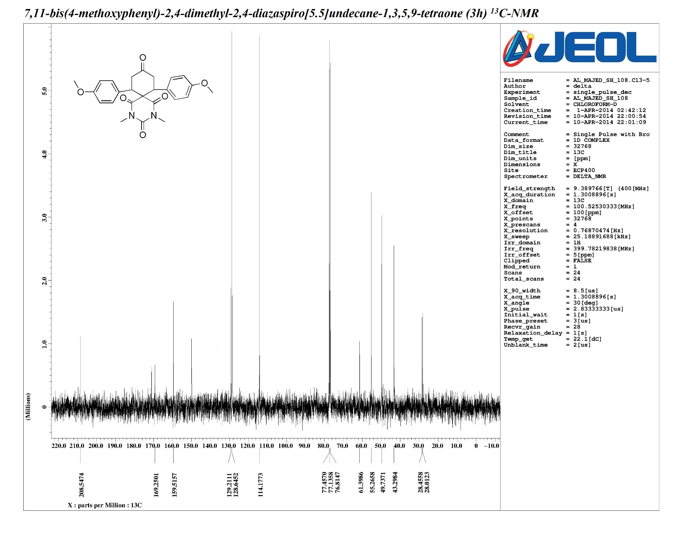
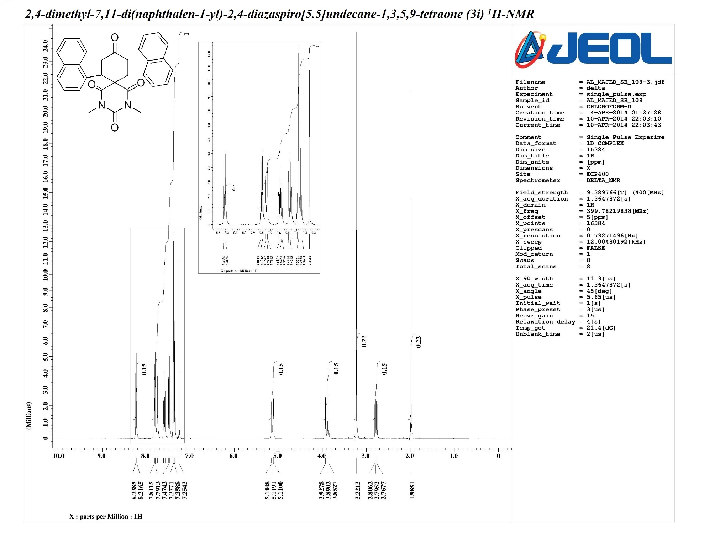
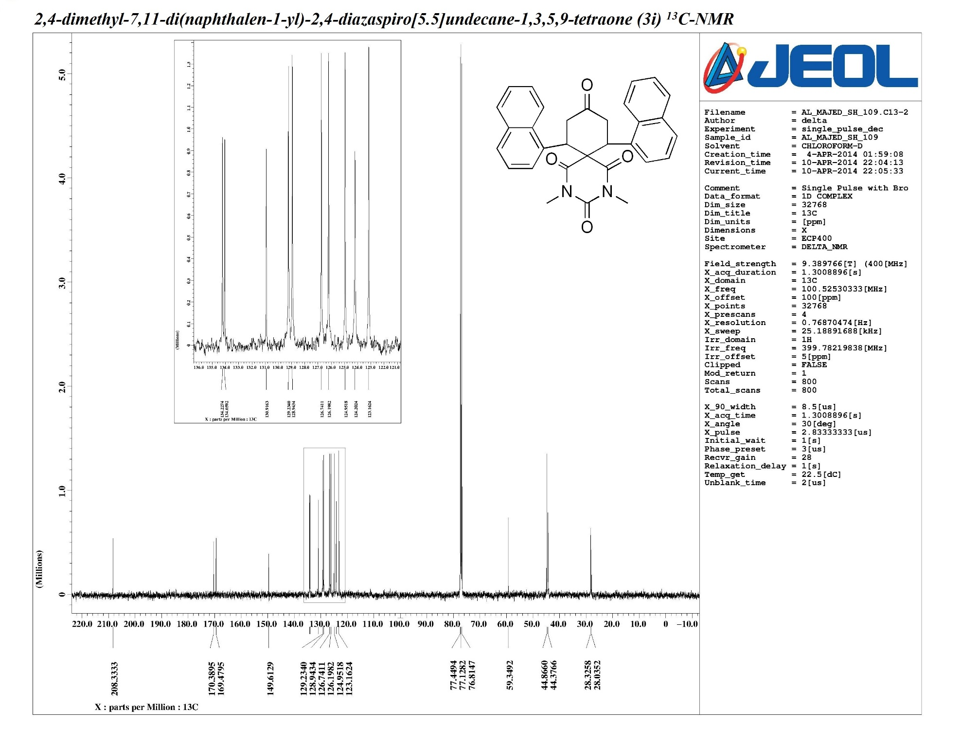
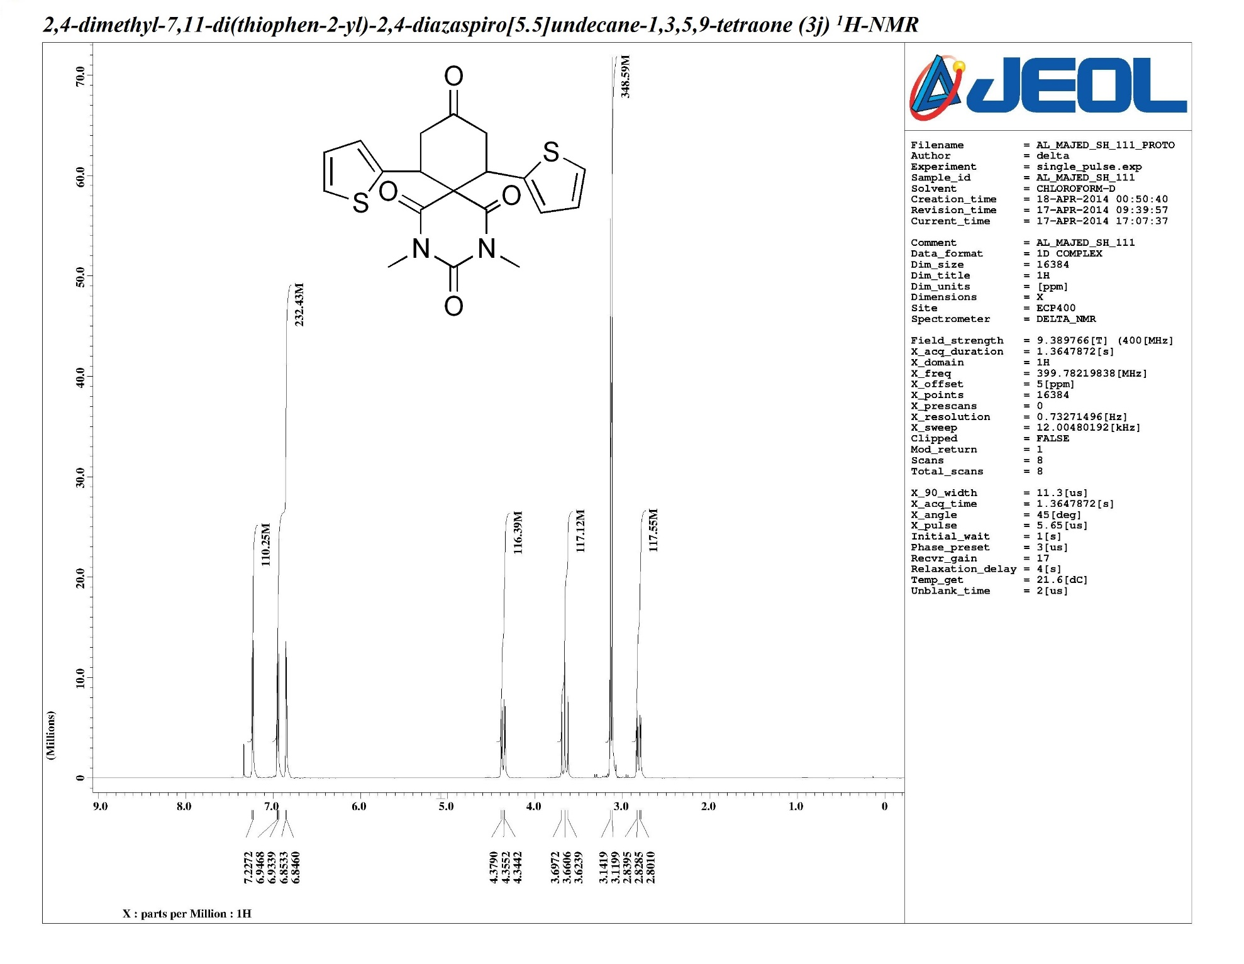
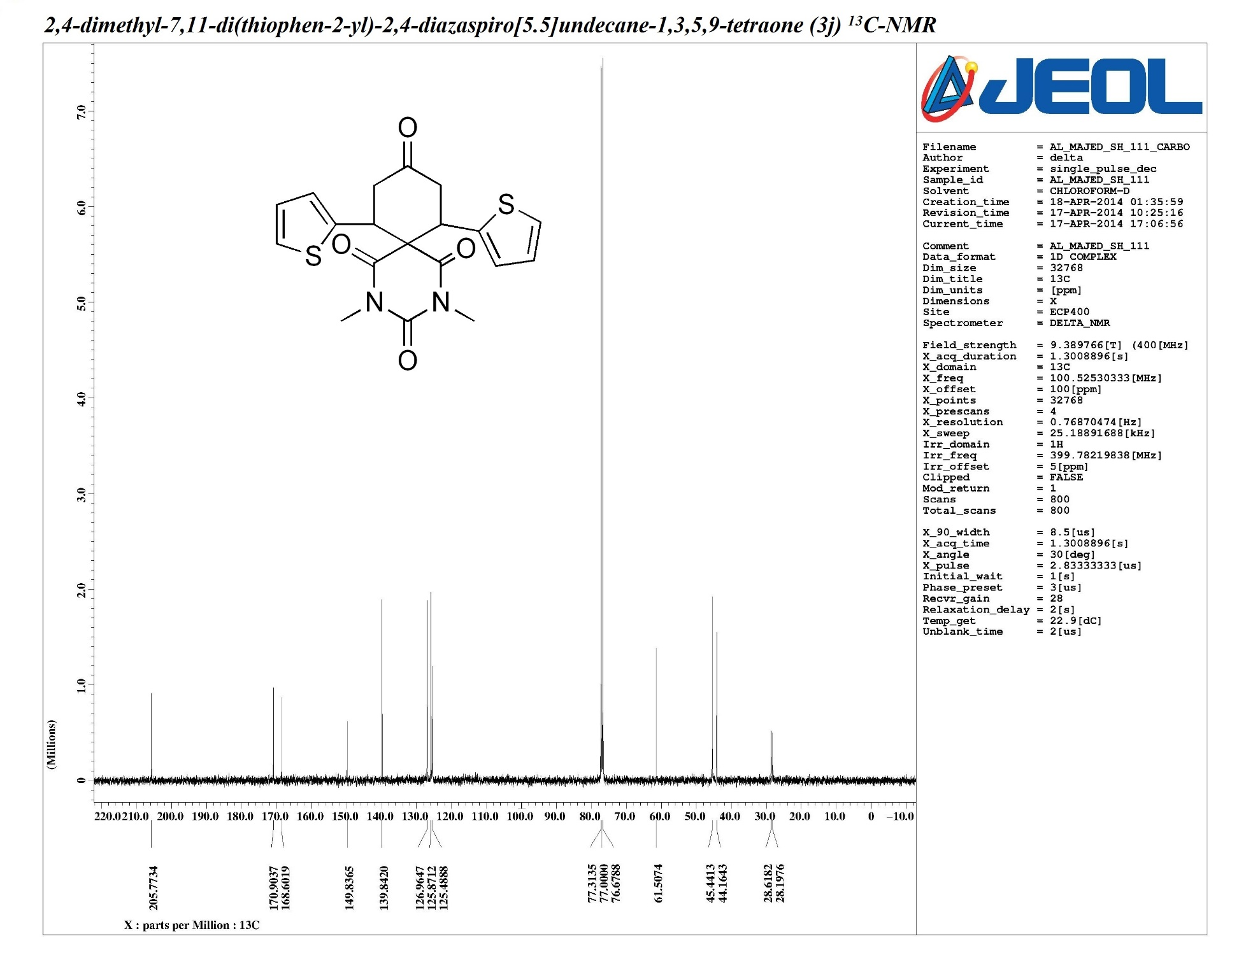
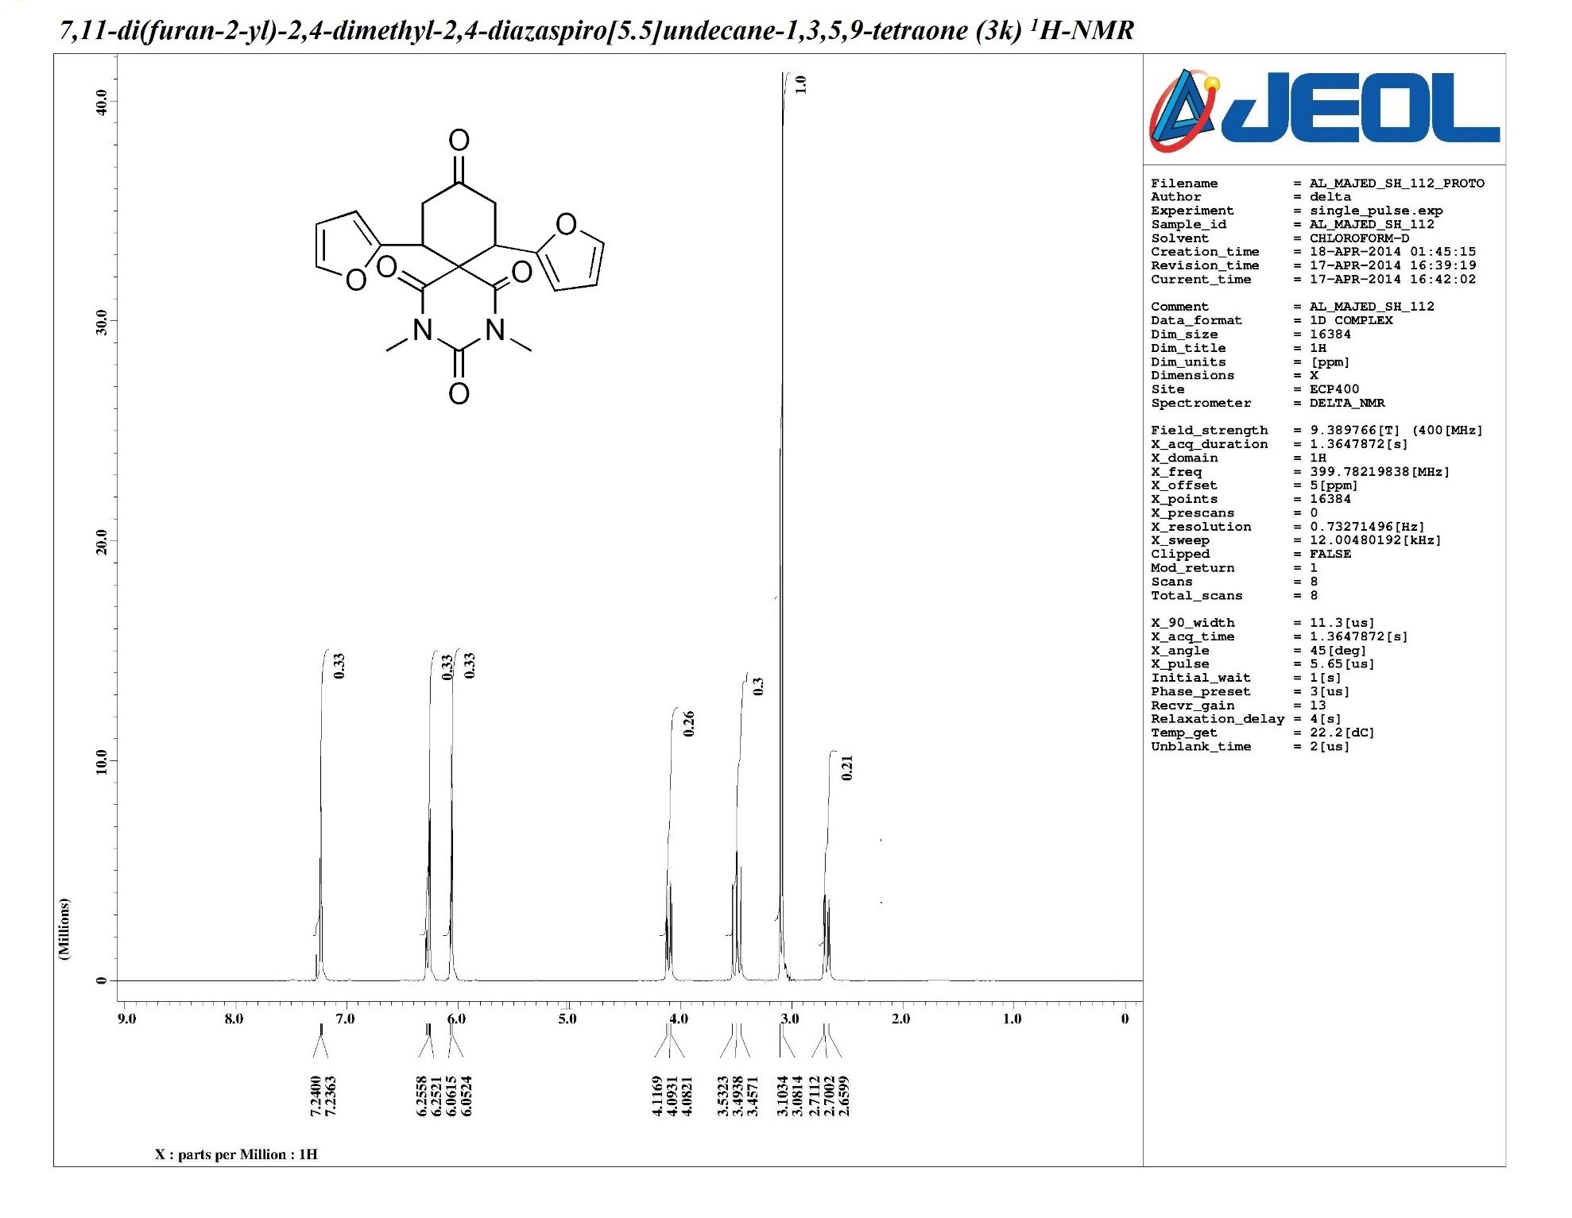
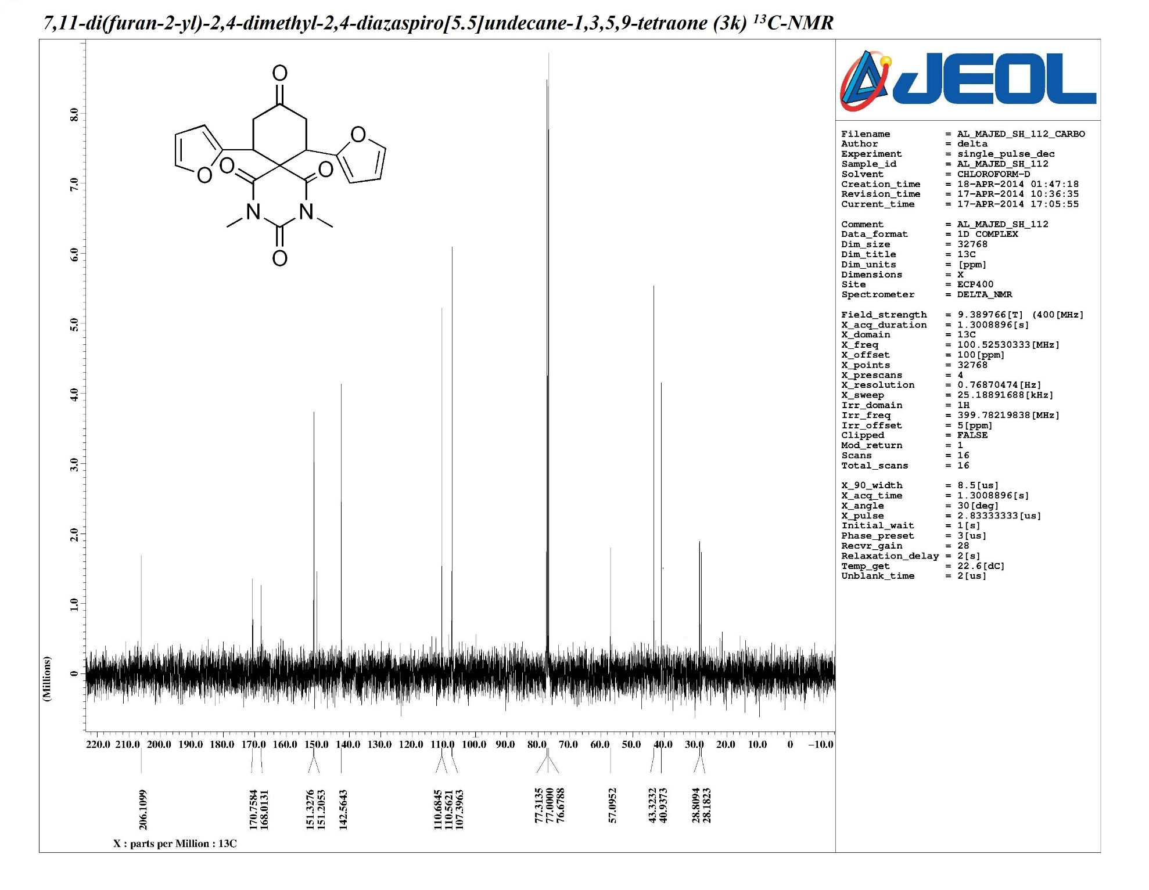
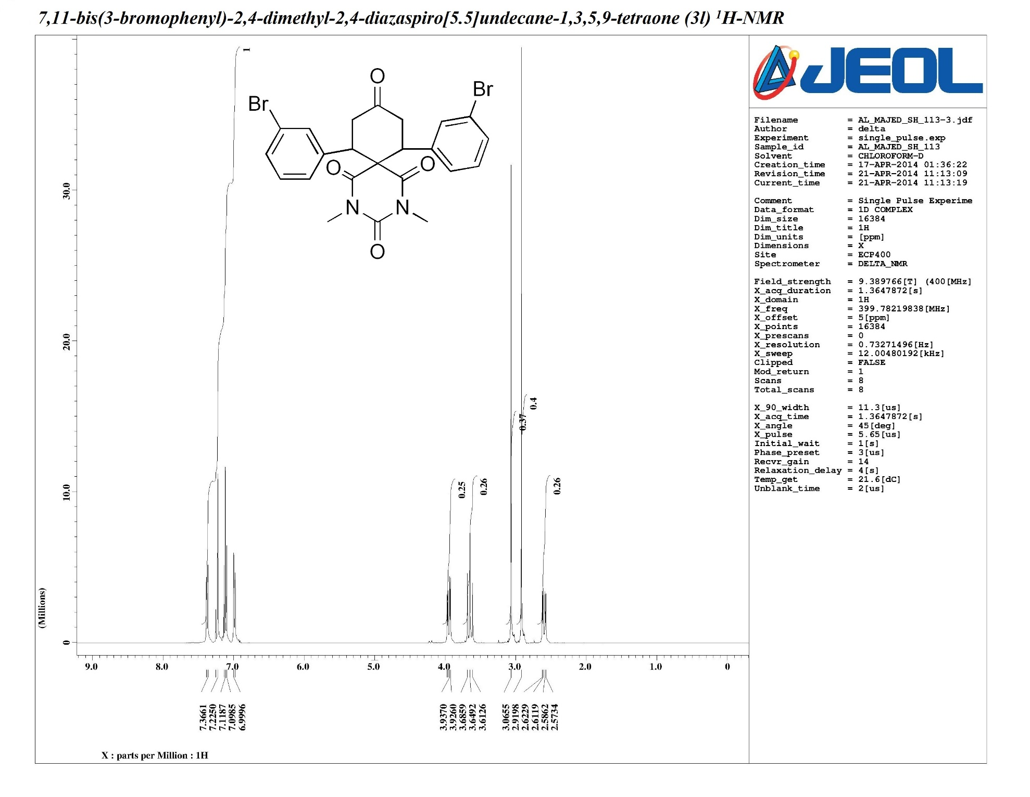
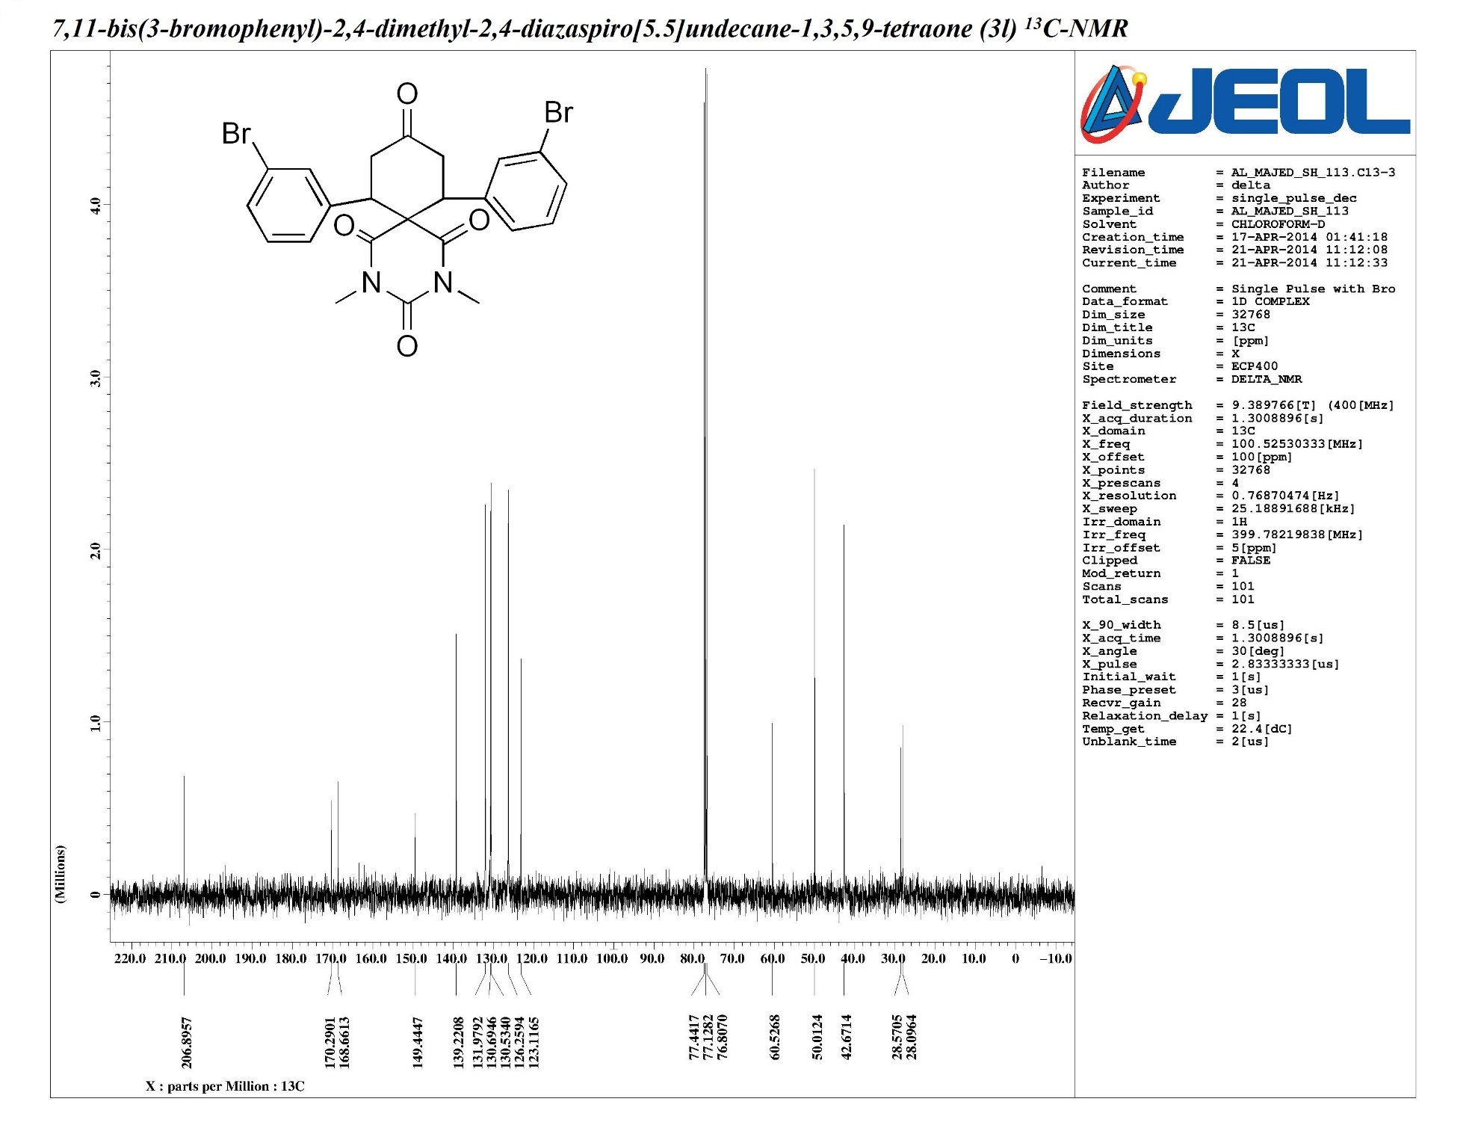
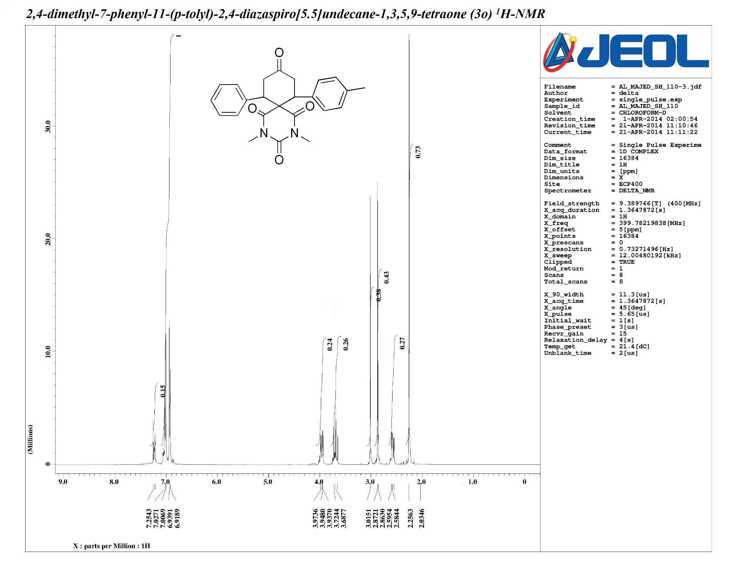
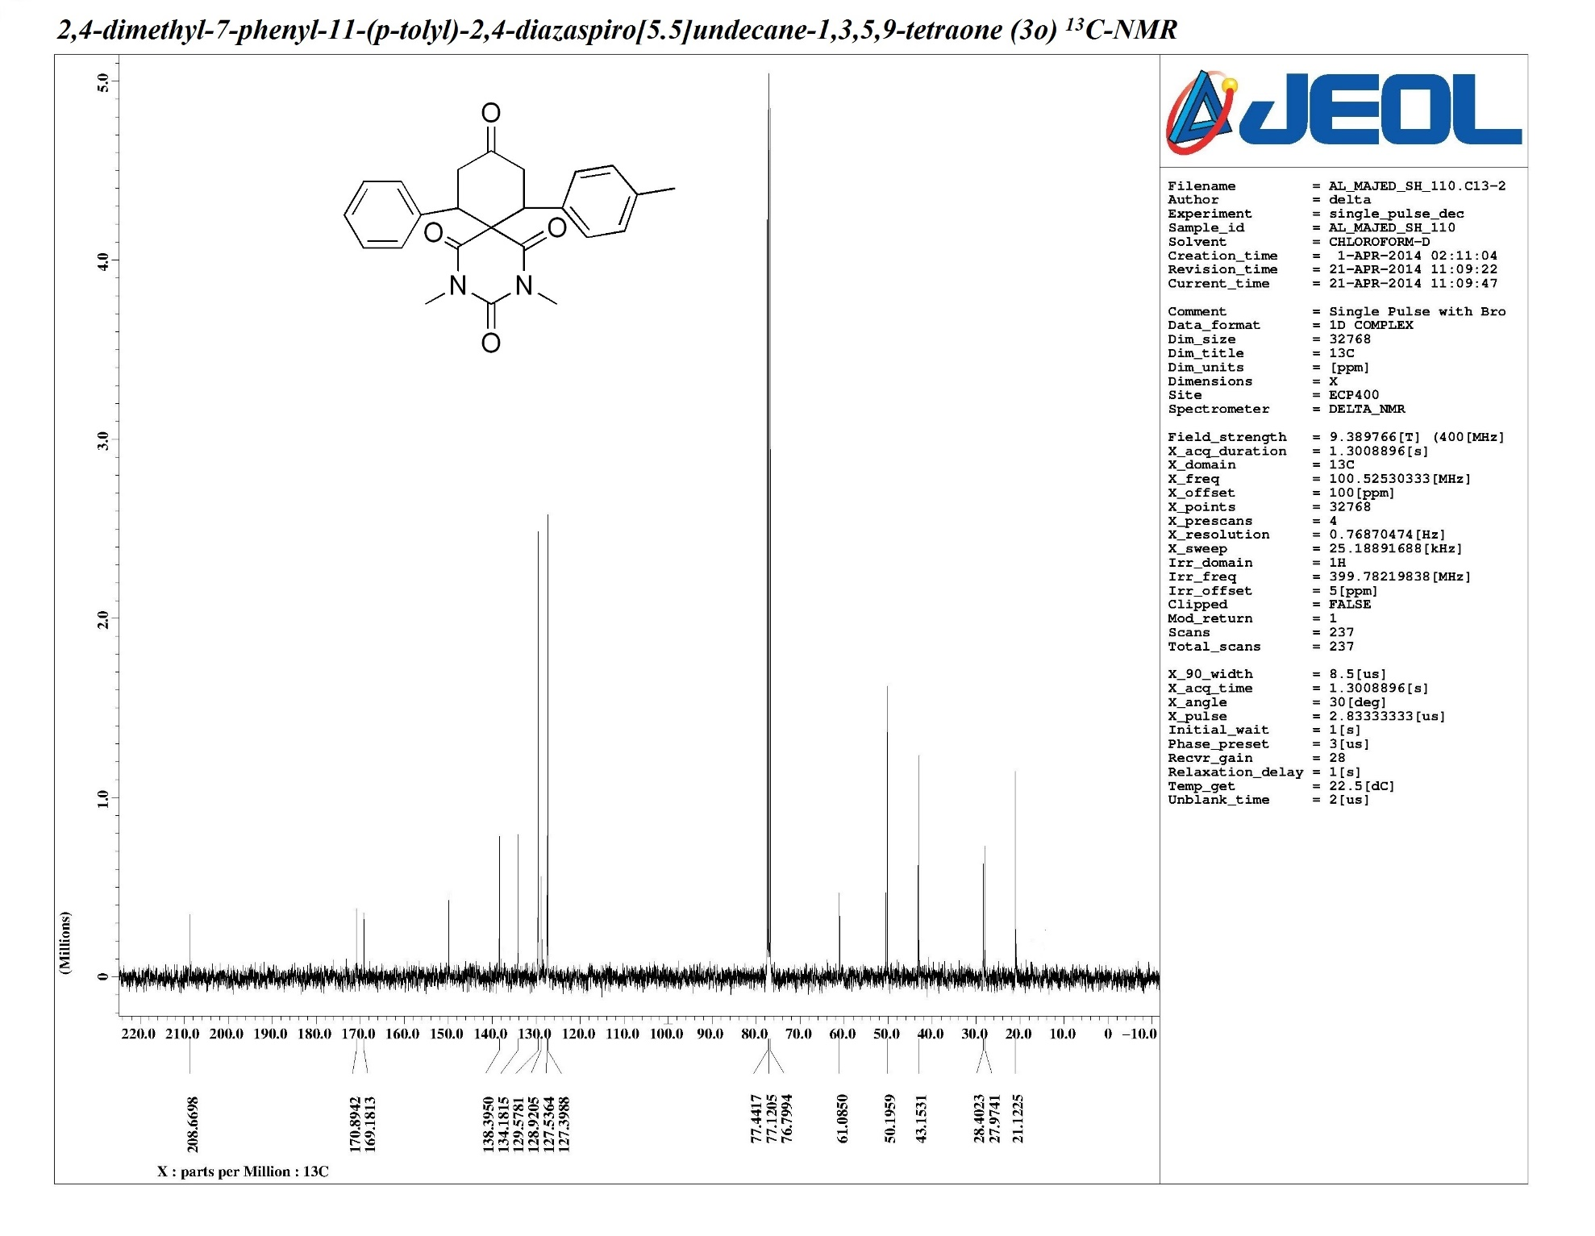
ORTEP diagram and Crystal data of 3a

Figure 1. X-Ray structure of 3a.
(CCDC number -1007513)

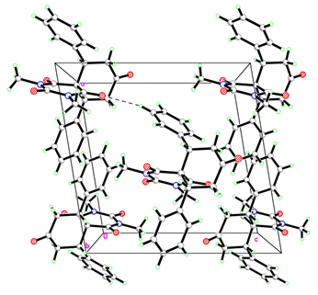

Figure. The crystal packing of compound 3a. Dashed line indicates the intermolecular interactions. The hydrogens do not involved in inter molecular interactions are omitted for clarity.

Crystal data

C₂₃H₂₂N₂O₄ | ?
M_{r} = 390.42 | D_{x} = 1.338 Mg m⁻³
Monoclinic, P2₁/n | Melting point: ? K
Hall symbol: ? | Mo Kα radiation, λ = 0.71073 Å
a = 11.5470 (6) Å | Cell parameters from ? reflections
b = 14.5322 (7) Å | θ = ?°
c = 11.7043 (6) Å | µ = 0.09 mm⁻¹
β = 99.3103 (15)° | T = 293 K
V = 1938.15 (17) Å³ | ?
Z = 4 | 0.41 × 0.29 × 0.20 mm
F(000) = 824

Data collection

?  diffractometer | R_{int} = 0.024
Radiation source: ? | θ_{max} = 30.6°, θ_{min} = 2.3°
? | h = −1616
? | k = −2020
107047 measured reflections | l = −1616
5959 independent reflections | Standard reflections: ?
5461 reflections with I > 2σ(I)

Refinement

Refinement on F² | Secondary atom site location: ?
Least-squares matrix: full | Hydrogen site location: inferred from neighbouring sites
R[F² > 2σ(F²)] = 0.041 | H-atom parameters constrained
wR(F²) = 0.120 | w = 1/[σ²(F_{o}²) + (0.0685P)² + 0.6594P]  where P = (F_{o}² + 2F_{c}²)/3
S = 1.06 | (Δ/σ)_{max} < 0.001
5959 reflections | Δρ_{max} = 0.49 e Å⁻³
264 parameters | Δρ_{min} = −0.28 e Å⁻³
0 restraints | Extinction correction: none
? constraints | Extinction coefficient: ?
Primary atom site location: ?

Fractional atomic coordinates and isotropic or equivalent isotropic displacement parameters (Å²)

 | x | y | z | U_{iso}*/U_{eq}
O1 | 0.54702 (6) | 0.08830 (5) | 0.61866 (6) | 0.01808 (14)
O2 | 0.63731 (8) | 0.39115 (5) | 0.64957 (7) | 0.02955 (18)
O3 | 0.64988 (6) | 0.25756 (5) | 0.30410 (6) | 0.01913 (14)
O4 | 0.50282 (7) | 0.00292 (6) | 0.14114 (6) | 0.02810 (17)
N1 | 0.58625 (7) | 0.24061 (5) | 0.63319 (6) | 0.01568 (15)
N2 | 0.65638 (8) | 0.32021 (6) | 0.48080 (7) | 0.02128 (17)
C1 | 0.57328 (7) | 0.15880 (6) | 0.57306 (7) | 0.01346 (15)
C2 | 0.62639 (9) | 0.32187 (6) | 0.59131 (8) | 0.01921 (17)
C3 | 0.63189 (8) | 0.24892 (6) | 0.40332 (7) | 0.01474 (16)
C4 | 0.58292 (7) | 0.16038 (6) | 0.44459 (7) | 0.01251 (15)
C5 | 0.65851 (7) | 0.07539 (6) | 0.42081 (7) | 0.01389 (15)
H5A | 0.6235 | 0.0221 | 0.4537 | 0.017*
C6 | 0.65287 (8) | 0.05448 (6) | 0.29129 (8) | 0.01806 (17)
H6A | 0.7006 | 0.0993 | 0.2588 | 0.022*
H6B | 0.6871 | −0.0057 | 0.2835 | 0.022*
C7 | 0.53065 (8) | 0.05576 (6) | 0.22118 (8) | 0.01847 (17)
C8 | 0.44696 (8) | 0.12928 (7) | 0.25014 (8) | 0.01834 (17)
H8A | 0.3675 | 0.1117 | 0.2174 | 0.022*
H8B | 0.4645 | 0.1866 | 0.2141 | 0.022*
C9 | 0.45336 (7) | 0.14522 (6) | 0.38080 (7) | 0.01389 (15)
H9A | 0.4262 | 0.0881 | 0.4122 | 0.017*
C10 | 0.37253 (7) | 0.22078 (6) | 0.41119 (7) | 0.01447 (16)
C11 | 0.36067 (8) | 0.30506 (6) | 0.35278 (8) | 0.01979 (18)
H11A | 0.3996 | 0.3146 | 0.2902 | 0.024*
C12 | 0.29112 (9) | 0.37486 (7) | 0.38731 (9) | 0.02316 (19)
H12A | 0.2836 | 0.4304 | 0.3474 | 0.028*
C13 | 0.23283 (9) | 0.36181 (6) | 0.48134 (9) | 0.02094 (18)
H13A | 0.1865 | 0.4085 | 0.5043 | 0.025*
C14 | 0.24438 (8) | 0.27858 (6) | 0.54069 (8) | 0.01755 (17)
H14A | 0.2064 | 0.2697 | 0.6041 | 0.021*
C15 | 0.31289 (7) | 0.20843 (6) | 0.50512 (7) | 0.01534 (16)
H15A | 0.3190 | 0.1526 | 0.5444 | 0.018*
C16 | 0.78350 (7) | 0.08238 (6) | 0.48522 (7) | 0.01498 (16)
C17 | 0.81874 (8) | 0.02885 (6) | 0.58382 (8) | 0.01724 (17)
H17A | 0.7653 | −0.0110 | 0.6093 | 0.021*
C18 | 0.93274 (8) | 0.03431 (7) | 0.64451 (8) | 0.01977 (18)
H18A | 0.9553 | −0.0025 | 0.7093 | 0.024*
C19 | 1.01263 (8) | 0.09479 (7) | 0.60825 (8) | 0.02087 (18)
H19A | 1.0885 | 0.0991 | 0.6490 | 0.025*
C20 | 0.97849 (8) | 0.14867 (7) | 0.51094 (9) | 0.02287 (19)
H20A | 1.0317 | 0.1895 | 0.4868 | 0.027*
C21 | 0.86532 (8) | 0.14220 (7) | 0.44918 (8) | 0.02030 (18)
H21A | 0.8439 | 0.1780 | 0.3833 | 0.024*
C22 | 0.55261 (9) | 0.24560 (7) | 0.74901 (8) | 0.02213 (19)
H22A | 0.5338 | 0.1851 | 0.7733 | 0.033*
H22B | 0.4854 | 0.2849 | 0.7465 | 0.033*
H22C | 0.6167 | 0.2701 | 0.8029 | 0.033*
C23 | 0.70703 (14) | 0.40506 (8) | 0.44134 (11) | 0.0389 (3)
H23A | 0.7492 | 0.3908 | 0.3793 | 0.058*
H23B | 0.7597 | 0.4319 | 0.5044 | 0.058*
H23C | 0.6452 | 0.4478 | 0.4145 | 0.058*

Atomic displacement parameters (Å²)

 | U¹¹ | U²² | U³³ | U¹² | U¹³ | U²³
O1 | 0.0216 (3) | 0.0173 (3) | 0.0165 (3) | −0.0009 (2) | 0.0065 (2) | 0.0033 (2)
O2 | 0.0450 (5) | 0.0192 (3) | 0.0249 (4) | −0.0053 (3) | 0.0070 (3) | −0.0088 (3)
O3 | 0.0245 (3) | 0.0192 (3) | 0.0151 (3) | −0.0027 (2) | 0.0074 (2) | 0.0019 (2)
O4 | 0.0351 (4) | 0.0308 (4) | 0.0181 (3) | −0.0024 (3) | 0.0031 (3) | −0.0100 (3)
N1 | 0.0188 (3) | 0.0169 (3) | 0.0119 (3) | −0.0009 (3) | 0.0041 (3) | −0.0024 (2)
N2 | 0.0330 (4) | 0.0145 (3) | 0.0172 (4) | −0.0087 (3) | 0.0068 (3) | −0.0015 (3)
C1 | 0.0134 (3) | 0.0148 (4) | 0.0125 (3) | 0.0001 (3) | 0.0031 (3) | −0.0004 (3)
C2 | 0.0242 (4) | 0.0165 (4) | 0.0169 (4) | −0.0024 (3) | 0.0032 (3) | −0.0028 (3)
C3 | 0.0159 (4) | 0.0139 (3) | 0.0147 (4) | −0.0018 (3) | 0.0033 (3) | 0.0002 (3)
C4 | 0.0143 (3) | 0.0121 (3) | 0.0116 (3) | −0.0016 (3) | 0.0038 (3) | −0.0004 (3)
C5 | 0.0153 (3) | 0.0129 (3) | 0.0141 (3) | −0.0011 (3) | 0.0044 (3) | −0.0015 (3)
C6 | 0.0207 (4) | 0.0187 (4) | 0.0157 (4) | 0.0002 (3) | 0.0057 (3) | −0.0040 (3)
C7 | 0.0232 (4) | 0.0200 (4) | 0.0130 (4) | −0.0026 (3) | 0.0050 (3) | −0.0015 (3)
C8 | 0.0191 (4) | 0.0217 (4) | 0.0138 (4) | −0.0005 (3) | 0.0013 (3) | −0.0023 (3)
C9 | 0.0144 (3) | 0.0140 (3) | 0.0136 (3) | −0.0017 (3) | 0.0030 (3) | −0.0006 (3)
C10 | 0.0137 (3) | 0.0140 (3) | 0.0157 (4) | −0.0016 (3) | 0.0023 (3) | 0.0000 (3)
C11 | 0.0218 (4) | 0.0172 (4) | 0.0221 (4) | 0.0005 (3) | 0.0088 (3) | 0.0039 (3)
C12 | 0.0268 (5) | 0.0148 (4) | 0.0298 (5) | 0.0019 (3) | 0.0100 (4) | 0.0044 (3)
C13 | 0.0215 (4) | 0.0156 (4) | 0.0267 (5) | 0.0000 (3) | 0.0069 (3) | −0.0029 (3)
C14 | 0.0173 (4) | 0.0186 (4) | 0.0173 (4) | −0.0024 (3) | 0.0045 (3) | −0.0029 (3)
C15 | 0.0156 (4) | 0.0154 (4) | 0.0151 (4) | −0.0018 (3) | 0.0028 (3) | 0.0009 (3)
C16 | 0.0145 (3) | 0.0151 (4) | 0.0162 (4) | 0.0000 (3) | 0.0052 (3) | −0.0025 (3)
C17 | 0.0187 (4) | 0.0158 (4) | 0.0178 (4) | −0.0008 (3) | 0.0046 (3) | −0.0015 (3)
C18 | 0.0208 (4) | 0.0205 (4) | 0.0176 (4) | 0.0023 (3) | 0.0019 (3) | −0.0017 (3)
C19 | 0.0163 (4) | 0.0259 (4) | 0.0203 (4) | −0.0001 (3) | 0.0028 (3) | −0.0061 (3)
C20 | 0.0167 (4) | 0.0285 (5) | 0.0245 (4) | −0.0050 (3) | 0.0065 (3) | −0.0008 (4)
C21 | 0.0176 (4) | 0.0244 (4) | 0.0199 (4) | −0.0024 (3) | 0.0058 (3) | 0.0031 (3)
C22 | 0.0254 (4) | 0.0290 (5) | 0.0133 (4) | 0.0001 (4) | 0.0071 (3) | −0.0043 (3)
C23 | 0.0692 (9) | 0.0219 (5) | 0.0271 (5) | −0.0241 (5) | 0.0125 (5) | −0.0013 (4)

Geometric parameters (Å, °)

O1—C1 | 1.2161 (10) | C10—C15 | 1.4001 (12)
O2—C2 | 1.2110 (11) | C11—C12 | 1.3937 (13)
O3—C3 | 1.2189 (11) | C11—H11A | 0.9300
O4—C7 | 1.2137 (12) | C12—C13 | 1.3928 (14)
N1—C1 | 1.3773 (11) | C12—H12A | 0.9300
N1—C2 | 1.3868 (12) | C13—C14 | 1.3905 (13)
N1—C22 | 1.4711 (11) | C13—H13A | 0.9300
N2—C3 | 1.3758 (11) | C14—C15 | 1.3946 (12)
N2—C2 | 1.3923 (12) | C14—H14A | 0.9300
N2—C23 | 1.4708 (13) | C15—H15A | 0.9300
C1—C4 | 1.5258 (11) | C16—C17 | 1.3966 (12)
C3—C4 | 1.5155 (11) | C16—C21 | 1.3983 (12)
C4—C5 | 1.5630 (12) | C17—C18 | 1.3932 (13)
C4—C9 | 1.5757 (12) | C17—H17A | 0.9300
C5—C16 | 1.5197 (12) | C18—C19 | 1.3894 (14)
C5—C6 | 1.5371 (12) | C18—H18A | 0.9300
C5—H5A | 0.9800 | C19—C20 | 1.3857 (14)
C6—C7 | 1.5135 (13) | C19—H19A | 0.9300
C6—H6A | 0.9700 | C20—C21 | 1.3904 (13)
C6—H6B | 0.9700 | C20—H20A | 0.9300
C7—C8 | 1.5154 (13) | C21—H21A | 0.9300
C8—C9 | 1.5367 (12) | C22—H22A | 0.9600
C8—H8A | 0.9700 | C22—H22B | 0.9600
C8—H8B | 0.9700 | C22—H22C | 0.9600
C9—C10 | 1.5200 (12) | C23—H23A | 0.9600
C9—H9A | 0.9800 | C23—H23B | 0.9600
C10—C11 | 1.3985 (12) | C23—H23C | 0.9600

C1—N1—C2 | 124.70 (7) | C11—C10—C15 | 118.32 (8)
C1—N1—C22 | 119.37 (8) | C11—C10—C9 | 122.25 (8)
C2—N1—C22 | 115.90 (7) | C15—C10—C9 | 119.33 (7)
C3—N2—C2 | 124.75 (8) | C12—C11—C10 | 120.74 (8)
C3—N2—C23 | 118.30 (8) | C12—C11—H11A | 119.6
C2—N2—C23 | 116.65 (8) | C10—C11—H11A | 119.6
O1—C1—N1 | 121.14 (8) | C13—C12—C11 | 120.32 (9)
O1—C1—C4 | 120.55 (7) | C13—C12—H12A | 119.8
N1—C1—C4 | 118.13 (7) | C11—C12—H12A | 119.8
O2—C2—N1 | 121.28 (9) | C14—C13—C12 | 119.58 (8)
O2—C2—N2 | 121.24 (9) | C14—C13—H13A | 120.2
N1—C2—N2 | 117.46 (8) | C12—C13—H13A | 120.2
O3—C3—N2 | 120.13 (8) | C13—C14—C15 | 119.99 (8)
O3—C3—C4 | 121.40 (8) | C13—C14—H14A | 120.0
N2—C3—C4 | 118.47 (7) | C15—C14—H14A | 120.0
C3—C4—C1 | 114.66 (7) | C14—C15—C10 | 121.04 (8)
C3—C4—C5 | 111.48 (7) | C14—C15—H15A | 119.5
C1—C4—C5 | 107.19 (7) | C10—C15—H15A | 119.5
C3—C4—C9 | 110.01 (7) | C17—C16—C21 | 118.34 (8)
C1—C4—C9 | 104.46 (6) | C17—C16—C5 | 119.94 (8)
C5—C4—C9 | 108.66 (6) | C21—C16—C5 | 121.71 (8)
C16—C5—C6 | 112.81 (7) | C18—C17—C16 | 120.97 (8)
C16—C5—C4 | 111.82 (7) | C18—C17—H17A | 119.5
C6—C5—C4 | 113.33 (7) | C16—C17—H17A | 119.5
C16—C5—H5A | 106.1 | C19—C18—C17 | 119.97 (9)
C6—C5—H5A | 106.1 | C19—C18—H18A | 120.0
C4—C5—H5A | 106.1 | C17—C18—H18A | 120.0
C7—C6—C5 | 114.79 (7) | C20—C19—C18 | 119.60 (9)
C7—C6—H6A | 108.6 | C20—C19—H19A | 120.2
C5—C6—H6A | 108.6 | C18—C19—H19A | 120.2
C7—C6—H6B | 108.6 | C19—C20—C21 | 120.50 (9)
C5—C6—H6B | 108.6 | C19—C20—H20A | 119.8
H6A—C6—H6B | 107.5 | C21—C20—H20A | 119.8
O4—C7—C6 | 121.19 (9) | C20—C21—C16 | 120.62 (9)
O4—C7—C8 | 121.33 (9) | C20—C21—H21A | 119.7
C6—C7—C8 | 117.38 (7) | C16—C21—H21A | 119.7
C7—C8—C9 | 113.53 (7) | N1—C22—H22A | 109.5
C7—C8—H8A | 108.9 | N1—C22—H22B | 109.5
C9—C8—H8A | 108.9 | H22A—C22—H22B | 109.5
C7—C8—H8B | 108.9 | N1—C22—H22C | 109.5
C9—C8—H8B | 108.9 | H22A—C22—H22C | 109.5
H8A—C8—H8B | 107.7 | H22B—C22—H22C | 109.5
C10—C9—C8 | 114.16 (7) | N2—C23—H23A | 109.5
C10—C9—C4 | 111.10 (7) | N2—C23—H23B | 109.5
C8—C9—C4 | 112.44 (7) | H23A—C23—H23B | 109.5
C10—C9—H9A | 106.2 | N2—C23—H23C | 109.5
C8—C9—H9A | 106.2 | H23A—C23—H23C | 109.5
C4—C9—H9A | 106.2 | H23B—C23—H23C | 109.5

C2—N1—C1—O1 | 173.75 (9) | C5—C6—C7—O4 | −144.58 (9)
C22—N1—C1—O1 | −8.25 (13) | C5—C6—C7—C8 | 39.05 (11)
C2—N1—C1—C4 | −11.15 (12) | O4—C7—C8—C9 | 142.35 (9)
C22—N1—C1—C4 | 166.85 (8) | C6—C7—C8—C9 | −41.29 (11)
C1—N1—C2—O2 | −178.92 (9) | C7—C8—C9—C10 | 178.26 (7)
C22—N1—C2—O2 | 3.01 (14) | C7—C8—C9—C4 | 50.52 (10)
C1—N1—C2—N2 | −0.45 (14) | C3—C4—C9—C10 | −63.79 (8)
C22—N1—C2—N2 | −178.52 (8) | C1—C4—C9—C10 | 59.75 (8)
C3—N2—C2—O2 | −170.62 (10) | C5—C4—C9—C10 | 173.90 (6)
C23—N2—C2—O2 | 2.90 (16) | C3—C4—C9—C8 | 65.55 (9)
C3—N2—C2—N1 | 10.91 (14) | C1—C4—C9—C8 | −170.91 (7)
C23—N2—C2—N1 | −175.57 (10) | C5—C4—C9—C8 | −56.76 (9)
C2—N2—C3—O3 | 171.92 (9) | C8—C9—C10—C11 | −43.70 (11)
C23—N2—C3—O3 | −1.50 (15) | C4—C9—C10—C11 | 84.73 (10)
C2—N2—C3—C4 | −8.29 (14) | C8—C9—C10—C15 | 140.20 (8)
C23—N2—C3—C4 | 178.28 (10) | C4—C9—C10—C15 | −91.38 (9)
O3—C3—C4—C1 | 176.16 (8) | C15—C10—C11—C12 | −0.04 (14)
N2—C3—C4—C1 | −3.62 (11) | C9—C10—C11—C12 | −176.18 (9)
O3—C3—C4—C5 | 54.15 (11) | C10—C11—C12—C13 | 0.42 (16)
N2—C3—C4—C5 | −125.64 (8) | C11—C12—C13—C14 | −0.03 (15)
O3—C3—C4—C9 | −66.47 (10) | C12—C13—C14—C15 | −0.74 (14)
N2—C3—C4—C9 | 113.75 (9) | C13—C14—C15—C10 | 1.14 (13)
O1—C1—C4—C3 | −172.21 (8) | C11—C10—C15—C14 | −0.73 (13)
N1—C1—C4—C3 | 12.66 (11) | C9—C10—C15—C14 | 175.52 (8)
O1—C1—C4—C5 | −47.89 (10) | C6—C5—C16—C17 | −126.17 (9)
N1—C1—C4—C5 | 136.98 (8) | C4—C5—C16—C17 | 104.69 (9)
O1—C1—C4—C9 | 67.30 (10) | C6—C5—C16—C21 | 54.48 (11)
N1—C1—C4—C9 | −107.83 (8) | C4—C5—C16—C21 | −74.66 (10)
C3—C4—C5—C16 | 61.81 (9) | C21—C16—C17—C18 | −0.41 (13)
C1—C4—C5—C16 | −64.43 (8) | C5—C16—C17—C18 | −179.78 (8)
C9—C4—C5—C16 | −176.78 (6) | C16—C17—C18—C19 | 1.08 (14)
C3—C4—C5—C6 | −67.06 (9) | C17—C18—C19—C20 | −0.68 (14)
C1—C4—C5—C6 | 166.70 (7) | C18—C19—C20—C21 | −0.37 (15)
C9—C4—C5—C6 | 54.35 (9) | C19—C20—C21—C16 | 1.04 (15)
C16—C5—C6—C7 | −174.48 (7) | C17—C16—C21—C20 | −0.65 (14)
C4—C5—C6—C7 | −46.12 (10) | C5—C16—C21—C20 | 178.71 (8)

All e.s.d.'s (except the e.s.d. in the dihedral angle between two l.s. planes) are estimated using the full covariance matrix. The cell e.s.d.'s are taken into account individually in the estimation of e.s.d.'s in distances, angles and torsion angles; correlations between e.s.d.'s in cell parameters are only used when they are defined by crystal symmetry. An approximate (isotropic) treatment of cell e.s.d.'s is used for estimating e.s.d.'s involving l.s. planes.

ORTEP diagram and Crystal data of 3h
Figure. X-Ray structure of 3h.
(CCDC number 1004326)
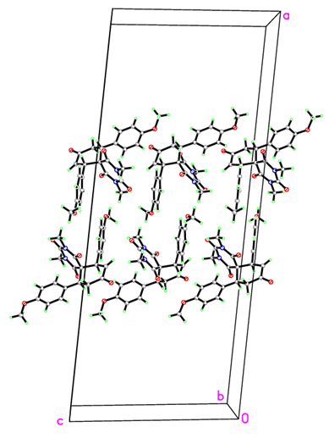
Figure. The crystal packing of compound 3h. Dashed line indicates the intermolecular interactions. The hydrogens do not involved in inter molecular interactions are omitted for clarity.
Crystal data

C₂₅H₂₅N₂O₆ | ?
M_{r} = 449.47 | D_{x} = 1.325 Mg m⁻³
Monoclinic, C2/c | Melting point: ? K
Hall symbol: ? | Mo Kα radiation, λ = 0.71073 Å
a = 37.494 (2) Å | Cell parameters from ? reflections
b = 7.8447 (4) Å | θ = ?°
c = 15.3990 (8) Å | µ = 0.10 mm⁻¹
β = 95.955 (3)° | T = 293 K
V = 4504.9 (4) Å³ | ?
Z = 8 | 0.59 × 0.41 × 0.35 mm
F(000) = 1896

Data collection

?  diffractometer | R_{int} = 0.054
Radiation source: ? | θ_{max} = 30.6°, θ_{min} = 2.7°
? | h = −5353
? | k = −1111
98664 measured reflections | l = −2222
6912 independent reflections | Standard reflections: ?
4506 reflections with I > 2σ(I)

Refinement

Refinement on F² | Secondary atom site location: ?
Least-squares matrix: full | Hydrogen site location: inferred from neighbouring sites
R[F² > 2σ(F²)] = 0.083 | H-atom parameters constrained
wR(F²) = 0.246 | w = 1/[σ²(F_{o}²) + (0.0964P)² + 6.2199P]  where P = (F_{o}² + 2F_{c}²)/3
S = 1.08 | (Δ/σ)_{max} < 0.001
6912 reflections | Δρ_{max} = 0.55 e Å⁻³
298 parameters | Δρ_{min} = −0.30 e Å⁻³
0 restraints | Extinction correction: none
? constraints | Extinction coefficient: ?
Primary atom site location: ?

Fractional atomic coordinates and isotropic or equivalent isotropic displacement parameters (Å²)

 | x | y | z | U_{iso}*/U_{eq}
O1 | 0.33555 (5) | 0.2761 (2) | 0.04085 (14) | 0.0652 (5)
O2 | 0.43364 (6) | 0.1697 (3) | 0.22642 (15) | 0.0848 (7)
O3 | 0.39522 (5) | −0.2539 (2) | 0.04404 (14) | 0.0643 (5)
O4 | 0.32639 (9) | −0.3473 (4) | −0.16989 (17) | 0.1167 (11)
O5 | 0.27131 (5) | −0.1431 (2) | 0.35528 (12) | 0.0592 (5)
O6 | 0.49551 (5) | 0.4168 (3) | −0.10215 (15) | 0.0752 (6)
N1 | 0.38437 (6) | 0.2224 (2) | 0.13347 (13) | 0.0486 (5)
N2 | 0.41298 (5) | −0.0460 (3) | 0.13808 (13) | 0.0467 (4)
C1 | 0.35891 (6) | 0.1765 (3) | 0.06758 (15) | 0.0446 (5)
C2 | 0.41167 (7) | 0.1200 (3) | 0.16941 (15) | 0.0504 (5)
C3 | 0.39088 (6) | −0.1100 (3) | 0.06977 (15) | 0.0443 (5)
C4 | 0.36149 (6) | 0.0024 (3) | 0.02549 (14) | 0.0415 (4)
C5 | 0.36838 (6) | 0.0374 (3) | −0.07143 (15) | 0.0474 (5)
H5A | 0.3487 | 0.1112 | −0.0955 | 0.057*
C6 | 0.36569 (8) | −0.1246 (4) | −0.12792 (18) | 0.0625 (7)
H6A | 0.3816 | −0.1450 | −0.1692 | 0.075*
C7 | 0.33645 (8) | −0.2479 (4) | −0.11389 (19) | 0.0632 (7)
C8 | 0.32060 (7) | −0.2499 (3) | −0.02806 (18) | 0.0582 (6)
H8A | 0.3323 | −0.3390 | 0.0081 | 0.070*
H8B | 0.2954 | −0.2800 | −0.0390 | 0.070*
C9 | 0.32359 (6) | −0.0826 (3) | 0.02344 (16) | 0.0464 (5)
H9A | 0.3070 | −0.0036 | −0.0093 | 0.056*
C10 | 0.31017 (6) | −0.0990 (3) | 0.11235 (16) | 0.0456 (5)
C11 | 0.32477 (6) | −0.2116 (3) | 0.17614 (17) | 0.0489 (5)
H11A | 0.3441 | −0.2796 | 0.1648 | 0.059*
C12 | 0.31126 (6) | −0.2249 (3) | 0.25610 (16) | 0.0482 (5)
H12A | 0.3214 | −0.3017 | 0.2976 | 0.058*
C13 | 0.28274 (6) | −0.1243 (3) | 0.27427 (16) | 0.0471 (5)
C14 | 0.26747 (7) | −0.0135 (3) | 0.21118 (18) | 0.0585 (6)
H14A | 0.2480 | 0.0535 | 0.2224 | 0.070*
C15 | 0.28117 (7) | −0.0025 (3) | 0.13158 (18) | 0.0579 (6)
H15A | 0.2706 | 0.0721 | 0.0896 | 0.070*
C16 | 0.40245 (6) | 0.1382 (3) | −0.07878 (14) | 0.0462 (5)
C17 | 0.43630 (7) | 0.0636 (3) | −0.07084 (17) | 0.0548 (6)
H17A | 0.4385 | −0.0530 | −0.0608 | 0.066*
C18 | 0.46660 (7) | 0.1598 (4) | −0.07768 (19) | 0.0605 (7)
H18A | 0.4890 | 0.1076 | −0.0711 | 0.073*
C19 | 0.46415 (7) | 0.3333 (4) | −0.09425 (16) | 0.0542 (6)
C20 | 0.43077 (7) | 0.4101 (3) | −0.10155 (18) | 0.0584 (6)
H20A | 0.4287 | 0.5268 | −0.1116 | 0.070*
C21 | 0.40039 (7) | 0.3124 (3) | −0.09383 (17) | 0.0546 (6)
H21A | 0.3781 | 0.3651 | −0.0989 | 0.066*
C22 | 0.38256 (11) | 0.3976 (3) | 0.1674 (2) | 0.0774 (9)
H22A | 0.3624 | 0.4556 | 0.1372 | 0.116*
H22B | 0.4042 | 0.4573 | 0.1583 | 0.116*
H22C | 0.3799 | 0.3938 | 0.2287 | 0.116*
C23 | 0.44091 (8) | −0.1587 (4) | 0.1808 (2) | 0.0732 (8)
H23A | 0.4391 | −0.2690 | 0.1537 | 0.110*
H23B | 0.4377 | −0.1695 | 0.2416 | 0.110*
H23C | 0.4641 | −0.1110 | 0.1748 | 0.110*
C24 | 0.23966 (8) | −0.0525 (4) | 0.3721 (2) | 0.0694 (8)
H24A | 0.2343 | −0.0756 | 0.4306 | 0.104*
H24B | 0.2199 | −0.0887 | 0.3316 | 0.104*
H24C | 0.2435 | 0.0676 | 0.3654 | 0.104*
C25 | 0.49371 (10) | 0.5930 (5) | −0.1221 (3) | 0.0914 (11)
H25A | 0.5175 | 0.6362 | −0.1258 | 0.137*
H25B | 0.4830 | 0.6527 | −0.0770 | 0.137*
H25C | 0.4795 | 0.6097 | −0.1769 | 0.137*

Atomic displacement parameters (Å²)

 | U¹¹ | U²² | U³³ | U¹² | U¹³ | U²³
O1 | 0.0670 (11) | 0.0422 (9) | 0.0860 (13) | 0.0169 (8) | 0.0058 (10) | 0.0020 (9)
O2 | 0.0891 (16) | 0.0831 (16) | 0.0760 (14) | −0.0175 (12) | −0.0210 (12) | −0.0100 (12)
O3 | 0.0695 (12) | 0.0381 (9) | 0.0846 (13) | 0.0143 (8) | 0.0047 (10) | −0.0040 (8)
O4 | 0.156 (3) | 0.112 (2) | 0.0857 (17) | −0.066 (2) | 0.0306 (17) | −0.0483 (16)
O5 | 0.0601 (10) | 0.0624 (11) | 0.0547 (10) | 0.0066 (8) | 0.0041 (8) | 0.0002 (8)
O6 | 0.0596 (11) | 0.0755 (14) | 0.0919 (15) | −0.0104 (10) | 0.0148 (10) | 0.0085 (11)
N1 | 0.0656 (12) | 0.0320 (9) | 0.0489 (10) | −0.0038 (8) | 0.0096 (9) | −0.0026 (8)
N2 | 0.0435 (10) | 0.0466 (10) | 0.0501 (10) | 0.0050 (8) | 0.0055 (8) | 0.0079 (8)
C1 | 0.0516 (12) | 0.0341 (10) | 0.0498 (12) | 0.0027 (9) | 0.0142 (9) | 0.0029 (9)
C2 | 0.0551 (13) | 0.0497 (13) | 0.0471 (12) | −0.0113 (10) | 0.0076 (10) | 0.0034 (10)
C3 | 0.0438 (11) | 0.0355 (10) | 0.0551 (12) | 0.0029 (8) | 0.0119 (9) | 0.0040 (9)
C4 | 0.0450 (11) | 0.0318 (9) | 0.0477 (11) | 0.0028 (8) | 0.0055 (9) | −0.0003 (8)
C5 | 0.0523 (12) | 0.0441 (12) | 0.0459 (11) | 0.0012 (10) | 0.0060 (9) | 0.0007 (9)
C6 | 0.0731 (17) | 0.0584 (15) | 0.0580 (15) | −0.0073 (13) | 0.0165 (13) | −0.0164 (12)
C7 | 0.0737 (18) | 0.0551 (15) | 0.0599 (15) | −0.0086 (13) | 0.0021 (13) | −0.0113 (12)
C8 | 0.0607 (15) | 0.0498 (14) | 0.0634 (15) | −0.0113 (11) | 0.0030 (12) | −0.0074 (11)
C9 | 0.0437 (11) | 0.0399 (11) | 0.0553 (13) | 0.0001 (9) | 0.0030 (9) | 0.0025 (9)
C10 | 0.0440 (11) | 0.0373 (10) | 0.0554 (12) | −0.0003 (9) | 0.0043 (9) | 0.0006 (9)
C11 | 0.0420 (11) | 0.0393 (11) | 0.0649 (14) | 0.0056 (9) | 0.0038 (10) | −0.0017 (10)
C12 | 0.0476 (12) | 0.0401 (11) | 0.0552 (13) | 0.0027 (9) | −0.0021 (10) | 0.0029 (9)
C13 | 0.0466 (12) | 0.0404 (11) | 0.0535 (12) | −0.0022 (9) | 0.0013 (9) | −0.0025 (9)
C14 | 0.0540 (14) | 0.0529 (14) | 0.0691 (16) | 0.0168 (11) | 0.0097 (12) | 0.0055 (12)
C15 | 0.0561 (14) | 0.0535 (14) | 0.0646 (15) | 0.0160 (11) | 0.0083 (11) | 0.0120 (12)
C16 | 0.0510 (12) | 0.0458 (12) | 0.0420 (11) | 0.0030 (10) | 0.0066 (9) | 0.0001 (9)
C17 | 0.0580 (14) | 0.0481 (13) | 0.0595 (14) | 0.0052 (11) | 0.0119 (11) | 0.0070 (11)
C18 | 0.0521 (14) | 0.0645 (16) | 0.0664 (16) | 0.0101 (12) | 0.0131 (12) | 0.0066 (13)
C19 | 0.0520 (13) | 0.0604 (15) | 0.0508 (13) | −0.0052 (11) | 0.0081 (10) | 0.0007 (11)
C20 | 0.0628 (15) | 0.0452 (13) | 0.0668 (16) | −0.0005 (11) | 0.0039 (12) | 0.0036 (11)
C21 | 0.0523 (13) | 0.0482 (13) | 0.0627 (15) | 0.0044 (10) | 0.0024 (11) | 0.0038 (11)
C22 | 0.119 (3) | 0.0383 (13) | 0.0732 (19) | −0.0032 (15) | 0.0039 (18) | −0.0125 (12)
C23 | 0.0607 (16) | 0.079 (2) | 0.0768 (19) | 0.0216 (15) | −0.0070 (14) | 0.0104 (16)
C24 | 0.0634 (16) | 0.080 (2) | 0.0660 (17) | 0.0082 (15) | 0.0149 (13) | −0.0036 (15)
C25 | 0.088 (2) | 0.084 (2) | 0.100 (3) | −0.032 (2) | 0.0019 (19) | 0.023 (2)

Geometric parameters (Å, °)

O1—C1 | 1.214 (3) | C11—C12 | 1.383 (4)
O2—C2 | 1.205 (3) | C11—H11A | 0.9300
O3—C3 | 1.213 (3) | C12—C13 | 1.381 (3)
O4—C7 | 1.194 (3) | C12—H12A | 0.9300
O5—C13 | 1.368 (3) | C13—C14 | 1.383 (3)
O5—C24 | 1.430 (3) | C14—C15 | 1.380 (4)
O6—C19 | 1.362 (3) | C14—H14A | 0.9300
O6—C25 | 1.416 (4) | C15—H15A | 0.9300
N1—C1 | 1.367 (3) | C16—C21 | 1.386 (3)
N1—C2 | 1.372 (3) | C16—C17 | 1.391 (3)
N1—C22 | 1.474 (3) | C17—C18 | 1.377 (4)
N2—C3 | 1.365 (3) | C17—H17A | 0.9300
N2—C2 | 1.391 (3) | C18—C19 | 1.386 (4)
N2—C23 | 1.472 (3) | C18—H18A | 0.9300
C1—C4 | 1.519 (3) | C19—C20 | 1.383 (4)
C3—C4 | 1.517 (3) | C20—C21 | 1.388 (4)
C4—C5 | 1.565 (3) | C20—H20A | 0.9300
C4—C9 | 1.567 (3) | C21—H21A | 0.9300
C5—C16 | 1.517 (3) | C22—H22A | 0.9600
C5—C6 | 1.537 (3) | C22—H22B | 0.9600
C5—H5A | 0.9800 | C22—H22C | 0.9600
C6—C7 | 1.495 (4) | C23—H23A | 0.9600
C6—H6A | 0.9300 | C23—H23B | 0.9600
C7—C8 | 1.504 (4) | C23—H23C | 0.9600
C8—C9 | 1.532 (3) | C24—H24A | 0.9600
C8—H8A | 0.9700 | C24—H24B | 0.9600
C8—H8B | 0.9700 | C24—H24C | 0.9600
C9—C10 | 1.512 (3) | C25—H25A | 0.9600
C9—H9A | 0.9800 | C25—H25B | 0.9600
C10—C15 | 1.382 (3) | C25—H25C | 0.9600
C10—C11 | 1.391 (3)

C13—O5—C24 | 117.1 (2) | C11—C12—H12A | 120.0
C19—O6—C25 | 117.8 (3) | C13—C12—H12A | 120.0
C1—N1—C2 | 125.37 (19) | O5—C13—C12 | 116.5 (2)
C1—N1—C22 | 117.0 (2) | O5—C13—C14 | 124.2 (2)
C2—N1—C22 | 117.6 (2) | C12—C13—C14 | 119.3 (2)
C3—N2—C2 | 124.81 (19) | C15—C14—C13 | 119.9 (2)
C3—N2—C23 | 118.0 (2) | C15—C14—H14A | 120.1
C2—N2—C23 | 117.1 (2) | C13—C14—H14A | 120.1
O1—C1—N1 | 120.4 (2) | C14—C15—C10 | 122.0 (2)
O1—C1—C4 | 120.7 (2) | C14—C15—H15A | 119.0
N1—C1—C4 | 118.90 (19) | C10—C15—H15A | 119.0
O2—C2—N1 | 122.0 (2) | C21—C16—C17 | 117.6 (2)
O2—C2—N2 | 120.6 (3) | C21—C16—C5 | 119.6 (2)
N1—C2—N2 | 117.4 (2) | C17—C16—C5 | 122.8 (2)
O3—C3—N2 | 120.2 (2) | C18—C17—C16 | 121.0 (2)
O3—C3—C4 | 120.7 (2) | C18—C17—H17A | 119.5
N2—C3—C4 | 119.15 (19) | C16—C17—H17A | 119.5
C3—C4—C1 | 113.97 (18) | C17—C18—C19 | 120.9 (2)
C3—C4—C5 | 110.28 (18) | C17—C18—H18A | 119.6
C1—C4—C5 | 105.86 (17) | C19—C18—H18A | 119.6
C3—C4—C9 | 112.14 (17) | O6—C19—C20 | 124.4 (3)
C1—C4—C9 | 107.05 (17) | O6—C19—C18 | 116.6 (2)
C5—C4—C9 | 107.13 (18) | C20—C19—C18 | 119.0 (2)
C16—C5—C6 | 113.3 (2) | C19—C20—C21 | 119.7 (2)
C16—C5—C4 | 112.72 (18) | C19—C20—H20A | 120.1
C6—C5—C4 | 112.76 (19) | C21—C20—H20A | 120.1
C16—C5—H5A | 105.8 | C16—C21—C20 | 121.8 (2)
C6—C5—H5A | 105.8 | C16—C21—H21A | 119.1
C4—C5—H5A | 105.8 | C20—C21—H21A | 119.1
C7—C6—C5 | 117.3 (2) | N1—C22—H22A | 109.5
C7—C6—H6A | 121.3 | N1—C22—H22B | 109.5
C5—C6—H6A | 121.3 | H22A—C22—H22B | 109.5
O4—C7—C6 | 120.0 (3) | N1—C22—H22C | 109.5
O4—C7—C8 | 120.2 (3) | H22A—C22—H22C | 109.5
C6—C7—C8 | 119.8 (2) | H22B—C22—H22C | 109.5
C7—C8—C9 | 115.6 (2) | N2—C23—H23A | 109.5
C7—C8—H8A | 108.4 | N2—C23—H23B | 109.5
C9—C8—H8A | 108.4 | H23A—C23—H23B | 109.5
C7—C8—H8B | 108.4 | N2—C23—H23C | 109.5
C9—C8—H8B | 108.4 | H23A—C23—H23C | 109.5
H8A—C8—H8B | 107.5 | H23B—C23—H23C | 109.5
C10—C9—C8 | 112.48 (19) | O5—C24—H24A | 109.5
C10—C9—C4 | 113.83 (18) | O5—C24—H24B | 109.5
C8—C9—C4 | 113.10 (19) | H24A—C24—H24B | 109.5
C10—C9—H9A | 105.5 | O5—C24—H24C | 109.5
C8—C9—H9A | 105.5 | H24A—C24—H24C | 109.5
C4—C9—H9A | 105.5 | H24B—C24—H24C | 109.5
C15—C10—C11 | 117.2 (2) | O6—C25—H25A | 109.5
C15—C10—C9 | 119.4 (2) | O6—C25—H25B | 109.5
C11—C10—C9 | 123.4 (2) | H25A—C25—H25B | 109.5
C12—C11—C10 | 121.6 (2) | O6—C25—H25C | 109.5
C12—C11—H11A | 119.2 | H25A—C25—H25C | 109.5
C10—C11—H11A | 119.2 | H25B—C25—H25C | 109.5
C11—C12—C13 | 120.0 (2)

C2—N1—C1—O1 | 179.2 (2) | C7—C8—C9—C10 | −174.8 (2)
C22—N1—C1—O1 | −1.9 (3) | C7—C8—C9—C4 | −44.1 (3)
C2—N1—C1—C4 | −3.9 (3) | C3—C4—C9—C10 | 68.2 (2)
C22—N1—C1—C4 | 175.0 (2) | C1—C4—C9—C10 | −57.5 (2)
C1—N1—C2—O2 | 178.6 (2) | C5—C4—C9—C10 | −170.66 (18)
C22—N1—C2—O2 | −0.3 (4) | C3—C4—C9—C8 | −61.8 (3)
C1—N1—C2—N2 | −2.0 (3) | C1—C4—C9—C8 | 172.5 (2)
C22—N1—C2—N2 | 179.1 (2) | C5—C4—C9—C8 | 59.3 (2)
C3—N2—C2—O2 | −175.2 (2) | C8—C9—C10—C15 | −117.8 (3)
C23—N2—C2—O2 | 3.2 (4) | C4—C9—C10—C15 | 111.9 (2)
C3—N2—C2—N1 | 5.4 (3) | C8—C9—C10—C11 | 59.9 (3)
C23—N2—C2—N1 | −176.2 (2) | C4—C9—C10—C11 | −70.4 (3)
C2—N2—C3—O3 | 176.1 (2) | C15—C10—C11—C12 | −1.0 (4)
C23—N2—C3—O3 | −2.3 (3) | C9—C10—C11—C12 | −178.8 (2)
C2—N2—C3—C4 | −2.5 (3) | C10—C11—C12—C13 | −0.4 (4)
C23—N2—C3—C4 | 179.1 (2) | C24—O5—C13—C12 | −174.0 (2)
O3—C3—C4—C1 | 178.1 (2) | C24—O5—C13—C14 | 5.6 (4)
N2—C3—C4—C1 | −3.3 (3) | C11—C12—C13—O5 | −179.0 (2)
O3—C3—C4—C5 | −63.0 (3) | C11—C12—C13—C14 | 1.4 (4)
N2—C3—C4—C5 | 115.6 (2) | O5—C13—C14—C15 | 179.4 (2)
O3—C3—C4—C9 | 56.3 (3) | C12—C13—C14—C15 | −1.1 (4)
N2—C3—C4—C9 | −125.1 (2) | C13—C14—C15—C10 | −0.3 (4)
O1—C1—C4—C3 | −176.8 (2) | C11—C10—C15—C14 | 1.3 (4)
N1—C1—C4—C3 | 6.2 (3) | C9—C10—C15—C14 | 179.2 (2)
O1—C1—C4—C5 | 61.8 (3) | C6—C5—C16—C21 | 131.1 (2)
N1—C1—C4—C5 | −115.1 (2) | C4—C5—C16—C21 | −99.3 (3)
O1—C1—C4—C9 | −52.2 (3) | C6—C5—C16—C17 | −49.0 (3)
N1—C1—C4—C9 | 130.8 (2) | C4—C5—C16—C17 | 80.5 (3)
C3—C4—C5—C16 | −64.3 (2) | C21—C16—C17—C18 | 0.0 (4)
C1—C4—C5—C16 | 59.4 (2) | C5—C16—C17—C18 | −179.8 (2)
C9—C4—C5—C16 | 173.42 (18) | C16—C17—C18—C19 | −1.2 (4)
C3—C4—C5—C6 | 65.5 (3) | C25—O6—C19—C20 | −2.2 (4)
C1—C4—C5—C6 | −170.7 (2) | C25—O6—C19—C18 | 177.9 (3)
C9—C4—C5—C6 | −56.8 (2) | C17—C18—C19—O6 | −178.3 (2)
C16—C5—C6—C7 | 169.8 (2) | C17—C18—C19—C20 | 1.7 (4)
C4—C5—C6—C7 | 40.2 (3) | O6—C19—C20—C21 | 178.9 (3)
C5—C6—C7—O4 | 158.5 (3) | C18—C19—C20—C21 | −1.2 (4)
C5—C6—C7—C8 | −23.4 (4) | C17—C16—C21—C20 | 0.5 (4)
O4—C7—C8—C9 | −156.9 (3) | C5—C16—C21—C20 | −179.6 (2)
C6—C7—C8—C9 | 25.1 (4) | C19—C20—C21—C16 | 0.1 (4)

All e.s.d.'s (except the e.s.d. in the dihedral angle between two l.s. planes) are estimated using the full covariance matrix. The cell e.s.d.'s are taken into account individually in the estimation of e.s.d.'s in distances, angles and torsion angles; correlations between e.s.d.'s in cell parameters are only used when they are defined by crystal symmetry. An approximate (isotropic) treatment of cell e.s.d.'s is used for estimating e.s.d.'s involving l.s. planes.

ORTEP diagram and Crystal data of 3i
Figure. X-Ray structure of 3i.
(CCDC number 1004327)

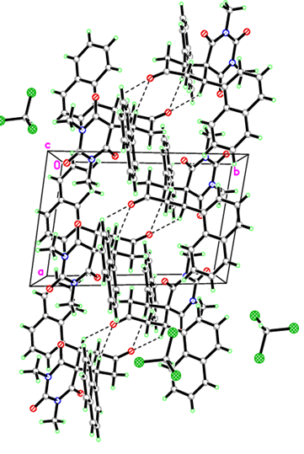
Figure. The crystal packing of compound 3i. Dashed line indicates the intermolecular interactions. The hydrogens do not involved in inter molecular interactions are omitted for clarity.

Crystal data

C₃₂H₂₇Cl₃N₂O₄ | F(000) = 632
M_{r} = 609.90 | ?
Triclinic, P | D_{x} = 1.394 Mg m⁻³
Hall symbol: ? | Melting point: ? K
a = 8.2784 (4) Å | Mo Kα radiation, λ = 0.71073 Å
b = 12.7854 (7) Å | Cell parameters from ? reflections
c = 15.1885 (8) Å | θ = ?°
α = 108.445 (2)° | µ = 0.36 mm⁻¹
β = 105.303 (2)° | T = 293 K
γ = 93.295 (2)° | ?
V = 1453.37 (13) Å³ | × × mm
Z = 2

Data collection

?  diffractometer | R_{int} = 0.059
Radiation source: ? | θ_{max} = 30.6°, θ_{min} = 2.6°
? | h = −1111
? | k = −1818
36460 measured reflections | l = −2121
8899 independent reflections | Standard reflections: ?
6087 reflections with I > 2σ(I)

Refinement

Refinement on F² | Secondary atom site location: ?
Least-squares matrix: full | Hydrogen site location: inferred from neighbouring sites
R[F² > 2σ(F²)] = 0.057 | H-atom parameters constrained
wR(F²) = 0.153 | w = 1/[σ²(F_{o}²) + (0.0605P)² + 0.9126P]  where P = (F_{o}² + 2F_{c}²)/3
S = 1.12 | (Δ/σ)_{max} < 0.001
8899 reflections | Δρ_{max} = 0.76 e Å⁻³
370 parameters | Δρ_{min} = −0.73 e Å⁻³
0 restraints | Extinction correction: none
? constraints | Extinction coefficient: ?
Primary atom site location: ?

Fractional atomic coordinates and isotropic or equivalent isotropic displacement parameters (Å²)

 | x | y | z | U_{iso}*/U_{eq}
Cl1 | 0.40573 (9) | −0.23561 (6) | −0.11957 (5) | 0.04239 (17)
Cl2 | 0.73018 (9) | −0.18819 (5) | 0.02738 (5) | 0.04436 (18)
Cl3 | 0.64512 (9) | −0.39042 (5) | −0.13973 (4) | 0.03775 (17)
O1 | −0.01706 (17) | 0.31090 (11) | 0.45904 (10) | 0.0183 (3)
O2 | 0.05560 (18) | 0.07141 (13) | 0.62535 (12) | 0.0268 (4)
O3 | −0.46469 (16) | 0.16741 (11) | 0.54529 (10) | 0.0157 (3)
O4 | −0.37442 (17) | 0.56165 (11) | 0.45991 (11) | 0.0189 (3)
N1 | 0.01816 (18) | 0.19209 (13) | 0.54207 (12) | 0.0142 (3)
N2 | −0.20319 (18) | 0.12570 (12) | 0.59199 (12) | 0.0122 (3)
C1 | −0.0764 (2) | 0.25890 (14) | 0.50110 (13) | 0.0124 (3)
C3 | −0.0366 (2) | 0.12646 (15) | 0.58955 (14) | 0.0153 (4)
C4 | −0.2495 (2) | 0.27087 (14) | 0.51515 (13) | 0.0105 (3)
C5 | −0.2332 (2) | 0.38673 (14) | 0.59856 (13) | 0.0120 (3)
H5A | −0.3447 | 0.3907 | 0.6093 | 0.014*
C6 | −0.1949 (2) | 0.48611 (15) | 0.56686 (14) | 0.0159 (4)
H6A | −0.1995 | 0.5546 | 0.6167 | 0.019*
H6B | −0.0805 | 0.4892 | 0.5617 | 0.019*
C7 | −0.3155 (2) | 0.48013 (15) | 0.47159 (14) | 0.0137 (4)
C8 | −0.3556 (2) | 0.36960 (15) | 0.39036 (14) | 0.0157 (4)
H8A | −0.2612 | 0.3590 | 0.3635 | 0.019*
H8B | −0.4544 | 0.3699 | 0.3391 | 0.019*
C9 | −0.3902 (2) | 0.27143 (14) | 0.42492 (13) | 0.0121 (3)
H9A | −0.4910 | 0.2840 | 0.4467 | 0.014*
C10 | −0.4428 (2) | 0.16257 (14) | 0.33887 (13) | 0.0129 (3)
C11 | −0.6159 (2) | 0.13558 (15) | 0.27801 (13) | 0.0137 (4)
C12 | −0.7436 (2) | 0.20092 (15) | 0.29897 (14) | 0.0159 (4)
H12A | −0.7153 | 0.2649 | 0.3540 | 0.019*
C13 | −0.9075 (3) | 0.17114 (18) | 0.23946 (16) | 0.0233 (4)
H13A | −0.9889 | 0.2148 | 0.2549 | 0.028*
C14 | −0.9539 (3) | 0.07522 (18) | 0.15531 (16) | 0.0261 (5)
H14A | −1.0653 | 0.0559 | 0.1152 | 0.031*
C15 | −0.8345 (3) | 0.01035 (17) | 0.13276 (15) | 0.0231 (4)
H15A | −0.8658 | −0.0528 | 0.0769 | 0.028*
C16 | −0.6639 (3) | 0.03772 (15) | 0.19307 (14) | 0.0175 (4)
C17 | −0.5417 (3) | −0.03141 (16) | 0.17146 (15) | 0.0208 (4)
H17A | −0.5718 | −0.0940 | 0.1152 | 0.025*
C18 | −0.3811 (3) | −0.00691 (16) | 0.23225 (15) | 0.0222 (4)
H18A | −0.3033 | −0.0547 | 0.2190 | 0.027*
C19A | −0.3315 (2) | 0.09073 (16) | 0.31553 (14) | 0.0181 (4)
H19A | −0.2203 | 0.1068 | 0.3557 | 0.022*
C19 | −0.3160 (2) | 0.18272 (14) | 0.54969 (13) | 0.0104 (3)
C20 | −0.1081 (2) | 0.39638 (14) | 0.69527 (14) | 0.0144 (4)
C21 | −0.1645 (2) | 0.37339 (15) | 0.76957 (14) | 0.0162 (4)
C22 | −0.3375 (3) | 0.34440 (16) | 0.76143 (15) | 0.0187 (4)
H22A | −0.4207 | 0.3397 | 0.7049 | 0.022*
C23 | −0.3843 (3) | 0.32328 (17) | 0.83489 (16) | 0.0249 (5)
H23A | −0.4983 | 0.3036 | 0.8274 | 0.030*
C24 | −0.2614 (3) | 0.33111 (19) | 0.92150 (17) | 0.0311 (5)
H24A | −0.2942 | 0.3172 | 0.9713 | 0.037*
C25 | −0.0947 (3) | 0.35900 (19) | 0.93241 (16) | 0.0306 (5)
H25A | −0.0143 | 0.3641 | 0.9900 | 0.037*
C26 | −0.0410 (3) | 0.38055 (16) | 0.85782 (15) | 0.0226 (4)
C27 | 0.1330 (3) | 0.41123 (18) | 0.87021 (17) | 0.0280 (5)
H27A | 0.2136 | 0.4157 | 0.9276 | 0.034*
C28 | 0.1834 (3) | 0.43413 (18) | 0.79943 (17) | 0.0254 (5)
H28A | 0.2979 | 0.4548 | 0.8087 | 0.031*
C29 | 0.0630 (2) | 0.42670 (16) | 0.71212 (15) | 0.0192 (4)
H29A | 0.0996 | 0.4427 | 0.6643 | 0.023*
C30 | 0.1937 (2) | 0.19176 (17) | 0.53820 (18) | 0.0225 (4)
H30A | 0.2170 | 0.2396 | 0.5040 | 0.034*
H30B | 0.2087 | 0.1172 | 0.5050 | 0.034*
H30C | 0.2701 | 0.2183 | 0.6031 | 0.034*
C31 | −0.2655 (3) | 0.05767 (16) | 0.64173 (16) | 0.0186 (4)
H31A | −0.3818 | 0.0649 | 0.6378 | 0.028*
H31B | −0.1984 | 0.0829 | 0.7087 | 0.028*
H31C | −0.2570 | −0.0191 | 0.6111 | 0.028*
C32 | 0.6211 (3) | −0.24951 (18) | −0.09712 (17) | 0.0279 (5)
H32A | 0.6703 | −0.2106 | −0.1324 | 0.033*

Atomic displacement parameters (Å²)

 | U¹¹ | U²² | U³³ | U¹² | U¹³ | U²³
Cl1 | 0.0467 (4) | 0.0539 (4) | 0.0368 (4) | 0.0206 (3) | 0.0173 (3) | 0.0231 (3)
Cl2 | 0.0578 (4) | 0.0347 (3) | 0.0268 (3) | 0.0040 (3) | 0.0074 (3) | −0.0032 (3)
Cl3 | 0.0527 (4) | 0.0203 (3) | 0.0290 (3) | 0.0096 (2) | −0.0010 (3) | 0.0035 (2)
O1 | 0.0166 (7) | 0.0184 (7) | 0.0264 (8) | 0.0027 (5) | 0.0109 (6) | 0.0128 (6)
O2 | 0.0170 (7) | 0.0313 (8) | 0.0457 (10) | 0.0126 (6) | 0.0114 (7) | 0.0285 (8)
O3 | 0.0101 (6) | 0.0165 (6) | 0.0229 (7) | 0.0025 (5) | 0.0070 (5) | 0.0082 (5)
O4 | 0.0170 (7) | 0.0139 (6) | 0.0295 (8) | 0.0049 (5) | 0.0068 (6) | 0.0120 (6)
N1 | 0.0082 (7) | 0.0142 (7) | 0.0247 (9) | 0.0040 (6) | 0.0076 (6) | 0.0101 (7)
N2 | 0.0112 (7) | 0.0115 (7) | 0.0184 (8) | 0.0031 (5) | 0.0068 (6) | 0.0089 (6)
C1 | 0.0111 (8) | 0.0095 (8) | 0.0169 (9) | 0.0016 (6) | 0.0056 (7) | 0.0037 (7)
C3 | 0.0121 (8) | 0.0139 (8) | 0.0223 (10) | 0.0030 (7) | 0.0063 (7) | 0.0085 (7)
C4 | 0.0096 (8) | 0.0086 (7) | 0.0144 (9) | 0.0028 (6) | 0.0049 (7) | 0.0044 (6)
C5 | 0.0104 (8) | 0.0110 (8) | 0.0153 (9) | 0.0030 (6) | 0.0038 (7) | 0.0051 (7)
C6 | 0.0179 (9) | 0.0108 (8) | 0.0188 (10) | 0.0031 (7) | 0.0034 (8) | 0.0063 (7)
C7 | 0.0117 (8) | 0.0121 (8) | 0.0202 (9) | 0.0015 (6) | 0.0067 (7) | 0.0076 (7)
C8 | 0.0186 (9) | 0.0127 (8) | 0.0174 (9) | 0.0044 (7) | 0.0043 (8) | 0.0077 (7)
C9 | 0.0109 (8) | 0.0108 (8) | 0.0144 (9) | 0.0033 (6) | 0.0024 (7) | 0.0050 (7)
C10 | 0.0163 (9) | 0.0103 (8) | 0.0136 (9) | 0.0025 (6) | 0.0057 (7) | 0.0052 (7)
C11 | 0.0163 (9) | 0.0121 (8) | 0.0139 (9) | 0.0016 (7) | 0.0035 (7) | 0.0070 (7)
C12 | 0.0157 (9) | 0.0143 (9) | 0.0168 (9) | 0.0019 (7) | 0.0028 (7) | 0.0060 (7)
C13 | 0.0174 (10) | 0.0247 (10) | 0.0247 (11) | 0.0029 (8) | 0.0019 (8) | 0.0079 (9)
C14 | 0.0193 (10) | 0.0277 (11) | 0.0231 (11) | −0.0031 (8) | −0.0037 (8) | 0.0071 (9)
C15 | 0.0272 (11) | 0.0183 (10) | 0.0169 (10) | −0.0046 (8) | −0.0003 (8) | 0.0036 (8)
C16 | 0.0234 (10) | 0.0143 (9) | 0.0140 (9) | −0.0002 (7) | 0.0040 (8) | 0.0056 (7)
C17 | 0.0312 (11) | 0.0130 (9) | 0.0160 (10) | 0.0021 (8) | 0.0071 (8) | 0.0019 (7)
C18 | 0.0285 (11) | 0.0163 (9) | 0.0215 (10) | 0.0098 (8) | 0.0094 (9) | 0.0035 (8)
C19A | 0.0187 (9) | 0.0174 (9) | 0.0170 (10) | 0.0064 (7) | 0.0047 (8) | 0.0045 (8)
C19 | 0.0098 (8) | 0.0094 (8) | 0.0116 (8) | 0.0016 (6) | 0.0042 (7) | 0.0024 (6)
C20 | 0.0153 (9) | 0.0094 (8) | 0.0165 (9) | 0.0041 (6) | 0.0030 (7) | 0.0029 (7)
C21 | 0.0218 (9) | 0.0092 (8) | 0.0152 (9) | 0.0040 (7) | 0.0044 (8) | 0.0017 (7)
C22 | 0.0237 (10) | 0.0142 (9) | 0.0194 (10) | 0.0052 (7) | 0.0088 (8) | 0.0050 (7)
C23 | 0.0345 (12) | 0.0179 (10) | 0.0265 (11) | 0.0049 (8) | 0.0172 (10) | 0.0066 (8)
C24 | 0.0526 (15) | 0.0244 (11) | 0.0214 (11) | 0.0060 (10) | 0.0166 (11) | 0.0102 (9)
C25 | 0.0448 (14) | 0.0277 (11) | 0.0172 (11) | 0.0062 (10) | 0.0036 (10) | 0.0094 (9)
C26 | 0.0288 (11) | 0.0165 (9) | 0.0182 (10) | 0.0044 (8) | 0.0014 (9) | 0.0047 (8)
C27 | 0.0263 (11) | 0.0257 (11) | 0.0218 (11) | 0.0041 (9) | −0.0066 (9) | 0.0058 (9)
C28 | 0.0162 (10) | 0.0219 (10) | 0.0296 (12) | 0.0001 (8) | −0.0028 (9) | 0.0057 (9)
C29 | 0.0160 (9) | 0.0171 (9) | 0.0222 (10) | 0.0016 (7) | 0.0031 (8) | 0.0062 (8)
C30 | 0.0110 (9) | 0.0215 (10) | 0.0424 (13) | 0.0066 (7) | 0.0140 (9) | 0.0153 (9)
C31 | 0.0202 (9) | 0.0180 (9) | 0.0267 (11) | 0.0056 (7) | 0.0115 (8) | 0.0158 (8)
C32 | 0.0439 (14) | 0.0195 (10) | 0.0239 (11) | 0.0057 (9) | 0.0137 (10) | 0.0094 (9)

Geometric parameters (Å, °)

Cl1—C32 | 1.755 (3) | C13—H13A | 0.9300
Cl2—C32 | 1.756 (2) | C14—C15 | 1.369 (3)
Cl3—C32 | 1.754 (2) | C14—H14A | 0.9300
O1—C1 | 1.220 (2) | C15—C16 | 1.419 (3)
O2—C3 | 1.208 (2) | C15—H15A | 0.9300
O3—C19 | 1.216 (2) | C16—C17 | 1.417 (3)
O4—C7 | 1.219 (2) | C17—C18 | 1.356 (3)
N1—C1 | 1.373 (2) | C17—H17A | 0.9300
N1—C3 | 1.393 (2) | C18—C19A | 1.412 (3)
N1—C30 | 1.470 (2) | C18—H18A | 0.9300
N2—C19 | 1.369 (2) | C19A—H19A | 0.9300
N2—C3 | 1.389 (2) | C20—C29 | 1.380 (3)
N2—C31 | 1.471 (2) | C20—C21 | 1.432 (3)
C1—C4 | 1.513 (2) | C21—C22 | 1.421 (3)
C4—C19 | 1.518 (2) | C21—C26 | 1.428 (3)
C4—C9 | 1.549 (2) | C22—C23 | 1.369 (3)
C4—C5 | 1.586 (2) | C22—H22A | 0.9300
C5—C20 | 1.521 (3) | C23—C24 | 1.405 (3)
C5—C6 | 1.539 (2) | C23—H23A | 0.9300
C5—H5A | 0.9800 | C24—C25 | 1.358 (4)
C6—C7 | 1.502 (3) | C24—H24A | 0.9300
C6—H6A | 0.9700 | C25—C26 | 1.416 (3)
C6—H6B | 0.9700 | C25—H25A | 0.9300
C7—C8 | 1.502 (3) | C26—C27 | 1.418 (3)
C8—C9 | 1.545 (2) | C27—C28 | 1.355 (3)
C8—H8A | 0.9700 | C27—H27A | 0.9300
C8—H8B | 0.9700 | C28—C29 | 1.405 (3)
C9—C10 | 1.521 (2) | C28—H28A | 0.9300
C9—H9A | 0.9800 | C29—H29A | 0.9300
C10—C19A | 1.372 (3) | C30—H30A | 0.9600
C10—C11 | 1.439 (3) | C30—H30B | 0.9600
C11—C12 | 1.424 (3) | C30—H30C | 0.9600
C11—C16 | 1.428 (3) | C31—H31A | 0.9600
C12—C13 | 1.370 (3) | C31—H31B | 0.9600
C12—H12A | 0.9300 | C31—H31C | 0.9600
C13—C14 | 1.407 (3) | C32—H32A | 0.9800

C1—N1—C3 | 125.53 (14) | C17—C16—C15 | 121.17 (18)
C1—N1—C30 | 117.57 (15) | C17—C16—C11 | 119.62 (18)
C3—N1—C30 | 116.88 (15) | C15—C16—C11 | 119.20 (18)
C19—N2—C3 | 124.58 (15) | C18—C17—C16 | 120.44 (18)
C19—N2—C31 | 117.02 (14) | C18—C17—H17A | 119.8
C3—N2—C31 | 118.39 (15) | C16—C17—H17A | 119.8
O1—C1—N1 | 120.07 (16) | C17—C18—C19A | 120.38 (19)
O1—C1—C4 | 121.75 (16) | C17—C18—H18A | 119.8
N1—C1—C4 | 118.08 (15) | C19A—C18—H18A | 119.8
O2—C3—N2 | 121.67 (16) | C10—C19A—C18 | 121.85 (19)
O2—C3—N1 | 121.52 (16) | C10—C19A—H19A | 119.1
N2—C3—N1 | 116.80 (15) | C18—C19A—H19A | 119.1
C1—C4—C19 | 113.66 (14) | O3—C19—N2 | 120.36 (16)
C1—C4—C9 | 115.31 (15) | O3—C19—C4 | 120.88 (15)
C19—C4—C9 | 107.02 (14) | N2—C19—C4 | 118.62 (14)
C1—C4—C5 | 107.84 (14) | C29—C20—C21 | 118.98 (18)
C19—C4—C5 | 105.71 (14) | C29—C20—C5 | 119.97 (17)
C9—C4—C5 | 106.69 (13) | C21—C20—C5 | 121.04 (16)
C20—C5—C6 | 111.64 (15) | C22—C21—C26 | 117.40 (18)
C20—C5—C4 | 113.38 (14) | C22—C21—C20 | 123.95 (18)
C6—C5—C4 | 111.77 (15) | C26—C21—C20 | 118.64 (18)
C20—C5—H5A | 106.5 | C23—C22—C21 | 121.5 (2)
C6—C5—H5A | 106.5 | C23—C22—H22A | 119.3
C4—C5—H5A | 106.5 | C21—C22—H22A | 119.3
C7—C6—C5 | 113.51 (15) | C22—C23—C24 | 120.5 (2)
C7—C6—H6A | 108.9 | C22—C23—H23A | 119.7
C5—C6—H6A | 108.9 | C24—C23—H23A | 119.7
C7—C6—H6B | 108.9 | C25—C24—C23 | 119.9 (2)
C5—C6—H6B | 108.9 | C25—C24—H24A | 120.0
H6A—C6—H6B | 107.7 | C23—C24—H24A | 120.0
O4—C7—C6 | 121.69 (17) | C24—C25—C26 | 121.3 (2)
O4—C7—C8 | 121.58 (18) | C24—C25—H25A | 119.3
C6—C7—C8 | 116.71 (15) | C26—C25—H25A | 119.3
C7—C8—C9 | 112.05 (15) | C27—C26—C25 | 121.0 (2)
C7—C8—H8A | 109.2 | C27—C26—C21 | 119.5 (2)
C9—C8—H8A | 109.2 | C25—C26—C21 | 119.4 (2)
C7—C8—H8B | 109.2 | C28—C27—C26 | 120.8 (2)
C9—C8—H8B | 109.2 | C28—C27—H27A | 119.6
H8A—C8—H8B | 107.9 | C26—C27—H27A | 119.6
C10—C9—C8 | 110.02 (15) | C27—C28—C29 | 120.1 (2)
C10—C9—C4 | 116.08 (14) | C27—C28—H28A | 120.0
C8—C9—C4 | 113.81 (14) | C29—C28—H28A | 120.0
C10—C9—H9A | 105.3 | C20—C29—C28 | 121.9 (2)
C8—C9—H9A | 105.3 | C20—C29—H29A | 119.0
C4—C9—H9A | 105.3 | C28—C29—H29A | 119.0
C19A—C10—C11 | 118.77 (17) | N1—C30—H30A | 109.5
C19A—C10—C9 | 122.85 (17) | N1—C30—H30B | 109.5
C11—C10—C9 | 118.36 (15) | H30A—C30—H30B | 109.5
C12—C11—C16 | 117.95 (17) | N1—C30—H30C | 109.5
C12—C11—C10 | 123.21 (17) | H30A—C30—H30C | 109.5
C16—C11—C10 | 118.84 (17) | H30B—C30—H30C | 109.5
C13—C12—C11 | 121.14 (18) | N2—C31—H31A | 109.5
C13—C12—H12A | 119.4 | N2—C31—H31B | 109.5
C11—C12—H12A | 119.4 | H31A—C31—H31B | 109.5
C12—C13—C14 | 120.7 (2) | N2—C31—H31C | 109.5
C12—C13—H13A | 119.6 | H31A—C31—H31C | 109.5
C14—C13—H13A | 119.6 | H31B—C31—H31C | 109.5
C15—C14—C13 | 119.8 (2) | Cl3—C32—Cl2 | 110.51 (13)
C15—C14—H14A | 120.1 | Cl3—C32—Cl1 | 110.63 (13)
C13—C14—H14A | 120.1 | Cl2—C32—Cl1 | 110.79 (13)
C14—C15—C16 | 121.20 (19) | Cl3—C32—H32A | 108.3
C14—C15—H15A | 119.4 | Cl2—C32—H32A | 108.3
C16—C15—H15A | 119.4 | Cl1—C32—H32A | 108.3

C3—N1—C1—O1 | −178.17 (18) | C12—C13—C14—C15 | 0.4 (3)
C30—N1—C1—O1 | 3.7 (3) | C13—C14—C15—C16 | 0.3 (3)
C3—N1—C1—C4 | 5.4 (3) | C14—C15—C16—C17 | 177.9 (2)
C30—N1—C1—C4 | −172.74 (17) | C14—C15—C16—C11 | −0.9 (3)
C19—N2—C3—O2 | −177.41 (19) | C12—C11—C16—C17 | −177.97 (17)
C31—N2—C3—O2 | 1.4 (3) | C10—C11—C16—C17 | 1.1 (3)
C19—N2—C3—N1 | 1.3 (3) | C12—C11—C16—C15 | 0.8 (3)
C31—N2—C3—N1 | −179.81 (16) | C10—C11—C16—C15 | 179.86 (17)
C1—N1—C3—O2 | −178.59 (19) | C15—C16—C17—C18 | −176.89 (19)
C30—N1—C3—O2 | −0.4 (3) | C11—C16—C17—C18 | 1.8 (3)
C1—N1—C3—N2 | 2.7 (3) | C16—C17—C18—C19A | −3.0 (3)
C30—N1—C3—N2 | −179.16 (17) | C11—C10—C19A—C18 | 1.8 (3)
O1—C1—C4—C19 | 167.88 (17) | C9—C10—C19A—C18 | −176.51 (18)
N1—C1—C4—C19 | −15.8 (2) | C17—C18—C19A—C10 | 1.2 (3)
O1—C1—C4—C9 | 43.8 (2) | C3—N2—C19—O3 | 171.34 (17)
N1—C1—C4—C9 | −139.88 (16) | C31—N2—C19—O3 | −7.5 (3)
O1—C1—C4—C5 | −75.3 (2) | C3—N2—C19—C4 | −12.9 (3)
N1—C1—C4—C5 | 101.05 (18) | C31—N2—C19—C4 | 168.20 (16)
C1—C4—C5—C20 | −59.75 (19) | C1—C4—C19—O3 | −164.90 (16)
C19—C4—C5—C20 | 62.15 (18) | C9—C4—C19—O3 | −36.4 (2)
C9—C4—C5—C20 | 175.83 (14) | C5—C4—C19—O3 | 77.0 (2)
C1—C4—C5—C6 | 67.49 (18) | C1—C4—C19—N2 | 19.4 (2)
C19—C4—C5—C6 | −170.61 (14) | C9—C4—C19—N2 | 147.88 (16)
C9—C4—C5—C6 | −56.93 (18) | C5—C4—C19—N2 | −98.66 (17)
C20—C5—C6—C7 | −179.99 (15) | C6—C5—C20—C29 | −44.8 (2)
C4—C5—C6—C7 | 51.8 (2) | C4—C5—C20—C29 | 82.5 (2)
C5—C6—C7—O4 | 136.48 (17) | C6—C5—C20—C21 | 135.82 (17)
C5—C6—C7—C8 | −45.4 (2) | C4—C5—C20—C21 | −96.86 (19)
O4—C7—C8—C9 | −137.62 (17) | C29—C20—C21—C22 | 178.27 (17)
C6—C7—C8—C9 | 44.3 (2) | C5—C20—C21—C22 | −2.3 (3)
C7—C8—C9—C10 | 175.81 (15) | C29—C20—C21—C26 | −1.2 (3)
C7—C8—C9—C4 | −51.9 (2) | C5—C20—C21—C26 | 178.15 (16)
C1—C4—C9—C10 | 67.23 (19) | C26—C21—C22—C23 | −0.5 (3)
C19—C4—C9—C10 | −60.28 (18) | C20—C21—C22—C23 | −179.98 (18)
C5—C4—C9—C10 | −173.07 (14) | C21—C22—C23—C24 | 0.8 (3)
C1—C4—C9—C8 | −62.02 (19) | C22—C23—C24—C25 | −0.5 (3)
C19—C4—C9—C8 | 170.47 (14) | C23—C24—C25—C26 | −0.1 (3)
C5—C4—C9—C8 | 57.68 (18) | C24—C25—C26—C27 | 179.1 (2)
C8—C9—C10—C19A | 97.5 (2) | C24—C25—C26—C21 | 0.3 (3)
C4—C9—C10—C19A | −33.6 (2) | C22—C21—C26—C27 | −178.83 (18)
C8—C9—C10—C11 | −80.82 (19) | C20—C21—C26—C27 | 0.7 (3)
C4—C9—C10—C11 | 148.12 (16) | C22—C21—C26—C25 | −0.1 (3)
C19A—C10—C11—C12 | 176.16 (17) | C20—C21—C26—C25 | 179.47 (18)
C9—C10—C11—C12 | −5.5 (3) | C25—C26—C27—C28 | −178.5 (2)
C19A—C10—C11—C16 | −2.9 (3) | C21—C26—C27—C28 | 0.2 (3)
C9—C10—C11—C16 | 175.52 (16) | C26—C27—C28—C29 | −0.6 (3)
C16—C11—C12—C13 | −0.2 (3) | C21—C20—C29—C28 | 0.9 (3)
C10—C11—C12—C13 | −179.18 (18) | C5—C20—C29—C28 | −178.49 (18)
C11—C12—C13—C14 | −0.4 (3) | C27—C28—C29—C20 | 0.0 (3)

All e.s.d.'s (except the e.s.d. in the dihedral angle between two l.s. planes) are estimated using the full covariance matrix. The cell e.s.d.'s are taken into account individually in the estimation of e.s.d.'s in distances, angles and torsion angles; correlations between e.s.d.'s in cell parameters are only used when they are defined by crystal symmetry. An approximate (isotropic) treatment of cell e.s.d.'s is used for estimating e.s.d.'s involving l.s. planes.

