Table (1): Molecular electronic spectra (λ_{max} (nm)ª and ε_{max} (mol⁻¹ cm²)) of the synthesized Fe(II) Schiff base amino acid complexes.
Compound | λ_{max} (nm) | ε_{max} (mol⁻¹ cm²) | Assignment
bsal | 266  292  380  410 | 1270  1330  1250  610 | π-π*  π-π*  n-π*  n-π*
bsali | 398(sh)  440  494 | 1310  824  900 | Intraligand band  LMCT band  d-d band
bsphal | 260  306  370  408 | 1250  1270  1080  300 | π-π*  n-π*  n-π*  n-π*
bsphali | 368(sh)  434  490 | 2744  2449  2766 | Intraligand band  LMCT band  d-d band
bsas | 292  306  380  410 | 1350  1290  1250  611 | π-π*  n-π*  n-π*  n-π*
bsasi | 376  438  488 | 1252  1332  1571 | Intraligand band  LMCT band  d-d band
bsh | 256  324  406 | 1330  1200  400 | π-π*  n-π*  n-π*
bshi | 368(sh)  428  460 | 1765  1518  1288 | Intraligand band  LMCT band  d-d band
bsar | 250  292  308  388 | 1400  1350  1280  1333 | π-π*  π-π*  n-π*  n-π*
bsari | 370  430  458(b) | 2350  2383  2650 | Intraligand band  LMCT band  d-d band
ª b= broad, sh= shoulder.

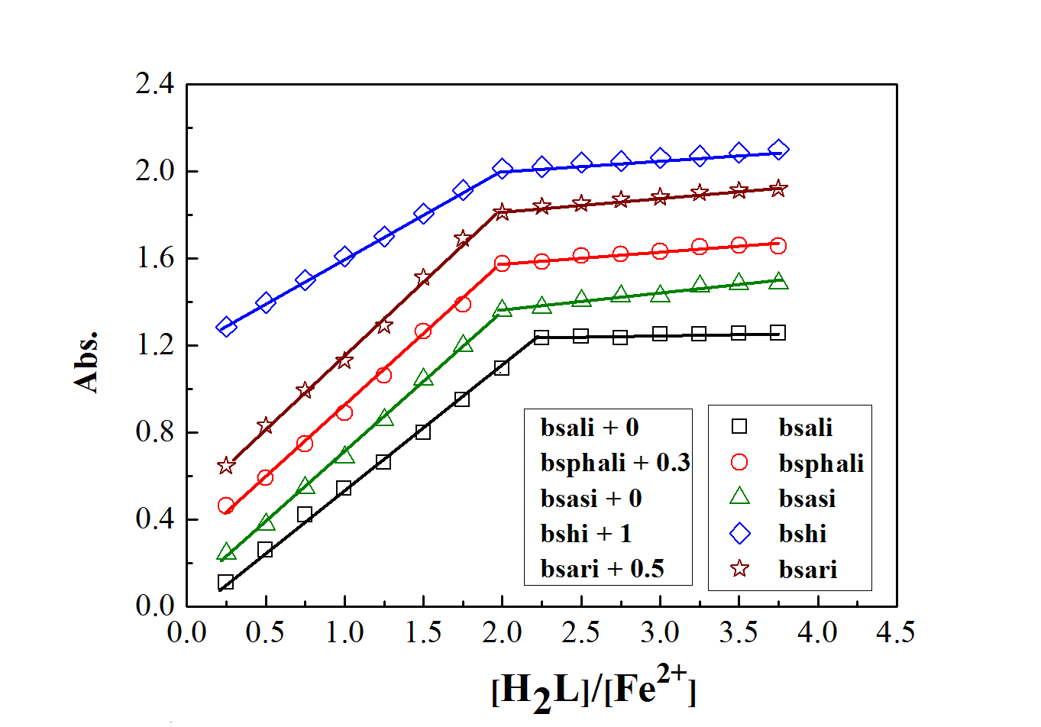

Fig. 1: Molar ratio plots for the studied complexes in aqueous - alcoholic mixture at [Fe²⁺] = 4 × 10⁻⁴ M (for bsali), [Fe²⁺] = 2 × 10⁻⁴ M (for bsphali, bshi, bsari), [Fe²⁺] =1×10⁻³ M (for bsasi) and 298 K.
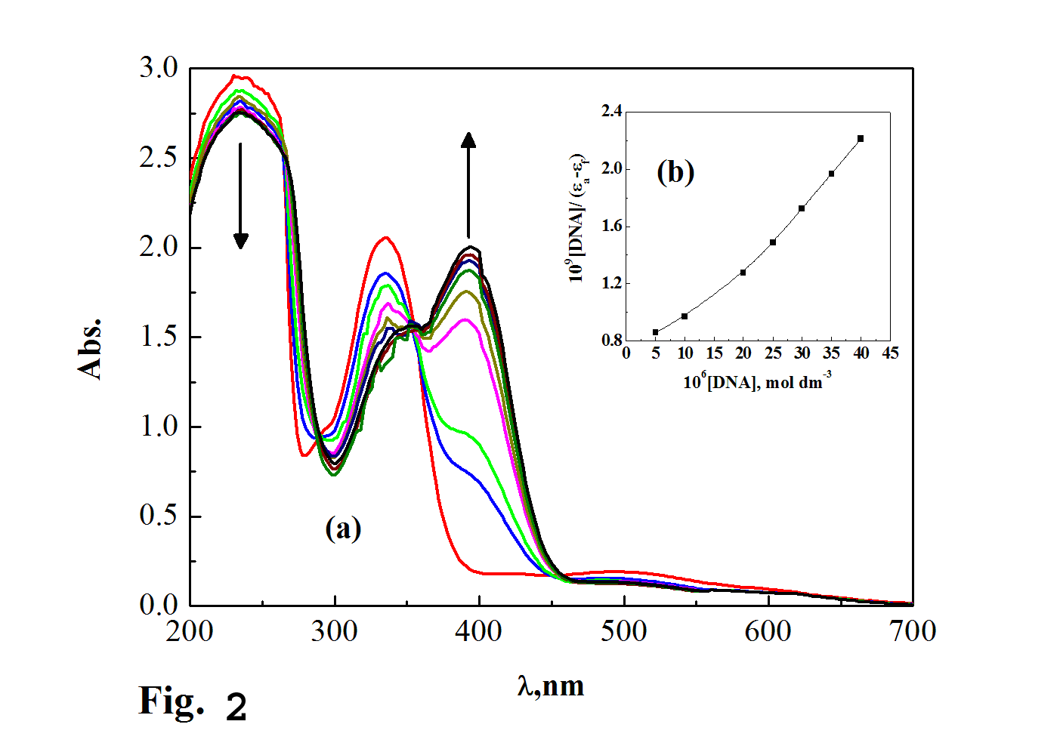

Fig. 2: (a): Spectrophotometer titration of bsali complex (10⁻⁴ M) in 0.01 M Tris buffer (pH 7.4, 25 °C) with CT-DNA from 0 µM (top) to 40 µM (bottom) CT-DNA with 5 µM intervals.
(b): Plot of [CTDNA]/(ε_{a} - ε_{f}) versus [CT-DNA] for the titration of CT-DNA with bsali complex.

