Graphical Abstract

The mechanism of stabilization of double base propellants (DBPs) by using inorganic stabilizers (Nano-clinoptilolite and micro-clinoptilolite) had been studied via the test of the mutual effect of the stabilizers on the surface structure of propellants and vice versa. This study had been performed by using XRD and Electron Microscope (AFM and TEM techniques). The role of stabilization of the inorganic stabilizer (Clinoptilolite) for DBPs depends on three suggested ways (Fig. 12); the first one included the absorption of NO_{x} gases on the external surface of stabilizers forming bi-layer. This by layer may be obtained by mutual interaction of NO_{x} negatively charged radicals and the well arranged positively charged cations of clinoptilolite. The second one included the partitioning of the evolved No_{x} into the internal cavities of clinoptilolite. The third one may involve the catch of NO_{x} by base specific binding of NO_{x} gas radical.

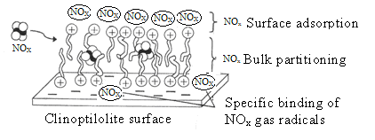

Fig. 12. Sketching drawing of (NO_{x}) forming a bi-layer (tail to tail) on the surface of clinoptilolite, and NO_{x} partitioning into the bi-layer.

