**Supplementary Material (ESI)**

**PROBING THE MOLECULAR ORIENTATION OF CHEMICALLY POLYMERIZED POLYTHIOPHENE-POLYROTAXANE VIA SOLID STATE NMR**

Mujeeb Khan1,4,*, Gunther Brunklaus2,4 and Shahzada Ahmad3,4

1Department of Chemistry, College of Science, King Saud University, P.O. Box 2455, Riyadh 11451, Kingdom of Saudi Arabia

2Westfaelische Wilhelms-Universitaet, Institut fuer Physikalische Chemie, D-48149 Muenster.

3Abengoa Research, C/ Energía Solar nº 1, Campus Palmas Altas, 41014, Sevilla, Spain.

4Max-Planck-Institut fu¨r Polymerforschung, Postfach 3148, D-55021 Mainz, Germany

*Correspondence E-mail: kmujeeb@ksu.edu.sa

**Table of contents**

Figure S1. 2D 1H-1H DQ NMR spectrum of polythiophene polyrotaxane…………….......... 2

Figure S2. 1H-13C CP-HETCOR NMR spectrum of thiophene [2]rotaxane…*….*................... 3

Figure S3. 15N CPMAS NMR spectra of thiophene [2]rotaxane and polythiophene polyrotaxane…………………………………………………………………..*….*................... 4

D:\ksu-Scientific-data\NMR manuscript\Proton-DQ-2.tif

**Figure S1:** 2D 1H-1H double-quantum (DQ) MAS NMR spectrum of polythiophene polyrotaxane.

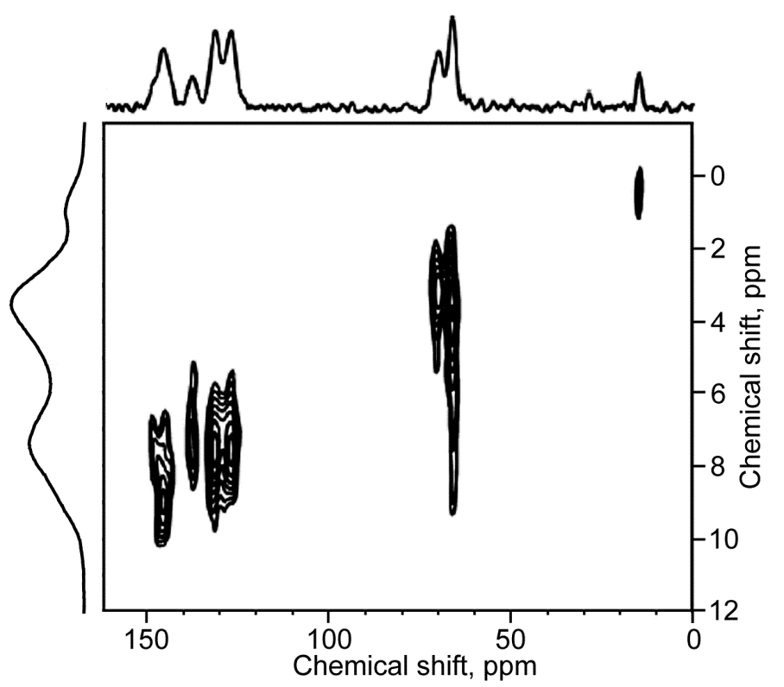

**Figure S2:** 1H-13C CP-HETCOR MAS NMR spectrum of thiophene [2]rotaxane.

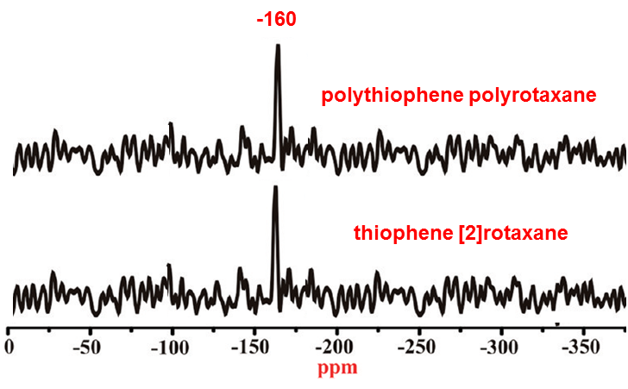

**Figure S3:** 15N CPMAS NMR spectra of thiophene [2]rotaxane and polythiophene polyrotaxane