**Supplementary File**

**Green synthesized silver nanoparticles successfully kill multi drug resistant bacteria via Reactive oxygen species mediated Membrane damage**

Balaram Dasa, Sandeep Kumar Dasha, Debasish Mandala,Totan Ghoshb, Sourav Chattopadhyaya, Satyajit Tripathya, Sabyasachi Dasa, Sankar kumar Deyc, Debasis Dasb, Somenath Roy**a\***

**a**Immunology and Microbiology Laboratory, Department of Human Physiology with Community Health, Vidyasagar University, Midnapore-721 102, West Bengal, India.

**b**Department of Chemistry, University of Calcutta, 92, A. P. C. Road, Kolkata - 700 009, India

### cDept. of Physiology, [Santal Bidroha Sardha Satabarsiki Mahavidyalaya](https://www.google.co.in/url?sa=t&rct=j&q=&esrc=s&source=web&cd=2&cad=rja&uact=8&ved=0CCgQFjAB&url=http%3A%2F%2Fen.wikipedia.org%2Fwiki%2FSantal_Bidroha_Sardha_Satabarsiki_Mahavidyalaya&ei=tOmjVLXBH9CAuwT_nYGADQ&usg=AFQjCNGjw7mlGgIfI0zNspPUD--dGmSY5g&bvm=bv.82001339,d.c2E), Goaltore, Paschim Midnapore,West Bengal,711221

**Running title: Anti-bacterial activity of green synthesized silver nanoparticles**

**\*Address of Correspondence**

Immunology and Microbiology Laboratory

Department of Human Physiology with Community Health

Vidyasagar University

Midnapore-721 102, West Bengal, India.

***E-mail:*** [***sroy.vu@hotmail.com***](mailto:sroy.vu@hotmail.com)

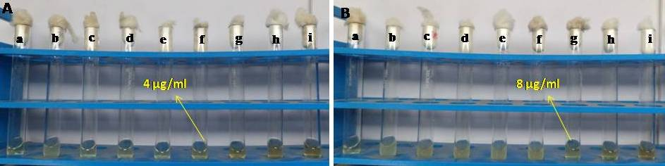

**Figure. S1**

C:\Users\BALARAM\Desktop\MBC.tif

**Figure. S2**

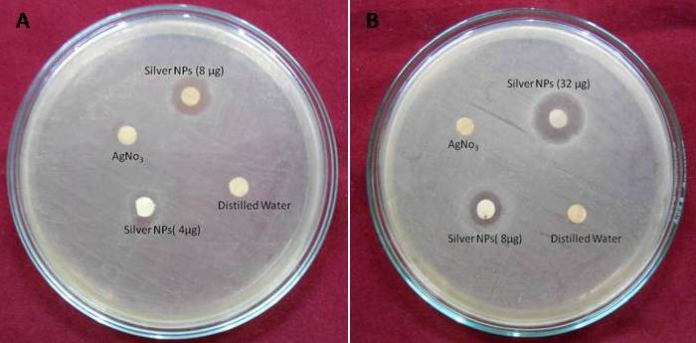

**Figure. S3**

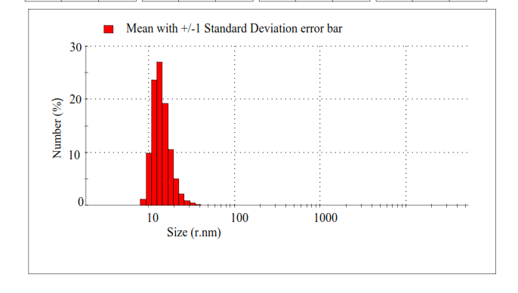

**Figure. S4**



**B**

**A**

**Figure. S5**

**CCC**