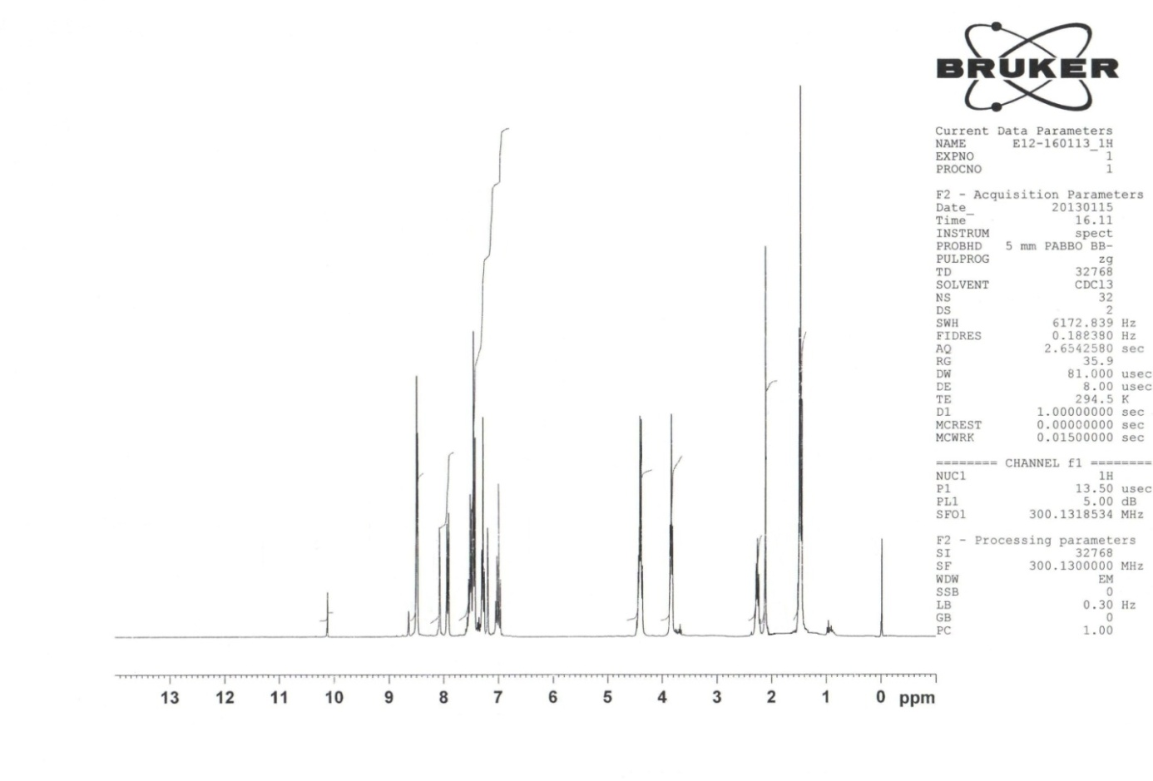

**Figure A**. 1H NMR spectrum of the ligand (L)

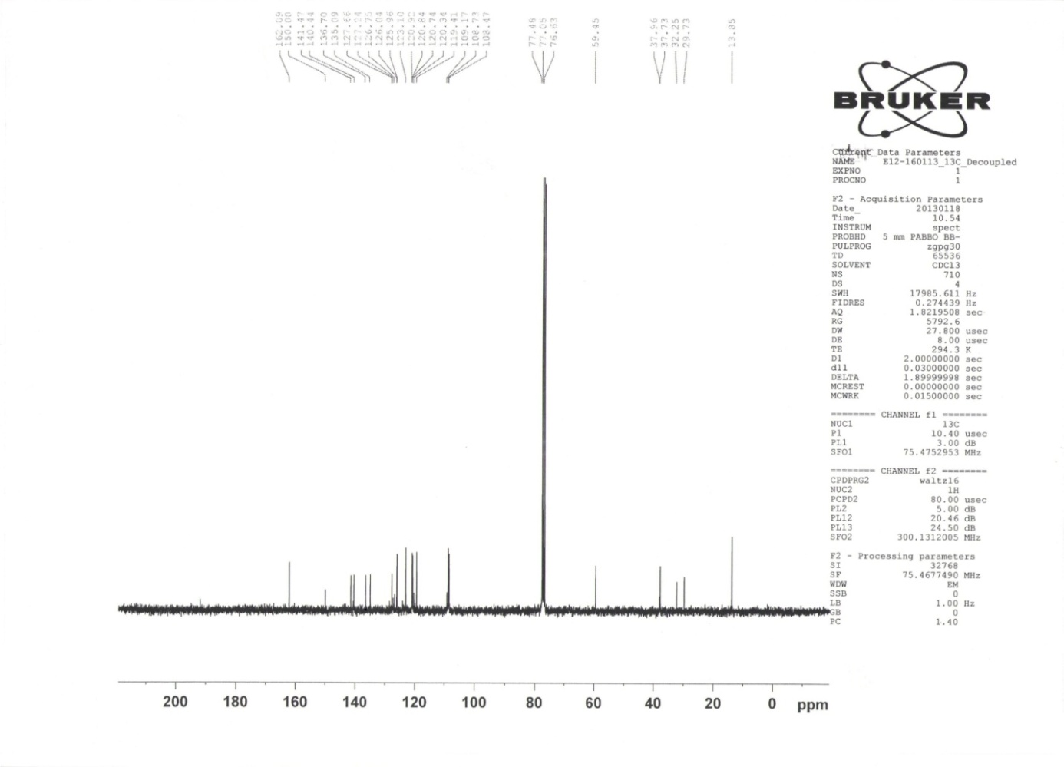

**Figure B**. 13C NMR spectrum of the ligand (L)

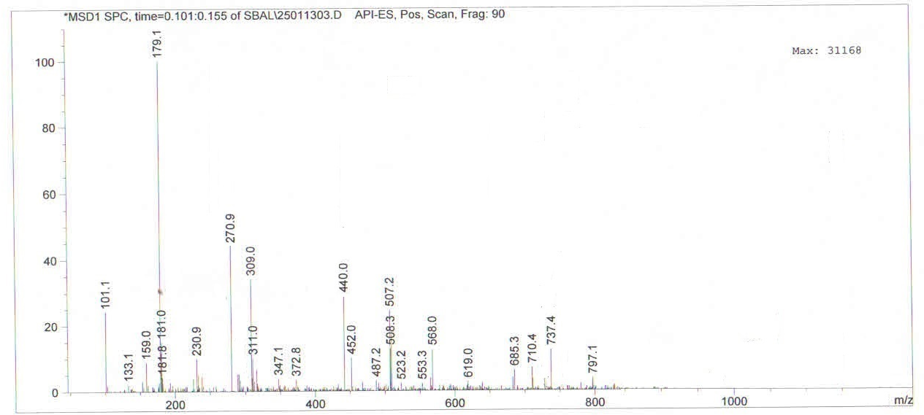

**Figure C**. LCMS spectrum of the ligand (L)

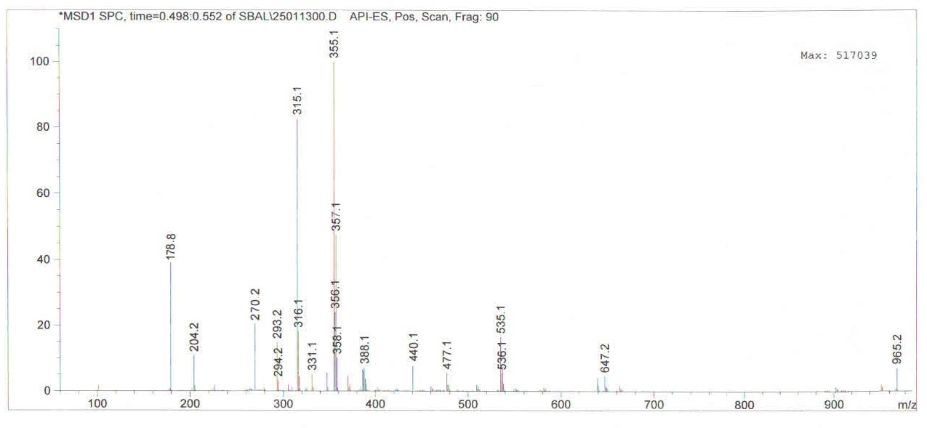

**Figure D**. LCMS spectrum of Co(II) Complex the ligand (L)

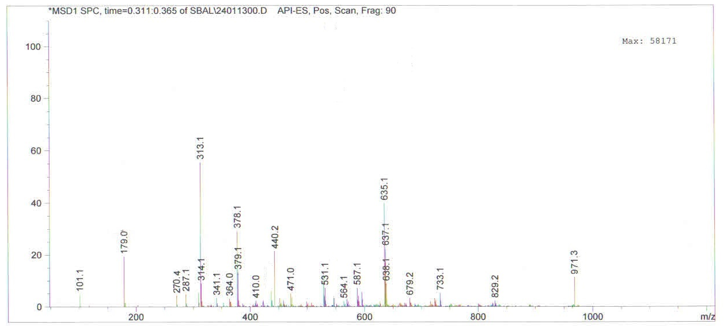

**Figure E**. LCMS spectrum of Cu(II) Complex the ligand (L)

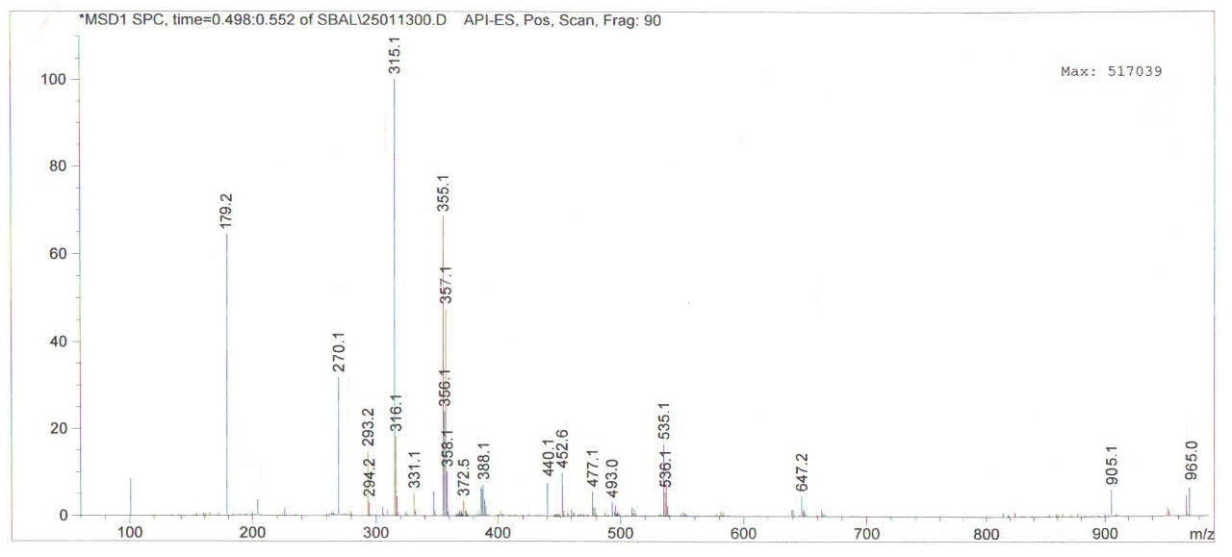

**Figure F**. LCMS spectrum of Ni(II) Complex the ligand (L)



**Figure G**. IR Spectrum of Ligand E12



**Figure H**. IR Spectrum of Cobalt complex of E12



**Figure I**. IR Spectrum of Nickel complex of E12



**Figure J**. IR Spectrum of Copper complex of E12