a) b)



10 mL

15 mL

20 mL

c)

Supplementary Fig. 1: Effect of defatting for stable baseline of GS chromatogram under HPLC-ELSD conditions of Beek and Montoro (2009); No-defatting (a and b): sample powder (2g) was extracted with 10 ml (a) and 20 ml (b) of 90% methanol for 1 hour by sonication; With defatting: sample powder (2g) was defatted with petroleum ether (15 mL) by sonication for 1 hour. Then the residue was extracted with 90% MeOH (10 mL, 15 mL and 20 mL, respectively) for 1 hour by sonication.

50

100

150

200

250

300

350

400

450

500

550

600

650

700

750

800

850

900

950

m/z

0.00

0.25

0.50

0.75

1.00

1.25

1.50

1.75

2.00

Inten.

(x10,000,000)

426

441

839

79

100

487

640

553

**a)**

50

100

150

200

250

300

350

400

450

500

550

600

650

700

750

800

850

900

950

m/z

0.00

0.25

0.50

0.75

1.00

1.25

1.50

1.75

2.00

Inten.

(x10,000,000)

815

467

407

817

351

489

**b)**

50

100

150

200

250

300

350

400

450

500

550

600

650

700

750

800

850

900

950

m/z

0.00

0.25

0.50

0.75

1.00

1.25

1.50

1.75

2.00

2.25

2.50

Inten.

(x10,000,000)

442

425

871

541

381

**c)**

50

100

150

200

250

300

350

400

450

500

550

600

650

700

750

800

850

900

950

m/z

0.00

0.25

0.50

0.75

1.00

1.25

1.50

1.75

2.00

2.25

2.50

Inten.

(x10,000,000)

847

423

367

459

505

255

**d)**

50

100

150

200

250

300

350

400

450

500

550

600

650

700

750

800

850

900

950

m/z

0.00

0.25

0.50

0.75

1.00

1.25

1.50

1.75

2.00

2.25

Inten.

(x10,000,000)

458

413

903

381

301

105

497.20

541.25

**e)**

50

100

150

200

250

300

350

400

450

500

550

600

650

700

750

800

850

900

950

m/z

0.00

0.25

0.50

0.75

1.00

1.25

1.50

1.75

2.00

2.25

2.50

Inten.

(x10,000,000)

879

439

383

255

521

**f)**

Supplementary Fig. 2. LC-MS spectra of standard compounds at positive and negative mode. MS conditions: Interface voltage; −3.5 kV (negative mode), 4.5 kV (positive mode), nebulizing gas flow rate; 3 L/min, drying gas; 15 L/min, desolvation line temp.; 250 °C, heat block temp.; 400 °C.

a) GA (positive mode, pseudomolecular ions: [M+H]+ *(m/z)* = 409, [M+H2O] *(m/z)* = 426, [M+Na]+ *(m/z)* = 431, [M+MeOH+H]+ *(m/z)* = 441, [2M+Na]+ *(m/z)*= 839)

b) GA (negative mode, pseudomolecular ions: [M-H]- *(m/z)* = 407, [M+CH3COO-]- *(m/z)* = 467, [2M-H]- *(m/z)*= 815)

c) GB (positive mode, pseudomolecular ions: [M+H]+ *(m/z)* = 425, [M+H2O] *(m/z)* = 442, [M+Na]+ *(m/z)* = 447, [M+MeOH+H]+ *(m/z)* = 457, [2M+Na]+ *(m/z)*= 871)

d) GB (negative mode, pseudomolecular ions: [M-H]- *(m/z)* = 423, [2M-H]- *(m/z)*= 847)

e) GC (positive mode, pseudomolecular ions: [M+H]+ *(m/z)* = 441, [M+H2O] *(m/z)* = 458, [M+Na]+ *(m/z)* = 463, [M+MeOH+H]+ *(m/z)* = 473, [2M+Na]+ *(m/z)*= 871)

f) GB (negative mode, pseudomolecular ions: [M-H]- *(m/z)*=439, [2M-H]- *(m/z)*= 879)

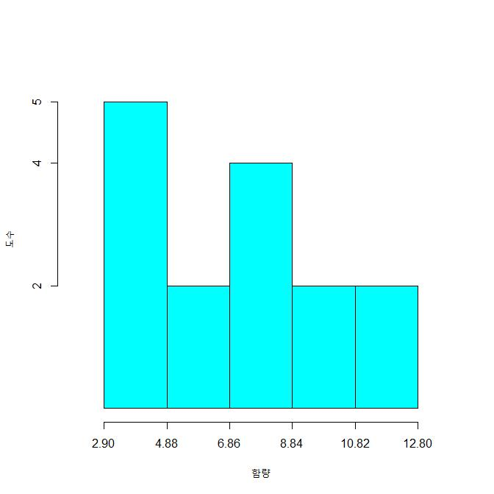

Number of sample

Content (μg/g)

a)

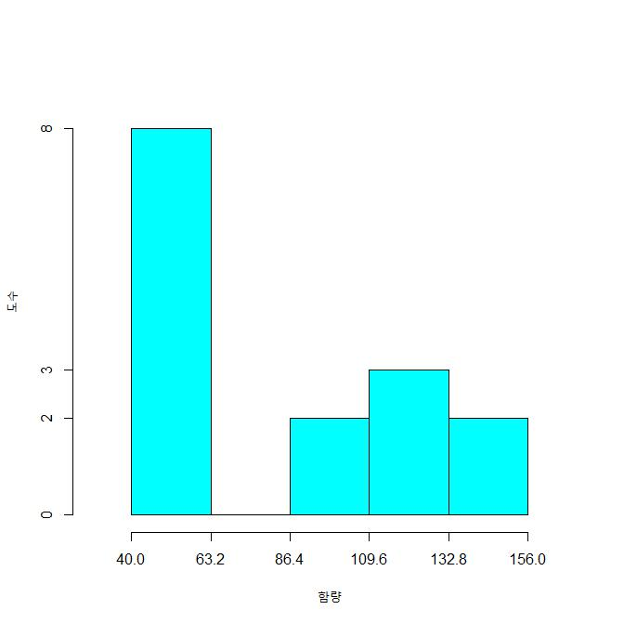

Number of sample

Content (μg/g)

b)

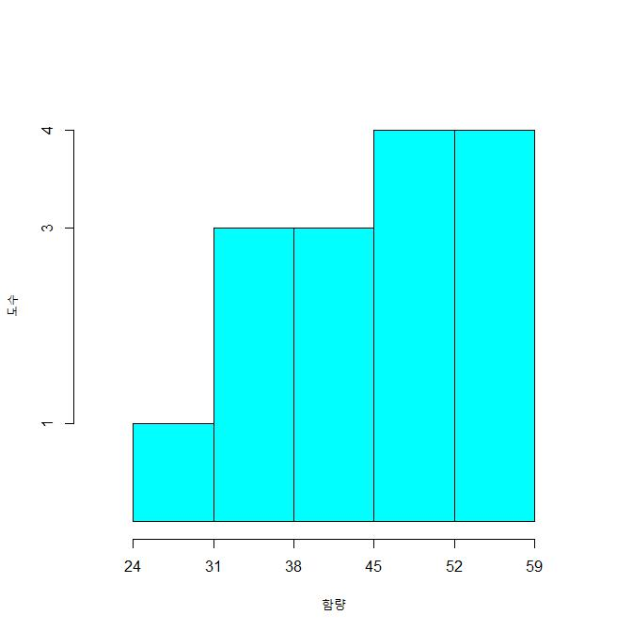

Number of sample

Content (μg/g)

c)

Supplementary Fig. 3. Histogram of maker compound content: (a) GA, (b) GB and (c) GC

Supplementary Table 1:Origin of fifteen samples

|  |  |  |  |
| --- | --- | --- | --- |
| Sample information | | Sample information | |
| No. | Origin | No. | Origin |
| GS-1 | Korea | GS-9 | China, Changchun |
| GS-2 | Korea, Jeonje | GS-10 | China, Changchun |
| GS-3 | Korea, Jecheon | GS-11 | China, Changchun |
| GS-4 | Korea, Youngju | GS-12 | China, Changchun |
| GS-5 | Korea | GS-13 | China, Changchun |
| GS-6 | Korea, Gongju | GS-14 | China, Changchun |
| GS-7 | Korea, Gongju | GS-15 | China, Changchun |
| GS-8 | Korea |  |  |

Supplementary Table 2. Yield of the ethyl acetate residue.

|  |  |  |  |  |
| --- | --- | --- | --- | --- |
| Sample | Sample weight (g) | Weight after defatting (g) | EtOAc residue weight (g) | Yield (%) |
| No. 1 | 6.0433 | 5.8600 | 0.0269 | 0.445 |
| No. 2 | 6.0497 | 5.8623 | 0.0273 | 0.451 |
| No. 3 | 6.0375 | 5.8056 | 0.0258 | 0.427 |
| Mean ± SD |  |  |  | 0.441 ± 0.012 |

Supplementary Table 3. Quantitative result a) GA, b) GB, c) GC.

|  |  |  |  |
| --- | --- | --- | --- |
|  | Mean (μg/g) | SD | RSD (%) |
| GS-1 | 2.92 | 0.05 | 1.55 |
| GS-2 | 4.18 | 0.04 | 1.00 |
| GS-3 | 2.95 | 0.07 | 2.29 |
| GS-4 | 5.85 | 0.06 | 1.07 |
| GS-5 | 2.94 | 0.05 | 1.82 |
| GS-6 | 8.23 | 0.17 | 2.01 |
| GS-7 | 8.32 | 0.15 | 1.80 |
| GS-8 | 3.38 | 0.11 | 3.17 |
| GS-9 | 8.54 | 0.24 | 2.85 |
| GS-10 | 11.17 | 0.75 | 6.68 |
| GS-11 | 12.71 | 0.27 | 2.10 |
| GS-12 | 9.06 | 0.21 | 2.27 |
| GS-13 | 7.83 | 0.08 | 1.02 |
| GS-14 | 11.16 | 0.21 | 1.89 |
| GS-15 | 5.24 | 0.19 | 3.66 |

a)

|  |  |  |  |
| --- | --- | --- | --- |
|  | Mean (μg/g) | SD | RSD (%) |
| GS-1 | 40.69 | 0.38 | 0.94 |
| GS-2 | 49.46 | 2.50 | 5.06 |
| GS-3 | 50.17 | 0.20 | 0.41 |
| GS-4 | 50.68 | 1.19 | 2.34 |
| GS-5 | 48.08 | 3.24 | 6.73 |
| GS-6 | 42.60 | 1.59 | 3.74 |
| GS-7 | 48.07 | 2.69 | 5.60 |
| GS-8 | 57.31 | 1.92 | 3.36 |
| GS-9 | 155.89 | 7.51 | 4.82 |
| GS-10 | 99.18 | 3.55 | 3.58 |
| GS-11 | 87.33 | 2.58 | 2.96 |
| GS-12 | 155.87 | 3.51 | 2.25 |
| GS-13 | 123.51 | 1.40 | 1.13 |
| GS-14 | 113.63 | 4.40 | 3.87 |
| GS-15 | 129.72 | 5.41 | 4.17 |

b)

|  |  |  |  |
| --- | --- | --- | --- |
|  | Mean (μg/g) | SD | RSD (%) |
| GS-1 | 24.68 | 0.50 | 2.02 |
| GS-2 | 34.46 | 0.81 | 2.34 |
| GS-3 | 34.33 | 0.53 | 1.55 |
| GS-4 | 50.78 | 3.54 | 6.98 |
| GS-5 | 43.32 | 0.38 | 0.87 |
| GS-6 | 40.92 | 0.75 | 1.84 |
| GS-7 | 35.75 | 0.65 | 1.83 |
| GS-8 | 38.43 | 0.26 | 0.67 |
| GS-9 | 58.97 | 0.51 | 0.86 |
| GS-10 | 47.05 | 0.51 | 1.09 |
| GS-11 | 48.39 | 1.39 | 2.88 |
| GS-12 | 56.78 | 3.07 | 5.41 |
| GS-13 | 57.86 | 0.62 | 1.06 |
| GS-14 | 55.30 | 0.84 | 1.51 |
| GS-15 | 49.33 | 2.24 | 4.54 |

c)

Supplementary Table 4. Establishment of content criteria by two methods

|  |  |  |  |  |
| --- | --- | --- | --- | --- |
| Method | Factors | Marker compounds | | |
| GA | GB | GC |
| RSD | Content criteria (μg/g) | 0.72 | 20.87 | 29.23 |
| Fail ratio (%) | 0.00 | 0.00 | 6.67 |
| Regression | Content criteria (μg/g) | 2.35 | 29.20 | 27.75 |
| Fail ratio (%) | 0.00 | 0.00 | 6.67 |