**Triazole containing magnetic core-silica shell nanoparticles for Pb2+, Cu2+ and Zn2+ removal**

Zakaria Mokadem,1 Sofiane Mekki,1 Salima Saïdi-Besbes,1* Geraldine Agusti,2 Abdelhamid Elaissari2,Aicha Derdour1

*1University Oran 1 Ahmed Benbella, Laboratoire de Synthèse Organique Appliquée (LSOA), Département de chimie, Faculté des sciences exactes et appliquées, BP 1524 EL Mnaouer, 31000 Oran – Algérie.*

*2 University Lyon-1, Villeurbanne; CNRS, UMR-5007, LAGEP- CPE; 43 bd 11 Novembre 1918, F-69622 Villeurbanne, France.*

[**\* Corresponding author :** salima_saidi@yahoo.fr](mailto:*%20Corresponding%20author :%20salima_saidi@yahoo.fr), [saidi.salima@univ-oran.dz](mailto:saidi.salima@univ-oran.dz), Tel : 0(213)555529020, Fax: 0(213) 41513077

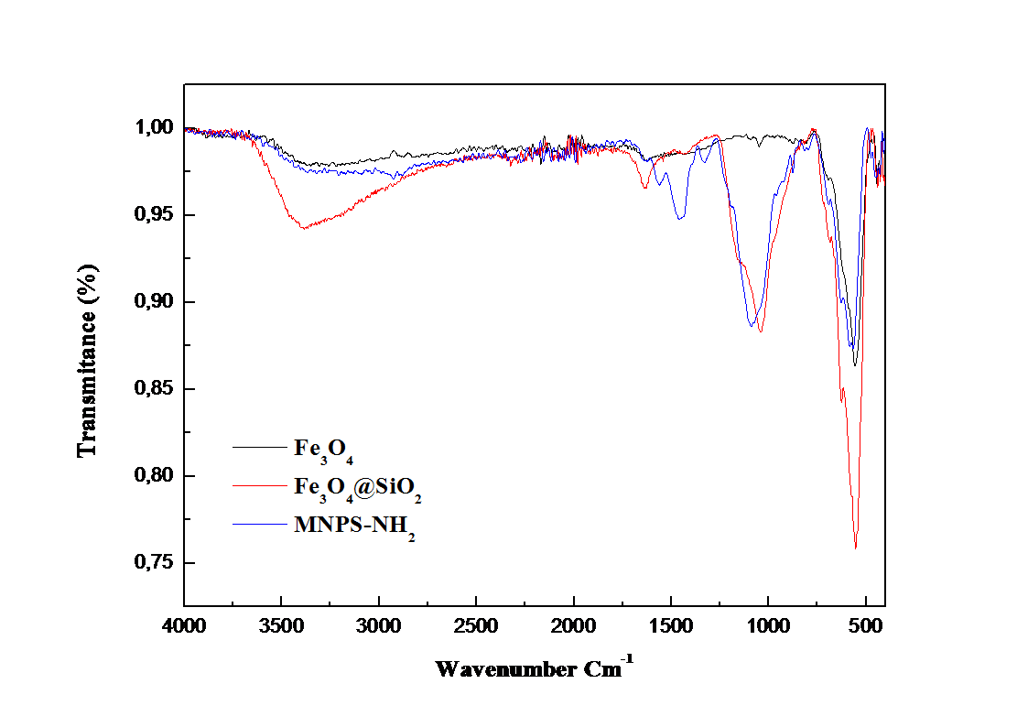

**Fig. S1.** FTIR spectra of MNPS magnetic nanoparticles.

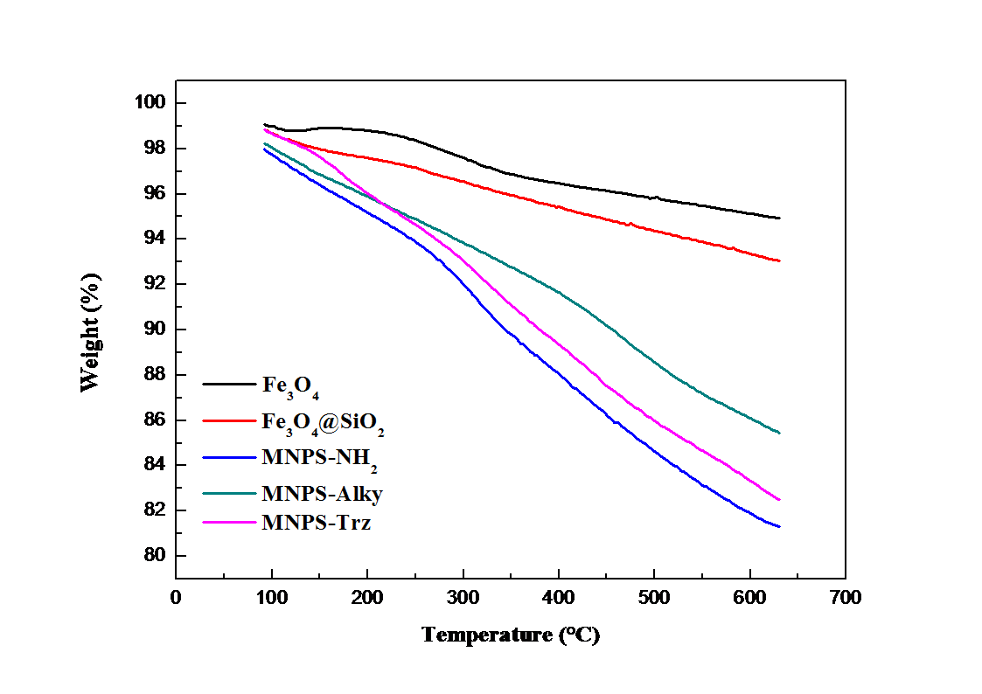

**Fig. S2.** TGA thermograms of MNPS magnetic nanoparticles



**Fig. S3.** Zeta potential of MNPS magnetic nanoparticles as function of pH in 1mM NaCl solution.

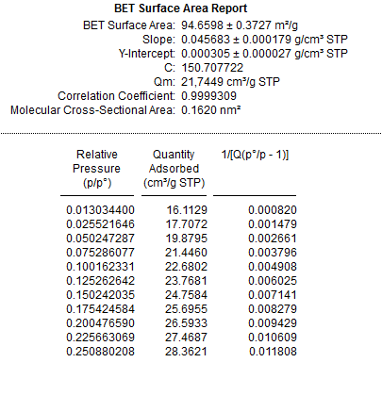

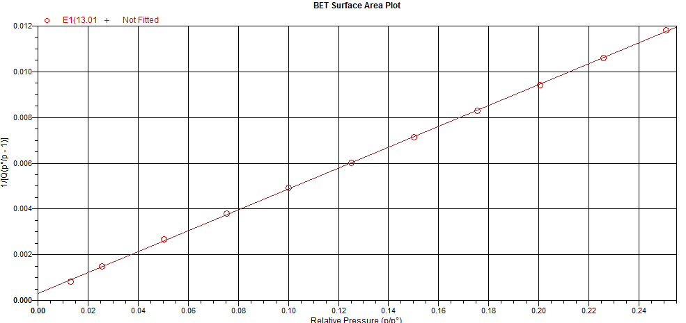

**Fig.S4.** BET data of Fe3O4 MNPs

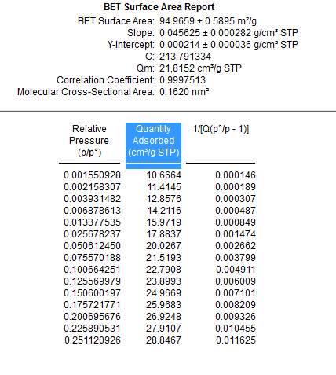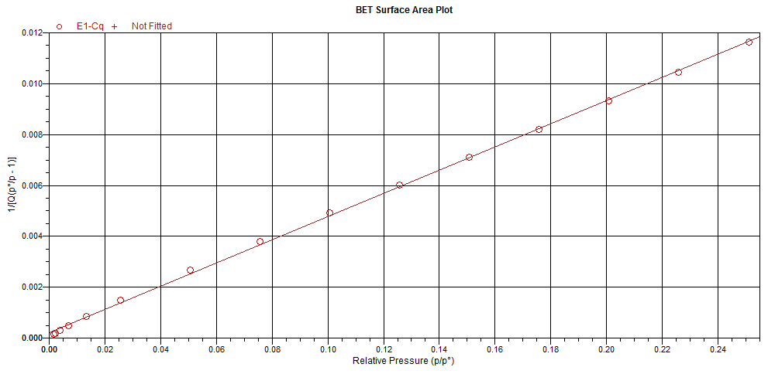

**Fig.S5.** BET data of Fe3O4@SiO2 MNPs

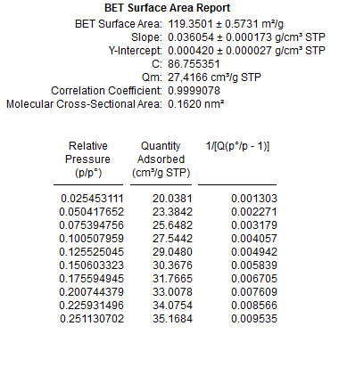

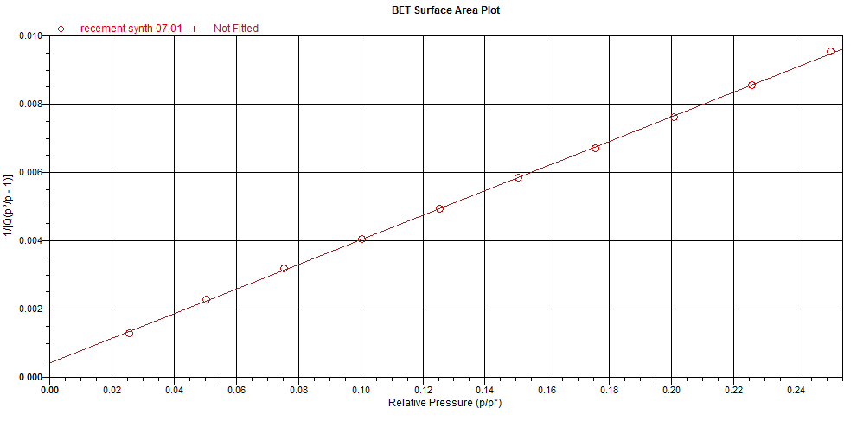

**Fig.S6.** BET data of MNP-Trz MNPs

**Table S1.** Overview of maximal adsorption capacity of various adsorbents for heavy metals

|  |  |  |  |  |  |
| --- | --- | --- | --- | --- | --- |
| **Sorbents** | **Adsorption capacity of ions (mg.g-1)** | | | **pH** | **Refs** |
| Cu2+ | Pb2+ | Zn2+ |
| Iron oxide nanoparticles | - | 36.0 | - | 5.5 | (Nassar 2010) |
| Amino-functionalized Fe3O4 @SiO2 core–shell magnetic nanomaterials | 29.84 | 76.66 | - | 6.2 | (Obata et al. 2008) |
| Magnetic particles modiﬁed with amino groups | 10.41 | - | - | 5.5 | (Lin et al. 2011) |
| Amino-functionalized magnetic nano-adsorbent | 12.4 | - | - | 5 | (Huang and Chen 2009) |
| Acrylic acid and crotonic acid copolymer-modiﬁed magnetic nanoparticles | 126.90 | 166.10 | 43.40 | 5.5 | (Ge et al. 2012) |
| Magnetic ϒ-Fe2O3 nanoparticles coated with poly-l-cysteine | 43.24 | 14.73 | 24. 59 | 7 | (White et al. 2009) |
| Amino-functionalized magnetic nanoparticles | 27.77 | - | - | 6 | (Hao et al. 2010) |
| Thiourea-modiﬁed magnetic chitosan microspheres | 66.70 | - | - | 5 | (Zhou et al. 2009) |
| Amino-functionalized Fe3O4 magnetic nanoparticles | - | 44.10 | - | 5 | (Tan et al. 2012) |
| Silica-supported dithiocarbamate magnetic particles | 20.36 | 70.40 | - | 5 | (Bai et al. 2011) |
| Gum Arabic modiﬁed magnetic nano-adsorbents | 38.50 | - | - | 5.1 | (Banerjee and Chen 2007) |
| Chitosan/magnetite composite beads | - | 63.30 | - | 6 | (Ray and Shipley 2015) |
| Glutaraldehyde magnetic nanoparticles | 61.07 | - | - | 4 | (Ozmen et al. 2010) |
| Carboxymethyl-β-cyclodextrin conjugated magnetic nanoparticles | 47.30 | - | - | 6 | (Badruddoza et al. 2011) |
| Xanthate-modiﬁed magnetic chitosan | 34.50 | 76.90 | 20.80 | 5 | (Zhu et al. 2012) |
| Aminodextran magnetic colloidal particles  Graphene oxide nanosheets decorated with Fe3O4 nanoparticles  Magnetic hydrogels | 11.62  18.26  105.61 | 100  -  126.40 | 40  - | 5  5.3 | (Chaabouni et al. 2013)  (Li et al. 2012)  (Ozay et al. 2010) |
| Triazole functionalized magnetic particles | 87.87 | 167.78 | 51.20 | 5.5 | this work |

Bai, L., Hu, H., Fu, W., Wan, J., Cheng, X., Zhuge, L., Xiong, L., Chen, Q., (2011) Synthesis of a novel silica-supported dithiocarbamate adsorbent and its properties for the removal of heavy metal ions. J. Hazard. Mater. 195, 261–275. doi: 10.1016/j.jhazmat.2011.08.038.

Chaabouni, A., Marzougui, Z., Elleuch, B., Eissa, M.M., Elaissari, A., 2013. Aminodextran Magnetic Colloidal Particles for Heavy Metals Removal. Sci. Adv. Mater. 5, 854–864. doi: 10.1166/sam.2013.1509.

Lin,Y., Chen, H., Lin, K., Chen, B., Chiou, C., 2011. Application of magnetic particles modified with amino groups to adsorb copper ions in aqueous solution. J. Environ. Sci. 23, 44–50. doi: 10.1016/S1001-0742(10)60371-3.

Ozay, O., Ekici, S., Baran, Y., Kubilay, S., Aktas, N.? Sahine, N., 2010. Utilization of magnetic hydrogels in the separation of toxic metal ions from aqueous environments. Desalination. 260, 57–64. doi: 10.1016/j.desal.2010.04.067.

Ozmen, M., Can, K., Arslan, G., Tor, A., Cengeloglu, Y., Ersoz, M., 2010. Adsorption of Cu(II) from aqueous solution by using modified Fe3O4 magnetic nanoparticles. Desalination. 254, 162–169. doi: 10.1016/j.desal.2009.11.043.

Tan, Y., Chen, M., Hao, Y., 2012. High efficient removal of Pb (II) by amino-functionalized Fe3O4 magnetic nano-particles. Chem. Eng. J. 191, 104–111. doi: 10.1016/j.cej.2012.02.075.

White, B.R., Stackhouse, B.T., Holcombe, J.A., 2009. Magnetic γ-Fe2O3 nanoparticles coated with poly-l-cysteine for chelation of As(III), Cu(II), Cd(II), Ni(II), Pb(II) and Zn(II). J. Hazard. Mater. 161, 848–853. doi: 10.1016/j.jhazmat.2008.04.105.

Zhou, L., Wang, Y., Liu, Z., Huang, Q., 2009. Characteristics of equilibrium, kinetics studies for adsorption of Hg(II), Cu(II), and Ni(II) ions by thiourea-modified magnetic chitosan microspheres. J. Hazard. Mater. 161, 995–1002. doi: 10.1016/j.jhazmat.2008.04.078.