SUPPORTING INFORMATION

Fig. S1 Comparison of photocatalytic degradation of 1,2-dichlorobenzene using photocatalyst A:T850/SnO₂/WO₃, B:T950/SnO₂/WO₃ and C:T1050/SnO₂/WO₃ under UV (λ = 365 nm, 12 watt) and fluorescence visible light source (λ > 400 nm, 36 watt) for 4 hours.

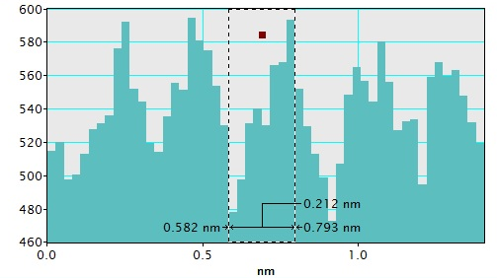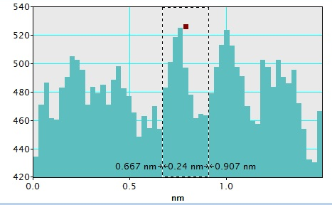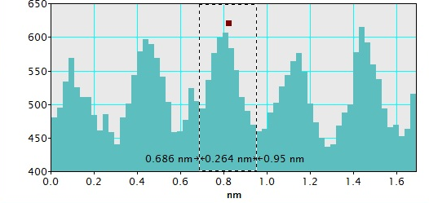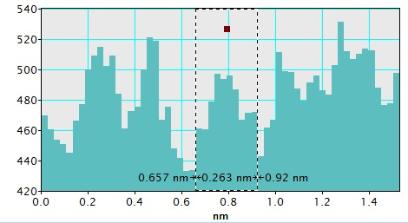
(a)
(b)
(c)
(d)
Fig. S2 HRTEM image for T950/SnO₂/WO₃ and the d-spacing for (a)TiO₂ (111), (b) TiO₂ (101), (c) SnO₂ (101) and (d) WO₃ (101).

Fig. S3 UV absorbance spectrum for photocatalytic degradation of 1,2-dichlorobenzene under visible light for 4 hours using T950/SnO₂/WO₃ photocatalyst immobilized on PVC. [DCB]=100ppm

Fig. S4 (i) Adsorption in dark and (ii) photocatalytic degradation of 1,2-dichlorobenzene T950/SnO₂/WO₃ immobilized on PVC film for 4 hours. [DCB]=100 ppm

Fig. S5 GCMS chromatography for the decomposition of 1,2-dichlorobenzene (DCB) before and after 4 hours irradiation under visible light using T950/SnO₂/WO₃ photocatalyst supported on PVC.

Table 3 Box–Behnken design experiments and experimental results
No. of Run | Calcination Temperature (°C) | Catalyst Loading (g) | pH | Observed Response (%) | Predicted Response (%)
1 | 850 | 0.25 | 5 | 86.71 | 86.69
2 | 850 | 0.20 | 7 | 87.14 | 87.12
3 | 850 | 0.40 | 7 | 85.60 | 85.68
4 | 850 | 0.25 | 9 | 87.10 | 87.06
5 | 950 | 0.10 | 5 | 91.67 | 91.71
6 | 950 | 0.40 | 5 | 89.68 | 89.63
7 | 950 | 0.25 | 7 | 95.52 | 95.70
8 | 950 | 0.25 | 7 | 95.49 | 95.70
9 | 950 | 0.25 | 7 | 95.89 | 95.70
10 | 950 | 0.25 | 7 | 95.73 | 95.70
11 | 950 | 0.25 | 7 | 95.86 | 95.70
12 | 950 | 0.10 | 9 | 92.10 | 92.15
13 | 950 | 0.40 | 9 | 90.57 | 90.53
14 | 1050 | 0.25 | 5 | 88.73 | 88.77
15 | 1050 | 0.10 | 7 | 89.98 | 89.90
16 | 1050 | 0.40 | 7 | 87.63 | 87.65
17 | 1050 | 0.25 | 9 | 89.71 | 89.73

Table 4 Analysis of variance (ANOVA) for photocatalytic efficiency from Box-Behnken Design
Source | Sum of Squares | Degree of Freedom | Mean Square | F-value | p-value Prob > F | Remark
Model | 210.60 | 9 | 23.40 | 1000.56 | <0.0001 | significant
A-Calcination Temp. | 11.28 | 1 | 11.28 | 482.38 | <0.0001
B-Catalyst Loading | 6.86 | 1 | 6.86 | 293.48 | <0.0001
C-pH | 0.90 | 1 | 0.90 | 38.68 | 0.0004
AB | 0.16 | 1 | 0.16 | 7.01 | 0.0330
AC | 0.087 | 1 | 0.087 | 3.72 | 0.0951
BC | 0.053 | 1 | 0.053 | 2.26 | 0.1763
A² | 128.60 | 1 | 128.60 | 5498.86 | <0.0001
B² | 28.11 | 1 | 28.11 | 1202.15 | <0.0001
C² | 18.73 | 1 | 18.73 | 800.80 | <0.0001
Residual | 0.16 | 7 | 0.023
Lack of Fit | 0.025 | 3 | 8.208E-003 | 0.24 | 0.8673 | not significant
Pure Error | 0.14 | 4 | 0.035
Cor. Total | 210.76 | 16
R² = 99.92%; Adj. R² = 99.82%; R² = 99.71%

