***Supporting Information***

**A synthesis of thioxo[3.3.3]propellanes from acenaphthoquinone-malononitrile adduct, primary amines and CS2 in water**

**Issa Yavari a,*, Aliyeh Khajeh-Khezri a, Mohammad Reza Halvagar b**

a *Department of Chemistry, University of Tarbiat Modares, PO Box 14115-175, Tehran, Iran*

b*Department of Inorganic Chemistry, Chemistry and Chemical Engineering Research Center of Iran, PO Box 14335-186, Tehran, Iran*

1. Molecular structure of product **6l**, Figure 1………………………………………….2

2. 1H and 13C NMR Spectra of the products **6a-m**…………………………………….....3



**Fig. 1.** Molecular structure and numbering scheme of **6l**; the thermal ellipsoids are drawn at the 40% probability level.

**S1:** 1H and 13C NMR spectra of 8-Amino-12-methyl-11-thioxo-9*a*,6*b* (epithiomethanoimino)acenaphtho[1,2-*b*]furan-9-carbonitrile (**6a**)

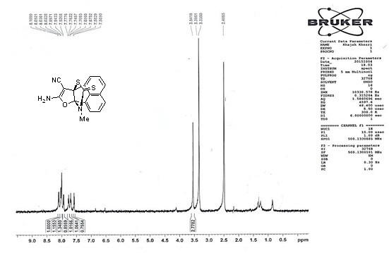

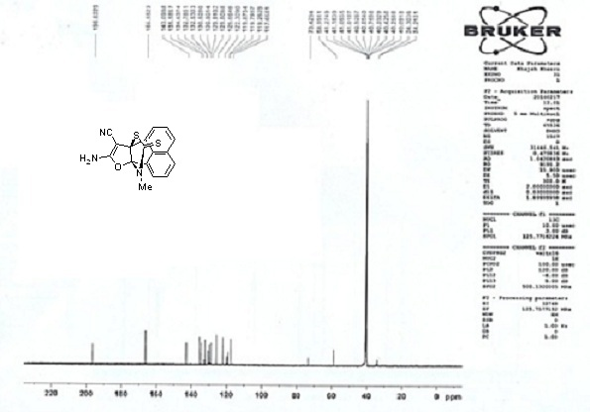

**S2:** 1H and 13C (C-H Coupling) NMR spectra of 8-Amino-12-ethyl-11-thioxo-9*a*,6*b*-(epithiomethanoimino)acenaphtho[1,2-*b*]furan-9-carbonitrile (**6b**)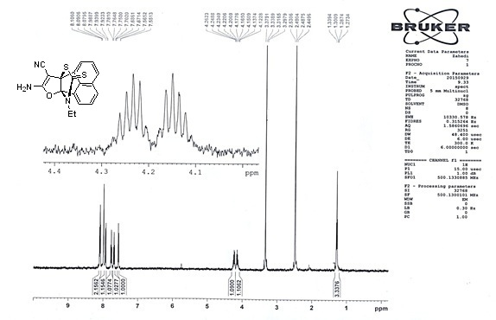

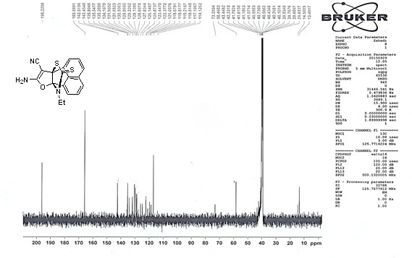

**S3:** 1H and 13C (C-H Coupling) NMR spectra of 8-Amino-12-propyl-11-thioxo-9*a*,6*b*-(epithiomethanoimino)acenaphtho[1,2-*b*]furan-9-carbonitrile (**6c**)

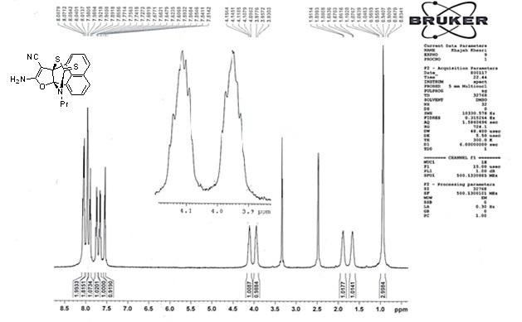

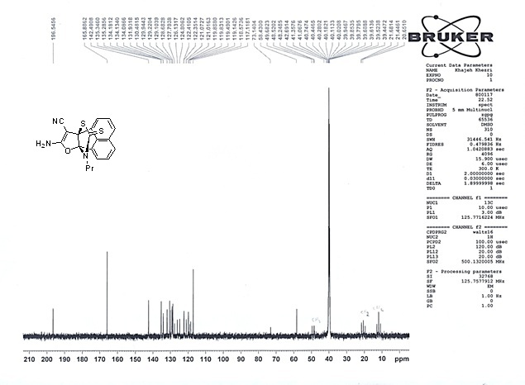

**S4:** 1H and 13C (C-H Coupling) NMR spectra of 8-Amino-12-butyl-11-thioxo-9*a*,6*b*-(epithiomethanoimino)acenaphtho[1,2-*b*]furan-9-carbonitrile (**6d**)

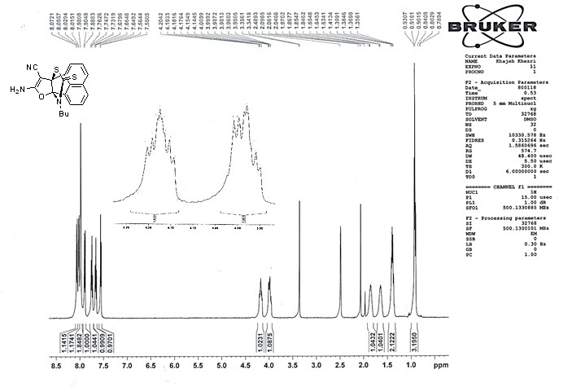

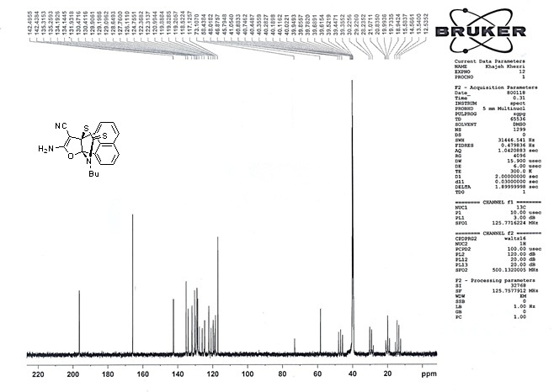

**S5:** 1H and 13C (C-H Coupling) NMR spectra of 8-Amino-12-benzyl-11-thioxo-9*a*,6*b*-(epithiomethanoimino)acenaphtho[1,2-*b*]furan-9-carbonitrile (**6e**)

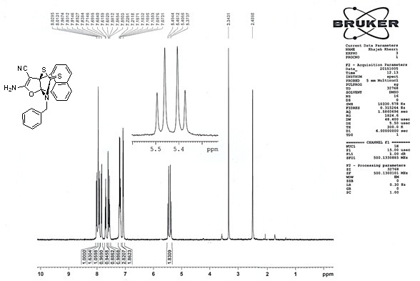

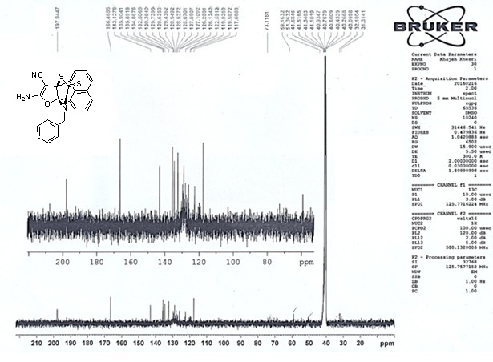

**S6:** 1H and 13C (C-H Coupling) NMR spectra of 8-Amino-12-(4-chlorobenzyl)-11-thioxo-9*a*,6*b*-(epithiomethanoimino)acenaphtho[1,2-*b*]furan-9-carbonitrile (**6f**)

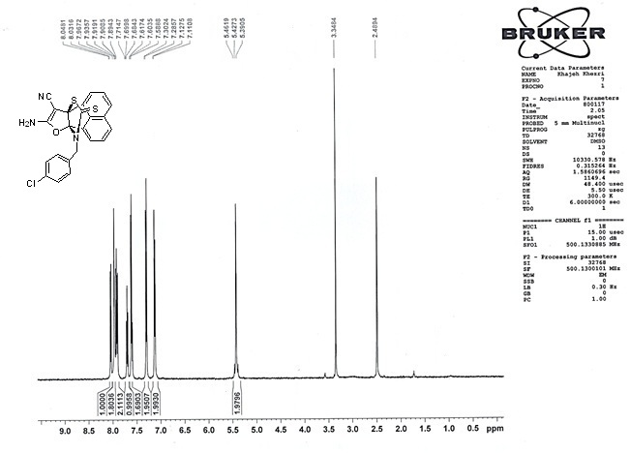

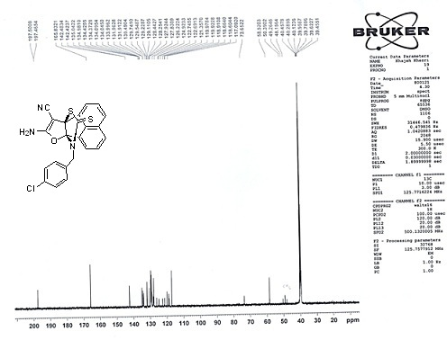

**S7:** 1H and 13C NMR spectra of 8-Amino-12-(2,4-dichlorobenzyl)-11-thioxo-9*a*,6*b*-(epithiomethanoimino)acenaphtho[1,2-*b*]furan-9-carbonitrile (**6g**)

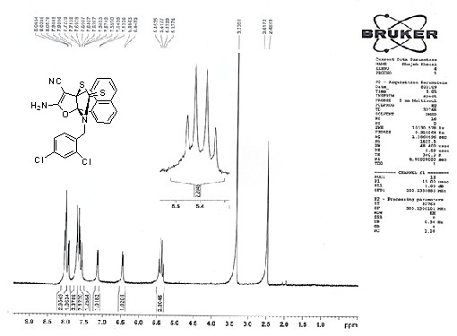

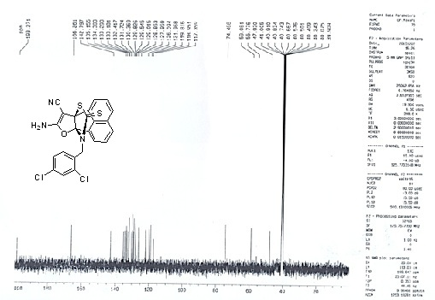

**S8:** 1H and 13C NMR spectra of 8-Amino-12-phenyl-11-thioxo-9*a*,6*b*-(epithiomethanoimino)acenaphtho[1,2-*b*]furan-9-carbonitrile (**6h**)

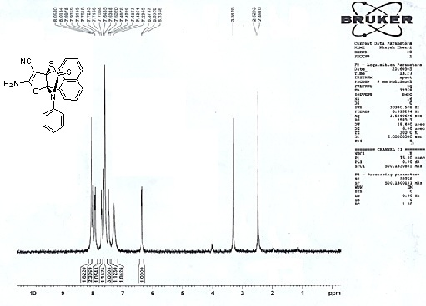

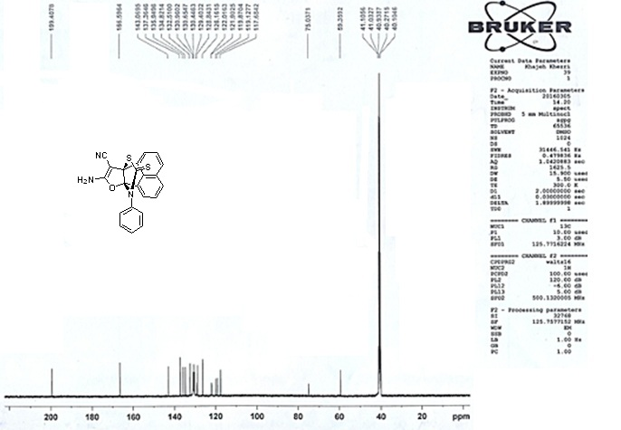

**S9:**1H and 13C (C-H Coupling) NMR spectra of 8-Amino-12-(4-methoxyphenyl)-11-thioxo-9*a*,6*b*-(epithiomethanoimino)acenaphtho[1,2-*b*]furan-9-carbonitrile (**6i**)

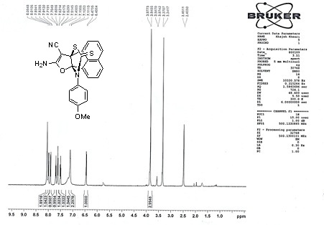

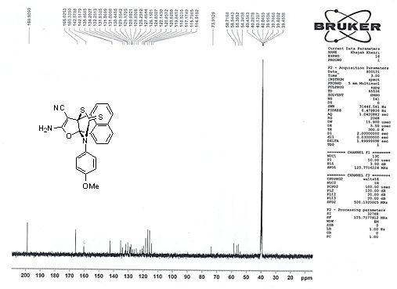

**S10:** 1H and 13C NMR spectra of 8-Amino-11-thioxo-12-(p-tolyl)-9*a*,6*b*-(epithiomethanoimino)acenaphtho[1,2-*b*]furan-9-carbonitrile (**6j**)

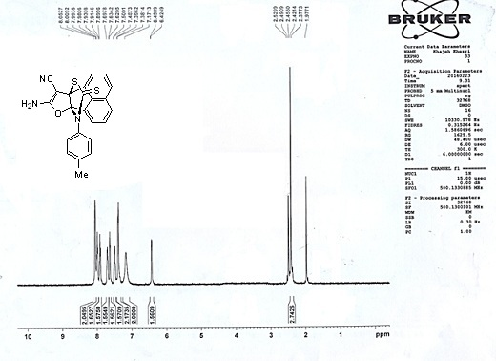

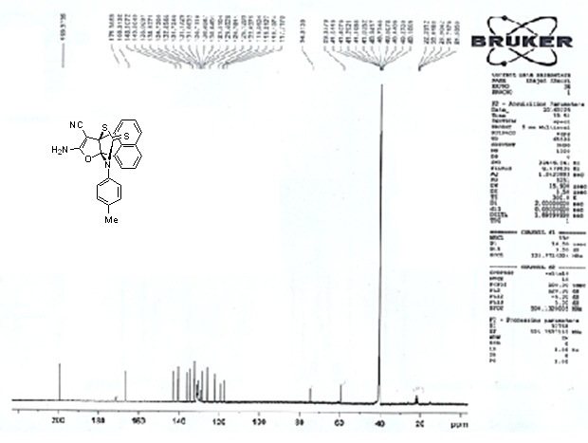

**S11:** 1H and 13C (C-H Coupling) NMR spectra ofEthyl-8-amino-12-ethyl-11-thioxo-9*a*,6*b*-(epithiomethanoimino)acenaphtho[1,2-*b*]furan-9-carboxylate (**6k**)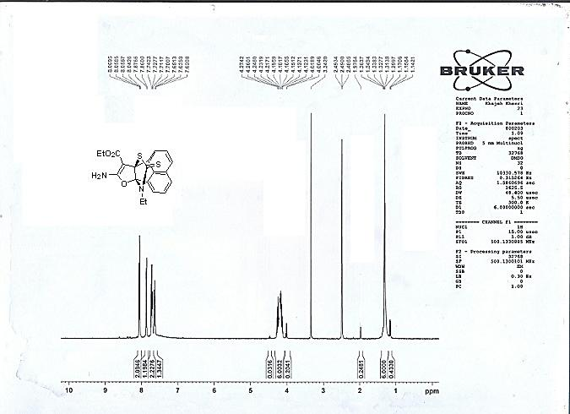

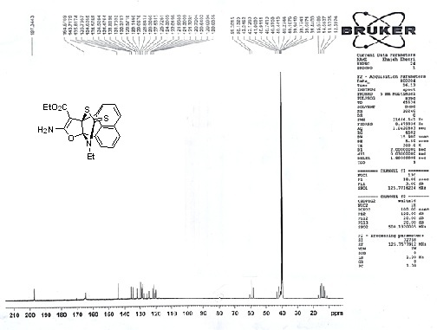

**S12:** 1H and 13C NMR spectra ofEthyl-8-amino-12-(4-chlorobenzyl)-11-thioxo-9*a*,6*b*-(epithiomethanoimino)acenaphtho[1,2-*b*]furan-9-carboxylate (**6l**)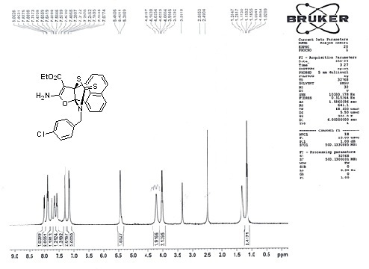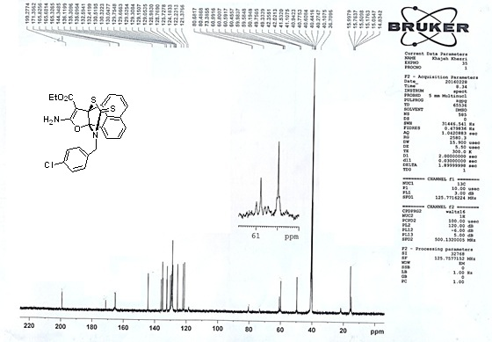

**S13:** 1H and 13C NMR spectra of Ethyl-8-amino-12-(4-methoxyphenyl)-11-thioxo-9*a*,6*b*-(epithiomethanoimino)acenaphtho[1,2-*b*]furan-9-carboxylate (**6m**)

