**Supporting Information**

**Journal:** Arabian Journal of Chemistry

**Title:** “Synthesis of 2D boron nitride doped polyaniline hybrid nanocomposites for photocatalytic degradation of carcinogenic dyes from aqueous solution”

**Authors:** Syed Shahabuddina*, Rashmin Khanam b, Mohammad Khalidc, Norazilawati Muhamad Sarihd , Juan Joon Chinge, Sharifah Mohamadd, and R. Saidur a,f *

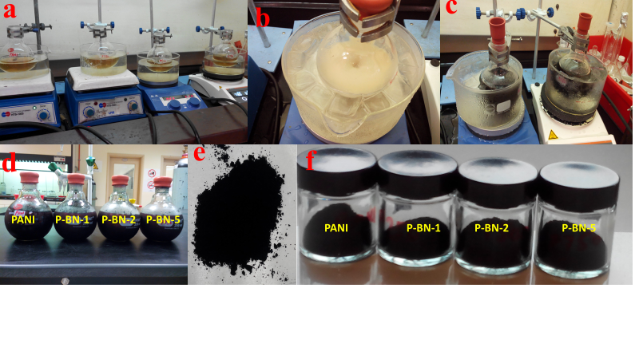

**Figure S1*.*** Experimental set up for the synthesis of PANI nanotube and h-BN nanosheets doped nanocomposites. (a) Round bottom flask with monomer equipped with stir bar (b) Reaction vessel with ice bath to maintain 0-5° C (c) Change in color of reaction mixture as an indication for polymerization (d) Completion of reaction after over night cooling (e) Drying and grinding of the obtained product and (f) Final PANI nanotubes and h-BN nanosheets nanocomposites stored in air tight jars.

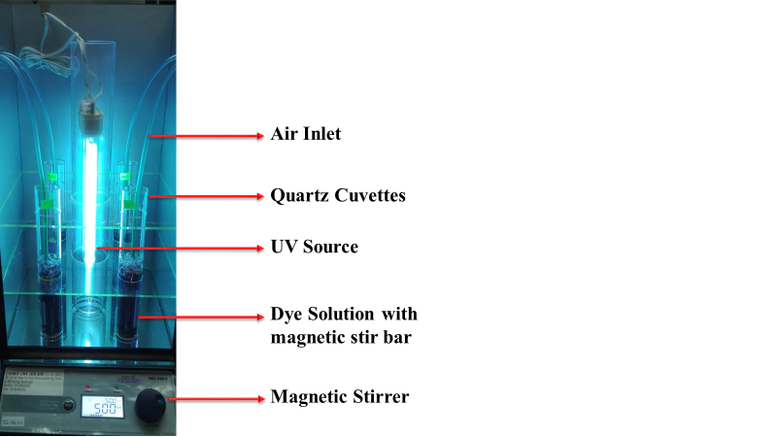

**Figure S2.** Photocatalytic chamber used for photocatalytic degradation of dyes.

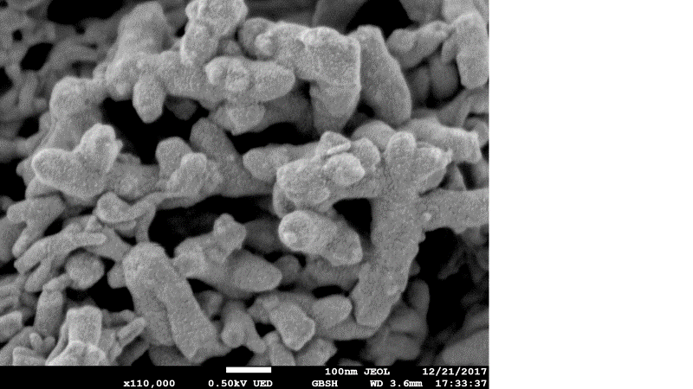

**Figure S3.** FESEM micrographs of P-BN-5 at higher magnification



**Figure S4.** FTIR spectrum of h-BN nanosheets doped nanocomposites.