**SUPPLEMENTARY FILE**

**Dispersion Test of GO in Polar and Non-polar solvent**

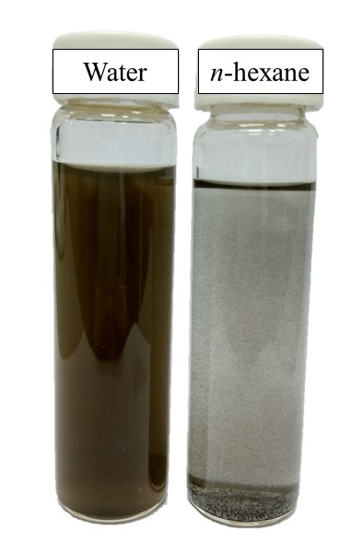

**Figure S1.** Comparison between the dispersion of 0.05 w/v% GO in water (polar) and *n*-hexane (non-polar) after 30-min ultrasonication. GO dispersed well in aqueous solution whereas it settled to the bottom of organic solvent very fast.

**Fabrication of TFN Membrane by Incorporating GO in PIP aqueous solution via Rolling IP Technique**

|  |  |
| --- | --- |
| **(a)** | **(b)** |
| **(c)** |

**Figure S2.** (a) Demonstration of the uneven distribution of GO nanosheets on the microporous substrate surface after pouring away amine aqueous solution containing 0.01 w/v% GO. The substrate was contacted with the solution for 2 min before pouring away and subject to rolling process (b, c) Amine aqueous solution before and after being used for substrate pouring. The images indicated that most of the GO nanosheets were not deposited on the substrate surface.

**Protein Adsorption Study on Fabricated Membranes**

**Methodology**

The protein adsorption tests were done by treating circular membrane sample with diameter of 48 mm with 250 mL of BSA solution (250 ppm). The conical flasks containing the protein solution and samples were shaken using an orbital shaker for 3 h. The absorbances of initial and final protein solutions were measured using an UV-vis spectrophotometer (DR 5000TM, Hach) at wavelength of 285 nm. The concentration of BSA solution was then interpolated based on the absorbance result.

**Table S1.** Protein adsorption capabilities of TFC and TFN membranes.

|  |  |
| --- | --- |
| **Membrane** | **Mass of BSA absorbed per specific area**  **(g/m2)** |
| TFC | 2.03 |
| TFC-f | 1.95 |
| TFN-f 0.03 | 0.56 |