**Synthesis of functionalized Cu:ZnS nanosystems and its antibacterial potential**

**C. Chalihaa, B.K. Natha, P. K. Vermab, E. Kalitaa\***

a. Department of Molecular Biology and Biotechnology, Tezpur University, Tezpur, Assam, 784028, India

b. National Institute of Plant Genome Research, Aruna Asaf Ali Marg, P.O. Box No. 10531,

New Delhi - 110 067

**\***Corresponding author. Tel.: +91 3712 275411

E-mail address: ekalita@tezu.ernet.in, eeshankalita@gmail.com

**Supplementary**

**Table S1.** Elemental composition of the as-synthesized nanosystems from EDX analysis

|  |  |  |  |  |
| --- | --- | --- | --- | --- |
| **Element** | **Weight %** | | **Atomic %** | |
| **MSA@**  **Cu:ZnS** | **SC@**  **Cu:ZnS** | **MSA@**  **Cu:ZnS** | **SC@**  **Cu: ZnS** |
| Zn | 45.66 | 18.01 | 19.49 | 7.09 |
| S | 2.54 | 0.88 | 2.21 | 0.70 |
| Cu | 9.23 | 31.76 | 4.05 | 12.86 |
| O | 42.57 | 49.36 | 74.24 | 79.35 |

**Table S2.** Ratio of Zn:Cu for the 1h time variant from EDX and MP-AES analysis

|  |  |  |
| --- | --- | --- |
| **Synthesized nanosystems** | **EDX** | **MP-AES** |
| MSA@Cu:ZnS | 4:1 | 3:1 |
| SC@Cu:ZnS | 1:2 | 1:3 |

**Table S3.** Area of zone of inhibition for native Cu:ZnS nanosystem against *E.coli* and *B.subtillis* for 1h-5h time variants.

|  |  |  |  |
| --- | --- | --- | --- |
| Refluxed variants | Concentration of nanosystems (mgml-1) | Area of zone of inhibition (cm²) | |
| *E.coli* | *B.subtillis* |
| 1 h | 5 | 0.38 ± 0.02 | ▬ |
| 8 | 0.64 ± 0.01 | ▬ |
| 10 | 0.79 ± 0.04 | 1.33 ± 0.01 |
| 2 h | 5 | ▬ | ▬ |
| 8 | 0.28 ± 0.03 | 0.35 ± 0.04 |
| 10 | 0.5 ± 0.01 | 0.95 ± 0.04 |
| 3 h | 5 | ▬ | ▬ |
| 8 | ▬ | ▬ |
| 10 | ▬ | 0.78 ± 0.02 |
| 4 h | 5 | ▬ | ▬ |
| 8 | ▬ | ▬ |
| 10 | ▬ | 0.72 ± 0.03 |
| 5 h | 5 | ▬ | ▬ |
| 8 | ▬ | ▬ |
| 10 | ▬ | 0.48 ± 0.03 |

**Table S4.** Area of zone of inhibition for MSA and SC against *E.coli* and *B.subtillis*

|  |  |  |  |
| --- | --- | --- | --- |
|  | Concentration (mgml-1) | Area of zone of inhibition (cm²) | |
| *E.coli* | *B.subtillis* |
| MSA | 5 | ▬ | ▬ |
| 8 | ▬ | ▬ |
| 10 | ▬ | ▬ |
| SC | 5 | ▬ | ▬ |
| 8 | ▬ | ▬ |
| 10 | ▬ | ▬ |

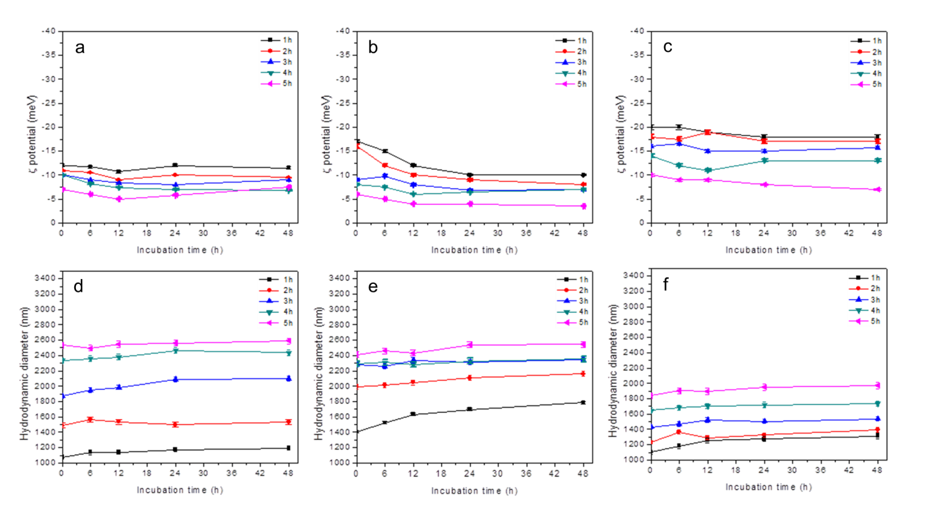

**Fig. S1.** ζ potential of Cu:ZnS at pH 2(a), 7(b) and 12(c) and Hydrodynamic diameter Cu:ZnS at pH 2 (d), 7(e) and 12(f)



**Fig. S2.** Concentration of Zn and Cu leachate in comparison to the concentration of total Zn and Cu in the synthesized variants