Figure 1 shows an overview of the X-ray emission lines identified in the XRF spectrum of the doped graphene. The presence of iodine in the sample is confirmed through observation of K-series X-ray emission lines. Two strong peaks for I-KA and I-K-B1 corresponding to iodine are observed in the XRF spectrum of each sample analyzed.

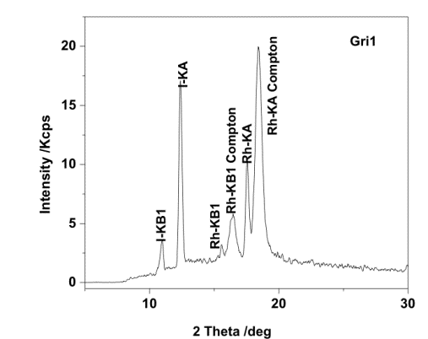 a) | 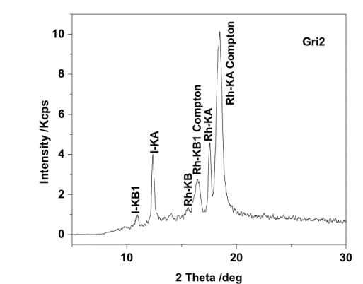b)
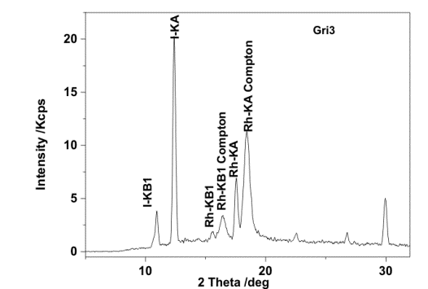c) | 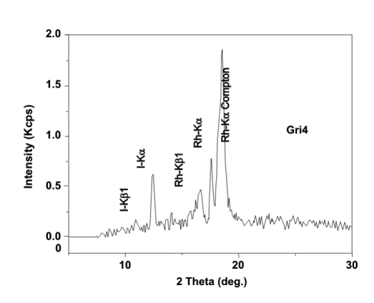d)
Figure 1. Iodine XRF spectra of iodine doped graphene samples: a) GrI 1, b) GrI 2, c) GrI 3 and d) GrI 4

The BET surface area was obtained from the nitrogen adsorption–desorption isotherms shown in figure 2. The isotherms were similar exhibiting a typical type IV curve at low relative pressure and a hysteresis loop at relative pressure from 0.4, indicating the presence of microporosity, mesoporosity, and some macroporosity.
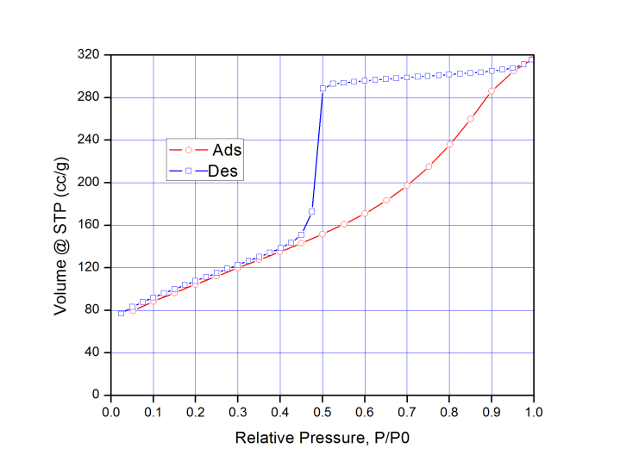
Figure 2. The adsorption–desorption isotherms for iodine doped graphene

