**Supporting Figures Captions:**

**Fig. S1.** FTIR spectra of (a) GO, (b) RGO and (c) ILRGO

**Fig. S2.** Contact angle measurements of (a) RGO and (b) ILRGO

**Fig. S3.** CVs of (a) PEDOT modified electrode and (b) PEDOT/ILRGO modified electrode at different scan rates from 10, 20, 40, 50, 75 and 100 mV/s using 5 mM [Fe(CN)6]-3/-4 in 0.1M KCl as a redox probe in 0.1 M PBS (inset showing the graph between peak current vs. (scan rate)1/2)

**Fig. S4.** Anson plots of ( • ) PEDOT and ( ♦ ) PEDOT/ILRGO coated electrodes

**Fig. S5.** DPVs of prepared sensor at varying (a) pH, (b) enzyme concentration, (c) concentrations of ATChI, and (d) incubation time.

**Fig. S6.** Current response of biosensor in (a) absence of pesticide, (b) presence of pesticide, (c) ascorbic acid, (d) Cd (II), (e) citric acid, (f) Cu(II), (g) Ni (II) (h) urea and (i) uric acid

**Fig. S7.** Calibration plots of apple juice obtained by spiking with (a) chlorpyrifos (b) malathion and (c) methyl parathion.

**Fig. S8.** Calibration plots of aerated beverages obtained by spiking with (a) chlorpyrifos (b) malathion and (c) methyl parathion.

**Supporting Table captions**

**Table S1**Various parameters obtained from calibration curve of all three pesticides

|  |  |  |  |
| --- | --- | --- | --- |
| **Parameters** | **Chlorpyrifos** | **Malathion** | **Methyl parathion** |
| **Slope (b)** | 2.44× 10-4 | 4.033× 10-4 | 4.46× 10-4 |
| **Intercept** | 0.00168 | 0.00165 | 0.00181 |
| **SD** | 3.28 × 10-6 | 1.579 × 10-5 | 1.62 × 10-5 |
| **Correlation coefficient** | 0.998 | 0.993 | 0.984 |
| **LOD (ng ml-1)** | 0.04 | 0.117 | 0.108 |
| **LOQ (ng ml-1)** | 0.134 | 0.39 | 0.363 |
| **Sensitivity** | 0.00168 | 0.00165 | 0.00181 |

final IR.tif



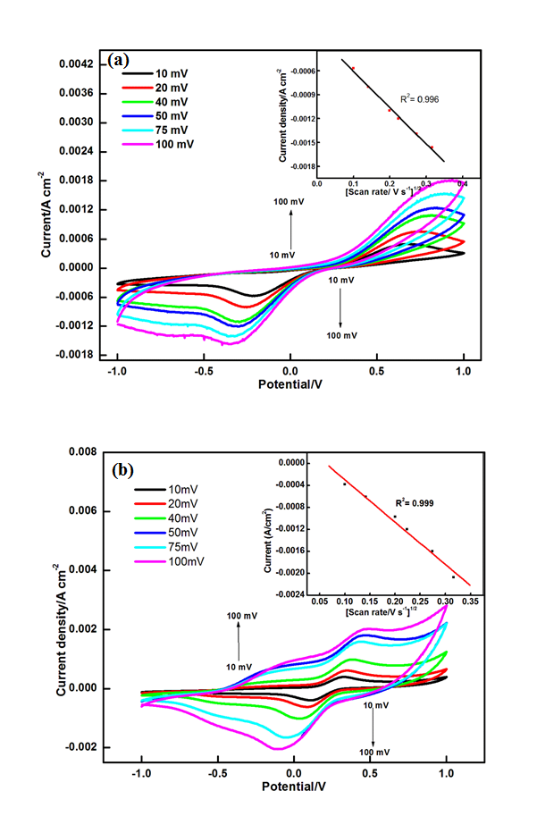







*Interference studies:*

The interference due to some common reagents was also studied to ensure that there is no concern caused by them. The signal of ATChI was compared with signal obtained in presence of other potential interfering species such as ascorbic acid, Cd (II), citric acid, Cu (II),Ni (II), urea and uric acidafter biosensor was incubated in pesticide of desired concentration. For this 5mM of each of these substances were added to electrochemical cell containing pesticides. As seen in graph no significant observable changes in peak currents were observed on addition of any of these compounds (Fig. S6). This indicates acceptable specificity and selectivity of the prepared system.

**

**