SUPPLEMENTARY MATERIAL
Total Synthesis and Anticancer activity of a cyclic heptapeptide from Marine sponge using water soluble peptide coupling agent EDC
M. Anand, M. Alagar, V. Selvaraj*
*Department of Chemistry, University College of Engineering Villupuram (A Constituent College of Anna University, Chennai-600 02), Kakuppam, Villupuram-605103, Tamil nadu, India
*Corresponding author: e-mail rajselva_77@yahoo.co.in, Phone: 01462-224500, Fax:01462-224500

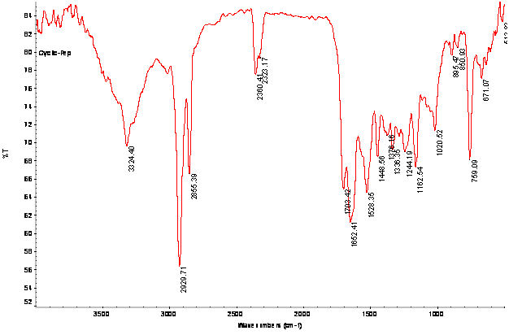

Figure 1: FTIR Spectrum of Euryjanicin A (8)

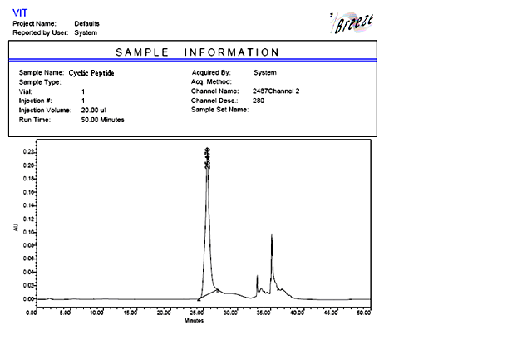
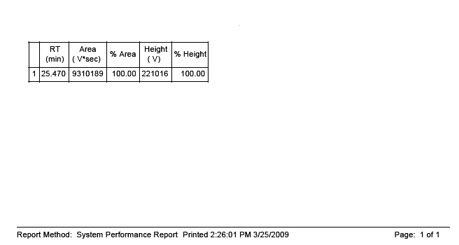

Figure 2: Preparative Chromatogram of Purified Cyclic heptapeptide (8)

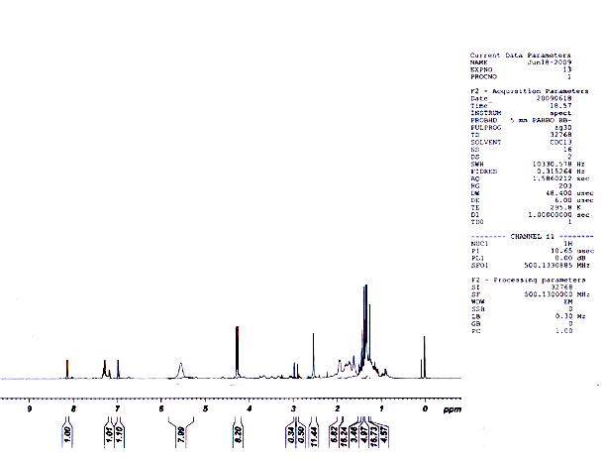

Figure 3: ¹H NMR Spectrum of Euryjanicin A (8).
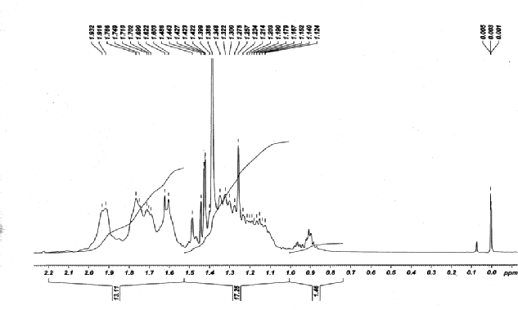

Enlarged Spectrum of Cyclic heptapeptide (8)

Figure 4: ¹³C NMR Spectrum of Euryjanicin A (8)

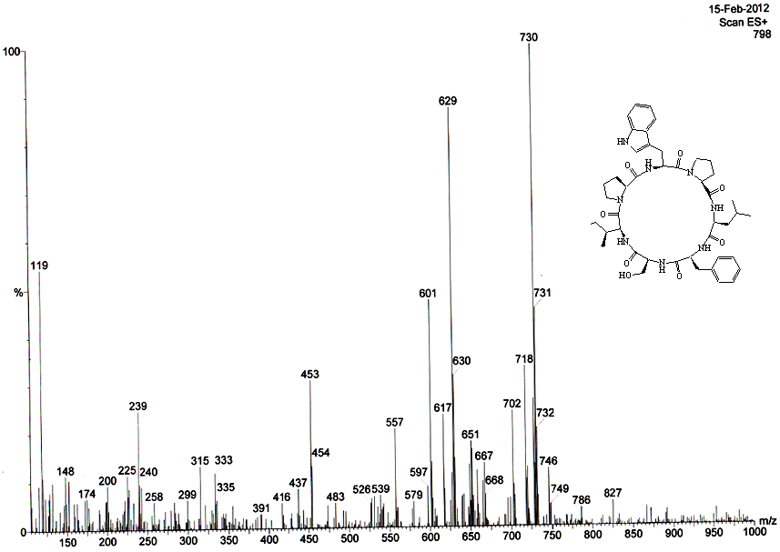

Figure 5: Mass Spectrum of Euryjanicin A (8).

