**Supplementary Material for Manuscript 2**

**SM 1. Characterization of adsorbents**

Infra-red (FT-IR) spectra of the synthesized adsorbent was obtained using Perkin Elmer Spectrum 1 FTIR spectrophotometer, using the scanning frequency of 4000–450 cm-1, to confirm the functional groups introduced as a result of the cross linking reaction. 0.1 mg of the cross linked starch polymer adsorbent in powdered form along with KBr were ground into fine particles and pressed to make pellets, which was used to obtain the FT-IR spectra.

Dry weight-based carbon, hydrogen and nitrogen contents of the synthesized adsorbents were determined by Elementar (Germany) Vario Macro Cube elemental analyzer to investigate the carbon content/hydrophobicity, polarity, level of aromaticity, polarizability, and the degree of the cross-linking before and after modification. Since the content of other elements are negligible, the oxygen content (fO) was calculated by equation of fO = 100 –fC − fH – fN.

Scanning Electron Micrographs (SEM images) were taken using Hitachi S4800 model Scanning Electron Microscope to study the effect of the cross linking process on the surface morphology of pristine starch and the adsorbents.

Brunauer Emmett Teller (BET) method was adopted for the surface area and pore analysis. ASAP 2020 Model (Micromeritics) was used to study the surface characteristics using N2 adsorption. The surface area was determined from the BET plot of the N2 adsorption data at liquid N2 temperature (77 K) and relative pressures (P/Po) between 0.02 and 0.20. 8 data points were used to construct the plot to derive the monolayer adsorption capacity, from which the surface area was calculated using the N2 molecular area of 16.2E-20 m2. The open surface areas and the micropore volumes were determined from t-plots by use of the N2 adsorption data. Perkin Elmer model Thermogravimetric and Differential Thermal Analysis (TGA/DTA) was used to investigate the thermal behaviour, phase changes and decomposition pattern of the prepared adsorbents.

**SM 2. Data Treatment**

To gain more insight into the kinetic mechanism, the kinetic data generated were modeled into the pseudo first order (Lagergren, 1898), pseudo second order (Ho and Mckay, 1998), Morris-Weber intra-particle diffusion and liquid film diffusion models (Qiu et al., 2009) as shown in equations S2.1-S2.4 respectively.

 S2.1

 S2.2

where,  and  are the amounts of PAHs adsorbed (mg/g) at equilibrium and at any time, t respectively,  (l/min) is the pseudo-first order rate constant, and  (g/mg/min) is the pseudo-second order rate constant. The initial rate constant *h,* was calculated as . The values of , , and  for pseudo second order model were computed from the plots of *t/qt* vs. *t*, while the values of , and for pseudo first order were computed from the plots of  vs. .

 S2.3

 S2.4

where  is the intra-particle diffusion rate constant,  is a constant related to adsorption on the surfaces of the pores,  (min-1) is liquid film diffusion constant which is a function of radius of adsorbent beads and the thickness of liquid film, while  and  are as previously explained.

To obtain some insights into the surface properties and degree of affinity of the adsorbent, sorption data has been fitted into Langmuir, Freundlich, and BET equilibrium isotherms using the linear forms of these models (Febrianto et al., 2008) as shown in equations S2.5 – S2.7.

Langmuir Equation  S2.5

Freundlich Isotherm  S2.6

where *qmax* (mg/g) and qe is the maximum adsorption and amount of solute adsorbed per unit weight of adsorbent (mg/g), respectively. *Ce* is same as above; *KL, Kf,* and *n* are isotherm constants obtained from the slopes and intercepts.

BET isotherm  S2.7

where *Cs* is the saturation concentration (solubility limit) of the solute in mg/L, *KB* is a constant related to the energy of interaction with the surface and the subsequent layers of adsorbates and *Q0* is the amount of solute adsorbed per unit weight of adsorbent in forming a complete monolayer on the surface.

The thermodynamic parameters of enthalpy (*ΔH)*, entropy (*ΔS)* and free energy change (*ΔG*) of the adsorption process were evaluated with equations S2.8 and S2.9

 S2.8

 S2.9

where *qe* and *Ce* are as explained initially, *T* is the absolute temperature in Kelvin (K) and *R* is universal gas constant (8.3144 J **·** mol -1 **·** K -1).

C:\Users\nnenna\Desktop\Manuscripts\P2 folder\P2 FTIR Update.tif

Fig. S1: Infra-red spectra of the cross-linked adsorbents

**C:\Users\a\Desktop\Adsorbent dose\ads dose combined 2.tif**

Figure S2: Effect of varying adsorbent dose on the sorption of phenanthrene for (a) MDIS and (b) HDIS adsorbents

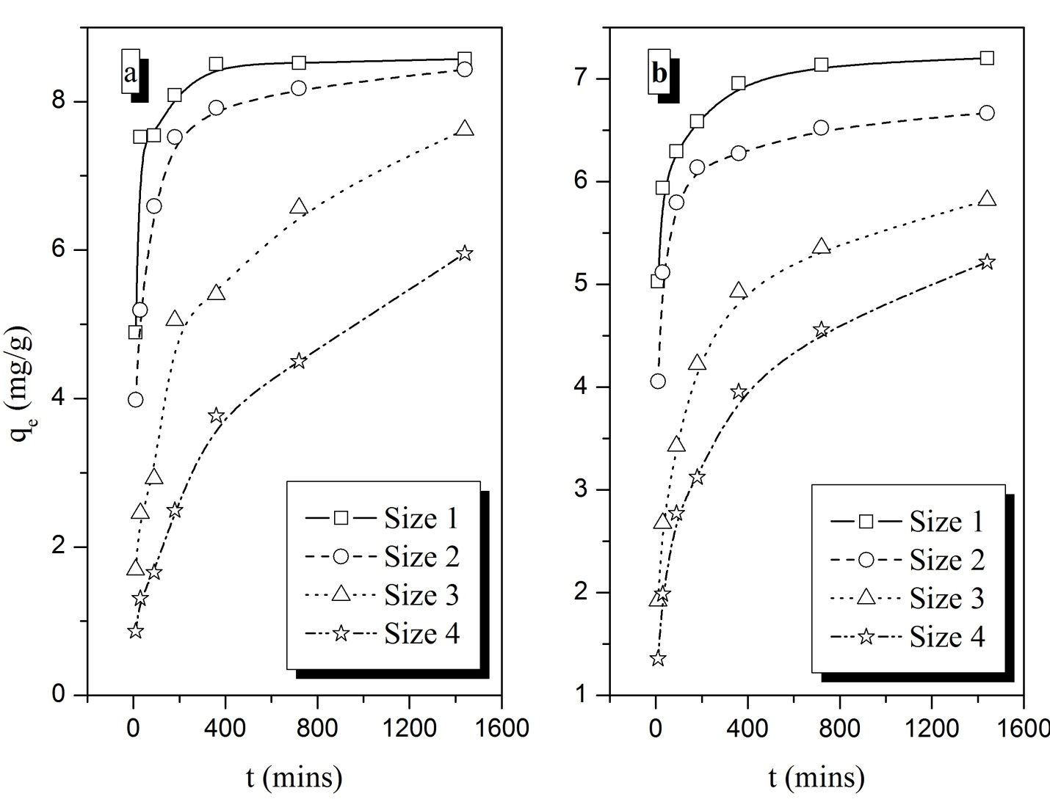

Fig. S3. Plot showing the effect of particle size on adsorption rate and equilibrium capacity of fluorene adsorption on (a) MDIS and (b) HDIS adsorbents

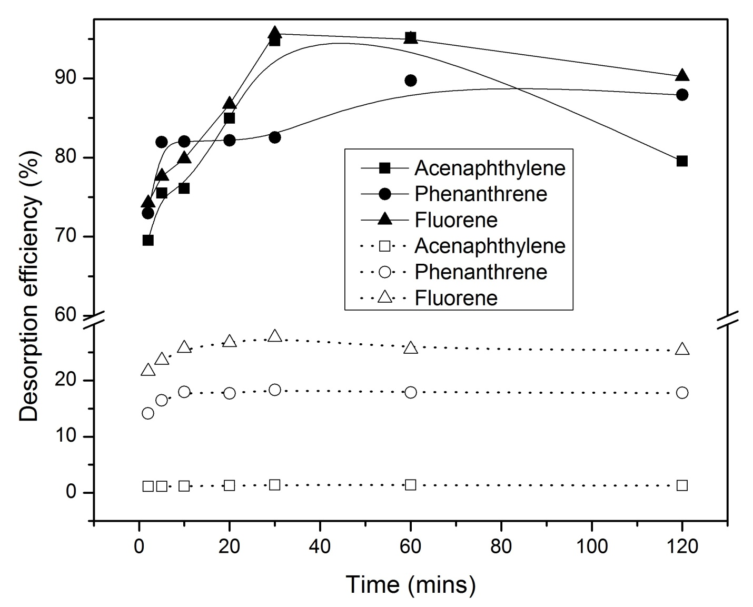

Fig. S6. Plot of effect of contact time on the desorption efficiency of MDIS (solid lines) and HDIS (dotted lines)

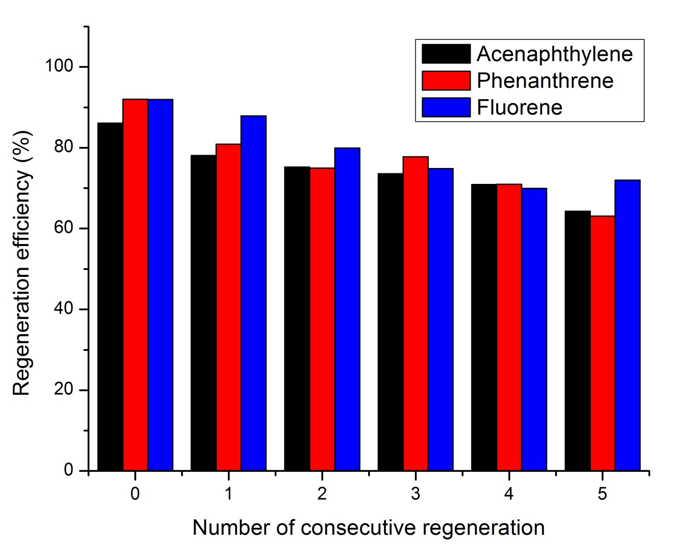

Fig. S7. Bar chart showing the regeneration efficiency of MDIS adsorbent

Table S1. Elemental composition of EPIAS and EPIMAS sets of adsorbents.

|  |  |  |  |  |  |  |  |  |
| --- | --- | --- | --- | --- | --- | --- | --- | --- |
| **Starch Adsorbent** | **Volume of amination reagent (mL)** | **N%** | **C%** | **H%** | **O%** | **C/H Ratio** | **N/C Ratio** | **(O+N)/C Ratio** |
| EPIAS 1 | 5.0 | 3.39 | 43.32 | 6.59 | 46.71 | 6.57 | 0.08 | 1.16 |
| EPIAS 2 | 10.0 | 6.79 | 43.24 | 6.60 | 43.38 | 6.55 | 0.15 | 1.16 |
| EPIAS 3 | 20.0 | 8.15 | 42.92 | 6.71 | 42.22 | 6.40 | 0.18 | 1.17 |
| EPIMAS1 | 10.0 | 4.92 | 42.67 | 6.24 | 46.17 | 6.84 | 0.12 | 1.20 |
| EPIMAS2 | 20.0 | 5.87 | 43.10 | 6.50 | 44.53 | 6.63 | 0.14 | 1.17 |
| EPIMAS3 | 30.0 | 7.14 | 43.13 | 6.80 | 42.93 | 6.35 | 0.17 | 1.16 |

**Table S2.** Pseudo second order model parameters for adsorption of fluorene using different adsorbent particle sizes

|  |  |  |  |  |  |  |  |  |
| --- | --- | --- | --- | --- | --- | --- | --- | --- |
| **Adsorbent** | **MDIS** | | | | **HDIS** | | | |
| **Particle size** | **1** | **2** | **3** | **4** | **1** | **2** | **3** | **4** |
| *k2* | 0.0135 | 0.0053 | 0.0012 | 0.0008 | 0.0124 | 0.0100 | 0.0030 | 0.0021 |
| *r2* | 1.0000 | 0.9998 | 0.9877 | 0.9584 | 0.9999 | 0.9998 | 0.9974 | 0.9913 |
| *qe expt. (mg/g)* | 8.5770 | 8.4315 | 7.6205 | 5.9550 | 7.1990 | 6.6880 | 5.8185 | 5.2150 |

Table S3. Effect of hardness (Ca2+), salinity (Na+), and pH on the adsorption behaviour of MDIS adsorbent

|  |  |  |  |  |  |
| --- | --- | --- | --- | --- | --- |
| Ca2+ (mg/L CaCO3) | (mg/g) | Na+ (Molarity) | (mg/g) | pH | (mg/g) |
| 0.00 | 4.5505 | 0.00 | 4.5140 | 3.5 | 4.5395 |
| 75.0 | 4.5410 | 0.01 | 4.5020 | 5.0 | 4.5010 |
| 100.0 | 4.5795 | 0.05 | 4.4920 | 6.5 | 4.5495 |
| 125.0 | 4.5390 | 0.10 | 4.4520 | 8.0 | 4.5384 |
| 150.0 | 4.6045 | 0.25 | 4.6250 | 9.5 | 4.6254 |
| 175.0 | 4.7543 | 0.50 | 4.9770 | 11.0 | 4.8812 |

Table S4. Isotherm model parameters for adsorption of PAHs

|  |  |  |  |  |
| --- | --- | --- | --- | --- |
|  | **Phenanthrene** | | **Acenaphthylene** | |
| **Model Parameters** | **MDIS** | **HDIS** | **MDIS** | **HDIS** |
| Langmuir Isotherm | |  |  |  |
| *KL* | 6.13424 | 0.9486 | 0.5100 | 0.2255 |
| *qmax* | 31.7158 | 11.5514 | 13.5501 | 13.3160 |
| *R2* | 0.9669 | 0.8223 | 0.9202 | 0.8604 |
| Freundlich Isotherm | |  |  |  |
| *Kf* | 46.2732 | 10.5548 | 12.1490 | 4.0261 |
| *n* | 1.4560 | 1.2257 | 0.76703 | 0.8044 |
| *R2* | 0.8219 | 0.8304 | 0.9254 | 0.7464 |
| BET Isotherm | |  |  |  |
| *KB* | 45.6703 | 4.6736 | 1.2594 | 1.0700 |
| *Qo* | 7.5239 | 4.2087 | 25.6386 | 10.7634 |
| *R2* | 0.8728 | 0.4889 | 0.2295 | 0.2492 |

Table S5. Pseudo second order (PSO) model parameters for adsorption of PAHs at different temperatures

|  |  |  |  |  |  |
| --- | --- | --- | --- | --- | --- |
|  | **Temp** | **K2** | **R2** | **qe** | **h** |
| **Phenanthrene** |  |  |  |  |  |
|  | 25oC | 0.0038 | 0.9994 | 9.2593 | 0.3292 |
| MDIS | 45oC | 0.0054 | 0.9993 | 9.1600 | 0.4497 |
|  | 60oC | 0.0095 | 0.9996 | 8.9831 | 0.7682 |
|  |  |  |  |  |  |
|  | 25oC | 0.0208 | 0.9999 | 6.4103 | 0.8564 |
| HDIS | 45oC | 0.0245 | 0.9998 | 6.7806 | 1.1255 |
|  | 60oC | 0.0253 | 0.9994 | 6.7159 | 1.1416 |
| **Acenaphthylene** |  |  |  |  |  |
|  | 25oC | 0.0034 | 0.9992 | 18.5632 | 1.1844 |
| MDIS | 45oC | 0.0058 | 0.9999 | 20.2061 | 2.3709 |
|  | 60oC | 0.0065 | 0.9999 | 20.7814 | 2.7899 |
|  |  |  |  |  |  |
|  | 25oC | 0.0053 | 0.9994 | 16.1238 | 1.3883 |
| HDIS | 45oC | 0.0092 | 0.9999 | 18.4536 | 3.1227 |
|  | 60oC | 0.0153 | 1.0000 | 19.3237 | 5.7168 |