Supplementary Material - Analyses of Gas Cromatography – Mass Spectrometer (GC-MS)

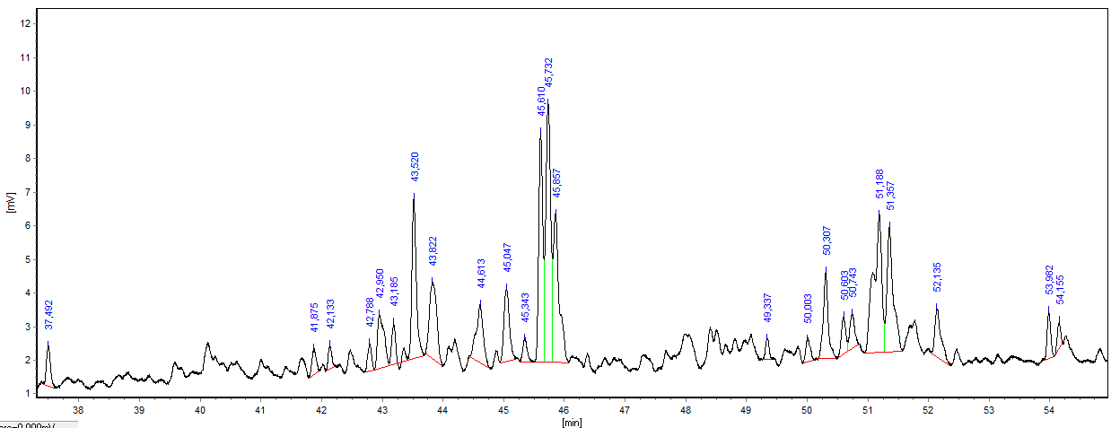

S1 – Cromatogram of volatile fractions from *Pterodon emarginatus* oil fruits.

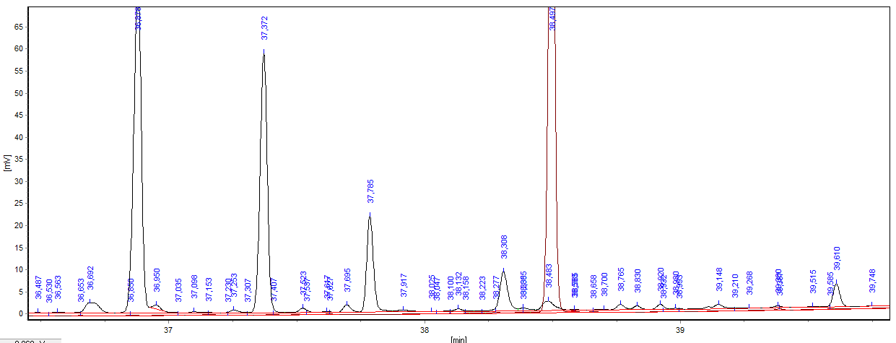

S2 – Cromatogram of fatty acids and squalene