**Supplementary material**

**Synthesis of isosorbide bis(methyl carbonate) by transesterification of isosorbide with dimethyl carbonate, and evidence of its usefulness as a monomer for manufacturing polycarbonates**

José R. Ochoa-Gómez,* Silvia Gil-Río, Belén Maestro-Madurga, Olga Gómez-Jiménez-Aberasturi, and Soraya Prieto-Fernández.

Tecnalia Research & Innovation, Department of Biorefinery, Parque Tecnológico de Álava, Leonardo Da Vinci 11, 01510 Miñano, Spain.

* Corresponding Author: José R. Ochoa-Gómez. E-mail: [jramon.ochoa@tecnalia.com](mailto:jramon.ochoa@tecnalia.com). Tel: (34) 629087981. Fax: (34) 945198117.

This Supporting Information has the total number of 7 pages, and it contains 6 figures, all of them related to the identification of isosorbide bis(methyl carbonate) by 1H-NMR and 13C-NMR.

Spectra were obtained in a Bruker Avance (500 MHz) spectrometer at room temperature using DMSO-d6 as a solvent. 1H-NMR were recorded at 500 MHz while 13C-NMR at 126 MHz.

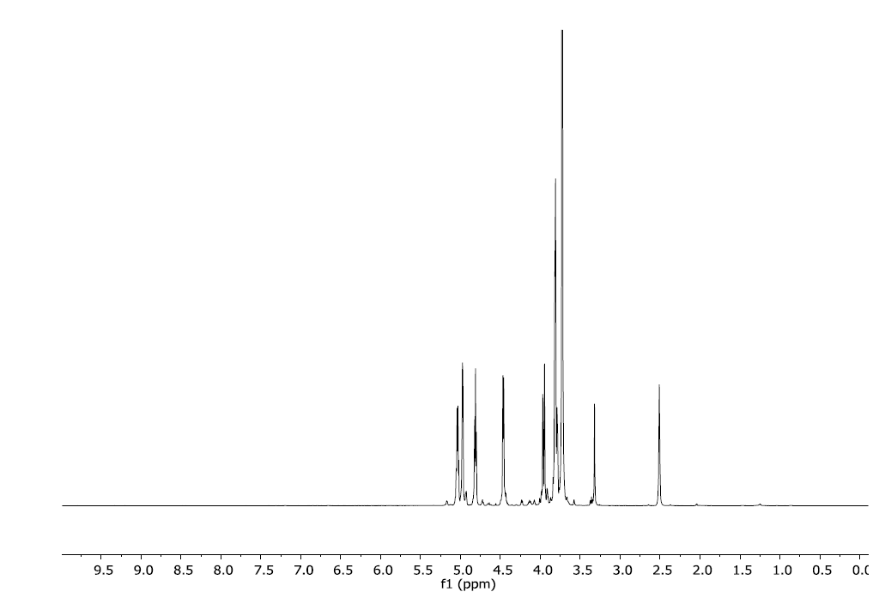

**Figure S1**. 1H-NMR spectrum,



**Figure S2.** 1H-NMR spectrum magnification between 3.5 and 5.3 ppm, showing the values of integrals.

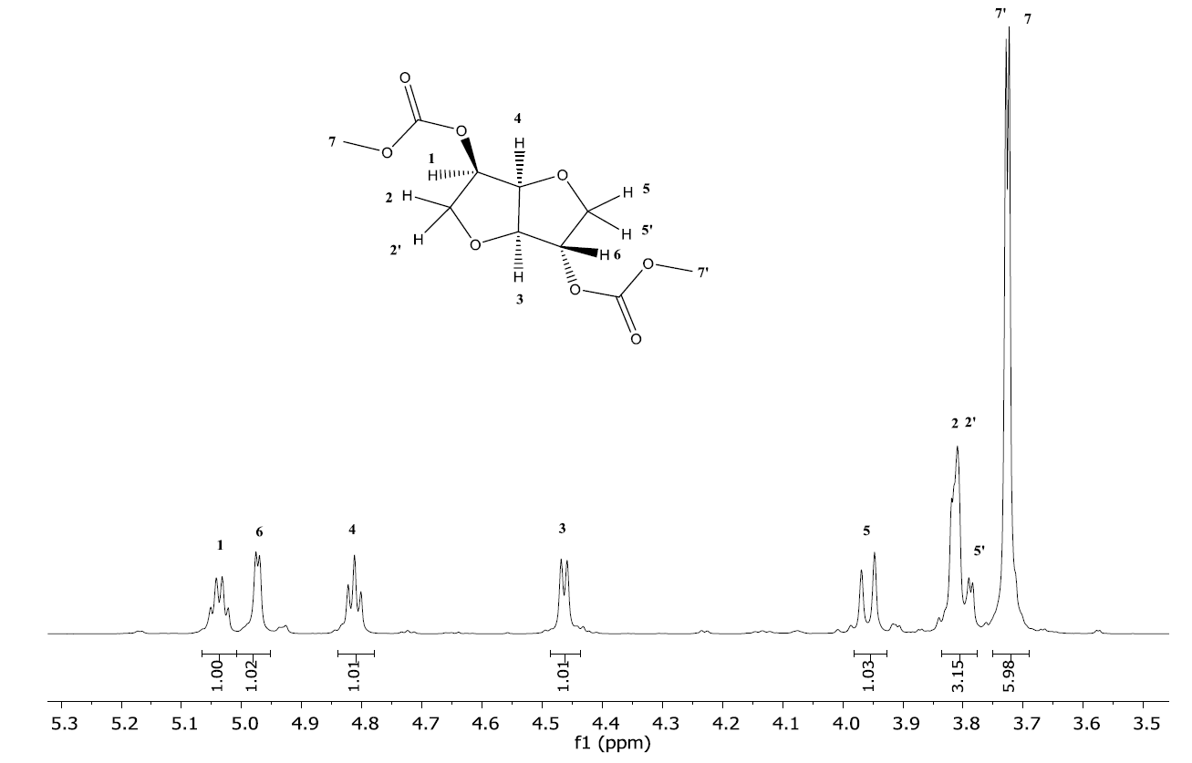

**Figure S3**. Assignment of 1H-NMR signals.

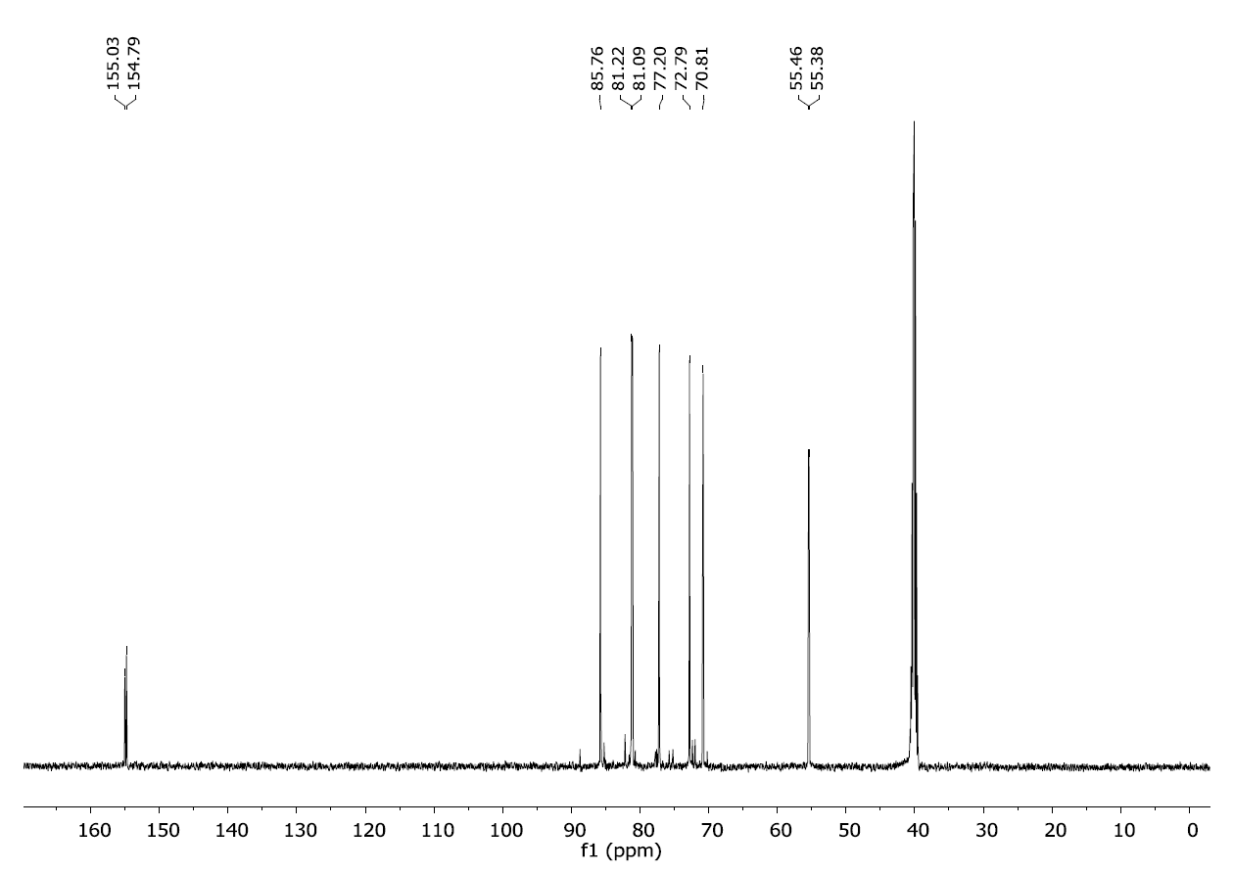

**Figure S4.** 13C-NMR spectrum.

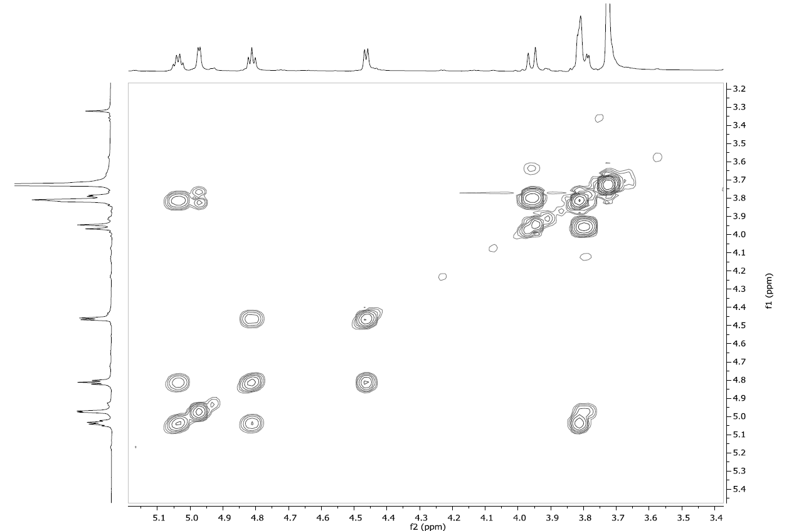

**Figure S5**. Homonuclear correlation spectrum, COSY.

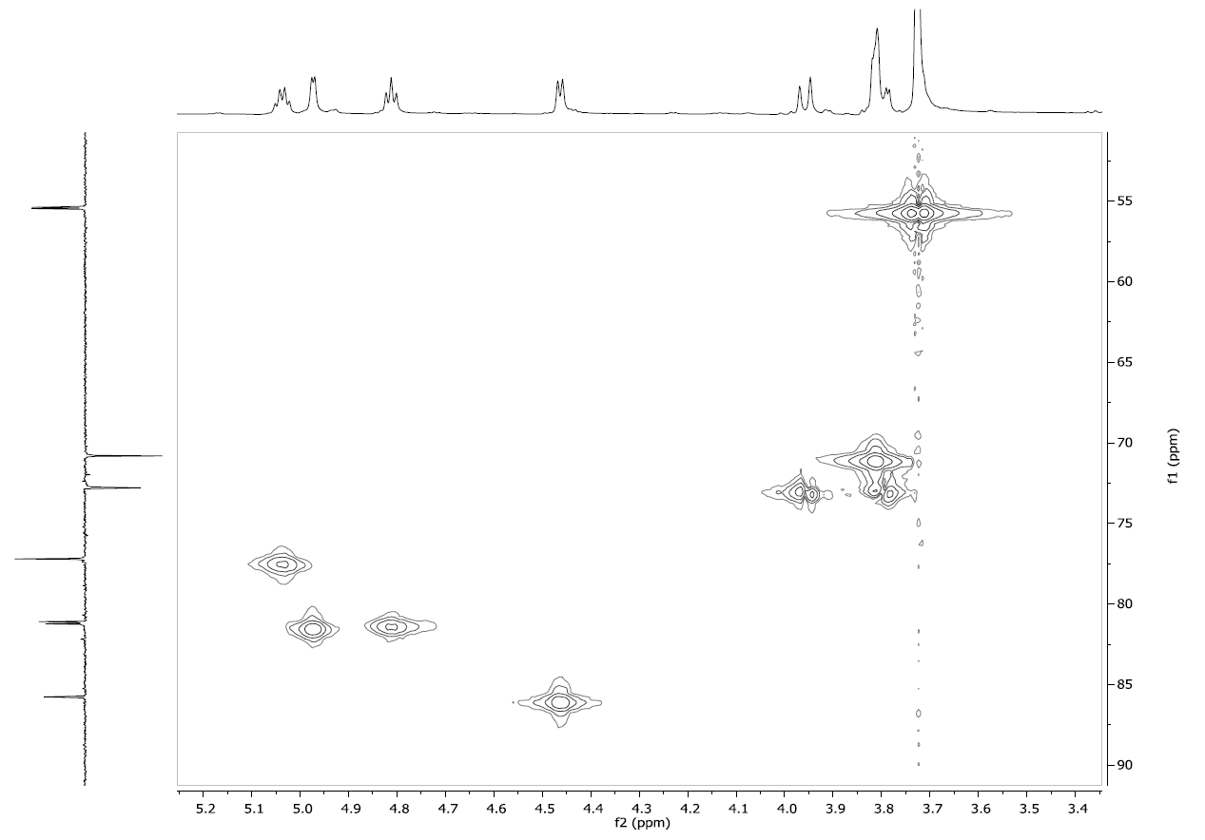

**Figure S6.** Correlation spectrum 1H-13C HMQC.