**Supporting Information**

**for**

**Magnetically recoverable *γ*-Fe2O3 nanoparticles as a sustainable and highly active catalyst for Friedel–Crafts benzoylation reaction under ultrasound irradiation**

**Table of contents**

**Section S1** Syntheses of Materials S2-S3

**Section S2** Recycling of *γ*-Fe3O4 nanoparticles S3

**Section S3** 1H and 13C NMR, GC-MS Data S4-S8

**Section S4** References S8

**Section S5** 1H and 13C NMR spectra S10-S22

**Section S1.** Syntheses of Materials

**Methods:**

**Chemicals and supplies.** Anisole (analytical standard, ≥ 99.9%), benzoyl chloride (≥ 99%), benzene (≥ 99%), 1,2-dimethoxybenzene (≥ 99%), ethoxybenzene (≥ 99%), 1,3-dimethoxybenzene (> 98%), 1,4-dimethoxybenzene (assay > 99%), 1,2,4-trimethoxybenzene (≥ 97%), mesitylene (GC, ≥ 99%), *m*-xylene (≥ 98%), *p*-xylene (≥ 99%), anthracene (≥ 97%), naphthalene (≥ 99%), 1-methylnaphthalene (≥ 95%) were purchased from Sigma-Aldrich. Silica gel 230–400 mesh (for flash chromatography) was obtained from HiMedia Laboratories Pvt. Ltd. (India). TLC (silica gel 60 F254) was bought from Merck. Ethyl acetate (≥ 99.5%), petrolium ether 60 – 90, chloroform (≥ 99%) were from Xilong Chemical Co., Ltd (China). Chloroform-*d*, 99.8% was obtained from Armar (Switzerland).

All starting materials, reagents and solvents were directly used without further purification.

**Analytical instruments**.

For ultrasound reaction, the ultrasonic bath Elma S30H was used. Powder X-ray diffraction (PXRD) patterns were recorded using a Bruker D8 Advance operated at 40 kV and 40 mA with a Ni filtered Cu Kα radiation (λ = 1.54178 Å) source, scanning rate 2° per min and 2θ angle ranging from 10° to 70°. The morphology of the sample was examined by transmission electron microscopy (TEM) using JEOL JEM 1400 with operating voltage at 100 kV. The magnetization of the sample was measured in the varied magnetic field between −16 and 16 kOe at room temperature using a vibrating sample magnetometer (VSM/Microsense, EV11, USA). Ultrasound irradiation was performed on an Elma apparatus. GC-MS analyses were performed on an Agilent GC System 7890 equipped with a mass selective detector Agilent 5973N and a capillary DB-5MS column (30 m × 250 μm × 0.25 μm). The 1H and 13C NMR spectra were recorded on a Bruker Advance 500 using CDCl3 as the solvent and solvent peaks or TMS as the internal standards.

Section S2. Recycling of *γ*-Fe2O3 nanoparticles

The recycling of *γ*-Fe2O3 nanoparticlescatalyst was carried out in the Friedel-Crafts benzoylation of anisole under sonification for 120 min. The recovery of catalyst is easy by external magnet. Due to its high stability in our method, *γ*-Fe2O3 nanoparticlescatalyst was easily recovered in a quantitative yield. After being washed with ethyl acetate, the catalyst was dried under vacuum and used for next cycle without further purification. Owning the easy of recovery and stability under this method, *γ*-Fe2O3 nanoparticlescatalyst was reused over six consecutive times without any significant loss in reactivity and regioselectivity. This is promising for its application on industrial processes. The process for recycling *γ*-Fe2O3 nanoparticlesis simple and effective so it could be applied on a large scale.

**Section S3.** 1H and 13C NMR, GC-MS data

**Benzophenone** 1,2,4

**1H NMR** (500 MHz, CDCl3): *δ* 7.81 – 7.59 (m, 4H), 7.55 (m, 2H), 7.45 (m, 4H).

**13C NMR** (125 MHz, CDCl3): *δ* 196.7, 137.6, 132.4, 130.1, 128.3.

**GC-MS** (EI, 70 eV) *m/z*: 182 ([M]+)

**4-methoxybenzophenone1,3,6**



**1H NMR** (300 MHz, CDCl3): *δ* 7.86-7.81 (m, 2H), 7.75 (dd, *J* = 8.3, 1.4 Hz, 2H), 7.55 (d, *J* = 7.5 Hz, 1H), 7.49-7.44 (m, 2H), 6.96 (d, *J* = 9.0 Hz, 2H), 3.88 (s, 3H).

**13C NMR** (75 MHz, CDCl3) *δ* 195.6, 163.2, 138.3, 132.6, 131.9, 130.2, 129.8, 128.2, 113.6, 55.5.

**GC-MS** (EI, 70 eV): *m/z* 212 (M+).

**3,4-dimethoxybenzophenone5**



**1H NMR** (300 MHz, CDCl3): *δ* 7.77 (dd, *J* = 8.4, 1.4 Hz, 2H), 7.49 (s, 1H), 7.46-7.36 (m, 3H), 6.90 (m, 2H), 3.96 (s, 3H), 3.95 (s, 3H).

**13C NMR** (75 MHz, CDCl3) *δ* 195.6, 153.0, 149.0, 138.3, 131.9, 130.2, 129.7, 128.2, 125.5, 112.1, 109.7, 56.1, 56.0.

**GC-MS** (EI, 70 eV): *m/z* 242 (M+).

**2,4-dimethoxybenzophenone5**



**1H NMR** (300 MHz, CDCl3): *δ* 7.77 (dd, *J* = 8.4, 1.4 Hz, 2H), 7.49 (s, 1H), 7.42 (dt, *J* = 1.8, 0.6 Hz, 1H), 7.39 (s, 2H), 6.53 (dd, *J* = 9.6, 5.3 Hz, 2H), 3.86 (s, 3H), 3.69 (s, 3H).

**13C NMR** (75 MHz, CDCl3) *δ* 195.6, 163.4, 159.6, 138.8, 132.3, 132.2, 129.7, 128.0, 121.5, 104.6, 98.8, 55.6, 55.5.

**GC-MS** (EI, 70 eV): *m/z* 242 (M+).

**2, 5-dimethoxybenzophenone4,5**



**1H NMR** (300 MHz, CDCl3): *δ* 7.84-7.80 (m, 2H), 7.57-7.52 (m, 1H), 7.47-7.38 (m, 2H), 7.01 (dd, *J* = 9.0, 3.0 Hz, 1H), 6.92 (dd, *J* = 6.0, 3.0 Hz, 2H), 3.78 (s, 3H), 3.66 (s, 3H).

**13C NMR** (75 MHz, CDCl3) *δ* 196.2, 153.5, 151.5, 137.6, 133.0, 129.8, 128.2, 117.3, 114.4, 113.1, 56.3, 55.8.

**GC-MS** (EI, 70 eV): *m/z* 242 (M+).

**2, 4, 5-trimethoxybenzophenone4**



**1H NMR** (500 MHz, CDCl3): *δ* 7.76 (d, *J* = 8.2 Hz, 2H), 7.51 (t, *J* = 6.8 Hz, 1H), 7.40 (t, *J* = 7.6 Hz, 2H), 7.02 (s, 1H), 6.55 (s, 1H), 3.94 (s, 3H), 3.83 (s, 3H), 3.64 (s, 3H).

**13C NMR** (125 MHz, CDCl3): *δ* 195.5, 153.4, 152.6, 143.3, 139.0, 132.3, 130.1, 129.5, 128.4, 128.0, 120.1, 113.6, 97.8, 56.6, 56.5, 56.2.

**GC-MS** (EI, 70 eV): *m/z* 272 (M*+*).

**2, 4, 6-trimethylbenzophenone4**



**1H NMR** (500 MHz, CDCl3): *δ* 7.80 (d, *J* = 7.2 Hz, 2H), 7.57 (t, *J*= 7.4 Hz, 1H), 7.44 (t, *J* = 7.8 Hz, 2H), 6.90 (s, 2H), 2.33 (s, 3H), 2.08 (s, 6H).

**13C NMR** (125 MHz, CDCl3) *δ* 200.8, 138.5, 137.4, 136.9, 134.2, 133.5, 129.4, 128.8, 128.4, 21.2, 19.4.

**GC-MS** (EI, 70 eV): *m/z* 223 (M+H).

**2, 4-dimethylbenzophenone3**



**1H NMR** (500 MHz, CDCl3): *δ* 7.77 (dd, *J* = 8.3, 1.2 Hz, 2H), 7.54 (t, *J* = 7.4 Hz, 1H), 7.42 (m, 2H), 7.21 (d, *J* = 7.7 Hz, 1H), 7.09 (s, 1H), 7.02 (d, *J* = 7.7 Hz, 1H), 2.36 (s, 3H), 2.31 (s, 3H).

**13C NMR** (125 MHz, CDCl3) *δ* 198.5, 140.6, 138.3, 137.3, 135.7, 132.8, 131.9, 130.1, 129.2, 128.4, 127.5, 125.8, 21.4, 20.1.

**GC-MS** (EI, 70 eV): *m/z* 210 (M+).

**2, 5-dimethylbenzophenone3,8**



**1H NMR** (500 MHz, CDCl3): *δ* 7.82 – 7.80 (m, 2H), 7.80 – 7.56 (m, 1H), 7.47 – 7.44 (m, 2H), 7.21 – 7.17 (m, 2H), 7.13 (s, 1H), 2.34 (s, 3H), 2.28 (s, 3H).

**13C NMR** (125 MHz, CDCl3) *δ* 198.9, 138.6, 137.8, 134.8, 133.4, 133.0, 130.9, 130.8, 130.1, 128.9, 128.4, 121.3, 20.8, 19.5.

**GC-MS** (EI, 70 eV): *m/z* 210 (M+).

**1-benzoylnaphthalene4,7**



**1H NMR** (500 MHz, CDCl3) *δ* 8.09 (d, *J* = 9.1 Hz, 1H), 8.01 (d, *J* = 8.2 Hz, 1H), 7.93 (d, *J* = 7.3 Hz, 1H), 7.87 (dd, *J* = 8.4, 1.3 Hz, 2H), 7.64 – 7.56 (m, 2H), 7.57 – 7.49 (m, 3H), 7.46 (dd, *J* = 8.0, 7.5 Hz, 2H).

**13C NMR** (125 MHz, CDCl3) *δ* 196.9, 138.1, 135.4, 135.0, 132.5, 132.4, 132.0, 130.3, 129.6, 128.5, 128.5, 128.5, 128.0, 127.0, 125.9.

**GC-MS** (EI, 70 eV) *m/z* 232 ([M]+).

**9-benzoylanthracene4,7**



**1H NMR** (500 MHz, CDCl3) *δ* 8.57 (s, 1H), 8.07 (d, *J* = 8.5 Hz, 2H), 7.83 (d, *J* = 7.4 Hz, 2H), 7.73 (dd, *J* = 8.7, 0.5 Hz, 2H), 7.58 (t, *J* = 7.4 Hz, 1H), 7.53 – 7.44 (m, 2H), 7.40 (td, *J* = 8.1, 4.3 Hz, 4H).

**13C NMR** (125 MHz, CDCl3) *δ* 200.2, 138.2, 134.0, 131.1, 130.1, 128.9, 128.7, 128.4, 126.6, 125.5, 125.3.

**GC-MS** (EI, 70 eV) *m/z* 282 ([M]+).

**2-benzoyl-1methylnaphthalene9**



**1H NMR** (500 MHz, CDCl3) *δ* 8.18 (dd, *J* = 8.5, 0.5 Hz, 1H), 8.09 (d, *J* = 8.5 Hz, 1H), 7.87 – 7.85 (m, 2H), 7.60 – 7.56 (m, 2H), 7.53 – 7.43 (m, 4H), 7.36 (dd, *J* = 7.5, 0.5 Hz 1H), 2.78 (s, 3H).

**13C NMR** (125 MHz, CDCl3) δ 198.1, 138.7, 138.3, 134.7, 133.0, 132.9, 131.1, 130.4, 128.4, 128.0, 126.4, 126.3, 125.1, 124.4, 19.9.

**GC-MS** (EI, 70 eV) *m/z* 246 ([M]+).

[**4-ethoxybenzophenone**](https://www.google.com.vn/search?biw=1242&bih=565&q=4-Methoxybenzophenone&spell=1&sa=X&ved=0ahUKEwjswc6nk-TNAhVDgI8KHU0RD0cQvwUIFigA)**10**



**1H NMR** (500 MHz, CDCl3) *δ* 7.81 (d, *J* = 8.9 Hz, 2H), 7.75 (dd, *J* = 8.3, 1.3 Hz, 2H), 7.55 (t, *J* = 6.8 Hz, 1H), 7.47 (d, *J* = 7.7 Hz, 2H), 6.94 (d, *J* = 8.9 Hz, 2H), 4.12 (q, *J* = 7.0 Hz, 2H), 1.45 (t, *J* = 7.0 Hz, 3H).

**13C NMR** (125 MHz, CDCl3) *δ* 195.6, 162.7, 138.4, 132.6, 131.8, 130.0, 129.7, 128.2, 114.0, 63.8, 14.7.

**GC-MS** (EI, 70 eV) *m/z* 226 ([M]+).

**Section S4.** References

1. Desmurs, J.; Labrouillere, M.; Le Roux, C.; Gaspard, H.; Laporterie, A.; Dubac, J., Surprising catalytic activity of bismuth (III) triflate in the Friedel-Crafts acylation reaction. *Tetrahedron Letters* **1997**, *38* (51), 8871-8874.

2. Sartori, G.; Maggi, R., Use of solid catalysts in Friedel-Crafts acylation reactions. *Chemical Reviews* **2006,** *106* (3), 1077-1104.

3. Earle, M.; Seddon, K.; Adams, C., Friedel–Crafts reactions in room temperature ionic liquids. *Chemical Communications* **1998,** (19), 2097-2098.

4. Sharghi, H.; Jokar, M.; Doroodmand, M. M.; Khalifeh, R., Catalytic Friedel–Crafts acylation and benzoylation of aromatic compounds using activated hematite as a novel heterogeneous catalyst. *Advanced Synthesis & Catalysis* **2010,** *352* (17), 3031-3044.

5. Tran, P. H.; Duus, F.; Le, T. N., Friedel–Crafts acylation using bismuth triflate in [BMI][PF 6]. *Tetrahedron Letters* **2012,** *53* (2), 222-224.

6. Kantam, M. L.; Ranganath, K. V. S.; Sateesh, M.; Kumar, K. B. S.; Choudary, B. M., Friedel–Crafts acylation of aromatics and heteroaromatics by beta zeolite. *Journal of Molecular Catalysis A: Chemical* **2005,** *225* (1), 15-20.

7. Gopalakrishnan, M.; Sureshkumar, P.; Kanagarajan, V.; Thanusu, J., Aluminium metal powder (atomized) catalyzed Friedel–Crafts acylation in solvent-free conditions: A facile and rapid synthesis of aryl ketones under microwave irradiation. *Catalysis Communications* **2005,** *6* (12), 753-756.

8. Kozhevnikov, I., Friedel–Crafts acylation and related reactions catalysed by heteropoly acids. *Applied Catalysis A: General* **2003,** *256* (1), 3-18.

9. Gmouh, S.; Yang, H.; Vaultier, M., Activation of bismuth (III) derivatives in ionic liquids: Novel and recyclable catalytic systems for Friedel-Crafts acylation of aromatic compounds. *Organic letters* **2003,** *5* (13), 2219-2222.

10. Duris, F.; Barbier-Baudry, D.; Dormond, A.; Desmurs, J. R.; Bernard, J. M., Lanthanide bis (trifluoromethylsulfonyl) amides vs. trifluoromethylsulfonates as catalysts for Friedel–Crafts acylations. *Journal of Molecular Catalysis A: Chemical* **2002,** *188* (1), 97-104.

**Section 5.** 1H and 13C NMR spectra

**1H and 13C NMR of Benzophenone**

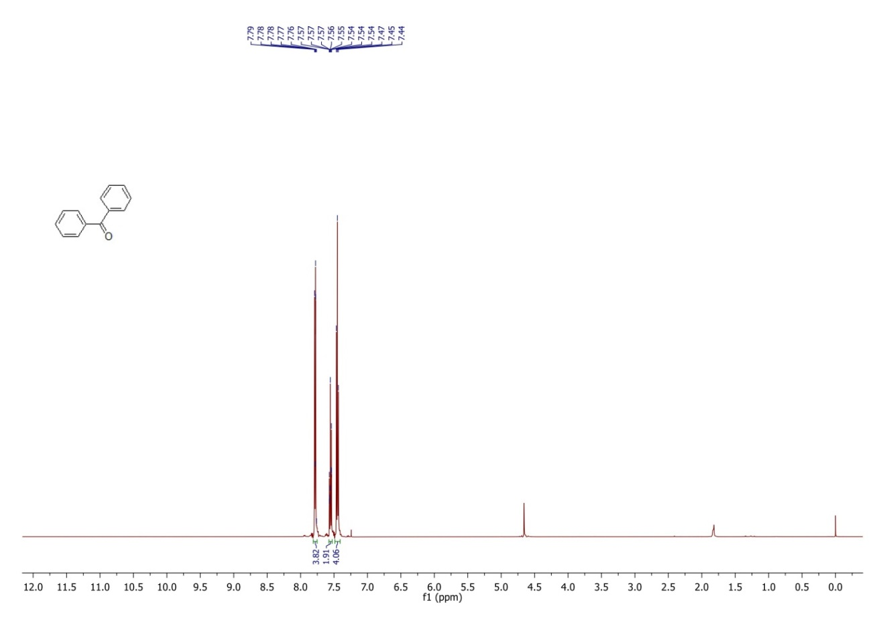

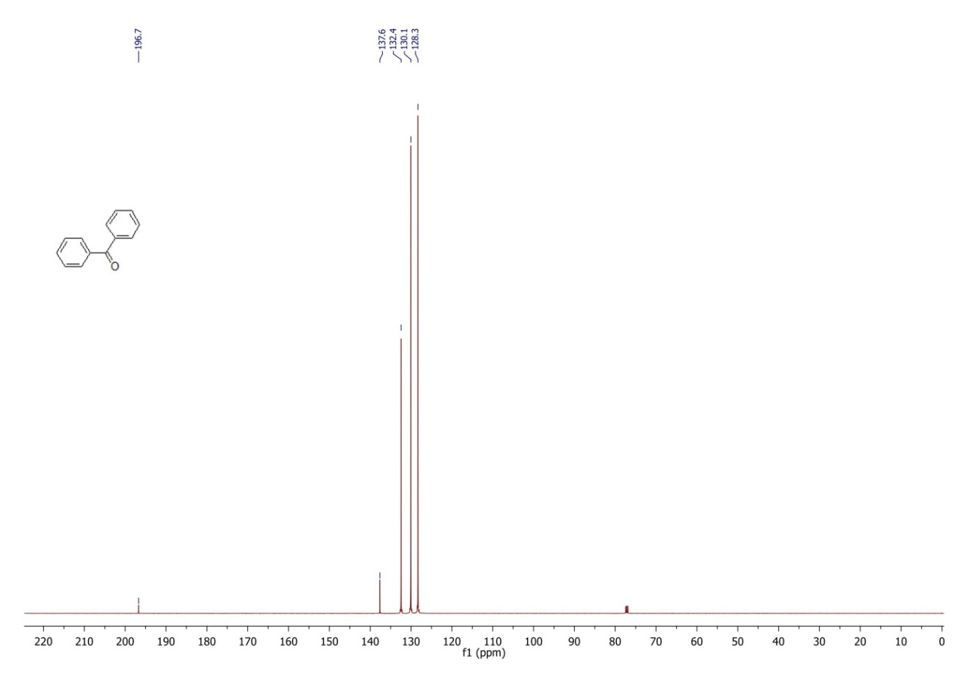

**1H and 13C NMR of 4-methoxyenzophenone**

**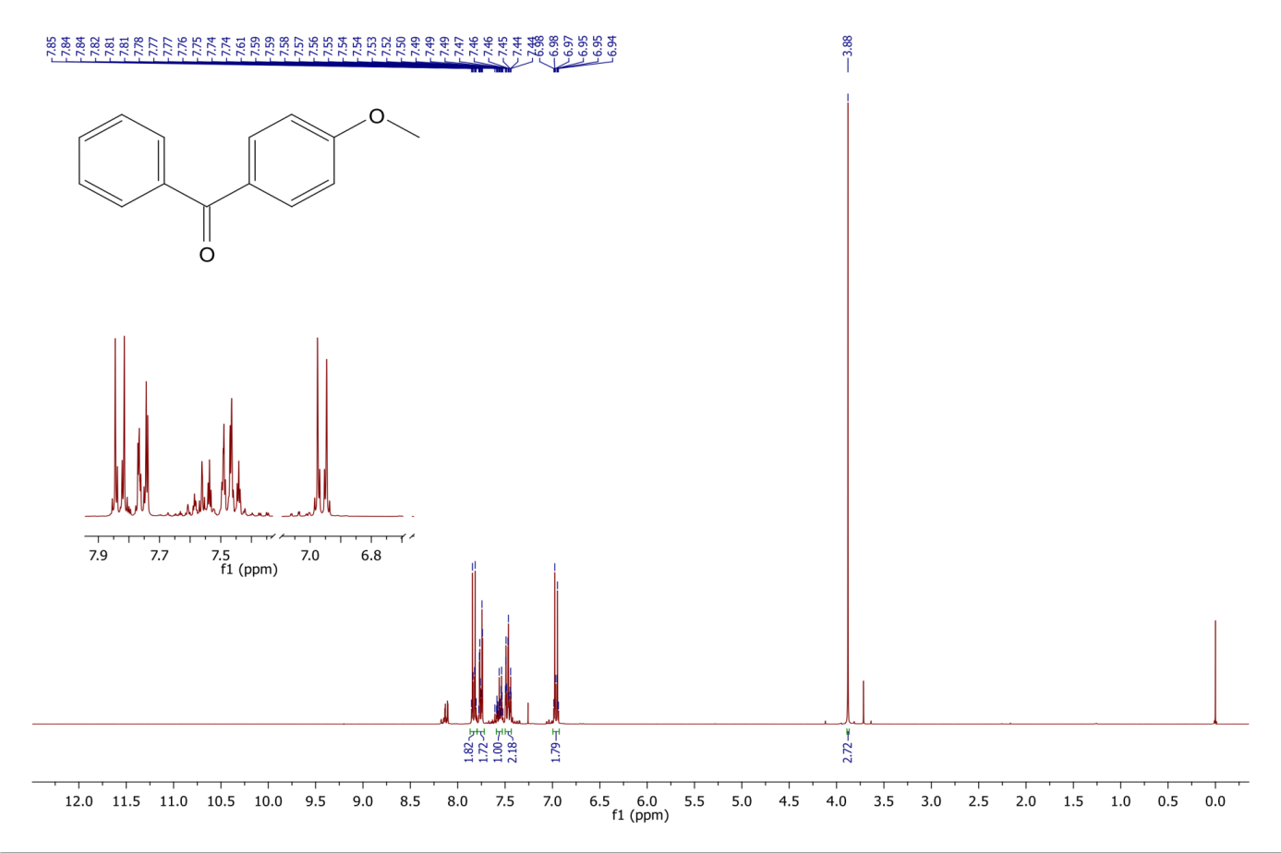**

**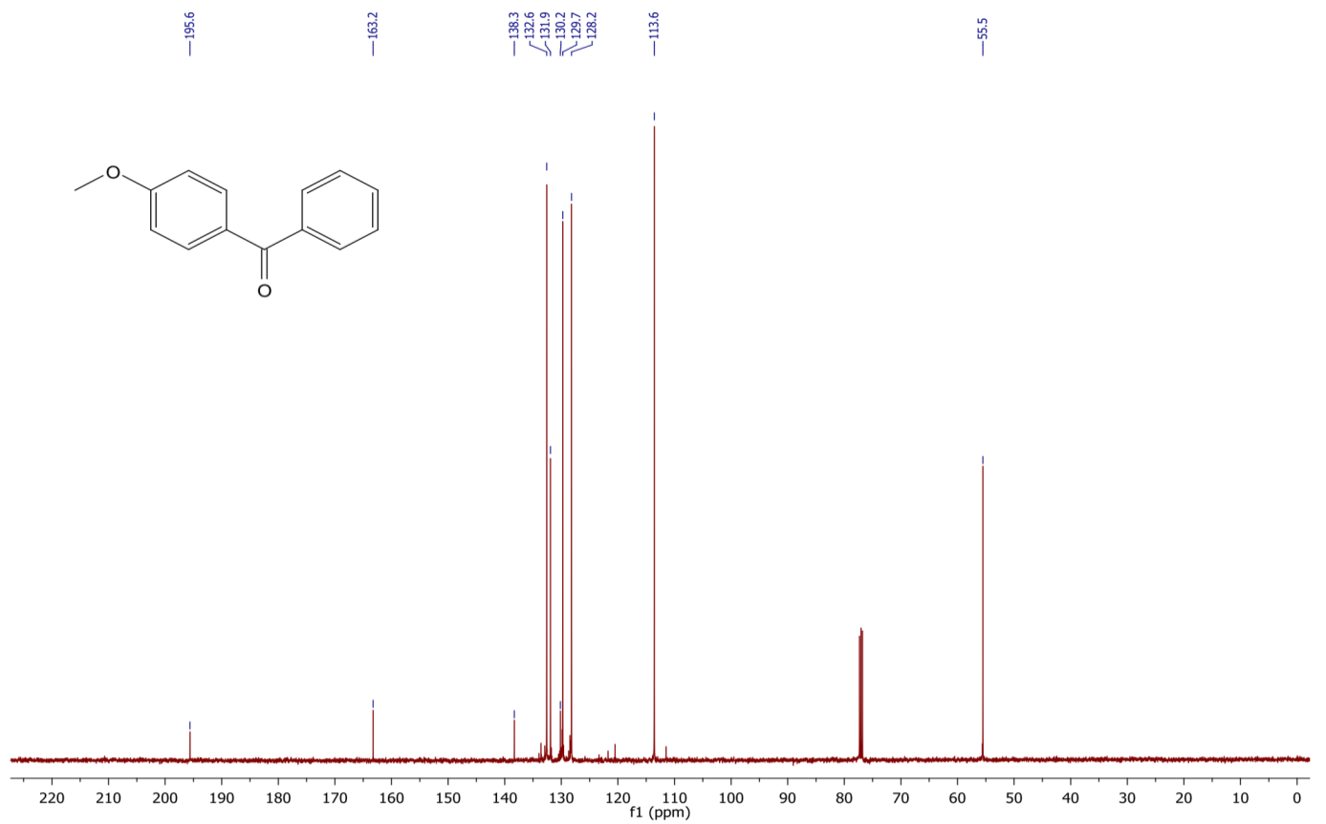**

**1H and 13C NMR of 3,4-dimethoxybenzophenone**

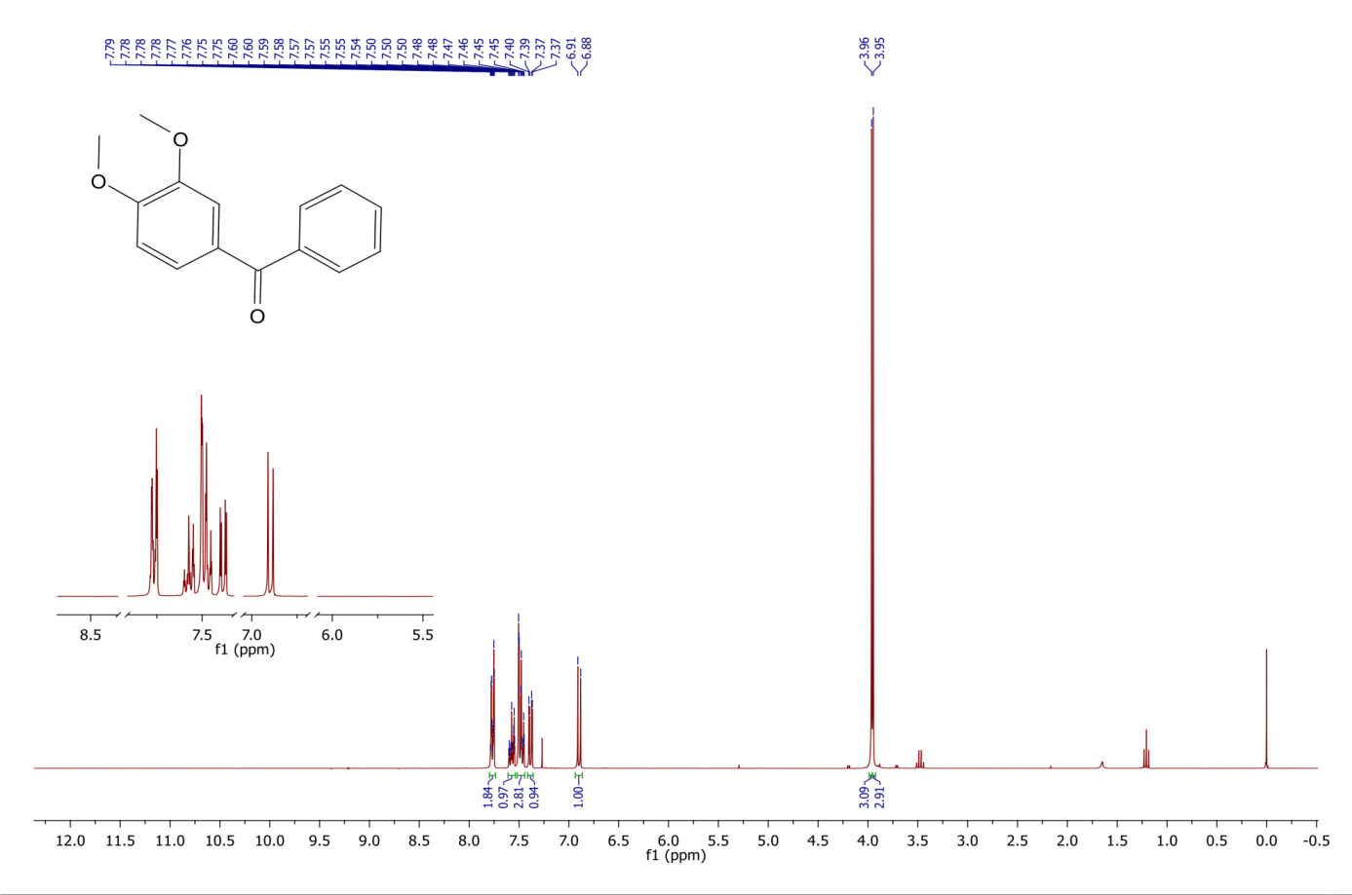



**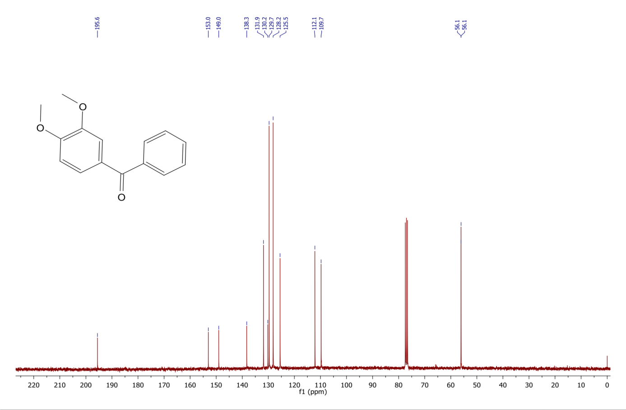**



**1H and 13C NMR of 2,4-dimethoxybenzophenone**

**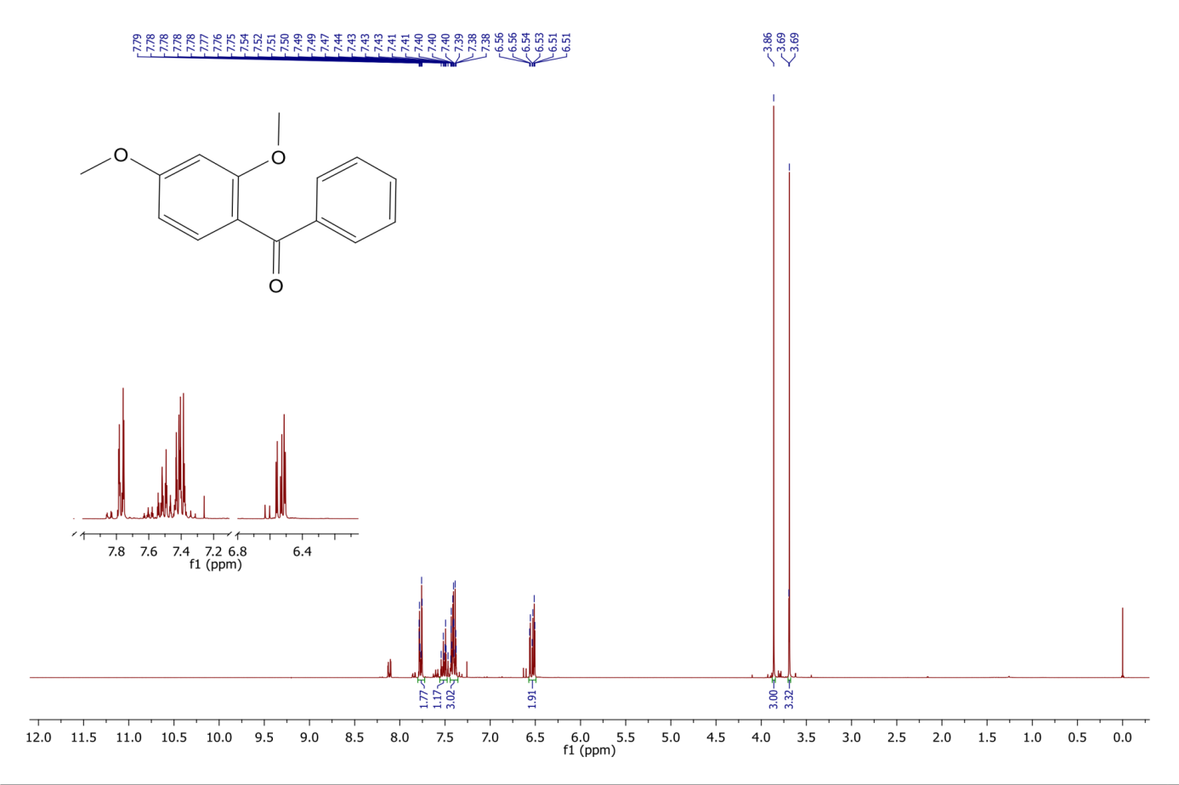**

**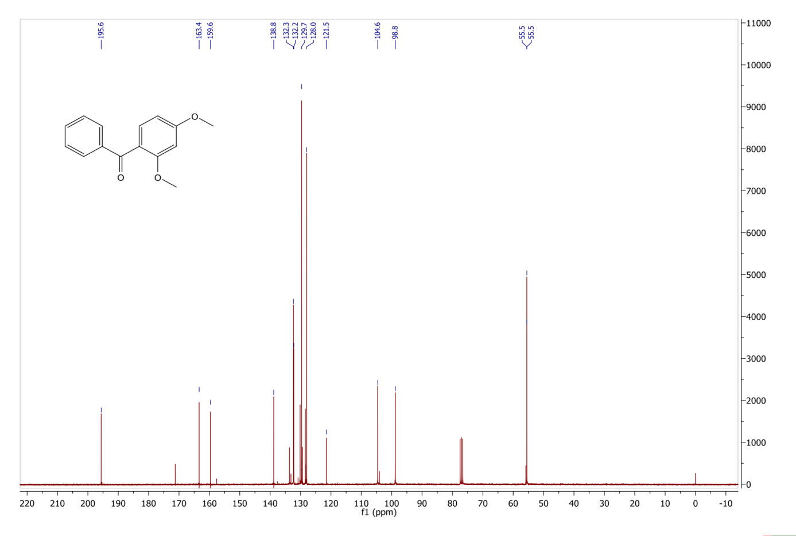**

**1H and 13C NMR of 2,5-dimethoxybenzophenone**

**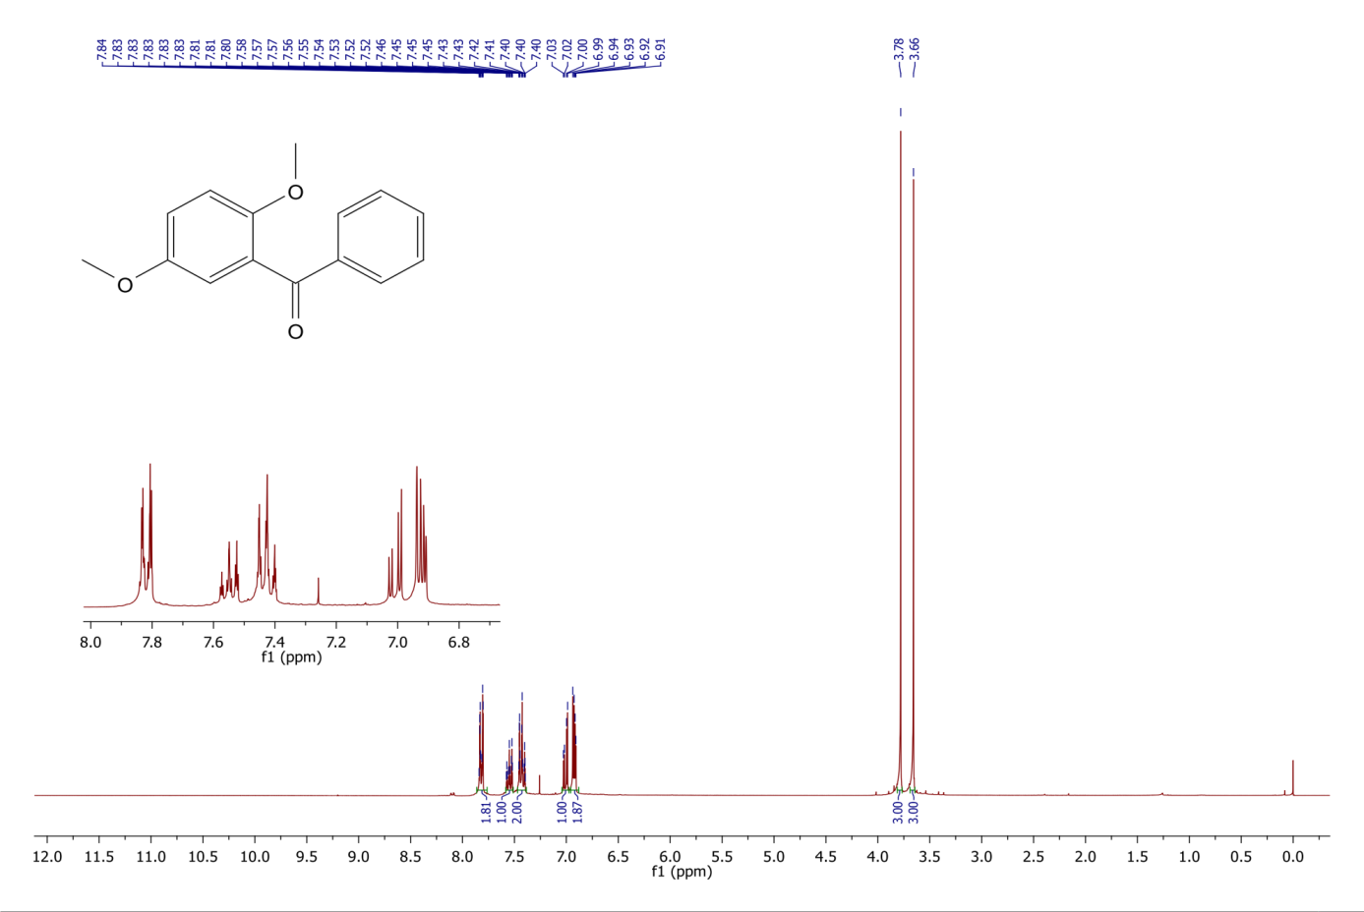**

**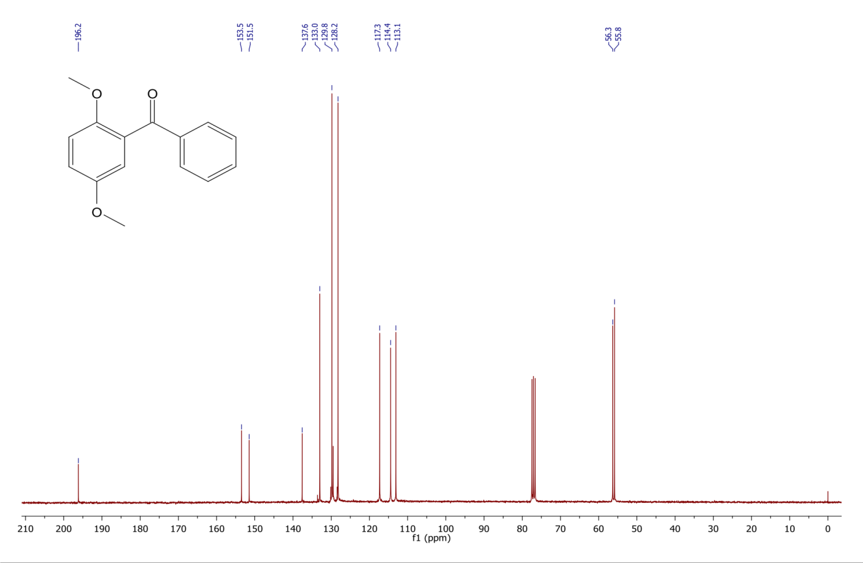**

**1H and 13C NMR of 2,4,5-trimethoxybenzophenone**

**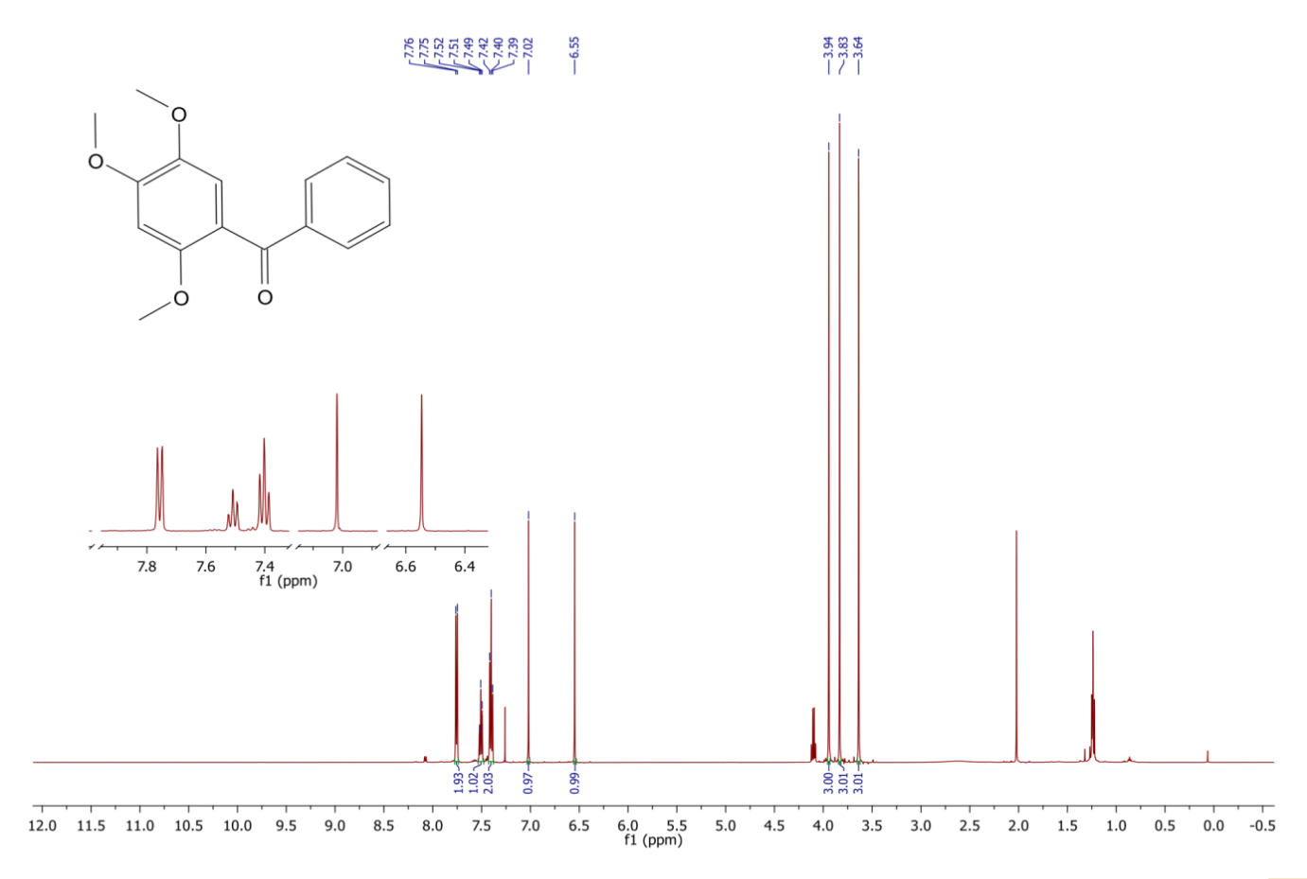**

**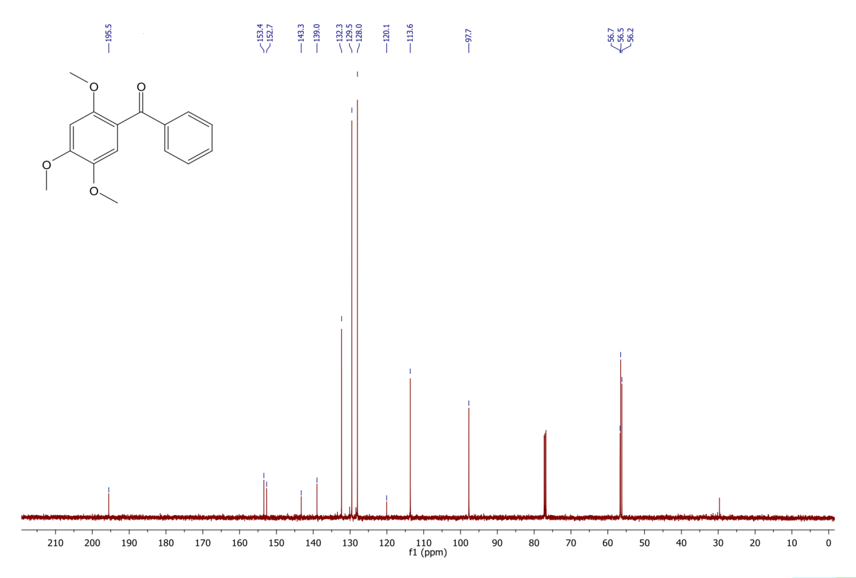**

**1H and 13C NMR of 2,4,6-trimethylbenzophenone**

**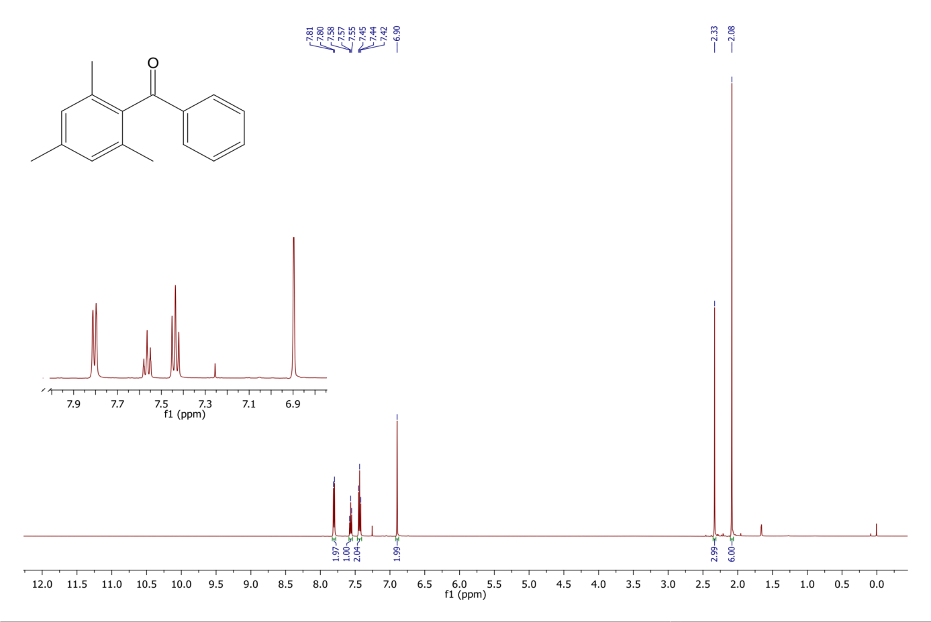**

**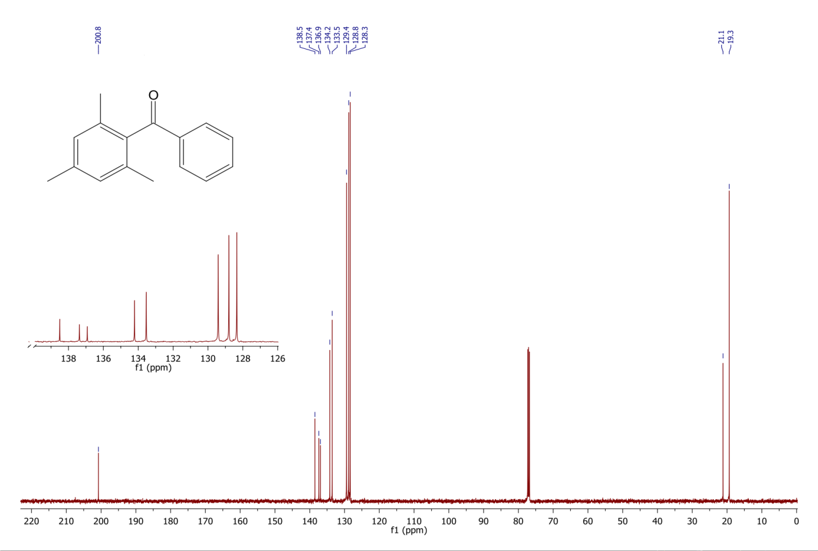**

**1H and 13C NMR of 2,4-dimethylbenzophenone**

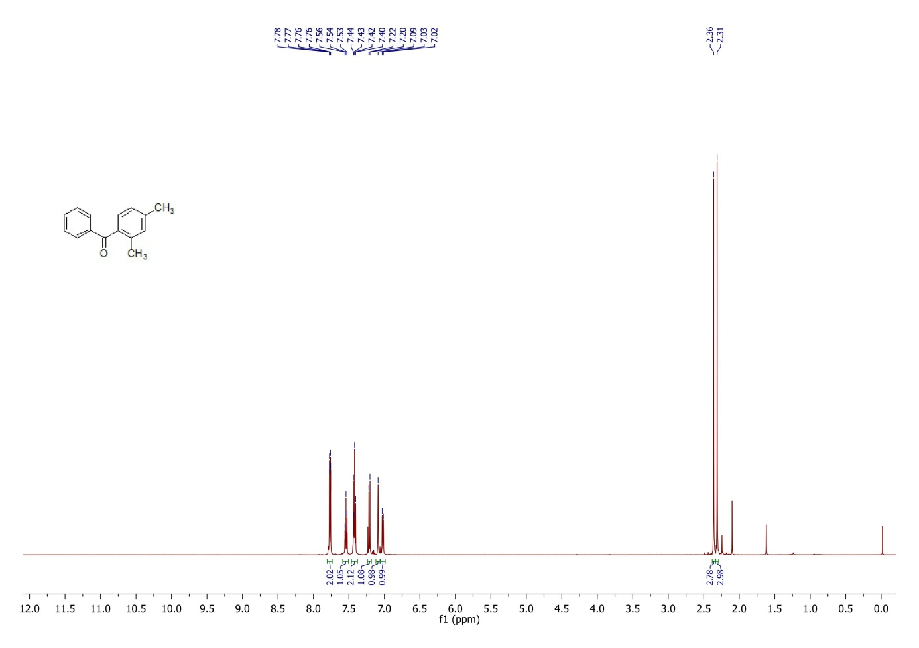



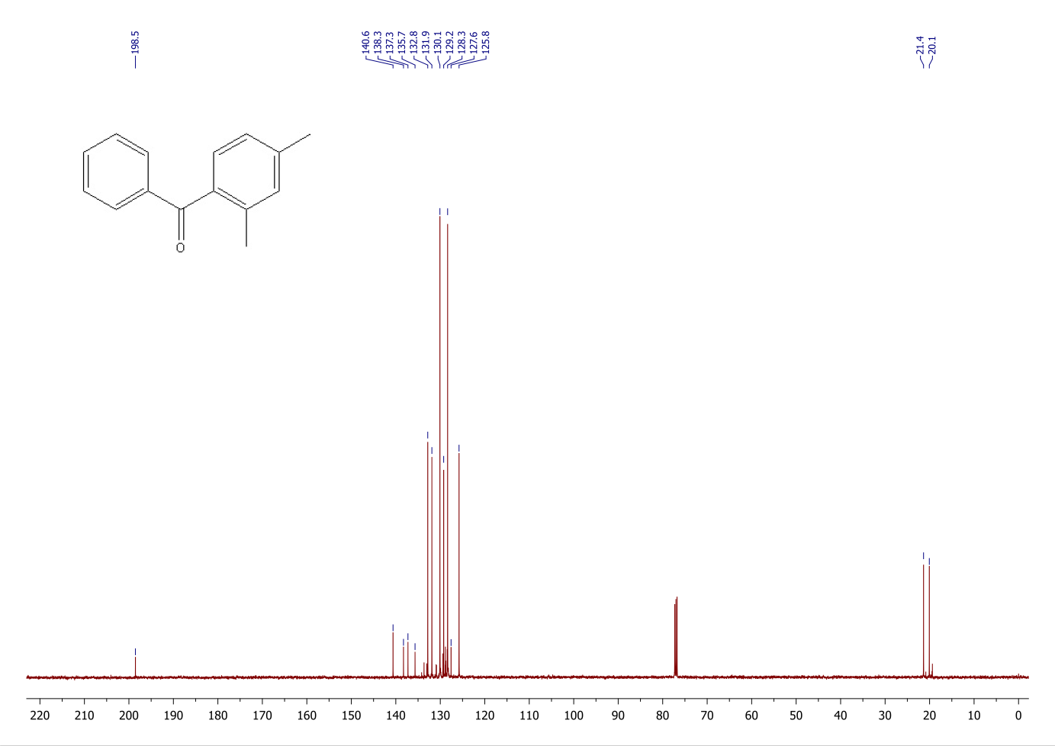

**1H and 13C NMR of 2,5-dimethylbenzophenone**

C:\Users\TRUONG HAI\Desktop\NMR\png\1H-NMR-p-XYLENE-PhCO_03.tif

C:\Users\TRUONG HAI\Desktop\NMR\png\13C-NMR-p-XYLENE-PhCO_01.tif

**1H and 13C NMR of 1-benzoylnaphthalene**

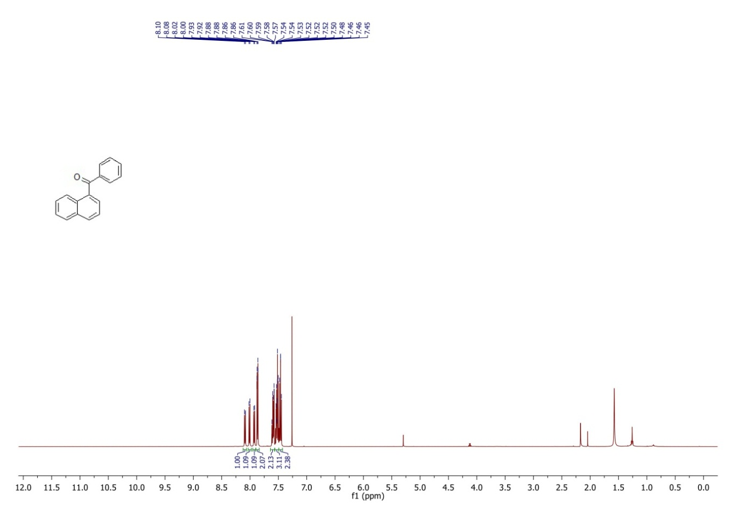

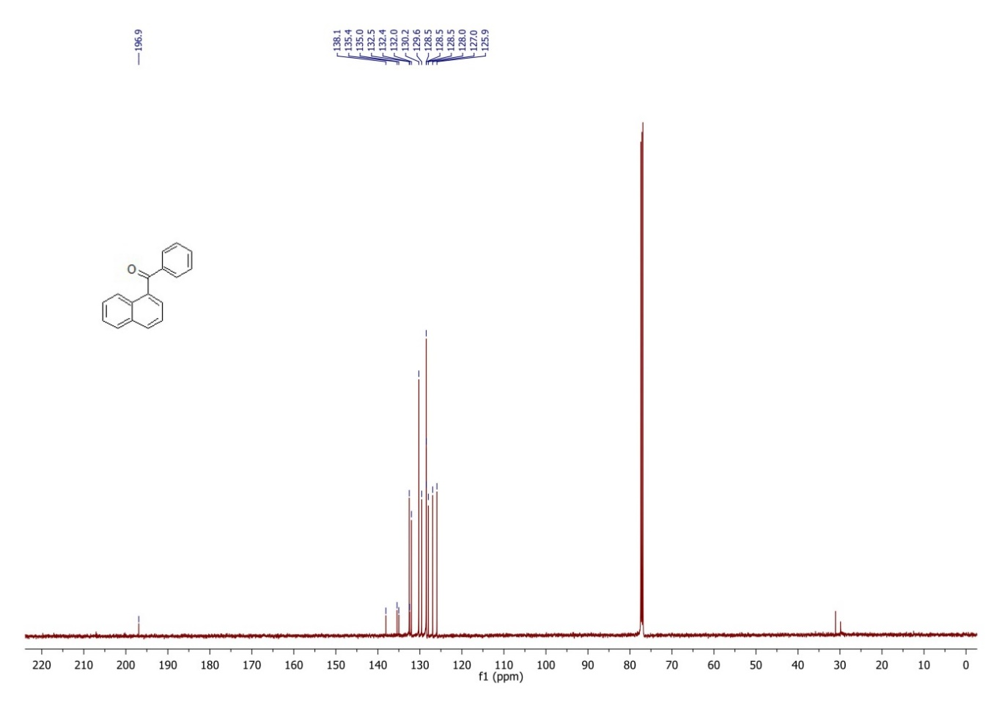

**1H and 13C NMR of 9-benzoylanthracene**

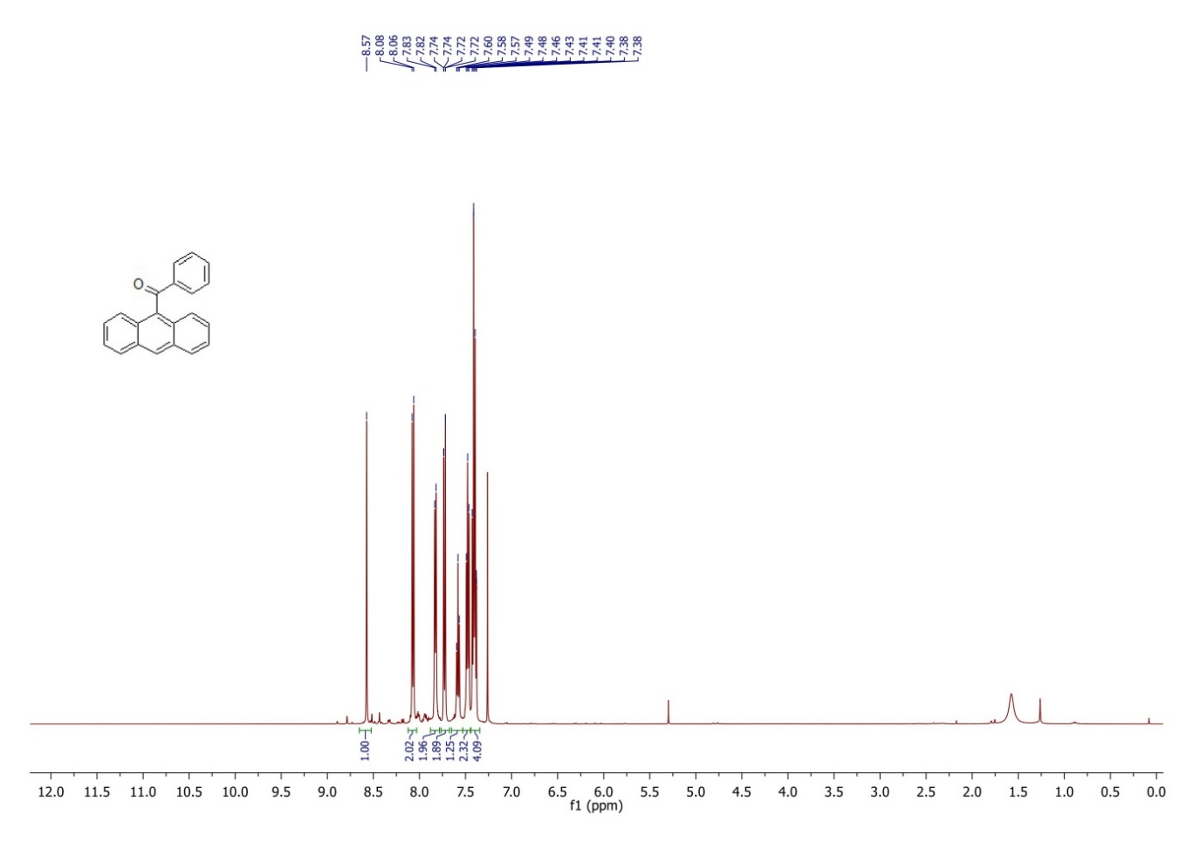

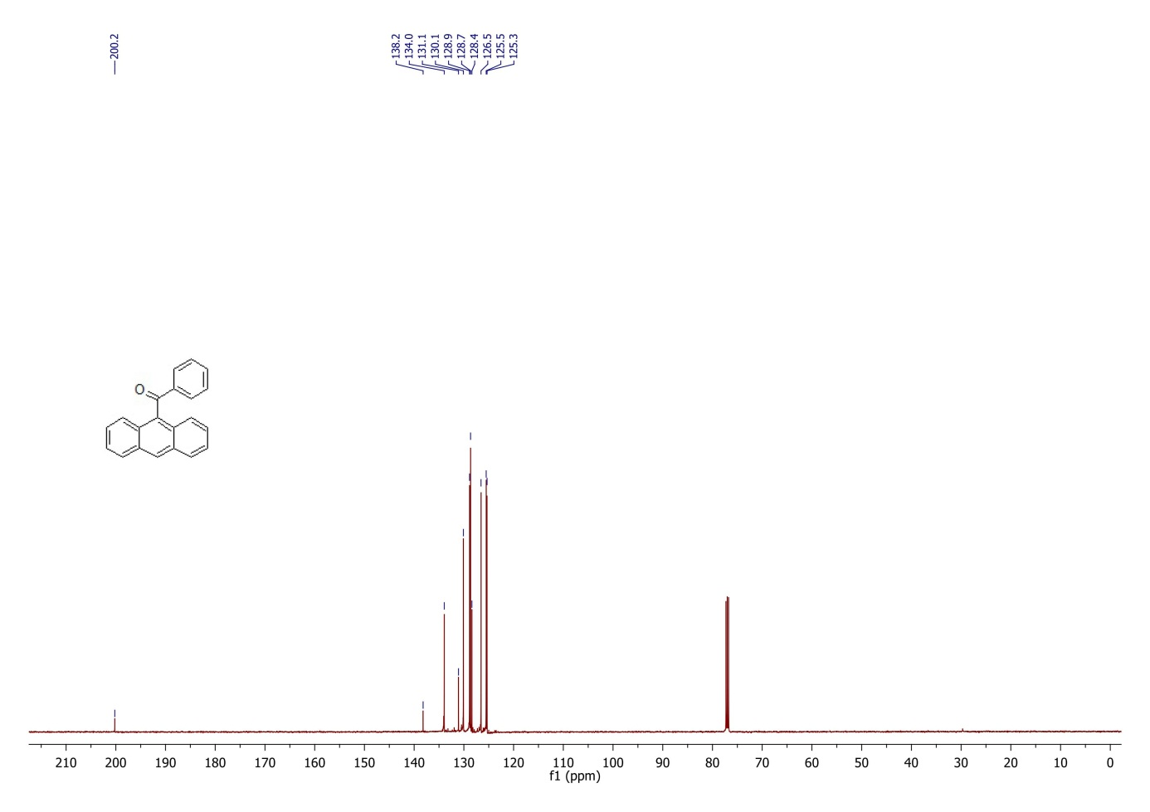

**1H and 13C NMR of 2-benoyl-1methylnaphthalene**

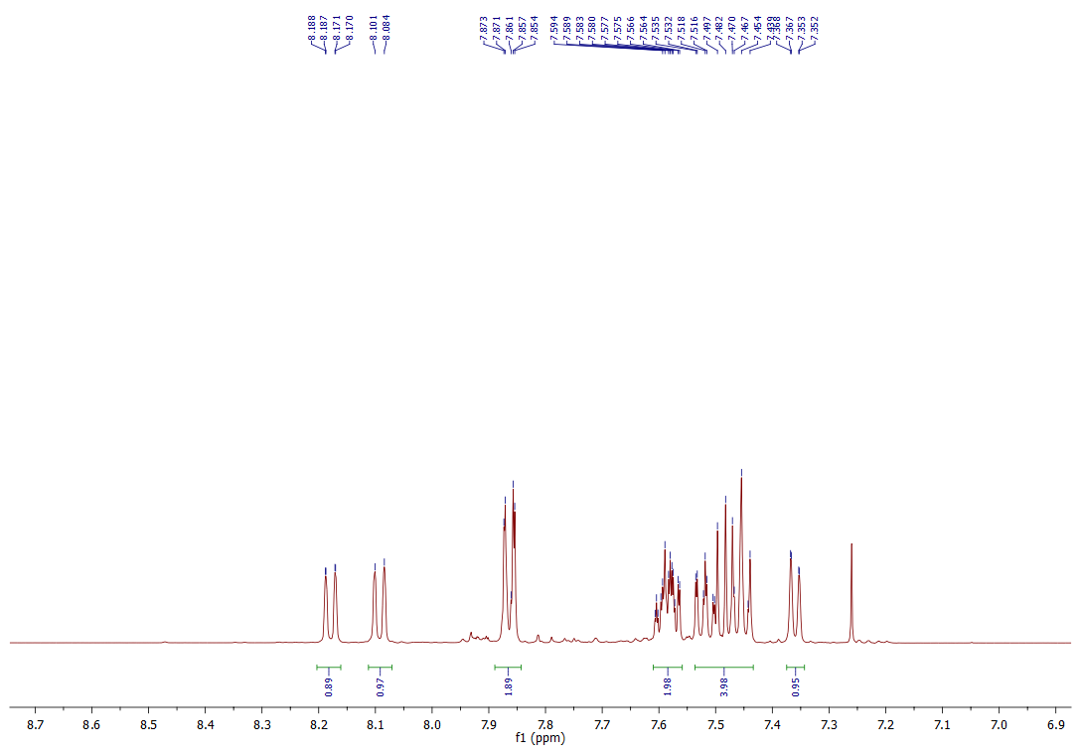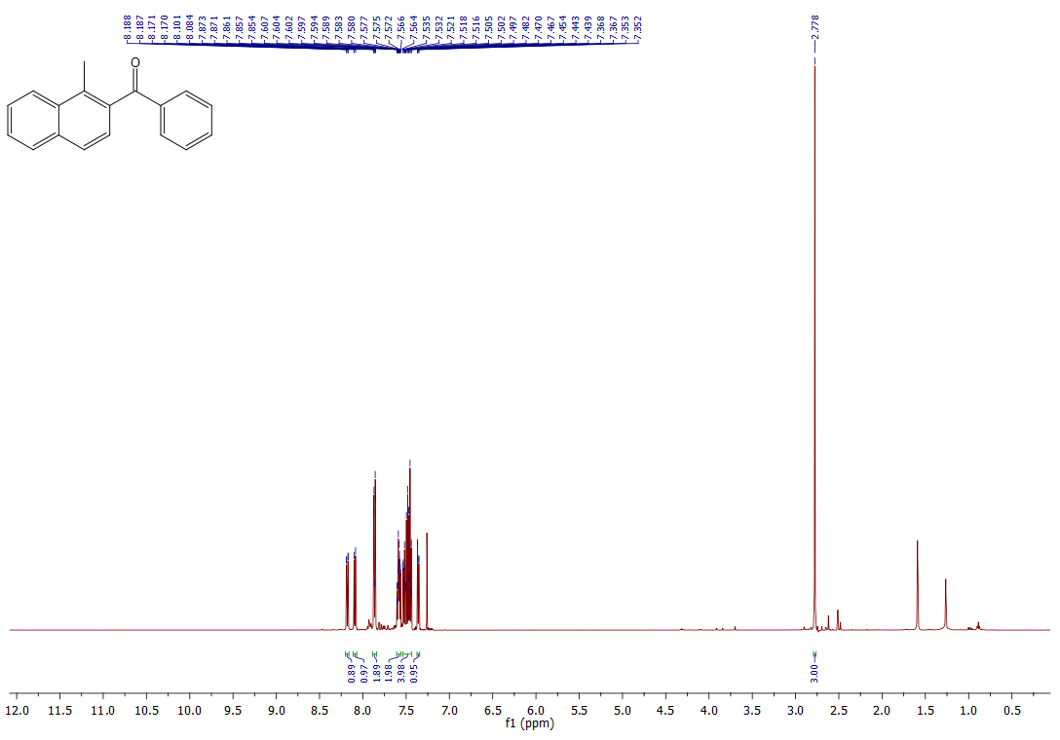

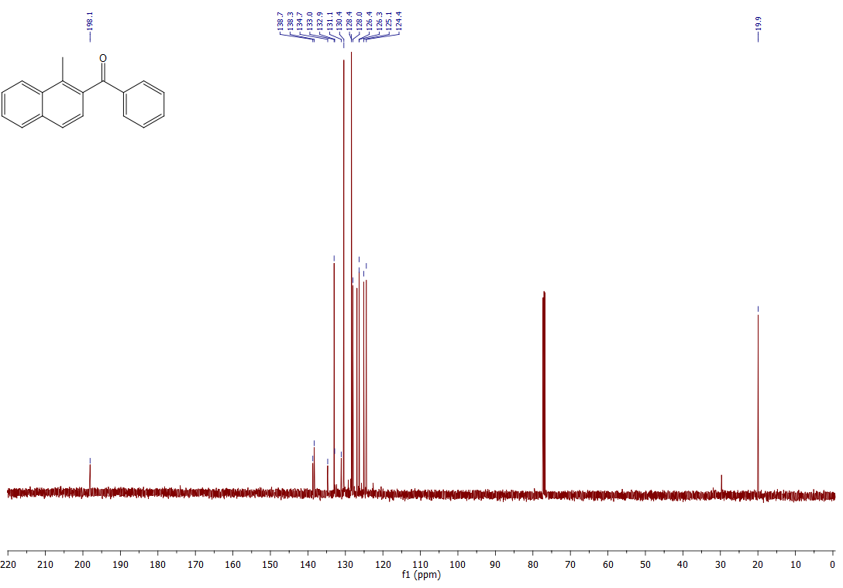

**1H and 13C NMR of 4-etoxibenzophenone**

