Supporting Information
Excellent bio-compatibility and in-vitro cytotoxicity of the highly enhanced luminescent with aqueous soluble NaGdF₄:Ce/Tb nanocrystals and their potential application in anti-cancer drug

Anees A. Ansari*¹, Shahanavaj Khan², A. Aldalbahi¹, A. K. Parchur³, B. Kumar³, Ashok Kumar⁴, Mohd Raish⁵, S. B. Rai³
¹King Abdullah Institute for Nanotechnology, King Saud University, Riyadh-11451, Saudi Arabia
²Nanomedicine & Biotechnology Research Unit, Department of Pharmaceutics, College of Pharmacy, PO Box 2457, King Saud University, Riyadh 11451, Saudi Arabia
³Department of Physics, Banaras Hindu University, Varanasi-221005, India
⁴Vitiligo Research Chair, College of Medicine, King Saud University, Riyadh 11451, Saudi Arabia
⁵Department of Pharmaceutics, College of Pharmacy, PO Box 2457, King Saud University, Riyadh 11451, Saudi Arabia

Table S1 The lifetime parameters obtained from the biexponential fitting to the luminescence decay data of the Core, Core/Shell, and Core/Shell/SiO₂ nanoparticles at 355 nm excitation (λ_{em} = 545 nm).
Nanoparticles | I₁(%) | τ₁(ms) | I₂(%) | τ₂(ms) | τ_{av}(ms) | R²
Core | 13 | 0.405 | 87 | 5.307 | 4.673 | 0.9913
Core/Shell | 10 | 0.306 | 90 | 3.525 | 3.210 | 0.9923
Core/Shell/SiO₂ | 43 | 2.241 | 57 | 4.355 | 3.444 | 0.9830

Figure S1

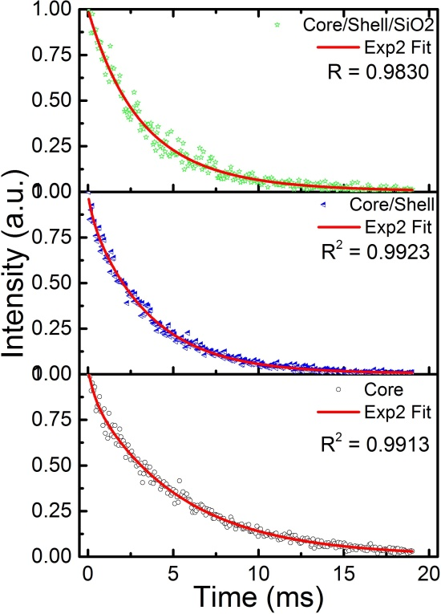
Figure S1 Photoluminescence decay curves of core, core/shell, and core/shell/SiO₂ nanoparticles at λ_{ex} = 355 nm and λ_{em} = 545 nm fitted using biexponential decay equations.

Fig. S2

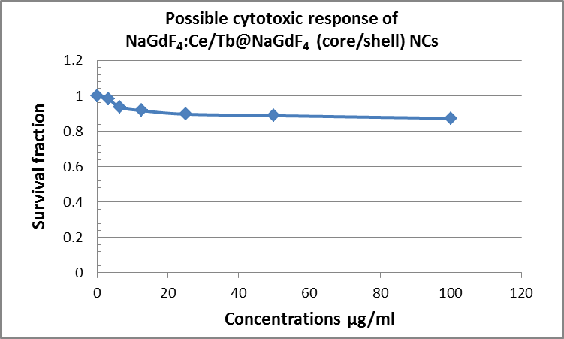
Fig. S2 In vitro estimation of possible cytotoxicity in HT-29 cells after incubation with different concentrations of NaGdF₄:Ce/Tb@NaGdF₄ (core/shell) NCs for 24 h at 37 ºC through MTT assay.

Fig. S3

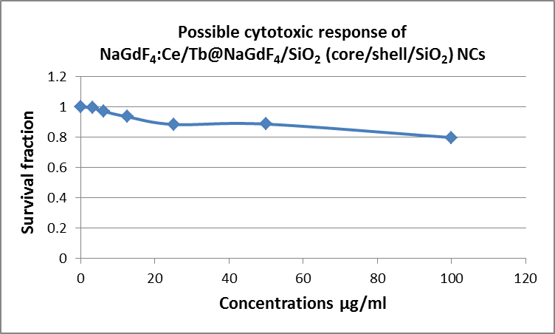

Fig. S3 In vitro estimation of possible cytotoxicity in HT-29 cells after incubation with different concentrations of NaGdF₄:Ce/Tb@NaGdF₄/SiO₂ (core/shell/SiO₂) NCs for 24 h at 37 ºC through MTT assay.

