**Supporting Information**

**A highly active copper-based metal-organic framework catalyst for a Friedel–Crafts alkylation in the synthesis of bis(indolyl)methanes under ultrasound irradiation**

Huong T. D. Nguyen,a,b The T. Nguyen,b Phuong T. K. Nguyen,*,a and Phuong Hoang Tran*,b

aCenter for Innovative Materials and Architectures (INOMAR), Vietnam National University – Ho Chi Minh City (VNU-HCM), Ho Chi Minh City 721337 (Vietnam)

bFaculty of Chemistry, University of Science, VNU-HCM, Ho Chi Minh City 721337 (Vietnam)

**Table of Contents**

**Section S1** Materials and Analytical Techniques S3–S4

**Section S2** Synthesis and Characterization of Heterogeneous MOF Catalysts S5–S10

**Section S3** General Catalytic Procedure for the Synthesis of Various Functionalized Bis(indolyl)methanes and Various Catalysts S11–S12

**Section S4** Leaching Studies S13

**Section S5** Optimized geometries of substrates and intermediates S14–S15

**Section S6** Bis(indolyl)methanes Derivatives Characterization S16–S44

**Section S7** References S45

**Section S1**: Materials and Analytical Techniques

**Materials**

Indole (99%), benzaldehyde (99%), 4-methylbenzaldehyde (97%), 4-methoxybenzaldehyde (98%), 4-*tert*-butylbenzaldehyde (97%), 4-nitrobenzaldehyde (98%), 4-fluorobenzaldehyde (98%), 4-chlorobenzaldehyde (97%), 4-bromobenzaldehyde (99%), 3-fluorobenzaldehyde (97%), 3-bromobenzaldehyde (97%), 2-fluorobenzaldehyde (97%), 2-bromobenzaldehyde (98%), 4-imidazolecarboxaldehyde (98%), aluminum chloride hexahydrate (AlCl3·6H2O, >99%), iron(III) chloride (FeCl3, 97%), hafnium(IV) chloride (HfCl4, 99%), copper(II) oxide (CuO, 98%), zinc oxide (ZnO, ≥99%), magnesium oxide (MgO, 97%), titanium(IV) oxide (TiO2, ≥99%), aluminum oxide (Al2O3, ≥98%), iron(III) oxide (Fe2O3, ≥99%), anhydrous toluene (99.8%), anhydrous methanol (MeOH, 99.8%), anhydrous 1,4-dioxane (99.9%), anhydrous ethanol (EtOH, ≥99.5%), anhydrous *m*-xylene (99%), ethyl acetate (EtOAc, 99%), anhydrous acetonitrile (99.8%), anhydrous *n*-butanol (99.8%), and anhydrous *tert*-butanol (≥99.5%) were obtained from Sigma-Aldrich Chemical Co. 5-Nitroindole (98%), 5-Methylindole (99%), 5-bromoindole (99%), 3,4-dihydroxybenzaldehyde (97%), terephthalaldehyde (98%), copper(II) acetate (Cu(CH3COO)2, 98%), copper(II) nitrate trihydrate (Cu(NO3)2·3H2O, >99%), copper(II) chloride dehydrate (CuCl2·2H2O, 99%), anhydrous copper(II) sulfate (CuSO4, 99%), anhydrous tetrahydrofuran (THF, 99.5%), *N*,*N*-diethylformamide (DEF, 99%), and *N*,*N*-dimethylformamide (DMF, 99.5%) were purchased from Acros Organics. Silica gel 230–400 mesh for flash chromatography, TLC plates (silica gel 60 F254), acetone, n-hexane, petroleum ether (boiling point 60 – 90 oC) and chloroform were obtained from Merck. Deuterated solvents, CDCl3 and DMSO-*d*6, were purchased from Cambridge Isotope Laboratories (Andover, MA) and used without further purification. The synthesis of hexakis(4-carboxyphenyl)benzene (H6CPB) was carried out according to a previously reported procedure.S1 All other chemicals were used without further purification unless otherwise noted.

**Analytical Techniques**

Ultrasonic irradiation was performed on an Elma S30H Ultrasonic cleaning unit (ultrasonic frequency of 37 kHz, nominal power of 280 W and output of 80 W). Gas chromatography-mass spectrometry (GC-MS) measurements were carried out on an Agilent GC System 7890 equipped with a mass selective detector (Agilent 5973N) and a capillary DB-5MS column (30 m × 250 µm × 0.25 µm). Analytical thin-layer chromatography (TLC) was performed on F-254 silica gel coated aluminum plates from Merck. Visualization was performed with a 254 nm UV lamp. Silica gel column chromatography was carried out with silica gel (60, 230-400 mesh) from Merck. 1H and 13C nuclear magnetic resonance (NMR) spectra were recorded on a Bruker Advance II 500 MHz NMR spectrometer. Chemical shifts were quoted in parts per million (ppm) and referenced to the appropriate solvent peak or 0 ppm for tetramethylsilane (TMS). The following abbreviations were used to describe peak patterns, where appropriate: s, singlet; and d, doublet. Coupling constants, *J*, were reported in Hertz (Hz). Scanning electron microscope (SEM) images were taken on a Hitachi S-4800 scanning electron microscope operating at an accelerating voltage of 1 kV. Fourier Transform infrared (FT-IR) spectra were recorded from KBr pellets using a Bruker Vertex 70 system, and the output signals are described as follows: s, strong; m, medium; w, weak; br, broad. Powder X-ray diffraction (PXRD) data was collected using a Bruker D8 Advance employing Ni-filtered Cu Kα (λ = 1.54178 Å) radiation. The system was also outfitted with an anti-scattering shield that prevents incident diffuse radiation from hitting the detector. Samples were placed on zero background sample holders and leveled with a spatula prior to measurement. The collected 2θ range was 3-50° with a step size of 0.02° and a fixed counting time of 1 s per step. Thermal gravimetric analysis (TGA) was performed on a TA Q500 thermal analysis system with the sample held in a platinum pan in a continuous airflow. High-resolution electrospray-ionization mass spectrometry (HR-ESI-MS) was conducted in negative ionization mode on an Agilent 1200 series high-performance liquid chromatography coupled to a Bruker micrOTOF-QII mass spectrometer detector. Inductively coupled plasma mass spectroscopy (ICP-MS) data was collected on an Agilent ICP-MS 7700x instrument. Low pressure nitrogen adsorption isotherms were recorded on a Micromeritics 3Flex. Helium (99.999% purity) was used to estimate the dead space and ultrahigh-purity-grade N2 (99.999% purity) was used throughout the adsorption experiments.

**Section S2**: Synthesis and Characterization of MOF Heterogeneous Catalysts

Synthesis

HKUST-1 (Basolite C300), MOF-177 (Basolite Z377), and ZIF-8 (Basolite Z1200) were purchased from Sigma-Aldrich Chemical Co. To yield guest-free material, HKUST-1, MOF-177, and ZIF-8 were activated under vacuum (10-3 Torr) and heated at 120, 150, 100 °C for 24 h, respectively.

*MOF-890*. MOF-890 was prepared by following a previously reported procedure by our group.S1 A prepared 0.165 M stock solution of copper nitrate trihydrate in DMF (0.5 mL) was inserted to an 8 mL vial, which was pre-loaded with H6CPB linker (20 mg, 0.025 mmol). The addition of deionized water (4 mL) to the mixture was followed and the reaction mixture was subsequently heated at 100 °C for 18 h to yield blue, block-shaped crystals. The single crystals of MOF-890 were then washed with DMF (3 × 10 mL) per day for three days total. To afford guest-free material, DMF-washed MOF-890 was immersed in anhydrous MeOH (3 × 10 mL) per day for a total of four days. The solvent-exchanged sample was activated under vacuum at ambient temperature for 24 h followed by heating at 150 °C under vacuum for an additional 24 h.

*Cu-MOF-2*. Cu-MOF-2 was prepared with slight modifications to a previously reported procedure.S2 A 0.26 M stock solution of copper nitrate trihydrate in DMF (1 mL) was added to an 8 mL vial, which was preloaded with terephthalic acid (43 mg, 0.26 mmol). This was followed by the addition of DMF (4 mL) to the vial. The reaction mixture was quickly sonicated and heated at 100 °C for 36 h, yielding blue crystals. The crystals were then thoroughly washed with DMF (3 × 5 mL per day for 3 days total). To yield guest-free material, DMF-washed Cu-MOF-2 was subsequently immersed in anhydrous EtOH (3 × 5 mL per day for 3 days total). The solvent-exchanged sample was activated under vacuum at ambient temperature for 24 h, followed by heating at 120 °C under vacuum for an additional 24 h. Importantly, the treatment in ethanol leads a difference discussed on the reported publication, as the diffraction pattern appears to become a more amorphous phase compared to a calculated and an as-synthesized sample. They proposed that the ethanol does not coordinate to the Cu clusters which facilitate the removing of guest molecules out the surface of this material.

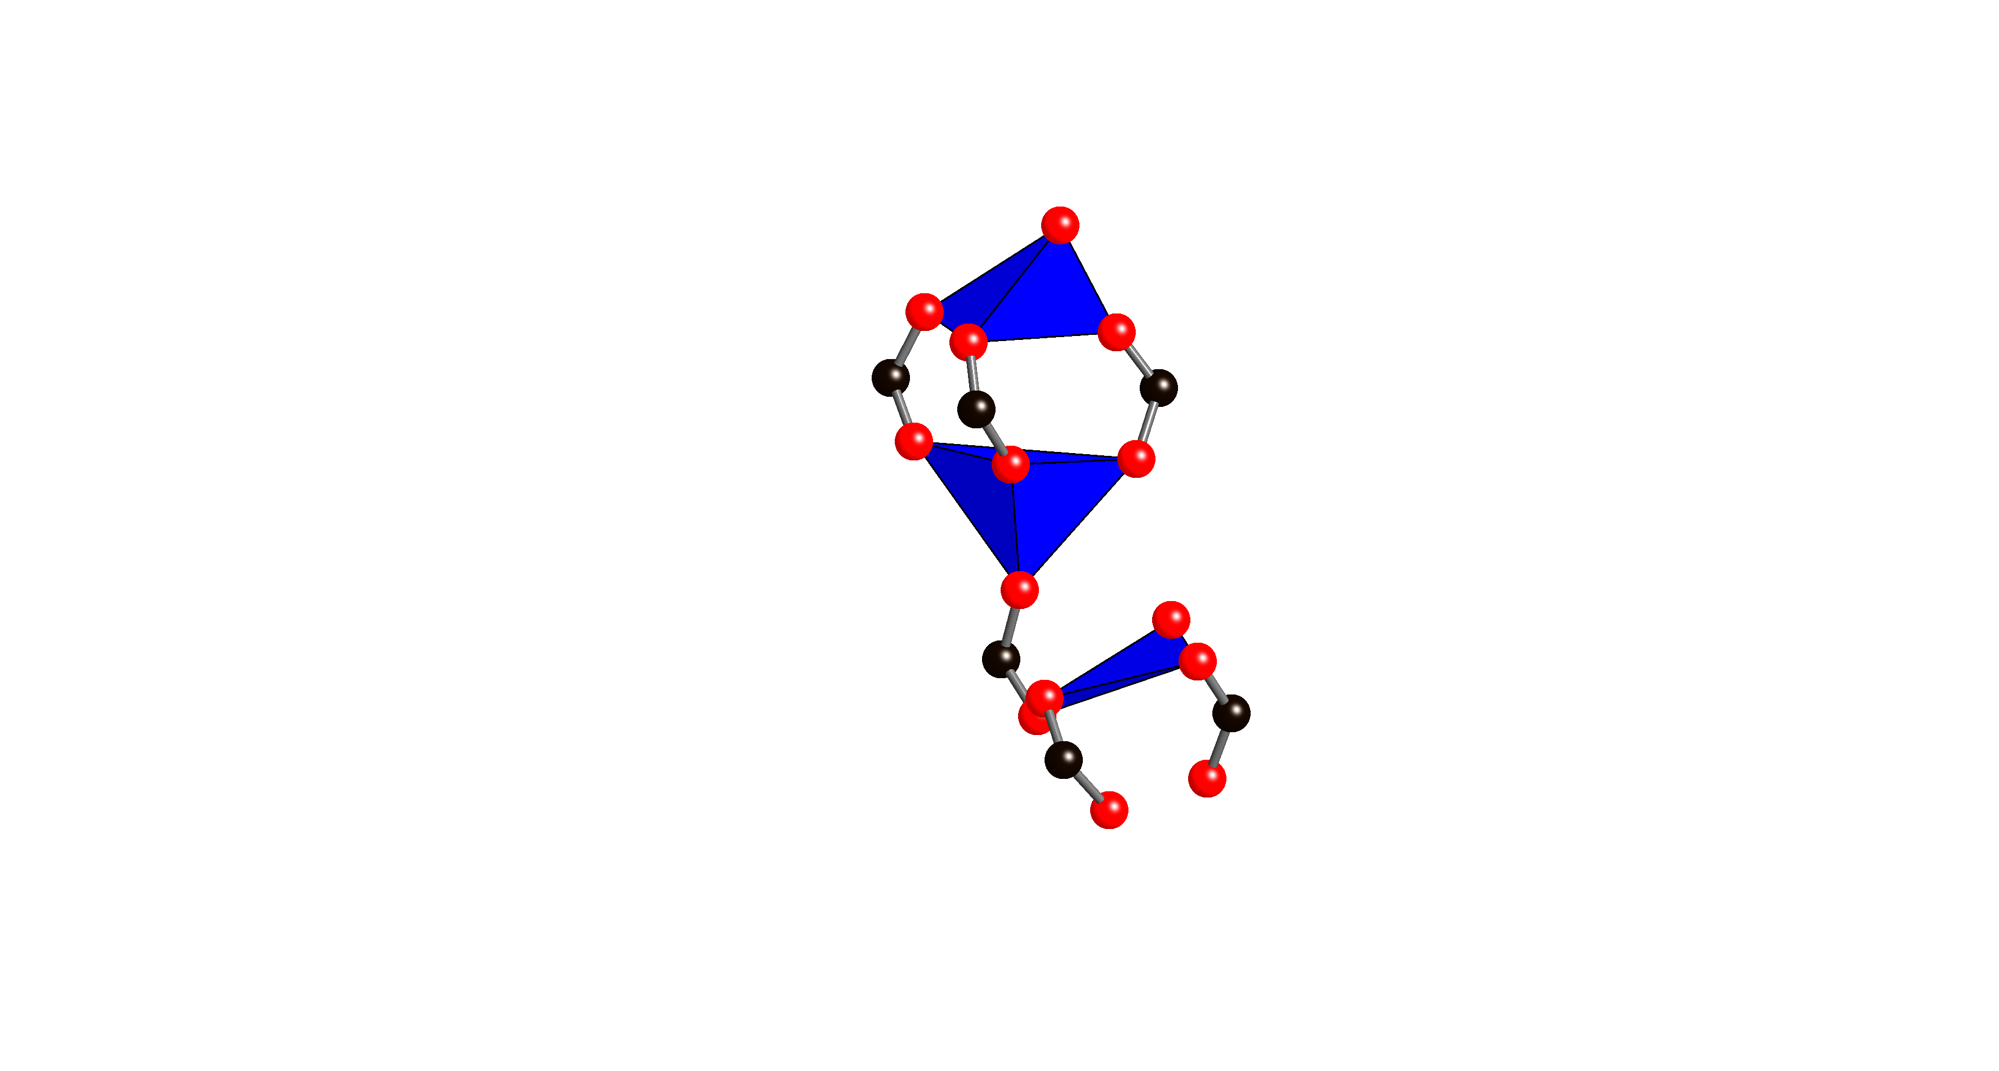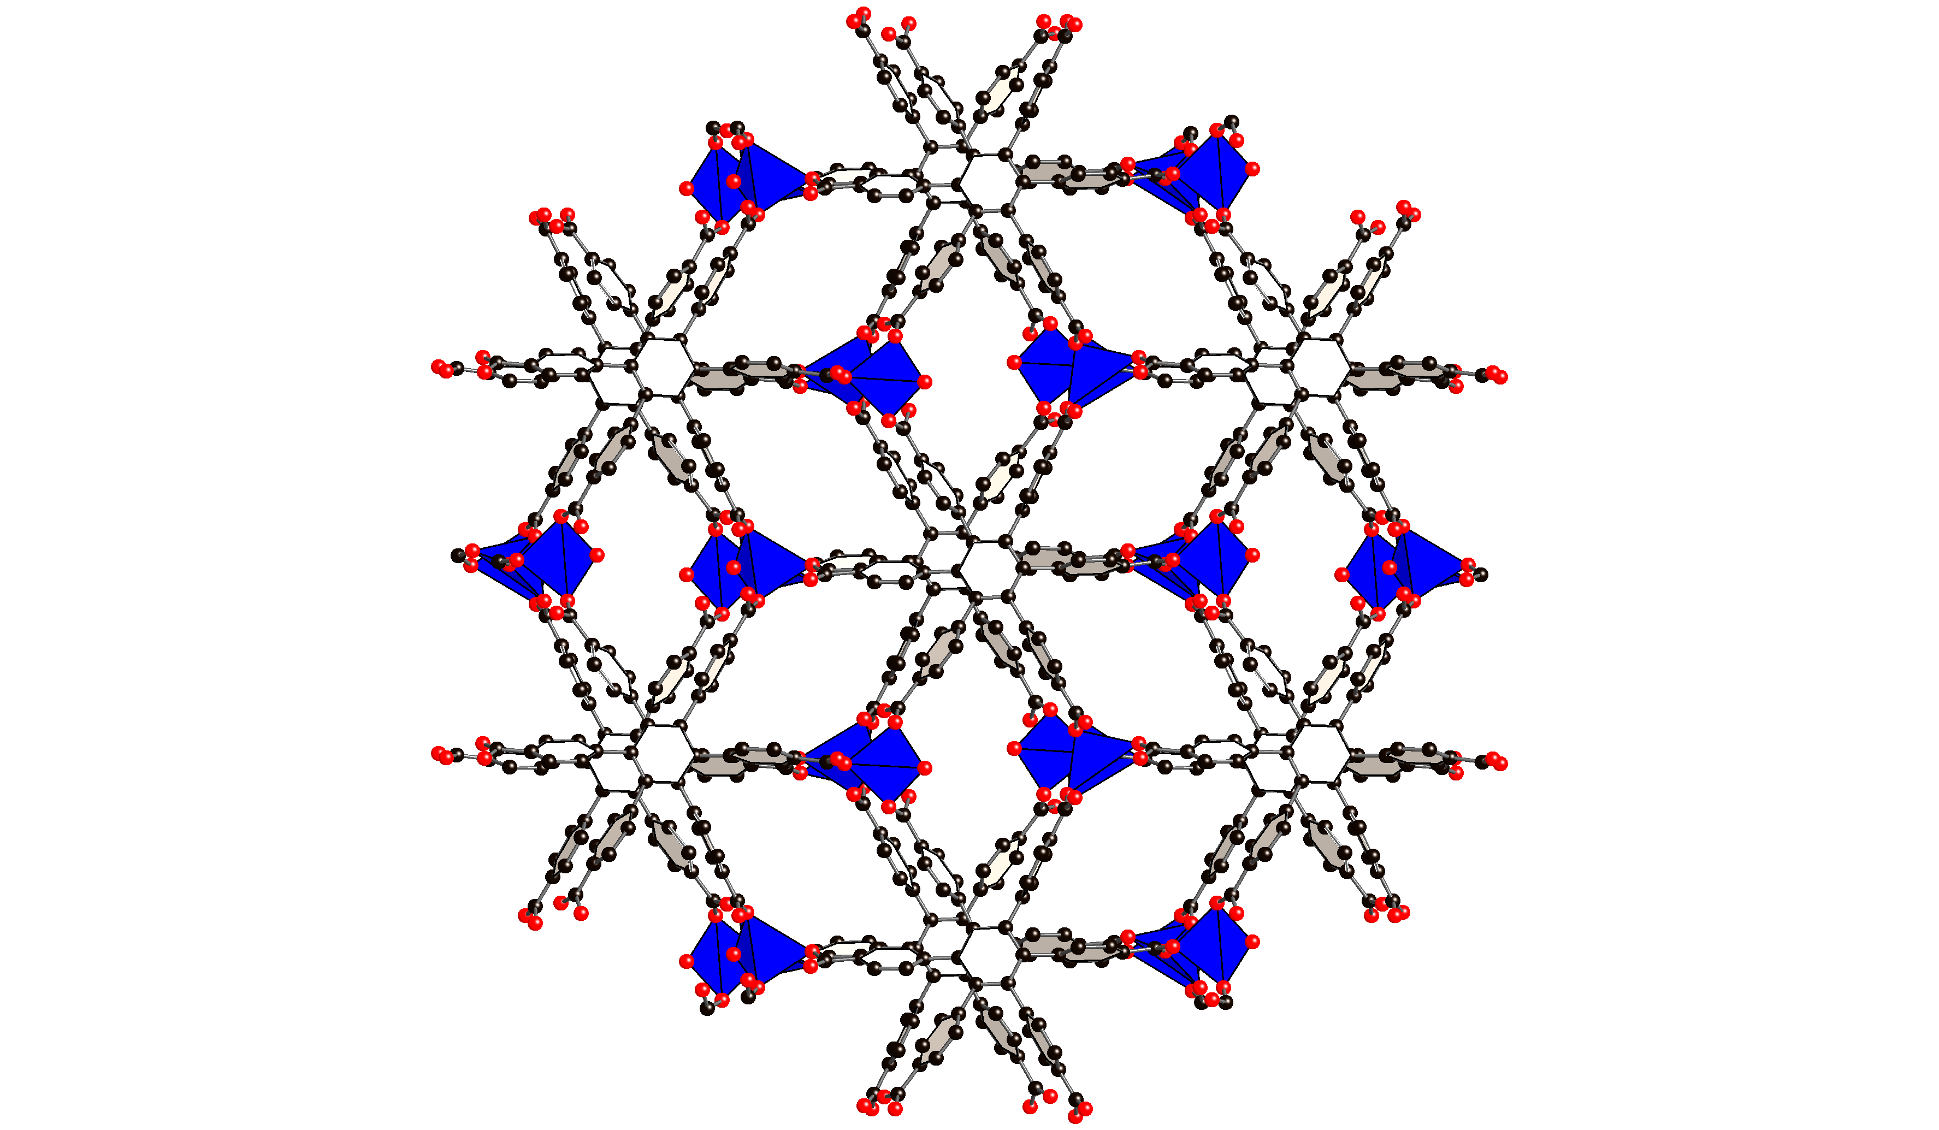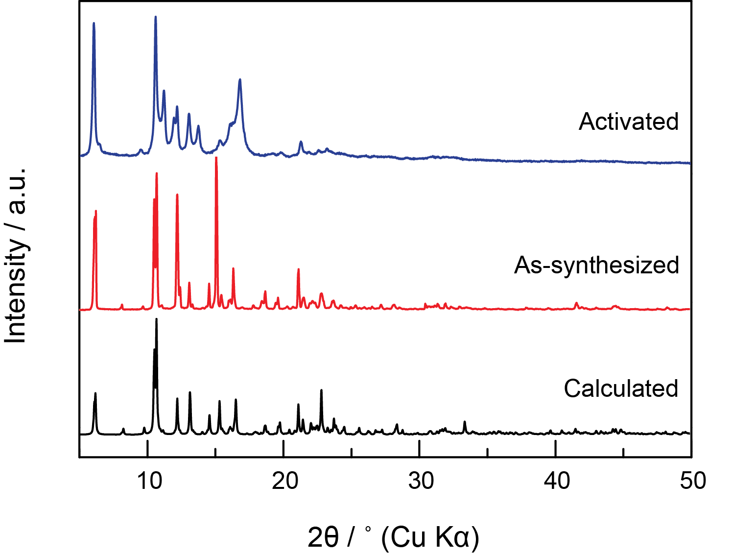Powder X-Ray Diffraction Patterns

Cu3(CO2)6(H2O)2

MOF-891

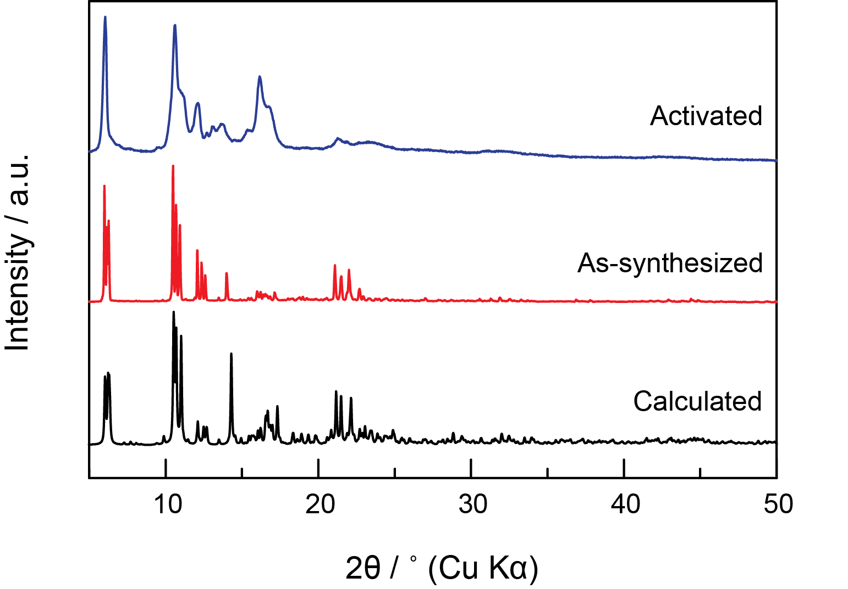**Figure S1**. (Left) PXRD patterns of calculated MOF-890 from the single crystal data (black), as- synthesized (red), activated (blue). (Right) Crystal structure of MOF-890 and Cu3(CO2)6 SBUs

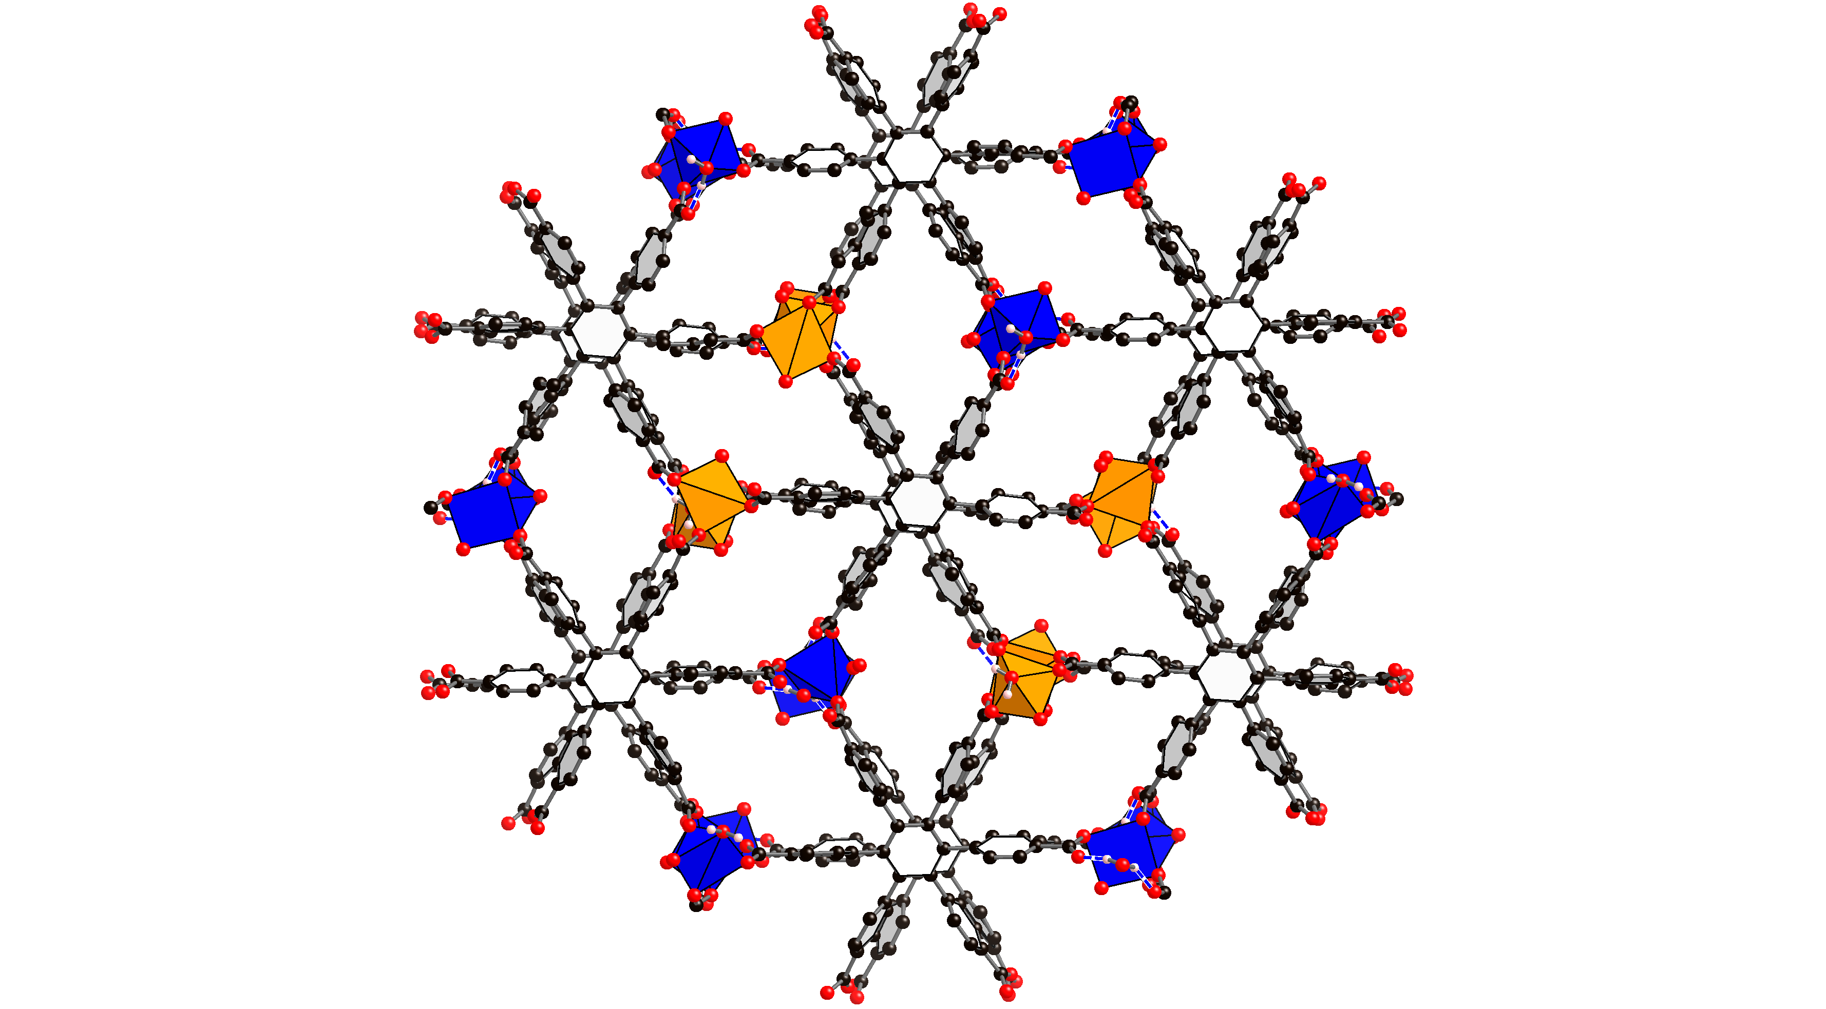

MOF-891

**Figure S2.** (Left) PXRD patterns of calculated MOF-891 from the single crystal data (black), as-synthesized (red), activated (blue). (Right) Crystal structure of MOF-891.

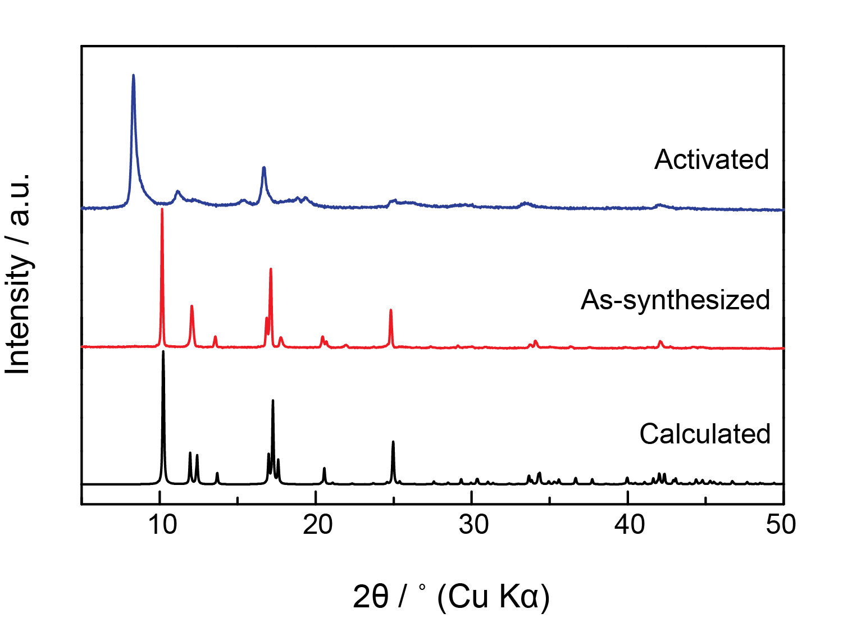**Figure S3**. (Left) PXRD patterns of calculated Cu-MOF-2 from the single crystal data (black), as-synthesized (red), activated (blue). (Right) Crystal structure of Cu-MOF-2.

Cu-MOF-2

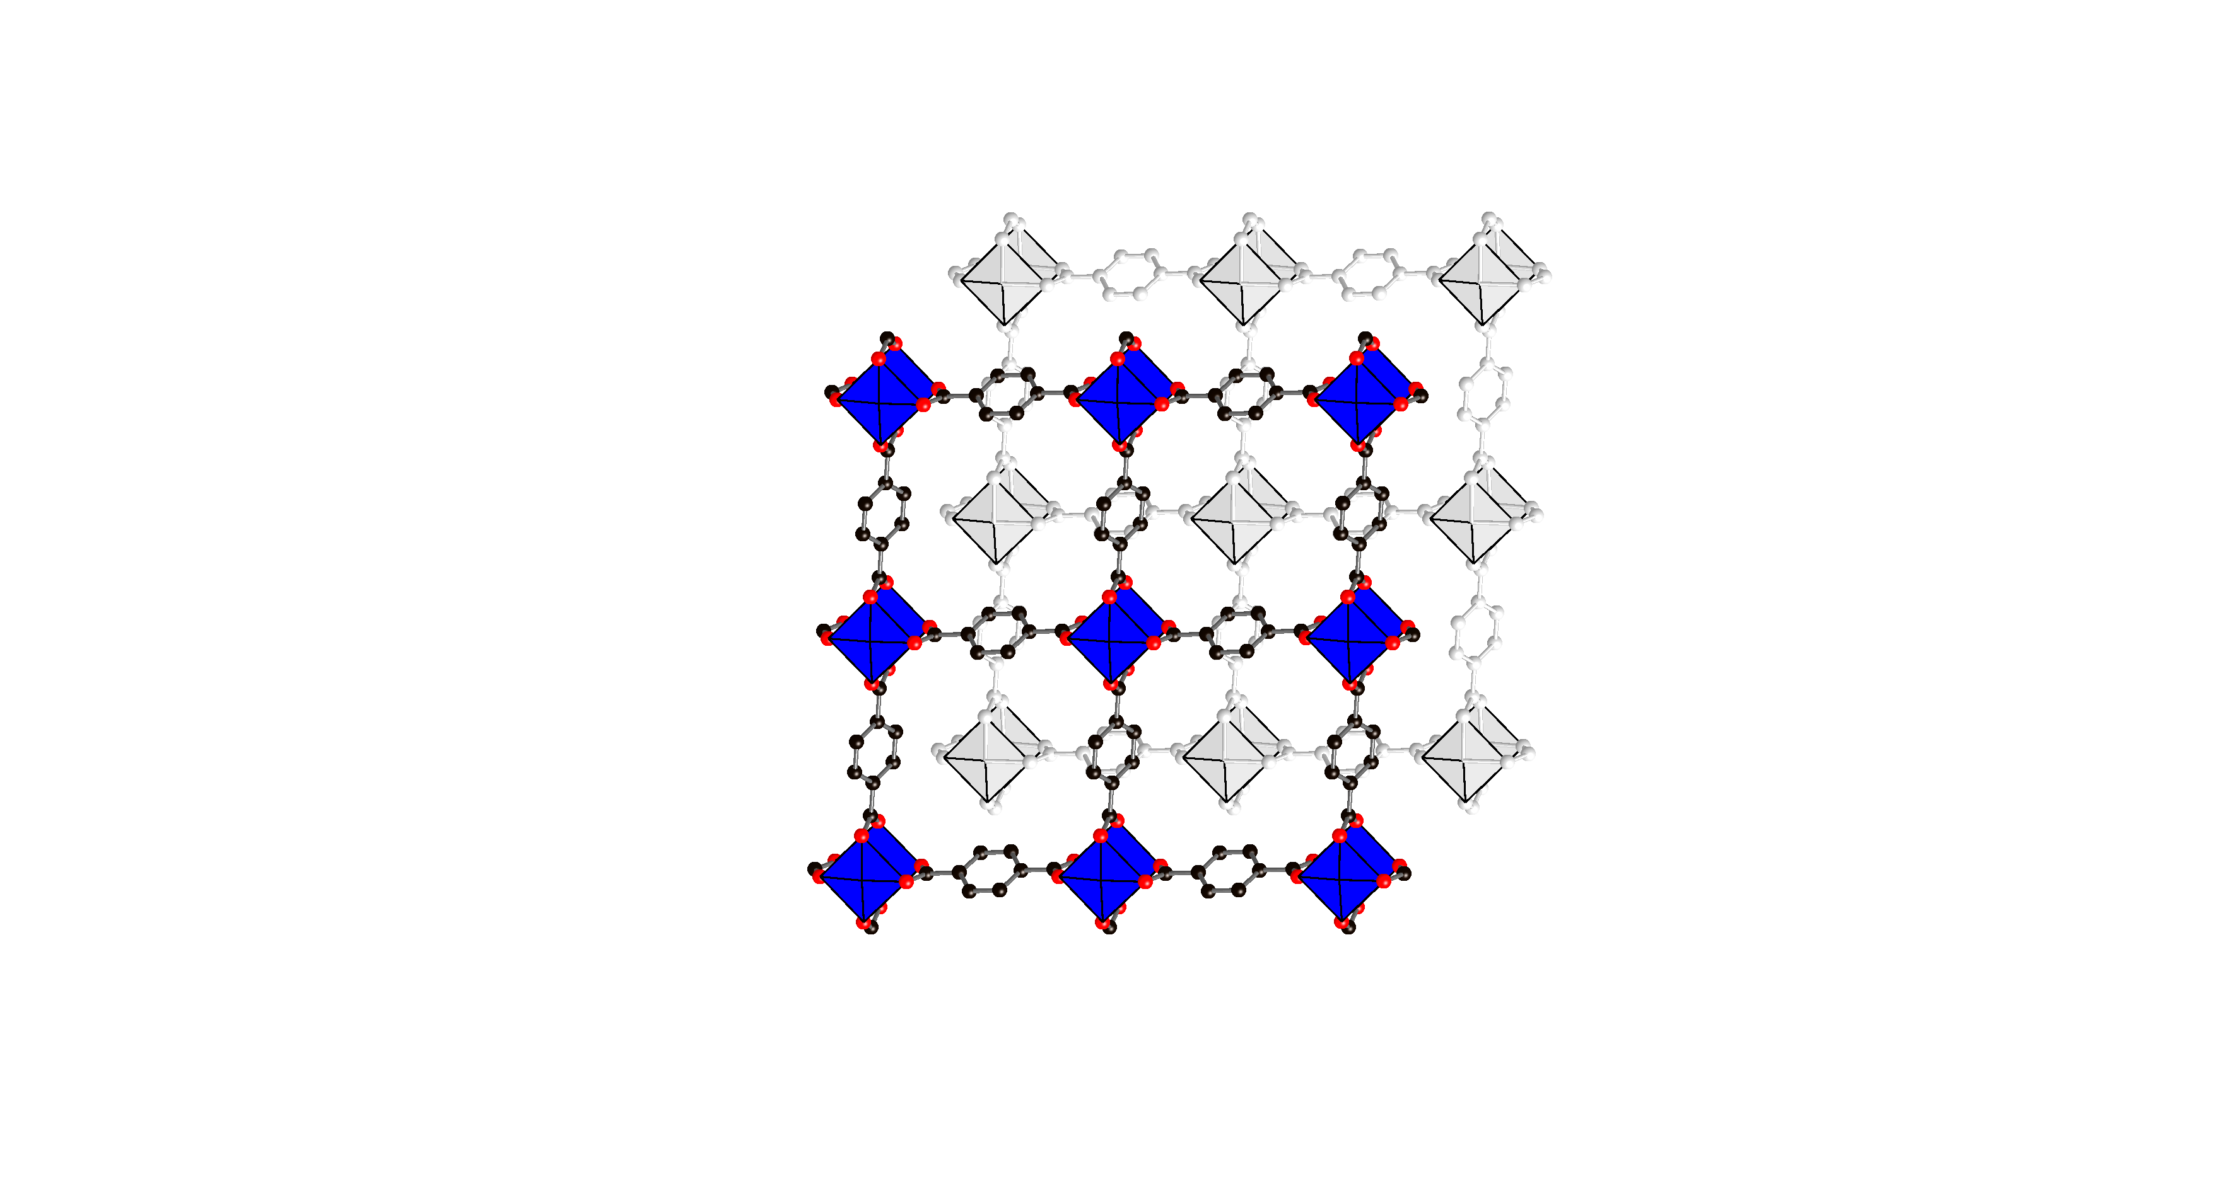

Gas Adsorption Analyses

Nitrogen isotherms were obtained using a 77 K liquid-N2 bath and used to determine the surface areas using the Micromeritics 3Flex software, assuming a value of 16.2 Å2 for the molecular cross-sectional area of N2. Pore size distributions were calculated using the non-local density functional theory (NLDFT) of N2 at 77 K adsorbed in NLDFT (SD3), N2-77-Carbon slit pores, as implemented in the Micromeritics software. Aperture metrics of the MOF structures (MOF-891, MOF-890, and Cu-MOF-2) were measured by distance between opposite oxygen atoms in the metal oxide clusters and two opposite edges of the largest pore (long dimension × short dimension). Cavity metrics of the MOF structures (MOF-177, ZIF-8, and HKUST-1) were approximately calculated by a diameter of internal spherical pore. The analysis of all MOF tested result in good fittings to the theoretical values taken from their crystal structure models.

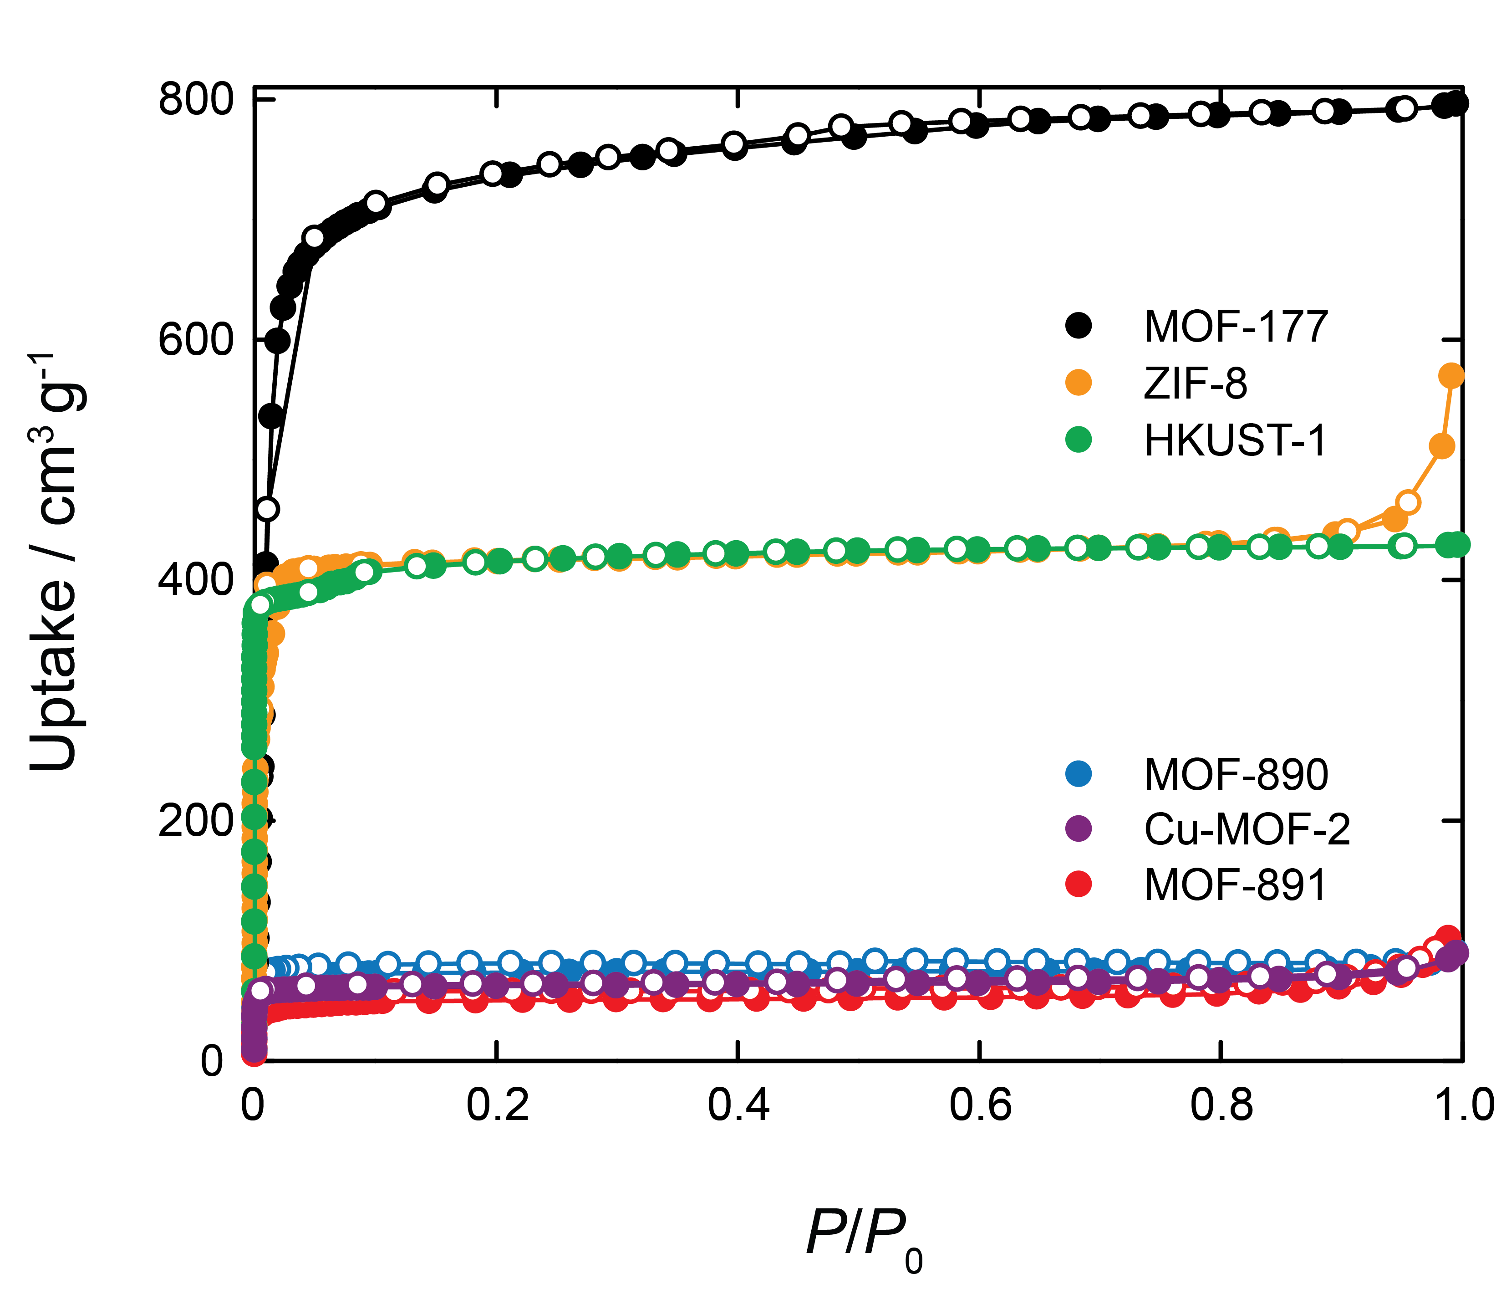

**Figure S4**. N2 adsorption-desorption isotherms of all MOFs applied for comparative reaction

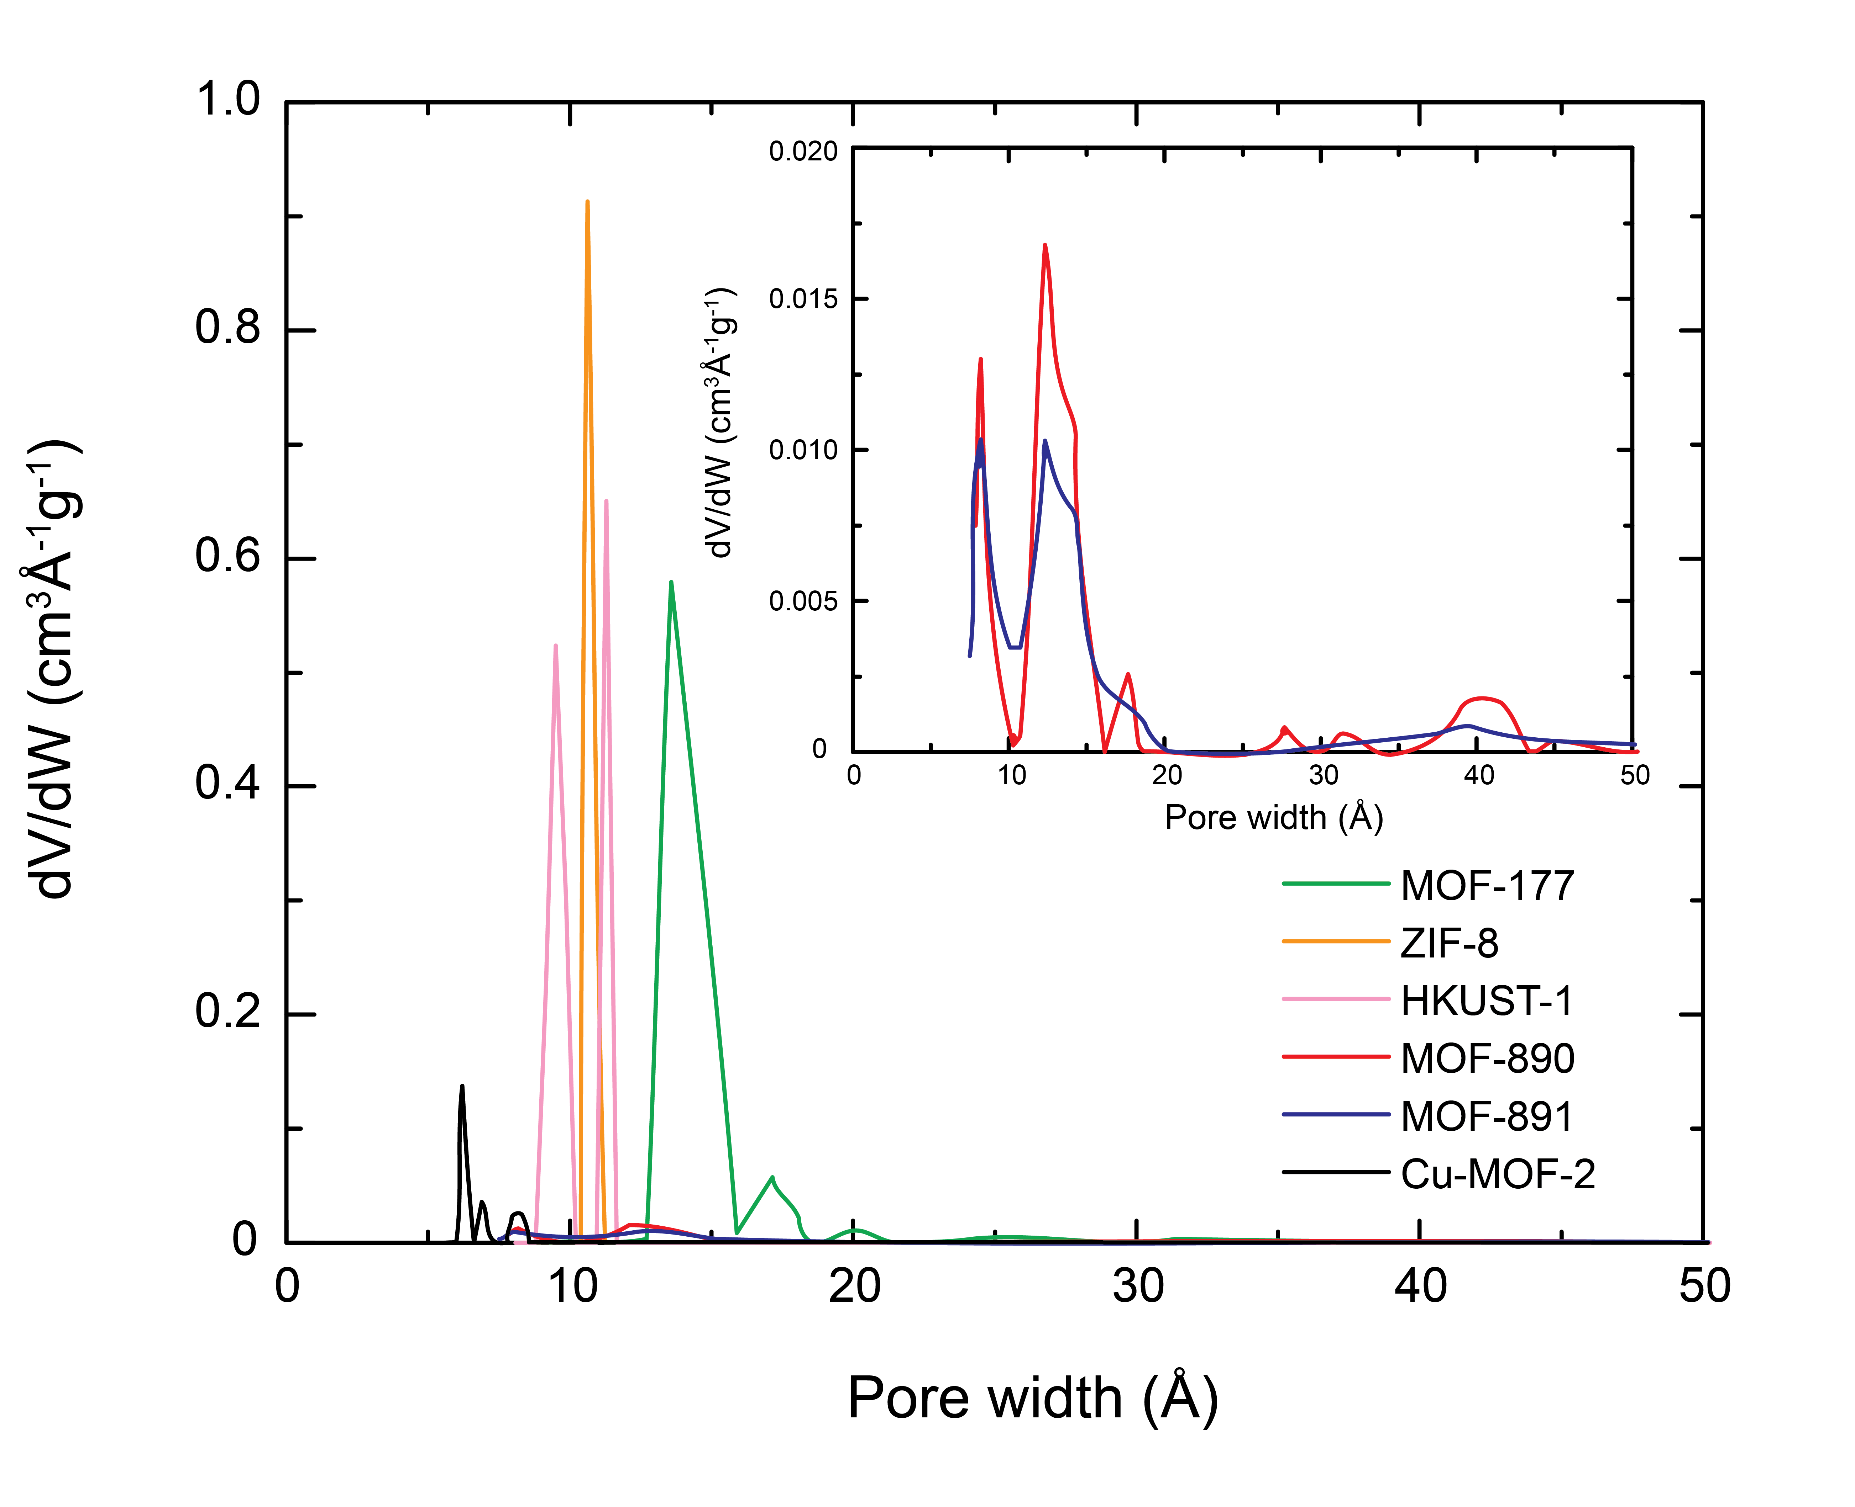

**Figure S5**. The pore size distribution curves of all comparative MOFs

**Table S1**. Comparison of BET surface area (SA), calculated pore size distribution (PSD) with those obtained from the experimental N2 isotherms measured from the activated MOFs, along with the theoretical pore aperture and cavity metrics values obtained from their crystal structure models.

|  |  |  |  |  |  |
| --- | --- | --- | --- | --- | --- |
| MOF | BET SA (m2 g-1) | | PSD (Å) | Aperture/Cavity metrics | |
| MOF-891  MOF-890  Cu-MOF-2  MOF-177  ZIF-8  HKUST-1 | | 250  290  246  2340  1500  1300 | 8.2 & 12.3  8.2 & 12.3  6.2 & 8.0  14 & 17  10.6  9.5 & 11.3 | | 9.2 × 14.4 Å2  9.2 × 14.4 Å2  7.3 × 8.8 Å2  17.0 Å  11.6 Å  9.0 & 11.1 Å |

Thermal Gravimetric Analyses (TGA)

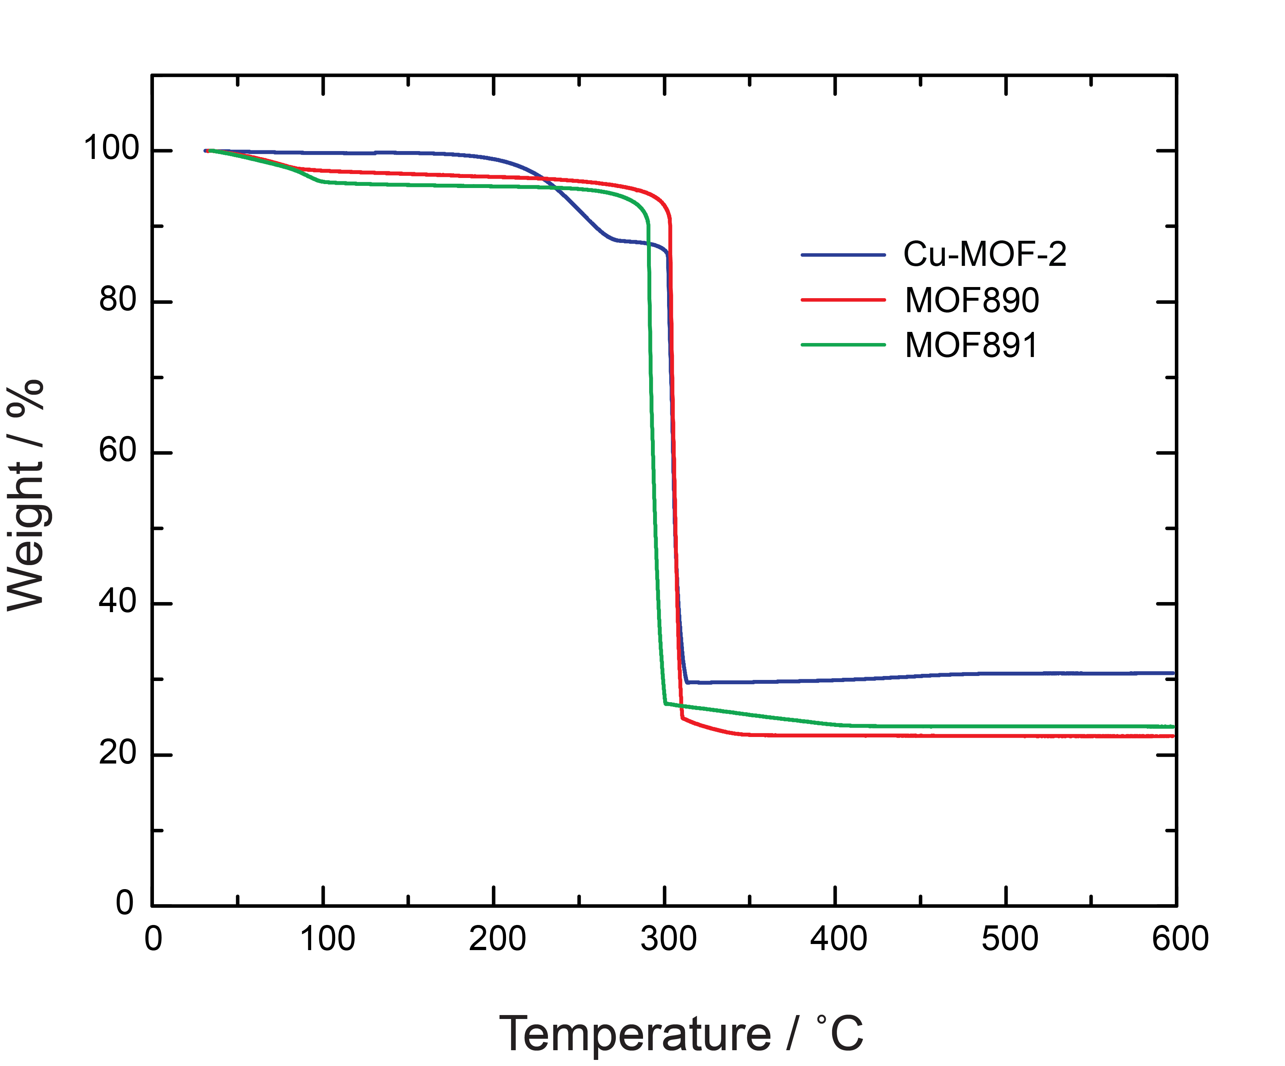

**Figure S6**. TGA traces of activated Cu-MOF-2, MOF-890 & MOF-891 at a heating rate of 5 °C min-1 under air flow.

**Section S3**: General Catalytic Procedure for the Synthesis of Various Functionalized Bis(indolyl)methanes and Various Catalysts



**Scheme S1**. Synthetic scheme for the formation of various functionalized bis(indolyl)methanes using a heterogeneous MOF-891 catalyst.

In general, an appropriate indole (0.23 g, 2 mmol) and benzaldehyde (0.1 g, 1 mmol) in *m*-xylene (2 mL) were added into a flask pre-charged with MOF-891 (0.013 g, 0.01 mmol, the molecular weight of MOF unit: 1322.76 g mol-1) catalyst. The reaction was then sonicated at RT for 1.5-2.5 hours and monitored by TLC. After completion of reaction, the MOF-891 catalyst was filtered from the reaction mixture and washed further with ethyl acetate (2 × 10 mL). The combined organic layers were evaporated under reduced pressure to obtain the crude product. The crude product was purified by silica gel column chromatography (90:10 acetone/petroleum ether) in order to afford the pure product, which was confirmed via FTIR, 1H-NMR, 13C-NMR, and GC-MS or HR-ESI-MS.



**Scheme S2:** General scheme of the synthesis of 3,3'-(phenylmethylene)bis(1H-indole) by various catalysts

An indole (0.23 g, 2 mmol) and benzaldehyde (0.1 g, 1 mmol) in *m*-xylene (2 mL) were added into a flask pre-charged with various catalysts (1 mol%). The reaction was then sonicated at RT for 1.5 hour and monitored by TLC. After completion of reaction, the heterogeneous catalysts were centrifuged from the reaction mixture and washed further with ethyl acetate (2 × 10 mL). In case of the reactions by the homogeneous catalysts, the reaction mixture was added ethyl acetate (5 mL) and extracted with water to remove the homogeneous salts. The combined organic layers were evaporated under reduced pressure to obtain the crude product. The crude product was purified by silica gel column chromatography (90:10 acetone/petroleum ether) in order to afford the pure product, which was confirmed via GC-MS.

**Section S4**: Leaching Studies

For the leaching test, a catalytic reaction was stopped after 0.5 h, the MOF-891 was separated from the reaction by centrifugation. The reaction solution was further sonicated for 1 h and the resulting solution measured on ICP analysis exhibited that only 1.78 ppm of Cu leached after reaction. Additionally, the experiment afforded only 52% isolated yield of corresponding product. Consequently, the formation of 3,3'-(phenylmethylene)bis(1*H*-indole) could not proceed after the MOF-891 catalyst was separated from the reaction solution, while 92% yield of 3,3'-(phenylmethylene)bis(1*H*-indole) was obtained in the heterogeneous catalysis under ultrasonic irradiation for 1.5 hour. The same experiments were taken and stopped at 1 and 1.5 h.

**Table S2**. Leaching studies

|  |  |  |  |
| --- | --- | --- | --- |
| Reaction time | 0.5 h | 1.0 h | 1.5 h |
| Isolated yield (%) | 52 | 78 | 92 |
| Cu2+ leaching (ppm) | 1.78 | 0.12 | 0.09 |

**Section S5**: Optimized geometries of substrates and intermediates.

**Table S3.** Optimized geometries of compounds at B3LYP/6-311G (d, p) level of DFT

|  |  |  |
| --- | --- | --- |
| **Compounds** | **Optimized structure** | **Dimensions (Å2)** |
| Benzaldehyde | C:\Users\User\Desktop\tinh toan tac chat\old data\aldehyde Image.tif | ~ 6.7 × 9.0 |
| Indole | C:\Users\User\Desktop\tinh toan tac chat\old data\indole2 Image.tif | ~ 7.4 × 8.9 |
| 4-(*Tert*-butyl) benzaldehyde | C:\Users\User\Desktop\tinh toan tac chat\old data\tesrt-benza2l Image.tif | ~ 6.8 × 11.0 |
| 5-methyl-1*H*-indole | C:\Users\User\Desktop\tinh toan tac chat\old data\indole-CH3-dft-ball Image.tif | ~ 7.4 × 10.1 |
| Product **1** | C:\Users\User\Desktop\tinh toan tac chat\pro1-hf Image.tif | ~ 11.5 × 13.4 |
| Product **17** | C:\Users\User\Desktop\tinh toan tac chat\pro17-hf-ball Image.tif | ~ 12.9 × 16.4 |

Color code: C, black; N, blue; O, red; H, pink.

**Section S6**: Bis(indolyl)methanes Derivatives Characterization

**3,3'-(phenylmethylene)bis(1*H*-indole) (1)**S3



FTIR **(**KBr, 4000 – 400 cm-1**):** 3414 (br), 3057 (w), 1730 (br), 1618 (s), 1517 (w), 1485 (w), 1456 (w), 1413 (s), 1336 (w), 1238 (w), 1200 (br), 1125 (br), 1011 (w), 746 (s), 701 (w), 617 (w), 426 (w).

1HNMR (500 MHz, CDCl3) δ = 7.90 (s, 2H, NH), 7.40 (d, *J* = 8.0 Hz, 2H), 7.36 – 7.34 (m, 4H), 7.28 (t, *J* = 7.5 Hz, 2H), 7.23 – 7.20 (m, 1H), 7.17 (t, *J* = 7.5 Hz, 2H), 7.01 (t, *J* = 8.0 Hz, 2H), 6.63 (s, 2H), 5.89 (s, 1H) ppm.

13C NMR (125 MHz, CDCl3) δ = 144.1, 136.7, 128.7, 128.2, 127.1, 126.1, 123.6, 121.9, 119.9, 119.7, 119.2, 111.1, 40.4 ppm.

GC-MS(EI, 70 eV) *m/z*: 322 ([M]+).

**3,3'-(p-tolylmethylene)bis(1*H*-indole) (2)**S3



FTIR (KBr, 4000 – 400 cm-1): 3695 (w), 3413 (br), 3055 (w), 2920 (br), 2853 (w), 1726 (br), 1608 (br), 1512 (w), 1484 (w), 1456 (w), 1414 (s), 1384 (w), 1337 (w), 1238 (w), 1201 (br), 1126 (br), 1036 (w), 745 (s), 469 (br), 425 (w).

1H NMR (500 MHz, CDCl3) δ = 7.89 (s, 2H, NH), 7.40 (d, *J* = 8.0 Hz, 2H), 7.34 (d, *J* = 8.0 Hz, 2H), 7.24 (d, *J* = 8.0 Hz, 2H), 7.18 – 7.15 (m, 2H), 7.09 (d, *J* = 7.5 Hz, 2H), 7.00 (t, *J* = 7.5 Hz, 2H), 6.66 (s, 2H), 5.85 (s, 1H), 2.33 (s, 3H) ppm.

13C NMR (125 MHz, CDCl3) δ = 141.0, 136.7, 135.5, 128.9, 128.6, 127.1, 123.6, 121.9, 120.1, 120.0119.1, 111.0, 40.1, 21.1 ppm.

GC-MS(EI, 70 eV) *m/z*: 336 ([M]+).

**3,3'-((4-(tert-butyl)phenyl)methylene)bis(1*H*-indole) (3)**S3



IR (KBr, 4000 – 400 cm-1): 3424 (br), 2961 (w), 2922 (w), 1720 (br), 1609 (br), 1514 (w), 1458 (br), 1413 (w), 1385 (w), 1270 (br), 1200 (br), 1117 (br), 797 (w), 743 (s).

1H NMR (500 MHz, CDCl3) δ = 7.90 (s, 2H), 7.41 (d, *J* = 7.9 Hz, 2H), 7.34 (d, *J* = 8.2 Hz, 2H), 7.28 (d, *J* = 1.4 Hz, 4H), 7.18 – 7.14 (m, 2H), 7.02 – 6.98 (m, 2H), 6.68 – 6.66 (m, 2H), 5.86 (s, 1H), 1.30 (s, 9H) ppm.

13C NMR (125 MHz, CDCl3) δ = 148.7, 140.9, 136.7, 128.3, 127.2, 125.3, 125.1, 123.6, 121.8, 120.0, 119.1, 111.0, 39.7, 34.4, 31.5 ppm.

GC-MS(EI, 70 eV) *m/z*: 378 ([M]+).

**3,3'-((4-fluorophenyl)methylene)bis(1*H*-indole) (4)**S3



FTIR (KBr, 4000 – 400 cm-1): 3409 (br), 3057 (w), 2963 (br), 2924 (br), 2856 (w), 1724 (br), 1604 (s), 1505 (s), 1456 (w), 1414 (s), 1336 (w), 1258 (w), 1217 (br), 1156 (w), 1095 (br), 1035 (w), 853 (w), 805 (s), 745 (s), 598 (w).

1H NMR (500 MHz, CDCl3) δ = 7.95 (s, 2H), 7.40 – 7.33 (m, 4H), 7.30 (dd, *J* = 8.5, 5.6 Hz, 2H), 7.19 – 7.16 (m, 2H), 7.03–7.00 (m, 2H), 6.98 – 6.94 (m, 2H), 6.64 (d, *J* = 1.5 Hz, 2H), 5.87 (s, 1H) ppm.

13C NMR (125 MHz, CDCl3) δ 161.6 (d, *J* = 241.25 Hz), 139.9, 136.9, 130.2 (d, *J* = 7.9 Hz), 127.1, 123.7, 122.2, 120.0, 119.7, 119.5, 115.1 (d, *J* = 20 Hz), 111.2 , 39.6 ppm.

GC-MS(EI, 70 eV) *m/z*: 340 ([M]+).

**3,3'-((3-fluorophenyl)methylene)bis(1*H*-indole) (5)**S4



FTIR (KBr, 4000 – 400 cm-1)**:**  3410 (br), 3057 (br), 2958 (w), 2922 (s), 2851 (s), 1712 (br), 1614 (s), 1587 (s), 1518 (w), 1485 (s), 1456 (br), 1414 (s), 1384 (w), 1337 (w), 1236 (br), 1124 (s), 1095 (w), 1010 (w), 940 (br), 882 (br), 774 (w), 744 (s), 692 (br), 597 (br), 424 (w).

1H NMR (500 MHz, DMSO) δ = 10.86 (s, 2H), 7.37 (d, *J* = 8.1 Hz, 2H), 7.34 – 7.28 (m, 3H), 7.23 (d, *J* = 7.6 Hz, 1H), 7.14 – 7.11 (m, 1H), 7.05 (t, *J* = 7.6 Hz, 2H), 7.00 (td, *J* = 8.4, 2.4 Hz, 1H), 6.92 – 6.85 (m, 4H), 5.90 (s, 1H) ppm.

13C NMR (125 MHz, CDCl3) δ 163.1 (d, *J* = 243.75 Hz), 147.0 (d, *J* = 3.8 Hz), 136.8, 129.7 (d, *J* = 8.2 Hz), 127.1, 124.5 (d, *J* = 2.5 Hz), 123.7, 122.2, 119.9, 119.5, 119.17, 115.71 (d, *J* = 21.25 Hz), 113.20 (d, *J* = 42.25 Hz), 111.25 (s), 40.11 (s).

GC-MS(EI, 70 eV) *m/z*: 340 ([M]+).

**3,3'-((2-fluorophenyl)methylene)bis(1*H*-indole) (6)**S5



FTIR (KBr, 4000 – 400 cm-1)**:**  3392 (s), 3055 (w), 2922 (w), 2853 (w), 1619 (br), 1581 (w), 1484 (s), 1455 (s), 1420 (w), 1337 (br), 1220 (s), 1094 (s), 1043 (w), 1009 (w), 795 (w), 749 (s), 605 (br), 499 (br), 421 (w).

1H NMR (500 MHz, DMSO) δ = 10.85 (s, 2H), 7.36 (d, *J* = 8.1 Hz, 2H), 7.24 (t, *J* = 8.8 Hz, 4H), 7.20 – 7.15 (m, 1H), 7.09 – 7.03 (m, 3H), 6.90 – 6.85 (m, 2H), 6.83 (d, *J* = 2.1 Hz, 2H), 6.10 (s, 1H) ppm.

13C NMR (125 MHz, CDCl3) δ 160.7 (d, *J* = 245 Hz), 136.7, 130.9 (d, *J* = 14.1 Hz), 130.4 (d, *J* = 4.1 Hz), 127.8 (d, *J* = 8.1 Hz), 126.9, 123.8 (d, *J* = 3.5 Hz), 123.6, 122.0, 119.8, 119.3, 118.3, 115.3, 115.2 (d, , *J* = 21.3 Hz), 32.52 (d, *J* = 3.9 Hz).

GC-MS(EI, 70 eV) *m/z*: 340 ([M]+).

**3,3'-((4-bromophenyl)methylene)bis(1*H*-indole) (7)**S6



FTIR (KBr, 4000 – 400 cm-1)**:**  3411 (br), 3056 (w), 2922 (w), 2852 (w), 1705 (br), 1618 (br), 1583 (br), 1518 (w), 1484 (s), 1457 (w), 1413 (s), 1335 (w), 1199 (br), 1125 (br), 1071 (w), 1010 (s), 746 (s), 425 (s).

1H NMR (500 MHz, CDCl3) δ = 7.93 (s, 2H), 7.41 – 7.38 (m, 2H), 7.38 – 7.34 (m, 4H), 7.23 – 7.16 (m, 4H), 7.04 – 7.00 (m, 2H), 6.63 (dd, *J* = 2.2, 0.8 Hz, 2H), 5.85 (s, 1H) ppm.

13C NMR (125 MHz, CDCl3) δ = 143.3, 136.9, 131.5, 130.64, 127.0, 123.8, 122.2, 119.9, 119.5, 119.3, 119.3, 111.3, 39.8 ppm.

GC-MS(EI, 70 eV) *m/z*: 400 ([M]+).

**3,3'-((3-bromophenyl)methylene)bis(1*H*-indole) (8)**S6



FTIR (KBr, 4000 – 400 cm-1)**:**  3410 (br), 3053 (w), 2924 (w), 1701 (w), 1618 (br), 1517 (w), 1456 (s), 1418 (s), 1383 (br), 1217 (br), 1148 (w), 1093 (s), 1038 (w), 1010 (w), 744 (s), 693 (br), 599 (br), 425 (s).

1H NMR (500 MHz, DMSO) δ = 10.84 (s, 2H), 7.49 (s, 1H), 7.37 – 7.32 (m, 4H), 7.27 (d, *J* = 7.9 Hz, 2H), 7.22 (t, *J* = 7.8 Hz, 1H), 7.05 – 7.00 (m, 2H), 6.89 – 6.82 (m, 4H), 5.86 (s, 1H) ppm.

13C NMR (125 MHz, CDCl3) δ = 146.7, 136.8, 131.8, 130.0, 129.5, 127.5, 127.0, 123.8, 122.5, 122.2, 119.9, 119.5, 119.1, 111.3, 40.1 ppm.

GC-MS(EI, 70 eV) *m/z*: 400 ([M]+).

**3,3'-((2-bromophenyl)methylene)bis(1*H*-indole) (9)**S5



FTIR (KBr, 4000 – 400 cm-1)**:**  3410 (br), 3053 (br), 1702 (s), 1618 (w), 1487 (w), 1417 (s), 1338 (s), 1219 (s), 1185 (s), 1011 (s), 794 (w), 742 (s), 680 (w), 599 (s), 423 (s).

1H NMR (500 MHz, DMSO) δ = 10.87 (s, 2H), 7.65 (dd, *J* = 8.0, 1.1 Hz, 1H), 7.38 (d, *J* = 8.1 Hz, 2H), 7.31 – 7.23 (m, 4H), 7.18 – 7.13 (m, 1H), 7.08 – 7.04 (m, 2H), 6.92 – 6.87 (m, 2H), 6.74 (d, *J* = 2.2 Hz, 2H), 6.20 (s, 1H) ppm.

13C NMR (125 MHz, DMSO) δ = 143.9, 137.1, 133.0, 130.81, 128.5, 128.0, 127.0, 124.4, 124.3, 121.5, 119.1, 118.8, 117.1, 112.0, 39.5 ppm.

GC-MS(EI, 70 eV) *m/z*: 400 ([M]+).

**3,3'-((4-chlorophenyl)methylene)bis(1*H*-indole) (10)**S6



FTIR (KBr, 4000 – 400 cm-1): 3413 (br), 2924 (w), 2854 (w), 1618 (br), 1516 (w), 1486 (s), 1457 (w), 1414 (s), 1335 (w), 1200 (br), 1124 (w), 1092 (br), 1013 (s), 746 (s), 594 (br), 500 (br), 423 (s).

1H NMR (500 MHz, CDCl3) δ = 7.93 (s, 2H), 7.36 (t, *J* = 7.5 Hz, 4H), 7.30 – 7.26 (m, 2H), 7.26 – 7.22 (m, 2H), 7.18 (t, *J* = 7.6 Hz, 2H), 7.03 – 7.00 (m, 2H), 6.65 – 6.62 (m, 2H), 5.86 (s, 1H) ppm.

13C NMR (125 MHz, CDCl3) δ = 142.7, 136.9, 131.9, 130.2, 128.5, 127.0, 123.7, 122.3, 119.9, 119.5, 119.3, 111.3, 39.5 ppm.

GC-MS(EI, 70 eV) *m/z*: 356 ([M]+).

**3,3'-((1*H*-imidazol-5-yl)methylene)bis(1*H*-indole) (11)**



FTIR (KBr, 4000 – 400 cm-1)**:**  3414 (br), 3054 (w), 2922 (w), 2854 (w), 1607 (br), 1511 (w), 1485 (s), 1455 (s), 1417 (w), 1385 (w), 1340 (br), 1094 (br), 1011 (w), 744 (s), 701 (w), 479 (br), 425 (w).

1H NMR (500 MHz, DMSO) δ = 10.78 (s, 2H), 7.33 (d, *J* = 8.1 Hz, 2H), 7.27 (d, *J* = 8.0 Hz, 2H), 7.25 – 7.21 (m, 1H), 7.18 (s, 1H), 7.13 (s, 1H), 7.07 – 6.96 (m, 4H), 6.80 (dd, *J* = 8.2, 1.7 Hz, 2H), 5.77 (s, 1H) ppm.

13C NMR (125 MHz, CDCl3) δ 129.6, 129.1, 128.7, 128.2, 127.1, 125.9, 123.7, 122.0, 120.1, 119.4, 111.1, 40.3 ppm.

HR – MS(ESI) m/z: [M+Na]+ Calcd for C20H16N4 335.1267; found 335.1251.

**4-(di(1*H*-indol-3-yl)methyl)benzene-1,2-diol (12)S7**



FTIR (KBr, 4000 – 400 cm-1)**:**  3429 (br), 2924 (w), 2854 (w), 1622 (br), 1512 (w), 1456 (w), 1413 (w), 1384 (s), 1197 (w), 1116 (w), 748 (s).

1H NMR (500 MHz, DMSO) δ = 10.79 (s, 2H), 7.34 (d, *J* = 8.1 Hz, 2H), 7.27 (d, *J* = 8.0 Hz, 2H), 7.25 – 7.21 (m, 1H), 7.18 (s, 1H), 7.13 (d, *J* = 0.9 Hz, 1H), 7.07 – 6.96 (m, 4H), 6.80 (dd, *J* = 8.2, 1.9 Hz, 2H), 5.77 (s, 1H) ppm.

13C NMR (126 MHz, CDCl3) δ 129.6, 129.1, 128.7, 128.2, 127.1, 125.9, 123.7, 123.7, 122.0, 120.1, 120.1, 120.0, 119.4, 111.1, 40.3 ppm.

HR – MS(ESI) m/z: [M-H2O-H]+ Calcd for C23H15N2O 335.1184; found 335.1776.

**3,3'-((4-nitrophenyl)methylene)bis(1*H*-indole) (13)S8**



FT-IR (KBr, 4000 – 400 cm-1): 3410, 3058, 2920, 1616, 1480, 1415, 1197, 1178, 1071, 741.

1H NMR (500 MHz, DMSO-*d*6) *δ* 10.89 (s, 2H), 8.13 (d, *J* = 9.0 Hz, 2H), 7.59 (d, *J* = 9.0 Hz, 2H), 7.35 (d, *J* = 8.5 Hz, 2H), 7.27 (d, *J* = 8.0 Hz, 2H), 7.06 – 7.01 (m, 2H), 6.88 – 6.85 (m, 4H), 6.01 (s, 1H) ppm.

13C NMR (125 MHz, DMSO-*d*6) *δ* 153.6, 146.3, 137.1, 129.9, 126.8, 124.3, 123.9, 121.6, 119.4, 118.9, 117.2, 112.1, 40.0 ppm.

GC-MS (EI, 70 eV) *m/z*: 367 ([M]+).

**3,3'-(phenylmethylene)bis(5-nitro-1*H*-indole) (14)S9**



FT-IR (KBr, 4000 – 400 cm-1): 3406, 3052, 2922, 1611, 1482, 1419, 1189, 1163, 1072, 739.

1H NMR (500 MHz, DMSO-*d*6) *δ* 11.66 (s, 2H), 8.31 (d, *J* = 2.0 Hz, 2H), 7.97 (dd, *J* = 9.0, 2.0 Hz, 2H), 7.55 (d, *J* = 9.0 Hz, 2H), 7.40 (d, *J* = 7.5 Hz, 2H), 7.32 (t, *J* = 7.5 Hz, 2H), 7.22 (t, *J* = 7.5 Hz, 2H), 7.14 (s, 1H), 6.19 (s, 1H) ppm.

13C NMR (125 MHz, DMSO-*d*6) *δ* 144.2, 140.7, 140.3, 128.9, 128.7, 128.0, 126.9, 126.3, 121.0, 117.1, 116.7, 112.6, 39.0.

LC-MS (EI, 70 eV) *m/z*: 413 ([M+H ]+).

**3,3'-((3-chlorophenyl)methylene)bis(5-methyl-1*H*-indole) (15)**



FTIR (KBr, 4000 – 400 cm-1)**:**  3408 (br), 3017 (br), 2920 (br), 2855 (w), 1623 (w), 1592 (br), 1515 (w), 1474 (s), 1421 (s), 1320 (w), 1220 (w), 1176 (w), 1093 (s), 998 (w), 871 (br), 795 (s), 768 (s), 736 (w), 703 (br), 590 (s), 423 (s)

1H NMR (500 MHz, DMSO) δ = 10.71 (s, 2H), 7.33 – 7.21 (m, 6H), 7.09 (s, 2H), 6.88 (d, *J* = 8.3 Hz, 2H), 6.76 (s, 2H), 5.81 (s, 1H), 2.28 (s, 6H) ppm.

13C NMR (125 MHz, DMSO) δ = 147.8, 135.0, 132.7, 129.9, 127.9, 127.0, 126.7, 126.6, 125.8, 123.8, 122.6, 118.4, 116.9, 111.2, 39.1, 21.3 ppm.

HR – MS(ESI) m/z: [M-H]+ Calcd for C25H20ClN2 383.1315; Found 383.1314.

**3,3'-(p-tolylmethylene)bis(5-methyl-1*H*-indole) (16)**



FTIR (KBr, 4000 – 400 cm-1)**:**  3411 (br), 3017 (br), 2918 (br), 2857 (w), 1702 (w), 1623 (br), 1582 (w), 1510 (s), 1481 (w), 1457 (w), 1419 (s), 1320 (w), 1221 (br), 1176 (w), 1091 (s), 1037 (w), 921 (w), 870 (w), 796 (s), 776 (s), 741 (w), 590 (s), 423 (s)

1H NMR (500 MHz, DMSO) δ = 10.61 (s, 2H), 7.23 – 7.19 (m, 4H), 7.06 (d, *J* = 6.8 Hz, 4H), 6.86 (d, *J* = 8.2 Hz, 2H), 6.68 (d, *J* = 1.8 Hz, 2H), 5.70 (s, 1H), 2.26 (s, 9H) ppm.

13C NMR (126 MHz, CDCl3) δ = 141.3, 135.5, 135.2, 129.0, 128.7, 128.5, 127.5, 123.9, 123.7, 119.7, 119.6, 110.8, 39.8, 21.6, 21.2 ppm.

HR – MS(ESI) m/z: [M-H]+ Calcd for C26H23N2 363.1861; Found 363.1889.

**3,3'-((4-(tert-butyl)phenyl)methylene)bis(5-methyl-1*H*-indole) (17)**



FTIR (KBr, 4000 – 400 cm-1)**:**  3413 (br), 3021 (w), 2961 (s), 2864 (w), 1704 (br), 1623 (w), 1582 (w), 1513 (w), 1479 (br), 1460 (w), 1418 (s), 1362 (s), 1342 (w), 1269 (br), 1176 (s), 1091 (s), 1018 (w), 922 (w), 869 (w), 794 (s), 715 (w), 590 (s), 423 (s).

1H NMR (500 MHz, DMSO) δ = 10.61 (s, 2H), 7.27 – 7.20 (m, 6H), 7.08 (s, 2H), 6.85 (d, *J* = 8.2 Hz, 2H), 6.73 (d, *J* = 2.0 Hz, 2H), 5.71 (s, 1H), 2.26 (s, 6H), 1.25 (s, 9H) ppm.

13C NMR (126 MHz, CDCl3) δ = 148.8, 141.2, 135.2, 128.5, 128.4, 127.6, 125.1, 123.9, 123.6, 119.8, 119.7, 110.8, 39.6, 34.5, 31.6, 21.6 ppm.

HR – MS (ESI) m/z: [M-H]+ Calcd for C29H29N2 405.2331; Found 405.2314.

**3,3'-((4-methoxyphenyl)methylene)bis(5-methyl-1*H*-indole) (18)**



FTIR (KBr, 4000 – 400 cm-1)**:** 3412 (br), 3019 (br), 2922 (br), 2853 (w), 1608 (br), 1509 (s), 1461 (br), 1384 (w), 1300 (br), 1245 (s), 1173 (s), 1093 (br), 1033 (w), 797 (br), 592 (w), 426 (w).

1H NMR (500 MHz, DMSO) δ = 10.60 (s, 2H), 7.22 (dd, *J* = 8.3, 3.8 Hz, 4H), 7.06 (s, 2H), 6.86 – 6.81 (m, 4H), 6.67 (s, 2H), 5.69 (s, 1H), 3.71 (s, 3H), 2.26 (s, 6H) ppm.

13C NMR (126 MHz, CDCl3) δ = 158.0, 136.6, 135.2, 129.7, 128.5, 127.5, 123.9, 123.65, 119.9, 119.7, 113.7, 110.8, 55.4, 39.3, 21.6 ppm.

HR – MS (ESI) m/z: [M-H]+ Calcd for C26H23N2O 379.1810; Found 379.184.

**3,3'-((3-fluorophenyl)methylene)bis(5-bromo-1*H*-indole) (19)**



FTIR (KBr, 4000 – 400 cm-1)**:**  3423 (br), 2921 (br), 2851 (w), 1697 (w), 1613 (s), 1587 (br), 1514 (w), 1457 (s), 1318 (w), 1245 (br), 1130 (w), 1096 (s), 945 (w), 883 (s), 795 (br), 696 (w), 683 (w), 582 (s), 548 (w), 473 (br), 420 (s).

1H NMR (500 MHz, DMSO) δ = 11.10 (s, 2H), 7.45 (d, *J* = 1.8 Hz, 2H), 7.36 – 7.32 (m, 3H), 7.20 (d, *J* = 7.7 Hz, 1H), 7.16 (dd, *J* = 8.6, 1.9 Hz, 2H), 7.12 – 7.09 (m, 1H), 7.02 (td, *J* = 8.4, 2.4 Hz, 1H), 6.94 (d, *J* = 2.1 Hz, 2H), 5.92 (s, 1H) ppm.

13C NMR (125 MHz, CDCl3) δ = 163.2 (d, *J* = 237.5 Hz), 146.0 (d, *J* = 6.6 Hz), 135.5, 130.0 (d, *J* = 8.2 Hz), 128.7, 125.3, 124.9, 124.4 (d, *J* = 2.6 Hz), 122.3, 118.5 (d, *J* = 1.4 Hz), 115.6 (d, *J* = 21.7), 113.7 (d, *J* = 21.3), 113.0, 112.8 (d, *J* = 1.6 Hz), 39.8 (d, *J* = 1.3 Hz) ppm.

HR – MS(ESI) m/z: [M-H]+ Calcd for C23H14Br2FN2 496.9487; Found 496.9471.

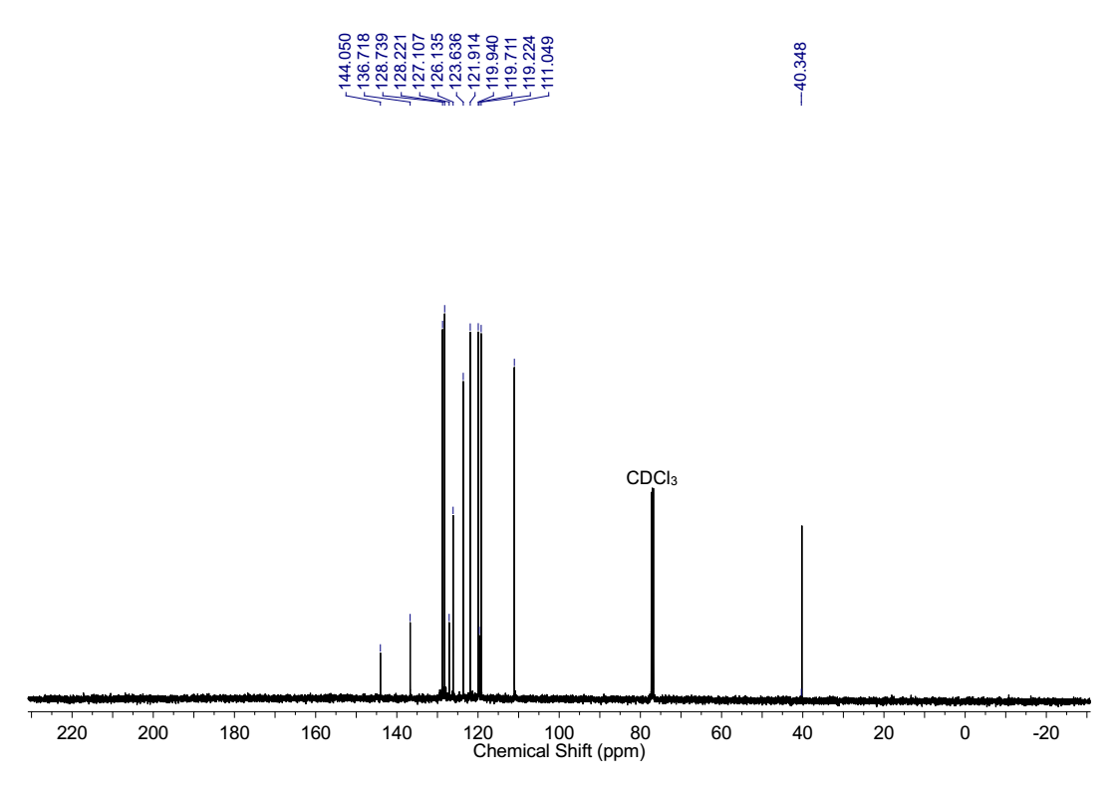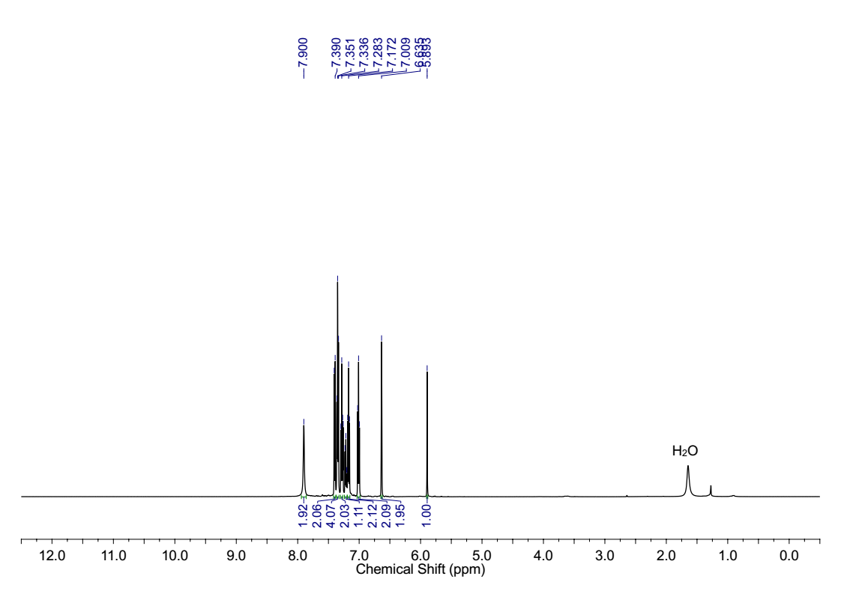****

**Figure S11**. 1H (top) and 13C (bottom) NMR spectra of 3,3'-(phenylmethylene)bis(1*H*-indole)

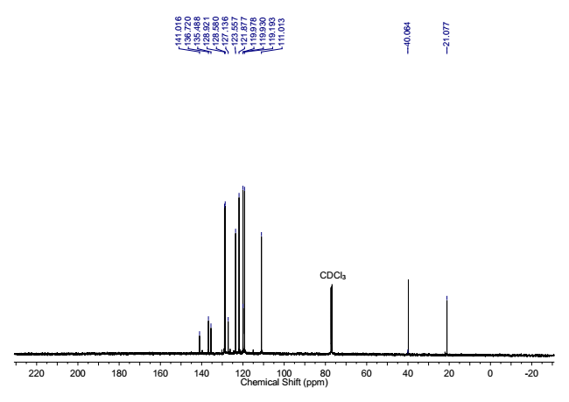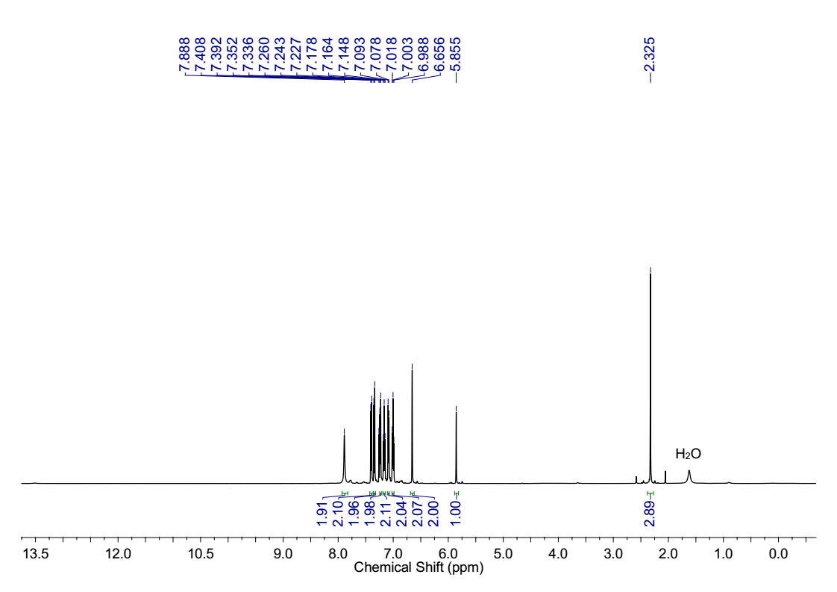 **Figure S12**. 1H (top) and 13C (bottom) NMR spectra of 3,3'-(p-tolylmethylene)bis(1*H*-indole)

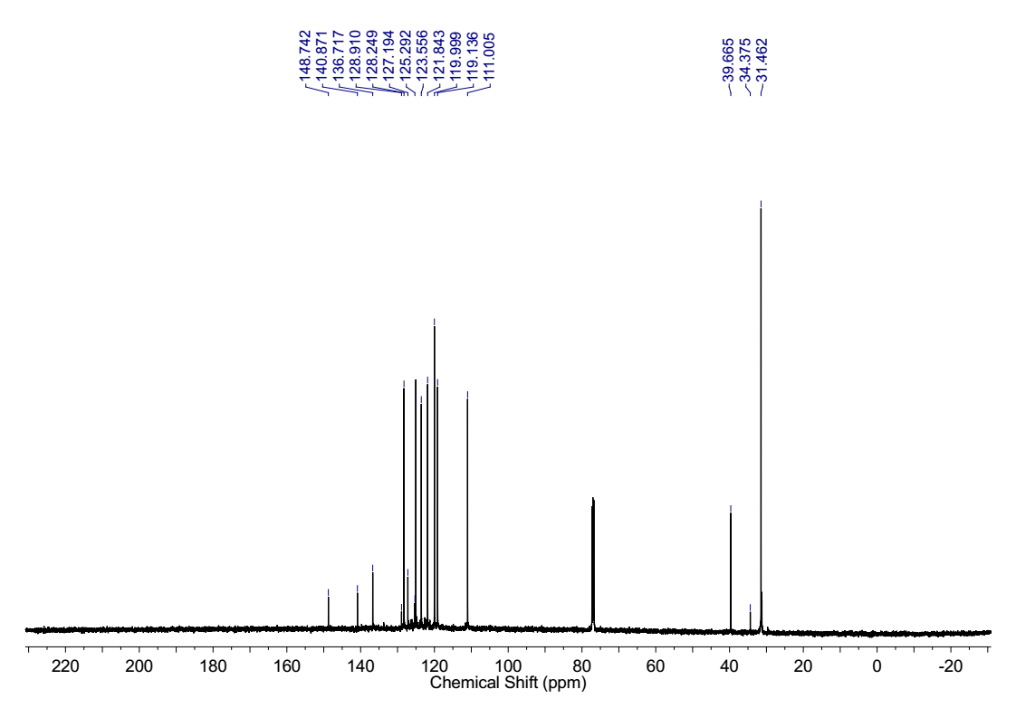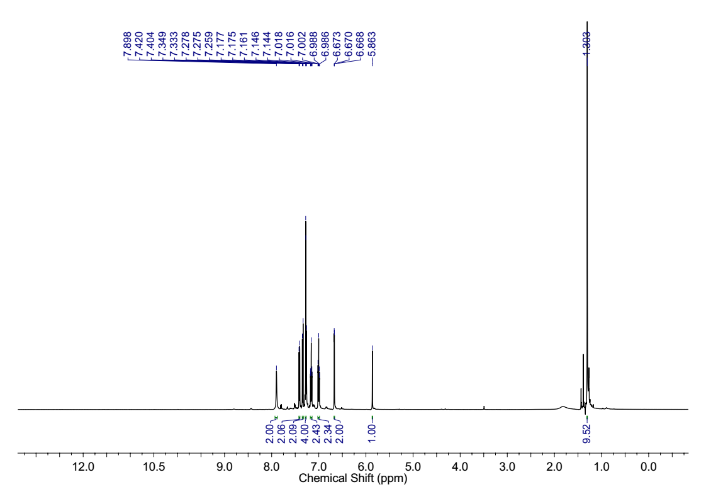**Figure S13**. 1H (top) and 13C (bottom) NMR spectra of 3,3'-((4-(tert-butyl)phenyl)methylene)bis(1*H*-indole)

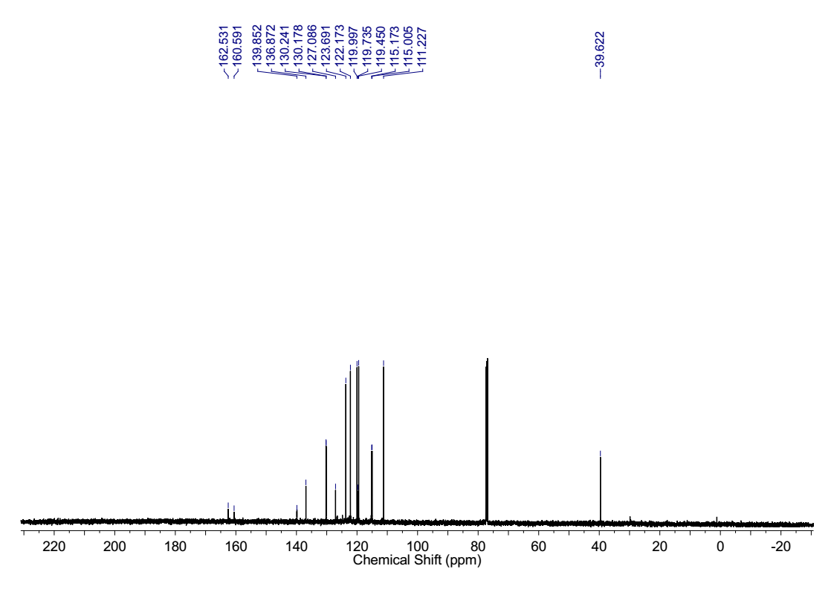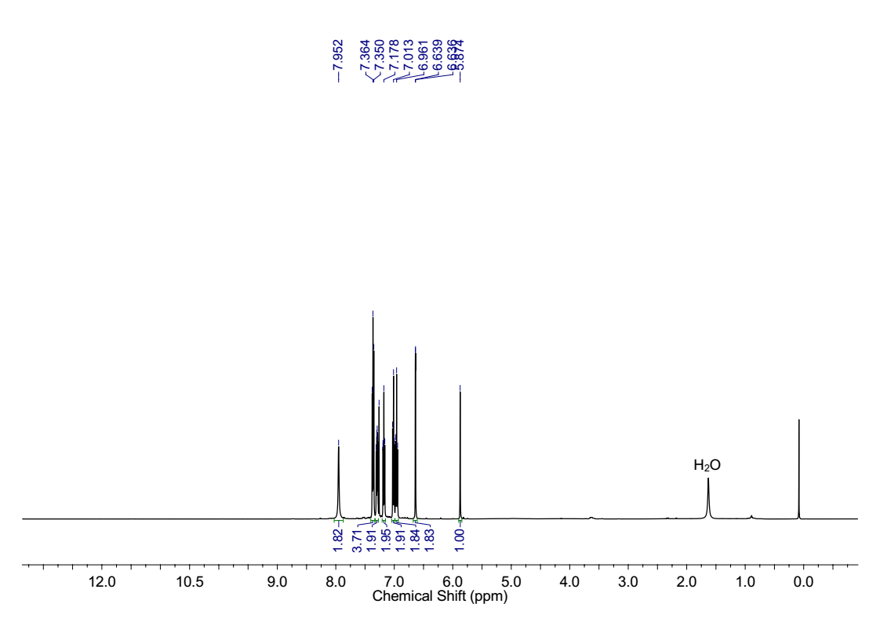 **Figure S14**. 1H (top) and 13C (bottom) NMR spectra of 3,3'-((4-fluorophenyl)methylene)bis(1*H*-indole)

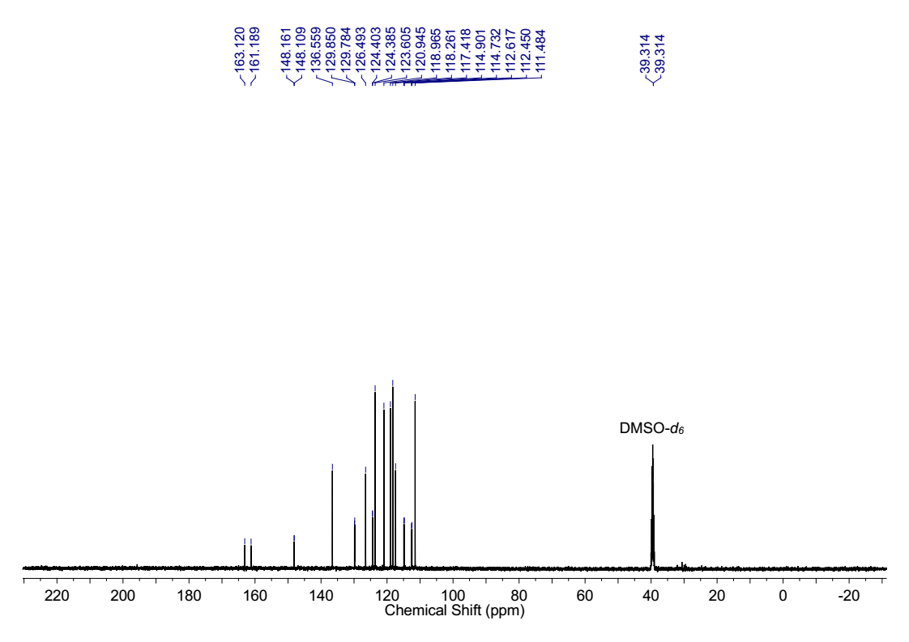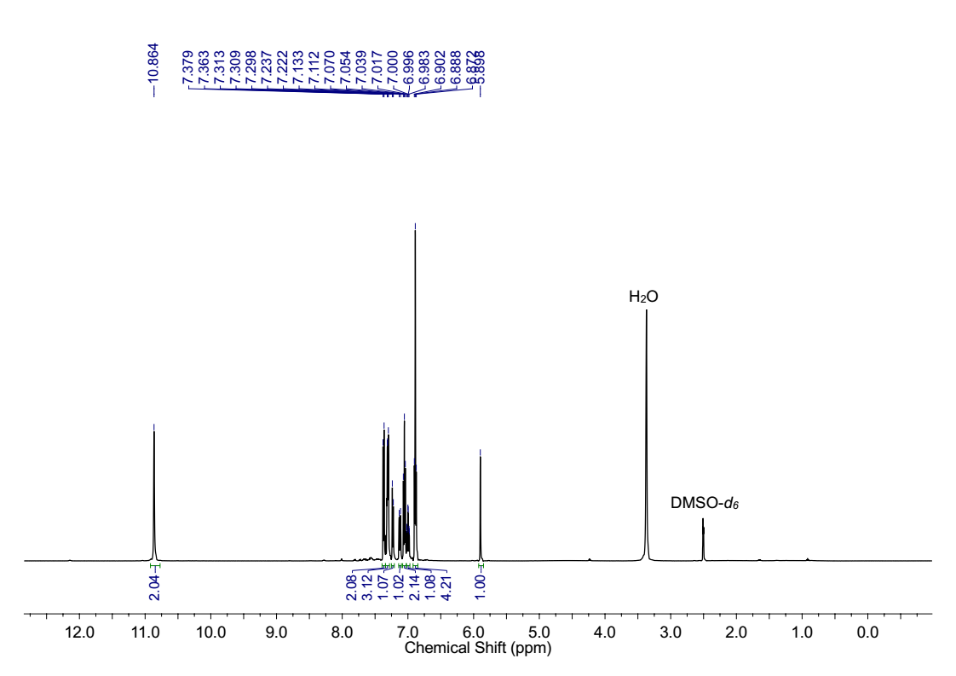 **Figure S15**. 1H (top) and 13C (bottom) NMR spectra of 3,3'-((3-fluorophenyl)methylene)bis(1*H*-indole)

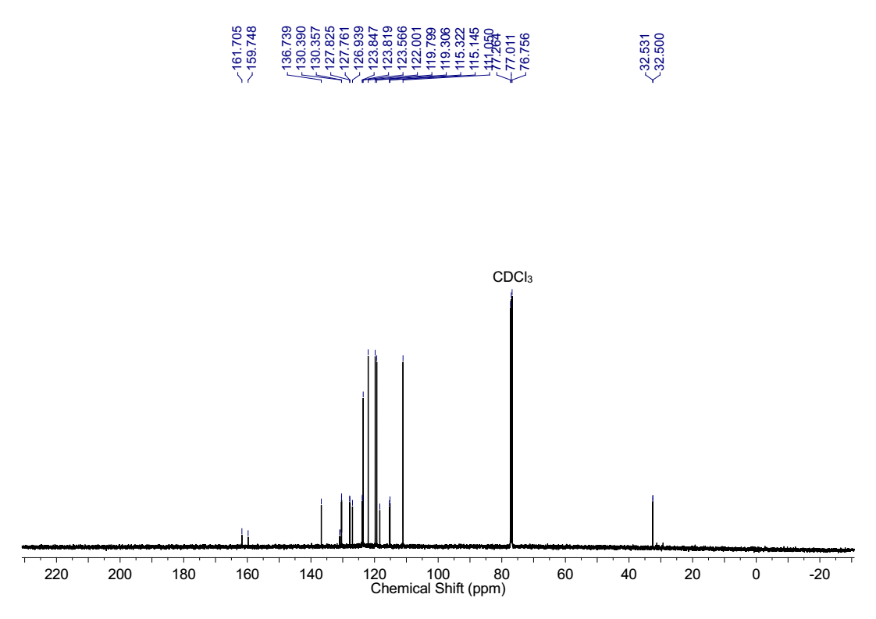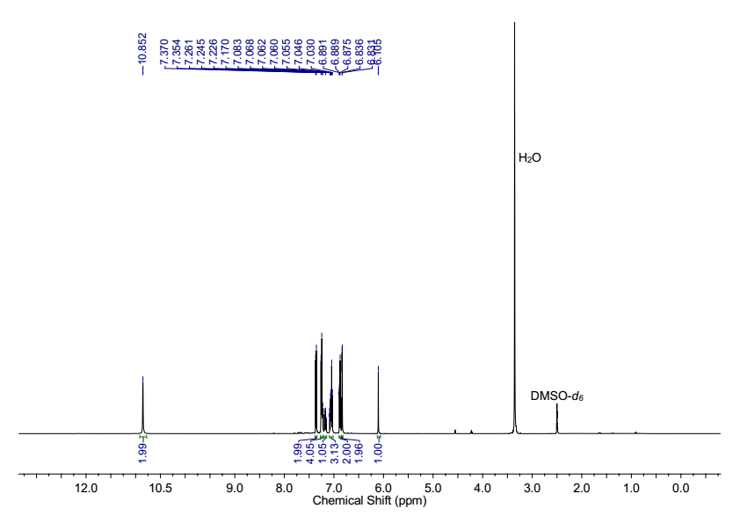**Figure S16**. 1H (top) and 13C (bottom) NMR spectra of 3,3'-((2-fluorophenyl)methylene)bis(1*H*-indole)

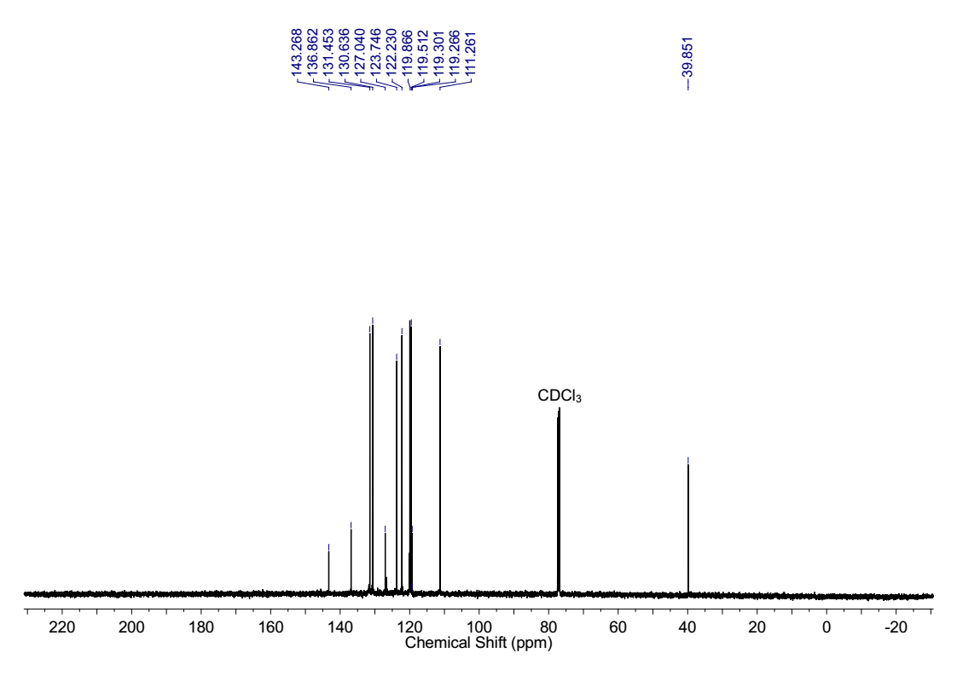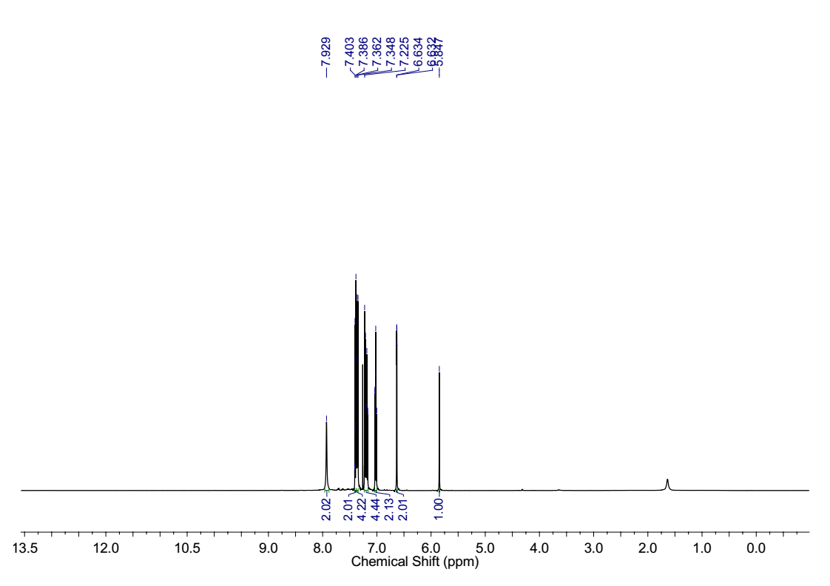 **Figure S17**. 1H (top) and 13C (bottom) NMR spectra of 3,3'-((4-bromophenyl)methylene)bis(1*H*-indole)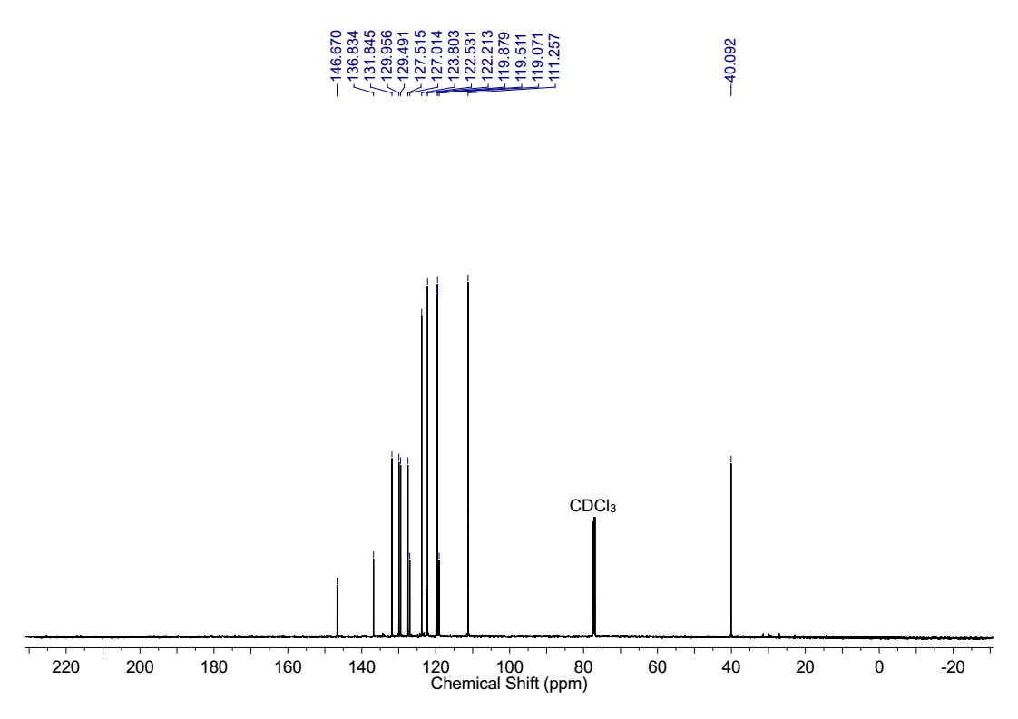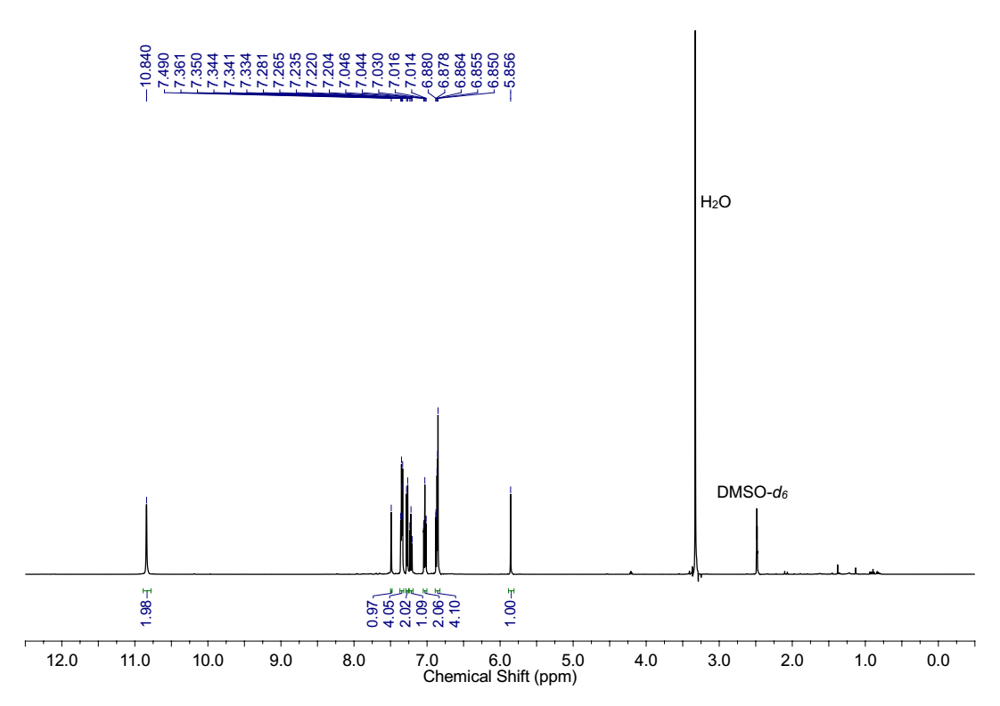**Figure S18**. 1H (top) and 13C (bottom) NMR spectra of 3,3'-((3-bromophenyl)methylene)bis(1*H*-indole)

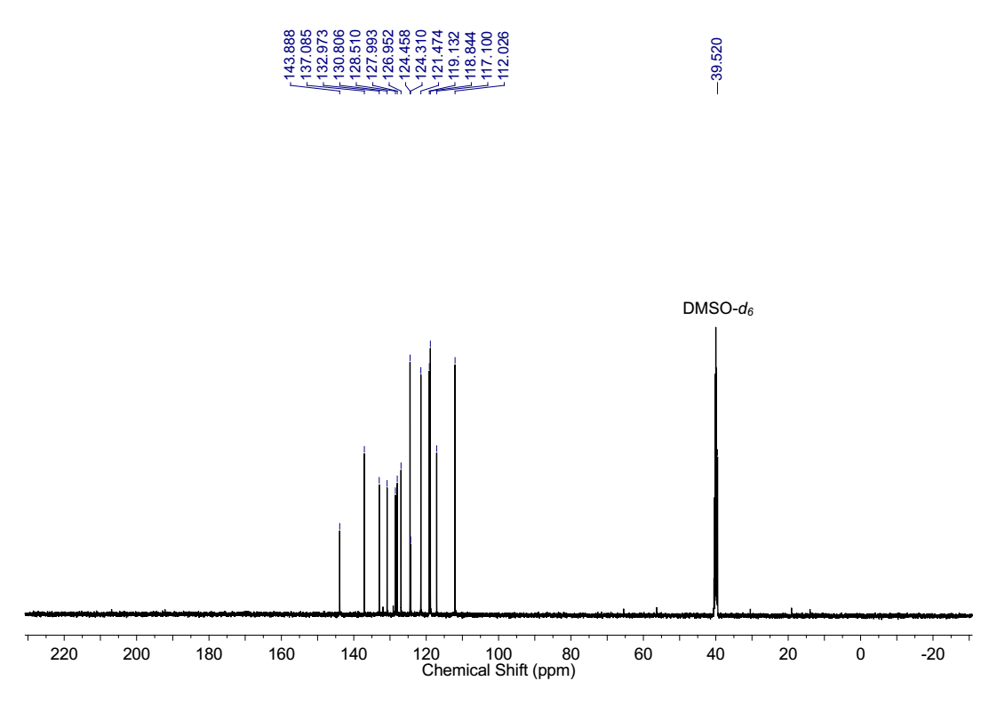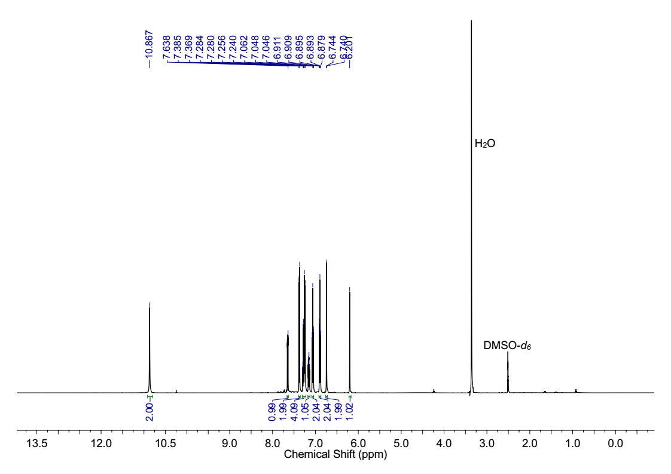 **Figure S19**. 1H (top) and 13C (bottom) NMR spectra of 3,3'-((2-bromophenyl)methylene)bis(1*H*-indole)

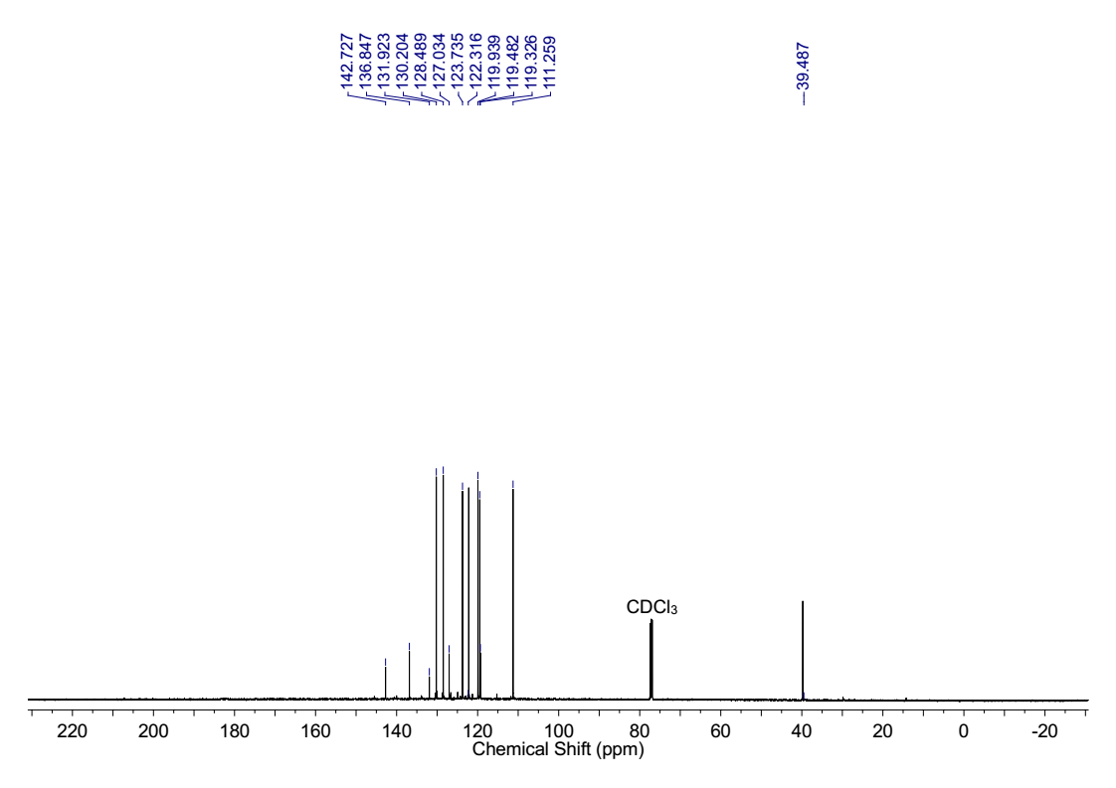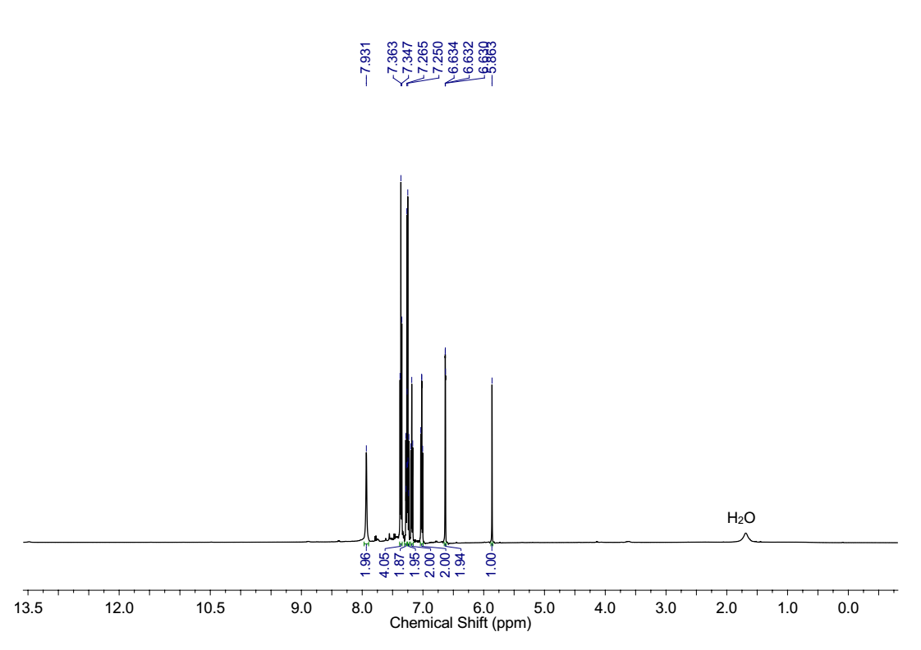 **Figure S20**. 1H (top) and 13C (bottom) NMR spectra of 3,3'-((4-chlorophenyl)methylene)bis(1*H*-indole).

****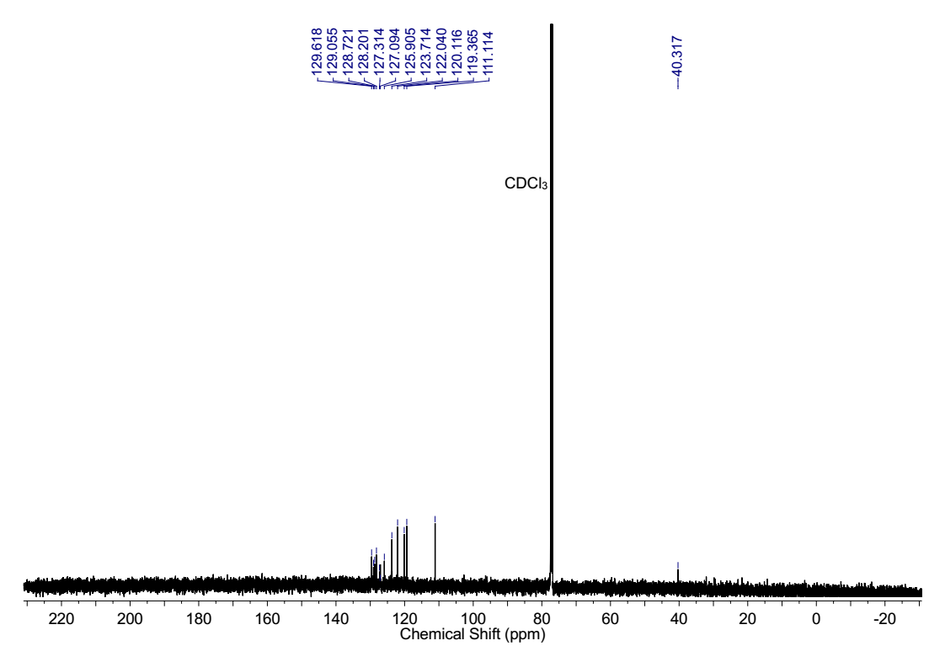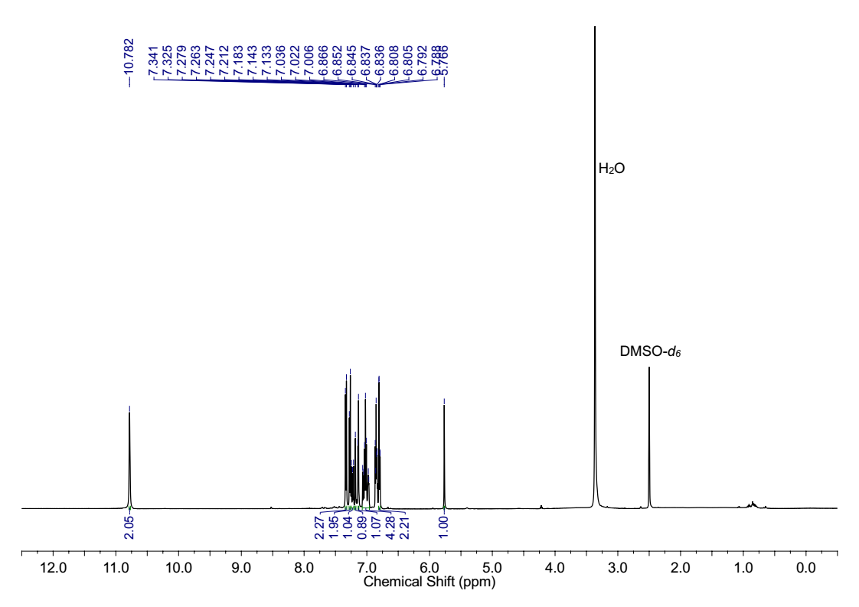**Figure S21**. 1H (top) and 13C (bottom) NMR spectra of 3,3'-((1*H*-imidazol-5-yl)methylene)bis(1*H*-indole)

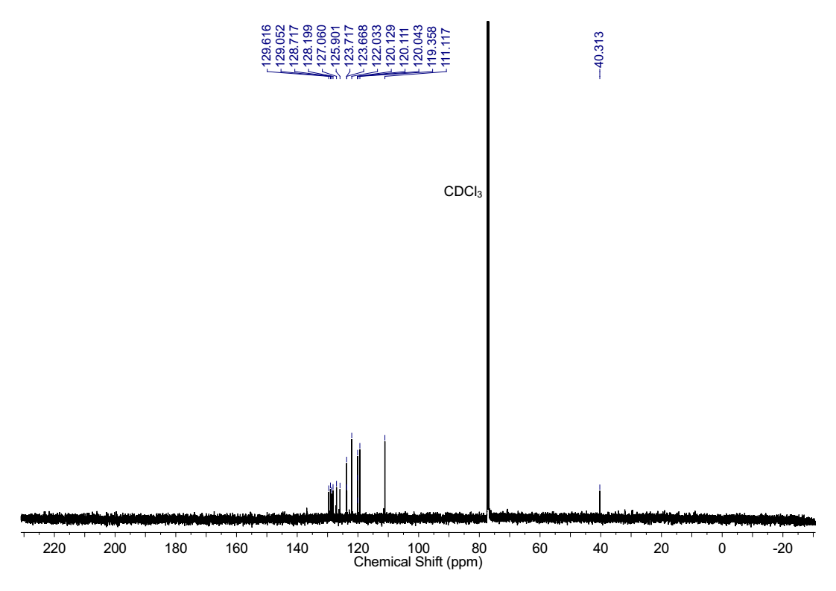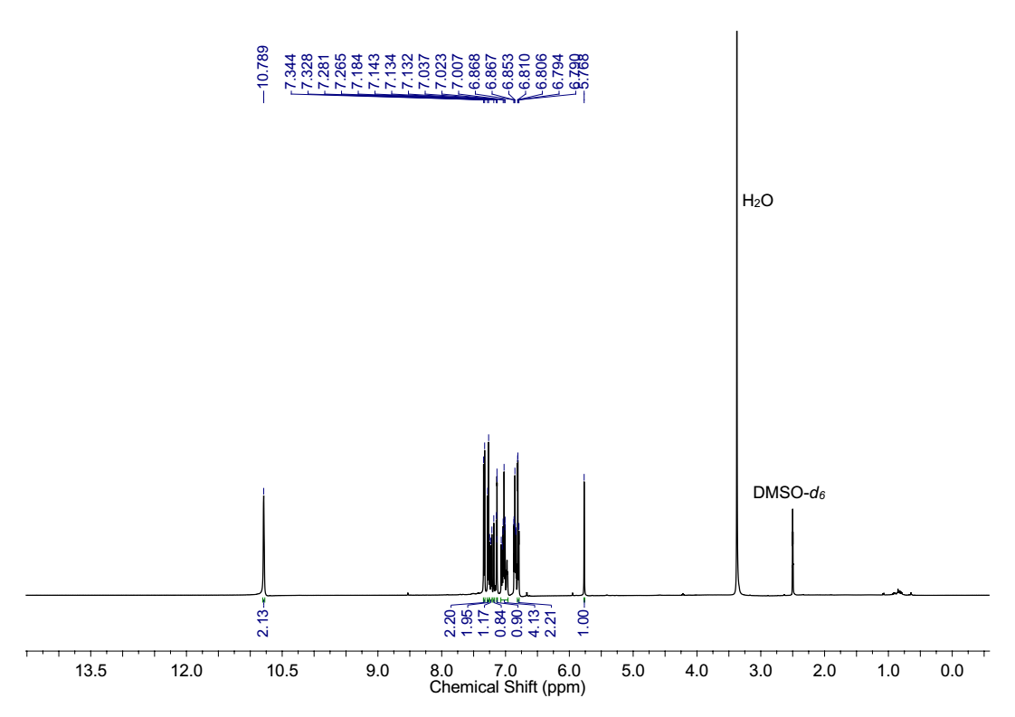**Figure S22**. 1H (top) and 13C (bottom) NMR spectra of 4-(di(1*H*-indol-3-yl)methyl)benzene-1,2-diol

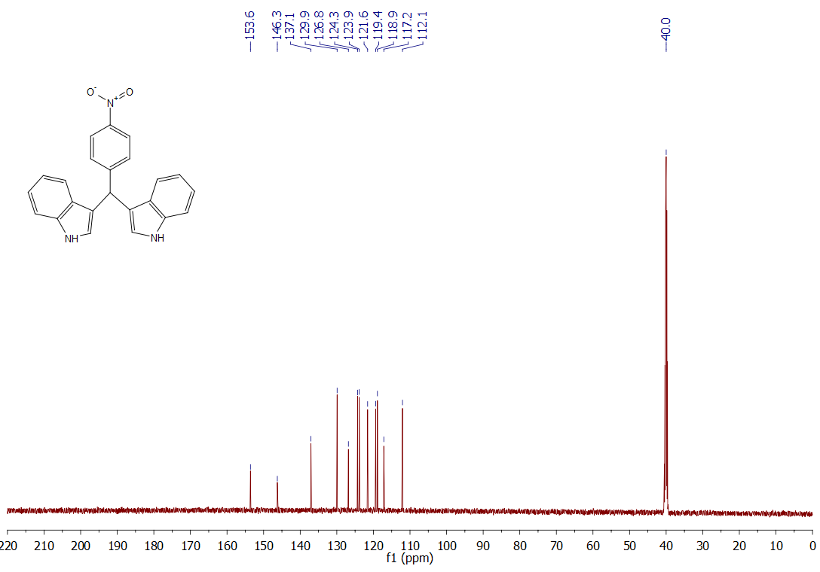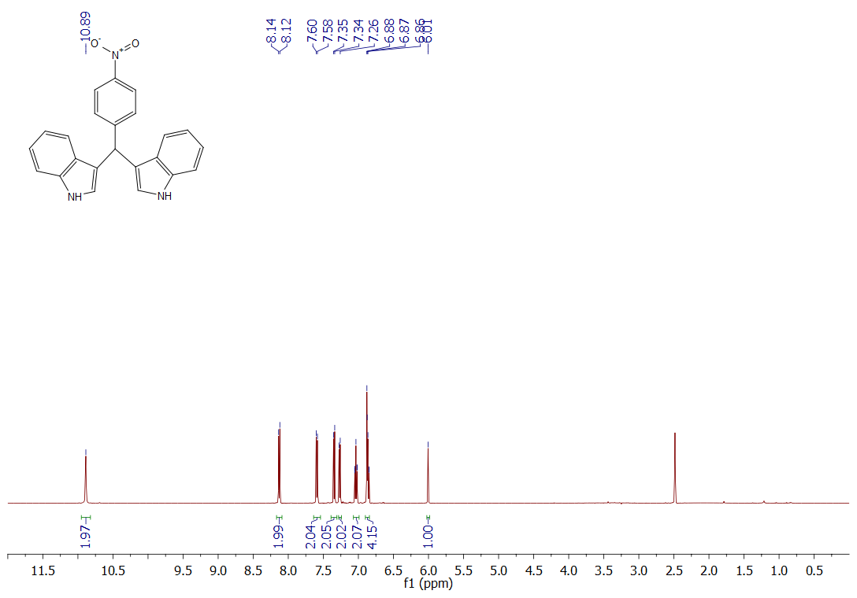**Figure S23.** 1H (top) and 13C (bottom) NMR spectra of 3,3'-((4-nitrophenyl)methylene)bis(1H-indole)

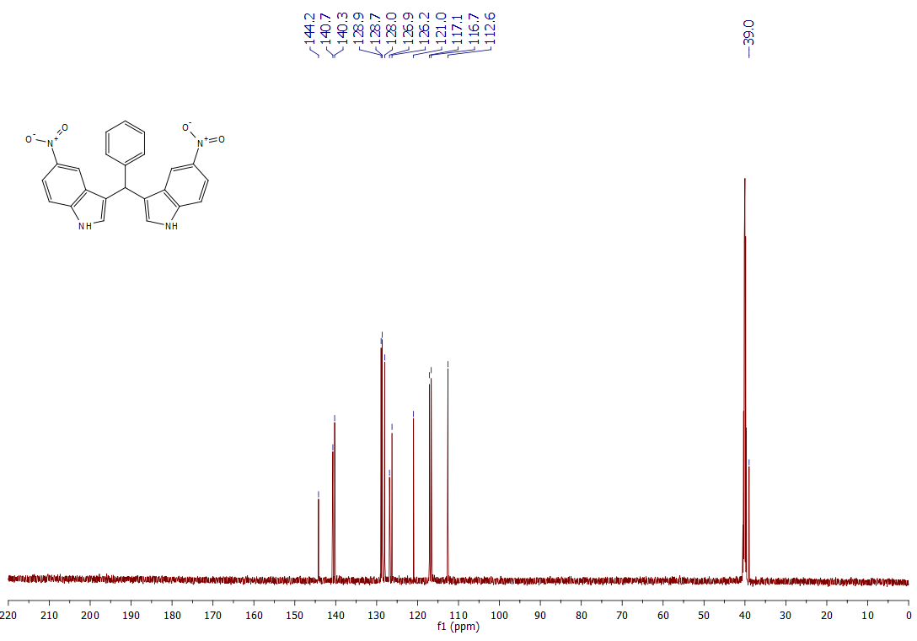**Figure S24.** 1H (top) and 13C (bottom) NMR spectra of 3,3'-(phenylmethylene)bis(5-nitro-1H-indole)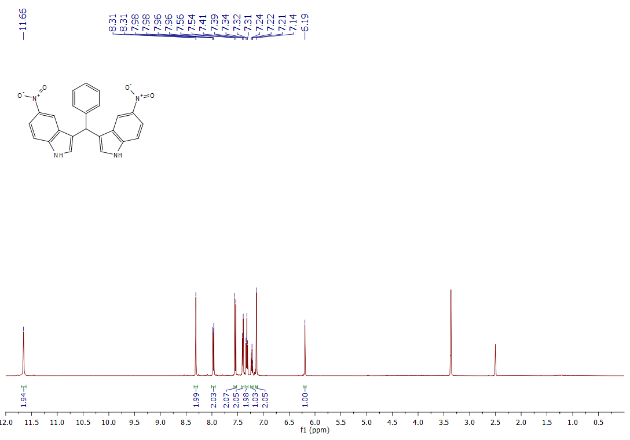

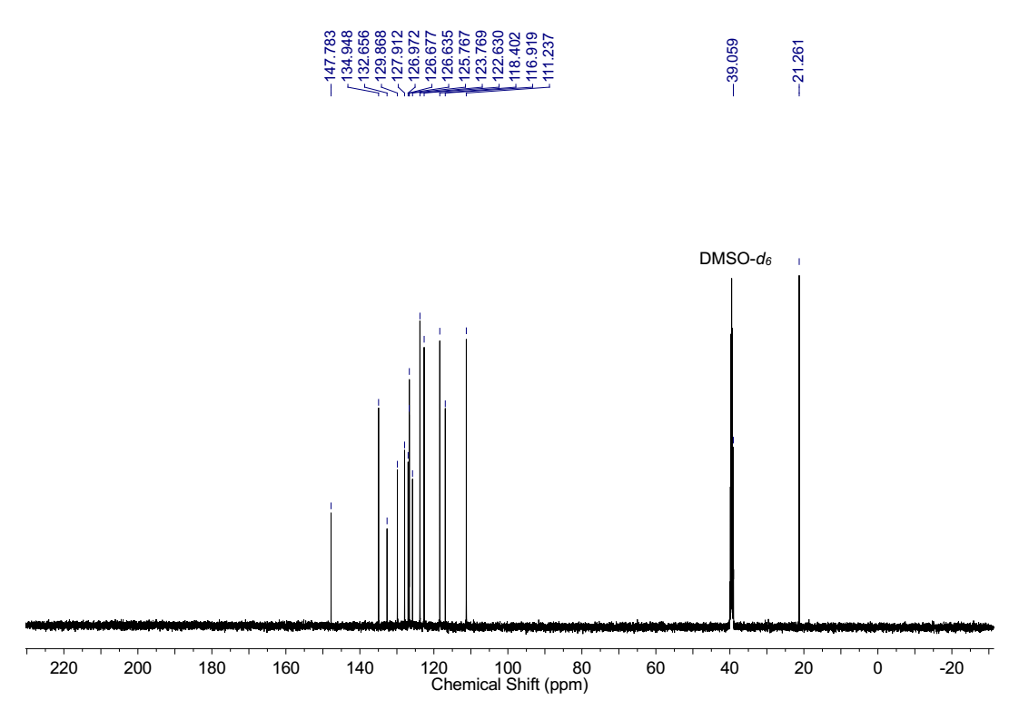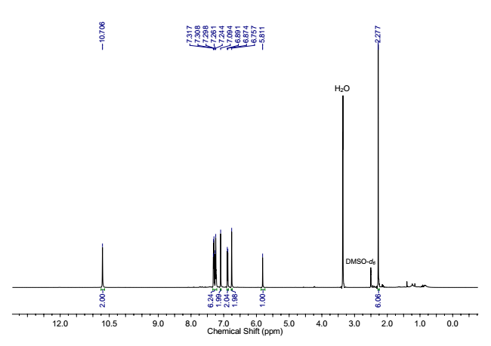**Figure S25**. 1H (top) and 13C (bottom) NMR spectra of 3,3'-((3-chlorophenyl)methylene)bis(5-methyl-1*H*-indole)

****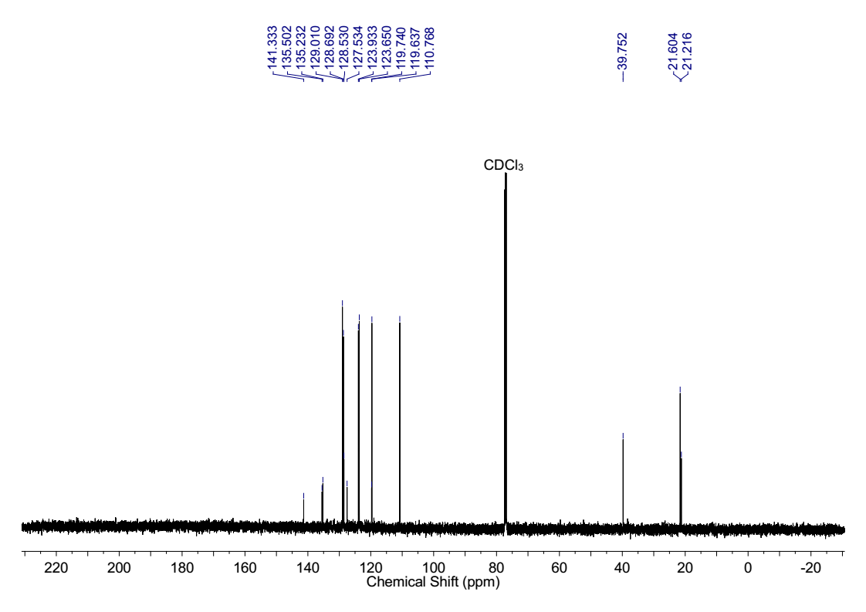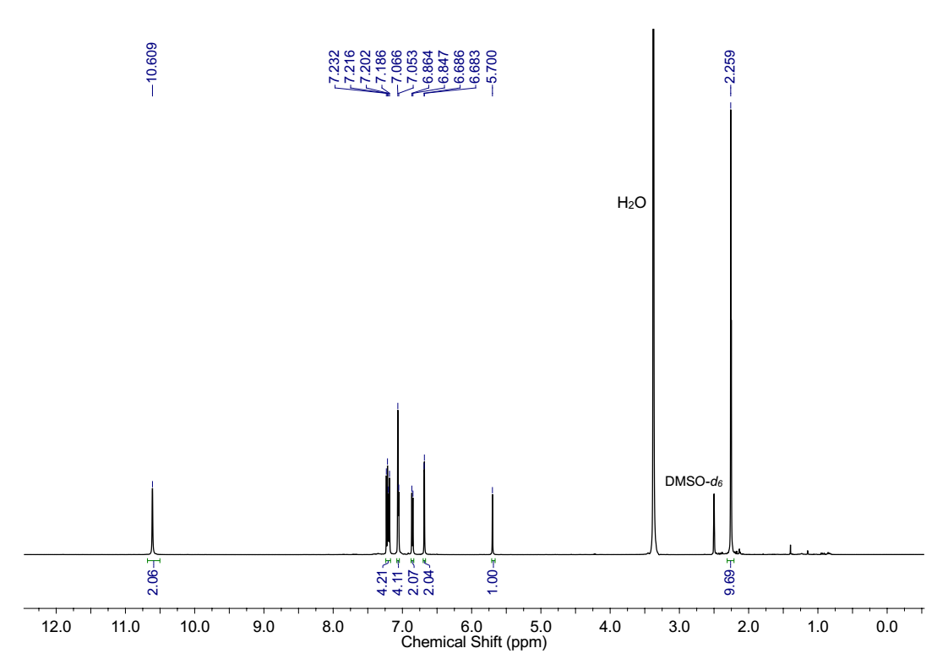**Figure S26**. 1H (top) and 13C (bottom) NMR spectra of 1,4-bis(di(1*H*-indol-3-yl)methyl)benzene

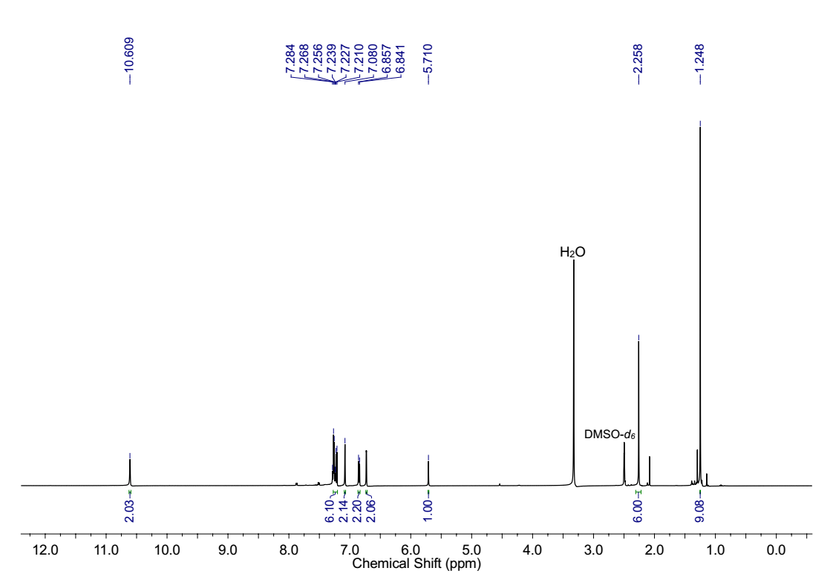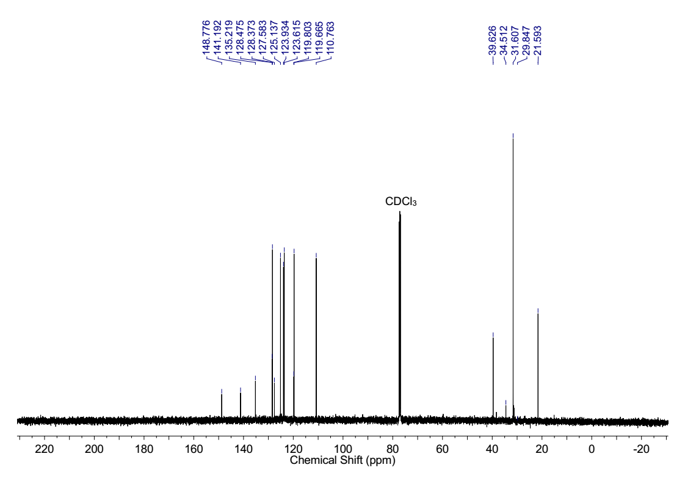**Figure S27**. 1H (top) and 13C (bottom) NMR spectra of 3,3'-((4-(tert-butyl)phenyl)methylene)bis(5-methyl-1*H*-indole)

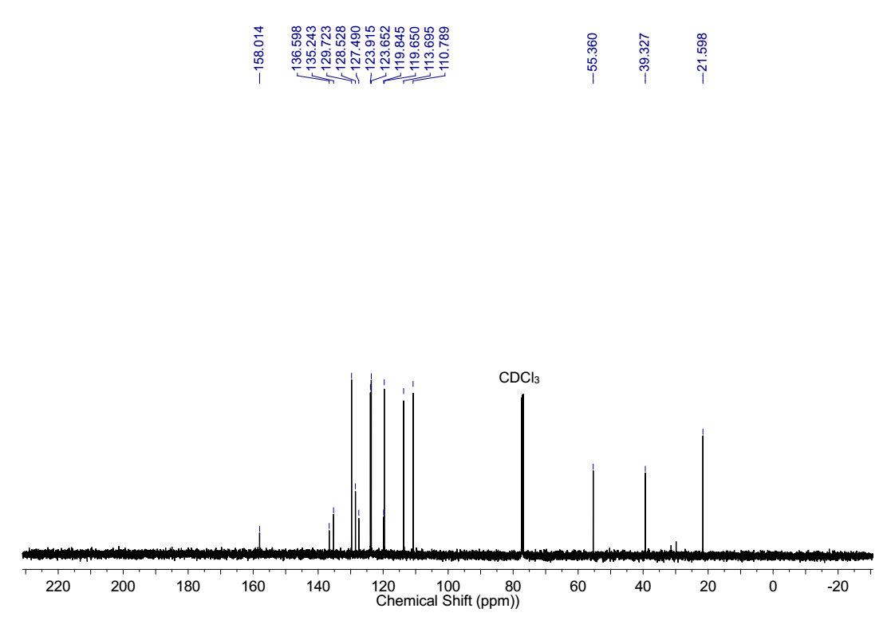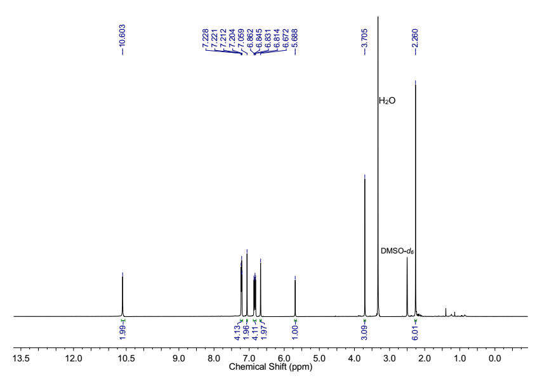**Figure S28**. 1H (top) and 13C (bottom) NMR spectra of3,3'-((4-methoxyphenyl)methylene)bis(5-methyl-1*H*-indole)

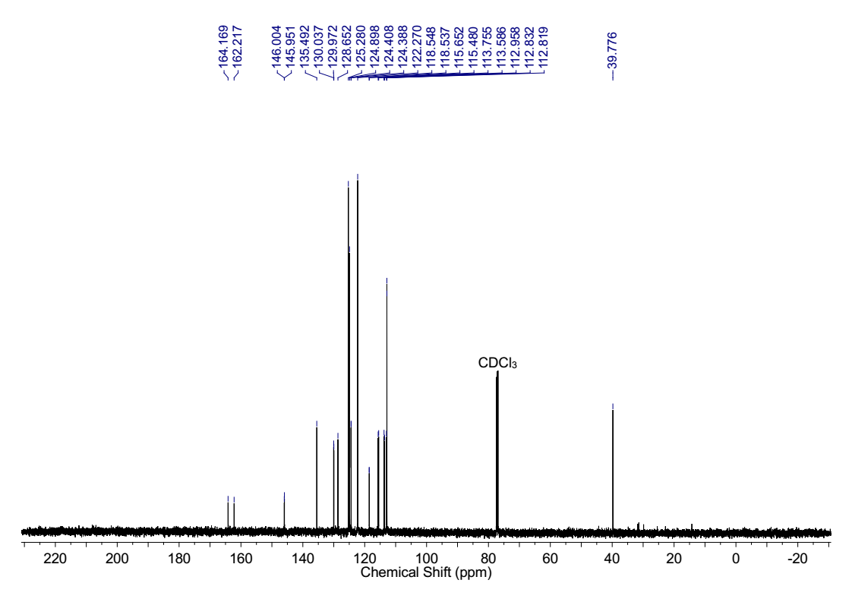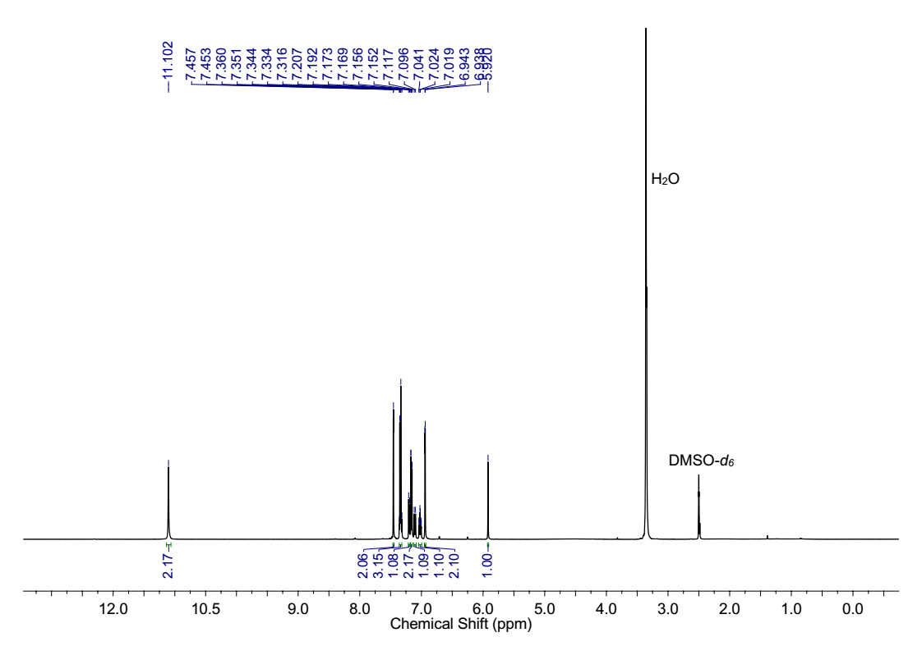**Figure S29**. 1H (top) and 13C (bottom) NMR spectra of 3,3'-((3-fluorophenyl)methylene)bis(5-bromo-1*H*-indole)

**Section S7**: References

[S1] P. T. K. Nguyen, H. T. D. Nguyen, H. Q. Pham, J. Kim, K. E. Cordova and H. Furukawa, *Inorg. Chem.*,2015, **54**, 10065-10072.

[S2] (a) J. Kim, B. Chen, T. M. Reineke, H. Li, M. Eddaoudi, D. B. Moler, M. O'Keeffe and O. M. Yaghi, *J. Am. Chem. Soc.*, 2001, **123**, 8239-8247; (b) C. G. Carson, K. Hardcastle, J. Schwartz, X. Liu, C. Hoffmann, R. A. Gerhardt and R. Tannenbaum, *Eur. J. Inorg. Chem.*,2009, **2009**, 2338-2343.

[S3] K. Gopalaiah, S. Chandrudu and A. Devi, *Synthesis,* 2015, **47**, 1766-1774.

[S4] Q. M. Abdul, P. Srinivas and K. N. Uday, *Chem. Bio. Inter.,* 2013, **3**, 334-338.

[S5] R. Vaid, M. Gupta, O. S. Chambyal and R. Gupta, *J. Chem. Sci.,* 2015, **127**, 987-997.

[S6] M. T. El Sayed, K. M. Ahmed, K. Mahmoud and A. Hilgeroth, *Eur. J. Med. Chem.*, 2015, **90**, 845-859.

[S7] R. Surasani, D. Kalita and K. B. Chandrasekhar, *Green Chem. Lett. Rev.*, 2013, **6**, 113-122.

[S8] W. E. Noland, H. V. Kumar, G. C. Flick, C. L. Aspros, J. H. Yoon, A. C. Wilt, N. Dehkordi, S. Thao, A. K. Schneerer, S. Gao and K. J. Tritch, *Tetrahedron*, 2017, **73**, 3913-3922.

[S9] G. A. Meshram and V. D. Patil, *Synth. Commun.*, 2009, 40, 29-38.