Supporting information

Influence of oxygen functionalization on physico-chemical properties of imidazolium based ionic liquids - experimental and computational study

Aleksandar Tot, Črtomir Podlipnik, Marija Bešter-Rogač, Slobodan Gadžurić, Milan Vraneš
Table S1. Water content of oxygen functionalized ionic liquids.
ILs | Water content in ppm
[OHC₂OC₂mIm][Cl] | 256
[C₂OC₂mIm][Cl] | 221
[OHC₃mIm][Cl] | 289
[OHC₃eIm][Cl] | 237
Table S2. Density (ρ), apparent molar volume (V_{ф}), and partial molar volume (V_{i}) at different temperatures and molality of IL (m) compositions of the IL (2) + H₂O (1) mixtures at p = 0.1 MPa.
m / mol·kg^{–1} |  | ρ/ g·cm^{–3} |  | V₁ / cm³·mol^{–1} |  | V₂ / cm³·mol^{–1} |  | V_{ϕ} / cm³·mol^{–1}
[OHC₃mIm][Cl]
T = 278.15 K
0.00313 | 1.000071 |  | 18.000 |  | 152.56 |  | 153.73
0.00563 | 1.000132 |  | 18.000 |  | 151.40 |  | 152.97
0.00813 | 1.000196 |  | 18.000 |  | 150.44 |  | 152.32
0.01141 | 1.000282 |  | 18.000 |  | 149.45 |  | 151.68
0.01556 | 1.000396 |  | 18.001 |  | 148.33 |  | 150.94
0.01831 | 1.000474 |  | 18.001 |  | 147.66 |  | 150.49
0.02047 | 1.000537 |  | 18.001 |  | 147.15 |  | 150.14
0.02501 | 1.000674 |  | 18.001 |  | 146.10 |  | 149.40
T = 283.15 K
0.00313 | 0.999756 |  | 18.006 |  | 154.19 |  | 155.37
0.00563 | 0.999814 |  | 18.006 |  | 152.86 |  | 154.44
0.00813 | 0.999873 |  | 18.006 |  | 152.07 |  | 153.96
0.01141 | 0.999955 |  | 18.006 |  | 150.97 |  | 153.21
0.01556 | 1.000063 |  | 18.006 |  | 149.84 |  | 152.46
0.01831 | 1.000137 |  | 18.006 |  | 149.16 |  | 152.01
0.02047 | 1.000195 |  | 18.007 |  | 148.74 |  | 151.75
0.02501 | 1.000326 |  | 18.007 |  | 147.64 |  | 150.97
T = 288.15 K
0.00313 | 0.999161 |  | 18.006 |  | 154.19 |  | 155.37
0.00563 | 0.999214 |  | 18.006 |  | 152.86 |  | 154.44
0.00813 | 0.999270 |  | 18.006 |  | 152.07 |  | 153.96
0.01141 | 0.999345 |  | 18.006 |  | 150.97 |  | 153.21
0.01556 | 0.999447 |  | 18.006 |  | 149.84 |  | 152.46
0.01831 | 0.999518 |  | 18.006 |  | 149.16 |  | 152.01
0.02047 | 0.999575 |  | 18.007 |  | 148.74 |  | 151.75
0.02501 | 0.999699 |  | 18.007 |  | 147.64 |  | 150.97
T = 293.15 K
0.00313 | 0.998266 |  | 18.032 |  | 157.53 |  | 158.78
0.00563 | 0.998316 |  | 18.032 |  | 156.17 |  | 157.84
0.00813 | 0.998368 |  | 18.033 |  | 155.24 |  | 157.25
0.01141 | 0.998440 |  | 18.033 |  | 154.11 |  | 156.49
0.01556 | 0.998536 |  | 18.033 |  | 152.91 |  | 155.69
0.01831 | 0.998603 |  | 18.033 |  | 152.15 |  | 155.16
0.02047 | 0.998654 |  | 18.033 |  | 151.74 |  | 154.93
0.02501 | 0.998771 |  | 18.034 |  | 150.64 |  | 154.17
T = 298.15 K
0.00313 | 0.997102 |  | 18.053 |  | 158.88 |  | 160.23
0.00563 | 0.997151 |  | 18.053 |  | 157.09 |  | 158.90
0.00813 | 0.997201 |  | 18.053 |  | 156.09 |  | 158.26
0.01141 | 0.997270 |  | 18.054 |  | 154.96 |  | 157.53
0.01556 | 0.997364 |  | 18.054 |  | 153.62 |  | 156.62
0.01831 | 0.997427 |  | 18.054 |  | 152.94 |  | 156.20
0.02047 | 0.997481 |  | 18.054 |  | 152.28 |  | 155.73
0.02501 | 0.997589 |  | 18.055 |  | 151.40 |  | 155.21
T = 303.15 K
0.00313 | 0.995699 |  | 18.079 |  | 160.05 |  | 161.40
0.00563 | 0.995744 |  | 18.079 |  | 158.54 |  | 160.35
0.00813 | 0.995792 |  | 18.079 |  | 157.41 |  | 159.59
0.01141 | 0.995859 |  | 18.079 |  | 156.12 |  | 158.70
0.01556 | 0.995945 |  | 18.079 |  | 155.04 |  | 158.05
0.01831 | 0.996008 |  | 18.080 |  | 154.17 |  | 157.44
0.02047 | 0.996056 |  | 18.080 |  | 153.70 |  | 157.15
0.02501 | 0.996165 |  | 18.080 |  | 152.55 |  | 156.37
T = 308.15 K
0.00313 | 0.994086 |  | 18.108 |  | 161.23 |  | 162.61
0.00563 | 0.994127 |  | 18.108 |  | 159.99 |  | 161.85
0.00813 | 0.994173 |  | 18.108 |  | 158.71 |  | 160.94
0.01141 | 0.994234 |  | 18.108 |  | 157.62 |  | 160.26
0.01556 | 0.994319 |  | 18.109 |  | 156.23 |  | 159.32
0.01831 | 0.994381 |  | 18.109 |  | 155.26 |  | 158.61
0.02047 | 0.994426 |  | 18.109 |  | 154.83 |  | 158.37
0.02501 | 0.994528 |  | 18.110 |  | 153.78 |  | 157.69
T = 313.15 K
0.00313 | 0.992262 |  | 18.141 |  | 162.71 |  | 164.18
0.00563 | 0.992301 |  | 18.141 |  | 161.23 |  | 163.20
0.00813 | 0.992344 |  | 18.141 |  | 159.96 |  | 162.33
0.01141 | 0.992402 |  | 18.142 |  | 158.79 |  | 161.59
0.01556 | 0.992483 |  | 18.142 |  | 157.35 |  | 160.62
0.01831 | 0.992541 |  | 18.142 |  | 156.42 |  | 159.97
0.02047 | 0.992588 |  | 18.143 |  | 155.76 |  | 159.52
0.02501 | 0.992685 |  | 18.143 |  | 154.72 |  | 158.88
[OHC₃eIm][Cl]
T = 278.15 K
0.00299 | 1.000106 |  | 18.000 |  | 154.55 |  | 154.95
0.00563 | 1.000201 |  | 18.000 |  | 154.15 |  | 154.70
0.00753 | 1.000271 |  | 18.000 |  | 153.79 |  | 154.42
0.01139 | 1.000413 |  | 18.000 |  | 153.36 |  | 154.14
0.01440 | 1.000524 |  | 18.000 |  | 153.10 |  | 153.97
0.02130 | 1.000782 |  | 18.000 |  | 152.56 |  | 153.62
0.02577 | 1.000951 |  | 18.001 |  | 152.24 |  | 153.41
0.03529 | 1.001314 |  | 18.001 |  | 151.65 |  | 153.01
T = 283.15 K
0.00299 | 0.999791 |  | 18.006 |  | 156.25 |  | 156.66
0.00563 | 0.999882 |  | 18.006 |  | 155.77 |  | 156.34
0.00753 | 0.999948 |  | 18.006 |  | 155.54 |  | 156.19
0.01139 | 1.000084 |  | 18.006 |  | 155.04 |  | 155.84
0.01440 | 1.000191 |  | 18.006 |  | 154.71 |  | 155.61
0.02130 | 1.000438 |  | 18.006 |  | 154.15 |  | 155.25
0.02577 | 1.000601 |  | 18.006 |  | 153.79 |  | 155.00
0.03529 | 1.000946 |  | 18.006 |  | 153.29 |  | 154.70
T = 288.15 K
0.00299 | 0.999196 |  | 18.016 |  | 158.00 |  | 158.41
0.00563 | 0.999283 |  | 18.016 |  | 157.44 |  | 158.01
0.00753 | 0.999346 |  | 18.016 |  | 157.20 |  | 157.86
0.01139 | 0.999476 |  | 18.016 |  | 156.69 |  | 157.50
0.01440 | 0.999578 |  | 18.016 |  | 156.38 |  | 157.29
0.02130 | 0.999815 |  | 18.017 |  | 155.78 |  | 156.88
0.02577 | 0.999968 |  | 18.017 |  | 155.53 |  | 156.75
0.03529 | 1.000299 |  | 18.017 |  | 154.97 |  | 156.40
T = 293.15 K
0.00299 | 0.998302 |  | 18.032 |  | 159.39 |  | 159.87
0.00563 | 0.998386 |  | 18.032 |  | 158.71 |  | 159.37
0.00753 | 0.998447 |  | 18.032 |  | 158.41 |  | 159.17
0.01139 | 0.998572 |  | 18.032 |  | 157.91 |  | 158.85
0.01440 | 0.998671 |  | 18.033 |  | 157.53 |  | 158.58
0.02130 | 0.9989 |  | 18.033 |  | 156.89 |  | 158.17
0.02577 | 0.999051 |  | 18.033 |  | 156.50 |  | 157.91
0.03529 | 0.999375 |  | 18.033 |  | 155.83 |  | 157.48
T = 298.15 K
0.00299 | 0.997138 |  | 18.053 |  | 160.82 |  | 161.36
0.00563 | 0.997219 |  | 18.053 |  | 160.02 |  | 160.77
0.00753 | 0.997278 |  | 18.053 |  | 159.64 |  | 160.51
0.01139 | 0.997399 |  | 18.053 |  | 159.07 |  | 160.14
0.01440 | 0.997496 |  | 18.053 |  | 158.58 |  | 159.78
0.02130 | 0.997718 |  | 18.054 |  | 157.90 |  | 159.36
0.02577 | 0.997865 |  | 18.054 |  | 157.46 |  | 159.07
0.03529 | 0.998179 |  | 18.054 |  | 156.77 |  | 158.65
T = 303.15 K
0.00299 | 0.995735 |  | 18.079 |  | 161.93 |  | 162.56
0.00563 | 0.995812 |  | 18.079 |  | 161.35 |  | 162.21
0.00753 | 0.995869 |  | 18.079 |  | 160.91 |  | 161.91
0.01139 | 0.995985 |  | 18.079 |  | 160.33 |  | 161.57
0.01440 | 0.996079 |  | 18.079 |  | 159.77 |  | 161.15
0.02130 | 0.996296 |  | 18.079 |  | 158.90 |  | 160.58
0.02577 | 0.996441 |  | 18.080 |  | 158.34 |  | 160.20
0.03529 | 0.996755 |  | 18.080 |  | 157.35 |  | 159.52
T = 308.15 K
0.00299 | 0.994121 |  | 18.108 |  | 163.46 |  | 164.13
0.00563 | 0.994195 |  | 18.108 |  | 162.76 |  | 163.69
0.00753 | 0.994250 |  | 18.108 |  | 162.26 |  | 163.34
0.01139 | 0.994363 |  | 18.108 |  | 161.53 |  | 162.85
0.01440 | 0.994453 |  | 18.108 |  | 161.01 |  | 162.49
0.02130 | 0.994662 |  | 18.109 |  | 160.13 |  | 161.94
0.02577 | 0.994804 |  | 18.109 |  | 159.48 |  | 161.47
0.03529 | 0.995105 |  | 18.109 |  | 158.55 |  | 160.88
T = 313.15 K
0.00299 | 0.992297 |  | 18.141 |  | 164.88 |  | 165.75
0.00563 | 0.992368 |  | 18.141 |  | 164.02 |  | 165.20
0.00753 | 0.992421 |  | 18.141 |  | 163.43 |  | 164.80
0.01139 | 0.992530 |  | 18.141 |  | 162.57 |  | 164.25
0.01440 | 0.992621 |  | 18.142 |  | 161.69 |  | 163.59
0.02130 | 0.992828 |  | 18.142 |  | 160.54 |  | 162.85
0.02577 | 0.992968 |  | 18.142 |  | 159.80 |  | 162.34
0.03529 | 0.993265 |  | 18.143 |  | 158.73 |  | 161.69
[C₂OC₂mIm][Cl]
T = 278.15 K
0.00293 | 1.000069 |  | 18.000 |  | 165.81 |  | 166.90
0.00514 | 1.000125 |  | 18.000 |  | 164.65 |  | 166.09
0.00725 | 1.000180 |  | 18.000 |  | 163.89 |  | 165.60
0.01103 | 1.000283 |  | 18.000 |  | 162.64 |  | 164.75
0.01351 | 1.000352 |  | 18.001 |  | 162.01 |  | 164.34
0.01622 | 1.000429 |  | 18.001 |  | 161.38 |  | 163.94
0.02031 | 1.000551 |  | 18.001 |  | 160.36 |  | 163.22
0.02856 | 1.000801 |  | 18.002 |  | 158.88 |  | 162.27
T = 283.15 K
0.00293 | 0.999755 |  | 18.006 |  | 167.16 |  | 168.31
0.00514 | 0.999808 |  | 18.006 |  | 165.98 |  | 167.50
0.00725 | 0.999862 |  | 18.006 |  | 164.95 |  | 166.75
0.01103 | 0.999961 |  | 18.006 |  | 163.67 |  | 165.89
0.01351 | 1.000027 |  | 18.006 |  | 163.04 |  | 165.50
0.01622 | 1.000102 |  | 18.006 |  | 162.34 |  | 165.03
0.02031 | 1.000217 |  | 18.006 |  | 161.44 |  | 164.45
0.02856 | 1.000459 |  | 18.007 |  | 159.87 |  | 163.44
T = 288.15 K
0.00293 | 0.999161 |  | 18.016 |  | 168.58 |  | 169.76
0.00514 | 0.999211 |  | 18.016 |  | 167.38 |  | 168.95
0.00725 | 0.999260 |  | 18.016 |  | 166.64 |  | 168.50
0.01103 | 0.999353 |  | 18.017 |  | 165.32 |  | 167.61
0.01351 | 0.999418 |  | 18.017 |  | 164.46 |  | 166.99
0.01622 | 0.999489 |  | 18.017 |  | 163.76 |  | 166.54
0.02031 | 0.999601 |  | 18.017 |  | 162.71 |  | 165.82
0.02856 | 0.999832 |  | 18.018 |  | 161.14 |  | 164.82
T = 293.15 K
0.00293 | 0.998266 |  | 18.032 |  | 170.29 |  | 171.61
0.00514 | 0.998313 |  | 18.032 |  | 168.90 |  | 170.64
0.00725 | 0.998361 |  | 18.033 |  | 167.80 |  | 169.87
0.01103 | 0.998448 |  | 18.033 |  | 166.54 |  | 169.10
0.01351 | 0.998508 |  | 18.033 |  | 165.78 |  | 168.61
0.01622 | 0.998578 |  | 18.033 |  | 164.86 |  | 167.97
0.02031 | 0.998686 |  | 18.034 |  | 163.71 |  | 167.19
0.02856 | 0.998914 |  | 18.034 |  | 161.82 |  | 165.93
T = 298.15 K
0.00293 | 0.997102 |  | 18.053 |  | 171.73 |  | 173.16
0.00514 | 0.997145 |  | 18.053 |  | 170.50 |  | 172.39
0.00725 | 0.997189 |  | 18.053 |  | 169.47 |  | 171.71
0.01103 | 0.997273 |  | 18.054 |  | 167.87 |  | 170.64
0.01351 | 0.997331 |  | 18.054 |  | 166.98 |  | 170.05
0.01622 | 0.997398 |  | 18.054 |  | 166.02 |  | 169.38
0.02031 | 0.997503 |  | 18.054 |  | 164.73 |  | 168.50
0.02856 | 0.997722 |  | 18.055 |  | 162.77 |  | 167.23
T = 303.15 K
0.00293 | 0.995699 |  | 18.079 |  | 172.88 |  | 174.41
0.00514 | 0.995741 |  | 18.079 |  | 171.36 |  | 173.39
0.00725 | 0.995783 |  | 18.079 |  | 170.36 |  | 172.76
0.01103 | 0.995867 |  | 18.079 |  | 168.44 |  | 171.41
0.01351 | 0.995922 |  | 18.079 |  | 167.64 |  | 170.93
0.01622 | 0.995988 |  | 18.080 |  | 166.61 |  | 170.21
0.02031 | 0.996088 |  | 18.080 |  | 165.42 |  | 169.45
0.02856 | 0.996308 |  | 18.081 |  | 163.15 |  | 167.93
T = 308.15 K
0.00293 | 0.994086 |  | 18.108 |  | 174.08 |  | 175.70
0.00514 | 0.994126 |  | 18.108 |  | 172.49 |  | 174.63
0.00725 | 0.994166 |  | 18.108 |  | 171.44 |  | 173.99
0.01103 | 0.994245 |  | 18.109 |  | 169.61 |  | 172.75
0.01351 | 0.994301 |  | 18.109 |  | 168.52 |  | 172.00
0.01622 | 0.994366 |  | 18.109 |  | 167.39 |  | 171.20
0.02031 | 0.994458 |  | 18.109 |  | 166.43 |  | 170.69
0.02856 | 0.994681 |  | 18.111 |  | 163.72 |  | 168.77
T = 313.15 K
0.00293 | 0.992262 |  | 18.141 |  | 175.63 |  | 177.38
0.00514 | 0.992299 |  | 18.141 |  | 173.98 |  | 176.30
0.00725 | 0.992339 |  | 18.141 |  | 172.50 |  | 175.26
0.01103 | 0.992415 |  | 18.142 |  | 170.56 |  | 173.96
0.01351 | 0.992469 |  | 18.142 |  | 169.42 |  | 173.18
0.01622 | 0.992526 |  | 18.142 |  | 168.61 |  | 172.73
0.02031 | 0.992622 |  | 18.143 |  | 167.15 |  | 171.76
0.02856 | 0.992838 |  | 18.144 |  | 164.38 |  | 169.86
[OHC₂OC₂mIm][Cl]
T = 278.15 K
0.00294 | 1.000148 |  | 18.000 |  | 153.71 |  | 156.00
0.00521 | 1.000271 |  | 18.000 |  | 151.37 |  | 154.42
0.00773 | 1.000412 |  | 18.001 |  | 149.38 |  | 153.09
0.01023 | 1.000556 |  | 18.001 |  | 147.74 |  | 152.02
0.01543 | 1.000864 |  | 18.001 |  | 145.08 |  | 150.33
0.01732 | 1.000982 |  | 18.002 |  | 144.04 |  | 149.61
0.02035 | 1.001179 |  | 18.002 |  | 142.31 |  | 148.34
0.02511 | 1.001485 |  | 18.003 |  | 140.39 |  | 147.09
T = 283.15 K
0.00294 | 0.999834 |  | 18.006 |  | 155.09 |  | 157.40
0.00521 | 0.999955 |  | 18.006 |  | 152.52 |  | 155.61
0.00773 | 1.000094 |  | 18.006 |  | 150.41 |  | 154.16
0.01023 | 1.000236 |  | 18.006 |  | 148.71 |  | 153.02
0.01543 | 1.000539 |  | 18.006 |  | 146.03 |  | 151.33
0.01732 | 1.000655 |  | 18.007 |  | 145.00 |  | 150.62
0.02035 | 1.000845 |  | 18.007 |  | 143.46 |  | 149.55
0.02511 | 1.001143 |  | 18.008 |  | 141.63 |  | 148.40
T = 288.15 K
0.00294 | 0.999240 |  | 18.006 |  | 156.41 |  | 158.83
0.00521 | 0.999359 |  | 18.006 |  | 153.60 |  | 156.82
0.00773 | 0.999492 |  | 18.006 |  | 151.86 |  | 155.78
0.01023 | 0.999634 |  | 18.006 |  | 149.75 |  | 154.26
0.01543 | 0.999930 |  | 18.006 |  | 147.08 |  | 152.62
0.01732 | 1.000042 |  | 18.007 |  | 146.14 |  | 152.01
0.02035 | 1.000229 |  | 18.007 |  | 144.52 |  | 150.89
0.02511 | 1.000536 |  | 18.008 |  | 142.06 |  | 149.13
T = 293.15 K
0.00294 | 0.998345 |  | 18.032 |  | 158.15 |  | 160.64
0.00521 | 0.998461 |  | 18.033 |  | 155.14 |  | 158.46
0.00773 | 0.998593 |  | 18.033 |  | 153.00 |  | 157.04
0.01023 | 0.998729 |  | 18.033 |  | 151.18 |  | 155.82
0.01543 | 0.999020 |  | 18.034 |  | 148.31 |  | 154.02
0.01732 | 0.999131 |  | 18.034 |  | 147.27 |  | 153.32
0.02035 | 0.999314 |  | 18.035 |  | 145.65 |  | 152.21
T = 298.15 K
0.00294 | 0.997181 |  | 18.053 |  | 159.50 |  | 162.14
0.00521 | 0.997293 |  | 18.053 |  | 156.60 |  | 160.13
0.00773 | 0.997421 |  | 18.054 |  | 154.43 |  | 158.73
0.01023 | 0.997554 |  | 18.054 |  | 152.48 |  | 157.42
0.01543 | 0.997843 |  | 18.054 |  | 149.17 |  | 155.24
0.01732 | 0.997951 |  | 18.055 |  | 148.16 |  | 154.60
0.02035 | 0.998131 |  | 18.055 |  | 146.49 |  | 153.46
0.02511 | 0.998426 |  | 18.056 |  | 143.98 |  | 151.73
T = 303.15 K
0.00294 | 0.995778 |  | 18.079 |  | 160.59 |  | 163.34
0.00521 | 0.995889 |  | 18.079 |  | 157.40 |  | 161.06
0.00773 | 0.996015 |  | 18.079 |  | 155.21 |  | 159.67
0.01023 | 0.996148 |  | 18.080 |  | 153.04 |  | 158.17
0.01543 | 0.996434 |  | 18.080 |  | 149.68 |  | 155.98
0.01732 | 0.996541 |  | 18.081 |  | 148.65 |  | 155.32
0.02035 | 0.996716 |  | 18.081 |  | 147.11 |  | 154.34
0.02511 | 0.997012 |  | 18.082 |  | 144.39 |  | 152.43
T = 308.15 K
0.00294 | 0.994165 |  | 18.108 |  | 161.73 |  | 164.57
0.00521 | 0.994274 |  | 18.108 |  | 158.44 |  | 162.22
0.00773 | 0.994398 |  | 18.109 |  | 156.16 |  | 160.77
0.01023 | 0.994526 |  | 18.109 |  | 154.24 |  | 159.53
0.01543 | 0.994813 |  | 18.110 |  | 150.37 |  | 156.87
0.01732 | 0.994919 |  | 18.110 |  | 149.30 |  | 156.19
0.02035 | 0.995086 |  | 18.111 |  | 148.04 |  | 155.51
0.02511 | 0.995385 |  | 18.112 |  | 144.98 |  | 153.27
T = 313.15 K
0.00294 | 0.992341 |  | 18.141 |  | 163.20 |  | 166.17
0.00521 | 0.992447 |  | 18.142 |  | 159.84 |  | 163.80
0.00773 | 0.992571 |  | 18.142 |  | 157.07 |  | 161.90
0.01023 | 0.992696 |  | 18.142 |  | 155.18 |  | 160.73
0.01543 | 0.992981 |  | 18.143 |  | 151.04 |  | 157.85
0.01732 | 0.993079 |  | 18.143 |  | 150.34 |  | 157.56
0.02035 | 0.993250 |  | 18.144 |  | 148.67 |  | 156.50
0.02511 | 0.993542 |  | 18.145 |  | 145.70 |  | 154.39
Standard uncertainties are: u(ρ) =3.15·10^{–4}g·cm^{–3}; u(m) = 3.5·10^{–4} mol·kg^{–1}; u(T) = 0.015 K;
u(V_{Φ}) = 8.6·10^{–3} cm³·mol^{–1}; u(V₂) = 8.1·10^{–3}cm³·mol^{–1};
Relative standard uncertainty: u_{r} (p)=0.015

Table S3. Viscosity (η) of ILs + H₂O binary mixture as a function of IL molality (m) in the temperature range from (278.15 to 313.15) K at p = 0.1 MPa
m / (mol·kg^{–1}) | T / (K)
m / (mol·kg^{–1}) | 278.15 | 283.15 | 288.15 | 293.15 | 298.15 | 303.15 | 308.15 | 313.15
m / (mol·kg^{–1}) | η / (mPa∙s)
m / (mol·kg^{–1}) | [OHC₃eIm][Cl]
0.0056 | 1.523 | 1.310 | 1.141 | 1.004 | 0.892 | 0.799 | 0.721 | 0.654
0.0114 | 1.528 | 1.314 | 1.143 | 1.007 | 0.895 | 0.801 | 0.723 | 0.655
0.0144 | 1.531 | 1.317 | 1.146 | 1.010 | 0.897 | 0.803 | 0.724 | 0.657
0.0258 | 1.539 | 1.323 | 1.153 | 1.014 | 0.902 | 0.807 | 0.728 | 0.661
0.0353 | 1.545 | 1.328 | 1.157 | 1.018 | 0.905 | 0.811 | 0.730 | 0.663
0.0411 | 1.550 | 1.333 | 1.160 | 1.021 | 0.907 | 0.813 | 0.732 | 0.664
0.0537 | 1.559 | 1.341 | 1.167 | 1.026 | 0.911 | 0.816 | 0.737 | 0.670
0.0753 | 1.576 | 1.357 | 1.179 | 1.036 | 0.921 | 0.823 | 0.743 | 0.674
0.0900 | 1.589 | 1.364 | 1.186 | 1.046 | 0.929 | 0.830 | 0.745 | 0.678
[OHC₃mIm][Cl]
0.0056 | 1.527 | 1.313 | 1.144 | 1.007 | 0.894 | 0.801 | 0.722 | 0.655
0.0114 | 1.533 | 1.319 | 1.148 | 1.011 | 0.898 | 0.804 | 0.725 | 0.658
0.0156 | 1.536 | 1.322 | 1.152 | 1.013 | 0.901 | 0.806 | 0.727 | 0.659
0.0205 | 1.541 | 1.325 | 1.155 | 1.016 | 0.904 | 0.808 | 0.729 | 0.661
0.0250 | 1.547 | 1.330 | 1.159 | 1.020 | 0.906 | 0.811 | 0.731 | 0.662
0.0350 | 1.556 | 1.338 | 1.165 | 1.026 | 0.910 | 0.815 | 0.735 | 0.665
0.0504 | 1.570 | 1.350 | 1.176 | 1.034 | 0.918 | 0.821 | 0.740 | 0.671
0.0701 | 1.589 | 1.365 | 1.188 | 1.044 | 0.927 | 0.830 | 0.748 | 0.679
0.0901 | 1.605 | 1.382 | 1.201 | 1.055 | 0.937 | 0.839 | 0.754 | 0.686
[C₂OC₂mIm][Cl]
0.0073 | 1.531 | 1.317 | 1.146 | 1.009 | 0.897 | 0.803 | 0.724 | 0.657
0.0110 | 1.535 | 1.322 | 1.150 | 1.013 | 0.899 | 0.805 | 0.726 | 0.659
0.0162 | 1.542 | 1.326 | 1.153 | 1.016 | 0.901 | 0.807 | 0.728 | 0.661
0.0203 | 1.546 | 1.330 | 1.158 | 1.020 | 0.905 | 0.810 | 0.731 | 0.663
0.0286 | 1.556 | 1.338 | 1.166 | 1.025 | 0.909 | 0.816 | 0.733 | 0.666
0.0394 | 1.568 | 1.349 | 1.173 | 1.032 | 0.916 | 0.820 | 0.739 | 0.670
0.0498 | 1.579 | 1.357 | 1.182 | 1.039 | 0.921 | 0.825 | 0.744 | 0.673
0.0602 | 1.590 | 1.368 | 1.189 | 1.046 | 0.929 | 0.831 | 0.747 | 0.678
0.0761 | 1.606 | 1.380 | 1.200 | 1.055 | 0.937 | 0.839 | 0.756 | 0.683
0.0889 | 1.620 | 1.390 | 1.212 | 1.065 | 0.945 | 0.844 | 0.762 | 0.688
[OHC₂OC₂mIm][Cl]
0.0052 | 1.531 | 1.317 | 1.147 | 1.010 | 0.897 | 0.804 | 0.725 | 0.658
0.0102 | 1.538 | 1.324 | 1.153 | 1.015 | 0.902 | 0.807 | 0.728 | 0.660
0.0154 | 1.546 | 1.330 | 1.157 | 1.019 | 0.905 | 0.810 | 0.731 | 0.663
0.0204 | 1.554 | 1.334 | 1.163 | 1.023 | 0.909 | 0.814 | 0.735 | 0.666
0.0251 | 1.559 | 1.340 | 1.168 | 1.026 | 0.913 | 0.817 | 0.737 | 0.668
0.0326 | 1.568 | 1.348 | 1.175 | 1.033 | 0.917 | 0.822 | 0.741 | 0.671
0.0489 | 1.587 | 1.365 | 1.187 | 1.045 | 0.928 | 0.830 | 0.748 | 0.677
0.0673 | 1.609 | 1.381 | 1.203 | 1.058 | 0.938 | 0.841 | 0.757 | 0.687
0.0860 | 1.627 | 1.397 | 1.215 | 1.072 | 0.950 | 0.850 | 0.764 | 0.694
Relative standard uncertainties: u_{r} (η) =0.05; u_{r} (p) = 0.015;
Standard uncertainties: u(T) = 0.02 K; u(m) = 3.5·10^{–4} mol·kg^{–1}

Table S4. Molar conductivity for investigated ionic liquids aqueous solutions in temperature range 278.15-313.15K.
m / (mol·kg^{–1}) | T / (K)
m / (mol·kg^{–1}) | 278.15 | 283.15 | 288.15 | 293.15 | 298.15 | 303.15 | 308.15 | 313.15
m / (mol·kg^{–1}) | Λ / (mS·cm²·mol^{–1})
m / (mol·kg^{–1}) | [OHC₃eIm][Cl]
0.000228 | 89.00 | 102.34 | 116.33 | 130.92 | 146.18 | 162.06 | 178.53 | 195.55
0.000506 | 87.97 | 101.00 | 114.76 | 129.11 | 144.06 | 159.26 | 173.64 | 190.27
0.000788 | 87.33 | 100.28 | 113.91 | 128.11 | 142.88 | 158.08 | 173.10 | 188.76
0.001114 | 86.90 | 99.76 | 113.27 | 127.35 | 142.01 | 157.17 | 172.69 | 188.10
0.001477 | 86.45 | 99.22 | 112.63 | 126.59 | 141.07 | 155.76 | 170.83 | 185.62
0.001904 | 86.03 | 98.68 | 112.01 | 125.88 | 140.32 | 155.15 | 170.15 | 185.10
0.002396 | 85.56 | 98.17 | 111.41 | 125.18 | 139.49 | 154.19 | 168.84 | 184.13
0.002952 | 85.17 | 97.67 | 110.85 | 124.56 | 138.77 | 153.33 | 167.80 | 182.82
0.003600 | 84.90 | 97.36 | 110.49 | 124.09 | 138.29 | 152.89 | 167.88 | 182.82
0.004338 | 84.46 | 96.86 | 109.83 | 123.39 | 137.48 | 151.81 | 165.86 | 181.01
[OHC₃mIm][Cl]
0.000228 | 88.48 | 101.64 | 115.71 | 130.02 | 145.08 | 160.26 | 175.53 | 192.55
0.000506 | 87.91 | 100.80 | 114.66 | 128.91 | 143.91 | 159.06 | 173.74 | 190.27
0.000788 | 87.33 | 100.18 | 113.91 | 128.11 | 142.88 | 158.08 | 172.90 | 188.76
0.001110 | 86.90 | 99.71 | 113.27 | 127.35 | 142.01 | 157.17 | 171.89 | 187.50
0.001480 | 86.45 | 99.22 | 112.63 | 126.59 | 141.07 | 156.16 | 170.83 | 186.22
0.001900 | 86.03 | 98.68 | 112.01 | 125.88 | 140.32 | 155.15 | 170.04 | 185.10
0.002400 | 85.56 | 98.17 | 111.41 | 125.18 | 139.49 | 154.19 | 168.84 | 184.13
0.002950 | 85.17 | 97.67 | 110.85 | 124.56 | 138.77 | 153.43 | 167.95 | 182.82
0.003600 | 84.90 | 97.36 | 110.49 | 124.09 | 138.29 | 152.59 | 167.08 | 182.16
0.004340 | 84.46 | 96.86 | 109.83 | 123.39 | 137.48 | 151.81 | 165.86 | 181.01
[C₂OC₂mIm][Cl]
0.000214 | 53.70 | 61.67 | 70.07 | 78.81 | 88.04 | 97.42 | 106.81 | 116.25
0.000470 | 53.37 | 61.26 | 69.60 | 78.32 | 87.40 | 96.64 | 106.04 | 115.34
0.000706 | 53.16 | 60.98 | 69.27 | 77.95 | 86.98 | 96.22 | 105.48 | 114.81
0.001003 | 52.93 | 60.74 | 68.97 | 77.54 | 86.53 | 95.61 | 104.76 | 114.08
0.001350 | 52.64 | 60.43 | 68.63 | 77.14 | 86.09 | 95.14 | 104.32 | 113.56
0.001730 | 52.41 | 60.16 | 68.30 | 76.78 | 85.62 | 94.68 | 103.84 | 113.10
0.002176 | 52.20 | 59.91 | 68.02 | 76.46 | 85.23 | 94.28 | 103.43 | 112.50
0.002710 | 51.94 | 59.62 | 67.68 | 76.08 | 84.78 | 93.71 | 102.80 | 111.90
0.003295 | 51.72 | 59.36 | 67.39 | 75.76 | 84.43 | 93.36 | 102.25 | 111.35
0.003960 | 51.48 | 59.09 | 67.07 | 75.37 | 84.01 | 92.86 | 101.58 | 110.78
[OHC₂OC₂mIm][Cl]
0.000429 | 53.45 | 61.29 | 69.66 | 78.17 | 87.09 | 96.25 | 105.55 | 114.92
0.000696 | 53.22 | 61.03 | 69.31 | 77.86 | 86.73 | 95.79 | 105.03 | 114.40
0.000993 | 53.02 | 60.79 | 69.00 | 77.55 | 86.39 | 95.42 | 104.57 | 113.96
0.00134 | 52.81 | 60.52 | 68.69 | 77.27 | 86.07 | 95.03 | 104.22 | 113.47
0.00173 | 52.61 | 60.27 | 68.45 | 76.91 | 85.70 | 94.65 | 103.71 | 113.02
0.00228 | 52.37 | 60.01 | 68.10 | 76.50 | 85.20 | 94.16 | 103.23 | 112.37
0.00294 | 52.05 | 59.68 | 67.71 | 76.05 | 84.71 | 93.60 | 102.55 | 111.74
0.00372 | 51.75 | 59.33 | 67.31 | 75.59 | 84.23 | 93.07 | 102.03 | 111.19
0.00465 | 51.51 | 59.06 | 66.99 | 75.23 | 83.79 | 92.60 | 101.52 | 110.62
0.00570 | 51.17 | 58.68 | 66.55 | 74.74 | 83.24 | 92.01 | 100.94 | 109.90
0.00679 | 50.88 | 58.33 | 66.17 | 74.30 | 82.75 | 91.47 | 100.40 | 109.31
Relative standard uncertainties: u_{r} (κ) =0.05; u_{r} (p) = 0.015;
Standard uncertainties: u(T) = 0.015 K; u(m) = 3.5·10^{–4} mol·kg^{–1}

Table S5. Masson’s equation fitting parameters for the IL + H₂O solutions in the temperature range from (278.15 to 313.15) K with the deviations of their fit (σ) and regression coefficient (R²)
Т / (K) | / (cm³·mol^{–1}) | / (cm^{9/2} ·mol^{–3/2}) | σ | R²
[OHC₂OC₂mIm][Cl]
278.15 | 160.88 | -84.50 | 0.0029 | 0.9992
283.15 | 162.12 | -85.40 | 0.0024 | 0.9993
288.15 | 163.52 | -89.21 | 0.0031 | 0.9993
293.15 | 165.30 | -91.87 | 0.0030 | 0.9990
298.15 | 167.34 | -97.73 | 0.0023 | 0.9991
303.15 | 168.60 | -101.14 | 0.0029 | 0.9992
308.15 | 170.03 | -104.69 | 0.0036 | 0.9990
313.15 | 171.82 | -109.66 | 0.0033 | 0.9991
[C₂OC₂mIm][Cl]
278.15 | 169.32 | -40.19 | 0.0024 | 0.9991
283.15 | 170.56 | -42.28 | 0.0021 | 0.9993
288.15 | 172.12 | -43.64 | 0.0028 | 0.9992
293.15 | 174.17 | -48.75 | 0.0018 | 0.9994
298.15 | 176.13 | -52.79 | 0.0029 | 0.9991
303.15 | 177.47 | -56.53 | 0.0031 | 0.9992
308.15 | 178.98 | -59.78 | 0.0035 | 0.9991
313.15 | 180.86 | -64.77 | 0.0038 | 0.9991
[OHC₃mIm][Cl]
278.15 | 156.60 | -41.78 | 0.0022 | 0.9991
283.15 | 157.70 | -42.07 | 0.0026 | 0.9990
288.15 | 159.60 | -43.94 | 0.0021 | 0.9995
293.15 | 161.25 | -44.58 | 0.0023 | 0.9992
298.15 | 162.70 | -48.22 | 0.0024 | 0.9993
303.15 | 164.00 | -48.31 | 0.0025 | 0.9994
308.15 | 165.45 | -49.42 | 0.0031 | 0.9993
313.15 | 167.12 | -52.49 | 0.0033 | 0.9992
[OHC₃eIm][Cl]
278.15 | 155.73 | -14.52 | 0.0024 | 0.9992
283.15 | 157.46 | -15.06 | 0.0019 | 0.9995
288.15 | 159.16 | -15.14 | 0.0023 | 0.9993
293.15 | 160.73 | -17.56 | 0.0023 | 0.9992
298.15 | 162.31 | -20.06 | 0.0024 | 0.9993
303.15 | 163.92 | -23.12 | 0.0029 | 0.9992
308.15 | 165.50 | -24.75 | 0.0034 | 0.9991
313.15 | 167.51 | -31.60 | 0.0039 | 0.9990

Table S6. Values of limiting molar expansibility at different temperatures
T / K | [OHC₂OC₂mIm] [Cl] | [C₂OC₂mIm] [Cl] | [OHC₃mIm] [Cl] | [OHC₃eIm] [Cl]
T / K | Eº_{φ} / cm³·mol⁻¹·K⁻¹
278.15 | 0.305 | 0.326 | 0.317 | 0.320
283.15 | 0.309 | 0.327 | 0.318 | 0.323
288.15 | 0.312 | 0.328 | 0.318 | 0.326
293.15 | 0.316 | 0.329 | 0.318 | 0.328
298.15 | 0.319 | 0.330 | 0.318 | 0.331
303.15 | 0.323 | 0.331 | 0.318 | 0.334
308.15 | 0.330 | 0.333 | 0.319 | 0.337
313.15 | 0.334 | 0.334 | 0.319 | 0.340
Table S7. The viscosity A coefficients for ILs in water in the temperature range from (278.15 to 313.15) K
T / K | A/(dm^{3/2}∙mol^{–1})
T / K | [OHC₂OC₂mIm][Cl] | [C₂OC₂mIm][Cl] | [OHC₃mIm][Cl] | [OHC₃eIm][Cl]
278.15 | 0.081 | 0.051 | 0.038 | 0.008
283.15 | 0.080 | 0.049 | 0.036 | 0.006
288.15 | 0.078 | 0.046 | 0.034 | 0.005
293.15 | 0.076 | 0.043 | 0.031 | 0.003
298.15 | 0.075 | 0.041 | 0.029 | 0.002
303.15 | 0.073 | 0.038 | 0.026 | 0.001
308.15 | 0.071 | 0.036 | 0.023 | 0.001
313.15 | 0.069 | 0.033 | 0.020 | 0.000

Table S8. Limiting molar conductivity for investigated ionic liquids cation.
T / K | [OHC₂OC₂mIm]⁺ | [C₂OC₂mIm]⁺ | [OHC₃mIm]⁺ | [OHC₃eIm]⁺
T / K | / mS·cm²·mol^{–1}
278.15 | 7.94 | 12.55 | 43.01 | 19.10
283.15 | 9.26 | 14.72 | 49.61 | 22.02
288.15 | 10.84 | 17.12 | 56.93 | 25.13
293.15 | 12.41 | 19.68 | 64.30 | 28.39
298.15 | 14.03 | 22.48 | 72.14 | 31.74
303.15 | 15.69 | 25.32 | 80.15 | 35.34
308.15 | 17.71 | 29.61 | 90.23 | 40.96
313.15 | 20.18 | 35.04 | 104.78 | 47.21
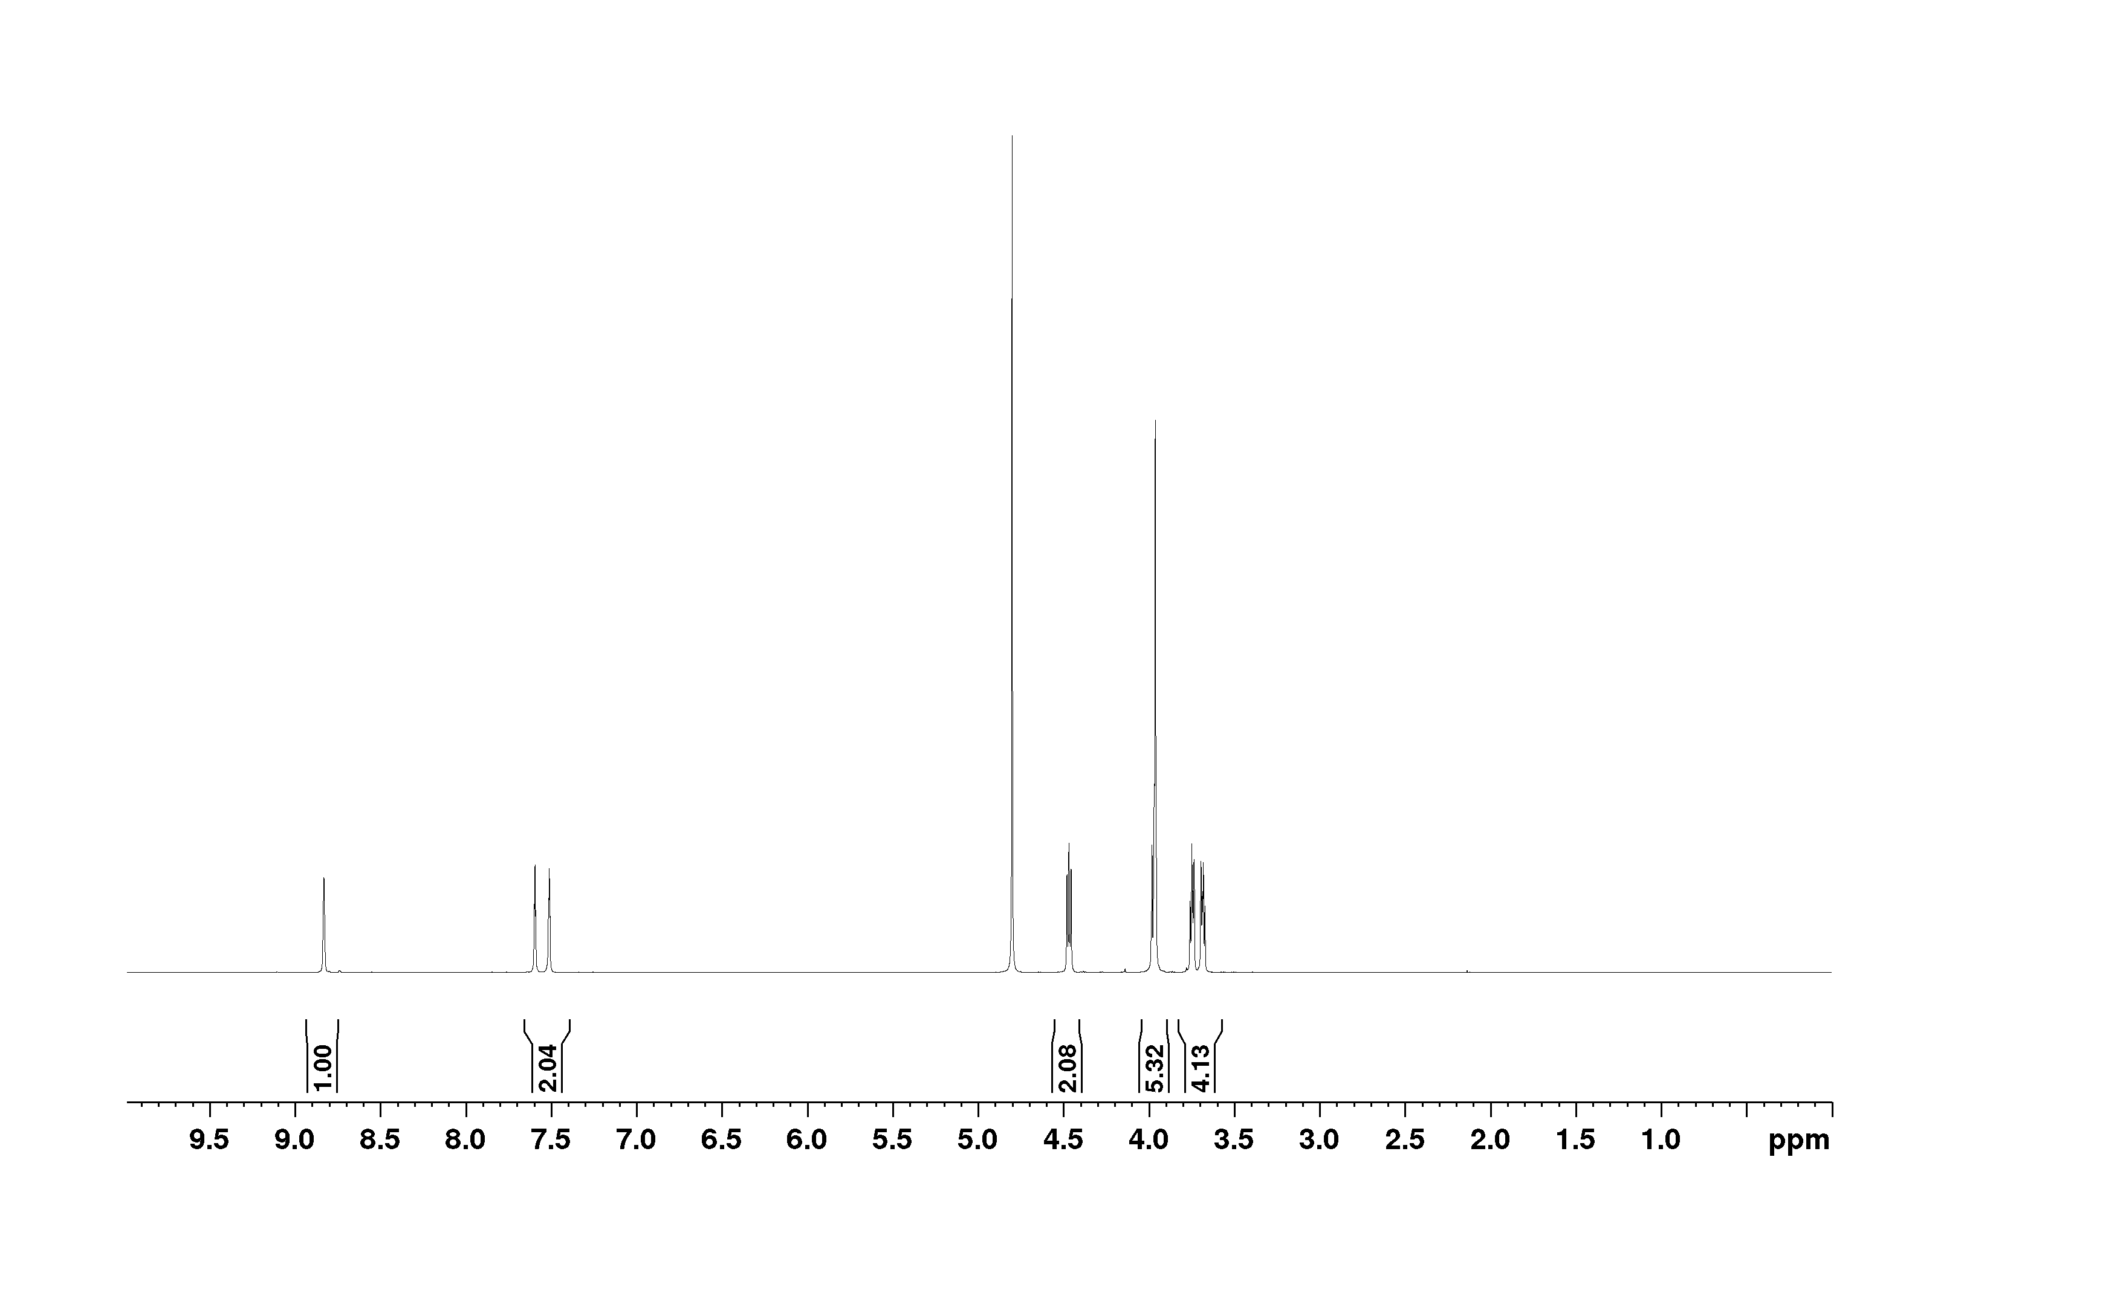
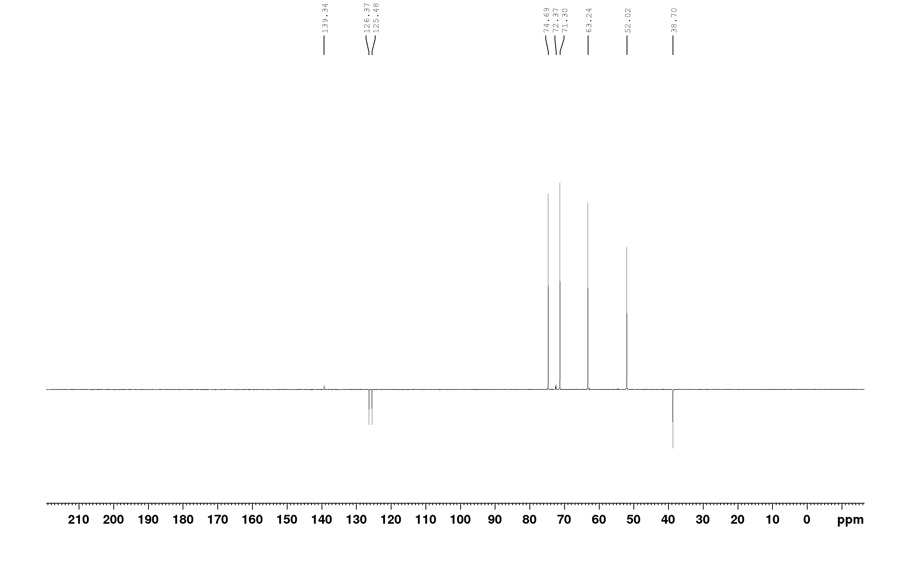
Figure S1. NMR spectra [OHC₂OC₂mim] [Cl]
¹H NMR spectrum (D₂O): 3.68 (m, 2H, NCH₂CH₂OCH₂CH₂OH); 3.74 (m, 2H, NCH₂CH₂OCH₂CH₂OH); 3.96 (s, 3H, CH₃); 3,99 (t, 2H, NCH₂CH₂OCH₂CH₂OH); 4.46 (t, J=4.8, NCH₂CH₂OCH₂CH₂OH); 7.51 and 7.60 (2xs, 2H, H-4 and H-5); 8.84 (s, 1H, H-2).
¹³C NMR spectrum (D₂O): 38.70 (CH₃); 52.02 (NCH₂CH₂OCH₂CH₂OH); 63.24 (NCH₂CH₂OCH₂CH₂OH); 71.30 (NCH₂CH₂OCH₂CH₂OH), 74,69 (NCH₂CH₂OCH₂CH₂OH); 125.48 and 126.37 (C-4 and C-5); 139.34 (d, C-2)
Figure S2. FTIR spectra [OHC₂OC₂mim] [Cl]
3099 (sym. stretching ν HC((4)C(5)H)); 3025 (sym. stretching ν HC(2)); 2960 (asym. stretching ν CH₃); 2830 (sym. stretching ν CH₃) 1522 (in-plane vibrations of imidazolium ring); 1432 and 1281 (stretching ν CC); 1376 (stretching ν C-O); 1172 (stretching ν C-O); 1110 (stretching ν C-O from ether group); 819 (in-plane bending mode δ CC);

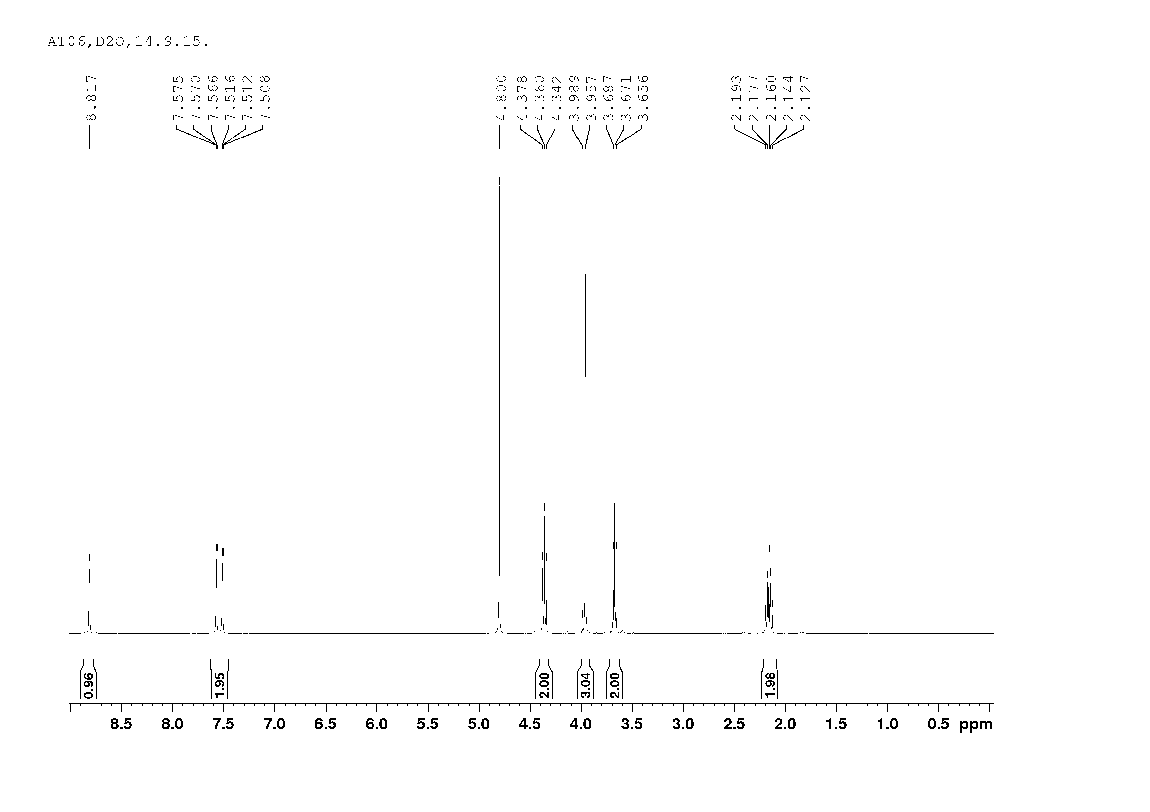
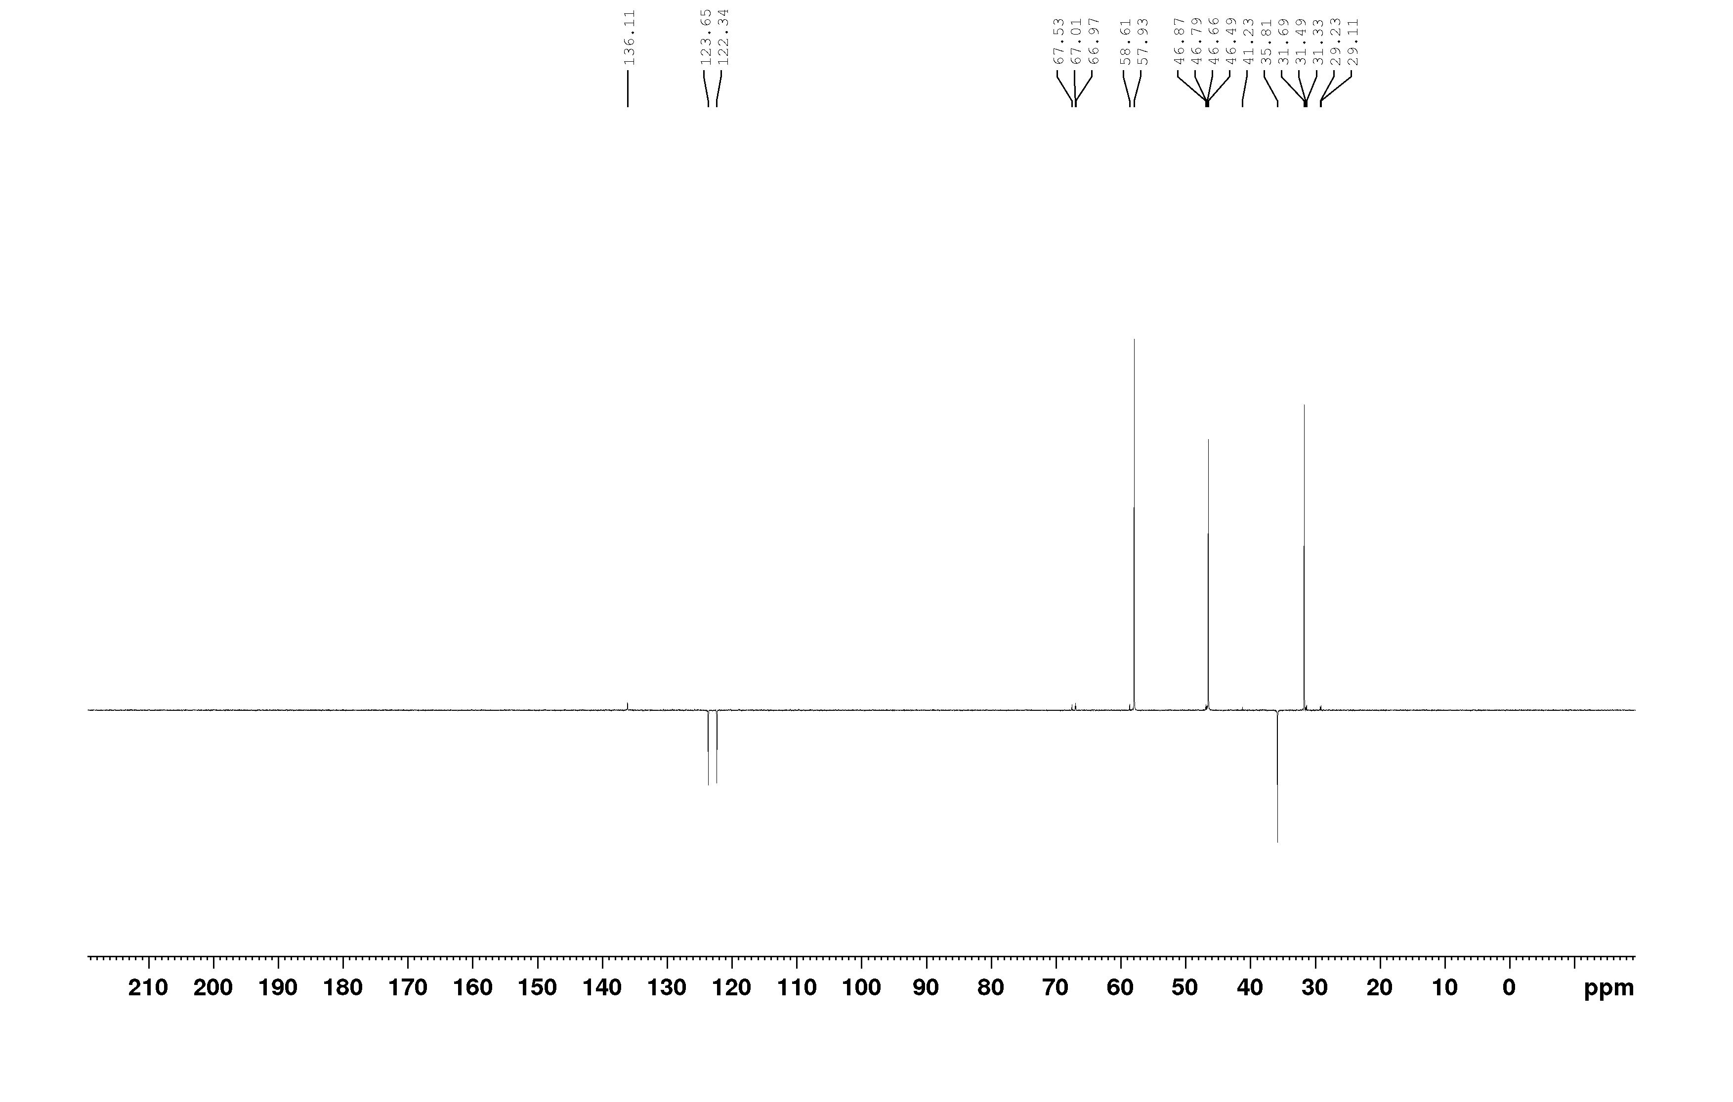
Figure S3. NMR spectra [C₃OHmim] [Cl]
[C₃OHmim] [Cl]
¹H NMR spectrum (D₂O): 2.16 (m, 2H, NCH₂CH₂CH₂OH); 3.67 (t, 2H, J=6.1 Hz, NCH₂CH₂CH₂OH); 3.96 (s, 3H, CH₃); 4,36 (t, 2H, J=7.1 Hz, NCH₂CH₂CH₂OH); 7.51 and 7.57 (2xs, 2H, H-4 and H-5); 8.82 (s, 1H, H-2).
¹³C NMR spectrum (D₂O): 31.49 (NCH₂CH₂CH₂OH); 35.81 (CH₃); 46,79 (NCH₂CH₂CH₂OH); 57.93 (NCH₂CH₂CH₂OH); 122.34 and 123.65 (C-4 and C-5); 136.11 (d, C-2)

Figure S4. FTIR spectra [C₃OHmim] [Cl]
IR (neat): 3285 (streching OH); 2956 (asym. stretching ν CH₃); 2875 (sym. stretching ν CH₃); 3072 (sym. stretching ν HC(2); 3145 (sym. stretching ν HC((4)C(5)H)); 1562 (in - plane vibrations of imidazolium ring); 1163 (sceletal vibrations of imidazolium ring)

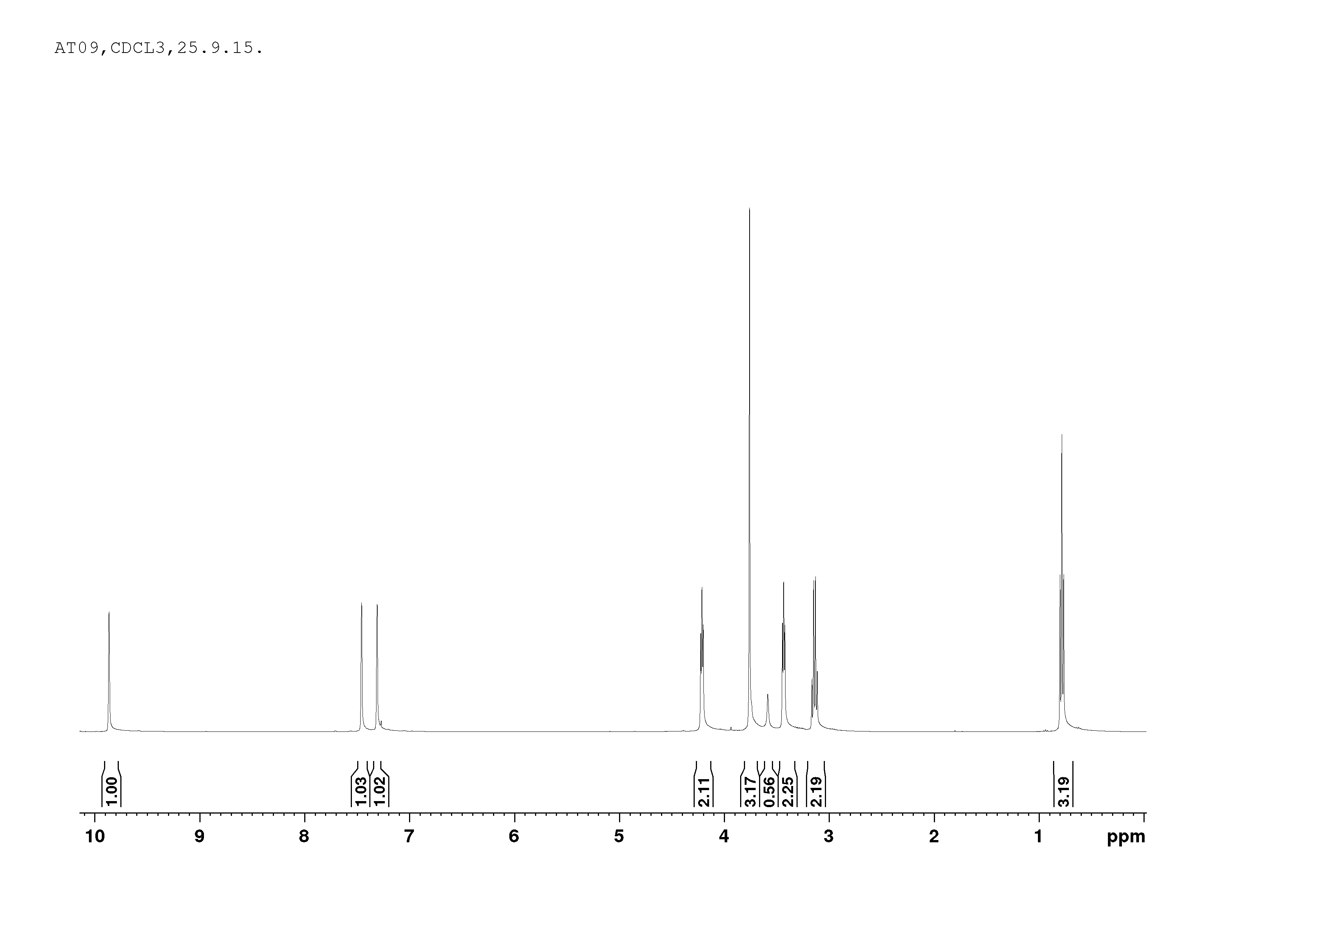
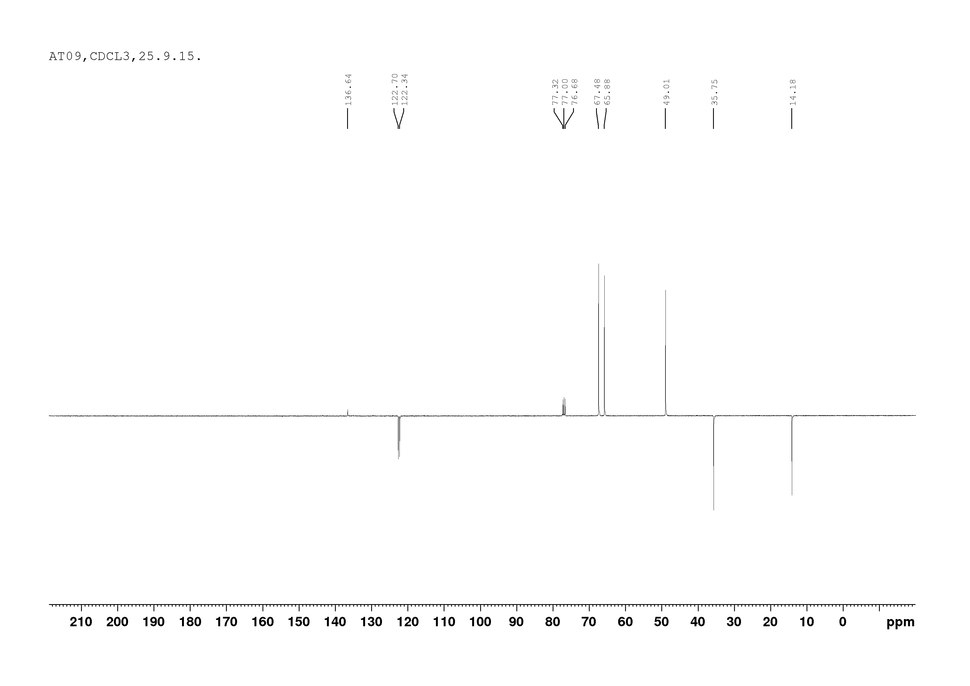
Figure S5. NMR spectra [C₂OC₂mim] [Cl]
¹H NMR spectrum (D₂O): 0.78 (t, 3H, J=6.9 Hz, NCH₂CH₂OCH₂CH₃); 3.14 (q, 2H, NCH₂CH₂OCH₂CH₃); 3.43 (t, 2H, NCH₂CH₂OCH₂CH₃); 3.75 (s, 3H, NCH₃); 4,21 (t, 2H, J=4.5 Hz, NCH₂CH₂CH₂OH); 7.30 and 7.46 (2xs, 2H, H-4 and H-5); 9.87 (s, 1H, H-2).
¹³C NMR spectrum (D₂O): 14.18 (NCH₂CH₂OCH₂CH₃); 35.75 (CH₃); 49.01 (NCH₂CH₂OCH₂CH₃); 65.88 (NCH₂CH₂OCH₂CH₃); 67.48 (NCH₂CH₂OCH₂CH₃); 122.34 and 122.70 (C-4 and C-5); 136.64 (d, C-2)
Figure S6. FTIR spectra [C₂OC₂mim] [Cl]
3141 (sym. stretching ν HC((4)C(5)H)); 3046 (sym. stretching ν HC(2)); 2967 (asym. stretching ν CH₃); 2868 (sym. stretching ν CH₃) 1568 (in-plane vibrations of imidazolium ring); 1450 (stretching ν CC); 1376 (stretching ν C-O); 1172 (stretching ν C-O); 1110 (stretching ν C-O from ether group); 819 (in-plane bending mode δ CC);
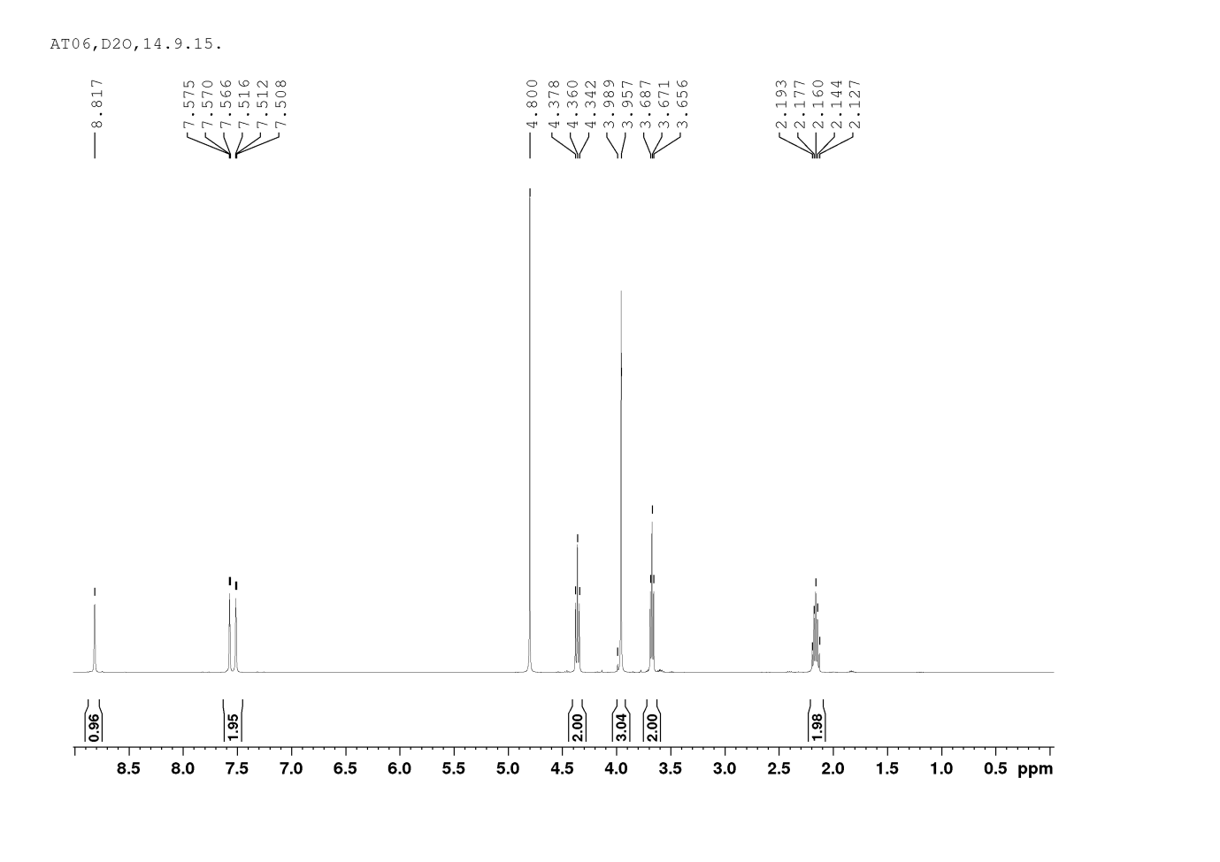
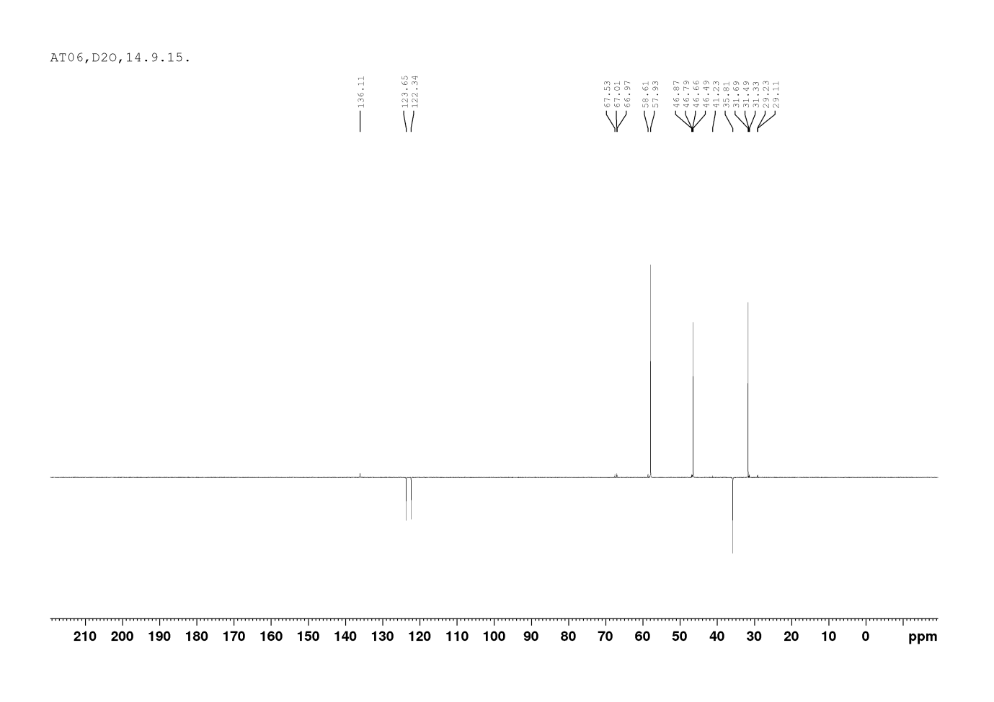
Figure S7. NMR spectra [C₃OHeim] [Cl]
¹HNMR (D₂O): 2.16 (m, 2H, NCH₂CH₂CH₂OH); 3.67 (t, 2H, J= 6.1 Hz, NCH₂CH₂CH₂OH); 3.96 (s, 3H, CH₃); 4.36 (t, 2H, J= 7.1 Hz, NCH₂CH₂CH₂OH); 7.51 and 7.57 (2xs, 2H, H-4 i H-5); 8.82 (s, 1H, H-2)
¹³CNMR (D₂O): 31.49 (NCH₂CH₂CH₂OH); 35.81 (CH₃); 46.79 (NCH₂CH₂CH₂OH); 57.93 (NCH₂CH₂CH₂OH); 122.34 i 123.65 (C-4 i C-5); 136.11 (d, C-2)
Figure S8. FTIR spectra [C₃OHeim] [Cl]

IR (neat): 3283 (streching OH); 2960 (asym. stretching ν CH₃); 2874 (sym. stretching ν CH₃); 3067 (sym. stretching ν HC(2); 3142 (sym. stretching ν HC((4)C(5)H)); 1561 (in - plane vibrations of imidazolium ring); 1164 (sceletal vibrations of imidazolium ring),
Figure S9. Variation of lnη viscosity with T^{–1} for pure ionic liquids: (), [OHC₃eIm][Cl]; (),[OHC₃mIm][Cl]; (▲),[C₂OC₂mIm][Cl]; (▽), [OHC₂OC₂mIm][Cl]
Figure S10. Variation of molar conductivity of pure ionic liquids with temperature: (), [OHC₃eIm][Cl]; (),[OHC₃mIm][Cl]; (▲),[C₂OC₂mIm][Cl]; (▽), [OHC₂OC₂mIm][Cl]

