

**Fig C1.** Key HMBC Correlations (red arrows) for compound MM-E

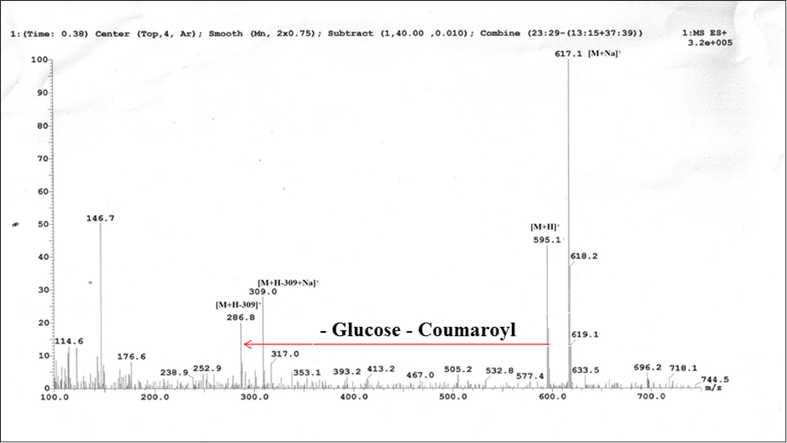

**Fig C2.** Mass Spectrum of MM-E

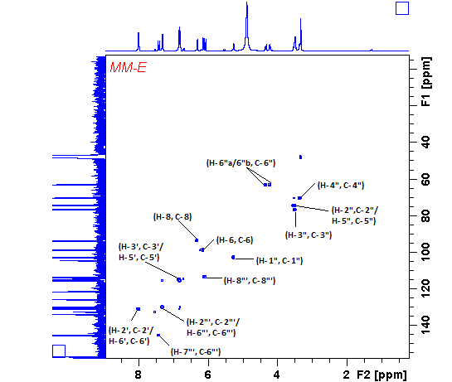

**Fig C3.** HSQC Spectrum of MM-E

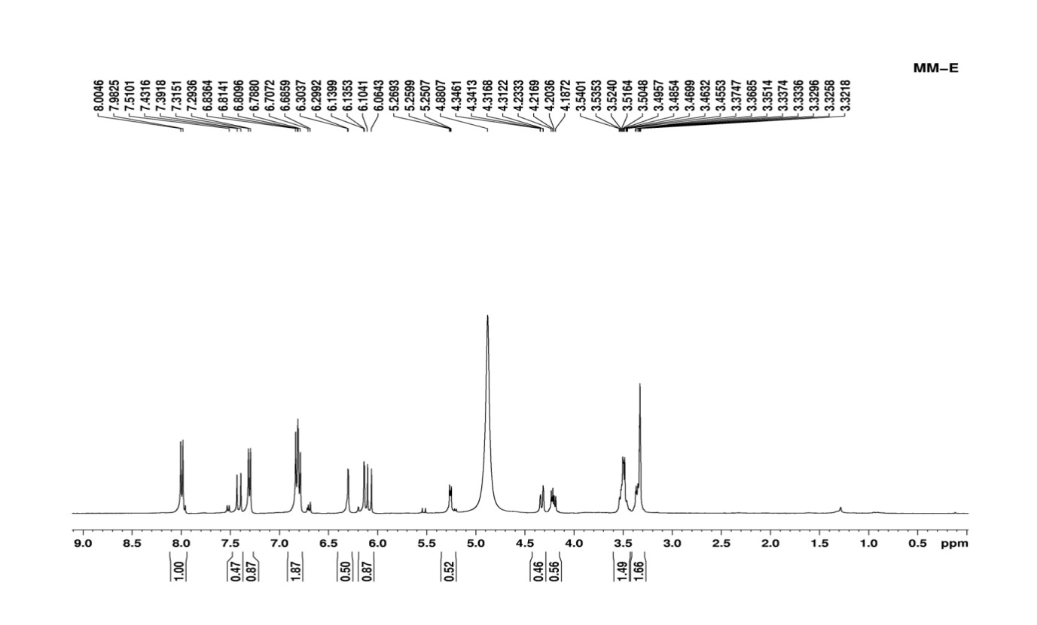

**Fig C4.** 1H Spectrum of MM-E

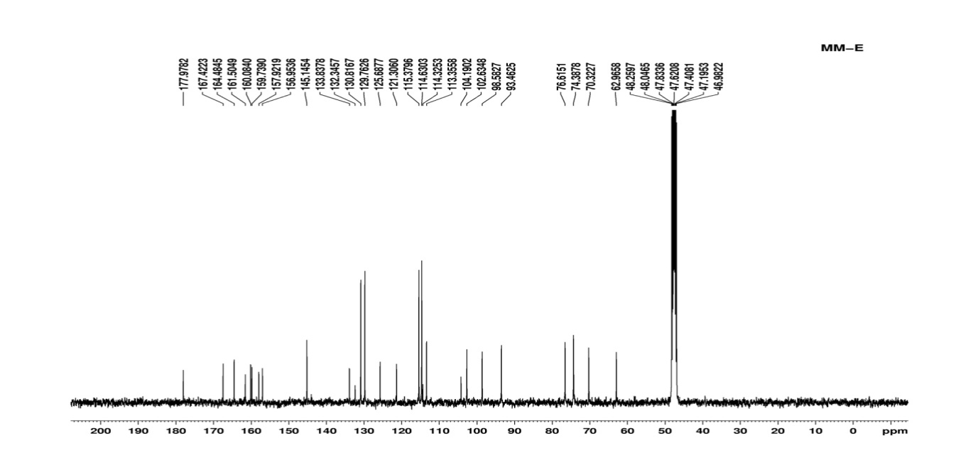

**Fig C5**.13C NMR Spectrum of MM-E

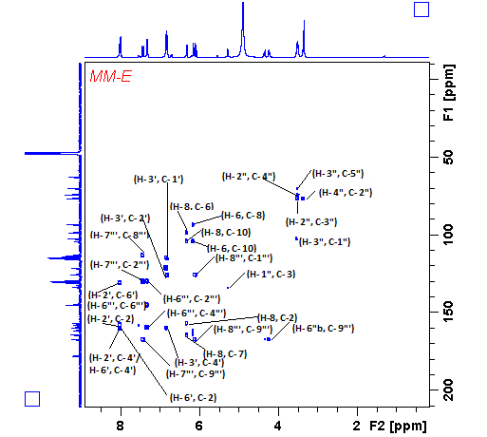

**Fig C6.** HMBC Spectrum of MM-E

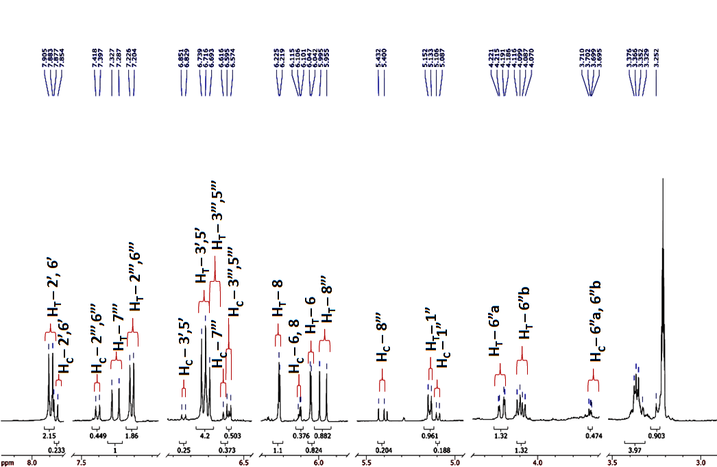

**Fig C7.** 1H NMR Spectrum of MM-E in CH3OH-d4;HT-trans isomer protons, HC- cis isomer protons

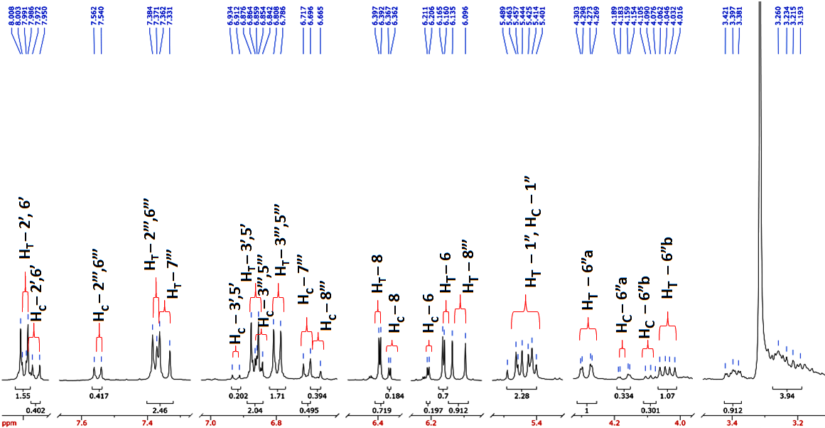

**Fig C8.**1H NMR Spectrum of MM-E in DMSO-d6; HT-trans isomer proton, HC- cis isomer proton



**Fig C9.** Key HMBC Correlations (red arrows) for compound MM-F

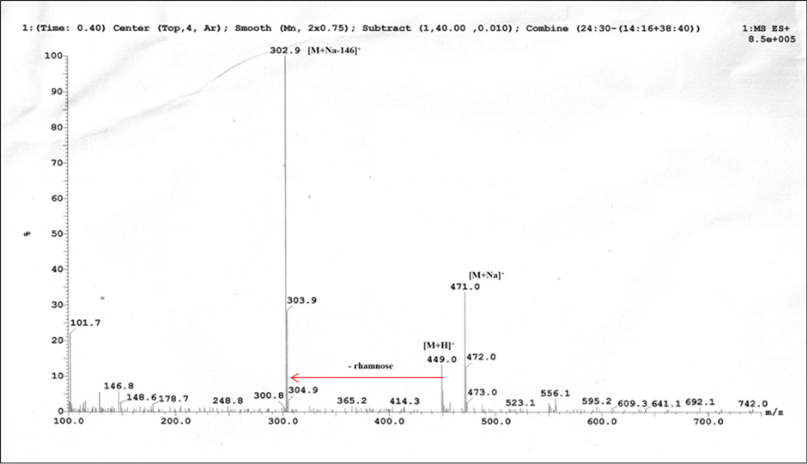

**Fig C10.** Mass Spectrum of MM- F

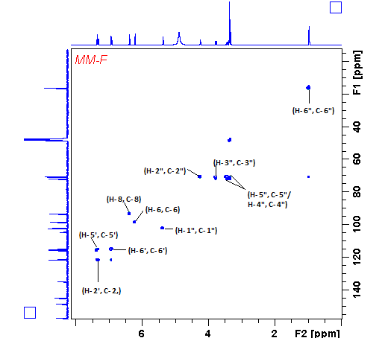

**Fig C11.** HSQC Spectrum of MM- F

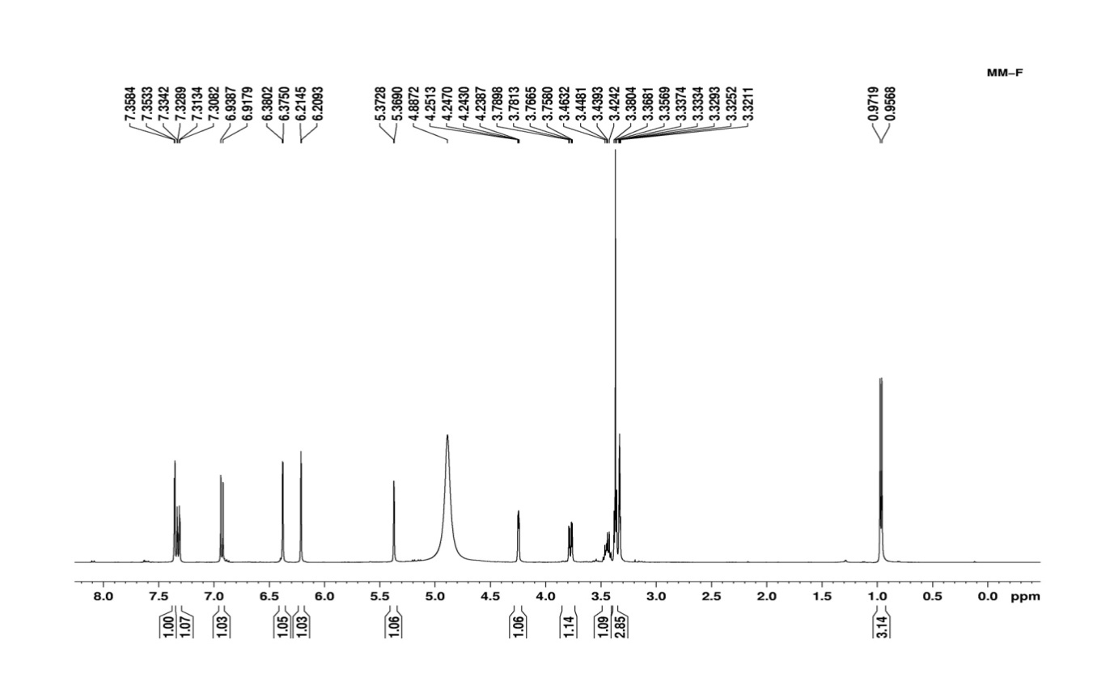

**Fig C12**. 1H Spectrum of MM-F

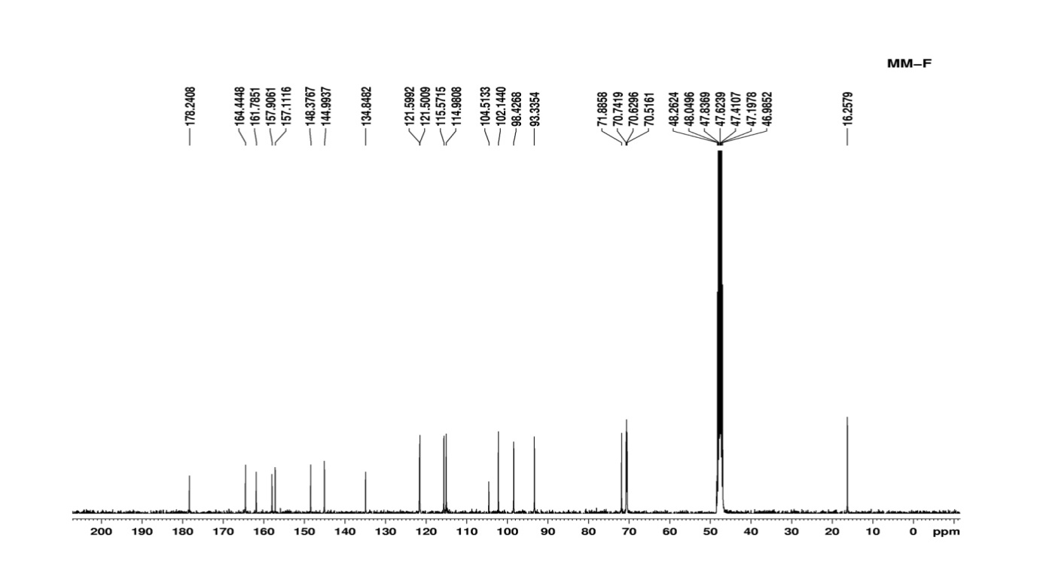

**Fig C13**. 13C Spectrum of MM-F

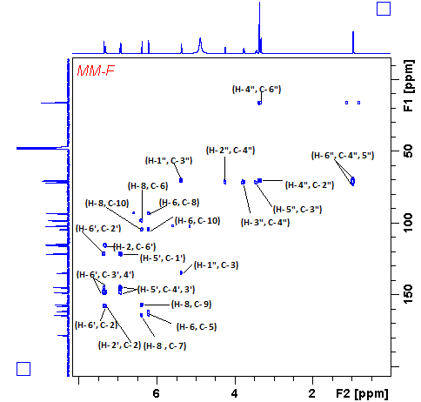

**Fig C14.** HMBC Spectrum of MM-F