**Supplementary Material**

**Self Assembly in an Aqueous Gemini Surfactant Containing Sugar based (Isosorbide) Spacer**

Kushan Parikh*a*, Sneha Singh*b*, Sanjeev Kumar*b*,*

*a*Soft Material Research Laboratory, Department of Chemistry, Faculty of Science, The Maharaja Sayajirao University of Baroda, Vadodara – 390 002, India.

*b*Applied Chemistry Department, Faculty of Technology & Engineering, The Maharaja Sayajirao University of Baroda, Vadodara – 390 002, India.

drksanjeev@gmail.com

**Supplementary Figures**

**Figure S1.** 1H NMR spectrum of 16-Isb-16 as a function of concentration in D2O. The peak (δ = ~4.69 ppm) which represents the proton of HOD.

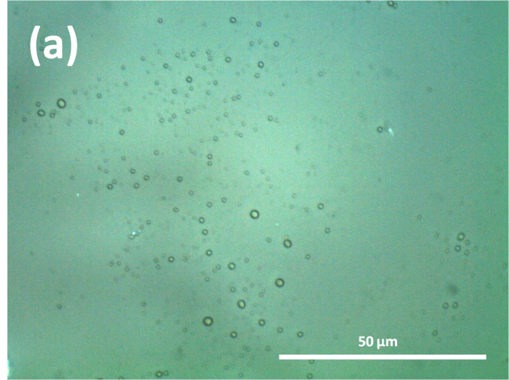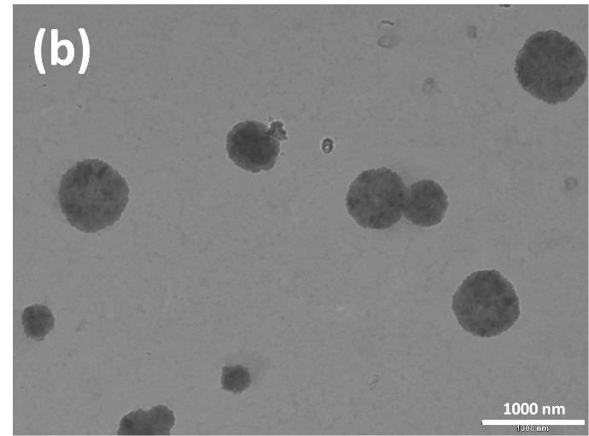

**Figure S2.** (*a*) Polarizing optical microscope (POM) image of 16-Isb-16 in aqueous solution at 1 mM: scale bar represents 50 μm. (*b*) TEM image of 1 mM aqueous solution of 16- Isb-16 at 25°C. Scale bar represents: 1000 nm.



**Figure S3.** pH & zeta (ζ)-potential variation with [16-Isb-16] in aqueous solution at 25°C.



**Figure S4.** pH mediated, by NaOH, (*a*) polydispersity (PD) index and (*b*) Zeta (*ζ*) potential of aqueous 16-Isb-16 at 25°C, (*c*) Hydrodynamic diameter(*D*h) of 16-Isb-16 solution with different concentrations (5 to 1 mM) with fixed 7.0 pH buffer at 25°C.



**Figure S5.** Plot of Polydispersity (PD) index *vs* [Salt] of 1 mM 16-Isb-16 at 25°C: (*a*) NaCl; (*b*) NaBr; (*c*) NaNO3; (*d*) NaSal.