Room-temperature fabrication of magnetite-boehmite sol-gel composites for heavy metal ions removal

Olga E. Shapovalova, Andrey S. Drozdov*, Ekaterina A. Brushkova, Maxim I. Morozov, Vladimir V. Vinogradov

Laboratory of Solution Chemistry of Advanced Materials and Technologies, ITMO University, St. Petersburg, 197101, Russian Federation

E-mail: drozdov@scamt.ru;

**Electronic Supplementary Information**

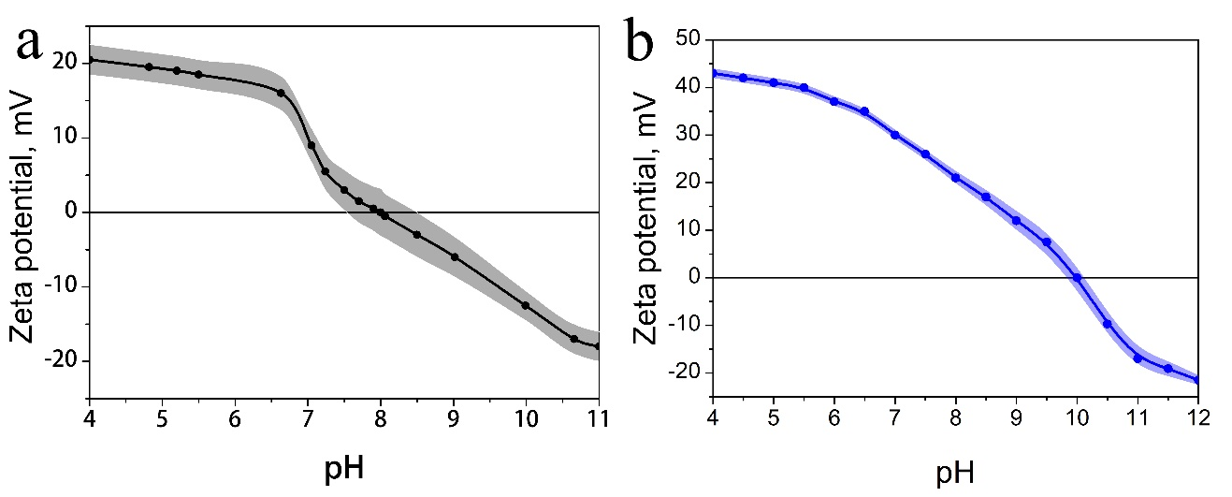

Figure 1S. Zeta potential of the ferria (a) and alumina (b) as a function of the pH. The isoelectric point of the hydrosols is shifted to a pH 8 and 10 respectively.

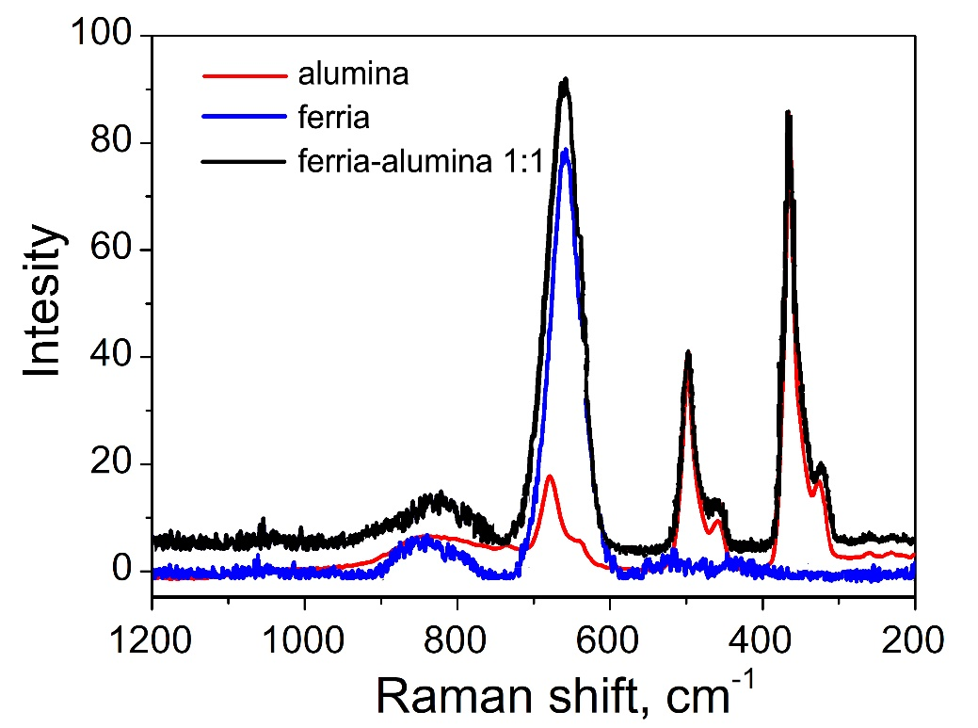

Figure 2S. Raman spectra of sol-gel materials. The spectra of 1:1 ferria-alumina composite contains peaks characteristic for both alumina and ferria matrix while absence of any additional signals is observed.

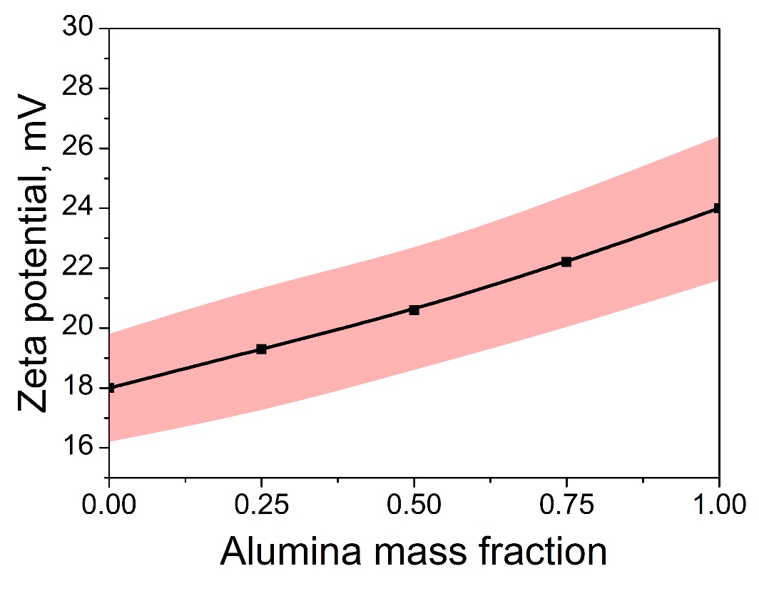

Figure 3S. Zeta potential of ferria-alumina composites as a function of alumina mass fraction.

Table 1S. Comparison of Langmuir adsorption capacities for Cr6+ remediation on ferria-alumina composites versus other adsorbents.

|  |  |  |
| --- | --- | --- |
| Ferria  3:1 Feria-alumina  1:1 Feria-alumina  1:3 Feria-alumina  Alumina | 23.5  33.4  43.6  52.9  62.4 | This study |
| Magnetite nanoparticles | 20.2 | Rajput, Shalini, Charles U. Pittman Jr, and Dinesh Mohan. "Magnetic magnetite (Fe3O4) nanoparticle synthesis and applications for lead (Pb2+) and chromium (Cr6+) removal from water." *Journal of colloid and interface science* 468 (2016): 334-346. |
| Magnetite –maghemite  nanoparticles | 6.0 | Chowdhury, Saidur Rahman, Ernest K. Yanful, and Allen R. Pratt. "Chemical states in XPS and Raman analysis during removal of Cr (VI) from contaminated water by mixed maghemite–magnetite nanoparticles." *Journal of hazardous materials* 235 (2012): 246-256. |
| Fe3O4 nanoparticles | 35.46 | Shen, Y. F., et al. "Preparation and application of magnetic Fe3O4 nanoparticles for wastewater purification." *Separation and Purification Technology* 68.3 (2009): 312-319. |
| Water-soluble  Fe3O4 nanoparticles | 41.5 | Wang, Lixia, et al. "Water-soluble Fe 3 O 4 nanoparticles with high solubility for removal of heavy-metal ions from waste water." *Dalton Transactions* 41.15 (2012): 4544-4551. |
| Ceria Micro/Nanocomposite | 5.9 | Zhong, Liang-Shu, et al. "3D flowerlike ceria micro/nanocomposite structure and its application for water treatment and CO removal." *Chemistry of Materials* 19.7 (2007): 1648-1655. |
| Fe3O4 hollow microspheres | 18.0 | Wang, Rongyue, et al. "Electrochemical properties of manganese ferrite-based supercapacitors in aqueous electrolyte: the effect of ionic radius." *Colloids and Surfaces A: Physicochemical and Engineering Aspects* 457 (2014): 94-99. |
| Maghemite nanoparticles | 13.88 | Yuan, Peng, et al. "Montmorillonite-supported magnetite nanoparticles for the removal of hexavalent chromium [Cr (VI)] from aqueous solutions." *Journal of Hazardous Materials* 166.2-3 (2009): 821-829. |
| Montmorillonite-supported  magnetite nanoparticles | 17.4 | Hu, Jing, Guohua Chen, and Irene MC Lo. "Removal and recovery of Cr (VI) from wastewater by maghemite nanoparticles." *Water research* 39.18 (2005): 4528-4536. |
| Modified jacobsite (MnFe2O4)  Nanoparticles | 31.6 | Hu, Jing, Irene MC Lo, and Guohua Chen. "Fast removal and recovery of Cr (VI) using surface-modified jacobsite (MnFe2O4) nanoparticles." *Langmuir* 21.24 (2005): 11173-11179. |
| Carbon nanotube supported  ceria nanoparticles | 26.8 | Di, Ze-Chao, et al. "Chromium adsorption by aligned carbon nanotubes supported ceria nanoparticles." *Chemosphere* 62.5 (2006): 861-865. |
| Fe3O4/Bacterial cellulose  nanocomposite | 25 | Zhu, Huixia, et al. "Biosynthesis of spherical Fe3O4/bacterial cellulose nanocomposites as adsorbents for heavy metal ions." *Carbohydrate Polymers* 86.4 (2011): 1558-1564. |