**Design, synthesis, molecular properties and *in vitro* antioxidant and antibacterial**

**potential of novel enantiopure isoxazolidine derivatives**

**Siwar Ghannay,a Sana Bakari,b Moncef Msaddek,a Sébastien Vidal,c Adel Kadri,b,d,* Kaïss Aouadia,\***

a Laboratory of Heterocyclic Chemistry, Natural Products and Reactivity, Faculty of Sciences of Monastir, University of Monastir, Avenue de l’Environnement, 5000 Monastir, Tunisia.

b Laboratory of Plant Biotechnology Applied to Crop Improvement, Faculty of Science of Sfax, University of Sfax, B.P. 11713000 Sfax, Tunisia.

c University of Lyon 1, Institut de Chimie et Biochimie Moléculaires et Supramoléculaires, UMR CNRS 5246, Bâtiment Lederer, 43 Boulevard du 11 Novembre 1918, F-69622 Villeurbanne, France

d College of Science and Arts in Baljurashi, Al Baha University, P.O.Box (1988). Al Baha, Saudi Arabia.

E-mail : kaiss_aouadi@hotmail.com

**Supplementary Information**

**Table of Contents**

**NMR Spectra**

1H and 13C NMR of **2f**

1H and 13C NMR of **2g**

1H and 13C NMR of **2h**

1H and 13C NMR of **2j**

1H and 13C NMR of **3a**

2D NMR 1H-1H COSY of **3a**

2D NMR 1H-13C HSQC of **3a**

2D NMR 1H-13C HMBC of **3a**

2D NMR 1H-1H NOESY of **3a**

1H and 13C NMR of **3b**

1H and 13C NMR of **3c**

1H and 13C NMR of **3d**

1H and 13C NMR of **3e**

1H and 13C NMR of **3f**

1H and 13C NMR of **3g**

1H and 13C NMR of **3h**

1H and 13C NMR of **3i**

1H and 13C NMR of **3j**

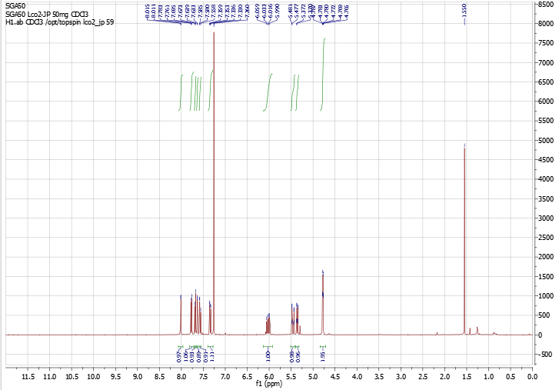



1H NMR of compound (**2f**)

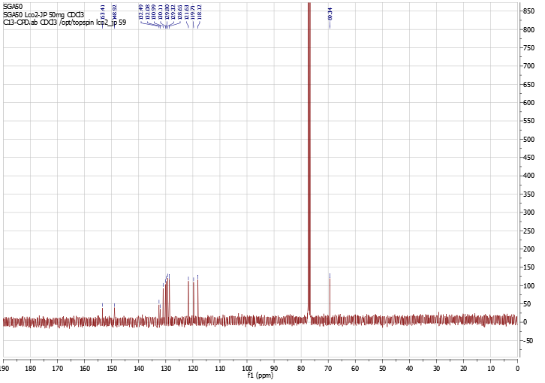



13C NMR of compound (**2f**)

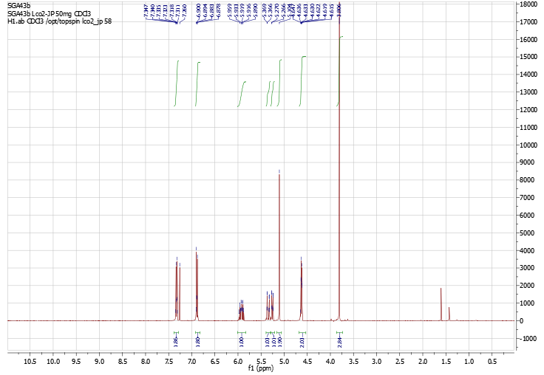



1H NMR of compound (**2g**)

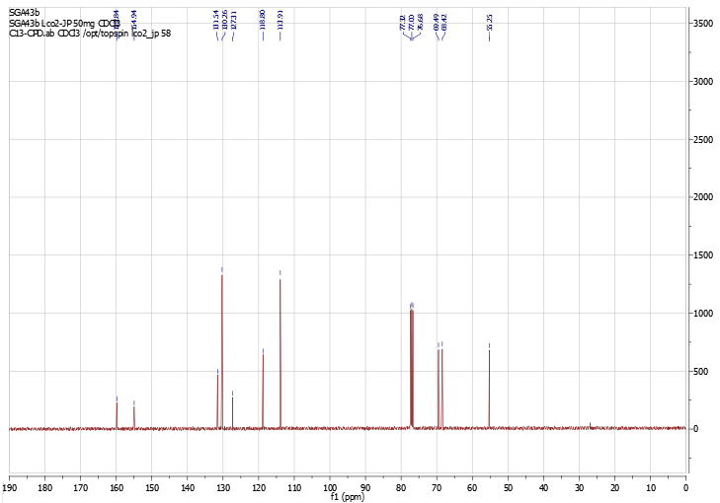

13C NMR of compound (**2g**)

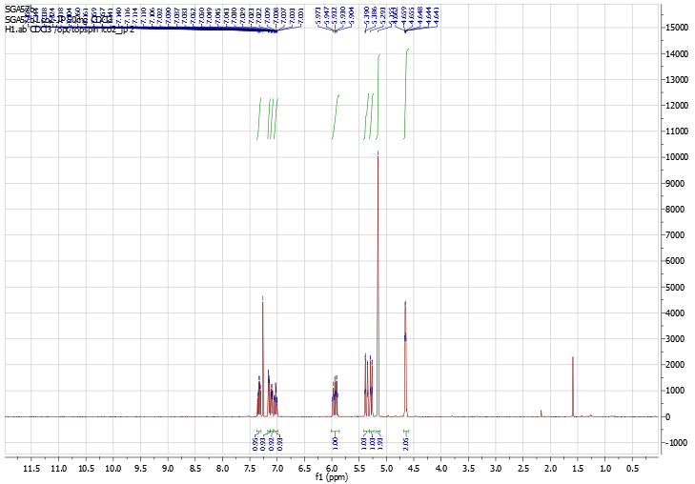



1H NMR of compound (**2h**)

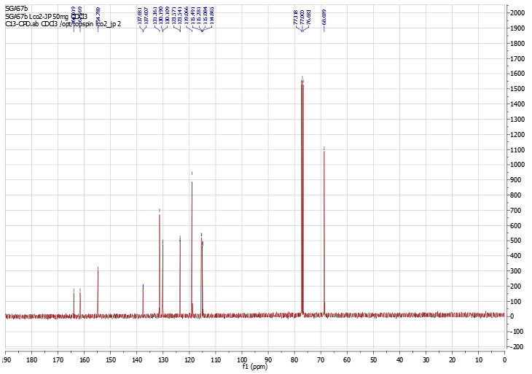

13C NMR of compound (**2h**)

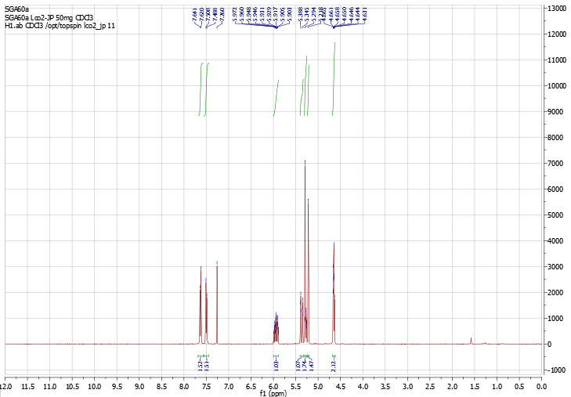



1H NMR of compound (**2j**)

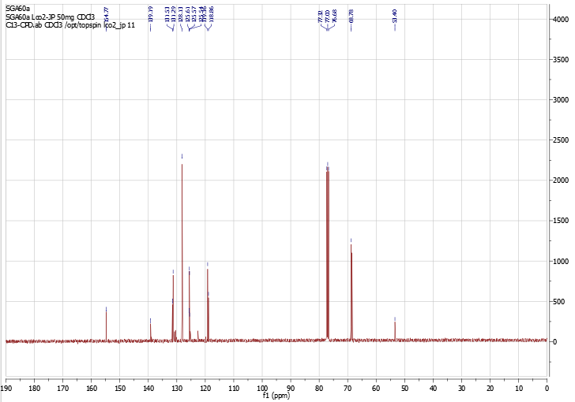

13C NMR of compound (**2j**)

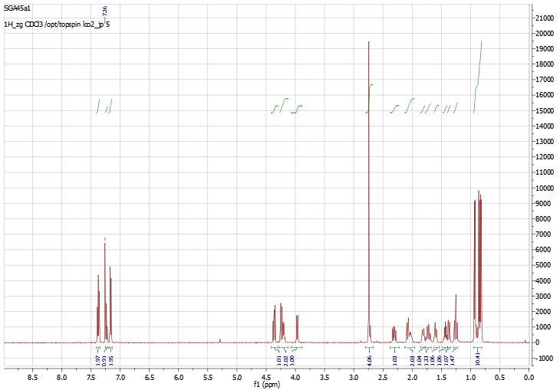



1H NMR of compound (**3a**)

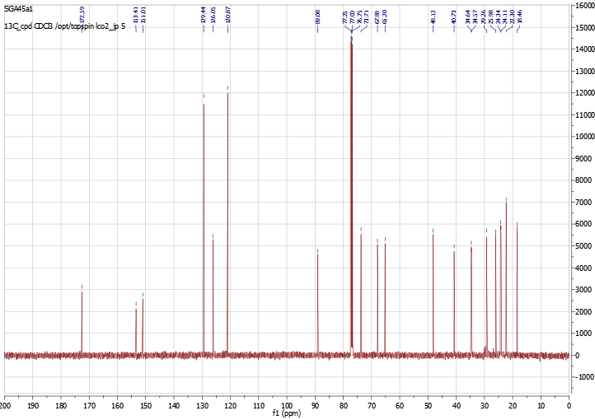



13C NMR of compound (**3a**)

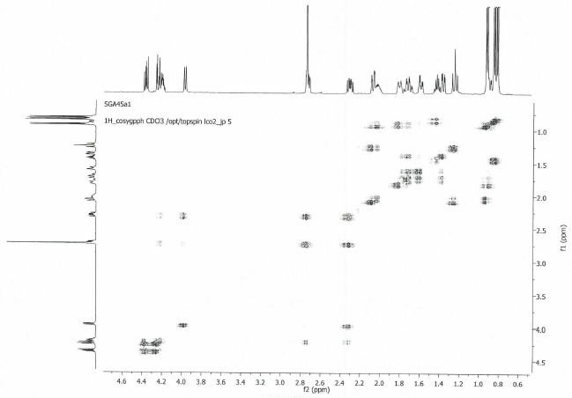

2D NMR 1H-1H COSY of compound (**3a**)

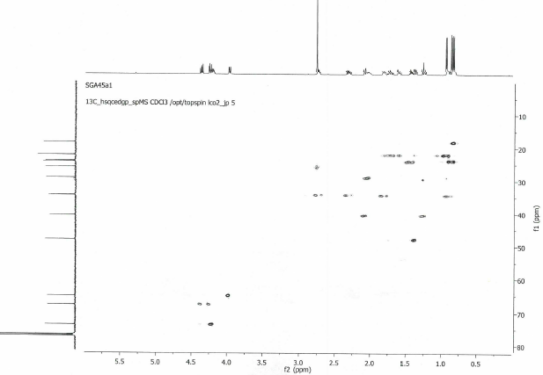

2D NMR 1H-1H HSQC of compound (**3a**)

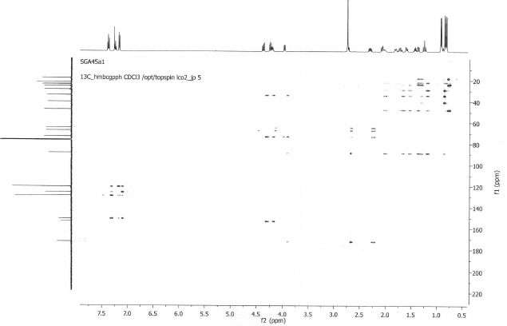

2D NMR 1H-13C HMBC of compound (**3a**)

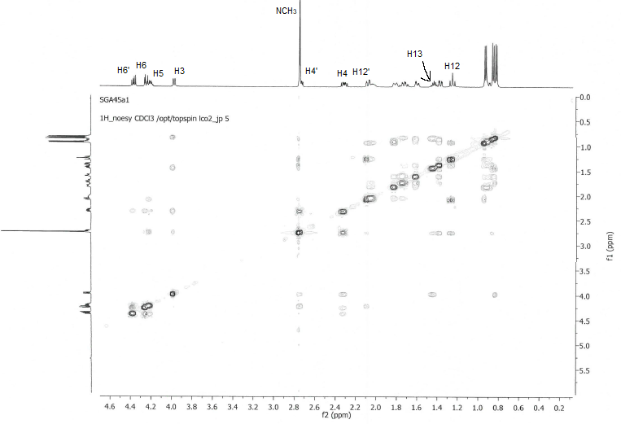

2D NMR 1H-1H NOESY of compound (**3a**)

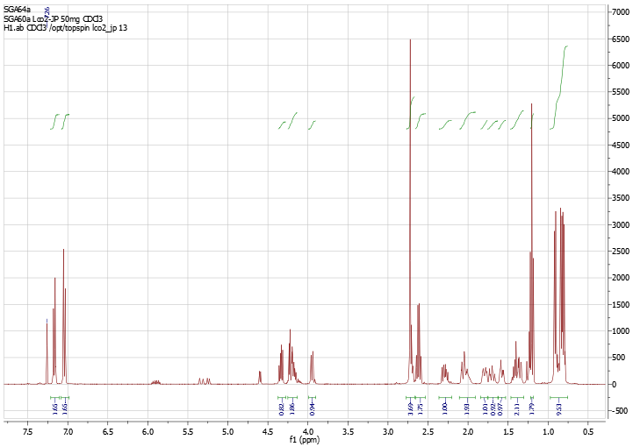



1H NMR of compound (**3b**)

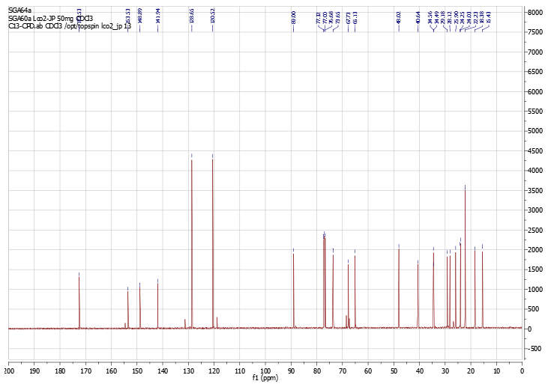



13C NMR of compound (**3b**)

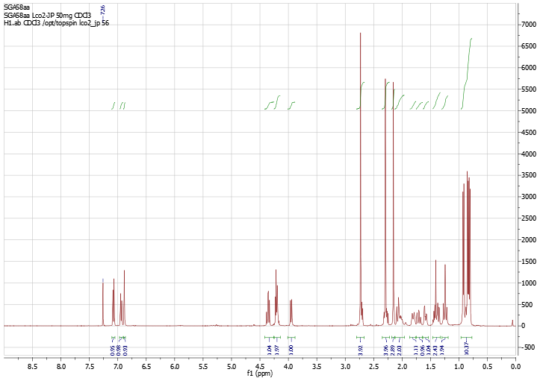



1H NMR of compound (**3c**)

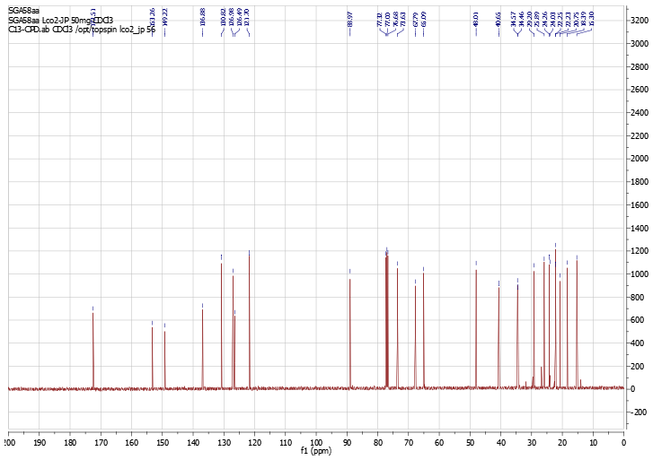



13C NMR of compound (**3c**)

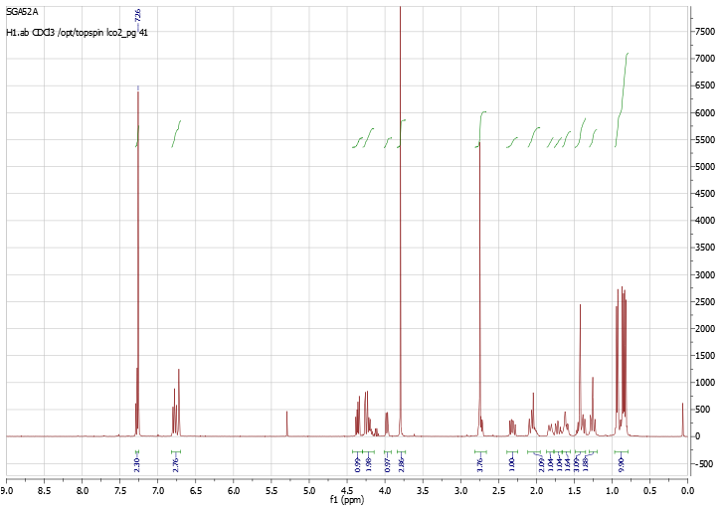



1H NMR of compound (**3d**)

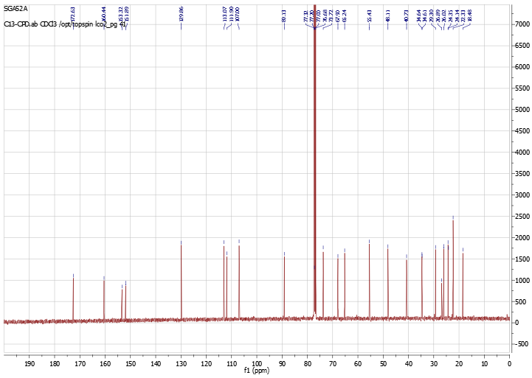

13C NMR of compound (**3d**)

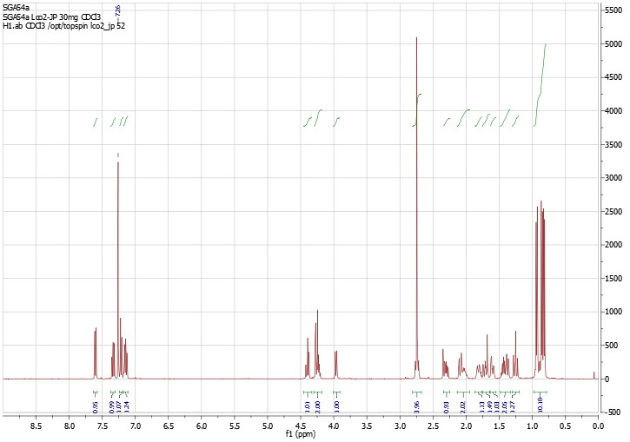



1H NMR of compound (**3e**)

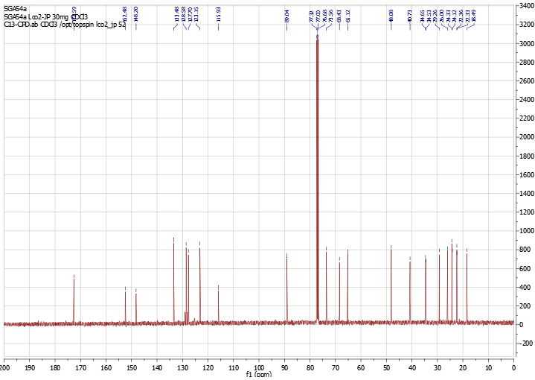

13C NMR of compound (**3e**)

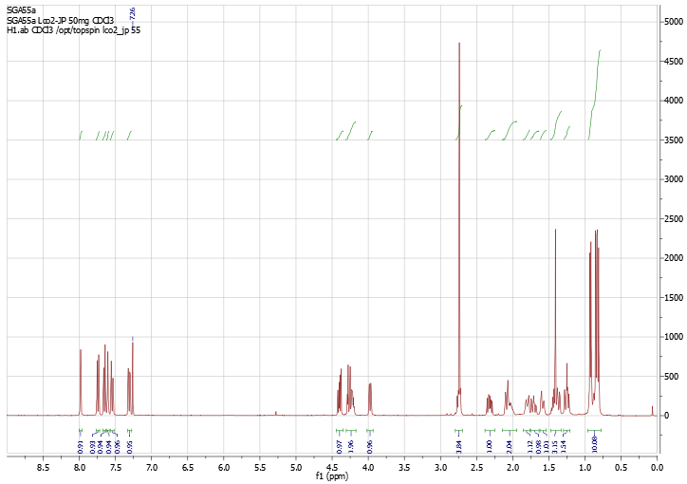



1H NMR of compound (**3f**)

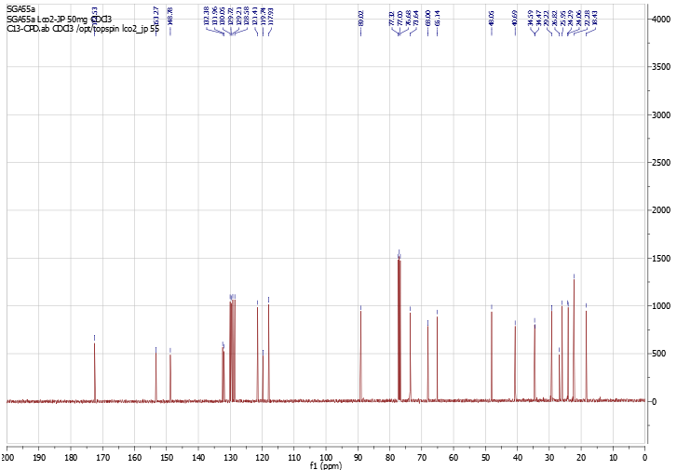



13C NMR of compound (**3f**)

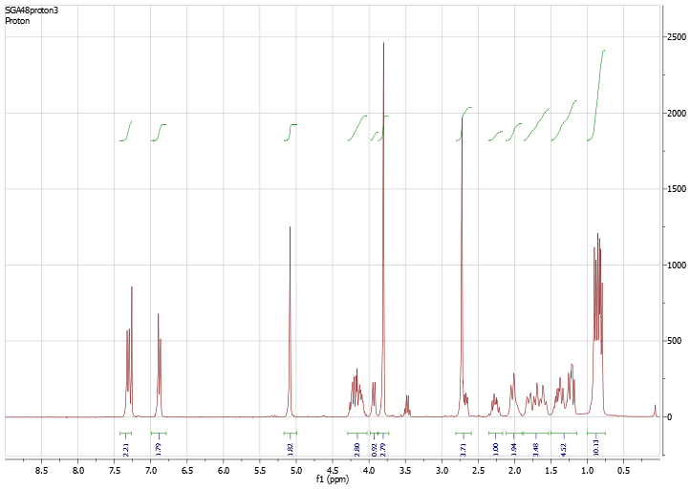



1H NMR of compound (**3g**)

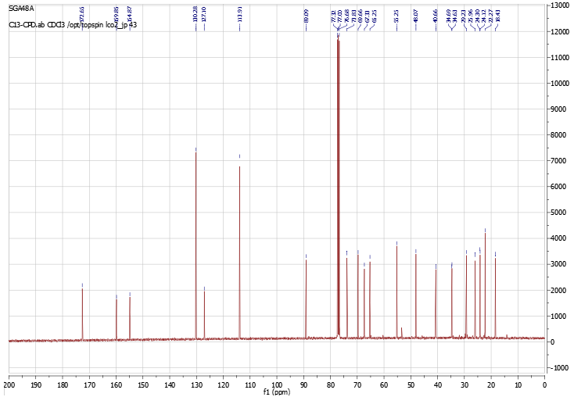



13C NMR of compound (**3g**)

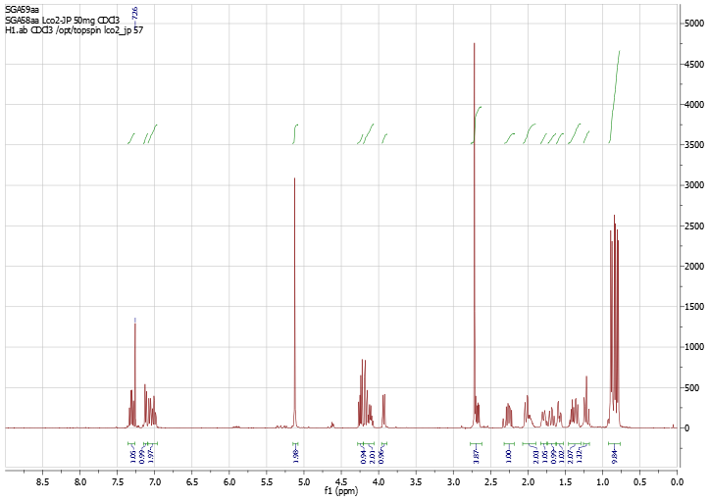



1H NMR of compound (**3h**)

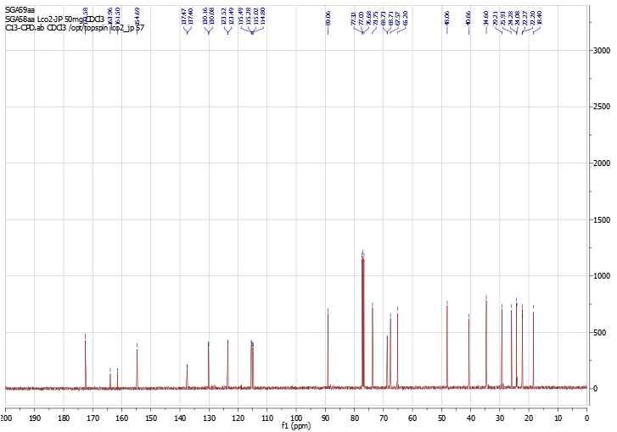



13C NMR of compound (**3h**)

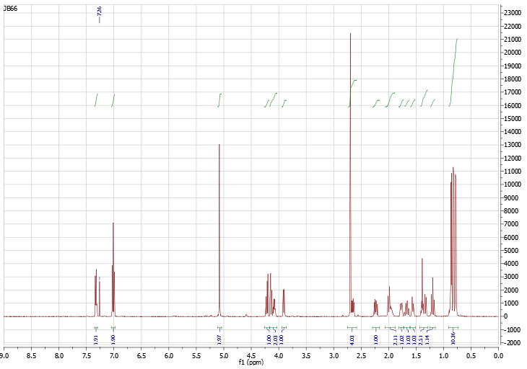



1H NMR of compound (**3i**)

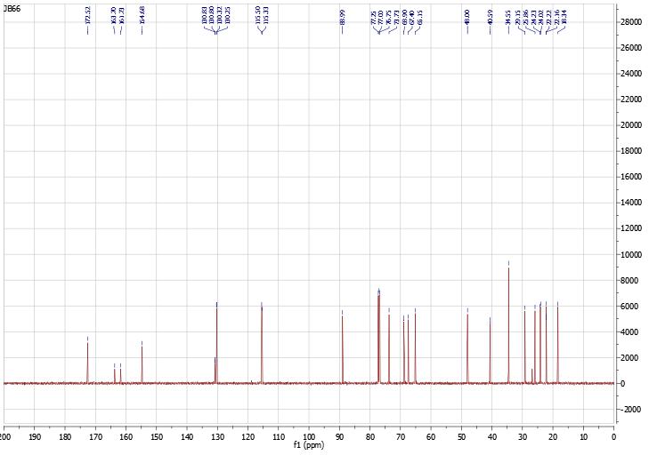

13C NMR of compound (**3i**)

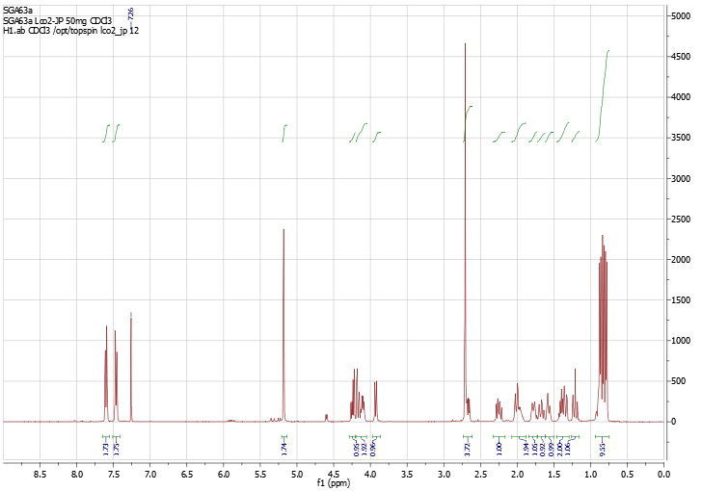



1H NMR of compound (**3j**)

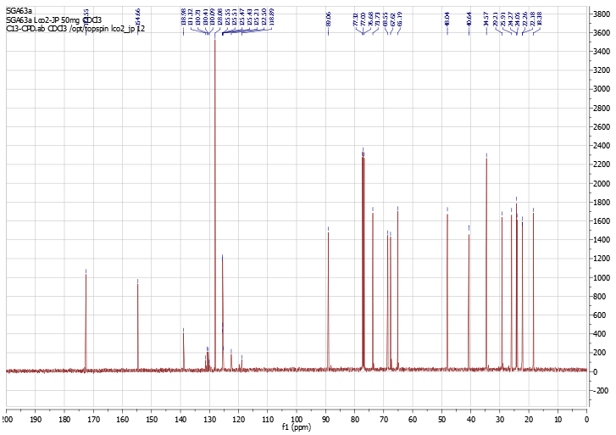



13C NMR of compound (**3j**)

Mathe

́

oBerthet,

†

ThomasCheviet,

†

GillesDujardin,

‡

IsabelleParrot,*

,†

andJeanMartinez

Mathe

́

oBerthet,

†

ThomasCheviet,

†

GillesDujardin,

‡

IsabelleParrot,*

,†

andJeanMartinez

Mathe

́

oBerthet,

†

ThomasCheviet,

†

GillesDujardin,

‡

IsabelleParrot,*

,†

andJeanMartinez