**Supporting information**

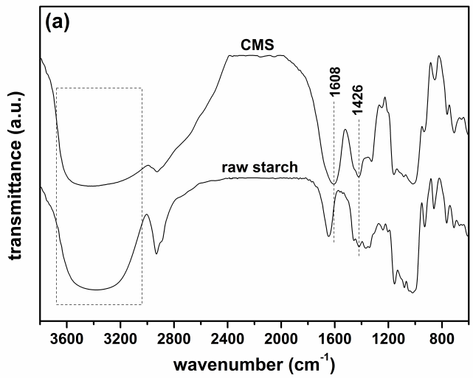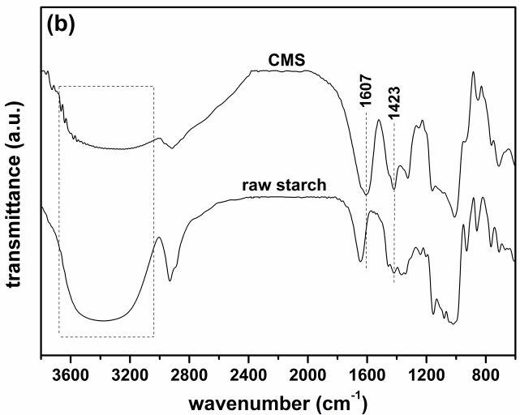

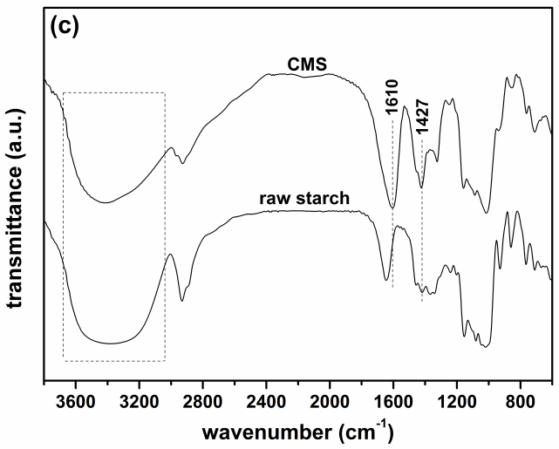

**Figure S1.** FTIR spectra of raw rice starches with different content of amylose and the carboxymethyl starches (CMS) synthesized from them. (a) low-amylose starch (6%), (b) medium-amylose starch (18%) and (c) high-amylose starch (30%).

Figure S2a.tifFigure S2b.tif

**Figure S2.** SEM images of (a) raw low-amylose starch and (b) CMS synthesized from low-amylose starch.

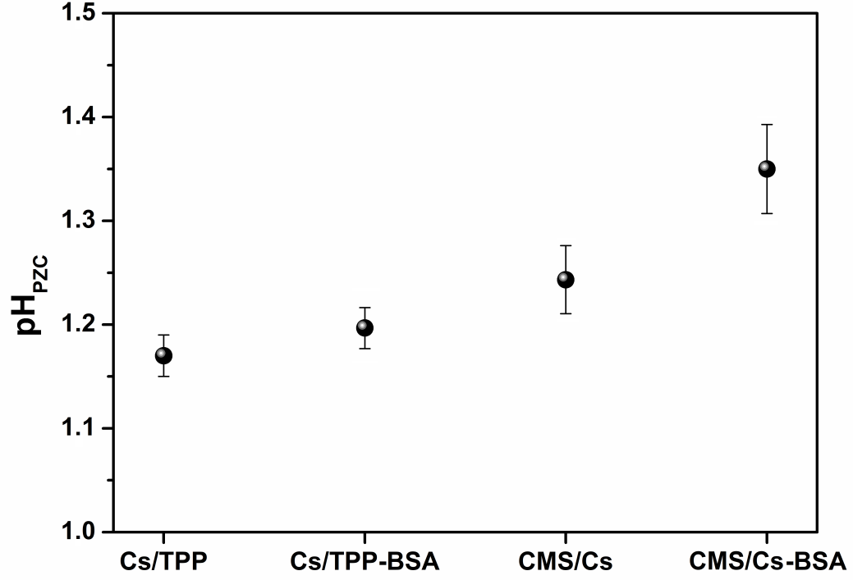

**Figure S3**. Determination of the pHPZC values for the microparticles and BSA-loaded microparticles.

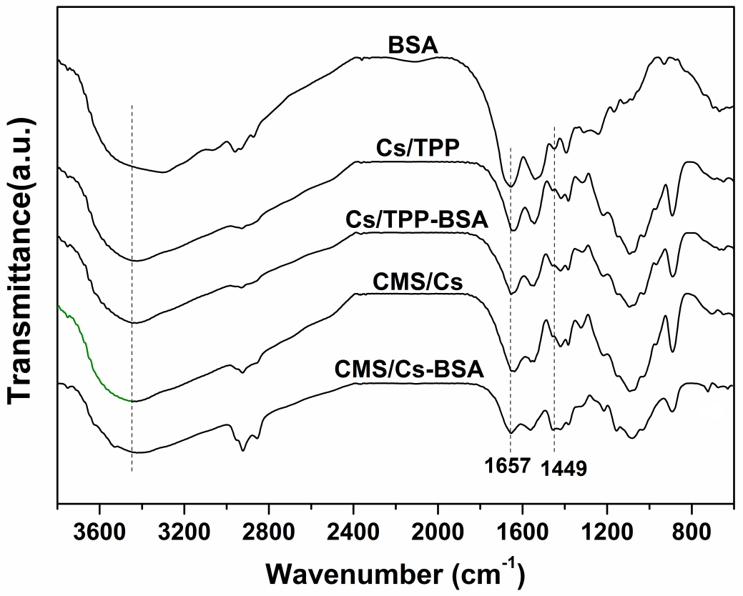

**Figure S4.** FTIR spectra of BSA, microparticles and BSA-loaded microparticles.

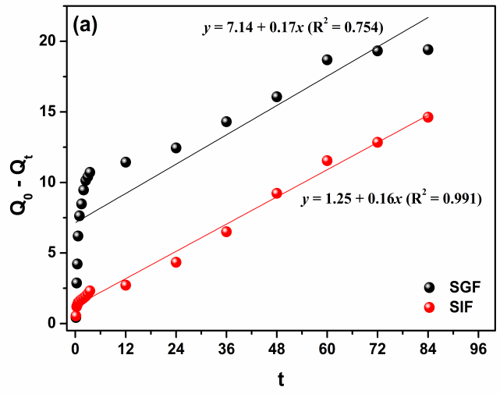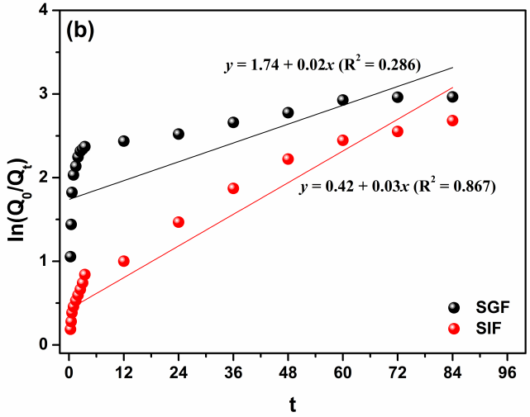

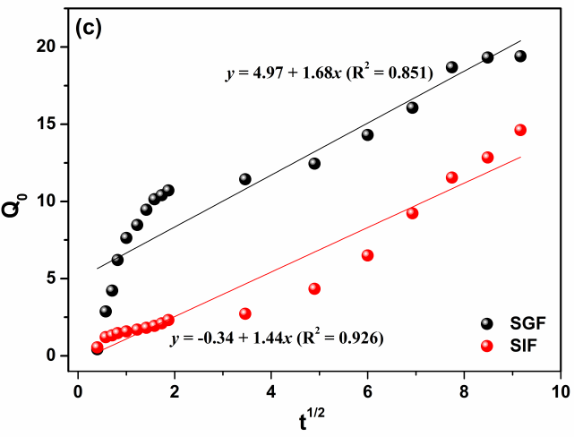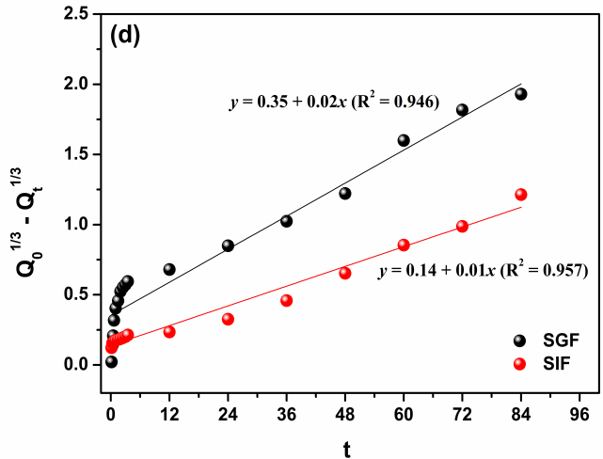

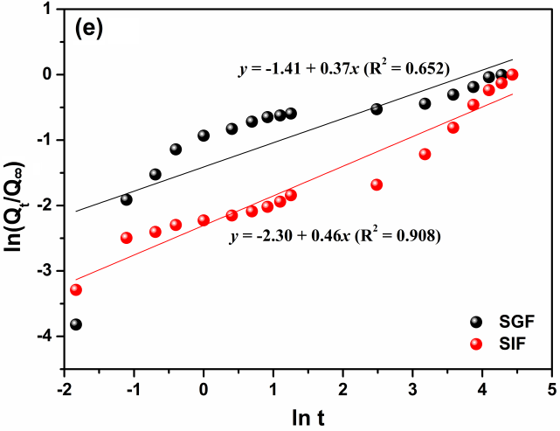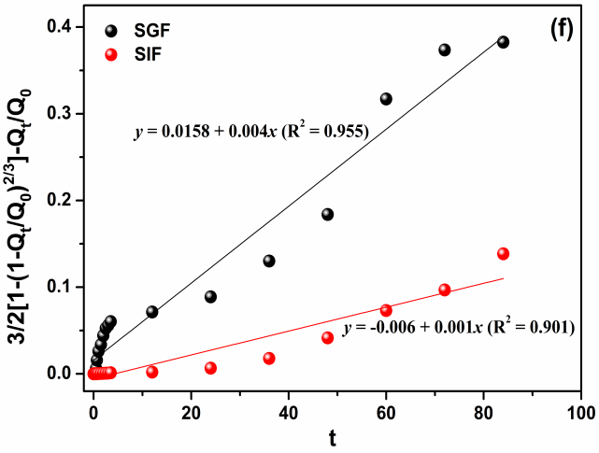

**Figure S5.** (a) Zero-order, (b) First-order, (c) Higuchi, (d) Hixson-Crowell, (e) Korsmeyer-Peppas, and (f) Baker-Lonsdale plots for the BSA release from CMS/Cs microparticles in SGF (pH 1.2) and SIF (pH 6.8) at 37 ºC.

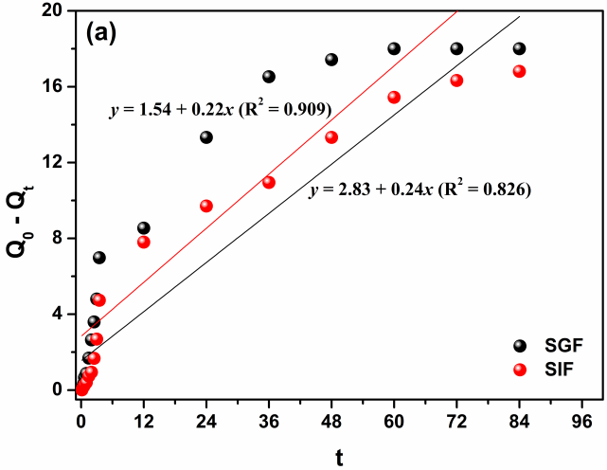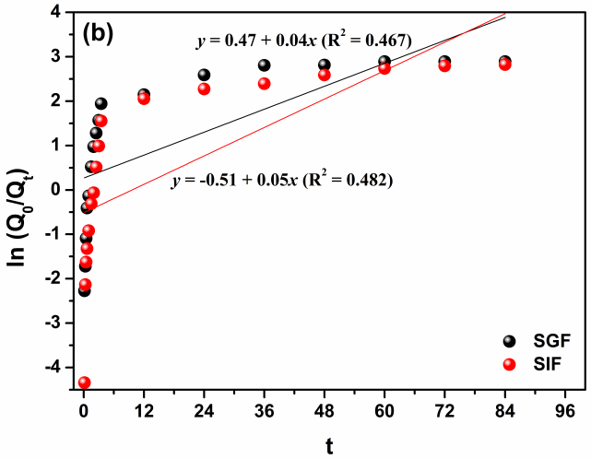

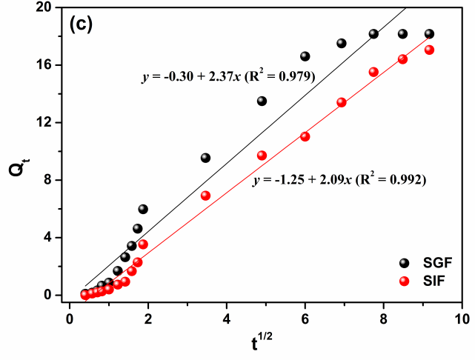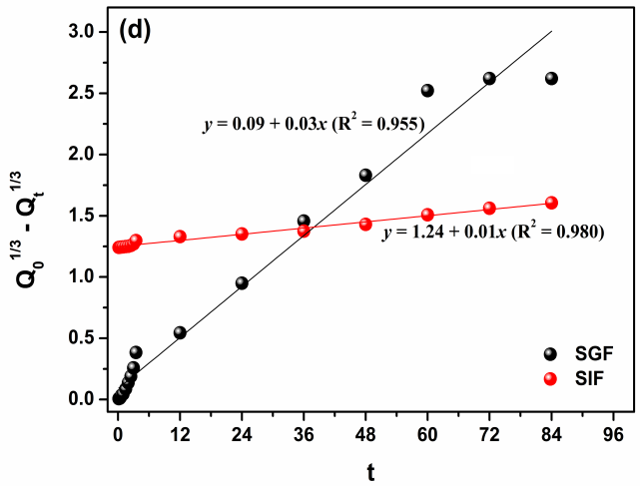

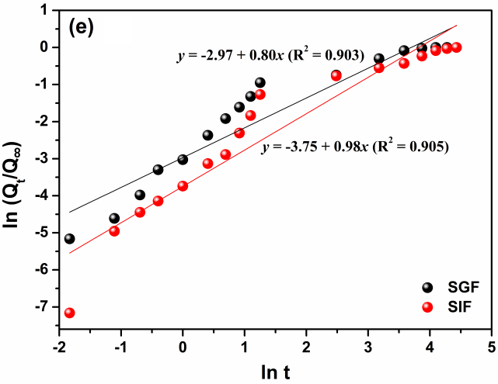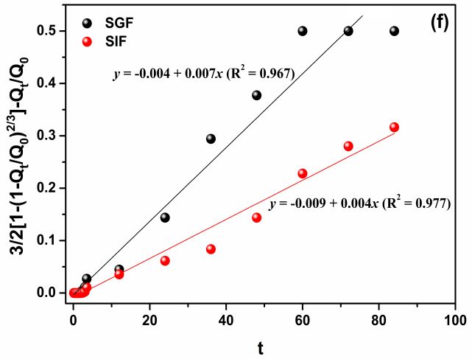

**Figure S6.** (a) Zero-order, (b) First-order, (c) Higuchi, (d) Hixson-Crowell, (e) Korsmeyer-Peppas, and (f) Baker-Lonsdale plots for the BSA release from Cs/TPP-BSA microparticles in SGF (pH 1.2) and SIF (pH 6.8) at 37 ºC.