**Integration of Virtual Screening and Computational Simulation Identifies Photodynamic Therapeutics against Human Protoporphyrinogen Oxidase IX (hPPO)**

**Supporting Information**

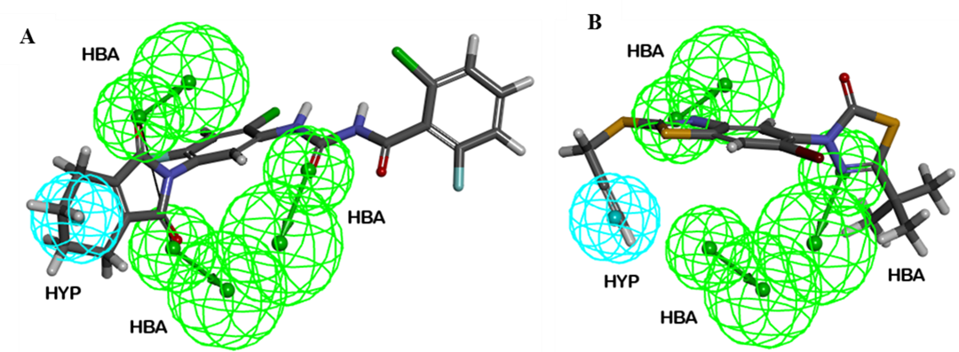**Figure S1:** **The best pharmacophore model Hypo1 mapped onto training set compounds:** **A**) highly active compound of training set and **B**) least active compound of training set.

**Figure S2: Test set compounds:** 2D chemical structures and Ki (nmol/L) values of 34 test 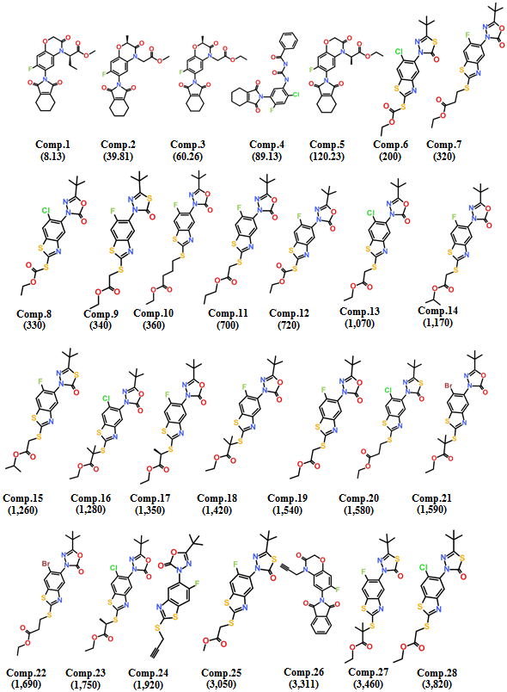set compounds for Hypo1 validation.

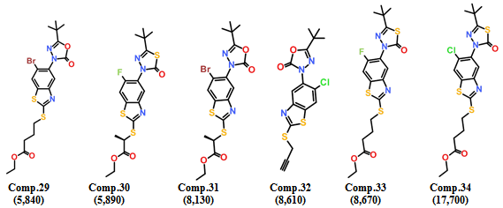

**Figure S3:** **Illustration of potential energy**. All the complexes showed lowest potential energies. Reference compound (red), Hit1 (green), Hit2 (cyan), and Hit3 (blue).

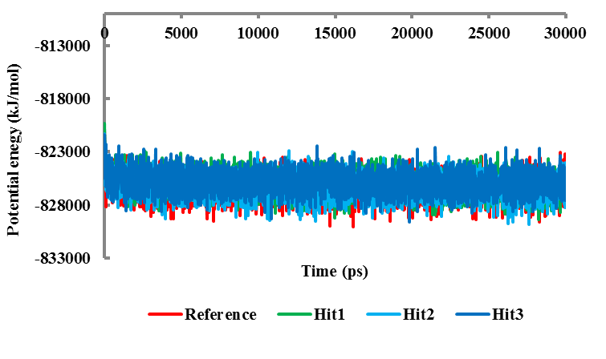

**Figure S4.** **Binding mode of the three hit molecules and Reference compound in the active site of hPPO**. The representative structures of all the compounds were superimposed (left) and enlarged (right). The hPPO is shown solid ribbon while the compounds are represented as sticks. Red, green, cyan and blue sticks represent the reference compound, Hit1, Hit2, and Hit3 respectively.

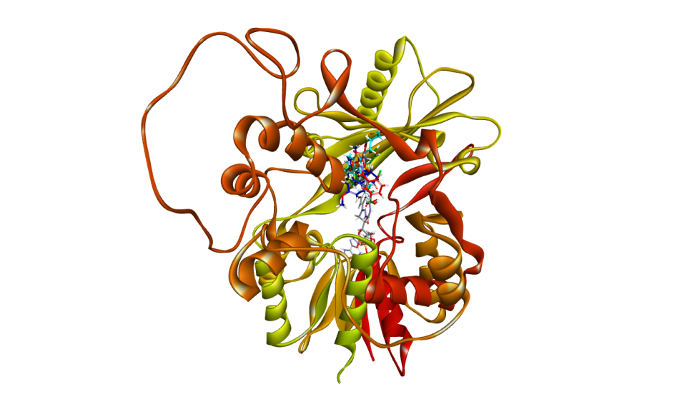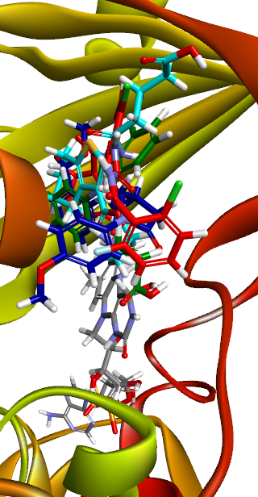

**Table S1. Screening of chemical databases by pharmacophore and characterization of drug-like compounds**

|  |  |  |  |  |
| --- | --- | --- | --- | --- |
| **Chemical Databases** | **Pharmacophore-mapped Compounds** | **Characterization of Drug-like Compounds** | | |
| ***Lipinski’s Rule of Five*** | ***ADMET Descriptors*** | |
| **NCI** | 19383 | 593 | | 221 |
| **Maybridge** | 40433 | 1044 | | 131 |
| **Chembridge** | 28931 | 608 | | 112 |
| **Asinex** | 129166 | 7567 | | 712 |