Supplementary Material

***Multifunctionalization of cyanuric chloride for the stepwise synthesis of potential multimodal imaging chemical entities***

Mário J.F. Calvete1,2, Sara M.A. Pinto1,2*, Hugh D. Burrows1,2, Margarida C.A. Castro1,2,3, Carlos F.G. C. Geraldes1,2,3, Mariette M. Pereira1,2*

1 *Department of Chemistry, Faculty of Science and Technology, University of Coimbra, Coimbra, Portugal*

2*Coimbra Chemistry Centre, CQC, University of Coimbra, Coimbra, Portugal*

3*Department of Life Sciences, Faculty of Science and Technology, University of Coimbra, Coimbra, Portugal*

Corresponding authors e-mails: [smpinto@qui.uc.pt](mailto:smpinto@qui.uc.pt), [mmpereira@qui.uc.pt](mailto:mmpereira@qui.uc.pt); Fax: +351 239827703; Tel: +351 239854474

**Contents**

1. Spectra of 5-(4-hydroxy-3-sulfonylphenyl)-10,15,20-(4-sulfonyltriphenyl) porphyrin **6**  2

2. Spectra of compound **5**

3. Spectrum of compound **5a**

4. Spectra of compound **8**

***1.******Spectra of*** ***5-(4-hydroxy-3-sulfonylphenyl)-10,15,20-(4-sulfonyltriphenyl)porphyrin 6***

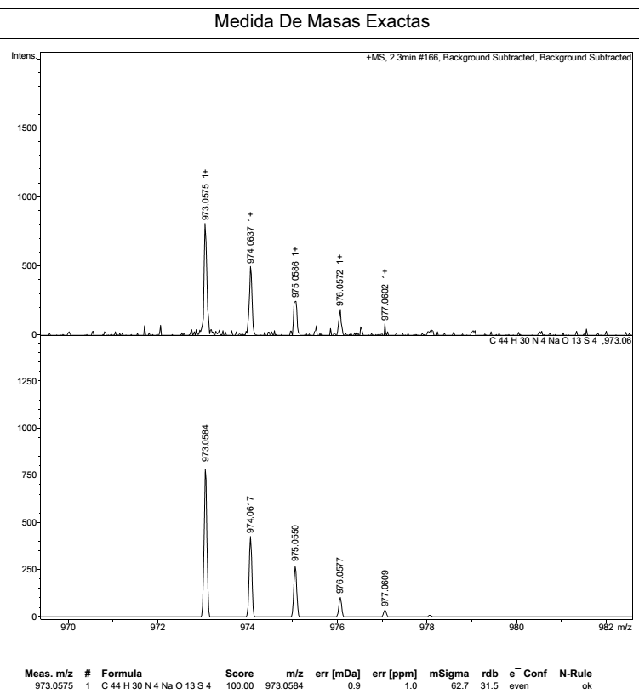

**Figure S1.** HRMS (ESI-FIA-TOF) mass spectrum of compound **6**. m/z calcd for [M + Na]+: C44H30NaN4O13S4 973.0584; found 973.0575.



**Figure 2.** 1H NMR spectrum of compound **6** (recorded in DMSO-d6). 1H NMR (400 MHz), δ, ppm: 8.92-8.84 (m, 8H, β-H), 8.21-8.18 (m, 8H, *ortho*-Ph-H), 8.06-804 (m, 7H, *meta*-Ph-H).



**Figure S3.** UV-vis spectrum of compound **6** (recorded in DMSO). UV-vis: λmax, nm (log e) 422 (4.36), 517 (3.41), 555 (3.14), 584 (2.94), 635 (1.94).

**2. *Spectra of compound 5***

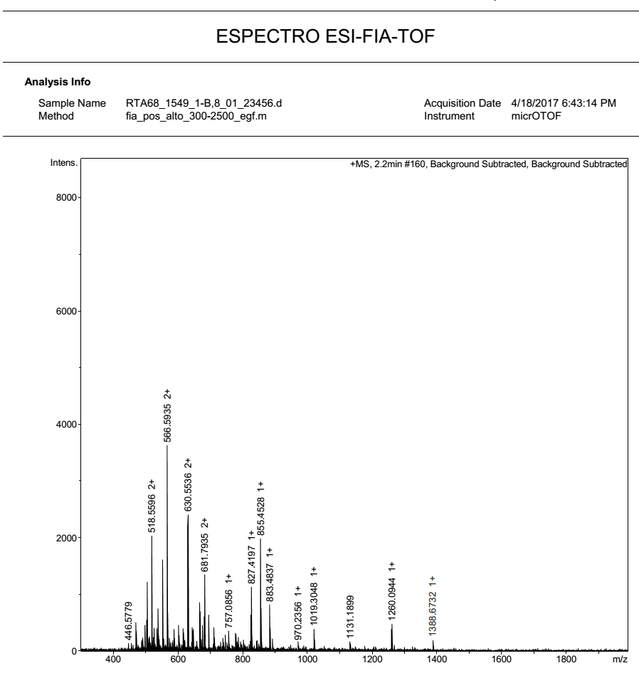

**Figure S4.** MS (ESI-FIA-TOF) mass spectrum of compound **5**. m/z calcd for [M + Li]+: C78H87LiN13O11 1388.6808; found 1388.6732.



**Figure S5.** 1H NMR spectrum of compound **5** (recorded in CDCl3).1H NMR (400 MHz), δ, ppm: 8.83-8.81 (broad signal, 8H, β-H), 8.16 (broad signal, 8H, Ar-H), 7.71-7.52 (multiplet, 11H, Ar-H), 4.30-4.12 (2 broad singlets, 6H, -OCH3), 3.70-2.17 (multiplets, 32H, -CH2CH3, -NCH2CO2-, -NCH2CHNH-, -HNCH-aminoacid, -N(CH2)2N-), 1.50-1.46 (multiplets, 12H, CH3CHCH3-aminoacid, -CH-CH2-CH-aminoacid, -OCH2CH3), 1.41-1.40 (broad signal, CH3CHCH3-aminoacid).



**Figure S6.** UV-vis spectrum of compound **5** (recorded in THF). UV-vis: λmax, nm (log ε) 419 (5.43), 515 (4.26), 550 (4.15), 589 (3.66), 646 (3.62).

**3. *Spectrum of compound 5a***

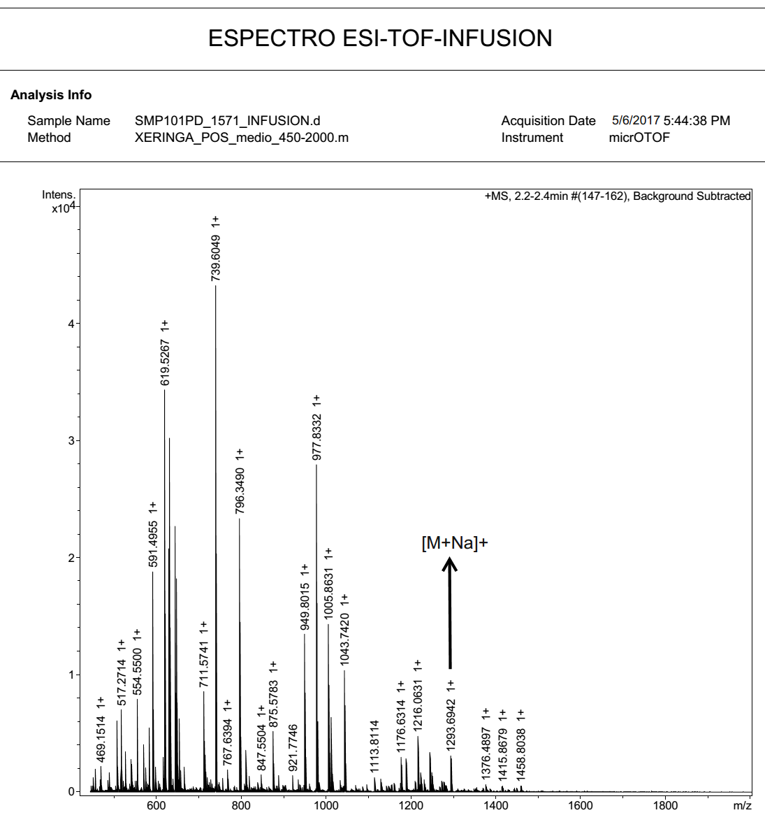

**Figure S7.** MS (ESI- TOF-INFUSION) mass spectrum of compound **5a**. m/z calcd for [M+Na+H]+: C70H72N13NaO11 1293.5372; found 1293.6942.

**4. *Spectra of compound 8***

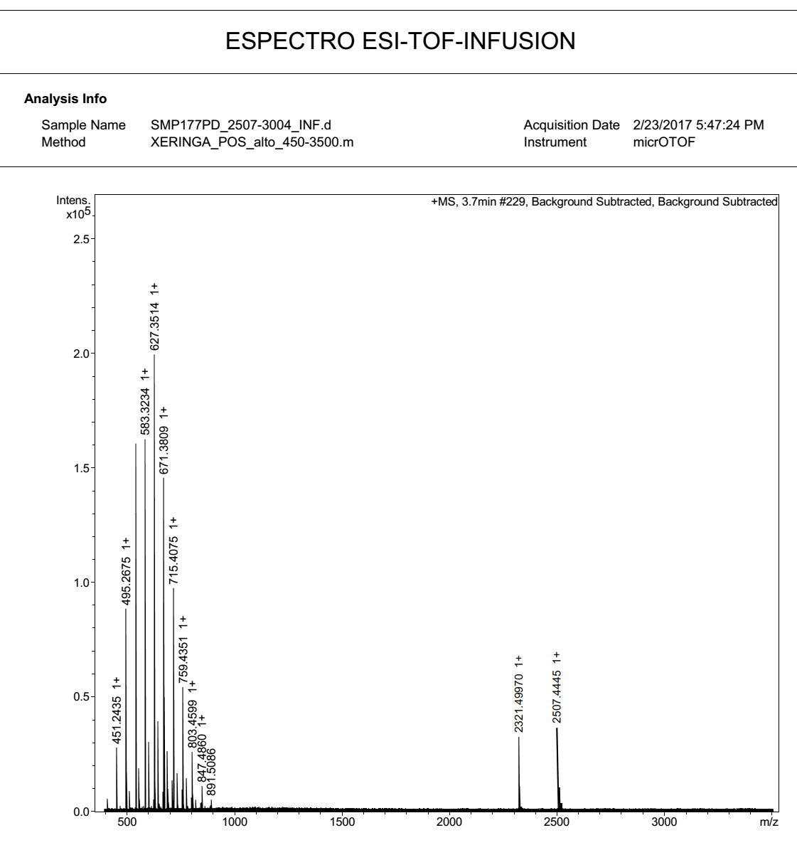

**Figure S8.** MS (ESI-FIA-TOF) mass spectrum of compound **8**. m/z calcd for [M]+: C115H102N16O34S8 2507.4544; found 2507.4445.



**Figure S9.** 1H NMR spectrum of compound **8** (recorded in DMSO-d6). 1H NMR (400 MHz), δ, ppm: 8.90-8.85 8.90-8.85 (broad signal, 16H, β-H), 8.21-8.01 (broad signal, 30H, Ar-H), 4.19-4.06 (multiplets, 10H, -OCH2CH3, -OCH3,-NCH2CHNH-), 3.64-2.61 (multiplets, 24H, -NCH2CO2-, -N(CH2)2N-, -NCH2CHNH-), 1.17 (broad triplet, 9H, -OCH2CH3).



**Figure S10.** UV-vis spectrum of compound **8** (recorded in DMSO). UV-vis: λmax, nm (log ε) 416 (5.06), 514 (3.91), 547 (3.79), 592 (3.29), 646 (3.07).