Supplementary Material

Ti³⁺ Self-doped Rutile/Anatase/TiO₂(B) Mixed-crystal Tri-phase Heterojunctions as Effective Visible-Light-Driven Photocatalysts

Junyan Kuangª, Zipeng Xing^{a,*}, Junwei Yinª, Zhenzi Li^{b}, Siyu Tanª, Meng Liª, Jiaojiao Jiangª, Qi Zhu^{a,*}, Wei Zhou^{a,*}

ª Department of Environmental Science, School of Chemistry and Materials Science, Key Laboratory of Functional Inorganic Material Chemistry, Ministry of Education of the People’s Republic of China, Heilongjiang University, Harbin 150080, P. R. China,
Tel: +86-451-8660-8616, Fax: +86-451-8660-8240,
Email: xingzipeng@hlju.edu.cn; hdzhuqi@hlju.edu.cn；zhouwei1@hlju.edu.cn
^{b} Department of Epidemiology and Biostatistics, Harbin Medical University, Harbin 150086, P. R. China
Figure S1. XRD patterns of TiO₂(B) rods which calcined at 400 ºC, 500 ºC, 600 ºC, 700 ºC, respectively.
Figure S2. O 1s (a) and Ti 2p (b) XPS spectra of PTB and G-PTB.

Figure S3. The degradation efficiency of MO for different quality ratio of P25:TiO₂(B) (a), and the effect of various scavengers on the degradation by G-PTB (b).
Figure S4. Electrochemical impedance spectra for G-PTB sample under dark and AM1.5 illumination.
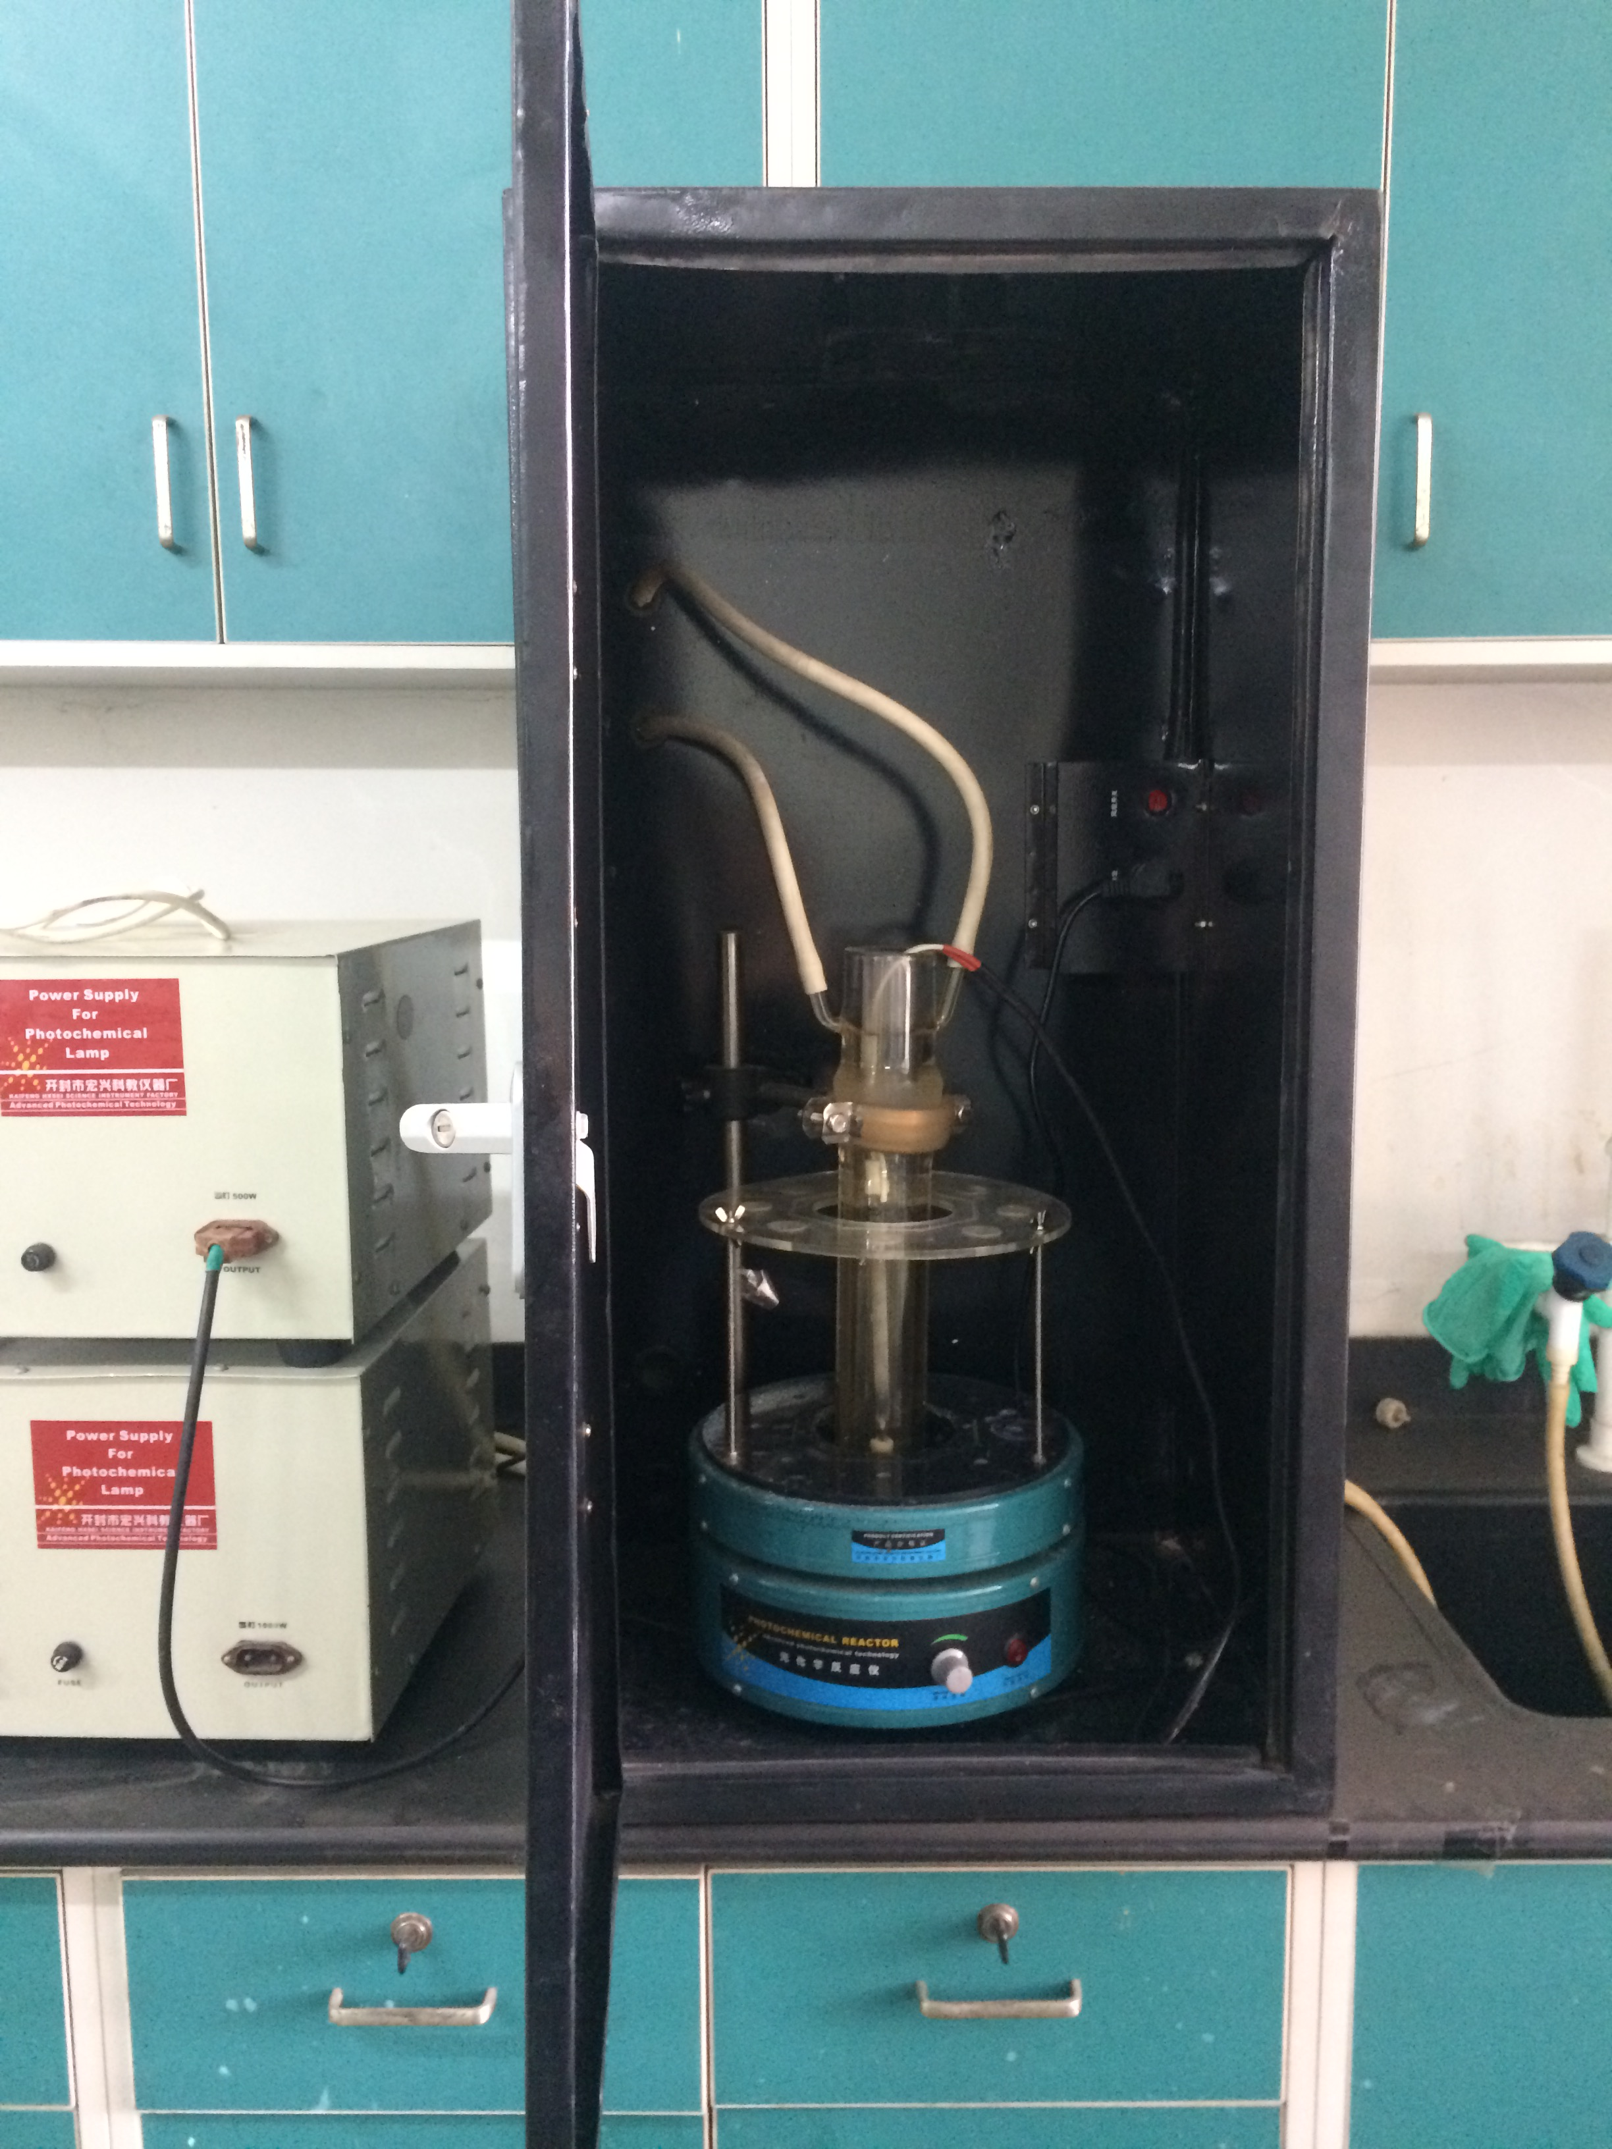
Figure S5. The photograph of photoreactor.
The photoreactor was purchased from KaiFeng HXSEI Science Instrument Factory. The photoreactor is consists of: 1) 500 W xenon lamp; 2) 500 W xenon lamp electrical controller; 3) quartz light source protection cold trap; 4) parallel reaction multi-tube magnetic stirrer; 5) 50 mL quartz glass test tube 6) test-tube fixed adapter; 7) water shortage alarm device; 8) stainless steel fixing device for reaction vessel; 9) response theme protection dark box; 10) protective cold trap fixer; 11) External circulation pipeline.
The long-arc xenon lamp was purchased from KaiFeng HXSEI Science Instrument Factory. The parameters are as follows:
Table S1. The parameters of the lamp.
Power (W) | starting current (A) | working current (A) | working voltage (V) | effective arc length (mm) | light intensity (cd) | wavelength range (nm)
500 | 8.3 | 6.4 | 75.6 | 220±20 | 1450 | 290-800

