Supporting materials

HL3 H₂L4
HL5 H₂L6
Scheme S1 Structures of acylhydrazide molecules mentioned in the main text.

Scheme S2 Isomerization of H₂L1 and H₃L2 in 1-3.

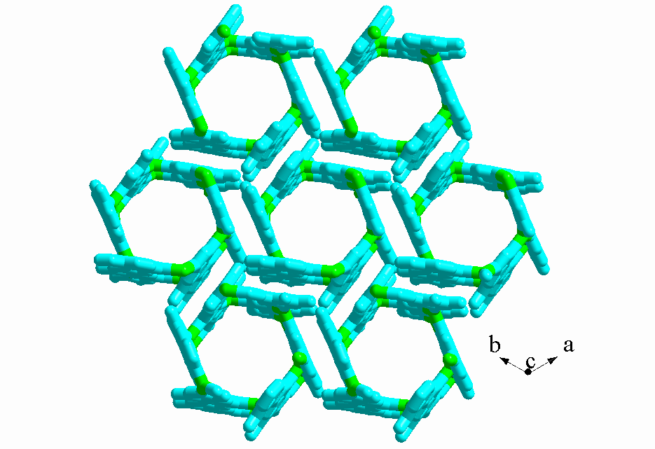
Fig. S1 Projection plot in ab plane, showing interactions between tubes in 1.

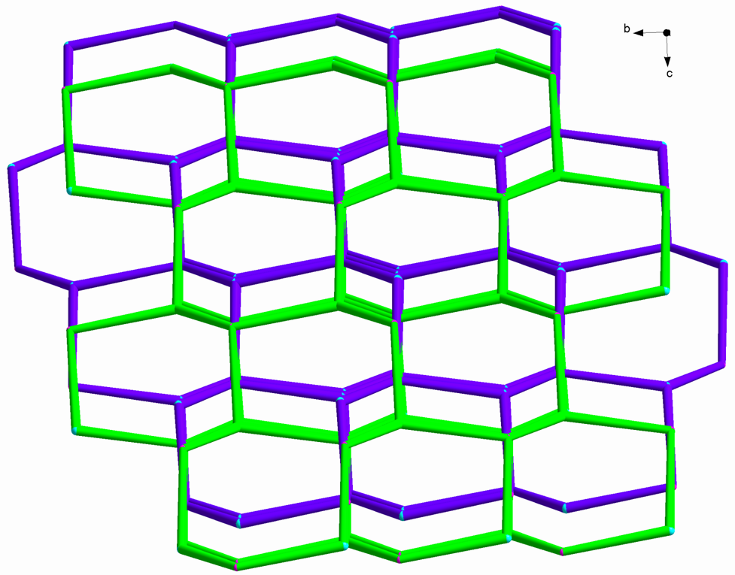

Fig. S2 Topology for 2-fold interpenetrated network in 3.

Fig. S3 Simulated (black) and experimental (red) powder XRD patterns of 1 (a), 2 (b) and 3 (c).

