**Improved Corrosion Resistance of Mild Steel in Acidic Solution by Hydrazone Derivatives: An Experimental and Computational Study**

**Hassane Lgaz1, Ill-Min Chung1*, Mustafa R. Albayati2, Abdelkarim Chaouiki3, Rachid Salghi3, Shaaban K. Mohamed4,5**

1*Department of Crop Science, College of Sanghur Life Science, Konkuk University, Seoul 05029, South Korea*

2*Department of Chemistry, College of Education, Kirkuk University, Kirkuk, Iraq*

3Laboratory of Applied Chemistry and Environment, ENSA, University Ibn Zohr, PO Box 1136, Agadir, Morocco

4Faculty of Science and Engineering, Health Care Division, Manchester Metropolitan University, Manchester M1 5GD, England

5Chemistry Department, Faculty of Science, Minia University, 61519 El-Minia, Egypt

*Corresponding author:

**Ill-Min Chung**

*Department of Crop Science, College of Sanghur Life Science, Konkuk University, Seoul 05029, South Korea. E-mail:* [imcim@konkuk.ac.kr](mailto:imcim@konkuk.ac.kr), Phone: +82-(0)2-450-3730



**Figure S1.** Variation of EOCP vs. potential of reference electrode for mild steel corrosion in 1.0 M HCl with and without 5 mM of hydrazone derivatives.

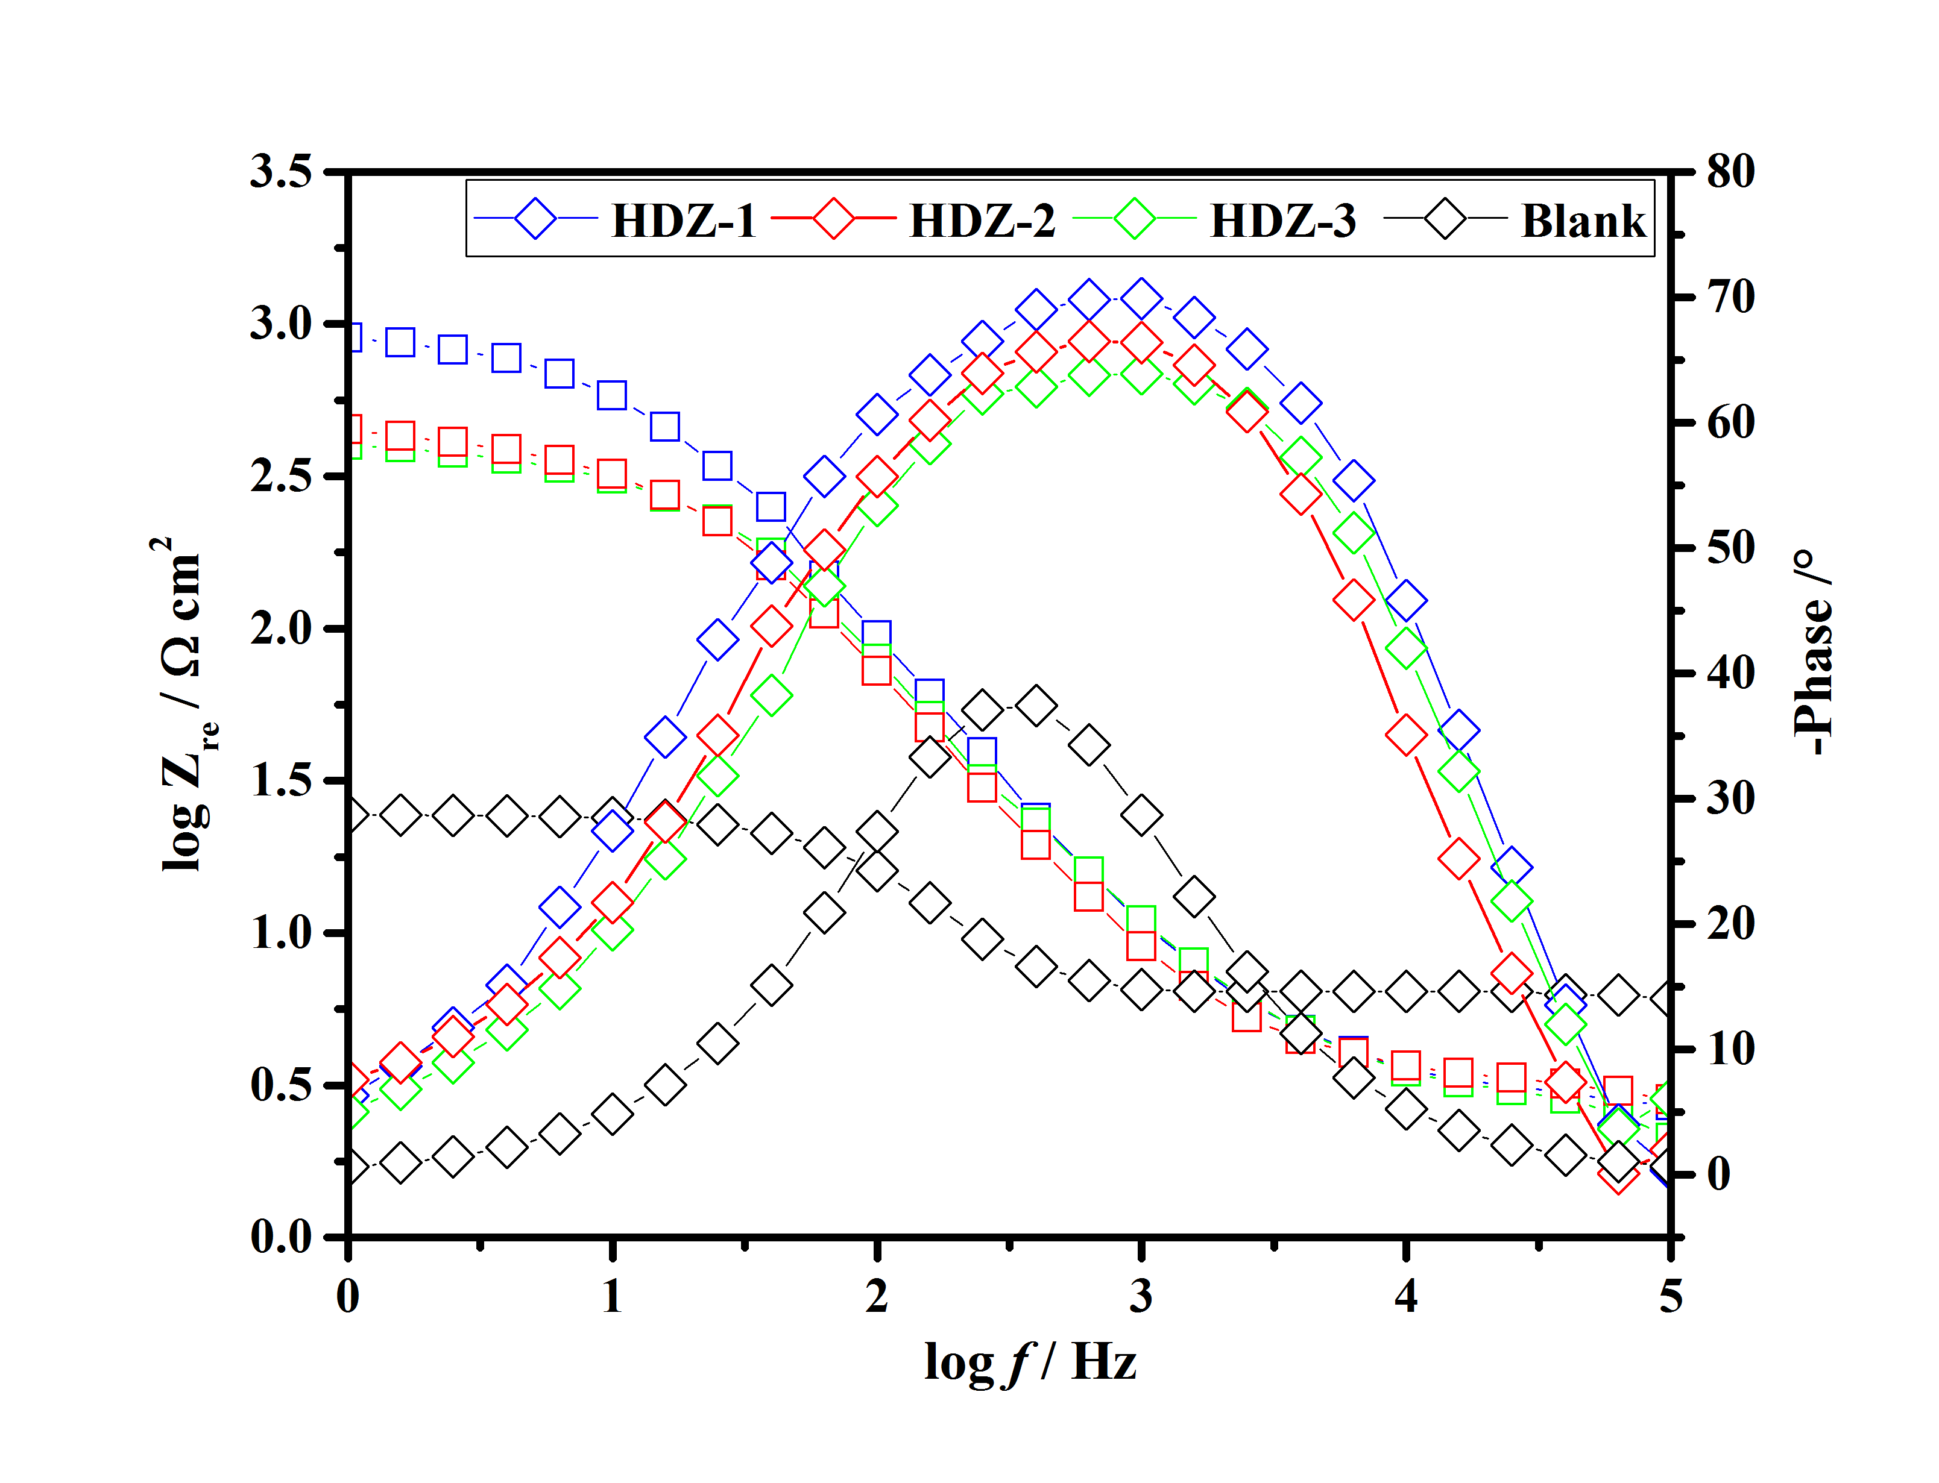

**Figure S2.** Bode plots for the mild steel in the corrosion medium and with 5×10-3 M HDZs.

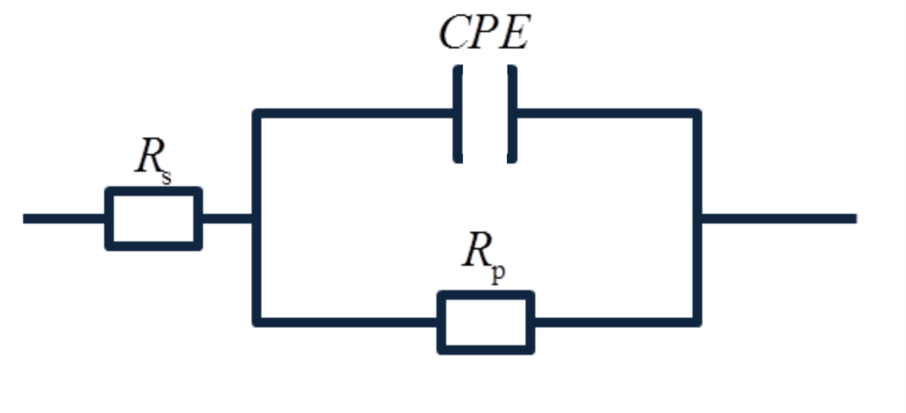

**Figure S3.** Equivalent electrical circuit used to fit the EIS spectra.

The temperature and energy fluctuation curves are represented in Figure S4. From the data in Figure S4, it is apparent that the system tends to equilibrium by the end of the simulation process.

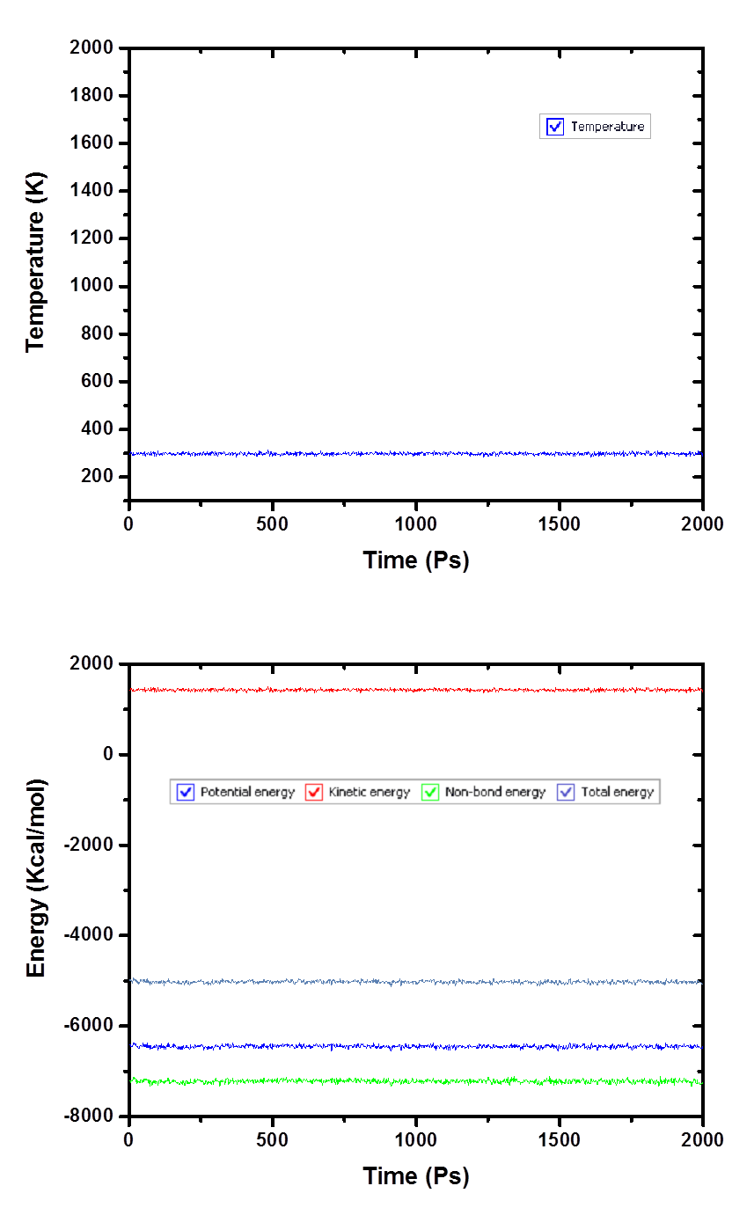

**Figure S4:** Temperature and energy equilibrium curves of the inhibitor molecules adsorbed on the Fe (110) surface in solution.