**Supporting Information**

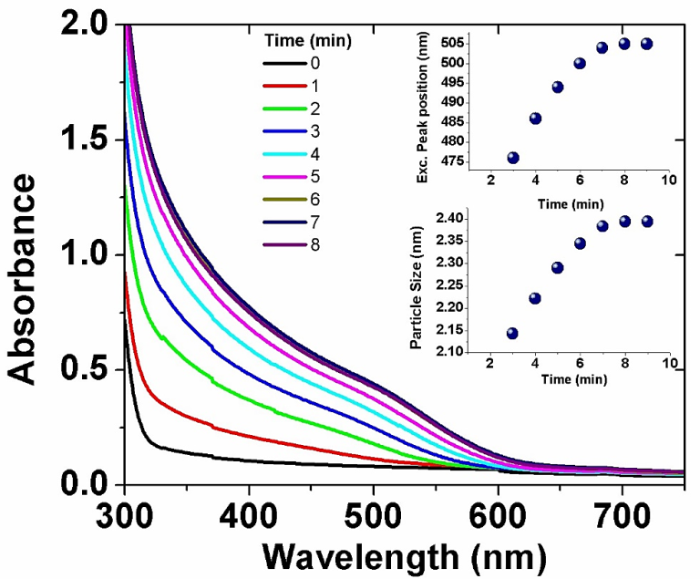

**Fig. S1** Absorption spectra of CdSe QDs synthesized with Cd:Se ratio 0.5:0.5 mM, insets: plots of excitonic peak position and particle size *vs* time of photoirradiation.

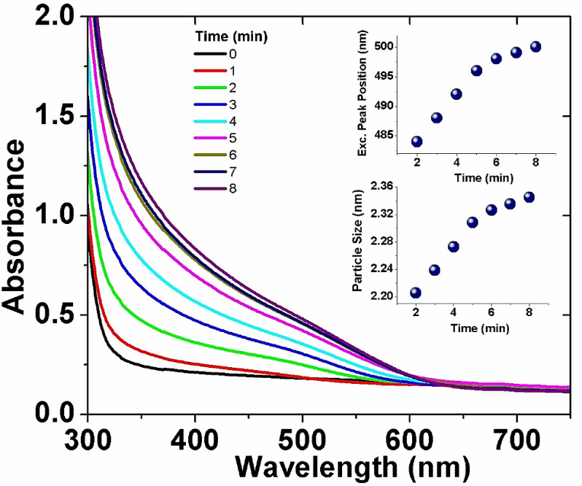

**Fig. S2** Absorption spectra of CdSe QDs synthesized with Cd:Se ratio 0.5:1.0 mM, insets: plots of excitonic peak position and particle size *vs* time of photoirradiation.

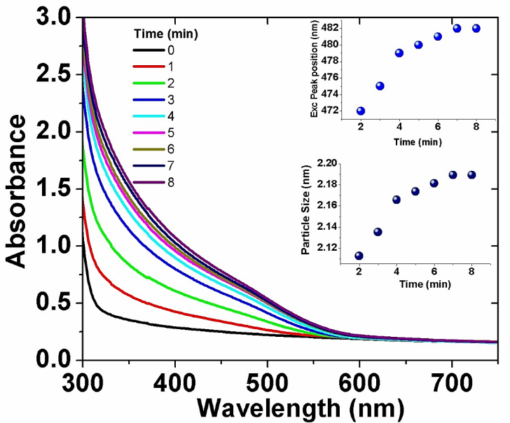

**Fig. S3** Absorption spectra of CdSe QDs synthesized with Cd:Se ratio 1.0:0.5 mM, insets: plots of excitonic peak position and particle size *vs* time of photoirradiation.

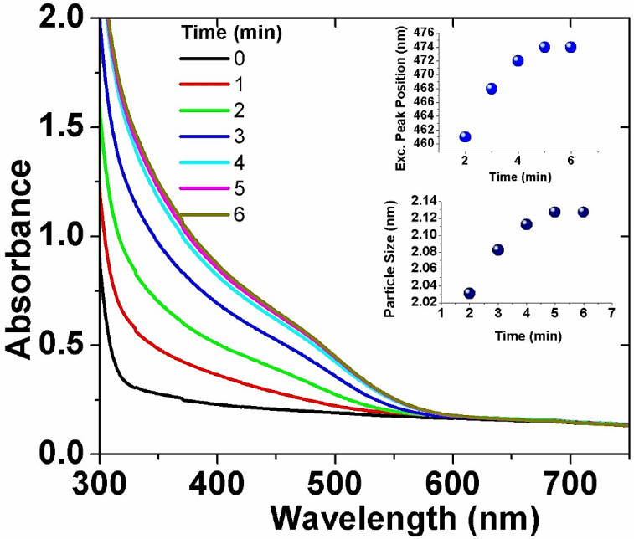

**Fig. S4** Absorption spectra of CdSe QDs synthesized with Cd:Se ratio 2.0:0.5 mM, insets: plots of excitonic peak position and particle size *vs* time of photoirradiation.

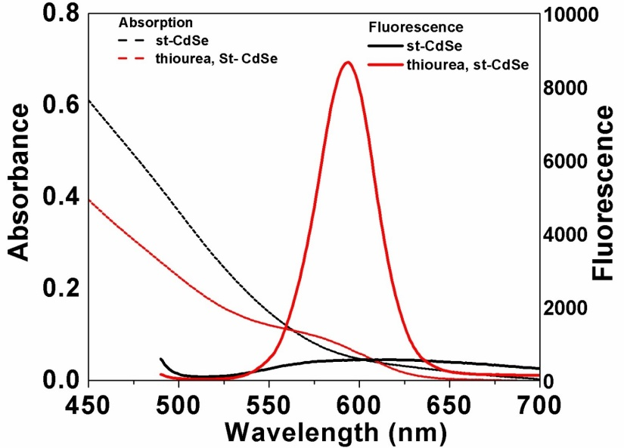

**Fig. S5** Absorption and photoluminescence spectra of starch capped CdSe QDs and after functionalization with thiourea.

**H:\Avi\cdse\photochem\polysaccharide work\manuscript image\dls plotm.tif**

**Fig. S6** DLS histograms of starch capped CdSe QDs **a**) before and **b**) after functionalization with thiourea.

C:\Users\Admin\Pictures\Saved Pictures\metal ion fl quenching life time combined (2).tif

**Fig. S7** Time-resolved PL decay profiles of CdSe QDs in the presence of different metal ions (**a**) Cu2+, (**b**) Cr6+ and (**c**) Hg2+.

H:\Avi\cdse\photochem\polysaccharide work\manuscript image\comb spc abs.tif

**Fig. S8** Absorption spectra of thiourea functionalized QDs and QDs with metal ions (Cu2+, Cr6+ and Hg2+).