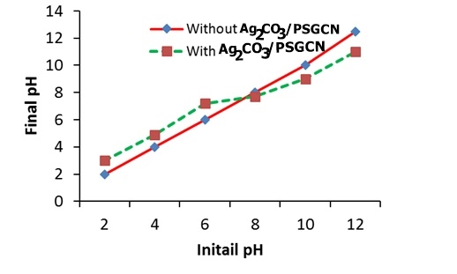

Fig. S1. pH of zero piont charage.

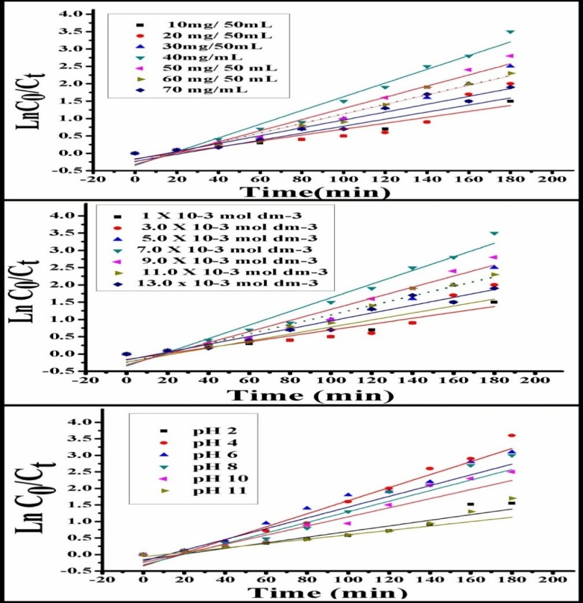

Fig. S2. Effect of reaction parameters on DNP degradation. Reaction conditions: [DNP] = 1.0× 10-3 mol dm-3; [photocatalyst] = 50 mg/100 ml; initial reaction pH= 4.0 and Light intensity = 750 lx.

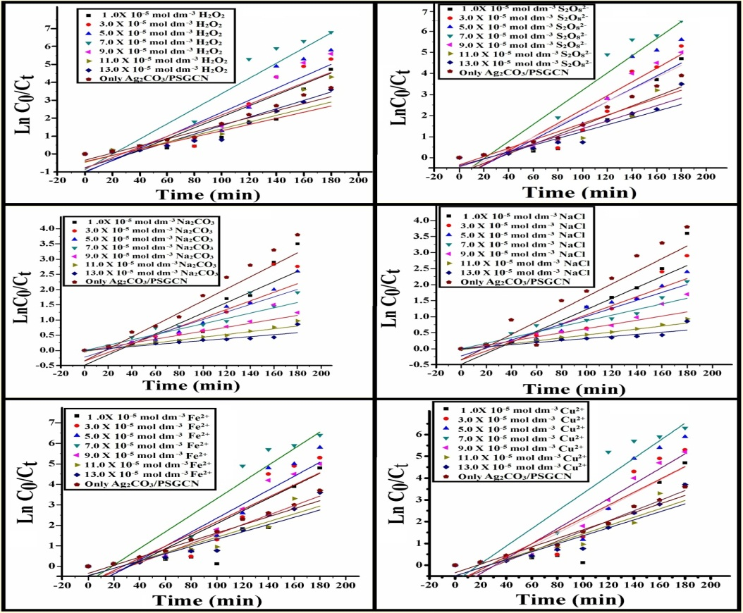

**Fig. S3.** Effect of different ions of DNP degradation. Reaction conditions: [DNP] = 1.0 × 10-3 mol dm-3; [photocatalyst] = 50 mg/100 ml; initial reaction pH= 4.0 and Light intensity = 750 lx.

**Table S1** : Effect of reaction parameters on photodegradation of phenol:

**Reaction parameters**: [DNP] = 1.0 × 10-3 mol dm-3; [catalyst] = 50 mg/100 ml; initial reaction pH= 4.0; Time = 120 min. and light intensity = 750 lx.

|  |  |  |  |  |  |  |  |  |
| --- | --- | --- | --- | --- | --- | --- | --- | --- |
| Catalyst loading | Catalyst loading ( mg/ 50 ml) | 1. 0 | 3.0 | 5.0 | 7.0 | 9.0 | 11.0 | 13.0 |
| k1 (min-1) | 0.027 | 0.063 | 0.075 | 0.087 | 0.080 | 0.078 | 0.070 |
| Initial DNP concentration | Conc. ( 10- 4 mol dm-3) | 1. 0 | 3.0 | 5.0 | 7.0 | 9.0 | 11.0 | 13.0 |
| k1 (min-1) | 0.022 | 0.042 | 0.052 | 0.087 | 0.079 | 0.074 | 0.068 |
| pH | pH | 2.0 | 4.0 | 6.0 | 7.0 | 8.0 | 10.0 | 12.0 |
| k1 (min-1) | 0.022 | 0.027 | 0.078 | 0.087 | 0.069 | 0.065 | 0.059 |