**Influence of extractions on physicochemical characterization and bioactivity of *Piper nigrum* oils: Study on the non-isothermal decomposition kinetic.**

**Supporting Information**

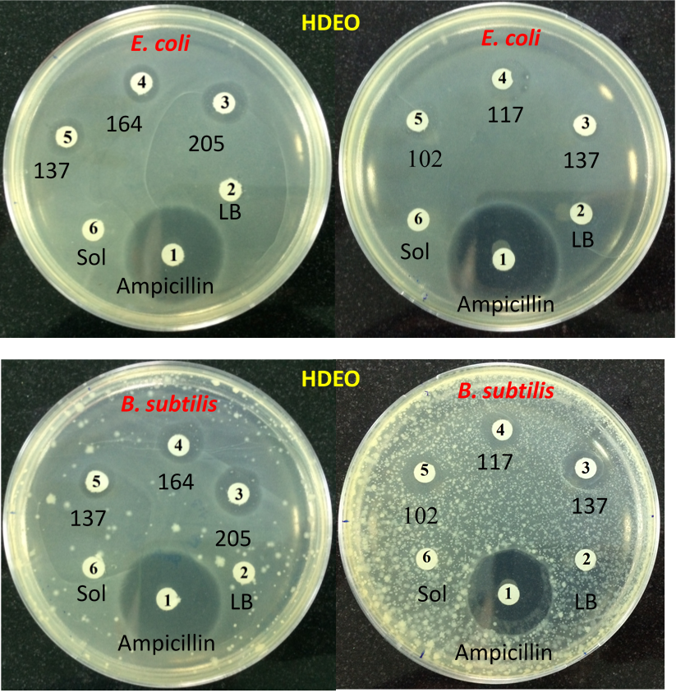

Figure S1. Antibacterial activity of HDEO sample

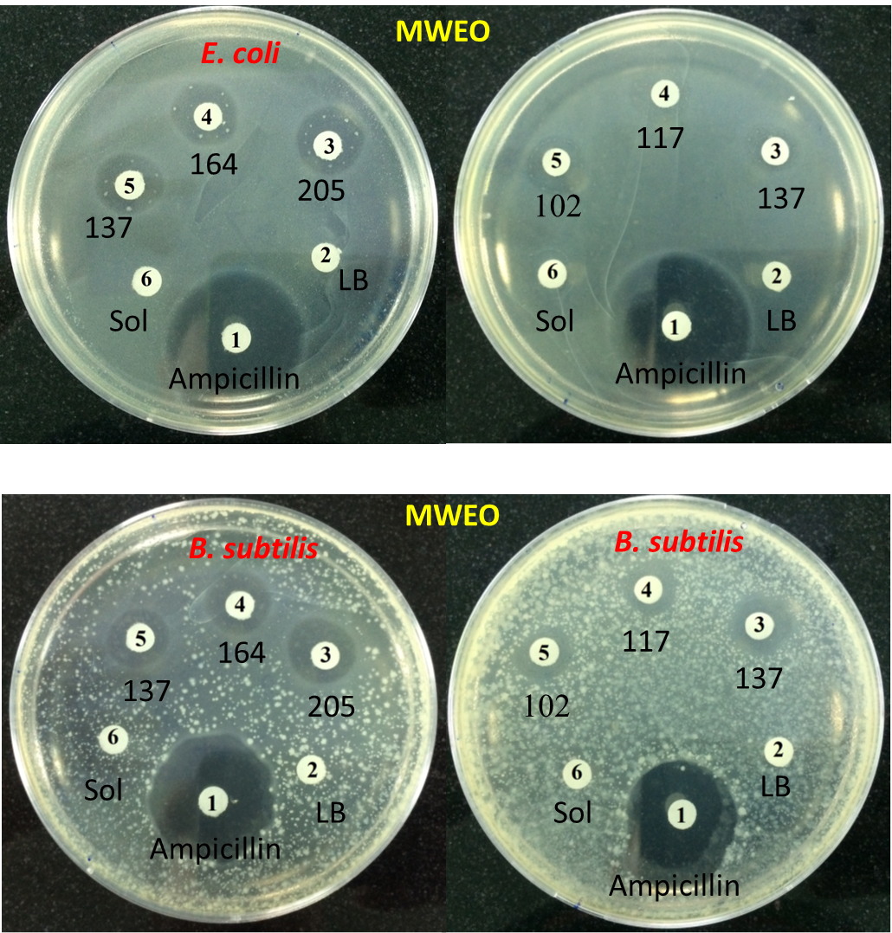

Figure S2. Antibacterial activity of MWEO sample