Supporting Information

Synthesis of seven membered heterocyclic rings: An easy access to Indeno-benzo[1,4]diazepines

Raza M. Ghalib ^{a,*}, Syad H. Mehdi ^{b}, Ali M. Malla ^{c}, Goran A. Bogdanović ^{d}, Srecko R. Trifunovic ^{e,} Mohd G. Alam ^{f}

ª Department of Chemistry, Faculty of Sciences and Arts - Khulais, University of Jeddah, P.O.Box 355, Posral Code 21921, Jeddah, Kingdom of Saudi Arabia
^{b} Department of Chemistry, S. P. G College, Lucknow, India
^{c}Department of Chemistry, Govt. Degree College, Beerwah, Jammu and kashmir
^{d} VINČA Institute of Nuclear Science, Laboratory of Theoretical Physics and Condensed Matter Physics, 522, 11001, University of Belgrade, Serbia
^{e} Department of Chemistry, Faculty of Science, University of Kragujevac, 34000 Kragujevac, Serbia
^{f} Department of Chemistry, Faculty of Science, Islamic University of Madinah, Madinah, Kingdom of Saudi Arabia

* corresponding author
E-mail: raza2005communications@gmail.com

Table of contents

X-ray Crystallographic Details.................................................................................................S3
NMR Spectra of New Compounds ..........................................................................................S8

X-ray Crystallographic Details

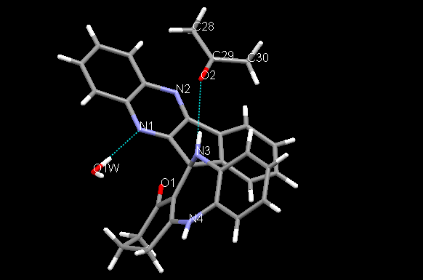
(a)
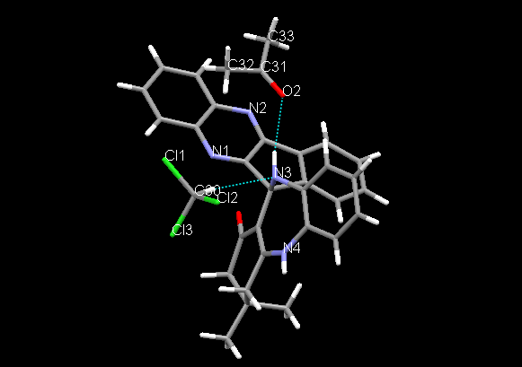
(b)

Fig. S1. A complete composition of the asymmetric unit for both crystal structures, 1 (a) and 2 (b). Hydrogen bonds within asymmetric units are shown with dotted blue lines.

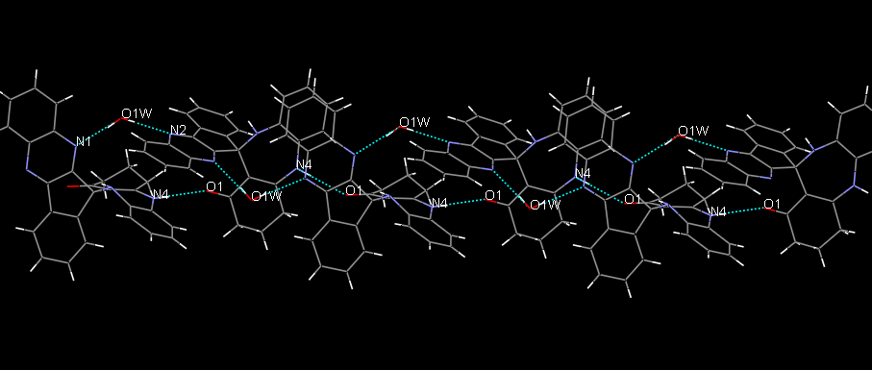
(a)
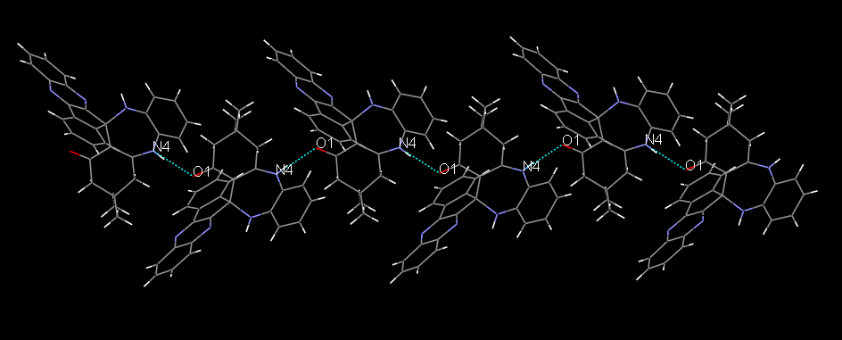
(b)

Fig. S2. The crystal packing fragment of 1 (a) and 2 (b) illustrating the formation of 1D-chains via the same N4-H...O1 hydrogen bond. In the case of 1 the neghburing molecules within the chain are additionaly connected via water molecules (O1w−H2w...N1 and O1w−H1w...N2 hydrogen bonds, Table 2).

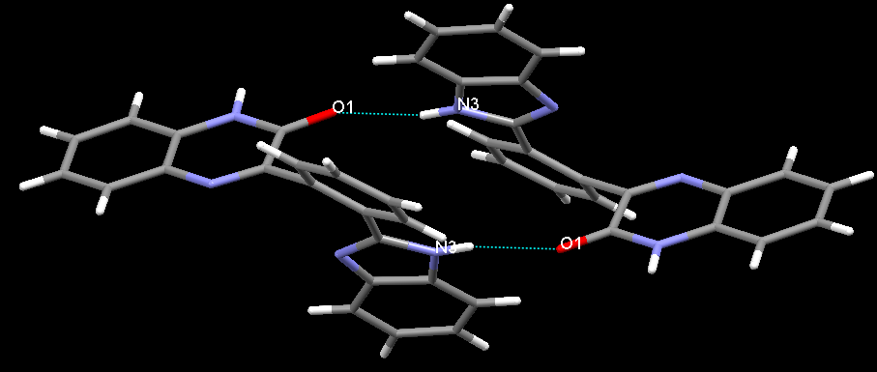

Fig. S3. Molecules of 3 use the N3-H…O1 hydrogen bonds to form the centrosymmetric dimers.

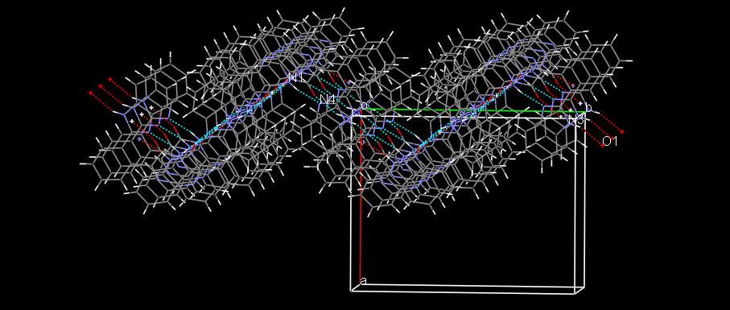
(a)
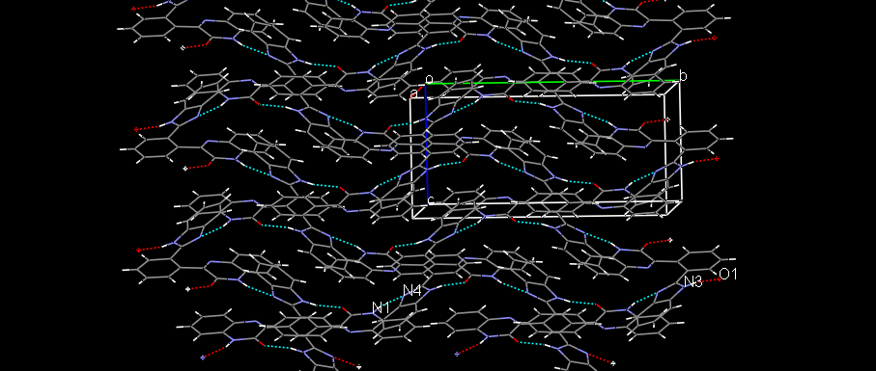
(b)

Fig. S4. The centrosymmetric dimers of 3 are interconnected via N1-H…N4 hydrogen bonds into bulky 2D (two-dimensional) network which extends in the (100) crystallographic plane. Packing diagram of 3 is shown in two orthogonal projections, (a) and (b).

Table S1. Selected crystallographic data for 1, 2 and 3.

 | 1 | 2 | 3
Empirical Formula  Formula weight  Colour, shape  Temperature (K)  Crystal size (mm)  Crystal system  Space group  Lattice constants  a (Å)  b (Å)  c (Å)  α (°)  β (°)  γ (°)  Volume (Å³)  Z  λ(Å)  Calculated density, ρ (g cm⁻³)  θ rang for data collection (°)  Absorption coefficient (mm⁻¹)  F(000)  Reflections collected  Independent reflections  Parameters  Goodness-of-fit  R₁, wR₂ [I > 2σ(I)]  Largest diff. peak and hole (eÅ⁻³) | C₃₀ H₂₈ N₄ O₃  492.56  Yellow, block  100(1)  0.16 x 0.31 x 0.34  Orthorhombic  Pna2₁  14.3066(2)  19.4946(3)  8.89550(10)  90  90  90  2480.97(6)  4  0.71073  1.319  1.77 – 30.55  0.087  1040  35072  7508 (R_{int} = 0.0376)  352  1.045  0.045, 0.101  0.309 and -0.276 | C₃₃ H₃₁ N₄ O₂ Cl₃  621.97  Yellow, needle  100(1)  0.10 x 0.11 x 0.67  Orthorhombic  Pbca  13.9728(4)  16.9180(6)  26.5240(6)  90  90  90  6270.1(3)  8  0. 71073  1.318  2.41 – 30.03  0.329  2592  35400  3220 (R_{int} = 0.0687)  391  1.035  0.0534, 0.1202  0.421 and -0.532 | C₂₁ H₁₄ N₄ O  338.36  Colourless, plate  100(1)  0.06 x 0.18 x 0.28  Monoclinic  P2₁/c  12.7120(6)  16.2571(6)  7.7380(3)  90  91.305(3)  90  1598.72(11)  4  0. 71073  1.406  2.51 – 29.98  0.090  704  17850  4584 (R_{int} = 0.0747)  243  1.042  0.0696, 0.1227  0.317 and -0.268

NMR Spectra of New Compounds

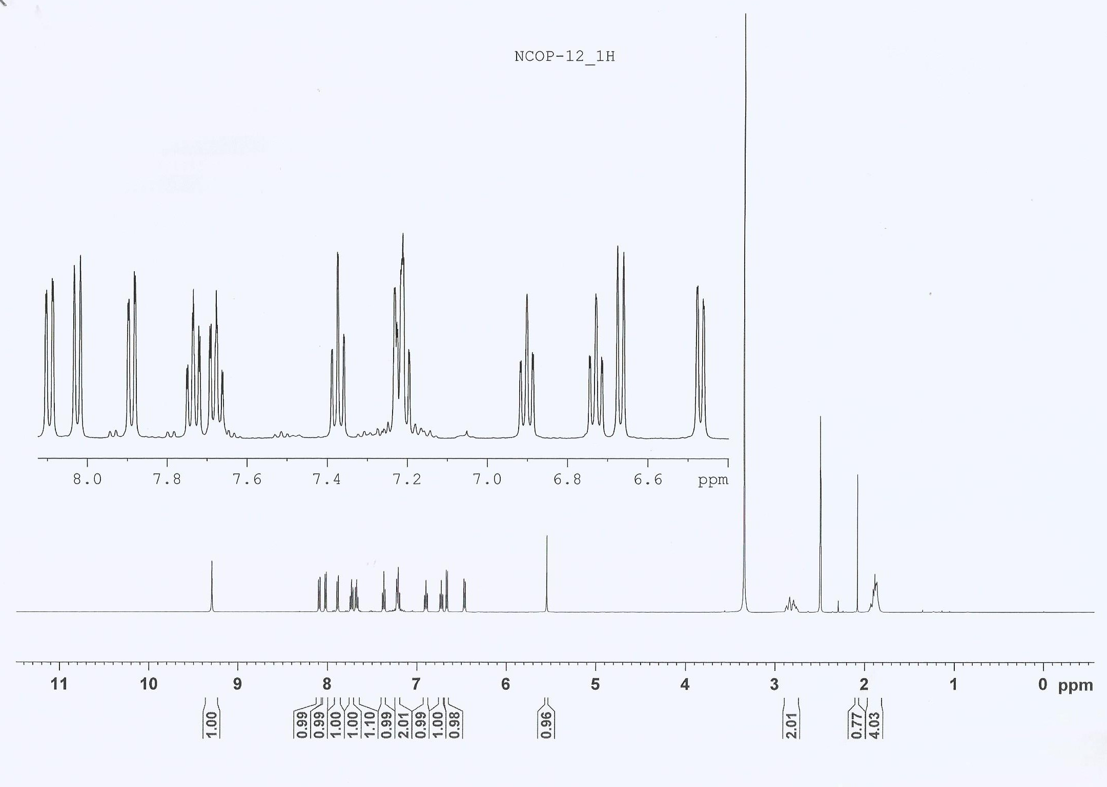

Fig. S5. ¹H NMR of 1

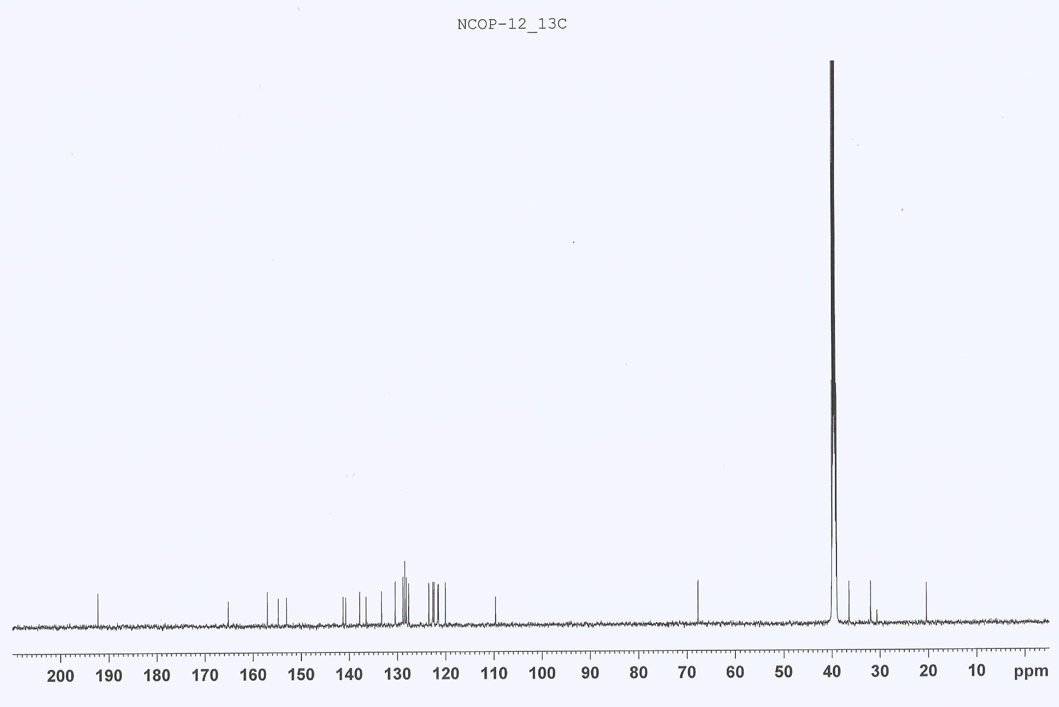
a

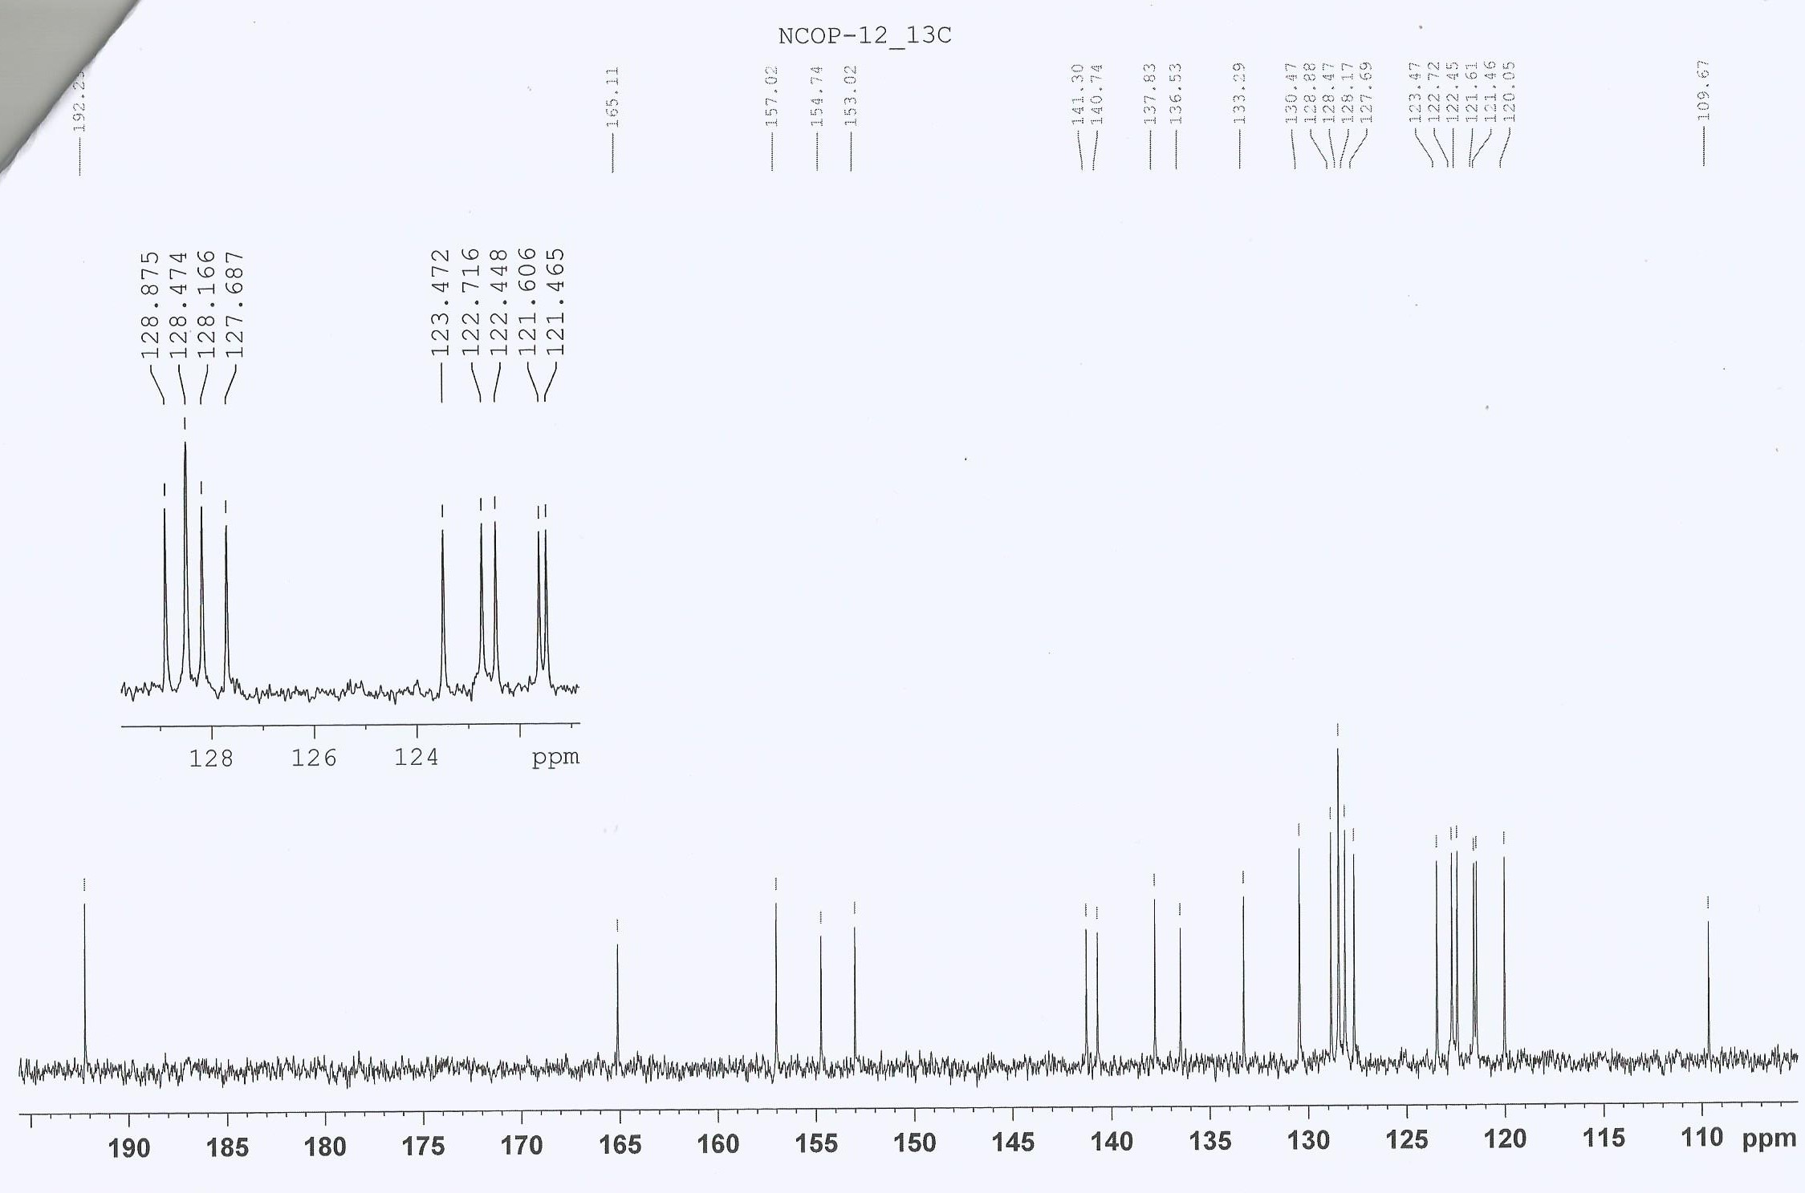

b
Fig. S6a & S6b. ¹³C NMR of 1

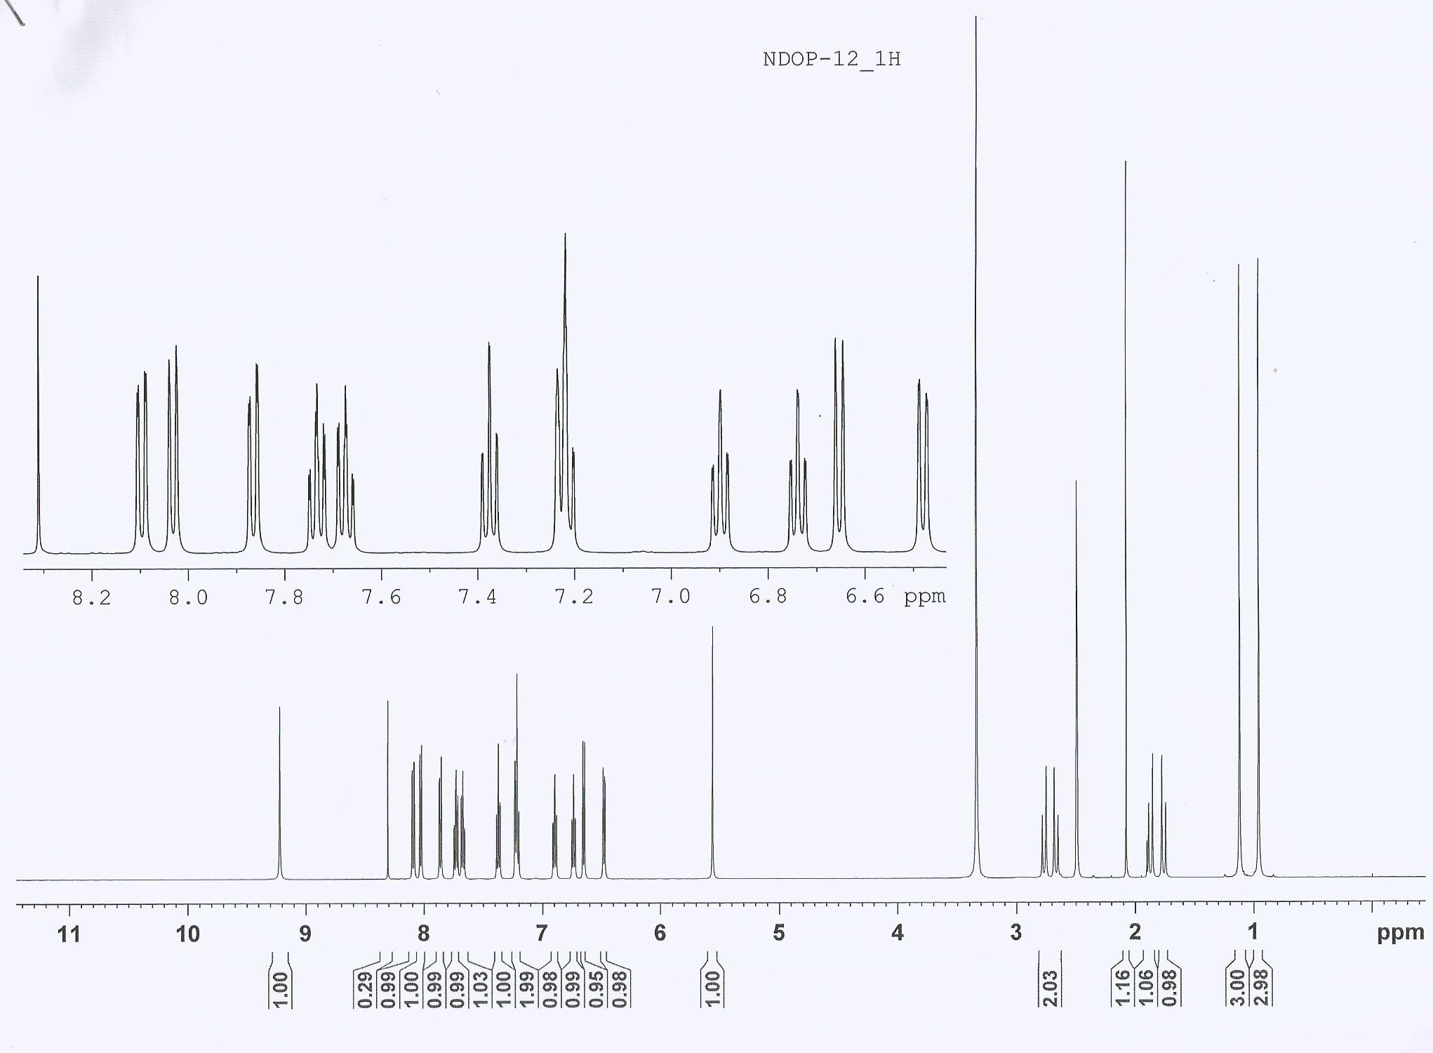

Fig. S7. ¹H NMR of 2

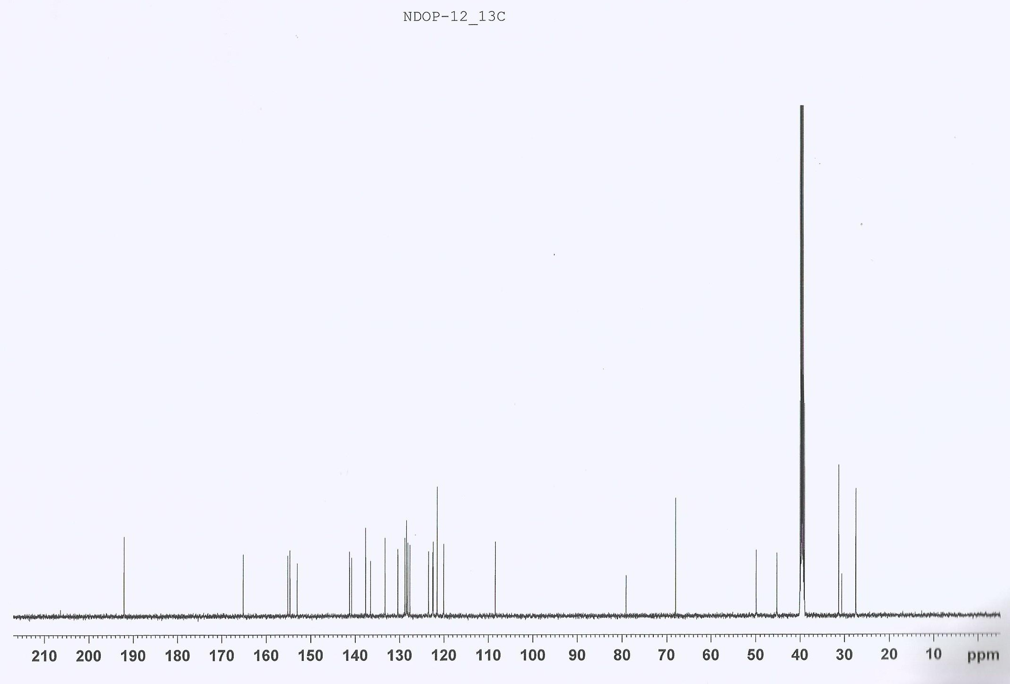

Fig. S8. ¹³C NMR of 2

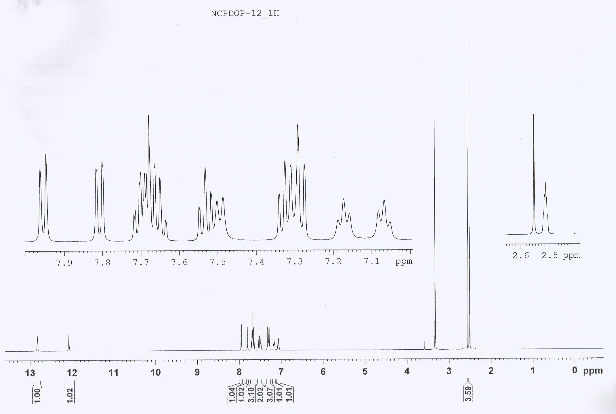

Fig. S9. ¹H NMR of 3

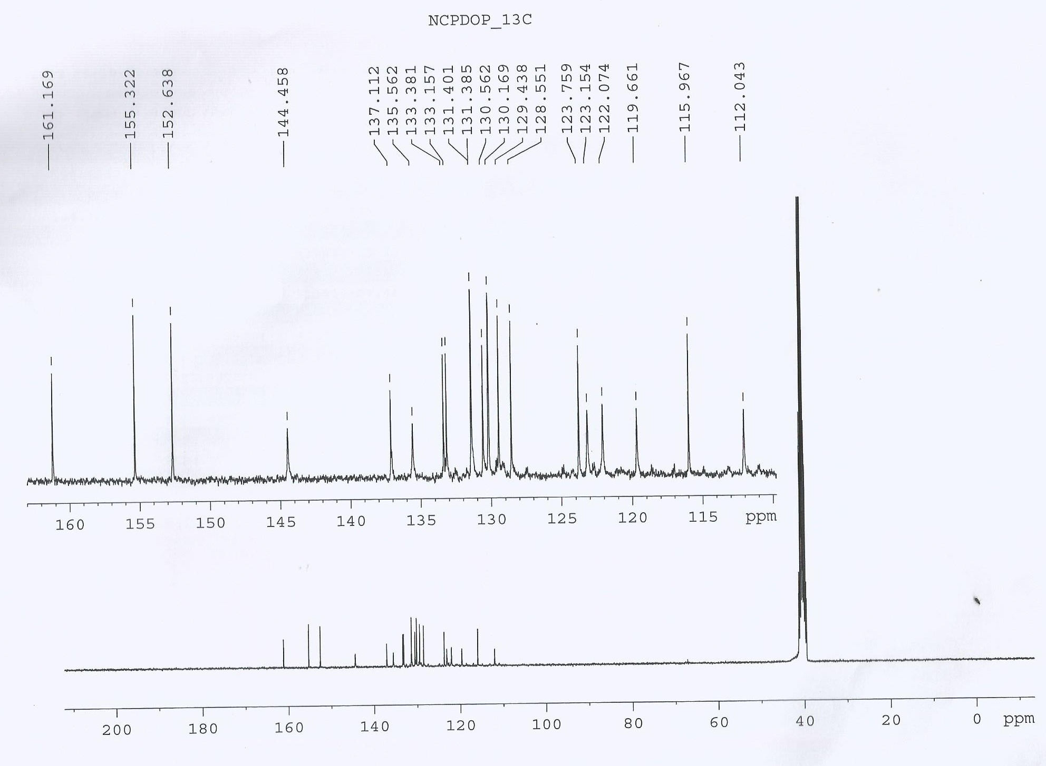

Fig. S10. ¹³C NMR of 3

