**Noble metallic nanoparticles from waste *Nypa fruticans* fruit husk: Biosynthesis, characterization, antibacterial activity and recyclable catalysis.**

**Supplementary Data**

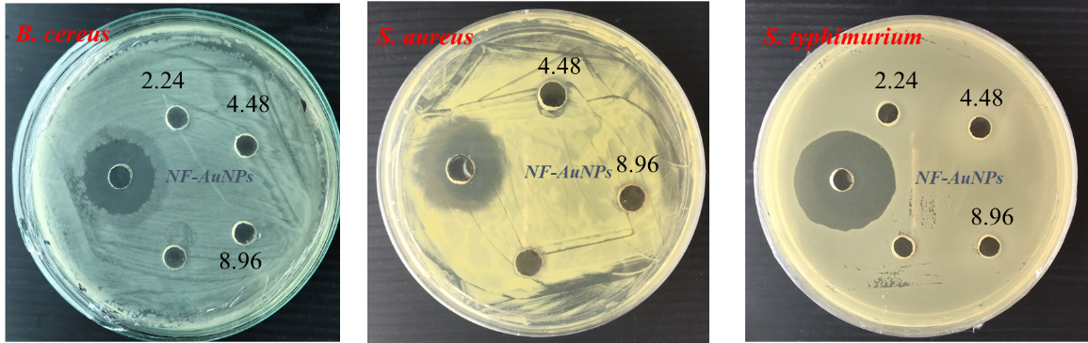

**Figure S1.** Images for antibacterial activity of NF-AuNPs

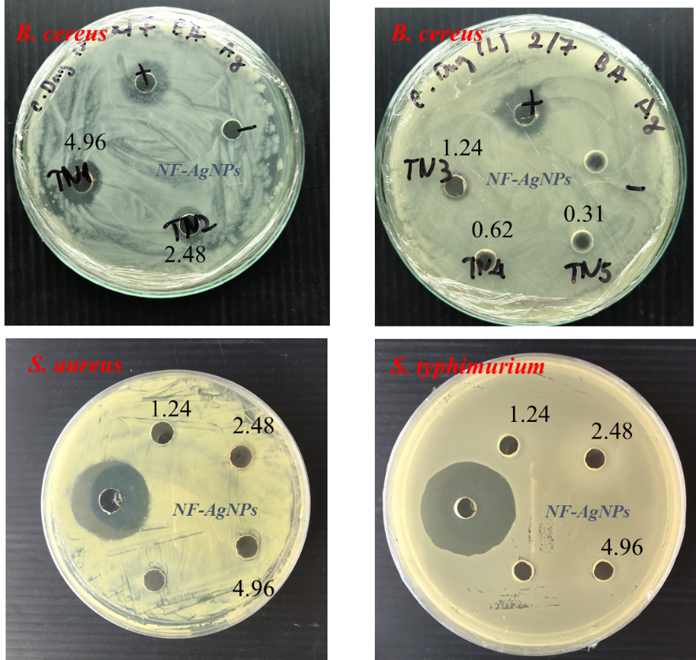

**Figure S2.** Images for antibacterial activity of NF-AgNPs



**Figure S3.** UV-Vis Spectra for degradation of *o*-nitrophenol using NF-AgNPs after five recycles.



**Figure S4.** UV-Vis Spectra for degradation of *m*-nitrophenol using NF-AgNPs after five recycles.



**Figure S5.** UV-Vis Spectra for degradation of *p*-nitrophenol using NF-AgNPs after five recycles



**Figure S6.** UV-Vis Spectra for degradation of *o*-nitrophenol using NF-AuNPs after five recycles



**Figure S7.** UV-Vis Spectra for degradation of *m*-nitrophenol using NF-AuNPs after five recycles



**Figure S8.** UV-Vis Spectra for degradation of *p*-nitrophenol using NF-AuNPs after five recycles

**Table S1.** Comparison of the rate constants of WBS-AgNPs and WBS-AuNPs catalysts towards the catalytic reduction of 4-nitrophenol

|  |  |  |  |  |
| --- | --- | --- | --- | --- |
| MNPs | Substrates | Size (nm) | knor (s-1 mg-1) | References |
| AgNPs | *D. longan* seed extract | 40 | 4.7 x 10-4 | Khan et al. 2016 |
| Halloysite nanotubes | 10 | 8.7 x 10-5 | Liu and Zhao, 2009 |
| *S. binhchauensis* extract | 20 | 4.2 x 10-3 | Nguyen, Huynh, 2020 |
| *J. subtriplinerve* extract | 8.0 | 18.2 x 10-3 | Nguyen, Huynh, 2020 |
| NF extract | 5-6 | 0.9 x 10-3 | This work |
| AuNPs | *T. montevideense* extract | 12-53 | 5.26 x 10-4 | Shen et al., 2016 |
| *A. lappa* extract | 24.7 | 6.87 × 10-3 | Nguyen, Vo, 2018 |
| *E. coli* cell | 50 | 4.13 x 10-5 | Srivatava et al. 2013 |
| NFextract | 3-4 | 1.14 x 10-3 | This work |

**References**

Khan, F. U., Chen, Y., Khan N. U., [Khan](https://www.sciencedirect.com/science/article/abs/pii/S1011134416305632" \l "!), Z. U. H., [Khan](https://www.sciencedirect.com/science/article/abs/pii/S1011134416305632#!), A. U., [Ahmad](https://www.sciencedirect.com/science/article/abs/pii/S1011134416305632#!), A., [Tahir](https://www.sciencedirect.com/science/article/abs/pii/S1011134416305632#!), K., [Wang](https://www.sciencedirect.com/science/article/abs/pii/S1011134416305632#!), L., [Khan](https://www.sciencedirect.com/science/article/abs/pii/S1011134416305632#!), M. R., [Wan](https://www.sciencedirect.com/science/article/abs/pii/S1011134416305632#!), P., 2016. Antioxidant and catalytic applications of silver nanoparticles using *Dimocarpus longan* seed extract as a reducing and stabilizing agent, J. Photoch. Photobio. B, 164, 44–351.

Liu, P., Zhao, M. 2009. Silver nanoparticle supported on halloysite nanotubes catalyzed reduction of 4-nitrophenol (4-NP), Applied Surface Science 255, 3989–3993.

Nguyen, T. M.T., Huynh, T. T. T., Dang, C. H., Mai, D.T., Nguyen, T. T. N., Nguyen, D. T., Dang, V. S., Nguyen, T. D., Nguyen T. D., 2020. Novel biogenic silver nanoparticles used for antibacterial effect and catalytic degradation of contaminants, Res. Chem. Intermediat.*,* 46, 1975–1990.

Nguyen, T.T.N., Vo, T.T., Nguyen, B. N.H., Nguyen, D.T., Dang, V.S., Dang, C.H., Nguyen, T.D., 2018. Silver and gold nanoparticles biosynthesized by aqueous extract of burdock root, Arctium Lappa as antimicrobial agent and catalyst for degradation of pollutants, Environ. Sci. Pollut. R. 25, 34247–34261.

Shen, W., Qu, Y., Pei X. et al., 2016. Green synthesis of gold nanoparticles by a newly isolated strain Trichosporon montevideense for catalytic hydrogenation of nitroaromatics, Biotechnol. Lett., 38, 1503–1508.

[Srivastava](https://www.ncbi.nlm.nih.gov/pubmed/?term=Srivastava%20SK%5BAuthor%5D&cauthor=true&cauthor_uid=23399317), S. K., [Yamada](https://www.ncbi.nlm.nih.gov/pubmed/?term=Yamada%20R%5BAuthor%5D&cauthor=true&cauthor_uid=23399317), R., [Ogino](https://www.ncbi.nlm.nih.gov/pubmed/?term=Ogino%20C%5BAuthor%5D&cauthor=true&cauthor_uid=23399317), C., [Kondo](https://www.ncbi.nlm.nih.gov/pubmed/?term=Kondo%20A%5BAuthor%5D&cauthor=true&cauthor_uid=23399317), A. 2013. Biogenic synthesis and characterization of gold nanoparticles by Escherichia coli K12 and its heterogeneous catalysis in degradation of 4-nitrophenol, [Nanoscale Res Lett](https://www.ncbi.nlm.nih.gov/pmc/articles/PMC3599219/)., 8(1): 70.