**Supplementary File**

**Fabrication of SiO2/CuFe2O4/polyaniline composite: A highly efficient adsorbent for heavy metals removal from aquatic environment**

**Md. Abu Taleba, Rajeev Kumara, Awad A. Al-Rashdib, Moaaz K. Seliemc,**

**M.A. Barakat a,d\***

aDepartment of Environmental Sciences, Faculty of Meteorology, Environment and Arid Land Agriculture, King Abdulaziz University, Jeddah-21589, Saudi Arabia

bDepartment of Chemistry, Al-Qunfudhah University College, Umm Al-Qura University, Saudi Arabia

cDepartment of Applied Mineralogy, Faculty of Earth Science, Beni-Suef University, 621, Egypt

dCentral Metallurgical R & D Institute, Helwan 11421, Cairo, Egypt

*Corresponding Author; M.A. Barakat

Email: [mabarakat@gmail.com](mailto:mabarakat@gmail.com)

ORCID: 0000-0001-6244-8394

Table S1: Textural parameters of SiO2 and SiO2/CuFe2SO4/PANI composites.

|  |  |  |  |
| --- | --- | --- | --- |
| Material | Specific surface areas (m2/g) | Average pore size (nm) | Total pores Volume (cm3/g) |
| SiO2/CuFe2SO4/PANI | 75.21 | 9.16 | 0.00344 |
| SiO2 | 224.99 | 9.08 | 0.012 |

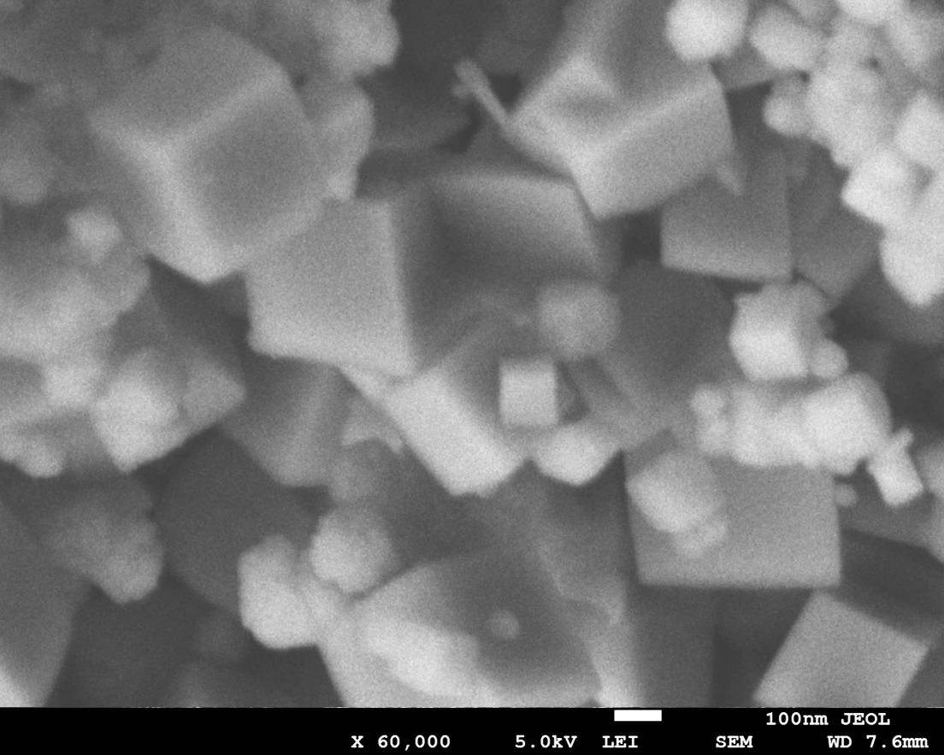

Fig. S1. SEM image of CuFe2O4

Fig. S2: Point of zero charge analysis (pHPZC) of SiO2 and SiO2/CuFe2O4/PANI composite

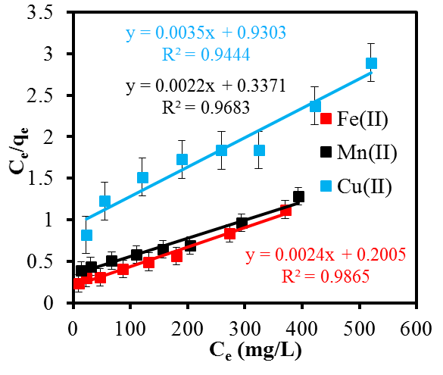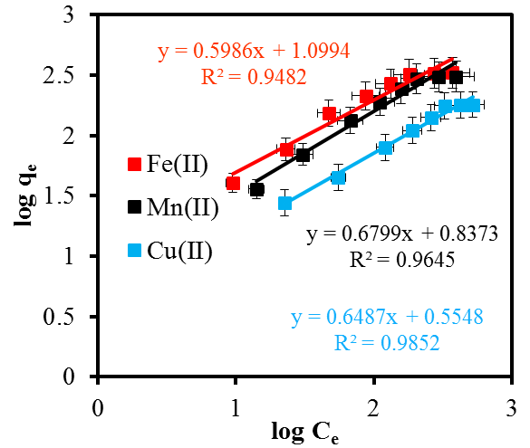

**(a)**

**(b)**

Fig. S3: Isotherms studies for the adsorption process; (a) Langmuir isotherm model (b) Freundlich isotherm model (Metal concentration (500 mg/L) , pH 5 for Fe(II) pH 5.18 for Mn(II), pH 5.3 Cu(II) , Time 5 h, Temperature (30 °C), adsorbent mass (0.02g),Volume (20 ml).

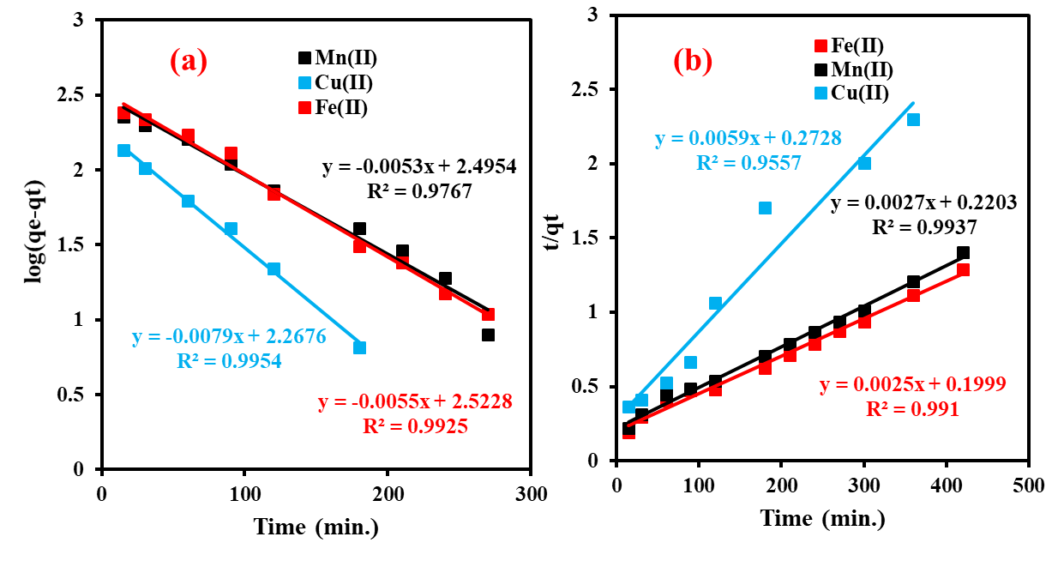

Fig.S4: Kinetics studies for the adsorption on Fe(II), Mn(II) and Cu(II) onto SiO2/CuFe2O4/PANI composites; (a) Pseudo-first-order kinetic; (b) Pseudo-second-order; (Metal concentration (500 mg/L), pH 5 for Fe(II) pH 5.18 for Mn(II) and pH 5.3 Cu(II) Time 5 (h), Temperature (30 °C), adsorbent mass (0.02g), Volume (20 ml).