**Multifunctional Zn0.3Al0.4O4.5 Crystals: An Efficient Photocatalyst for Formaldehyde Degradation and EBT Adsorption**

Umesh Fegade*, a, Ganesh Jethaveb, Wei-Gang Hongc, Imran Khand, Hadi M. Marwanie, Inamuddine*, Ren-Jang Wu**,c Rajesh Dhakef

aDepartment of Chemistry, Bhusawal Arts, Science and P. O. Nahata Commerce College, Bhusawal, (MH), India.

bSchool of Environmental and Earth sciences, KBCNMU, Jalgaon, (MH), India.

cDepartment of Applied Chemistry, Providence University, Shalu, Taichung 433, Taiwan.

dApplied Science Section, Faculty of Engineering and Technology, Aligarh Muslim University, Aligarh- 202 002, India

eChemistry Department, Faculty of Science, King Abdulaziz University, Jeddah 21589, Saudi Arabia

fDepartment of Chemistry, D. N. Bhole College, Bhusawal, (MH), India.

*Corresponding authors. E-mail addresses: [inamuddin@zhcet.ac.in](mailto:inamuddin@zhcet.ac.in), [umeshfegade@gmail.com](mailto:umeshfegade@gmail.com)

**Corresponding Author: E-mail: [rjwu@pu.edu.tw](mailto:rjwu@pu.edu.tw)

**Formaldehyde degradation system**

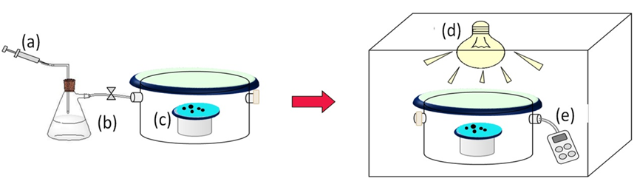

**Figure S1:** System of photocatalytic formaldehyde degradation (a) HCHO gas injected into the flask, (b) 36% Formalin solution, (c) photocatalyst, (d) 18 W daylight lamp, (e) Formaldehyde gas detector.

**Table S1:** Degradation of HCHO versus time on various photo catalysts

|  |  |  |  |
| --- | --- | --- | --- |
| Catalysts  Rate of degradation (%) | ZnAlO NPs | TiO2 | P-25 TiO2 |
| Time (min) |  |  |  |
| 0 | 0 | 0 | 0 |
| 20 | 52 | 20 | 28 |
| 40 | 72 | 42 | 51 |
| 60 | 80 | 60 | 68 |
| 90 | 86 | 65 | 74 |
| 120 | 89 | 67 | 76 |

**Figure S2:** Effect of contact time on the adsorption of EBT on the ZnAlO NPs surface.