Selective synthesis of ZIFs from zinc and nickel nitrate solution for photocatalytic H₂O₂ production
Ai-Lun Changª, Van-Huy Nguyen^{b}, Kun-Yi Andrew Lin^{c}, Chechia Hu^{a*}
ª Department of Chemical Engineering, R&D center for Membrane Technology and Research Center for Circular Economy, Chung Yuan Christian University, Chungli Dist., Taoyuan City 32023, Taiwan
^{b} Institute of Research and Development, Duy Tan University, Da Nang 550000, Vietnam
^{c} Department of Environmental Engineering & Innovation and Development Center of Sustainable Agriculture, National Chung Hsing University, Taichung City, Taiwan 40227
* To whom correspondence should be addressed. E-mail: chechiahu@cycu.edu.tw
Tel: 886-3-2654152 Fax: 886-3-2654199

Synthesis of xNi-ZIF-8
For the synthesis of xNi-ZIF-8, a solution of 2-methylimidazole (Hmim, 8.2 g in 20 mL water) with a mixture of zinc nitrate and nickel nitrate solutions in a mole ratio of 1:20 and 1:10 produced 5Ni-ZIF-8, and 10Ni-ZIF-8, respectively.
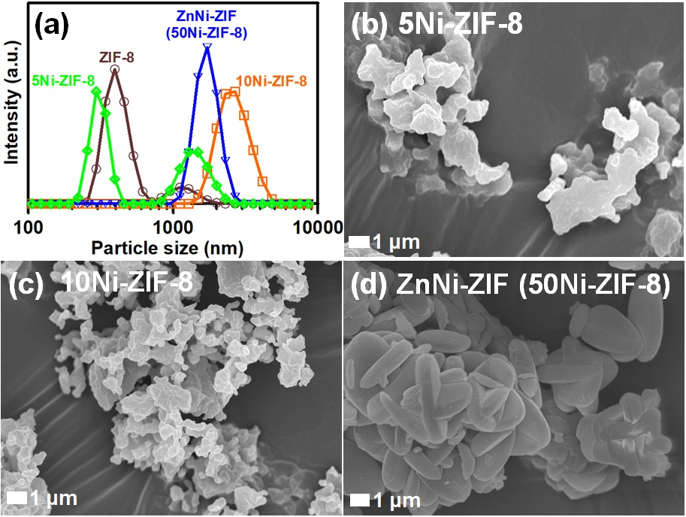
Figure S1 (a) Particle size distribution measured by DLS measurement, and (b-d) SEM images for ZIF-8, 5Ni-ZIF-8, 10Ni-ZIF-8, and ZnNi-ZIF (50Ni-ZIF-8) samples.

