**Supplementary Information**

**Influence of N sources on the photocatalytic activity of N-doped TiO2**

Pratibha V. Bakre, S. G. Tilve* and R. N. Shirsat

*School of Chemical Sciences, Goa University, Taleigao Plateau, Goa, 403206 (India).*

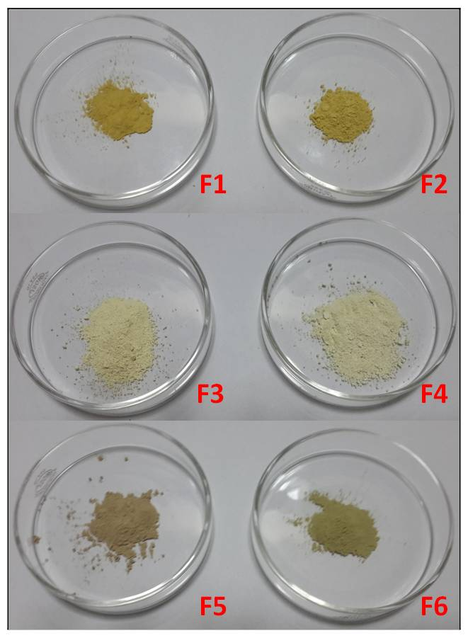

Fig. $1*—Colors of the samples F1- F6*

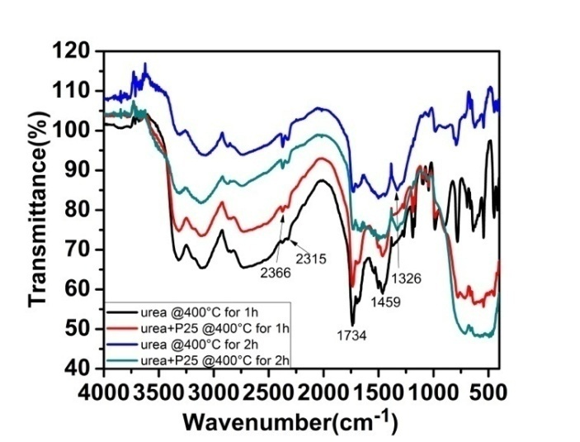

**Fig. $2**—*IR spectra of urea and Urea + P25 heating after 1 and 2 h at 400°C*



**Fig. $3**— *The mechanism of formation of products on TiO2 surface seen in IR from urea and semicarbazide*



**Fig. $4**—*Mechanism of decomposition of N,N’-dimethyl urea decomposition on TiO2*

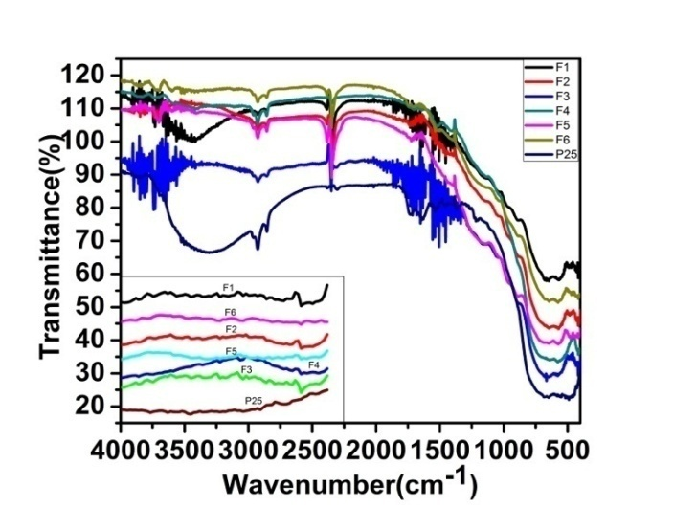

**Fig. $5**—*IR spectra of samples heated at 1000°C*

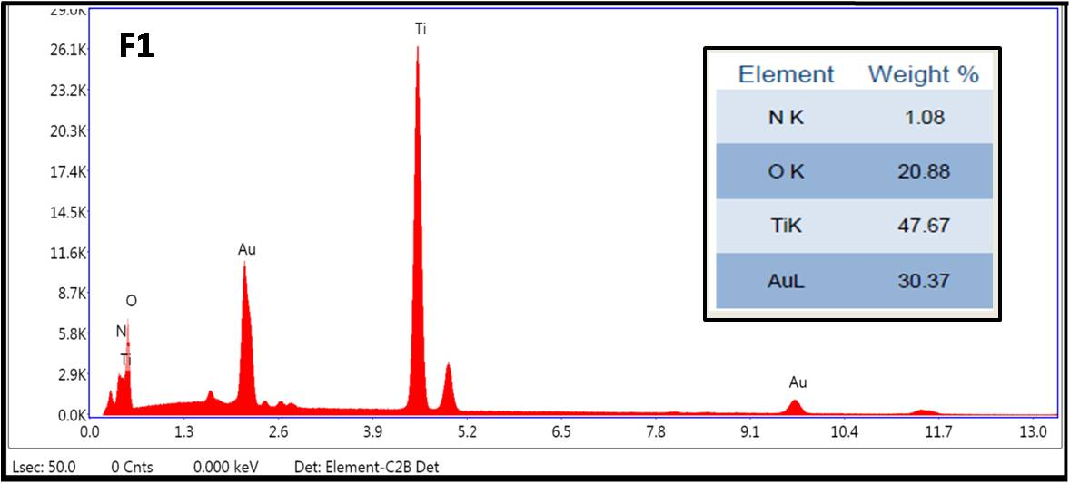

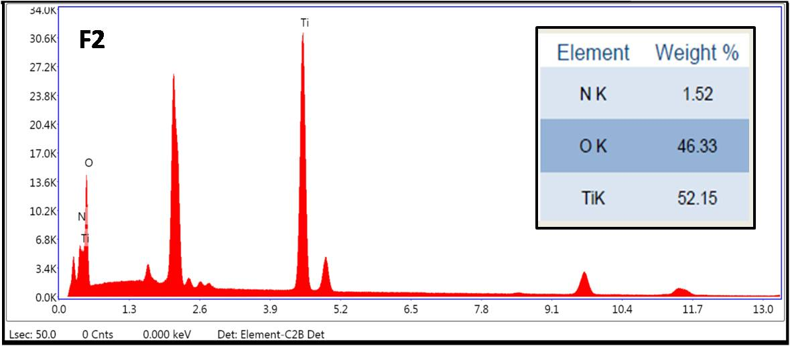

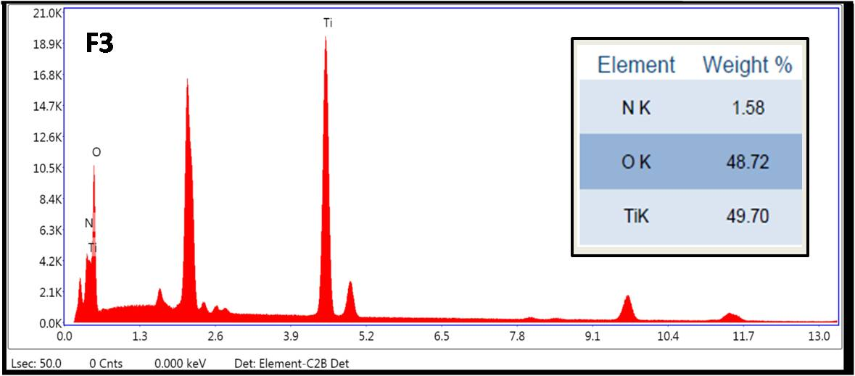

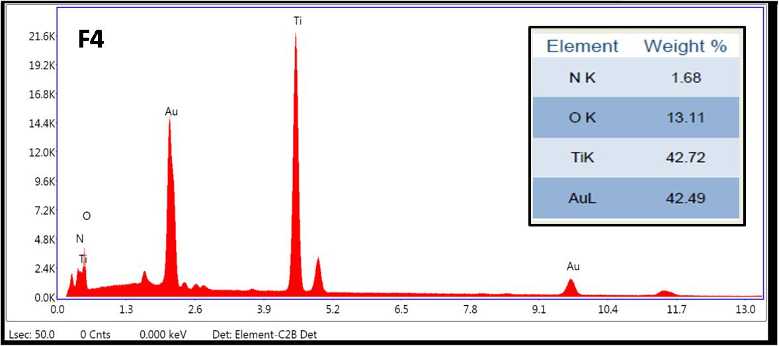

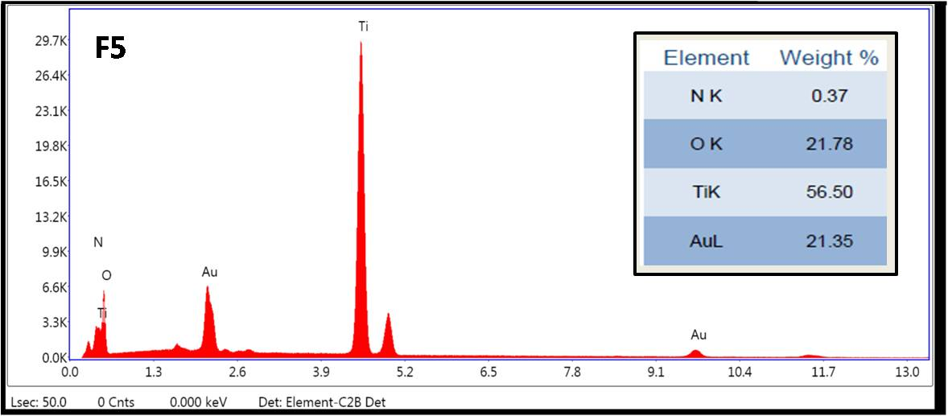

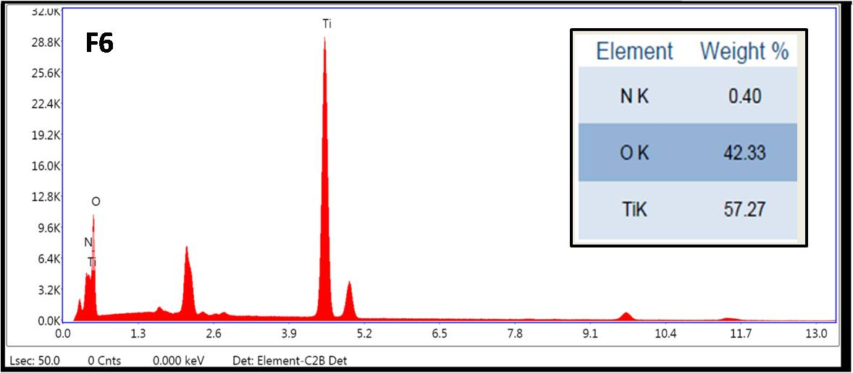

**Fig. $6**—*EDX plots for samples calcined at 500 ºC*

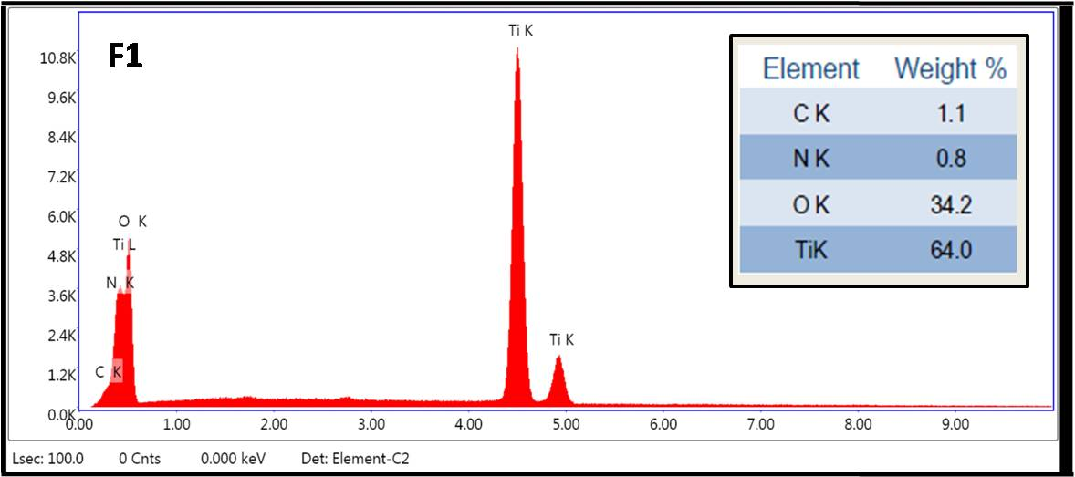

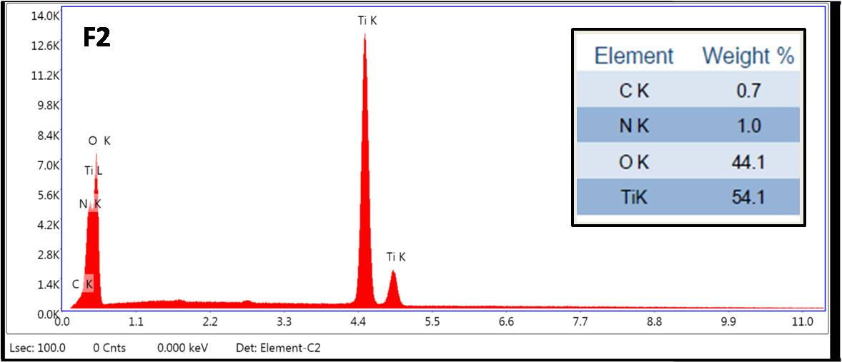

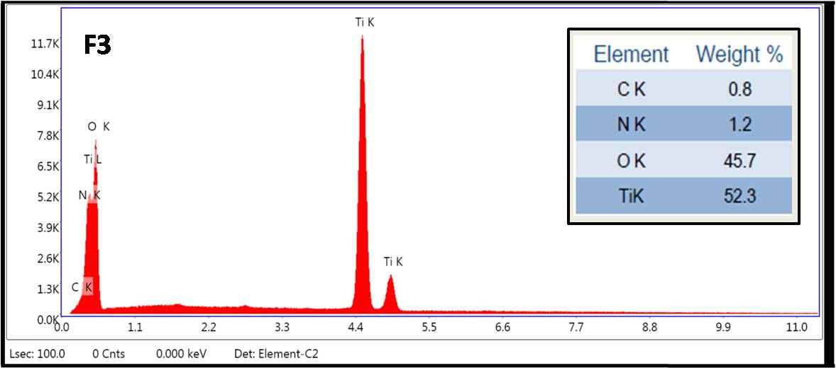

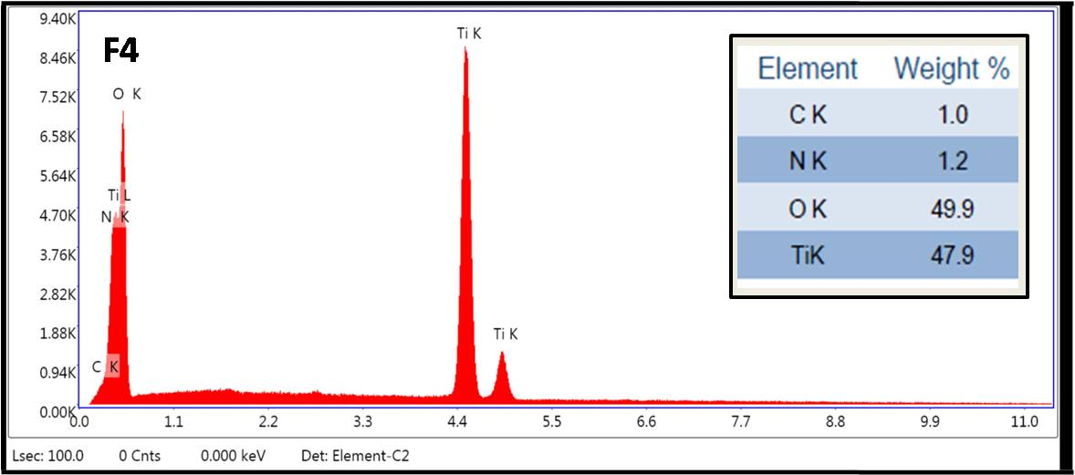

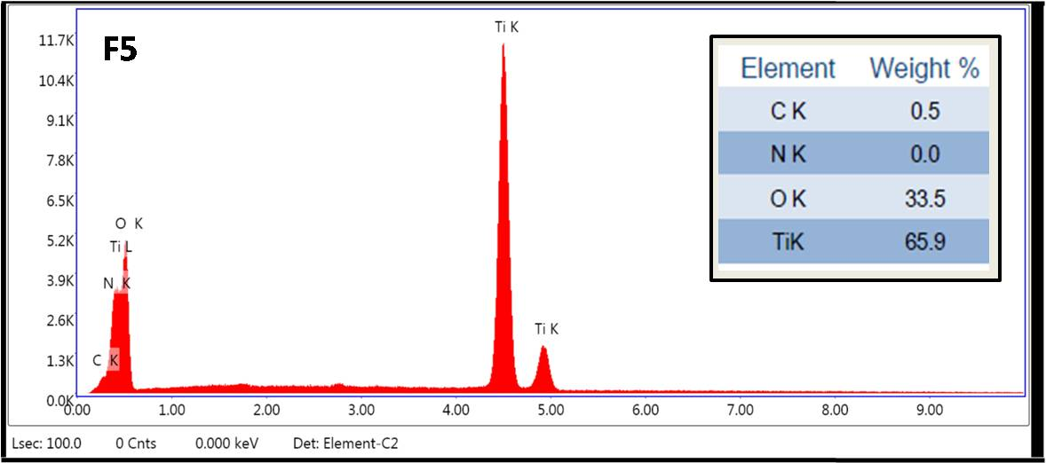

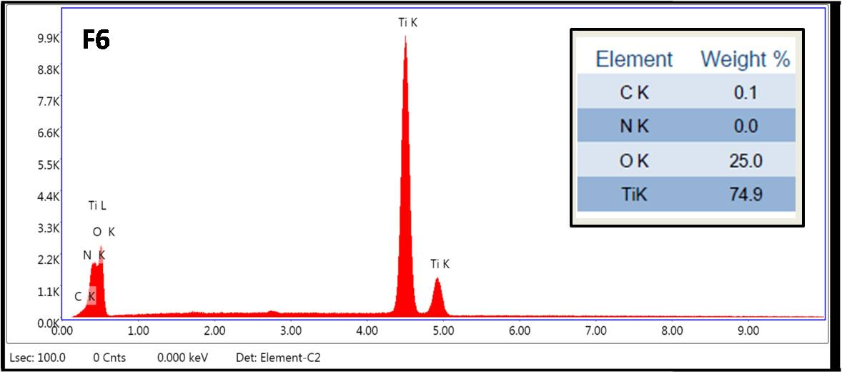

**Fig. $7**—*EDX plots for samples calcined at 1000 ºC*

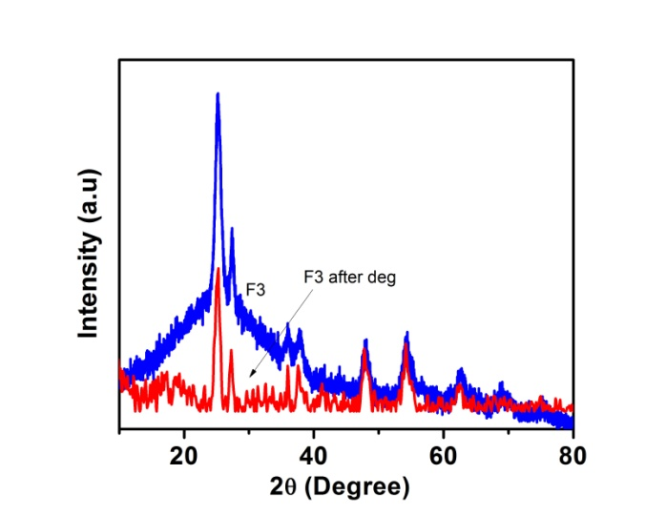

**Fig. $8**—*Comparative studies of XRD plots of sample before and after degradation*

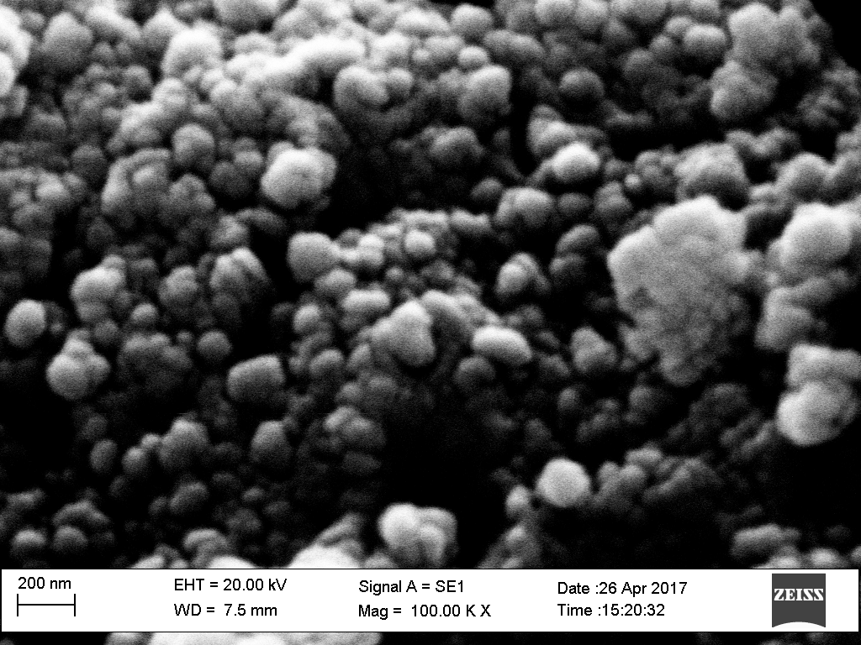 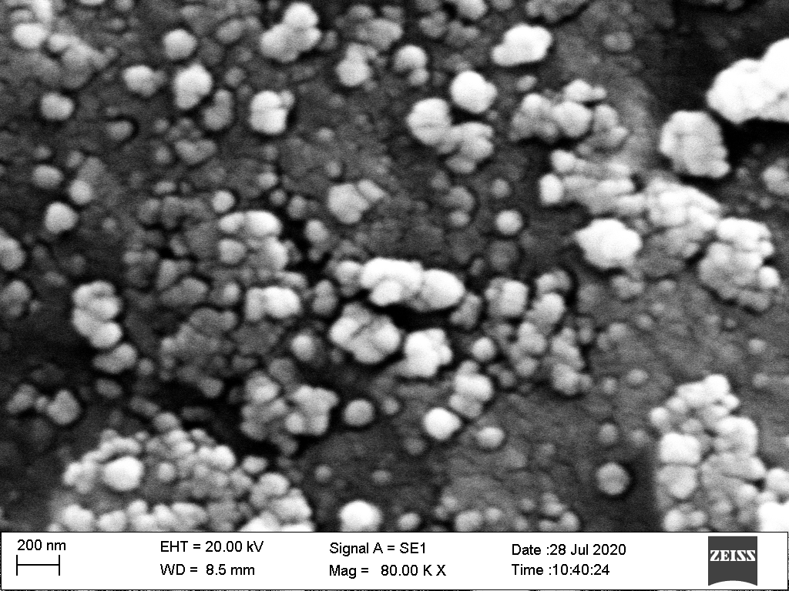

**Fig. $9**- *SEM of sample before degradation* **Fig. $10**- *SEM of sample after degradation*

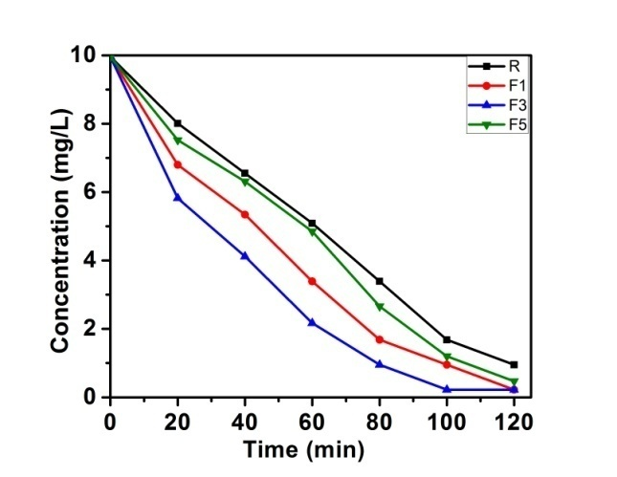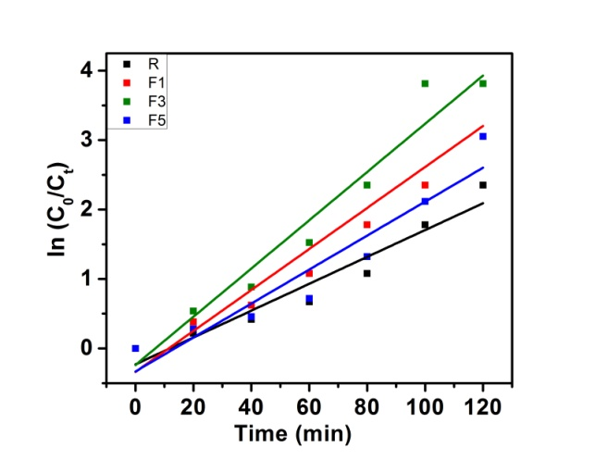

**Fig. $11**— *UV degradation plots and Kinetics studies of MB*

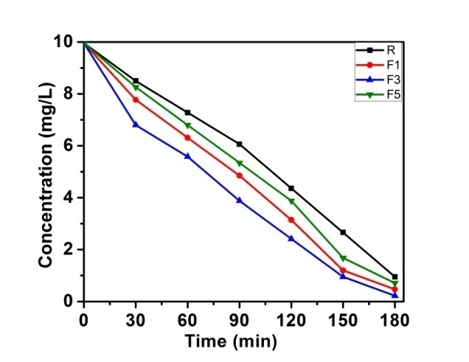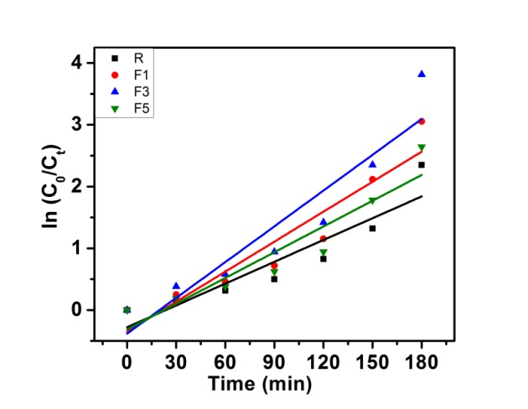

**Fig. $12**— *UV degradation plots and Kinetics studies of MB*

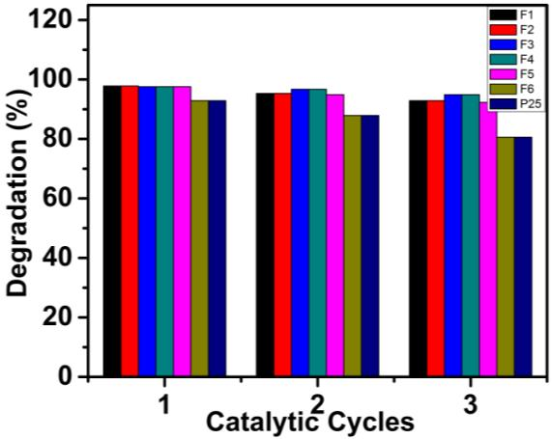 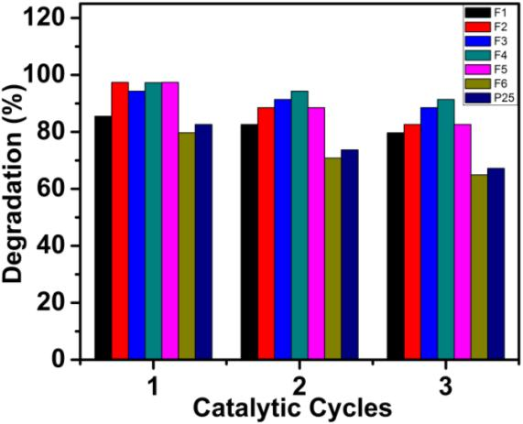

**Fig. $13**—*Recyclability studies for MB* **Fig.$14**—*Recyclability studies for RB*