Supplementary file

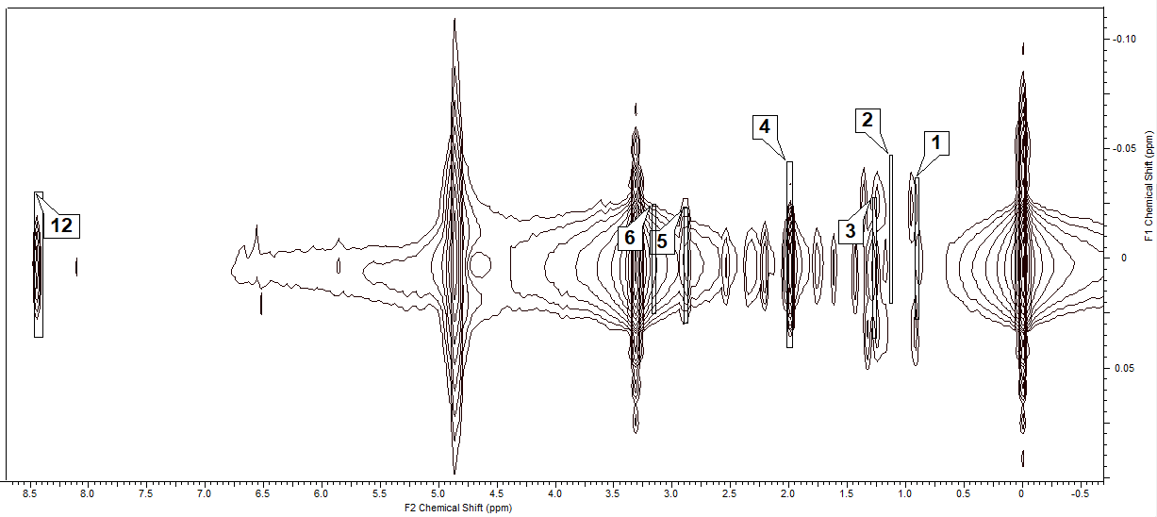

S1. 2D *J*-resolved experiments of *S. polycystum* in the region from -0.50 to  8.50. For the interpretation of the numbers assigned to the metabolites in the 2D *J*-resolved experiments, refer to Table 1.