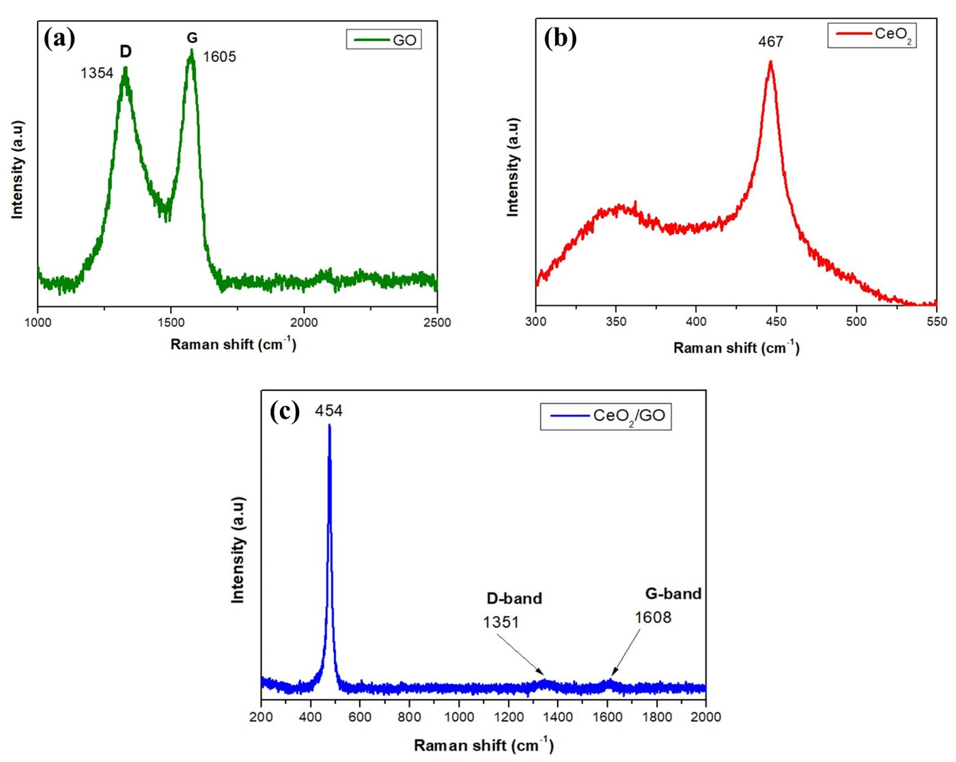

Supporting Fig.1. Raman analysis of (a) GO, (b) CeO2and (c) CeO2/GO nanocomposite

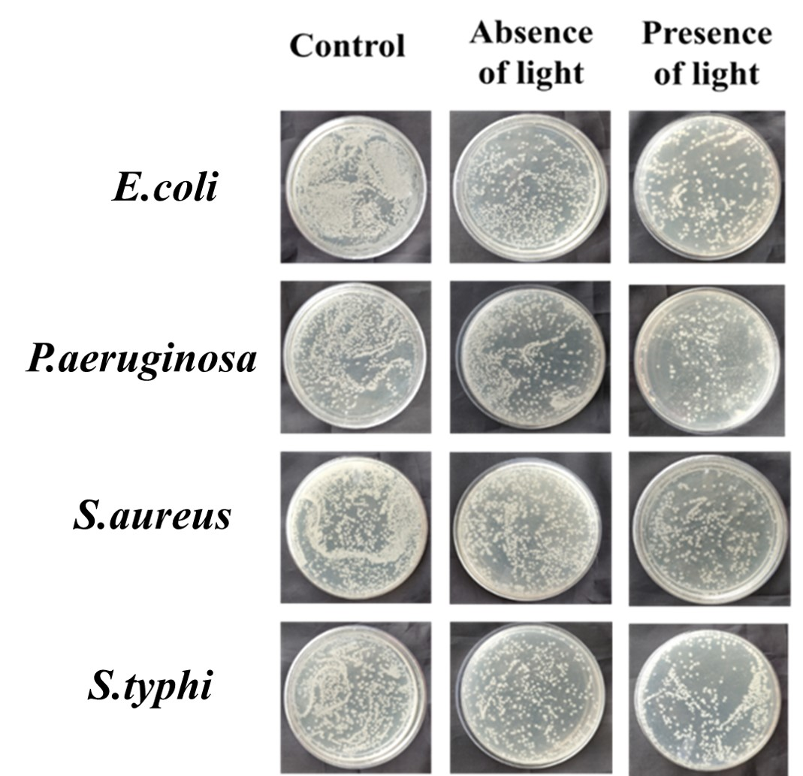

Supporting Fig. 2. Colony count for CeO2 /GO nanocomposite.