**Cross-mixing study of a poisonous *Cestrum* species, *Cestrum diurnum* in herbal raw material by chemical fingerprinting using LC-ESI-QTOF-MS/MS**

Hamna Shadaba, Muhammad Noman Khana, Faraz Ul Haqa, Hamad Alib, Hesham R. El-Seedic,d,* and Syed Ghulam Musharraf,a,b,*

*aH.E.J. Research Institute of Chemistry, International Center for Chemical and Biological Sciences, University of Karachi, Karachi-75270, Pakistan*

*bDr. Panjwani Center for Molecular Medicine and Drug Research, International Center for Chemical and Biological Sciences, University of Karachi, Karachi-75270, Pakistan*

*cPharmacognosy Group, Department of Pharmaceutical Biosciences, BMC, Uppsala University, SE-751 23 Uppsala, Sweden.*

*dInternational Research Center for Food Nutrition and Safety, Jiangsu University, Zhenjiang, 212013, China*

Correspondence:

**Prof. Dr. Syed Ghulam Musharraf**

H.E.J. Research Institute of Chemistry, International Center for Chemical and Biological Sciences, University of Karachi, Karachi-75270, Pakistan

Tel.: +92 213 4824924-5; 4819010; fax: + 92 213 4819018-9.

*E-mail address:* [musharraf1977@yahoo.com](mailto:musharraf1977@yahoo.com)

**Prof. Dr. Hesham R. El-Seedi**

Pharmacognosy Group, Department of Pharmaceutical Biosciences, BMC, Uppsala University, SE-751 23 Uppsala, Sweden.

Tel.: +46 73 5668234

*E-mail address:*  [hesham.el-seedi@farmbio.uu.se](mailto:hesham.el-seedi@farmbio.uu.se.)

**Supplementary Tables**

**Supplementary Table 1:** locations of the study areas with GPS coordinates.

|  |  |  |  |
| --- | --- | --- | --- |
| **S.NO** | **Sample Code** | **Area** | **GPS Location** |
| 1 | CD-1 | University of Karachi | 24.941682, 67.119367 |
| 2 | CD-2 | University of Karachi | 24.9440442, 67.123421 |
| 3 | CD-3 | P.E.C.H.S Karachi | 24.869374, 67.0621091 |
| 4 | CD-4 | Gulistan-e-Johar, Block-2 | 24.9209278, 67.088154 |
| 5 | CD-5 | Gulshan-e-Iqbal, Karachi | 24.920727, 67.088154 |
| 6 | CD-6 | Sector A, DHA Lahore | 31.470402, 74.439113 |
| 7 | CD-7 | Sihala, Islamabad | 33.543596, 73.19600 |
| 8 | CN-1 | Salarzo Pashat | 33.51563, 71. 31568 |
| 9 | CN-2 | Munda Qala | 34.49281, 71.41175 |
| 10 | CN-3 | Nawagai Bajour | 34.40123, 71.19001 |
| 11 | CN-4 | Qazafi Bajour | 34.4897, 71.39542 |
| 12 | CN-5 | Barkhalozo Mamund | 34.50054, 71.25104 |
| 13 | CN-6 | Lal Qila Dir | 34.53101, 71.48163 |
| 14 | CN-7 | Gawaliar Society, Karachi. | 24.96681, 67.119297 |
| 15 | CN-8 | Karachi university circular road | 24.9440442, 67.123421 |
| 16 | CN-9 | Sector A, DHA Lahore | 31.470402, 74.439113 |
| 17 | CN-10 | Sihala, Islamabad | 33.543596, 73.196100 |
| 18 | CP-1 | Gulshan-e-Iqbal, Karachi | 24.920676, 67.088181 |
| 19 | CP-2 | Defence Housing Authority | 25.038222, 67.449625 |
| 20 | CP-3 | Defence Housing Authority | 25.038222, 67.449625 |

CD= *Cestrum diurnum,* CN= *Cestrum nocturnum,* CP= *Cestrum parqui*

**Supplementary Table 2:** MS/MS spectra of identified compounds.

|  |  |
| --- | --- |
| **Code** | **MS/MS** |
| 1 |  |
| 2 |  |
| 3 |  |
| 4 |  |
| 5 |  |
| 6 |  |
| 7 |  |
| 8 |  |
| 9 |  |
| 10 |  |
| 11 |  |
| 12 |  |
| 13 |  |
| 14 |  |
| 15 |  |
| 16 |  |
| 17 |  |
| 18 |  |
| 19 |  |
| 20 |  |
| 21 |  |
| 22 |  |
| 23 |  |
| 24 |  |
| 25 |  |
| 26 |  |
| 27 |  |
| 28 |  |
| 29 |  |
| 30 |  |
| 31 |  |
| 32 |  |
| 33 |  |

|  |  |
| --- | --- |
| 34 |  |
| 35 |  |
| 36 |  |
| 37 |  |
| 38 |  |
| 39 |  |
| 40 |  |
| 41 |  |
| 42 |  |
| 43 |  |
| 44 |  |

**Supplementary Table 3:**Concentration of nornicotine in *Cestrum* species *C. diurnum* (CD), *C. nocturnum* (CN) and *C. parqui* (CP)*.*

|  |  |
| --- | --- |
| **Codes** | **Nornicotine concentration in mg\Kg** |
| CD1 | 10.218 |
| CD2 | 10.356 |
| CD3 | 10.158 |
| CD4 | 10.298 |
| CD5 | 11.270 |
| CD6 | 10.184 |
| CD7 | 10.610 |
| CN1 | 10.450 |
| CN2 | 10.336 |
| CN3 | 10.278 |
| CN4 | 10.358 |
| CN5 | 10.082 |
| CN6 | 10.046 |
| CN7 | 10.068 |
| CN8 | 10.104 |
| CN9 | 10.070 |
| CN10 | 10.196 |
| CP1 | 10.050 |
| CP2 | 10.210 |
| CP3 | 10.068 |

**Supplementary Table 4:** %Accuracy and %RSD of nornicotine.

|  |  |  |  |  |  |  |
| --- | --- | --- | --- | --- | --- | --- |
| **Nornicotine concentrations in ng/mL** | **Intra-Day** | | | **Inter-Day** | | |
| **Found concentration in ng/mL** | **%RSD** | **%Accuracy** | **Found concentration in ng/mL** | **%RSD** | **%Accuracy** |
|
| 25 | 25.4 | 4.8 | 101.5 | 24.7 | 4.5 | 98.7 |
| 175 | 175.3 | 3.0 | 100.2 | 173.0 | 3.7 | 98.9 |
| 375 | 370.9 | 3.8 | 98.9 | 386.2 | 0.8 | 103.0 |

**Supplementary Figures**

A

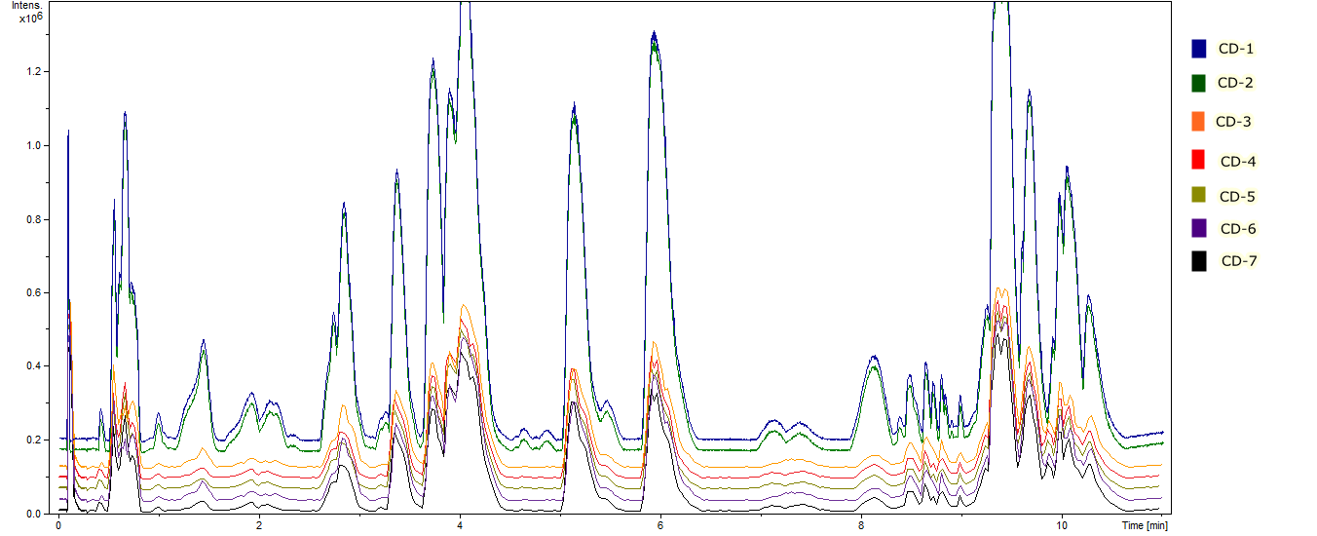

B

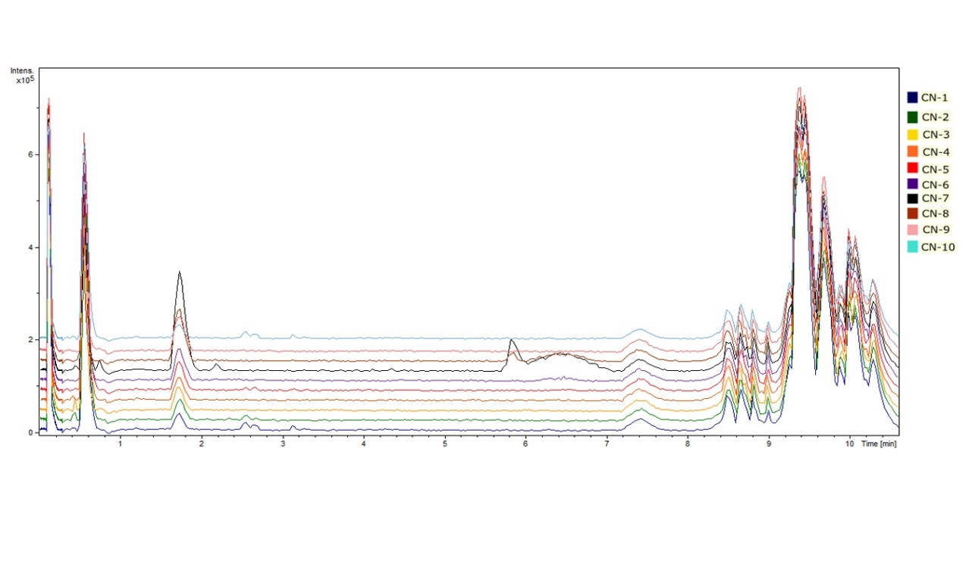

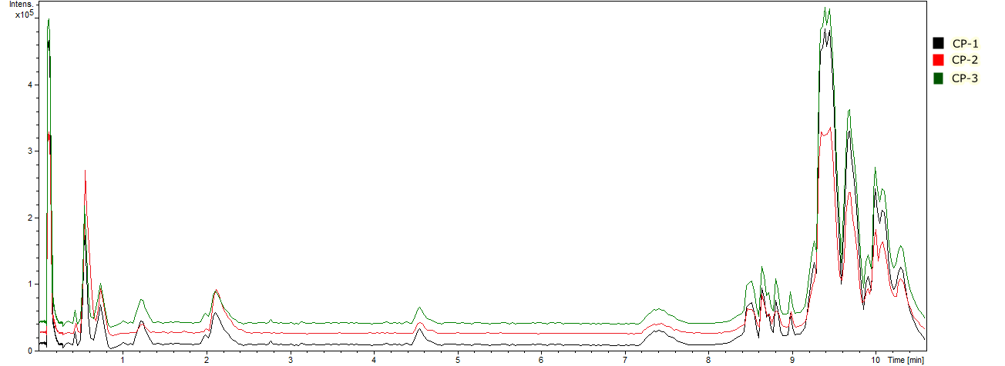

C

**Supplementary Figure 1:** Base peak chromatograms (BPC) of (A) C. diurnum (n= 7) (B) C. nocturnum (n= 10) and (C) C. parqui (n=3) samples from different geographical locations.

**Supplementary Figure 2:** PCA scattered plot of identified compounds in positive and negative modes of ionization.

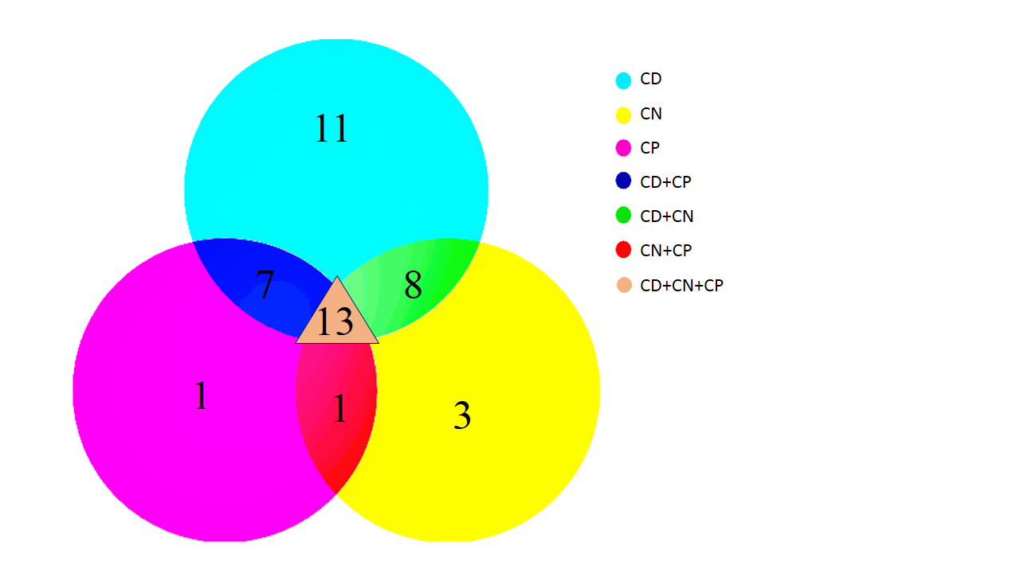

**Supplementary Figure 3:** Venn diagrams of identified compounds in positive and negative modes of ionization.

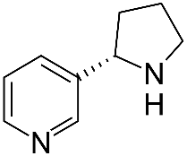

A



B

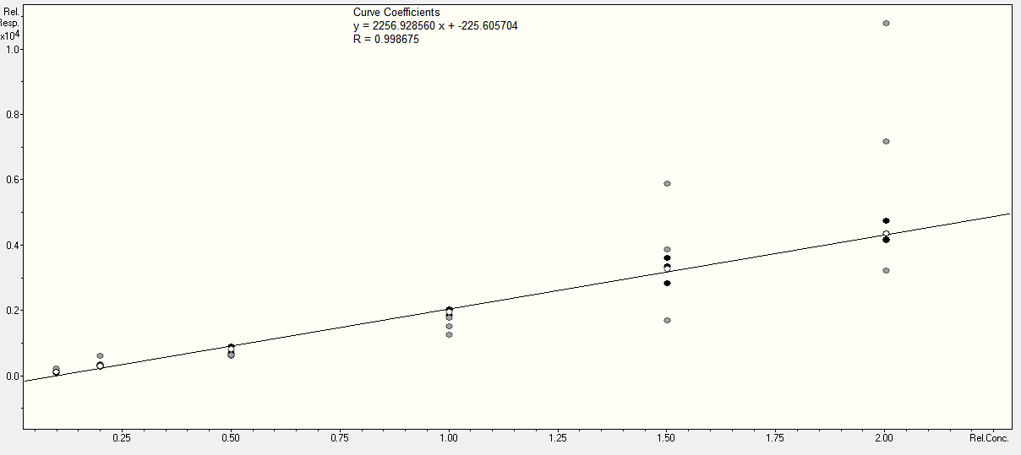

C

**Supplementary Figure 4:** (A) Extracted ion chromatogram of nornicotine (148.2 m/z) peak appeared at 0.4 min. (B) MS/MS spectra of nornicotine. (C) Curve coefficient and regression value R of nornicotine.

A

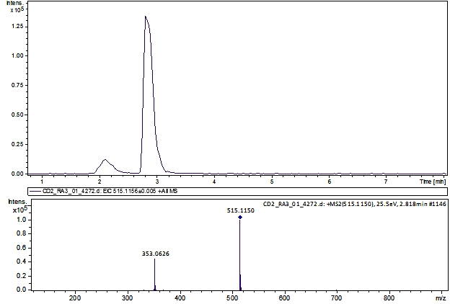

MS/MS

Compound A

**B**

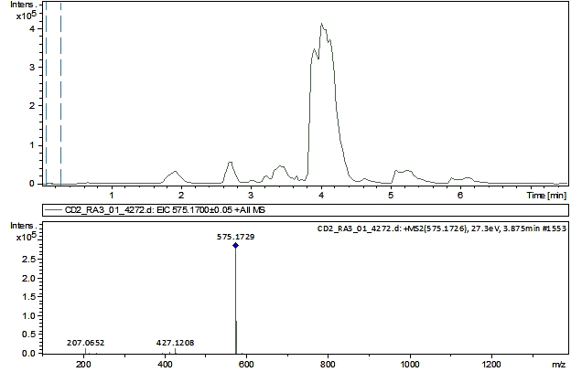

MS/MS

Compound B

**C**

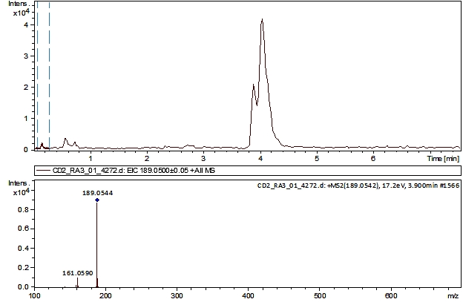

MS/MS

Compound C

**D**

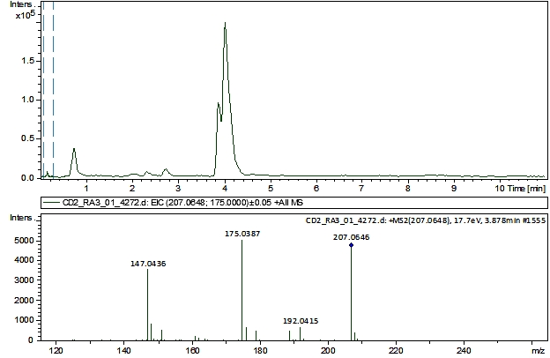

MS/MS

Compound D

**E**

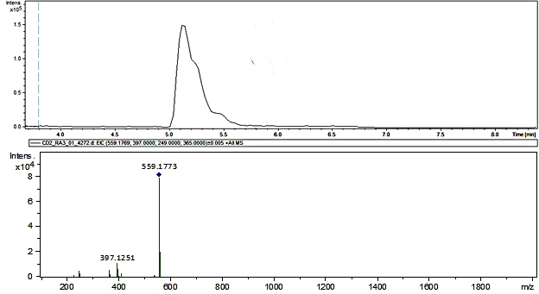

MS/MS

Compound E

**Supplementary Figure 5:** Compounds **A, B, C, D** and **E** and their fragment ions chromatograms.